- INTRODUCTION

Dance class management gives on idea about how the students details, teaching staff details, dance exams details are maintained in the particular concern. The dance class management system also includes some special features like students of the dance class can be recognized from their ID number. It helps them from the manual work from which it is very difficult to find the record of the students and the information those ones who have left the dance class .
This system is designed for dance class management, through this workload will be reduced and information will be handled efficiently,

1.1 Scope of Project
This software product the dance class management to improve their services for all
the students of the dance class. This also reduce the manual work of the persons in admin
penal and the bundle of registers that were search when to find the information of a
previous student, because through this system you can store the data of the students
of the dance class.
Through this you can check the personal profile of all the current students
within few minutes the data base of the system will help you to check a particular one.
The system will help you to check the attendance of every student and the student’s
dance class dues. The students of the dance class will be recognized from the ID number allocated batch wise.

1.2 Applications of project

- To display records of student and teachers.
- To save record of attendance and exams.

2.REQUIREMENTS

  - Hardware requirements

Device | Specification
Processor | Intel Core Dual 2.0 GHz or more
Monitor | LCD/CRT
RAM | 256MB
Other Device | Mouse, Keyboard
Hard disk | Minimum 20GB

  - Software requirements

Device | Specification
Operating System | Microsoft Windows 8.1
Front End | PHP version 5.2
Back End | MongoDB

3.2 Data Dictionary
Data dictionary is the repository information describing the data in the database. It is also known as ‘Metadata’.
The Data dictionary is specified in the form of tables as follows:

Table 3.2.1: Teacher information:

Field | Type | Size
T_id | Int | 30
Name | Varchar | 30
Phone_no | Int | 12
Qualification | Varchar | 30
Address | Varchar | 30

Table 3.2.2:Teaching staff attendance:

Field | Type | Size
T_id | Int | 10
Batch_no | Int | 10
Date | Int | Default
Status | Varchar | 20

Table 3.2.3:Students’ attendance:

Field | Type | Size
S_id | Int | 10
Batch_no | Int | 10
Date | Int | Default
Status | Varchar | 20

Table 3.2.4:Dance programme information:

Field | Type | Size
Venue | Varchar | 30
No of students | Int | 10
No of performances | Int | 10
Date | Int | Default

Table 3.2.5: Student Reg from:

Field | Type | Size
Name | varchar | 30
Phone_no | Int | 12
Address | varchar | 30
Email_id | varchar | 30
Date | Int | Default
Dance_Type | varchar | 30

Table 3.2.6: Exam form:

Field | Type | Size
Exam name | varchar | 30
Date | Int | Default
Day | varchar | 15
Dance_Type | varchar | 30

3.3 Relational Database Design

stud_1
>use mydatabase
switched to db mydatabase
>db.sinfo.find().pretty()
{

"_id" : ObjectId("5432a339f8bf0e1c17000003"),
"name" : "dhanashree",
"phno" : "9988776655",
"add" : "pune",
"email" : "dhanashree@gmail.com",
"dob" : "9-7-1995",
"dtype" : "Bharatnatyam"
}

Teacher1

> db.tinfo.find().pretty()
{
"_id" : ObjectId("54338c8bf8bf0ed00a000000"),
"T_id" : "100",
"name" : "punam",
"phno" : "998877",
"qual" : "b-ed",
"d_type" : "Bharatnatyam"
}

Teacher attendance
> db.tattendance.find().pretty()

{
"_id" : ObjectId("542fce9cf8bf0e680600000f"),
"id1" : "1",
"batch1" : "o",
"date1" : "9",
"status1" : "p"
}
{
"_id" : ObjectId("542fce9cf8bf0e6806000010"),
"id2" : "2",
"batch2" : "i",
"date2" : "9",
"status2" : "p"
}
{
"_id" : ObjectId("542fce9cf8bf0e6806000011"),
"id3" : "7",
"batch3" : "kn",
"date3" : "9",
"status3" : "p"
}
{
"_id" : ObjectId("542fce9cf8bf0e6806000012"),
"id4" : "8",
"batch4" : "m",
"date4" : "9",
"status4" : "p"
}

Exam info:
> db.einfo.find().pretty()
{
"_id" : ObjectId("5433ba14f8bf0e0808000003"),
"name" : "vocational",
"date" : "25/11/2014",
"day" : "Monday"
}

3.4 Database Normalization:
1.Normalization is a process in which we systematically examine relations for anomalies and, when detected, remove those anomalies by splitting up the
relation into two new, related, relations.
2.Normalization is an important part of the database development process: Often during normalization, the database designers get their first real look into how the data are going to interact in the database.
3.Finding problems with the database structure at this stage is strongly preferred to finding problems further along in the development process because at this point it is fairly easy to cycle back to the conceptual model (Entity Relationship model) and make changes.
4.Normalization can also be thought of as a trade-off between data redundancy and performance.

I.First Normal Form(1NF):
A relation is said to be in 1NF if it contains no non-atomic values and each
row can provide a unique combination of values.

II.Second Normal Form (2NF)
A relation is said to be in 2NF f if it is already in 1NF and each and every
attribute fully depends on the primary key of the relation. Speaking inversely,
if a table has some attributes which is not dependant on the primary key of
that table, then it is not in 2NF.

III.Third Normal Form (3NF)
A relation is said to be in 3NF, if it is already in 2NF and there exists no transitive dependency in that relation. Speaking inversely, if a table contains transitive dependency, then it is not in 3NF, and the table must be split to bring it into 3NF.What is a transitive dependency?
Within a relation if we see
A → B [B depends on A] And
B → C [C depends on B]
Then we may derive
A → C[C depends on A]
4.SOURCE CODE

MODULE

- Student registration form:
<html><head>
<title>validation</title>
<script language="javascript">
function verify()
{
if (document.form1.Name.value == "")
{
alert("Please give the name");
document.form1.Name.focus();
return false;
}
if (document.form1.Address.value == "")
{
alert("Please give address");
document.form1.Address.focus();
return false;
}
return( true );
}
</script>
</head>
<!-- Creating Form -->
<body bgcolor="white"><center><font size=5>
<form method="POST" action="successstud.php" name="form1">
<b><h3>REGISTRATION FORM</h3></b>
<table border=1 align=center bgcolor="Lavender" cellpadding=20px><br>
<td colspan=6 align=center><b>STUDENT INFORMATION</td>
<form name ="registration Form" action="successstud.php " method="POST"><tr>
<td>Name:</td><td> <input type = "text" name = "Name" size=30 maxlength=30></td></tr>
<tr><td>Phone_No :</td> <td><input type = "text" name = "Ph_no" size=12 maxlength=12></td></tr>
<tr><td>Address :</td><td><textarea name="Address" id="Address" size=30 maxlength=30></textarea> </td></tr>
<tr><td>email_id:</td><td> <input type = "text" name = "eid" size=30 maxlength=30></td></tr>
<tr><td>Date:</td><td><textarea name="date" rows="2" cols="20"></textarea></td></tr>
<tr><td> Dance_Type:<td><select name="dance_type">
<option value="-1" selected>select..</option>
<option value="Bharatnatyam">Bharatnatyam</option>
<option value="Hip-Hop">Hip-Hop</option> </select></td> </td></tr>
<tr><td colspan =2 align="center">
<button type="submit">submit</button>
<button type="Reset">Reset</button></td></tr></table><br /><br />
<center><h3><u><b><a href="http://localhost/stud.html">BACK</a></u></b></h3></center></form></body></html>

- PHP code:
<?php
$m=new MongoClient();
$db=$m->mydatabase;
$collection=$db->sinfo;
$name=$_POST['Name'];
$Phno=$_POST['Ph_no'];
$add=$_POST['Address'];
$email=$_POST['eid'];
$DOB=$_POST['date'];
$Dtype=$_POST['dance_type'];
$disp = $collection->find();
foreach($disp as $doc)
{
if($email===$doc['email']){
$f=1;
}
else{
$f=0;
}
}
if($f===1){
echo"Email already exists";
}
else{
$dc=array("name"=>$name,"phno"=>$Phno,"add"=>$add,"email"=>$email,
"dob"=> $DOB,"dtype"=>$Dtype);
$inse=$collection->insert($dc); echo "<center>";
echo "<h1>REGISTERED SUCCESSFULLY!!!!</h1><br/>";
echo "document inserted successfully";
echo "<br /><br />";
echo"<h2><u><b><a href='http://localhost/stud_info.html'>BACK</a></u>
</b></h2>";
echo "</center>"; } ?>
- html code for managing staff login:
<html>
<body align="center"><br><br><br><br>
<font size="+4">MANAGING STAFF LOGIN</font><br><br>
<form method="POST" action="password.php" name="form1">
<table align="center"><tr><td>
<form action="password.php" method="POST">
Username: <input type="text" name="Username"><br>
password: <input type="password" name="password"><br><br>
<button type="submit"> Submit</button>
<buttontype="Reset">Reset</button><buttontype="Previous"><a href="eg.html">previous</a></button></form></html></body>
- PHP code:
<?php
$m=new MongoClient();
$db=$m->mydatabase;
$collection=$db->minfo;
$user=$_POST['Username'];
$pswd=$_POST['password'];
$disp = $collection->find();
foreach($disp as $doc)
{
if($pswd===$doc['pswd']){
$f=1;
}
else{
$f=0;
}
}
if($f===1){
echo '<br><br><br><br><h1><b><center><a href="managing.html">Click here </a></center></b></h1>';
}
else{
echo "<br><br><br><br><h1><b><center>wrong username or password!!!!</center></b></h1>"; }?>

- HTML code for attendance:
<html><head>
<title>table</title>
<body bgcolor="white">
<table align="center" border="1" bgcolor="Lavender"style="width:75%" cellpadding="15px">
<form name ="registration Form" action = "satnd.php" method="POST">
<caption><font color="Black"><h2><b><u>STUDENT'S ATTENDANCE</b></caption>
<tr><td><u>stud_id</td>
<td><u>Batch_no</td>
<td><u>Date</td>
<td><u>Status</td></tr>
<tr>
<td><textarea rows="2" cols="20" name="11"></textarea></td>
<td><textarea rows="2" cols="20" name="12"></textarea></td>
<td><textarea rows="2" cols="20" name="13"></textarea></td>
<td><textarea rows="2" cols="20" name="14"></textarea></td></tr>
<tr>
<td><textarea rows="2" cols="20" name="21"></textarea></td>
<td><textarea rows="2" cols="20" name="22"></textarea></td>
<td><textarea rows="2" cols="20" name="23"></textarea></td>
<td><textarea rows="2" cols="20" name="24"></textarea></td></tr>
<tr>
<td><textarea rows="2" cols="20" name="31"></textarea></td>
<td><textarea rows="2" cols="20" name="32"></textarea></td>
<td><textarea rows="2" cols="20" name="33"></textarea></td>
<td><textarea rows="2" cols="20" name="34"></textarea></td></tr>
<tr>
<td><textarea rows="2" cols="20" name="41"></textarea></td>
<td><textarea rows="2" cols="20" name="42"></textarea></td>
<td><textarea rows="2" cols="20" name="43"></textarea></td>
<td><textarea rows="2" cols="20" name="44"></textarea></td></tr></table>
<table align="center" cellpadding="20px" cellspacing="15px">
<tr><td><input type="submit" name="submit" value="submit"></td></tr></table></form></head>
</body></html>
- PHP code:
<html>
<body align="center"><br><br><br><br>
<h1> ATTENDANCE CHECKED!!!!</h1>
<?php
$m=new MongoClient();
echo "connected";
$db=$m->mydatabase;
echo"mydb database selected";
$collection=$db->sattendance;
$stud_id1=$_POST['11'];
$Batch_no1=$_POST['12'];
$Date1=$_POST['13'];
$Status1=$_POST['14'];
$dc=array("id1"=>$stud_id1,"batch1"=>$Batch_no1,"date1"=>$Date1,"status1"=>$Status1);
$inse=$collection->insert($dc);
$stud_id2=$_POST['21'];
$Batch_no2=$_POST['22'];
$Date2=$_POST['23'];
$Status2=$_POST['24'];
$dc1=array("id2"=>$stud_id2,"batch2"=>$Batch_no2,"date2"=>$Date2,"status2"=>$Status2);
$inse=$collection->insert($dc1);
$stud_id3=$_POST['31'];
$Batch_no3=$_POST['32'];
$Date3=$_POST['33'];
$Status3=$_POST['34'];
$dc2=array("id3"=>$stud_id3,"batch3"=>$Batch_no3,"date3"=>$Date3,"status3"=>$Status3);
$inse=$collection->insert($dc2);
$stud_id4=$_POST['41'];
$Batch_no4=$_POST['42'];
$Status4=$_POST['44'];
$Date4=$_POST['43'];
$dc3=array("id4"=>$stud_id4,"batch4"=>$Batch_no4,"date4"=>$Date4,"status4"=>$Status4);
$inse=$collection->insert($dc3);
echo"document inserted successfully"; ?></body></html>

5.GRAPHICAL USER INTERFACE

- Home page


- Managing staff login page:
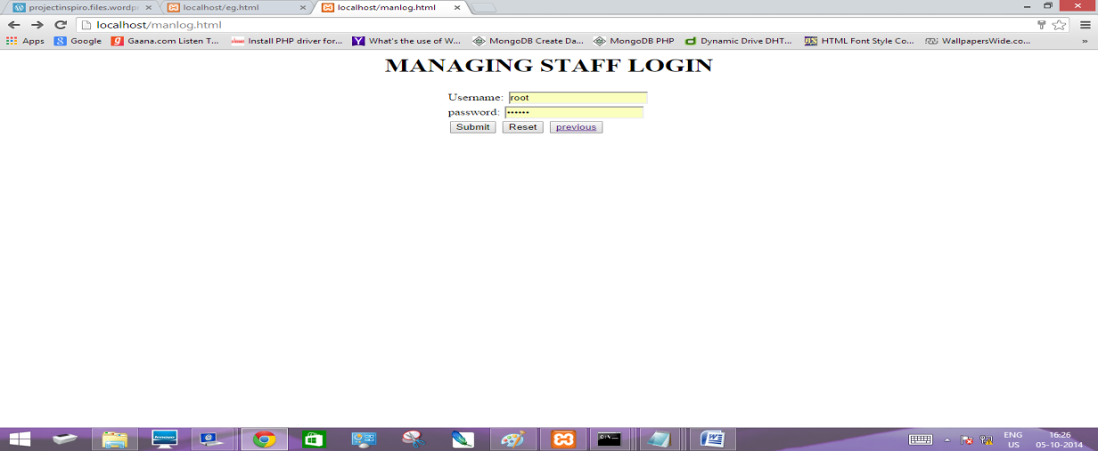

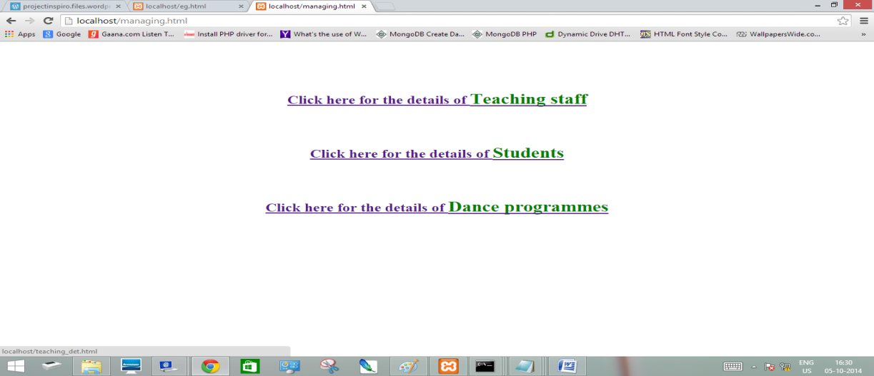

- Student registration form:
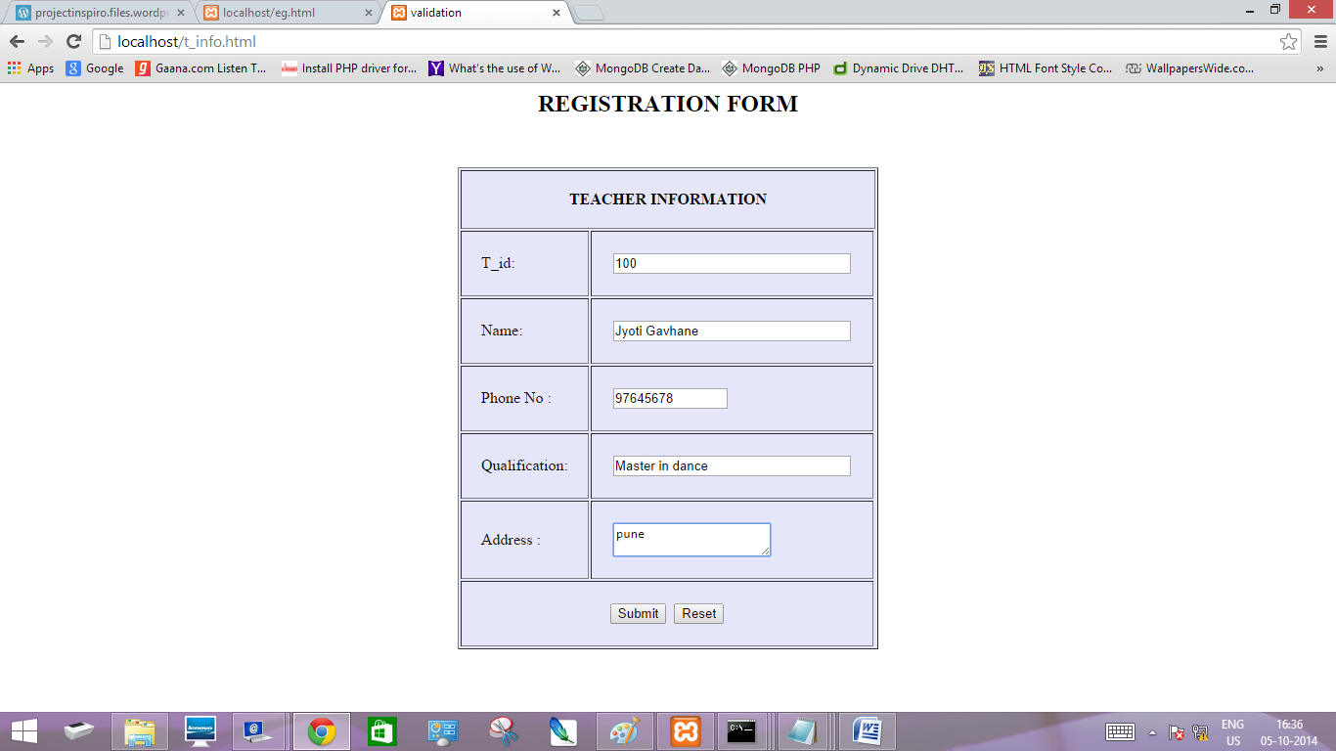

6.DATA REPORT

7.TESTING DOCUMENT

Testing is the first stage of software development before we release the product to customer. Suring testing we try to make sure that the software does exactly that what it is supposed to do.
The software testing consists of level of testing:
1. Unit Testing - This testing forces verification efforts on the smallest of the software. While doing this, each module was tested to see that information properly flows into add out of the program under consideration.
2. Integration Testing - Once all the Modules have been tested individually, then system is tested by integration module.
3. System Testing - Last of all the whole system is tested to find whether the system and its original objectives tally, whether the current specification and system’s documentation match.

Sr no | Test steps | Test data | Expected Result | Actual Result | Pass/Fail
1. | Administrator Login | Username/Password | Access only the correct entry | Access only the correct entry | Pass
2. | Character value entered in the place of numeric | ‘abc’ in place of contact number | Error message asking user to enter numeric value | Error message asking user to enter numeric value | Pass
3. | Field left blank | While adding the user record if any field left blank | Error message asking user  to enter all fields | Error message asking user to enter all fields | Pass
4. | Form Submitting | New form before submitting previous one | Error message asking user to fill and submit the previous form. | Error message asking user to fill and submit the previous form. | Pass

- FUTURE ENHANCEMENT

I.We here have created a very small version of a very big project, in upcoming future we intend to make this a full scale fully functioning Website
II. We have provided ability that any numbers of students can take admission
using registration form.
III. The analysis assumes conservative and uniform spread of values, this may not hold and more sophisticated tools for estimation should be used.
IV. Managing staff can delete the student record if the student wants to cancel his admission, via email .
V. Greater information about the user can be stored and the user may update
his data status via email .

9.CONCLUSION

After all the rigorous sittings and hours of hard labour by all the team members, the project is finally completed and has really shaped in a satisfying way. The application stands out in most of its performance requirements and also has a very friendly and self-explaining user interface.
The application is very practical and simple to run and use. In today’s time when maintaining backup is so much important that everyone needs to save and keep record of their data, this application can prove to be very handy to the user in terms of keeping track of teaching staff information ,students’ data, attendance. It also satisfies security concerns asit is based on username, password and one time verification code. We hope the application ends up giving a nice experience to every user and has no fatal errors and any severe drawback.

10.REFERENCES/BIBLOGRAPHY

The project is developed with some of the fine ideas & tools from the following-
10.1 Books Referred:
Silbertz A, Korth H.,Sudarshan S., “Database System Concepts”,4th edition
10.2 Websites
http://www.tutorialspoint.com/
http://www.stackoverflow.com/
http://www.google.com/

Format of Miniproject Report

- Paper Size : A- 4 size bond paper

- Margins :
Top : 1”
Bottom : 1”
Left : 1.25”
Right : 0.75”

3. Line Spacing: 1.5 lines

4. Title of Chapter

Font : Times New Roman (Bold face)
Size : 14 point
Alignment : Right Alignment
One thick line (2¼ point weight) after the name of chapter.

- Headings
First Order Heading: ( for example – 1. Introduction)
Font : Times New Roman (Bold Face)(CAPITAL)
Size : 14 point
One blank line before the heading. (12 points)

Second Order Heading : (for example – 1.1. Evolution)
Font : Times New Roman (Bold Face)
Size : 13 point
One blank line before the heading. (12 points)

Third Order Heading : ( for example – 1.1.1. Image Processing)
Font : Times New Roman (Bold Face)
Size : 12 point
One blank line before the heading. (12 points)
6. Text
Font : Times New Roman
Size : 12 point

Heading / Sub-Heading
Alignment : Justified (Full Text)
7. Page Numbering ( Centered)
Till page, “ FIGURE INDEX” : Roman ( I, II, …etc. )

For Remaining Pages
(i.e. from ABSTRACT -to- REFERENCES) : 1, 2, …… N

10. References
Line Spacing : 1.5 Line
Font : Times New Roman
Size : 12 point
Publication details & URL must be in Italics
Format:
- Author’s Name, “Article Title”, Complete URL of Web Page.
- Author’s Name, “Title of the Book”, Publication, Edition, Year of Printing.

For Example:

[1] “Author Guidelines”, http://.computer.org/cspress/instruct.htm
[2] “Database System Concepts Fifth Edition”, Avi Silberschatz, Henry F. Korth, S. Sudarshan

Note :

- Miniproject Report must be spiral binding
- Report must be written in your own English language.
- “Cover Page, First Page, Specimen Copy “are only for students instructions, it should not be printed in the report.
- Sequence of pages to be followed as:
  - First Page
  - Certificate
  - Index
  - Table Index (optional)
  - Figure Index (optional)
  - Abstract
  - Theory
  - Conclusion
  - References

