**COMPUTER_VISION**

**Code 1:**

* Using OpenCV to capture and display live video from a webcam or an IP camera stream.

**Code 2:**

* It captures live video frames from the webcam using OpenCV and saves each frame as a JPEG image in a folder.

**Code 3:**

* The program loads and displays the image using OpenCV.

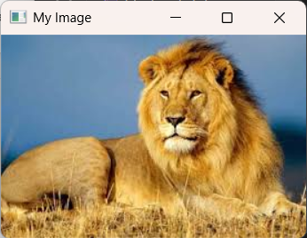

**Code 4:**

* It gives the image in different types of flips using OpenCV.
* **Cv2.flip(img,0)** – flips the image vertically
* **Cv2.flip(img,1) –** flips the image horizontally
* **Cv2.flip(img, -1) –** flips the image both vertically and horizontally.

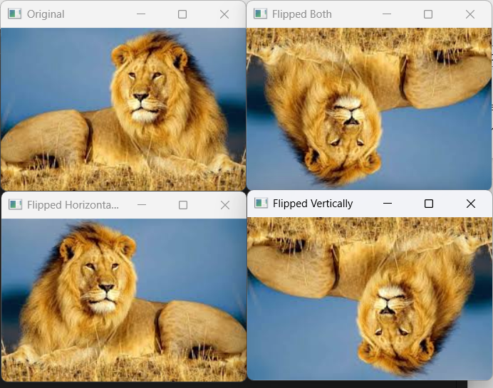

**Code 5:**

* The code loads an image, resizes it to 300x300 pixels, displays both the original and resized images and saves the resized image as “resized_output.jpg”.

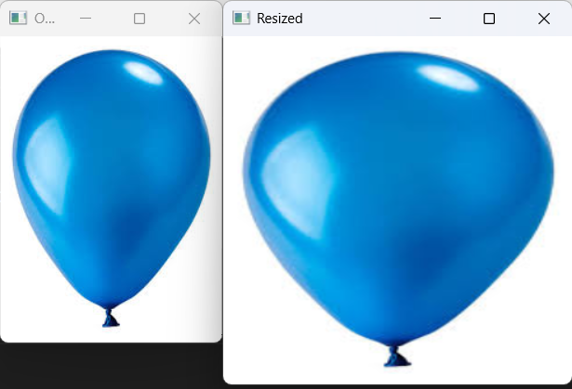

**Code 6:**

* It converts a colour image to grayscale using OpenCV.

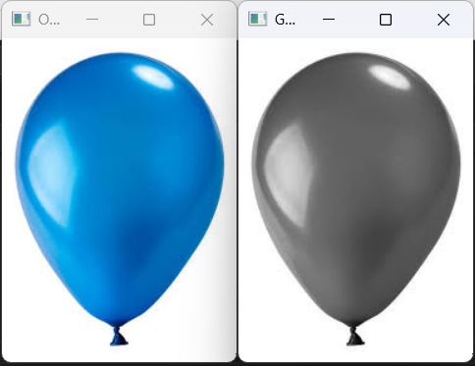

**Code 7:**

* The code applies a Gaussian Blur to an image using OpenCV.

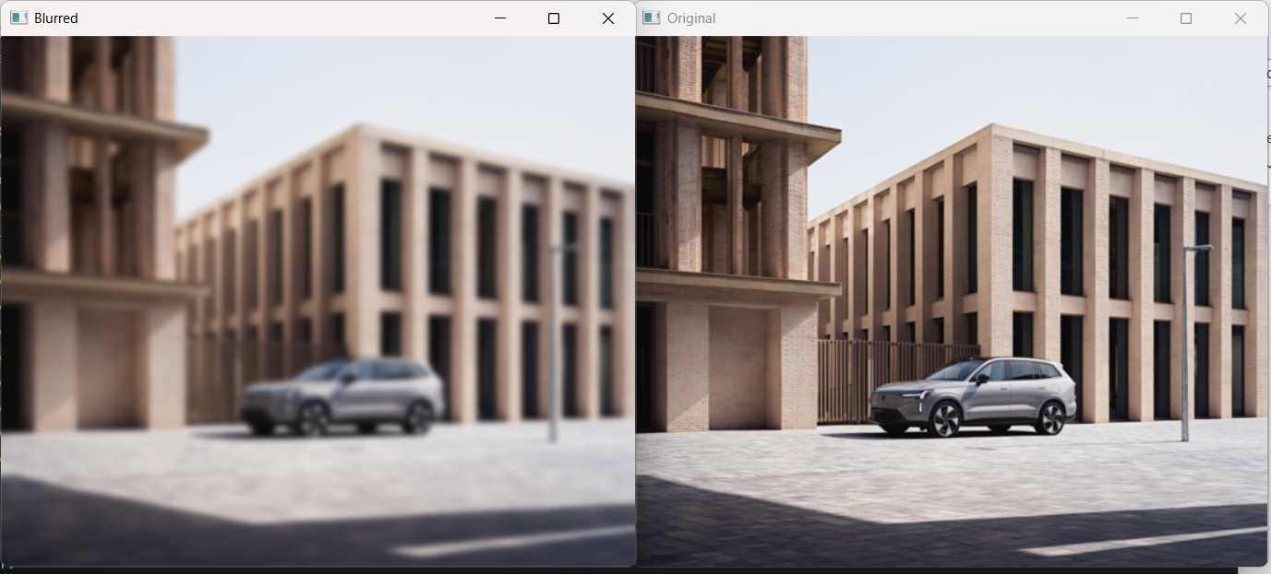

**Code 8:**

* This code draws a basic shapes and text on a black image using OpenCV.

**Code 9:**

* This code uses OpenCV and performed image thresholding on a grayscale image.

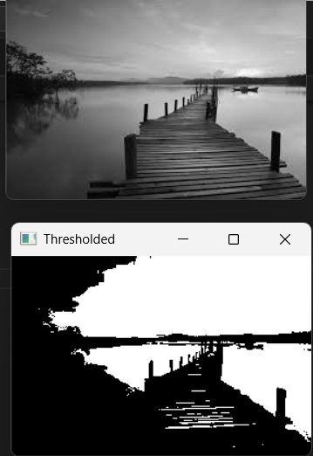

**Code 10:**

* This code applied Canny edge detection on a grayscale image using OpenCV.

**Code 11:**

* This code performed face detection using OpenCV.

**Code 12:**

* This code used OpenCV to detect and draw contours on an image.

**Code 13:**

* This code used OpenCV to detect and isolate blue colour in an image by using HSV colour space.

**Code 14:**

* This code uses OpenCV for foreground extraction from an image.

**Code 15:**

* This code captures video from the webcam and tracks blue colour in real-time using OpenCV and HSV colour space.

**Code 16:**

* The code uses OpenCV to perform morphological operations i.e. erosion and dilation on a binary image which helps in refining shapes.

