**Machine learning concepts**

**Array 1:**

* Used basic NumPy array creation methods
* Covered 1D and 2D arrays, arrays of ones and zeros
* arrays like ranges and linearly spaced values

**Array 2:**

* NumPy’s arithmetic and mathematical operations

1. Addition
2. Subtraction
3. Multiplication
4. Division
5. Square root
6. Exponentiation

**Array 3:**

* NumPy indexing and slicing
* Modifying elements

**Array 4:**

* Key statistical values
* Maximum and minimum values
* Sum, mean, mean deviation
* Index of max and min

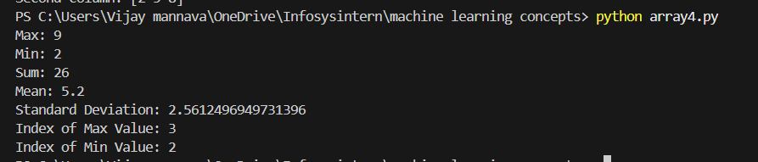

**Array 5:**

* generating random numbers and shuffling arrays

**Array 6:**

* Splitting the dataset into training and testing

**Array 7:**

* Linear Regression model to fit a linear model to data, make predictions, and inspect model parameters.

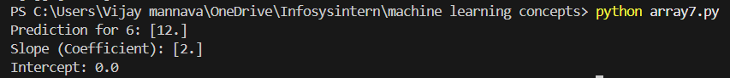

**Array 8:**

* LogisticRegression model for binary classification problems, where outputs are probabilities

**Array 9:**

* training and visualizing a Decision Tree Classifier with the Iris dataset using scikit-learn's  DecisionTreeClassifier and matplotlib for plotting

**Array 10:**

* standardize features in a dataset so that each feature has a mean of 0 and a standard deviation of 1.

**Array 11:**

* KMeans clustering using scikit-learn, which partitions the input 2D points into clusters based on their similarity.

**Array 12**:

* Principal Component Analysis (PCA) on the Iris dataset using scikit-learn.

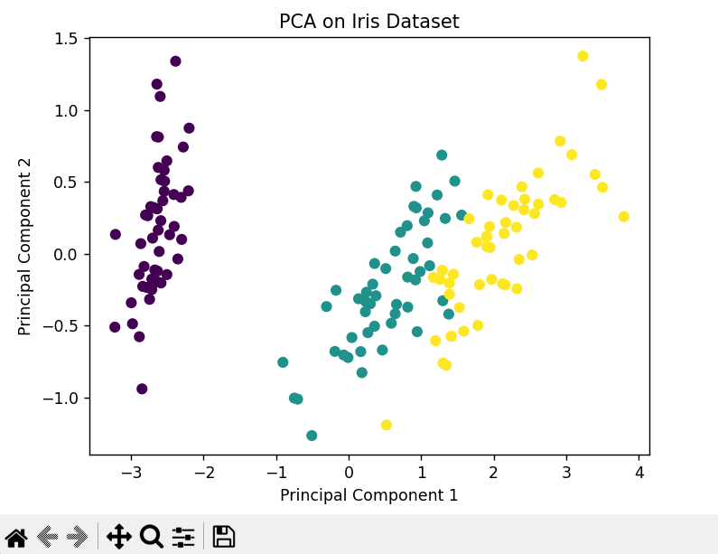

**Array 13:**

* Agglomerative Clustering, a type of hierarchical clustering that groups similar data points step-by-step until the desired number of clusters is formed**.**

**Plot 1:**

* Creating a simple line plot using matplotlib
* Plotting the values to see their relationship

**Plot 2:**

* generated a basic line plot in mathplotlib
* quadratic relationship of y=x2

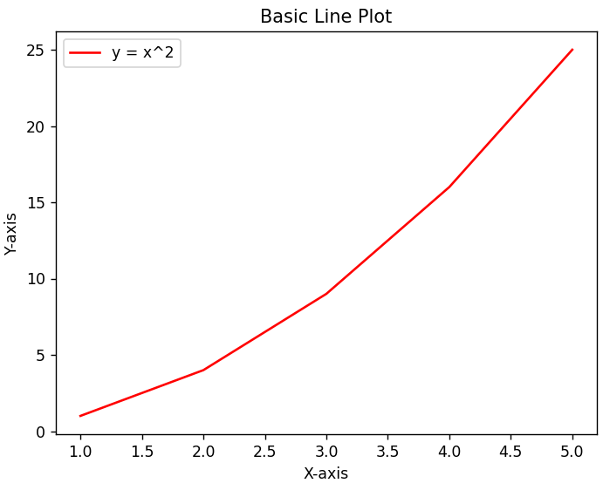

**Plot 3:**

* Linear, quadratic and cubic functions are done are the same figure using matplotlib’s default line plot
* Labelled each curve

**Plot 4:**

* Created a scatter plot in matplotlib
* visualizing paired data points with large, green circles

**Plot 5:**

* This code creates a basic vertical bar chart using matplotlib
* The categories "A" through "E" are shown on the x-axis
* corresponding values define the height of each orange bar

**Plot 6:**

* This code generates a histogram using matplotlib to visualize the distribution of 1000 random numbers generated.

**Plot 7:**

* This code creates a pie chart using matplotlib to display the proportions of four categories: Apples, Bananas, Cherries, and Dates

**Plot 8:**

* It uses matplotlib's subplot() function to create two side-by-side plots—one line plot and one bar plot in the same figure.

**Plot 9:**

* This code creates a customized line plot using matplotlib, specifying visual styles for line colour, line style, markers, and sizes.

**Plot 10:**

* This code creates a 3D surface plot using matplotlib and Numpy to check the given sin function.

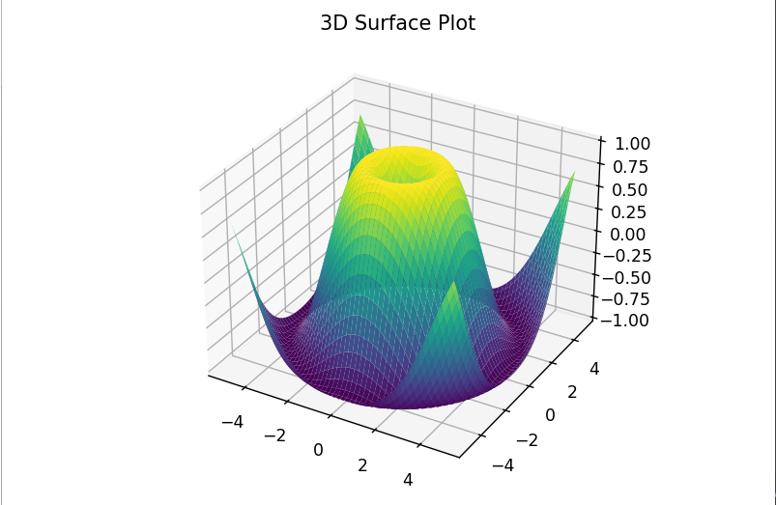

**Linear_regression.py**

* The concept used here is linear regression, which is a supervised machine learning method for modelling and predicting the relationship using a straight-line equation.

