Day-1

> Question-1

import java.util.Scanner;
class Calc {
int x, y;
String op;
public Calc(int x, int y, String op) {
this.x = x;
this.y = y;
this.op = op;
}
public String calculate() {
switch (op) {
case "Addition":
return String.valueOf(x + y);
case "Subtraction":
return String.valueOf(x - y);
case "Multiplication":
return String.valueOf(x * y);
case "Division":
if (y != 0) {
return String.valueOf(x / y);
} else {
return "Cannot divide by zero";
}
case "Modulus":
return String.valueOf(x % y);
default:
return "Cannot perform the operation";
}
}

public static void main(String[] args) {
Scanner scanner = new Scanner(System.in);
int x = scanner.nextInt();
int y = scanner.nextInt();
scanner.nextLine();
String op = scanner.nextLine();
Calc z = new Calc(x, y, op);
String result = z.calculate();
System.out.println(result);
}
}

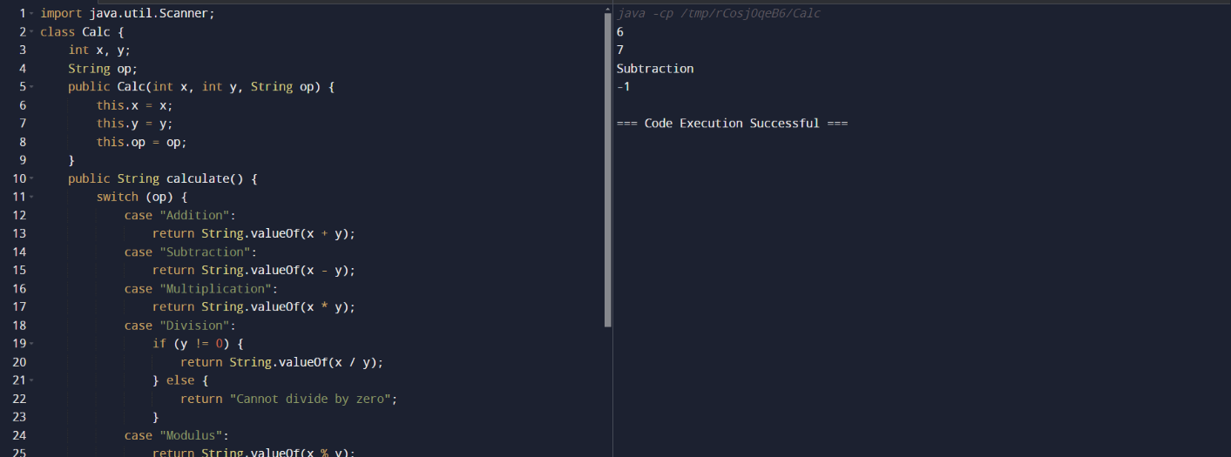

> Question-2

import java.util.Scanner;

public class Prime {
public static void main(String[] args) {
Scanner scanner = new Scanner(System.in);
int num = scanner.nextInt();
int count = 0;
for (int i = 1; i <= num; i++) {
if (num % i == 0) {
count++;
}
}
if (count == 2) {
System.out.println("It is a prime number");
} else {
System.out.println("Not a prime number");
}
scanner.close();
}
}

