Day-2

> Question-1

public class FactorFinding {

public static void main(String[] args) {
int num = 20;
findFactor(num);
}

public static void findFactor(int num) {
for (int i = 1; i <= num; i++) {
if (num % i == 0) {
System.out.println(i);
}
}
}
}

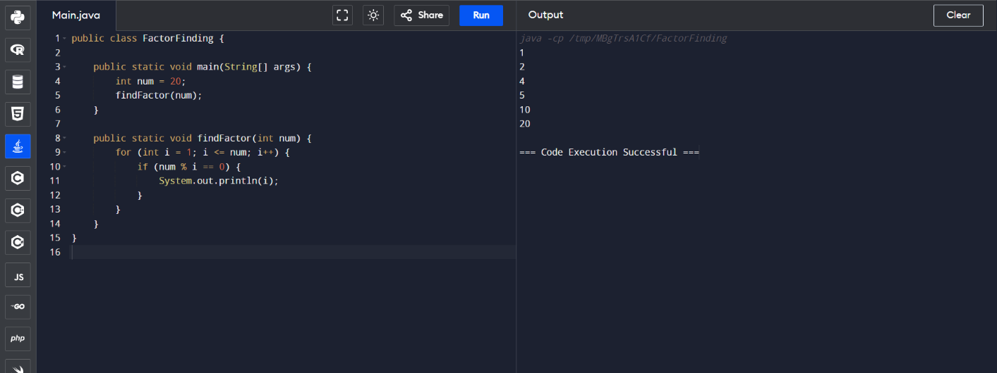

> Question-2

public class StringReverse {

public static void main(String[] args) {
String string = "Reversed String";
String revString = revString(string);
System.out.println(string);
System.out.println(revString);
}

public static String revString(String str) {
if (str == null || str.isEmpty()) {
return str;
}
StringBuilder reversed = new StringBuilder(str);
return reversed.reverse().toString();
}
}

