**Aim:** Study of Network IP

**Theory:**

* Classification of IP Addresses
* Sub netting
* Super netting

**1. IP Address:**

a) An IPv4 address is a 32-bit address that uniquely and universally defines the connection of a device (for example, a computer or a router) to the Internet.

b) The IPv4 addresses are unique and universal.

c) The address space of IPv4 is 232 or 4,294,967,296.

d) Dotted-decimal notation and binary notation for an IPv4 address



**2. Classification of IP Addresses:**



**3. Sub netting**:

A **subnetwork** or **subnet** is a logical subdivision of an [IP network](https://en.wikipedia.org/wiki/IP_network).The practice of dividing a network into two or more networks is called **subnetting**. Computers that belong to a subnet are addressed with an identical [most-significant bit](https://en.wikipedia.org/wiki/Most-significant_bit)-group in their [IP addresses](https://en.wikipedia.org/wiki/IP_address). This results in the logical division of an IP address into two fields, the *network number* or *routing prefix* and the *rest field* or *host identifier*. The *rest field* is an identifier for a specific [host](https://en.wikipedia.org/wiki/Host_(network)) or network interface.

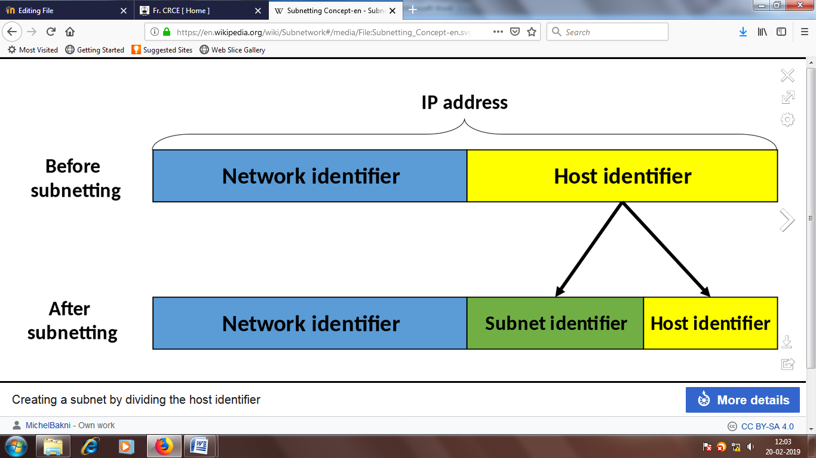

**4. Super netting**

**Supernetting** is the opposite of [Subnetting](https://www.geeksforgeeks.org/ip-addressing-classless-addressing/). In subnetting, a single big network is divided into multiple smaller subnetworks. In Supernetting, multiple networks are combined into a bigger network termed as a Supernetwork or Supernet.

Supernetting is mainly used in Route Summarization, where routes to multiple networks with similar network prefixes are combined into a single routing entry, with the routing entry pointing to a Super network, encompassing all the networks. This in turn significantly reduces the size of routing tables and also the size of routing updates exchanged by routing protocols.

* When multiple networks are combined to form a bigger network, it is termed as super-netting
* Super netting is used in route aggregation to reduce the size of routing tables and routing table updates

There are some points which should be kept in mind while supernetting:

1. All the IP address should be contiguous.
2. Size of all the small networks should be equal and must be in form of 2n.
3. First IP address should be exactly divisible by whole size of supernet.

|  |
| --- |
| **Conclusion:** |

|  |
| --- |
| **Post lab:**  1. Find the range of addresses in the following blocks.  a. 200.17.21.128/27  b. 17.34.16.0/23  2. In a block of addresses we know the IP address of one host is 182.44.82.16/26. What are the first address and last address in this block?  3. An organization is granted the block 211.17.180.0/24. The administrator wants to create 32 subnets.  a. Find the subnet mask.  b. Find the number of addresses in each subnet.  c. Find the first and last address in subnet 1.  d. Find the first and last address in subnet 32.  4. An organization is granted the block 16.0.0.0/8. The administrator wants to create 500 fixed length subnets.  a. Find the subnet mask.  b. Find the number of addresses in each subnet.  c. Find the first and last address in subnet 1.  d. Find the first and last address in subnet 500. |

Signature of Faculty Date of Completion