STANDARD OPERATING PROCEDURE (SOP)
StockCraft – Stovecraft Traceability
Operator Guide: Login, Main Window, Work Order Inspection, Reprint and Reports
Item | Details
Application | StockCraft (screen title: “Stovecraft Traceability”)
Version shown on login screen | 1.0.0.4
Document version / date | 1.0 / 15 October 2026
Prepared by | ______________________
Approved by | ______________________

1. What is this document?
This guide tells you, step by step, how to use the StockCraft application. It is written for operators, supervisors and quality staff. You do not need any computer knowledge. Just follow the steps and look at the pictures.
StockCraft keeps a record of every sticker (label) printed and scanned on the production line, so we always know what was made, what was scanned and what was missed.

Short words used in this guide
Word | Meaning
IC / Child | The small (inner) carton sticker. Each one has its own serial number.
MC / Master Carton | The big carton sticker. One master carton holds many IC cartons (the “Pack Size”).
Work Order No | The production order number you are working on.
Line Code | The name of the production line (for example Line 1).
PLC | The machine controller. When a carton reaches the sensor, the PLC sends a signal and the IC sticker prints.
Scanner | The barcode scanner that reads the IC sticker after it is stuck on the carton.
NG | “Not Good”. A wrong or repeated scan.

2. Login
You must log in before you can use the application.
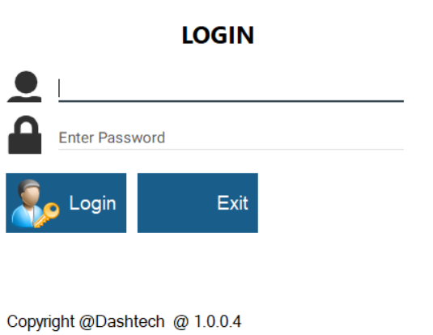
Figure 1: Login screen
- Double-click the StockCraft icon. The LOGIN screen opens.
- Type your User ID in the first box (the cursor is already there): 1
- Type your Password in the second box: 1
- Click Login (or press Enter). The Main Window opens.
- To close the program without logging in, click Exit.

Login details for this setup: User ID = 1 and Password = 1. If your supervisor gives you a different User ID and Password, use those instead. Do not share them with others.

If you see this message | What to do
Please enter user id / Please enter password | You left a box empty. Fill it and click Login.
Invalid UserID and Password. Please try again | Type the ID and password again carefully.
Selected user is not active, Please enter another user id | Your user is switched off. Ask the administrator.
Unable to connect with last database setting | The computer cannot reach the database. Call the administrator or IT support.

3. Main Window
After login you see the Main Window. All work starts from here.
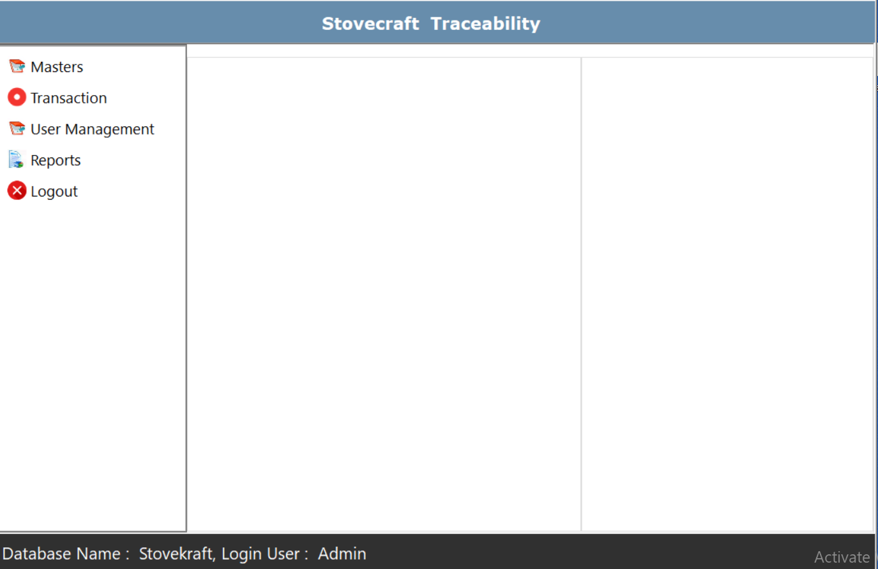
Figure 2: Main Window after login
Part | What it is
Blue bar (top) | The name of the application: “Stovecraft Traceability”.
Menu (left side) | Five options: Masters, Transaction, User Management, Reports and Logout. Click an option to see its list, then click the screen you want.
Two white areas (middle and right) | Empty display areas. You do not have to do anything here.
Black bar (bottom) | Shows the Database Name and the Login User. Look here to be sure you are logged in with your own name.

Good to know: The Main Window has no minimize or close button. To leave it, use Logout (see section 9).

What is in each menu option
Menu option | Screens inside
Masters | Site Master, Item Master, Line Master, PrinterMaster. (Set-up data – normally the administrator uses these.)
Transaction | Work Order Inspection, IC REPRINT, MC REPRINT. (Daily production work.)
User Management | User Master, User Rights. (Administrator only.)
Reports | Child Print Report, MC Print Report, Inspection Report, Latest Scan Report, Missing Scan Report.
Logout | Closes the Main Window.

Why some options may be missing: Admin users see everything. Other users see only the screens the administrator has given them. If you cannot see a screen you need, ask the administrator.

4. Masters

4.1 Item Master – product list
Item Master keeps the list of products (Product ID, Model, Wattage, Voltage and Degree of Protection). The list at the bottom shows all products already saved.
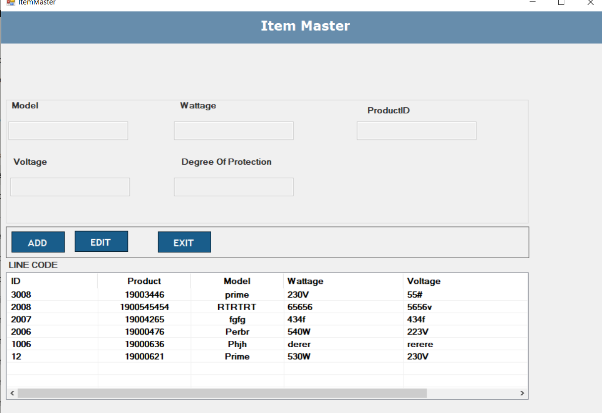
Figure 3: Item Master screen
To add a new product:
- Click Main Window → Masters → Item Master.
- Click ADD. The boxes become ready and the button changes to SAVE.
- Fill in Model, Wattage, ProductID, Voltage and Degree Of Protection. Model must not be empty.
- Click SAVE. The new product appears in the list below.
To change an existing product:
- Click the product in the list at the bottom. Its details come into the boxes.
- Click EDIT (it changes to UPDATE), correct the details, then click UPDATE.
- Click EXIT when you are done.

4.2 Other masters (administrator)
Screen | Use
Site Master | Site Code, Site Name, State, City, Address.
Line Master | Line Code and Line Name of each production line.
PrinterMaster | For each Line Code: Printer IP and Port, Master-carton Printer IP, Scanner IP and Port, PLC IP and Port. Work Order Inspection picks these up automatically.

5. Transaction – daily production work

5.1 Work Order Inspection (main production screen)
This is the screen the operator keeps open all day. It connects to the PLC and the scanner, prints the IC stickers, checks every scan and shows live counts.
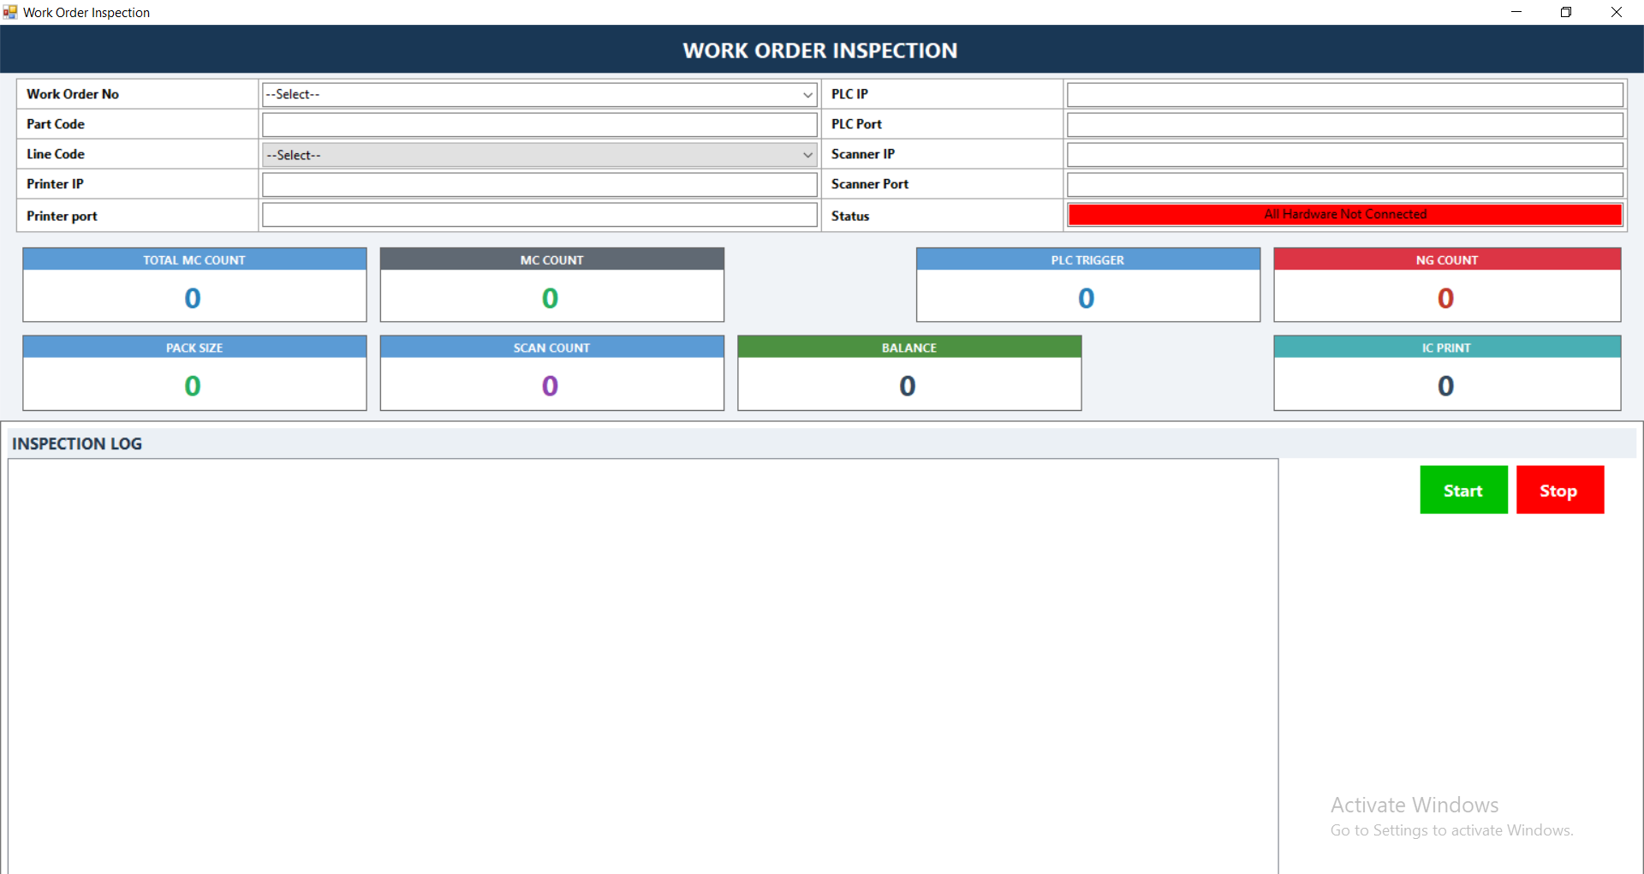
Figure 4: Work Order Inspection screen

Top part – selection boxes
Box | What to do
Work Order No | Choose your work order from the list. Part Code, Pack Size and Total MC Count fill in by themselves.
Part Code | Shows automatically. Do not type here.
Line Code | Choose your line. Printer IP / Port, PLC IP / Port and Scanner IP / Port fill in by themselves and are locked.
Status | Red “All Hardware Not Connected” means the PLC and scanner are not yet connected. It turns to “All Hardware Connected” after you press Start and everything is fine.

Middle part – counters
Counter | What it tells you
TOTAL MC COUNT | How many master cartons the work order needs in total.
MC COUNT | How many master cartons are completed so far.
PACK SIZE | How many IC cartons go in one master carton.
SCAN COUNT | How many IC cartons are scanned in the current master carton.
PLC TRIGGER | How many times the machine sensor has given a signal.
IC PRINT | How many IC stickers are printed.
BALANCE | How many IC cartons are still left to do.
NG COUNT | How many wrong or repeated scans happened.

Bottom part – Inspection Log
The big white box shows what the system is doing, line by line (for example “Scanner Connected”, “PLC Connected Successfully”, “Child Print Saved + Printed”). Read it when something does not work.
How to run an inspection:
- Click Main Window → Transaction → Work Order Inspection.
- Choose the Work Order No.
- Choose the Line Code. Check that Part Code and the IP boxes are filled.
- Click the green Start button. Wait until the Status turns green: “All Hardware Connected”.
- The machine now works. When a carton reaches the sensor, the IC sticker prints by itself. Stick it on the carton.
- The scanner reads the IC sticker. The SCAN COUNT goes up. When SCAN COUNT reaches the PACK SIZE, the master carton sticker prints. Stick it on the master carton.
- Watch the NG COUNT and the Inspection Log. Do not ignore a red message.
- When the shift or work order is finished, click the red Stop button. Then close the screen.

Message in Inspection Log | What it means / what to do
Please select Work Order / Part Code | You forgot to choose it. Choose it and press Start again.
PLC / Scanner IP Missing, Invalid Port | The line settings are not complete. Call the administrator.
Scanner Connection Failed. Auto reconnect chalu hai | The scanner is not connected. The system keeps trying. Check the scanner cable / power.
Duplicate Child Serial | This IC sticker was already scanned. Remove the carton (NG).
WRONG SERIAL | The sticker scanned is not the expected one. Check the sticker.
Master Carton already completed | The master carton is full. Wait for the next one.
All Child Serials Already Printed | All stickers for this work order are printed. The work order is finished.
Printer IP / Port Missing or Invalid | Printer settings are wrong. Call the administrator.

Important: Press Stop before closing the screen. Do not open Work Order Inspection twice for the same line on the same computer.

5.2 IC REPRINT – print an IC sticker again
Use this when an IC sticker is damaged, torn or did not print properly.
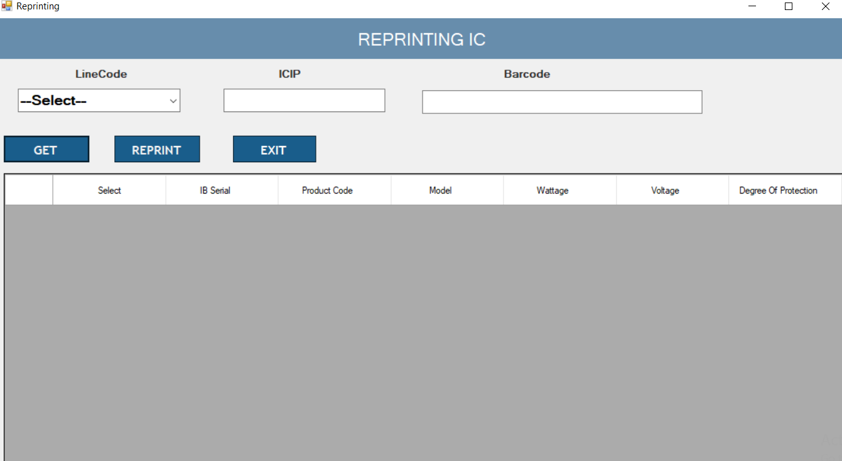
Figure 5: Reprinting IC screen
- Click Main Window → Transaction → IC REPRINT.
- Choose the Line Code. The ICIP (printer) box fills in.
- Scan or type the IC Barcode in the Barcode box.
- Click GET. The sticker details appear in the table (IC Serial No, Product Code, Model, Wattage, Voltage, Degree Of Protection).
- Tick the box in the “Select” column of the sticker you want to print again.
- Click REPRINT. The sticker prints.
- Click EXIT to close.
If the message “No data found to reprint” appears, check the barcode and the line.

5.3 MC REPRINT – print a master carton sticker again
Use this when a master carton sticker is damaged or lost.
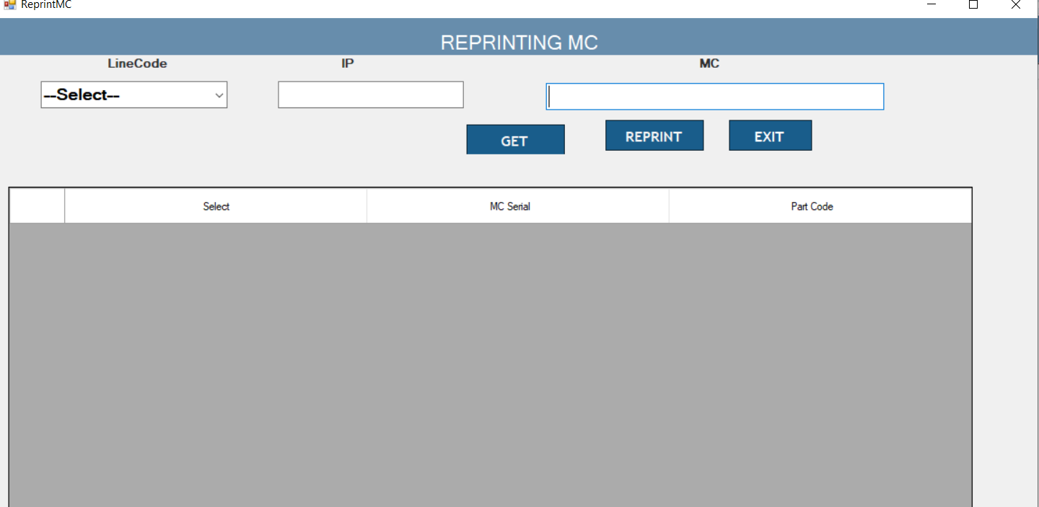
Figure 6: Reprinting MC screen
- Click Main Window → Transaction → MC REPRINT.
- Choose the Line Code. The IP (printer) box fills in.
- Scan or type the MC barcode in the MC box.
- Click GET. The MC Serial and Part Code appear in the table.
- Tick the “Select” box of the sticker you want.
- Click REPRINT, then EXIT when finished.

6. Reports
Reports show what has already happened. All five report screens work in the same way, so learn this once:
- Choose From Date and To Date (click the small calendar arrow to pick a date and time).
- If you want one particular work order (or serial), choose a Filter and type the number in Value.
- Click GET. The table fills. “Total Count” shows how many rows were found.
- To keep the report, click EXPORT IN EXCEL (or EXPORT IN PDF where available), choose a folder and save.
- Click CLEAR to start a new search, and EXIT to close.

Tip: If the message “No result found” comes, change the dates or check the work order number. Make the date range wide enough – the screens start with today’s date and time only.

Report | Filter choices | Quick use
Child Print Report | CHILDSerialNo, MCSerial, WorkOrderNo | How many IC stickers were printed
MC Print Report | MCSerial, WorkOrderNo | How many master carton stickers were printed
Inspection Report | IC Serial No, Barcode, WorkOrderNo | How many were scanned
Latest Scan Report | IC Serial No, Barcode, WorkOrderNo | Which scan was last (top 20)
Missing Scan Report | Work Order No | Which stickers were not scanned

6.1 Child Print Report – how many IC stickers were printed
Use this to know how many IC stickers came out on any day (date-wise), or for one work order.
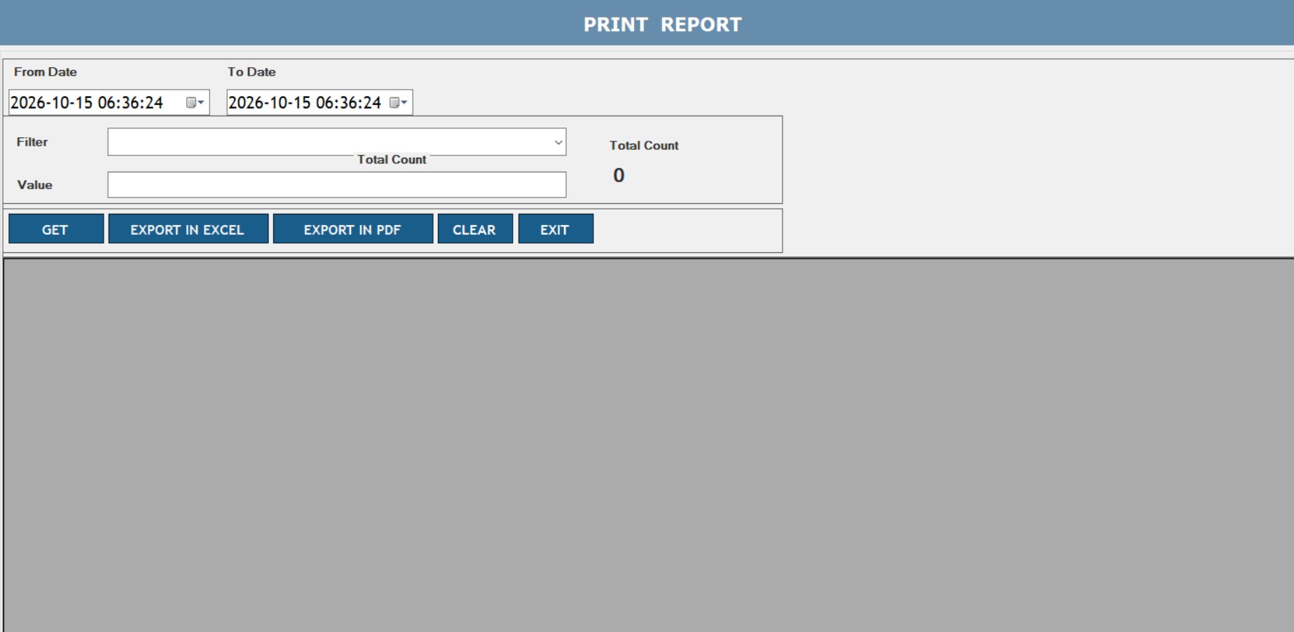
Figure 7: Child Print Report (Print Report) screen
- Click Main Window → Reports → Child Print Report.
- Set From Date and To Date. For one day, use the start and end of that day.
- For one work order only: Filter = WorkOrderNo, Value = the work order number.
- Click GET. Read the number in “Total Count” – this is the number of IC stickers printed.
- Save with EXPORT IN EXCEL or EXPORT IN PDF if needed.

6.2 MC Print Report – master carton stickers printed
Use this to see master carton stickers printed between two dates, or for one work order.
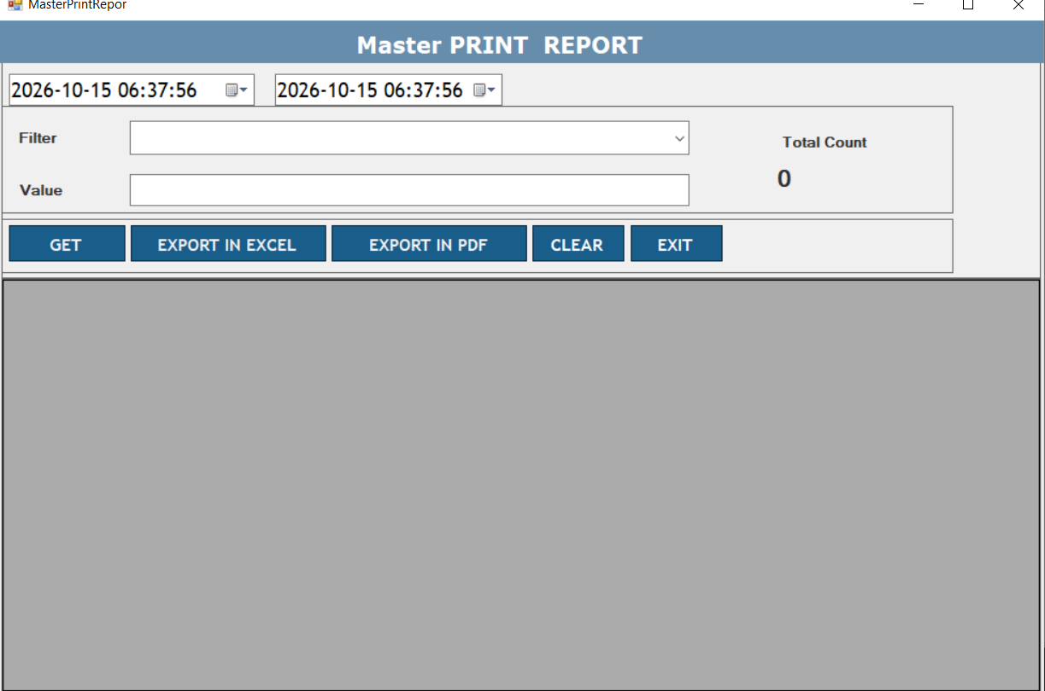
Figure 8: Master Print Report screen
- Click Main Window → Reports → MC Print Report.
- Set the two dates.
- To see one work order: Filter = WorkOrderNo, Value = the work order number. (You can also search by MCSerial.)
- Click GET. “Total Count” shows how many master carton stickers were printed.
- Export to Excel or PDF if needed.

6.3 Inspection Report – how many were scanned
Use this to see how many IC cartons were scanned during inspection, date-wise, or for one work order.
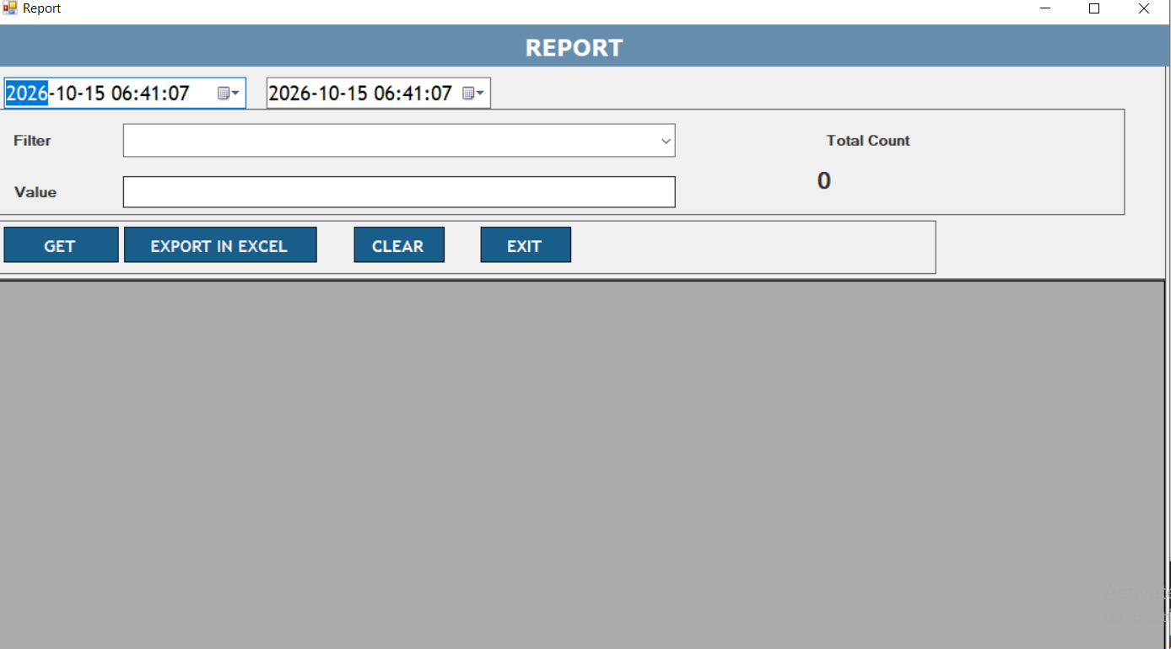
Figure 9: Inspection Report screen
- Click Main Window → Reports → Inspection Report.
- Set From Date and To Date.
- Choose a Filter (WorkOrderNo, IC Serial No or Barcode) and type the Value. This report asks for both a filter and a value – if you leave them empty, it shows “Please select filter” or “Please enter value”.
- Click GET. “Total Count” is the number of scans. Save with EXPORT IN EXCEL.

6.4 Latest Scan Report – where to continue scanning
This report shows the last 20 scans. The scan at the very top is the newest one. Use it to find where scanning stopped, so you can start the next scan right after it.
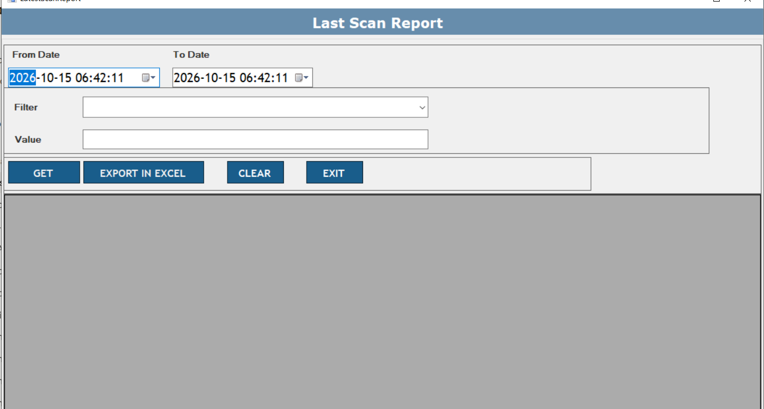
Figure 10: Last Scan Report screen
- Click Main Window → Reports → Latest Scan Report.
- Set the dates (use a wide range so the latest scans are included).
- Choose Filter = WorkOrderNo and type your work order number.
- Click GET. The top row is the most recent scan. Continue your next scan after that one.

6.5 Missing Scan Report – which stickers were not scanned
After a work order is finished, it is hard to know if some IC stickers were never scanned (for example 10 stickers missed). This report tells you exactly which ones.
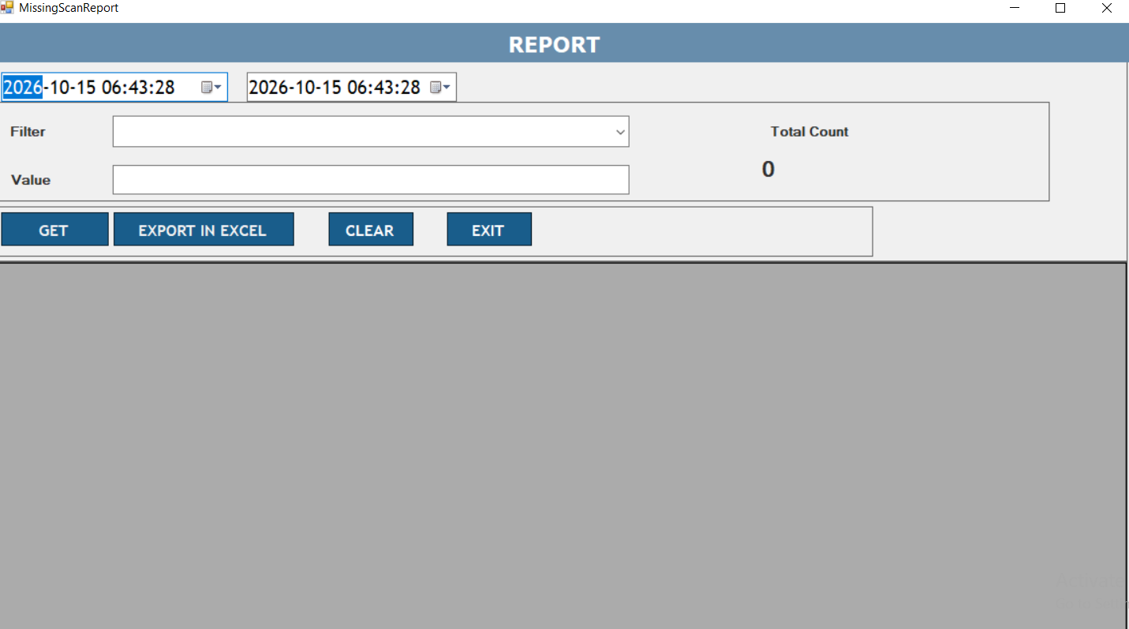
Figure 11: Missing Scan Report screen
- Click Main Window → Reports → Missing Scan Report.
- Set From Date and To Date so that the whole work order period is covered.
- Choose the Work Order filter and type the work order number.
- Click GET. The table lists the IC serials that were printed but not scanned. “Total Count” is the number of missing stickers.
- Find those cartons, scan them, or note them down. Use EXPORT IN EXCEL to give the list to your supervisor.

7. Logout
- Close every open screen with its EXIT button. On Work Order Inspection press Stop first.
- In the Main Window click Logout. The Main Window closes.
- To log in again, start the StockCraft application again if the login screen does not appear.

8. Problems and what to do
Problem | What to do
“You does not have right to access, Please contact to admin.” and the program closes | Your user has no screens. Ask the administrator to give you rights.
A menu screen is missing | You do not have the right for it. Ask the administrator.
Status stays red “All Hardware Not Connected” | Check PLC and scanner power and network cables, then press Stop and Start again. Read the Inspection Log.
IC sticker does not print | Check printer power, paper and ribbon. Read the Inspection Log. If the sticker is lost, use IC REPRINT.
Report shows “No result found” | Widen the date range and check the work order number.
Any red error box | Write down the message, click OK and tell your supervisor. Do not keep pressing the button.

9. Do’s and Don’ts
- Do check the Work Order No and Line Code before pressing Start.
- Do read the Inspection Log when something looks wrong.
- Do press Stop and Logout when you leave the machine.
- Do run the Missing Scan Report after each work order is finished.
- Don’t share your User ID and password.
- Don’t change Master data unless you are authorised.
- Don’t reprint a sticker without checking the old one is destroyed – this avoids two stickers with the same number.

