Random number generation

Email Programming (Send panel to mail)

Html control (Request.form)

Ajax control

How to display calendar

1. Using culture info concept implementing data and time.
2. All date and time concept use in globalization
3. Working of date and time parameter using data time object.

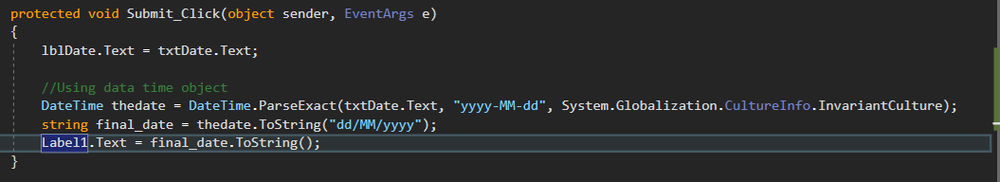

Ajax configuration

How to connect Ajax in .NET framework?

1. Store ajax.dll inside bin directory
2. Add reference
3. Include register assembly inside the source page



1. Create css (optional)
2. Using manager tag inside the form tag. //active ajax tool kit
3. ModelPopupextender Control
   1. ID
   2. Runat
   3. Popupcontrolid
   4. Target control id (show button id)
   5. Cancel control id
   6. Background css class = cssname

Assignment

Ajax calendar control

Ajax pop up

RowBound Event –

1. Automatically active gridview.
2. OnRowDataBound Event

Tmp

1. CURD grid view
2. List view CURD
3. Store procedure
4. 3 tier (CURD)
5. Validation (Client Side)
6. Try catch
7. Textbox
8. Tv –