1. Listview(crud operation)

2. Datatable(searching concept)

3. Dataview

4. 3 tier architecture with store procedure or without store procedure.

5. Project module(online complaint)(class object / procedure)

Other Concept in dotnet framework

Access html textbox control

\*\*\*How to display empty grid view \*\*\*

There are two attribute is to be set in side grid view

1. ShowHeaderWhenEmpty
2. EmptyDataText = “message”
3. EmptyDataText = “No Record Found”

\*\*\*Email Programming\*\*\*

Include mail library (using system.net.mail)

There are two types of mail

1. Generic mail – google.com, Hotmail.com
2. Domain mail – @Company name

Mail property –

To

From

Subject

Body

Mail Protocol – SMTP (simple mail transfer protocol)

Mail format – html

Mail object –

1. MailMessage Object (set mail property ) – to, form, subject, body
2. SMTPClinet Object : (set the mail credential (id, password))
   1. Only use verify mail.

Smtp property

1. Set the mail server

Types of password –

1. System password
2. Network password
3. Document password

Mail Security –

1. Ssl – server security liscence

How to create encrypted password?

How to generate random number?

NGP-2023-ra,do

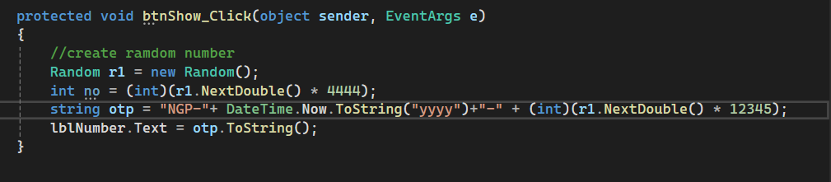

How to create dynamic directory

Run time

1. Include io library

Enter Directory Name – textbox (button) create

enter drop down list – view all directory name

File Upload Control

Button upload