File Name – Registration.aspx

<%@ Page Language="C#" AutoEventWireup="true" CodeBehind="registration.aspx.cs" Inherits="WebApplication1.registration" %>

<!DOCTYPE html>

<html xmlns="http://www.w3.org/1999/xhtml">

<head runat="server">

<title></title>

<link rel="stylesheet" href="https://maxcdn.bootstrapcdn.com/bootstrap/4.0.0/css/bootstrap.min.css">

<link rel="stylesheet" type="text/css" href="StyleSheet1.css" />

</head>

<body class="bg-img">

<div>

<div class="registration-form">

<form class="A1" id="form1" runat="server">

<div class="registration-logo with-border">

<h1><b>Registration Form</b></h1>

</div>

<div class="row">

<div class="col-md-6">

<div class="form-group">

<asp:TextBox ID="txtId" runat="server" class="form-control item" placeholder="Enter ID" ></asp:TextBox>

</div>

</div>

<div class="col-md-6">

<div class="form-group">

<asp:TextBox ID="txtName" runat="server" class="form-control item" placeholder="Enter Name" ></asp:TextBox>

</div>

</div>

</div>

<div class="row">

<div class="col-sm-12">

<div>

<asp:TextBox runat="server" id="txtEmail" placeholder="Enter Email" class="form-control item"></asp:TextBox>

</div>

</div>

</div>

<div class="row">

<div class="col-md-6">

<div class="form-group">

<asp:TextBox ID="txtMobile" runat="server" class="form-control item" placeholder="Enter Mobile"></asp:TextBox>

</div>

</div>

<div class="col-md-6">

<div class="form-group">

<asp:DropDownList ID="ddlCity" runat="server" class="form-control " placeholder="Select City">

<asp:ListItem>SelectCity</asp:ListItem>

<asp:ListItem>Nagpur</asp:ListItem>

<asp:ListItem>Pune</asp:ListItem>

<asp:ListItem>Mumbai</asp:ListItem>

</asp:DropDownList>

</div>

</div>

</div>

<div class="row">

<div class="col-md-6">

<div class="form-group">

<asp:TextBox ID="txtAddress" runat="server" class="form-control item" placeholder="Enter Address"></asp:TextBox>

<!-- <select class="countrypicker form-control item"></select> -->

</div>

</div>

<div class="col-md-6">

<div class="form-group">

<asp:TextBox ID="txtPin" runat="server" class="form-control item" placeholder="Enter Pin"></asp:TextBox>

</div>

</div>

</div>

<div class="row">

<div class="col-md-3">

<div class="form-group">

Upload File :

</div>

</div>

<div class="col-md-9">

<div class="form-group">

<asp:FileUpload ID="FileUpload1" runat="server" />

</div>

</div>

</div>

<div class="row">

<div class="col-md-4">

<asp:Button ID="btnSubmit" runat="server" Text="Submit" class="btn btn-block login-button" OnClick="btnSubmit_Click"/>

</div>

<div class="col-md-4">

<asp:Button ID="btnUpdate" runat="server" class="btn btn-block login-button" Text="Update" OnClick="btnUpdate_Click" />

</div>

<div class="col-md-4">

<asp:Button ID="btnNext" runat="server" Text="Next" class="btn btn-block login-button" OnClick="btnNext_Click"/>

</div>

</div>

</form>

</div>

</div>

</body>

</html>

File Name – Registration.aspx.cs

using System;

using System.Collections.Generic;

using System.Linq;

using System.Web;

using System.Web.UI;

using System.Web.UI.WebControls;

using System.Data.SqlClient;

using System.Configuration;

namespace WebApplication1

{

public partial class registration : System.Web.UI.Page

{

SqlConnection con;

SqlCommand com;

SqlDataReader dr;

protected void Page_Load(object sender, EventArgs e)

{

if(!IsPostBack)

{

}

}

protected void btnSubmit_Click(object sender, EventArgs e)

{

try

{

if(string.IsNullOrEmpty(txtId.Text) && string.IsNullOrEmpty(txtName.Text) && string.IsNullOrEmpty(txtEmail.Text)

&& string.IsNullOrEmpty(txtMobile.Text) && string.IsNullOrEmpty(ddlCity.SelectedValue) &&

string.IsNullOrEmpty(txtAddress.Text) && string.IsNullOrEmpty(txtPin.Text) &&

string.IsNullOrEmpty(FileUpload1.FileName))

{

Response.Write("Provide all details");

}

else

{

Session["se_id"] = txtId.Text;

string path = ConfigurationManager.AppSettings["BioDB"];

con = new SqlConnection(path);

con.Open();

string gen_id = "SELECT Count(Id)+1 FROM BasicInfoDB";

com = new SqlCommand(gen_id, con);

string auto_id = "BIO-" + DateTime.Now.ToString("yyyy") + "-" + DateTime.Now.ToString("MM") + "-00-" + com.ExecuteScalar().ToString();

FileUpload1.SaveAs(Server.MapPath("~") + "\\upload\\" + FileUpload1.FileName);

string insert_q = "INSERT INTO BasicInfoDB (Id, Name, Email, Mobile, City, Address, Pincode, upload) values (@Id1, @Name1, @Email1, @Mobile1, @City1, @Address1, @Pincode1, @Upload1);";

com = new SqlCommand(insert_q, con);

com.Parameters.AddWithValue("@Id1", auto_id.ToString());

com.Parameters.AddWithValue("@Name1", txtName.Text);

com.Parameters.AddWithValue("@Email1", txtEmail.Text);

com.Parameters.AddWithValue("@Mobile1", txtMobile.Text);

com.Parameters.AddWithValue("@City1", ddlCity.SelectedValue);

com.Parameters.AddWithValue("@Address1", txtAddress.Text);

com.Parameters.AddWithValue("@Pincode1", txtPin.Text);

com.Parameters.AddWithValue("@Upload1", FileUpload1.FileName);

com.ExecuteNonQuery();

Session["g_id"] = auto_id;

Response.Write("<script>alert('Data Inserted')</script>");

txtId.Text = auto_id;

}

}

catch(Exception ob)

{

}

}

protected void btnNext_Click(object sender, EventArgs e)

{

Response.Redirect("Qulification.aspx");

}

protected void btnUpdate_Click(object sender, EventArgs e)

{

string path = ConfigurationManager.AppSettings["BioDB"];

con = new SqlConnection(path);

con.Open();

string update_q = "UPDATE BasicInfoDB set Name = @Name1, Email = @Email1, Mobile = @Mobile1, City = @City1, Address = @Address1, Pincode = @Pincode1, upload = @upload1 WHERE Id = @Id1;";

com = new SqlCommand(update_q, con);

com.Parameters.AddWithValue("@id1", (string)Session["g_id"]);

com.Parameters.AddWithValue("@Name1", txtName.Text);

com.Parameters.AddWithValue("@Email1", txtEmail.Text);

com.Parameters.AddWithValue("@Mobile1", txtMobile.Text);

com.Parameters.AddWithValue("@City1", ddlCity.SelectedValue);

com.Parameters.AddWithValue("@Address1", txtAddress.Text);

com.Parameters.AddWithValue("@Pincode1", txtPin.Text);

com.Parameters.AddWithValue("@Upload1", FileUpload1.FileName);

com.ExecuteNonQuery();

Response.Write("Data Updated");

}

}

}

File Name – Qualification.aspx

<%@ Page Language="C#" AutoEventWireup="true" CodeBehind="Qulification.aspx.cs" Inherits="WebApplication1.Qulification" %>

<!DOCTYPE html>

<html xmlns="http://www.w3.org/1999/xhtml">

<head runat="server">

<title></title>

<link rel="stylesheet" type="text/css" href="StyleSheet1.css" />

<link rel="stylesheet" href="https://maxcdn.bootstrapcdn.com/bootstrap/4.0.0/css/bootstrap.min.css" />

</head>

<body class="bg-img" style="background-color: lightblue">

<div>

<div class="registration-form">

<form class="A1" id="form1" runat="server">

<div class="registration-logo with-border">

<h1><b>Registration Form</b></h1>

</div>

<div class="row">

<div class="col-md-6">

<div class="form-group">

<asp:TextBox ID="txtId" runat="server" class="form-control item" placeholder="Enter ID"></asp:TextBox>

</div>

</div>

<div class="col-md-6">

<div class="form-group">

<asp:DropDownList ID="ddlDegree" runat="server" class="form-control item">

<asp:ListItem>Select Degree</asp:ListItem>

<asp:ListItem>UG</asp:ListItem>

<asp:ListItem>PG</asp:ListItem>

</asp:DropDownList>

</div>

</div>

</div>

<div class="row">

<div class="col-md-6">

<div class="form-group">

<asp:TextBox ID="txtUG" runat="server" class="form-control item" placeholder="Enter UG Name"></asp:TextBox>

</div>

</div>

<div class="col-md-6">

<div class="form-group">

<asp:TextBox ID="txtPG" runat="server" class="form-control item" placeholder="Enter PG Name"></asp:TextBox>

</div>

</div>

</div>

<div class="row">

<div class="col-md-12">

<div class="form-group">

<asp:RangeValidator ID="RangeValidator1" runat="server" ErrorMessage="YOP Between 2012 to 2016" ControlToValidate="txtYear" MaximumValue="2016" MinimumValue="2012"></asp:RangeValidator>

<asp:TextBox ID="txtYear" runat="server" class="form-control item" placeholder="Enter YOP PG"></asp:TextBox>

<!-- <select class="countrypicker form-control item"></select> -->

</div>

</div>

</div>

<div class="row">

<div class="col-md-4">

<asp:Button ID="btnSubmit" runat="server" Text="Submit" class="btn btn-block login-button" OnClick="btnSubmit_Click" />

</div>

<div class="col-md-4">

<asp:Button ID="btnUpdate" runat="server" Text="Update" class="btn btn-block login-button" OnClick="btnUpdate_Click" />

</div>

<div class="col-md-4">

<asp:Button ID="btnNext" runat="server" Text="Next" class="btn btn-block login-button" OnClick="btnNext_Click" />

</div>

</div>

</form>

</div>

</div>

</body>

</html>

File Name - Qualification.aspx.cs

using System;

using System.Collections.Generic;

using System.Linq;

using System.Web;

using System.Web.UI;

using System.Web.UI.WebControls;

using System.Data.SqlClient;

using System.Configuration;

namespace WebApplication1

{

public partial class Qulification : System.Web.UI.Page

{

SqlConnection con;

SqlCommand com;

SqlDataReader dr;

protected void Page_Load(object sender, EventArgs e)

{

if(!IsPostBack)

{

txtId.Text = (string)Session["g_id"];

}

}

protected void btnSubmit_Click(object sender, EventArgs e)

{

string path = ConfigurationManager.AppSettings["BioDB"];

con = new SqlConnection(path);

con.Open();

string insert_q = "INSERT INTO EduInfoDB (Id, Degree, Ugname, Pgname, YOP) values (@Id1, @Degree1, @Ugname1, @Pgname1, @YOP1);";

com = new SqlCommand(insert_q, con);

com.Parameters.AddWithValue("@Id1",(string)Session["g_id"]);

com.Parameters.AddWithValue("@Degree1", ddlDegree.SelectedValue);

com.Parameters.AddWithValue("@Ugname1",txtUG.Text);

com.Parameters.AddWithValue("@Pgname1", txtPG.Text);

com.Parameters.AddWithValue("@YOP1", txtYear.Text);

com.ExecuteNonQuery();

Response.Write("Data Inserted");

}

protected void btnNext_Click(object sender, EventArgs e)

{

Response.Redirect("experience.aspx");

}

protected void btnUpdate_Click(object sender, EventArgs e)

{

string path = ConfigurationManager.AppSettings["BioDB"];

con = new SqlConnection(path);

con.Open();

string update_q = "UPDATE EduInfoDB SET Degree = @Degree1, Ugname = @Ugname1, Pgname = @Pgname, YOP = @YOP1 WHERE Id = @Id1;";

com = new SqlCommand(update_q, con);

com.Parameters.AddWithValue("@Id1", (string)Session["g_id"]);

com.Parameters.AddWithValue("@Degree1", ddlDegree.SelectedValue);

com.Parameters.AddWithValue("@Ugname1", txtUG.Text);

com.Parameters.AddWithValue("@Pgname1", txtPG.Text);

com.Parameters.AddWithValue("@YOP1", txtYear.Text);

com.ExecuteNonQuery();

Response.Write("Data Inserted");

}

}

}

File Name – experience.aspx

<%@ Page Language="C#" AutoEventWireup="true" CodeBehind="experience.aspx.cs" Inherits="WebApplication1.experience" %>

<!DOCTYPE html>

<html xmlns="http://www.w3.org/1999/xhtml">

<head runat="server">

<title></title>

<link rel="stylesheet" type="text/css" href="StyleSheet1.css" />

<link rel="stylesheet" href="https://maxcdn.bootstrapcdn.com/bootstrap/4.0.0/css/bootstrap.min.css" />

</head>

<body class="bg-img" style="background-color: lightblue">

<div>

<div class="registration-form">

<form class="A1" id="form1" runat="server">

<div class="registration-logo with-border">

<h1><b>Experience Info</b></h1>

</div>

<div class="row">

<div class="col-md-6">

<div class="form-group">

<asp:TextBox ID="txtId" runat="server" class="form-control item" placeholder="Enter ID"></asp:TextBox>

</div>

</div>

<div class="col-md-6">

<div class="form-group">

<asp:DropDownList ID="ddlExp" runat="server" class="form-control item">

<asp:ListItem>Select Experience</asp:ListItem>

<asp:ListItem>2</asp:ListItem>

<asp:ListItem>3</asp:ListItem>

<asp:ListItem>4</asp:ListItem>

</asp:DropDownList>

</div>

</div>

</div>

<div class="row">

<div class="col-md-6">

<div class="form-group">

<asp:TextBox ID="txtComp" runat="server" class="form-control item" placeholder="Enter Name Of Company"></asp:TextBox>

</div>

</div>

<div class="col-md-6">

<div class="form-group">

<asp:TextBox ID="txtOther" runat="server" class="form-control item" placeholder="Enter Other Exprence"></asp:TextBox>

</div>

</div>

</div>

<div class="row">

<div class="col-md-12">

<div class="form-group">

<asp:Calendar ID="Calendar1" runat="server" class="form-control item"></asp:Calendar>

</div>

</div>

</div>

<div class="row">

<div class="col-md-4">

<asp:Button ID="btnSubmit" runat="server" Text="Submit" class="btn btn-block login-button" OnClick="btnSubmit_Click" />

</div>

<div class="col-md-4">

<asp:Button ID="btnUpdate" runat="server" Text="Update" class="btn btn-block login-button" OnClick="btnUpdate_Click" />

</div>

<div class="col-md-4">

<asp:Button ID="btnNext" runat="server" Text="Next" class="btn btn-block login-button" OnClick="btnNext_Click" />

</div>

</div>

</form>

</div>

</div>

</body>

</html>

File Name - experience.aspx.cs

using System;

using System.Collections.Generic;

using System.Linq;

using System.Web;

using System.Web.UI;

using System.Web.UI.WebControls;

using System.Data.SqlClient;

using System.Configuration;

using System.Globalization;

namespace WebApplication1

{

public partial class experience : System.Web.UI.Page

{

SqlConnection _connection;

SqlCommand _command;

SqlDataReader _reader;

protected void Page_Load(object sender, EventArgs e)

{

if(!IsPostBack)

{

txtId.Text = (string)Session["g_id"];

}

}

protected void btnSubmit_Click(object sender, EventArgs e)

{

string path = ConfigurationManager.AppSettings["BioDB"];

_connection = new SqlConnection(path);

_connection.Open();

string selectedDateString = Calendar1.SelectedDate.ToString("yyyy/MM/dd");

string insert_q = "INSERT INTO Exp (Id, YOE, Namecomp, Dateofj, Otherexp) VALUES (@id1, @YOE1, @Namecomp1, @Dateofj1, @Otherexp1);";

_command = new SqlCommand(insert_q, _connection);

_command.Parameters.AddWithValue("@id1", (string)Session["g_id"]);

_command.Parameters.AddWithValue("@YOE1", ddlExp.SelectedValue);

_command.Parameters.AddWithValue("@NameComp1", txtComp.Text);

_command.Parameters.AddWithValue("@Dateofj1", selectedDateString);

_command.Parameters.AddWithValue("@Otherexp1",txtOther.Text);

_command.ExecuteNonQuery();

Response.Write("Data Inserted");

}

protected void btnNext_Click(object sender, EventArgs e)

{

Response.Redirect("objective.aspx");

}

protected void btnUpdate_Click(object sender, EventArgs e)

{

string path = ConfigurationManager.AppSettings["BioDB"];

_connection = new SqlConnection(path);

_connection.Open();

string selectedDateString = Calendar1.SelectedDate.ToString("yyyy/MM/dd");

string update_q = "UPDATE Exp SET YOE = @YOE1, Namecomp = @Namecomp1, Dateofj = @Dateofj1, Otherexp = @Otherexp1 WHERE Id = @Id1";

_command = new SqlCommand(update_q, _connection);

_command.Parameters.AddWithValue("@Id1", (string)Session["g_id"]);

_command.Parameters.AddWithValue("@YOE1", ddlExp.SelectedValue);

_command.Parameters.AddWithValue("@Namecomp1", txtComp.Text);

_command.Parameters.AddWithValue("@Dateofj1", selectedDateString);

_command.Parameters.AddWithValue("@Otherexp1", txtOther.Text);

_command.ExecuteNonQuery();

Response.Write(" Data Update");

}

}

}

File Name – Objective.aspx

<%@ Page Language="C#" AutoEventWireup="true" CodeBehind="Qulification.aspx.cs" Inherits="WebApplication1.Qulification" %>

<!DOCTYPE html>

<html xmlns="http://www.w3.org/1999/xhtml">

<head runat="server">

<title></title>

<link rel="stylesheet" type="text/css" href="StyleSheet1.css" />

<link rel="stylesheet" href="https://maxcdn.bootstrapcdn.com/bootstrap/4.0.0/css/bootstrap.min.css" />

</head>

<body class="bg-img" style="background-color: lightblue">

<div>

<div class="registration-form">

<form class="A1" id="form1" runat="server">

<div class="registration-logo with-border">

<h1><b>Registration Form</b></h1>

</div>

<div class="row">

<div class="col-md-6">

<div class="form-group">

<asp:TextBox ID="txtId" runat="server" class="form-control item" placeholder="Enter ID"></asp:TextBox>

</div>

</div>

<div class="col-md-6">

<div class="form-group">

<asp:DropDownList ID="ddlDegree" runat="server" class="form-control item">

<asp:ListItem>Select Degree</asp:ListItem>

<asp:ListItem>UG</asp:ListItem>

<asp:ListItem>PG</asp:ListItem>

</asp:DropDownList>

</div>

</div>

</div>

<div class="row">

<div class="col-md-6">

<div class="form-group">

<asp:TextBox ID="txtUG" runat="server" class="form-control item" placeholder="Enter UG Name"></asp:TextBox>

</div>

</div>

<div class="col-md-6">

<div class="form-group">

<asp:TextBox ID="txtPG" runat="server" class="form-control item" placeholder="Enter PG Name"></asp:TextBox>

</div>

</div>

</div>

<div class="row">

<div class="col-md-12">

<div class="form-group">

<asp:RangeValidator ID="RangeValidator1" runat="server" ErrorMessage="YOP Between 2012 to 2016" ControlToValidate="txtYear" MaximumValue="2016" MinimumValue="2012"></asp:RangeValidator>

<asp:TextBox ID="txtYear" runat="server" class="form-control item" placeholder="Enter YOP PG"></asp:TextBox>

<!-- <select class="countrypicker form-control item"></select> -->

</div>

</div>

</div>

<div class="row">

<div class="col-md-4">

<asp:Button ID="btnSubmit" runat="server" Text="Submit" class="btn btn-block login-button" OnClick="btnSubmit_Click" />

</div>

<div class="col-md-4">

<asp:Button ID="btnUpdate" runat="server" Text="Update" class="btn btn-block login-button" OnClick="btnUpdate_Click" />

</div>

<div class="col-md-4">

<asp:Button ID="btnNext" runat="server" Text="Next" class="btn btn-block login-button" OnClick="btnNext_Click" />

</div>

</div>

</form>

</div>

</div>

</body>

</html>

File Name – Objective.aspx.cs

using System;

using System.Collections.Generic;

using System.Linq;

using System.Web;

using System.Web.UI;

using System.Web.UI.WebControls;

using System.Data.SqlClient;

using System.Configuration;

using System.EnterpriseServices;

using System.Drawing;

using System.Xml.Linq;

namespace WebApplication1

{

public partial class objective : System.Web.UI.Page

{

SqlConnection conn;

SqlCommand cmd;

SqlDataReader rdr;

protected void Page_Load(object sender, EventArgs e)

{

if(!IsPostBack)

{

txtId.Text = (string)Session["g_id"];

}

}

protected void btnSubmit_Click(object sender, EventArgs e)

{

string path = ConfigurationManager.AppSettings["BioDB"];

conn = new SqlConnection(path);

conn.Open();

string insert_q = "INSERT INTO Obj (Id, obj) VALUES (@Id1, @Obj1)";

cmd = new SqlCommand(insert_q, conn);

cmd.Parameters.AddWithValue("@Id1", (string)Session["g_id"]);

cmd.Parameters.AddWithValue("@Obj1", txtObj.Text);

cmd.ExecuteNonQuery();

Response.Write("Data Inserted");

}

protected void btnFinish_Click(object sender, EventArgs e)

{

Response.Redirect("finial.aspx");

}

protected void btnUpdate_Click(object sender, EventArgs e)

{

string path = ConfigurationManager.AppSettings["BioDB"];

conn = new SqlConnection(path);

conn.Open();

string insert_q = "UPDATE Obj SET obj = @obj1 WHERE Id = @Id1";

cmd = new SqlCommand(insert_q, conn);

cmd.Parameters.AddWithValue("@Id1", (string)Session["g_id"]);

cmd.Parameters.AddWithValue("@Obj1", txtObj.Text);

cmd.ExecuteNonQuery();

Response.Write("Data Updated");

}

}

}

File Name – Finial.aspx

<%@ Page Language="C#" AutoEventWireup="true" CodeBehind="finial.aspx.cs" Inherits="WebApplication1.finial" %>

<!DOCTYPE html>

<html xmlns="http://www.w3.org/1999/xhtml">

<head runat="server">

<title></title>

<link rel="stylesheet" type="text/css" href="StyleSheet2.css" />

<link rel="shortcut icon" href="favicon.ico">

<link href='https://fonts.googleapis.com/css?family=Roboto:400,500,400italic,300italic,300,500italic,700,700italic,900,900italic' rel='stylesheet' type='text/css'>

<link href="https://maxcdn.bootstrapcdn.com/bootstrap/3.3.7/css/bootstrap.min.css" rel="stylesheet">

<link rel="stylesheet" href="https://cdnjs.cloudflare.com/ajax/libs/font-awesome/4.7.0/css/font-awesome.css">

</head>

<body>

<form id="form1" runat="server">

<div>

<div class="wrapper">

<div class="sidebar-wrapper">

<div class="profile-container"> <asp:Image class="profile-img" ID="Image1" runat="server" />

<h1 class="name">

<asp:Label ID="lblName" runat="server" Text="Label"></asp:Label></h1>

<h3 class="tagline">Web Developer</h3> </div>

<!--//profile-container-->

<div class="contact-container container-block">

<ul class="list-unstyled contact-list">

<li class="email"><i class="fa fa-envelope"></i><a href="shindesharad71@gmail.com">

<asp:Label ID="lblEmail" runat="server" Text="Label"></asp:Label></a></li>

<li class="phone"><i class="fa fa-phone"></i><a href="tel:07038555441">

<asp:Label ID="lblMobile" runat="server" Text="Label"></asp:Label></a></li>

<li class="phone"><i class="fa fa-phone"></i><a href="tel:07038555441">

<asp:Label ID="lblCity" runat="server" Text="Label"></asp:Label></a></li>

<li class="phone"><i class="fa fa-phone"></i><a href="tel:07038555441">

<asp:Label ID="lblpin" runat="server" Text="Label"></asp:Label></a></li>

<li class="phone"><i class="fa fa-phone"></i><a href="tel:07038555441">

<asp:Label ID="lblAddress" runat="server" Text="Label"></asp:Label></a></li>

</ul>

</div>

<!--//contact-container-->

<div class="education-container container-block">

<h2 class="container-block-title">Education</h2>

<div class="item">

<h4 class="degree">

<asp:Label ID="lblUgname" runat="server" Text="Label"></asp:Label></h4>

<h5 class="meta">University of Pune</h5>

</div>

<!--//item-->

<div class="item">

<h4 class="degree">

<asp:Label ID="lblPgname" runat="server" Text="Label"></asp:Label></h4>

<h5 class="meta">

<asp:Label ID="lblYop" runat="server" Text="Label"></asp:Label></h5>

<div class="time">2012 - 2015</div>

</div>

<!--//item-->

</div>

<!--//education-container-->

<div class="languages-container container-block">

<h2 class="container-block-title">Languages</h2>

<ul class="list-unstyled interests-list">

<li>Marathi <span class="lang-desc">(Native)</span></li>

<li>English <span class="lang-desc">(Professional)</span></li>

<li>Hindi <span class="lang-desc">(Professional)</span></li>

</ul>

</div>

</div>

<!--//sidebar-wrapper-->

<div class="main-wrapper">

<section class="section summary-section">

<h2 class="section-title"><i class="fa fa-user"></i>Career Profile</h2>

<div class="summary">

<p>

<asp:Label ID="lblObj" runat="server" Text="Label"></asp:Label></p>

</div>

<!--//summary-->

</section>

<!--//section-->

<section class="skills-section section">

<h2 class="section-title"><i class="fa fa-rocket"></i>Skills &amp; Proficiency</h2>

<div class="skillset">

<div class="item">

<h3 class="level-title">HTML5 &amp; CSS</h3>

<div class="level-bar">

<div class="level-bar-inner" data-level="85%"> </div>

</div>

<!--//level-bar-->

</div>

<!--//item-->

<div class="item">

<h3 class="level-title">Bootstrap</h3>

<div class="level-bar">

<div class="level-bar-inner" data-level="70%"> </div>

</div>

<!--//level-bar-->

</div>

<!--//item-->

<div class="item">

<h3 class="level-title">Javascript &amp; jQuery</h3>

<div class="level-bar">

<div class="level-bar-inner" data-level="68%"> </div>

</div>

<!--//level-bar-->

</div>

<!--//item-->

<div class="item">

<h3 class="level-title">PHP &amp; MySQL</h3>

<div class="level-bar">

<div class="level-bar-inner" data-level="76%"> </div>

</div>

<!--//level-bar-->

</div>

<!--//item-->

<div class="item">

<h3 class="level-title">Angular</h3>

<div class="level-bar">

<div class="level-bar-inner" data-level="48%"> </div>

</div>

<!--//level-bar-->

</div>

<!--//item-->

</div>

</section>

<!--//skills-section-->

<section class="section experiences-section">

<h2 class="section-title"><i class="fa fa-briefcase"></i>Experiences</h2>

<div class="item">

<div class="meta">

<div class="upper-row">

<h3 class="job-title">

<asp:Label ID="lblComp" runat="server" Text="Label"></asp:Label></h3>

<div class="time">

<asp:Label ID="lblYear" runat="server" Text="Label"></asp:Label></div>

</div>

<!--//upper-row-->

<div class="company">Date Of Joining : <asp:Label ID="lblJdate" runat="server" Text="Label"></asp:Label></div>

</div>

<!--//meta-->

<div class="details">

<p>Other Experence : <asp:Label ID="lblOther" runat="server" Text="Label"></asp:Label></p>

</div>

<!--//details-->

</div>

<!--//item-->

</section>

<!--//section-->

<section class="section projects-section">

<h2 class="section-title"><i class="fa fa-archive"></i>Projects</h2>

<div class="intro">

<p>I made some open source projects. Here are my some best projects.</p>

</div>

<!--//intro-->

<div class="item"> <span class="project-title"><a href="http://club-zero.in" target="_blank">Club ZERO</a></span> - <span class="project-tagline">A elite group of Developers, Designers and Managers.</span></div>

<!--//item-->

<div class="item"> <span class="project-title"><a href="https://github.com/shindesharad71/Club-Manager" target="_blank">Club Manager</a></span> - <span class="project-tagline">A Social Club/Group Organizer with Blogging Platform Made Using PHP.</span> </div>

<!--//item-->

<div class="item"> <span class="project-title"><a href="https://github.com/shindesharad71/DigiWord" target="_blank">DigiWord</a></span> - <span class="project-tagline">A Single Author Blogging Platform Created with PHP & Bootstrap.</span> </div>

<!--//item-->

<div class="item"> <span class="project-title"><a href="https://github.com/shindesharad71/account-registration-verification-in-php" target="_blank">Account Manager</a></span> - <span class="project-tagline">A simple php user registration and email verification module.</span> </div>

<!--//item-->

</section>

<!--//section-->

</div>

<!--//main-body-->

</div>

<footer class="footer">

<div class="text-center">

<small class="copyright"><a href="http://sharadshinde.in" target="_blank">Sharad Shinde</a> 2016</small>

</div>

</footer>

</div>

</form>

</body>

</html>

File Name – Finial.aspx.cs

using System;

using System.Collections.Generic;

using System.Linq;

using System.Web;

using System.Web.UI;

using System.Web.UI.WebControls;

using System.Data.SqlClient;

using System.Configuration;

using System.Xml.Linq;

namespace WebApplication1

{

public partial class finial : System.Web.UI.Page

{

SqlConnection _conn;

SqlCommand _command;

SqlDataReader _reader;

protected void Page_Load(object sender, EventArgs e)

{

if (!IsPostBack)

{

string path = ConfigurationManager.AppSettings["BioDB"];

_conn = new SqlConnection(path);

_conn.Open();

string table1 = "SELECT * FROM BasicInfoDB WHERE Id = @Id1";

_command = new SqlCommand(table1, _conn);

_command.Parameters.AddWithValue("@Id1", (string)Session["g_id"]);

_reader = _command.ExecuteReader();

if (_reader.Read())

{

lblName.Text = _reader["Name"].ToString();

lblEmail.Text = _reader["Email"].ToString();

lblMobile.Text = _reader["Mobile"].ToString();

lblCity.Text = _reader["City"].ToString();

lblAddress.Text = _reader["Address"].ToString();

lblpin.Text = _reader["Pincode"].ToString();

Image1.ImageUrl = "~/upload/"+_reader["upload"].ToString();

}

else

{

Response.Write("Record not avaiable");

}

_reader.Close();

string table4 = "SELECT * FROM Obj WHERE Id = @Id2";

_command = new SqlCommand(table4, _conn);

_command.Parameters.AddWithValue("@Id2", (string)Session["g_id"]);

_reader = _command.ExecuteReader();

if (_reader.Read())

{

lblObj.Text = _reader["obj"].ToString();

}

else

{

Response.Write("Record not avaiable");

}

_reader.Close();

string table2 = "SELECT * FROM EduInfoDB WHERE Id = @Id3";

_command = new SqlCommand(table2, _conn);

_command.Parameters.AddWithValue("@Id3", (string)Session["g_id"]);

_reader = _command.ExecuteReader();

if (_reader.Read())

{

lblUgname.Text = _reader["Ugname"].ToString();

lblPgname.Text = _reader["PgName"].ToString();

lblYop.Text = _reader["YOP"].ToString();

}

else

{

Response.Write("Record not avaiable");

}

_reader.Close();

string table_3 = "SELECT * FROM Exp WHERE Id = @Id5";

_command = new SqlCommand(table_3, _conn);

_command.Parameters.AddWithValue("@Id5", (string)Session["g_id"]);

_reader = _command.ExecuteReader();

if(_reader.Read())

{

lblYear.Text = _reader["YOE"].ToString();

lblComp.Text = _reader["Namecomp"].ToString();

lblJdate.Text = _reader["Dateofj"].ToString();

lblOther.Text = _reader["Otherexp"].ToString();

}

}

}

}

}

Screen 1 –

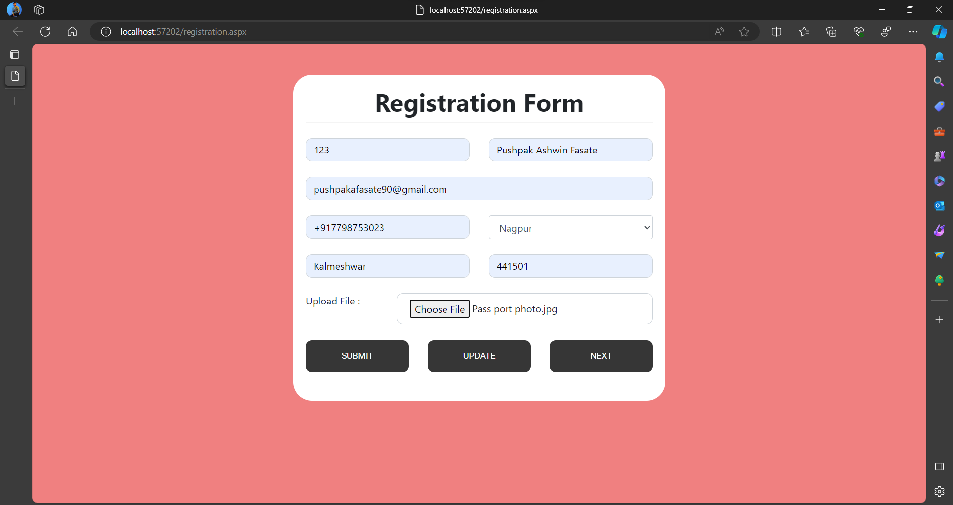

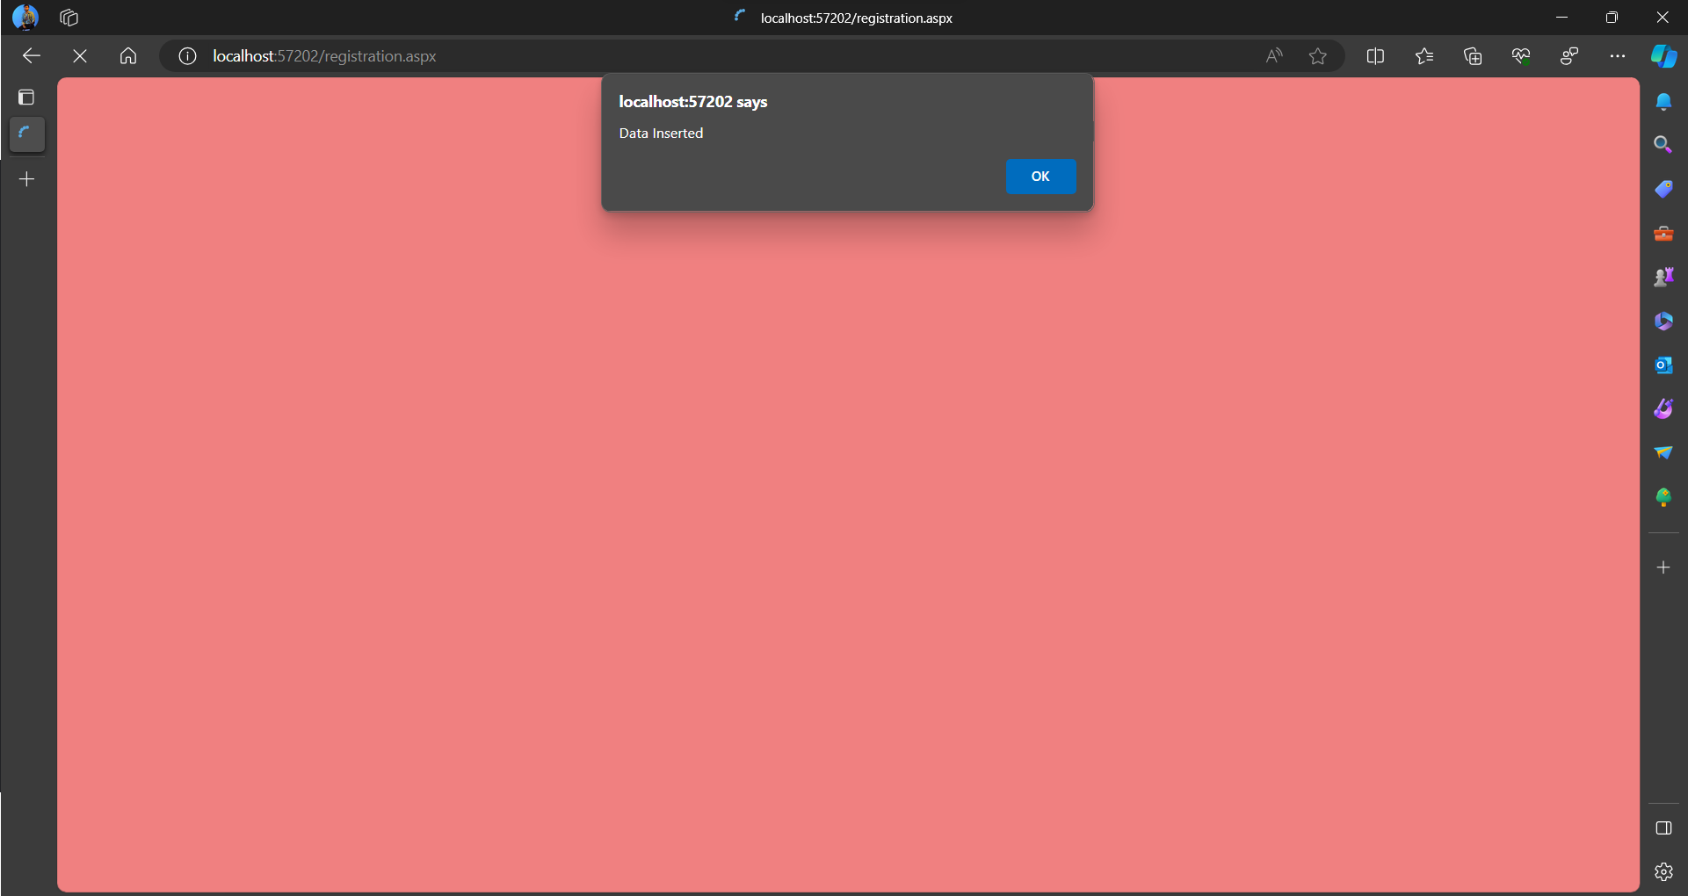

Screen – 2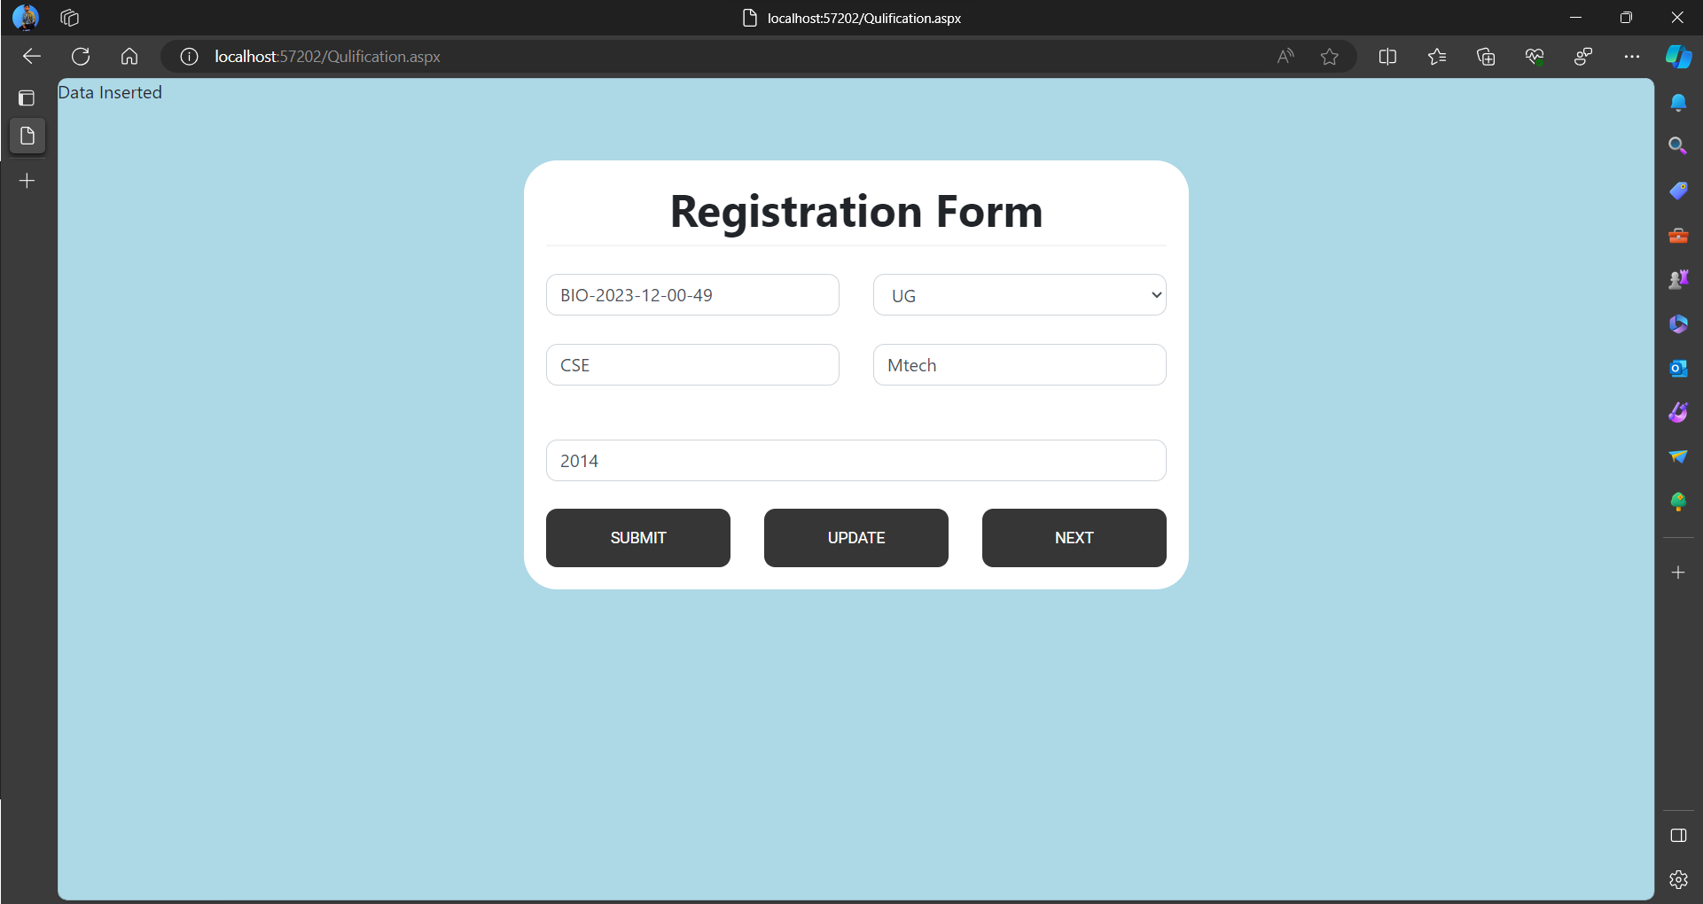

Screen – 3

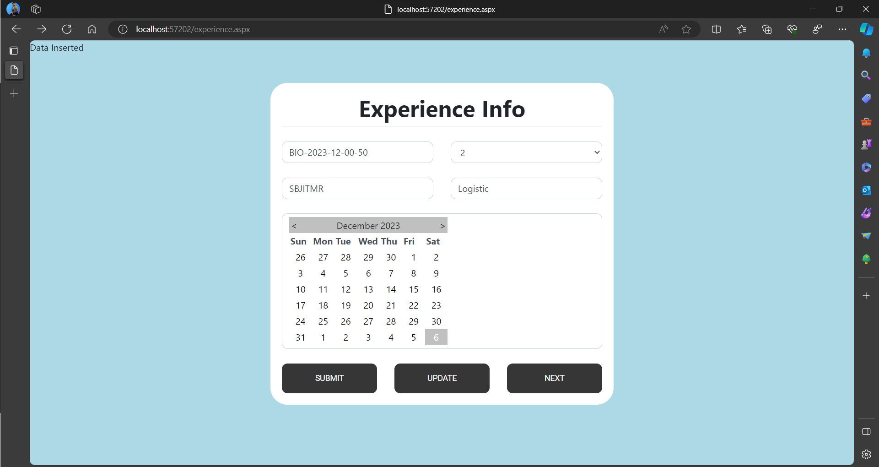

Screen – 4

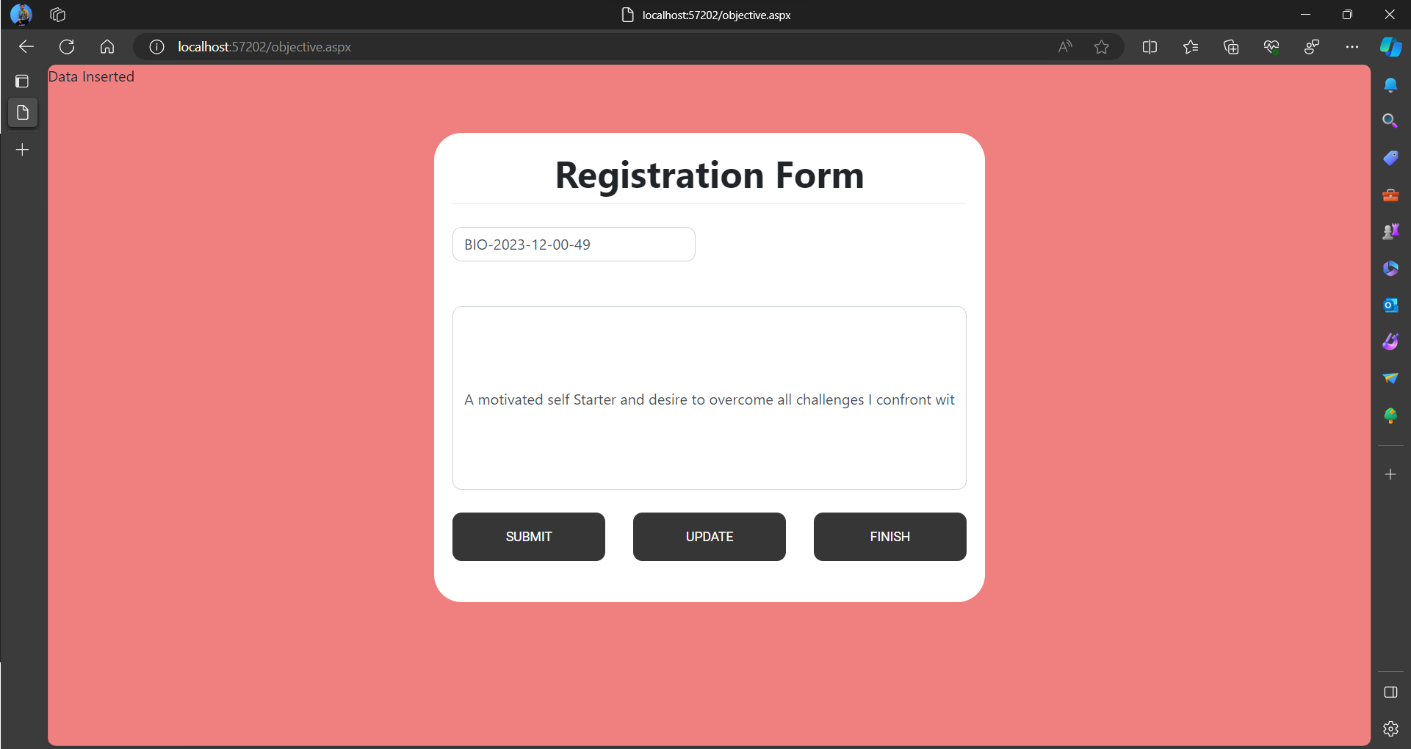

Screen 5 –

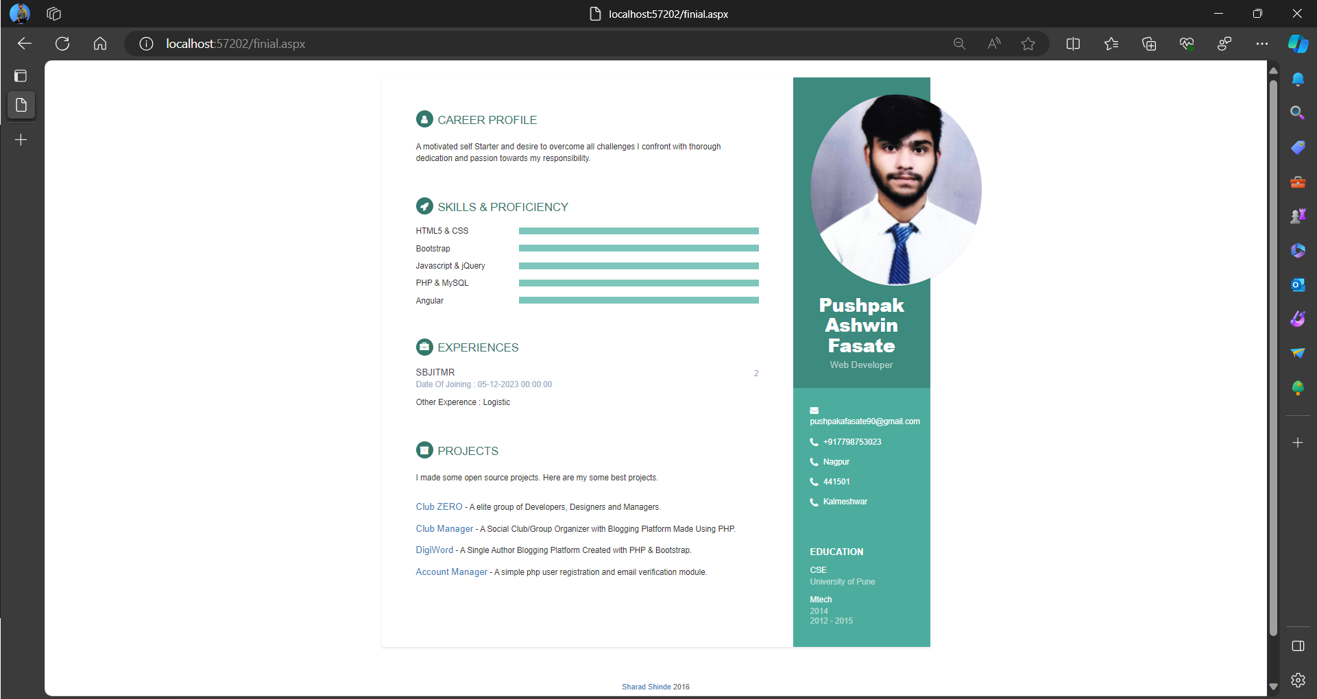

Updating Objective –

