File Name - Default.aspx

<%@ Page Language="C#" AutoEventWireup="true" CodeBehind="Default.aspx.cs" Inherits="WebApplication1.Default" %>

<!DOCTYPE html>

<html xmlns="http://www.w3.org/1999/xhtml">

<head runat="server">

<title>Registration Form</title>

<link rel="stylesheet" href="https://maxcdn.bootstrapcdn.com/bootstrap/4.0.0/css/bootstrap.min.css" />

<link rel="stylesheet" type="text/css" href="StyleSheet1.css" />

</head>

<body class="bg-img">

<div>

<div class="registration-form">

<form class="A1" id="form1" runat="server">

<div class="A1"></div>

<div class="registration-logo with-border">

<h1><b>Registration Form</b></h1>

</div>

<div class="row">

<div class="col-md-6">

<div class="form-group">

<asp:TextBox ID="txtId" runat="server" class="form-control item" placeholder="Enter ID"></asp:TextBox>

</div>

</div>

<div class="col-md-6">

<div class="form-group">

<asp:TextBox ID="txtName" runat="server" class="form-control item" placeholder="Enter Name"></asp:TextBox>

</div>

</div>

</div>

<div class="row">

<div class="col-sm-12">

<div>

<asp:TextBox runat="server" ID="txtEmail" placeholder="Enter Email" class="form-control item"></asp:TextBox>

</div>

</div>

</div>

<div class="row">

<div class="col-md-6">

<div class="form-group">

<asp:TextBox ID="txtMobile" runat="server" class="form-control item" placeholder="Enter Mobile"></asp:TextBox>

</div>

</div>

<div class="col-md-6">

<div class="form-group">

<asp:TextBox ID="txtCollege" runat="server" class="form-control item" placeholder="Enter College"></asp:TextBox>

</div>

</div>

</div>

<div class="row">

<div class="col-md-6">

<div class="form-group">

<asp:TextBox ID="txtBranch" runat="server" class="form-control item" placeholder="Enter Branch"></asp:TextBox>

</div>

</div>

<div class="col-md-6">

<div class="form-group">

<asp:TextBox ID="txtTotal" runat="server" class="form-control item" placeholder="Enter Total"></asp:TextBox>

</div>

</div>

</div>

<div class="row">

<div class="col-md-6">

<div class="form-group">

<asp:TextBox ID="txtPercentage" runat="server" class="form-control item" placeholder="Enter Percentage"></asp:TextBox>

<!-- <select class="countrypicker form-control item"></select> -->

</div>

</div>

<div class="col-md-6">

<div class="form-group">

<asp:TextBox ID="txtGrade" runat="server" class="form-control item" placeholder="Enter Grade"></asp:TextBox>

</div>

</div>

</div>

<div class="row">

<div class="col-md-6">

<asp:Button ID="btnSubmit" runat="server" Text="Submit" class="btn btn-block login-button" OnClick="btnSubmit_Click" />

</div>

<div class="col-md-6">

<asp:Button ID="btnShow" runat="server" Text="Show" class="btn btn-block login-button" OnClick="btnShow_Click" />

</div>

</div>

<div style="position: absolute; left: 150px; top: 600px; padding-bottom:100px">

<asp:GridView ID="GridView1" runat="server" AutoGenerateColumns="False" onRowDataBound="GridView1_RowDataBound" CellPadding="4" ForeColor="#333333" GridLines="None">

<AlternatingRowStyle BackColor="White" />

<Columns>

<asp:TemplateField HeaderText="Sr No.">

<ItemTemplate>

<%# Container.DataItemIndex+1 %>

</ItemTemplate>

</asp:TemplateField>

<asp:BoundField DataField="Id" HeaderText="ID"></asp:BoundField>

<asp:BoundField DataField="Name" HeaderText="Name"></asp:BoundField>

<asp:BoundField DataField="Email" HeaderText="Email"></asp:BoundField>

<asp:BoundField DataField="Mobile" HeaderText="Mobile"></asp:BoundField>

<asp:TemplateField HeaderText="Status">

<ItemTemplate >

<asp:DropDownList ID="DropDownList1" runat="server">

<asp:ListItem Value="Select">Please Select</asp:ListItem>

<asp:ListItem Value="Approv">Approv</asp:ListItem>

<asp:ListItem Value="Reject">Reject</asp:ListItem>

</asp:DropDownList>

</ItemTemplate>

</asp:TemplateField>

<asp:BoundField DataField="Total" HeaderText="Total" ></asp:BoundField>

<asp:BoundField DataField="Grade" HeaderText="Grade"></asp:BoundField>

<asp:TemplateField HeaderText="Action">

<ItemTemplate>

<asp:Button ID="btnUpdate" runat="server" Text="Update" onclick="btnUpdate_Click"/>

</ItemTemplate>

</asp:TemplateField>

<asp:TemplateField HeaderText="Action">

<ItemTemplate>

<asp:Button ID="btnDelete" runat="server" Text="Delete" onclick="btnDelete_Click"/>

</ItemTemplate>

</asp:TemplateField>

<asp:TemplateField HeaderText="Action">

<ItemTemplate>

<asp:Button ID="btnView" runat="server" Text="View" onclick="btnView_Click"/>

</ItemTemplate>

</asp:TemplateField>

</Columns>

<EditRowStyle BackColor="#2461BF" />

<FooterStyle BackColor="#507CD1" Font-Bold="True" ForeColor="White" />

<HeaderStyle BackColor="#507CD1" Font-Bold="True" ForeColor="White" />

<PagerStyle BackColor="#2461BF" ForeColor="White" HorizontalAlign="Center" />

<RowStyle BackColor="#EFF3FB" />

<SelectedRowStyle BackColor="#D1DDF1" Font-Bold="True" ForeColor="#333333" />

<SortedAscendingCellStyle BackColor="#F5F7FB" />

<SortedAscendingHeaderStyle BackColor="#6D95E1" />

<SortedDescendingCellStyle BackColor="#E9EBEF" />

<SortedDescendingHeaderStyle BackColor="#4870BE" />

</asp:GridView>

</div>

</form>

</div>

</div>

</body>

</html>

File Name – Default.aspx.cs

using System;

using System.Collections.Generic;

using System.Linq;

using System.Web;

using System.Web.UI;

using System.Web.UI.WebControls;

using System.Data.SqlClient;

using System.Configuration;

using System.Drawing;

namespace WebApplication1

{

public partial class Default : System.Web.UI.Page

{

SqlConnection conn;

SqlCommand cmd;

SqlDataReader reader;

protected void Page_Load(object sender, EventArgs e)

{

if(!IsPostBack)

{

}

}

protected void btnSubmit_Click(object sender, EventArgs e)

{

try

{

// All Field Are Required

if (txtId.Text == "" || txtName.Text == "" || txtEmail.Text == "" || txtCollege.Text == "" ||

txtMobile.Text == "" || txtBranch.Text == "" || txtTotal.Text == "" || txtPercentage.Text == "")

{

throw new Exception("All Field are Require");

}

else

{

//Calculating Grade

string grade;

if(int.Parse(txtTotal.Text) >= 250)

{

grade = "Grade A";

}

else if (int.Parse(txtTotal.Text) >= 150 && int.Parse(txtTotal.Text) <= 250)

{

grade = "Grade B";

}

else if (int.Parse(txtTotal.Text) >= 100 && int.Parse(txtTotal.Text) <= 150)

{

grade = "Grade C";

}

else

{

grade = "Fail";

}

txtGrade.Text = grade;

//Connecting database

string path = ConfigurationManager.AppSettings["stuDB"];

conn = new SqlConnection(path);

conn.Open();

//insert query

string insert_q = "INSERT INTO student (Id, Name, Email, Mobile, College, Branch, Status, Total, percentage, Grade) VALUES (@Id1, @Name1, @Email1, @Mobile1, @College1, @Branch1, @Status1, @Total1, @percentage1, @Grade1)";

cmd = new SqlCommand(insert_q, conn);

cmd.Parameters.AddWithValue("@Id1", txtId.Text);

cmd.Parameters.AddWithValue("@Name1", txtName.Text);

cmd.Parameters.AddWithValue("@Email1", txtEmail.Text);

cmd.Parameters.AddWithValue("@Mobile1", txtMobile.Text);

cmd.Parameters.AddWithValue("@College1", txtCollege.Text);

cmd.Parameters.AddWithValue("@Branch1", txtBranch.Text);

cmd.Parameters.AddWithValue("@Status1","");

cmd.Parameters.AddWithValue("@Total1", txtTotal.Text);

cmd.Parameters.AddWithValue("@percentage1", txtPercentage.Text);

cmd.Parameters.AddWithValue("@Grade1", grade.ToString());

//Execute Query

cmd.ExecuteNonQuery();

Response.Write("<Script>alert('Data Inserted')</Script>");

}

}

catch (Exception ex)

{

//Response.Write(ex);

Response.Write("All Field are Require");

}

}

protected void btnShow_Click(object sender, EventArgs e)

{

//Connecting database

string path = ConfigurationManager.AppSettings["stuDB"];

conn = new SqlConnection(path);

conn.Open();

//How data in grid

string select_q = "SELECT * FROM student;";

cmd = new SqlCommand(select_q, conn);

reader = cmd.ExecuteReader();

GridView1.DataSource = reader;

GridView1.DataBind();

reader.Close();

}

protected void btnUpdate_Click(object sender, EventArgs e)

{

GridViewRow rd = ((Button)sender).NamingContainer as GridViewRow;

string g_id = rd.Cells[1].Text;

DropDownList sel = (DropDownList)rd.FindControl("DropDownList1");

string sele = sel.Text;

string path = ConfigurationManager.AppSettings["stuDB"];

conn = new SqlConnection(path);

conn.Open();

//insert query

string update_q = "UPDATE student SET Status = @Status1 WHERE Id = @Id1";

cmd = new SqlCommand(update_q, conn);

cmd.Parameters.AddWithValue("@Id1", g_id.ToString());

cmd.Parameters.AddWithValue("@Status1", sele.ToString());

cmd.ExecuteNonQuery();

Response.Write("Updated");

}

protected void GridView1_RowDataBound(object sender, GridViewRowEventArgs e)

{

if (e.Row.RowType == DataControlRowType.DataRow)

{

TableCell cell = e.Row.Cells[7];

string garde = cell.Text;

if (garde == "Grade B")

{

cell.BackColor = Color.Yellow;

}

}

if (e.Row.RowType == DataControlRowType.DataRow)

{

// Assuming the grade is in the third cell of each row (index 2)

string grade = e.Row.Cells[7].Text;

// Assuming the View button is in the last cell of each row

Button btnView = (Button)e.Row.Cells[e.Row.Cells.Count - 1].FindControl("btnView");

// Check if the grade is 'A'

if (grade.Equals("Grade A", StringComparison.OrdinalIgnoreCase))

{

// Enable the View button

btnView.Enabled = true;

}

else

{

// Disable the View button for grades other than 'A'

btnView.Enabled = false;

}

}

}

protected void btnDelete_Click(object sender, EventArgs e)

{

GridViewRow rd = ((Button)sender).NamingContainer as GridViewRow;

string g_id = rd.Cells[1].Text;

string path = ConfigurationManager.AppSettings["stuDB"];

conn = new SqlConnection(path);

conn.Open();

//insert query

string delete_q = "DELETE FROM student where Id = @Id1";

cmd = new SqlCommand(delete_q, conn);

cmd.Parameters.AddWithValue("@Id1", g_id.ToString());

cmd.ExecuteNonQuery();

Response.Redirect("default.aspx");

Response.Write("Delete");

}

protected void btnView_Click(object sender, EventArgs e)

{

GridViewRow rd = ((Button)sender).NamingContainer as GridViewRow;

Session["s_id"] = rd.Cells[1].Text;

Response.Redirect("report.aspx");

}

}

}

File Name – report.aspx

<%@ Page Language="C#" AutoEventWireup="true" CodeBehind="report.aspx.cs" Inherits="WebApplication1.report_aspx" %>

<!DOCTYPE html>

<html xmlns="http://www.w3.org/1999/xhtml">

<head runat="server">

<title></title>

<link rel="stylesheet" type="text/css" href="Style.css" />

</head>

<body>

<form id="form1" runat="server">

<div class="bg"></div>

<div class="card">

<div class="top">

<p class="category">Nature</p>

</div>

<div class="bottom">

<h2></h2>

<div class="author">

<div class="profile"></div>

</div>

<div class="intro">

Id :<asp:Label ID="lblId" runat="server" Text="Label"></asp:Label>

<br />

Name:<asp:Label ID="lblName" runat="server" Text="Label"></asp:Label>

<br />

Email:<asp:Label ID="lblEmail" runat="server" Text="Label"></asp:Label>

<br />

Mobile:<asp:Label ID="lblMobile" runat="server" Text="Label"></asp:Label>

<br />

Status:<asp:Label ID="lblStatus" runat="server" Text="Label"></asp:Label>

<br />

Grade:<asp:Label ID="lblGrade" runat="server" Text="Label"></asp:Label>

<br />

Percentage:<asp:Label ID="lblPercentage" runat="server" Text="Label"></asp:Label>

<br />

Total:<asp:Label ID="lblTotal" runat="server" Text="Label"></asp:Label>

<br />

</div>

</div>

</div>

</form>

</body>

</html>

File Name – report.aspx.cs

using System;

using System.Collections.Generic;

using System.Linq;

using System.Web;

using System.Web.UI;

using System.Web.UI.WebControls;

using System.Data.SqlClient;

using System.Configuration;

namespace WebApplication1

{

public partial class report_aspx : System.Web.UI.Page

{

SqlConnection conn;

SqlCommand com;

SqlDataReader dr;

protected void Page_Load(object sender, EventArgs e)

{

if (!IsPostBack)

{

string path = ConfigurationManager.AppSettings["stuDB"];

conn = new SqlConnection(path);

conn.Open();

string select_q = "select * from student WHERE Id=@Id1";

com = new SqlCommand(select_q, conn);

com.Parameters.AddWithValue("@Id1", (string)Session["s_id"]);

dr = com.ExecuteReader();

if (dr.Read())

{

lblId.Text = (string)Session["s_id"];

lblName.Text = dr["Name"].ToString();

lblEmail.Text = dr["Email"].ToString();

lblMobile.Text = dr["Mobile"].ToString();

lblStatus.Text = dr["Status"].ToString();

lblPercentage.Text = dr["Percentage"].ToString();

lblGrade.Text = dr["Grade"].ToString();

lblTotal.Text = dr["Total"].ToString();

}

dr.Close();

}

}

}

}

File Name – StyleSheet.css (default page)

@import "https://stackpath.bootstrapcdn.com/font-awesome/4.7.0/css/font-awesome.min.css";

body {

background-color: #C7D3D4FF;

}

.grid_a {

position: absolute;

left: 0;

top: 0;

}

.registration-logo {

font-size: 35px;

text-align: center;

margin-bottom: 25px;

font-weight: 300;

}

.registration-form {

padding: 50px 10px;

}

.with-border {

border-bottom: 2px solid #f4f4f4;

}

.registration-form form {

background-color: #FFF;

max-width: 600px;

margin: auto;

padding: 20px;

border-radius: 30px;

}

.registration-form .item {

border-radius: 10px;

margin-bottom: 25px;

}

.registration-form .login-button {

font-family: "Roboto", sans-serif;

text-transform: uppercase;

border-radius: 10px;

background: #363636;

width: 100%;

padding: 15px;

color: #FFFFFF;

font-size: 14px;

}

.login-button:hover, .login-button:active, .login-button:focus {

background: #00001a;

}

#A3 {

margin-top: 10px;

}

@media (max-width: 576px) {

.login-form form,

.registration-form form {

padding: 50px 20px;

}

}

[type=file] {

position: absolute;

filter: alpha(opacity=0);

opacity: 0;

}

input,

[type=file] + label {

border-radius: 10px;

margin-bottom: 25px;

padding: 10px 20px;

display: block;

border: 1px solid #ced4da;

text-align: left;

width: 100%;

background-clip: padding-box;

position: relative;

}

[type=file] + label {

text-align: left;

width: 100%;

background-color: #fff;

background-clip: padding-box;

color: #495057;

border: 1px solid #ced4da;

border-radius: 10px;

transition: border-color .15s ease-in-out,box-shadow .15s ease-in-out;

}

[type=file] + label:hover {

background: #3399ff;

}

File Name – Style.css

@import "https://stackpath.bootstrapcdn.com/font-awesome/4.7.0/css/font-awesome.min.css";

body {

background-color: #C7D3D4FF;

}

.grid_a {

position: absolute;

left: 0;

top: 0;

}

.registration-logo {

font-size: 35px;

text-align: center;

margin-bottom: 25px;

font-weight: 300;

}

.registration-form {

padding: 50px 10px;

}

.with-border {

border-bottom: 2px solid #f4f4f4;

}

.registration-form form {

background-color: #FFF;

max-width: 600px;

margin: auto;

padding: 20px;

border-radius: 30px;

}

.registration-form .item {

border-radius: 10px;

margin-bottom: 25px;

}

.registration-form .login-button {

font-family: "Roboto", sans-serif;

text-transform: uppercase;

border-radius: 10px;

background: #363636;

width: 100%;

padding: 15px;

color: #FFFFFF;

font-size: 14px;

}

.login-button:hover, .login-button:active, .login-button:focus {

background: #00001a;

}

#A3 {

margin-top: 10px;

}

@media (max-width: 576px) {

.login-form form,

.registration-form form {

padding: 50px 20px;

}

}

[type=file] {

position: absolute;

filter: alpha(opacity=0);

opacity: 0;

}

input,

[type=file] + label {

border-radius: 10px;

margin-bottom: 25px;

padding: 10px 20px;

display: block;

border: 1px solid #ced4da;

text-align: left;

width: 100%;

background-clip: padding-box;

position: relative;

}

[type=file] + label {

text-align: left;

width: 100%;

background-color: #fff;

background-clip: padding-box;

color: #495057;

border: 1px solid #ced4da;

border-radius: 10px;

transition: border-color .15s ease-in-out,box-shadow .15s ease-in-out;

}

[type=file] + label:hover {

background: #3399ff;

}

File Name - Style.css (report page)

@import url('https://fonts.googleapis.com/css?family=Open+Sans:300,400,700');

* {

margin: 0;

overflow: hidden;

font-family: 'Open Sans', sans-serif;

color: #555;

}

body {

background-color: #C7D3D4FF;

}

.bg {

height: 110vh;

width: 110%;

position: absolute;

background-color:lightblue;

background-size: cover;

filter: blur(4px);

z-index: 0;

}

.card {

height: 500px;

width: 380px;

background-color: white;

position: absolute;

z-index: 1;

top: 100px;

left:550px;

}

.top {

height: 42%;

width: 100%;

background-image: url(https://images.unsplash.com/photo-1519681393784-d120267933ba?ixlib=rb-1.2.1&auto=format&fit=crop&w=1050&q=80);

background-size: cover;

}

.category {

background-color: orange;

width: 100px;

height: 30px;

color: white;

text-transform: uppercase;

display: flex;

align-items: center;

justify-content: center;

font-size: 16px;

letter-spacing: 1px;

}

h2 {

padding: 22px 22px 0;

}

p {

font-size: 18px;

padding: 0 22px;

line-height: 24px;

}

.intro {

position:absolute;

width: 85%;

left:50px;

}

a:link,

a:visited {

text-decoration: none;

color: #;

}

a:hover {

color: orange;

transition: .3s;

}

.author {

display: flex;

align-items: center;

}

/*

.profile {

background-image: url(https://images.unsplash.com/photo-1438761681033-6461ffad8d80?ixlib=rb-1.2.1&ixid=eyJhcHBfaWQiOjEyMDd9&auto=format&fit=crop&w=1050&q=80);

background-size: cover;

background-position: center;

height: 36px;

width: 36px;

border-radius: 50%;

margin: 10px 0 10px 22px;

}

*/

.name {

padding-left: 10px;

cursor: pointer;

font-weight: 300;

}

.name a {

font-weight: 400;

color: orange;

}

.info {

display: flex;

color: #999;

font-size: 14px;

margin-top: 8px;

padding-left: 0;

}

.info a {

cursor: pointer;

}

ion-icon {

height: 20px;

width: 20px;

display: flex;

padding: 10px 8px 0 22px;

}

Output –

Screen 1

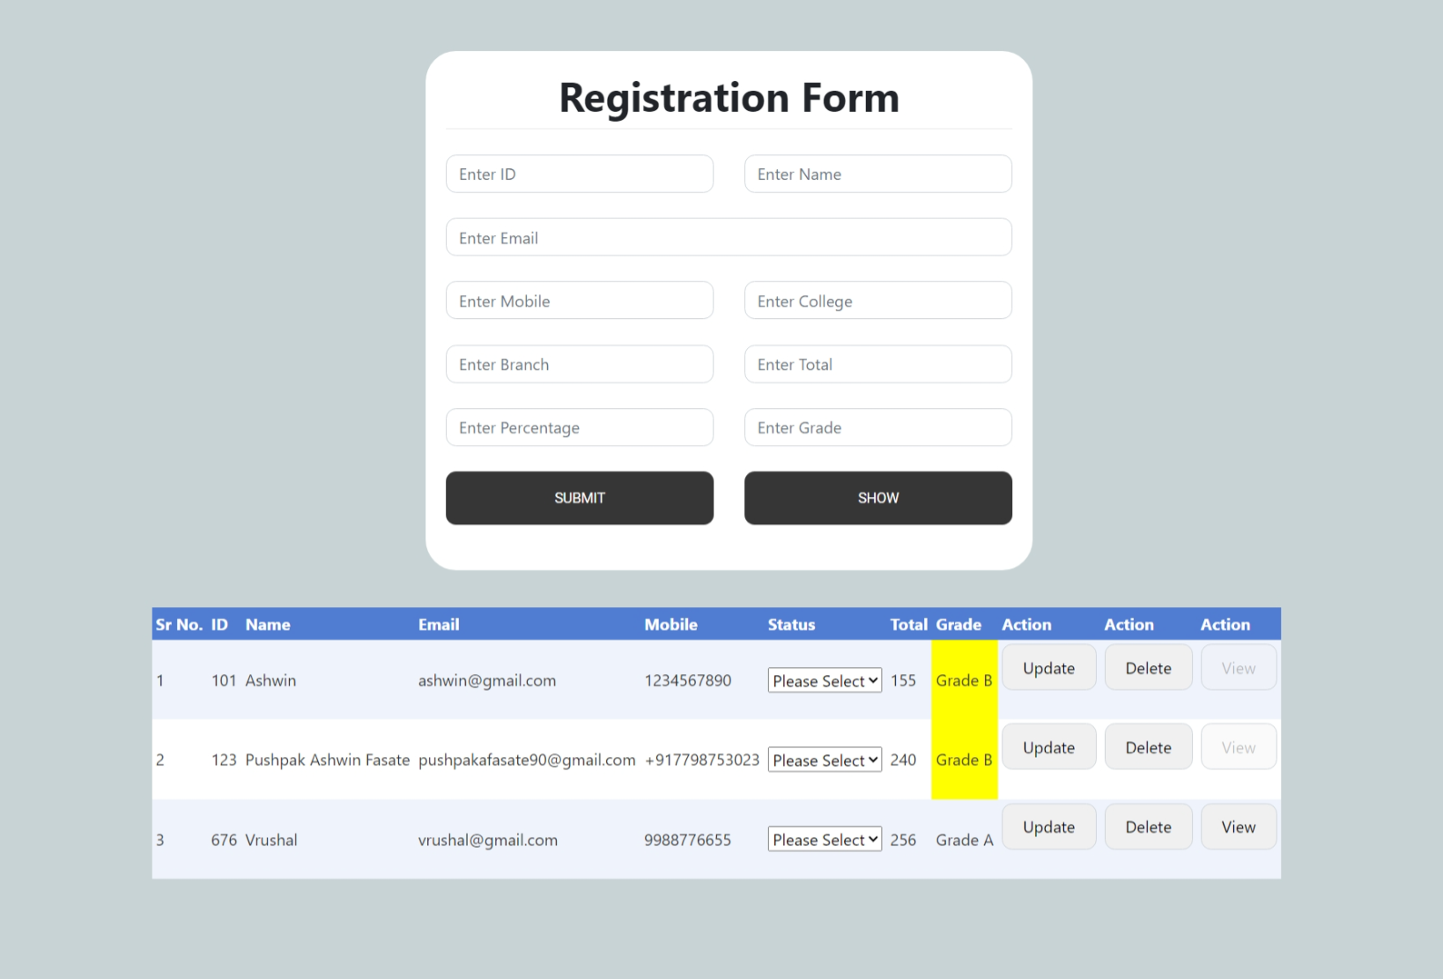

Screen 2 Insert

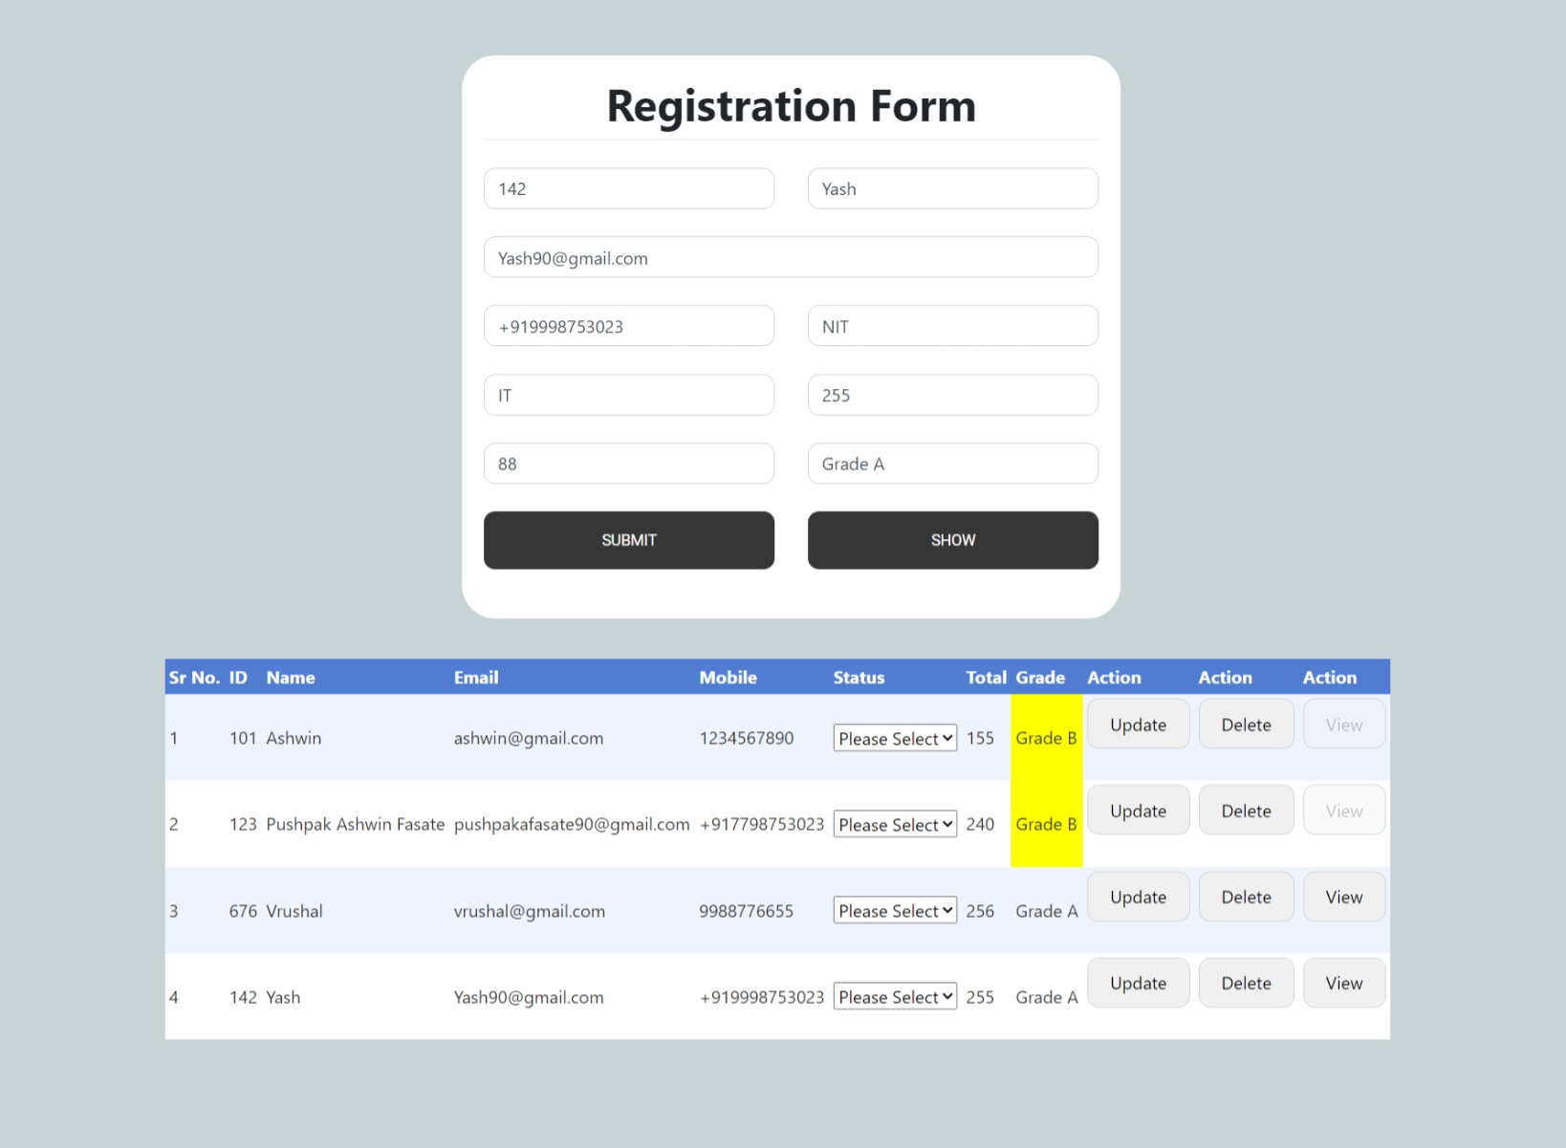

Screen 3 – Update

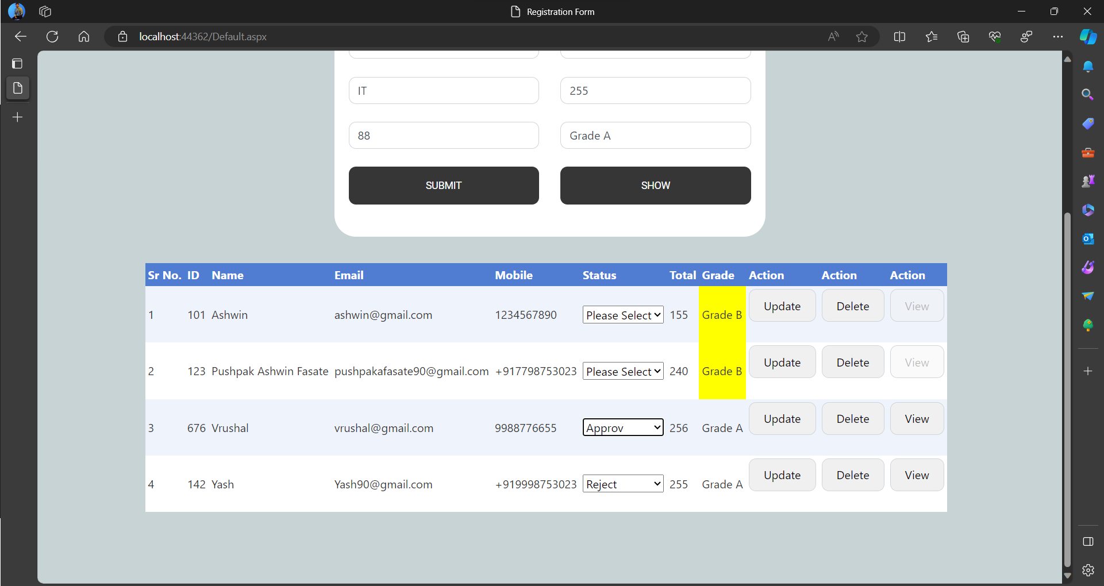

Screen 4 - Delete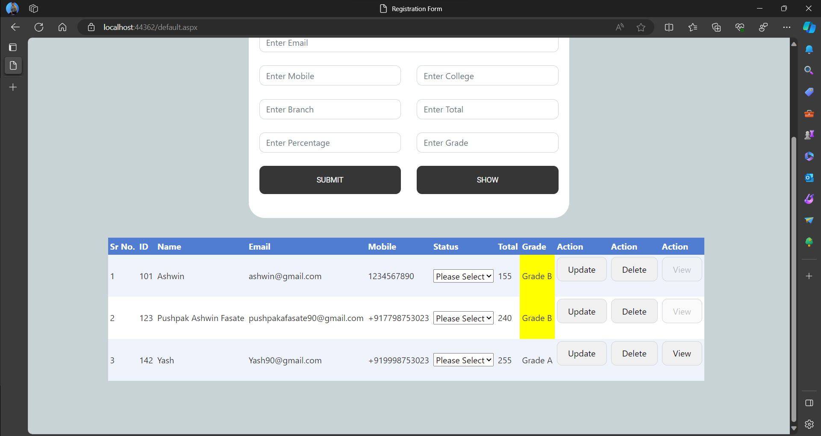

Screen 5 - View

