List View

File Name Default.aspx

<%@ Page Language="C#" AutoEventWireup="true" CodeBehind="default.aspx.cs" Inherits="WebApplication1._default" %>

<!DOCTYPE html>

<html xmlns="http://www.w3.org/1999/xhtml">

<head runat="server">

<title></title>

</head>

<body>

<form id="form1" runat="server">

<div>

<h1>Detail View</h1>

<p>Enter Your Roll No. :

<asp:TextBox ID="txtRoll" runat="server"></asp:TextBox></p>

<asp:Button ID="btnFind" runat="server" Text="Find" OnClick="btnFind_Click" /><br />

<p>Enter Your Name :

<asp:TextBox ID="txtName" runat="server"></asp:TextBox></p>

<p>Enter Your City :

<asp:TextBox ID="txtCity" runat="server"></asp:TextBox></p>

<asp:Button ID="btnSubmit" runat="server" Text="Submit" OnClick="btnSubmit_Click" />

<asp:Button ID="btnShow" runat="server" Text="Show" OnClick="btnShow_Click" />

<br />

<asp:ListView ID="ListView1" runat="server" GroupPlaceholderID="GroupPlaceholder1" ItemPlaceholderID="ItemPlaceholder1" OnItemCommand="ListView1_ItemCommand">

<LayoutTemplate>

<table border="1">

<tr>

<th>Roll no.</th>

<th>Student Name. </th>

<th>City.</th>

<th>Update</th>

<th>Delete</th>

</tr>

<asp:PlaceHolder runat="server" ID="GroupPlaceholder1"></asp:PlaceHolder>

</table>

</LayoutTemplate>

<GroupTemplate>

<tr>

<asp:PlaceHolder runat="server" ID="ItemPlaceholder1"></asp:PlaceHolder>

</tr>

</GroupTemplate>

<ItemTemplate>

<td>

<asp:TextBox ID="txtLid" runat="server" Text='<%# Eval("Id") %>'></asp:TextBox>

</td>

<td>

<asp:TextBox ID="txtLname" runat="server" Text='<%# Eval("Name") %>'></asp:TextBox>

</td>

<td>

<asp:TextBox ID="txtLcity" runat="server" Text='<%# Eval("City") %>'></asp:TextBox>

</td>

<td>

<asp:Button ID="btnUpdate" runat="server" Text="Update" CommandName="update"></asp:Button>

</td>

<td>

<asp:Button ID="btnDelete" runat="server" Text="Delete" CommandName="delete"></asp:Button>

</td>

</ItemTemplate>

</asp:ListView>

</div>

</form>

</body>

</html>

File Name Default.aspx.cs

using System;

using System.Collections.Generic;

using System.Linq;

using System.Web;

using System.Web.UI;

using System.Web.UI.WebControls;

using System.Data.SqlClient;

using System.Configuration;

using System.Drawing;

namespace WebApplication1

{

public partial class _default : System.Web.UI.Page

{

SqlConnection _connection;

SqlCommand _command;

SqlDataReader _reader;

protected void Page_Load(object sender, EventArgs e)

{

}

protected void btnShow_Click(object sender, EventArgs e)

{

//Connection

string path = ConfigurationManager.AppSettings["oldDB"];

_connection = new SqlConnection(path);

_connection.Open();

//Query

string select_q = "SELECT * FROM old_student";

_command = new SqlCommand(select_q, _connection);

_reader = _command.ExecuteReader();

ListView1.DataSource = _reader;

ListView1.DataBind();

_reader.Close();

}

protected void btnSubmit_Click(object sender, EventArgs e)

{

//Connection

string path = ConfigurationManager.AppSettings["oldDB"];

_connection = new SqlConnection(path);

_connection.Open();

//Query

string insert_q = "INSERT INTO old_student(Id, Name, City) VALUES (@Id1, @Name1, @City1)";

_command = new SqlCommand(insert_q, _connection);

_command.Parameters.AddWithValue("Id1", txtRoll.Text);

_command.Parameters.AddWithValue("Name1", txtName.Text);

_command.Parameters.AddWithValue("City1", txtCity.Text);

Response.Write("Data Inserted");

_command.ExecuteNonQuery();

}

protected void btnFind_Click(object sender, EventArgs e)

{

//Connection

string path = ConfigurationManager.AppSettings["oldDB"];

_connection = new SqlConnection(path);

_connection.Open();

//Query

string find_q = "SELECT * FROM old_student WHERE Id = @Id1";

_command = new SqlCommand(find_q, _connection);

_command.Parameters.AddWithValue("Id1",txtRoll.Text);

_reader = _command.ExecuteReader();

ListView1.DataSource = _reader;

ListView1.DataBind();

_reader.Close();

}

protected void ListView1_ItemCommand(object sender, ListViewCommandEventArgs e)

{

if(e.CommandName == "update")

{

//Connection

string path = ConfigurationManager.AppSettings["oldDB"];

_connection = new SqlConnection(path);

_connection.Open();

//Find Control

TextBox txtListId = (TextBox)e.Item.FindControl("txtLid");

TextBox txtListName = (TextBox)e.Item.FindControl("txtLname");

TextBox txtListCity = (TextBox)e.Item.FindControl("txtLcity");

//Query

string update_q = "UPDATE old_student SET Name = @Name1, City = @City1 WHERE Id = @Id1";

_command = new SqlCommand(update_q, _connection);

_command.Parameters.AddWithValue("Id1",txtListId.Text);

_command.Parameters.AddWithValue("Name1", txtListName.Text);

_command.Parameters.AddWithValue("City1", txtListCity.Text);

_command.ExecuteNonQuery();

Response.Redirect("default.aspx");

}

else if(e.CommandName == "delete")

{

//Connection

string path = ConfigurationManager.AppSettings["oldDB"];

_connection = new SqlConnection(path);

_connection.Open();

//Find Control

TextBox txtListId = (TextBox)e.Item.FindControl("txtLid");

//Query

string update_q = "DELETE FROM old_student WHERE Id = @Id1";

_command = new SqlCommand(update_q, _connection);

_command.Parameters.AddWithValue("Id1", txtListId.Text);

_command.ExecuteNonQuery();

Response.Redirect("default.aspx");

}

}

}

}

Insert Data

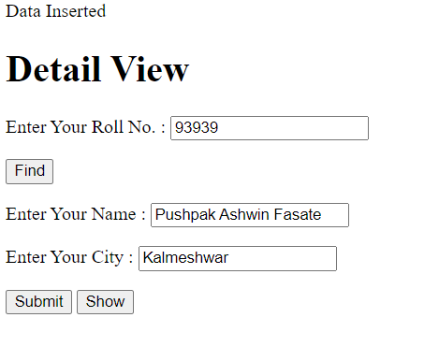

Show Detail View

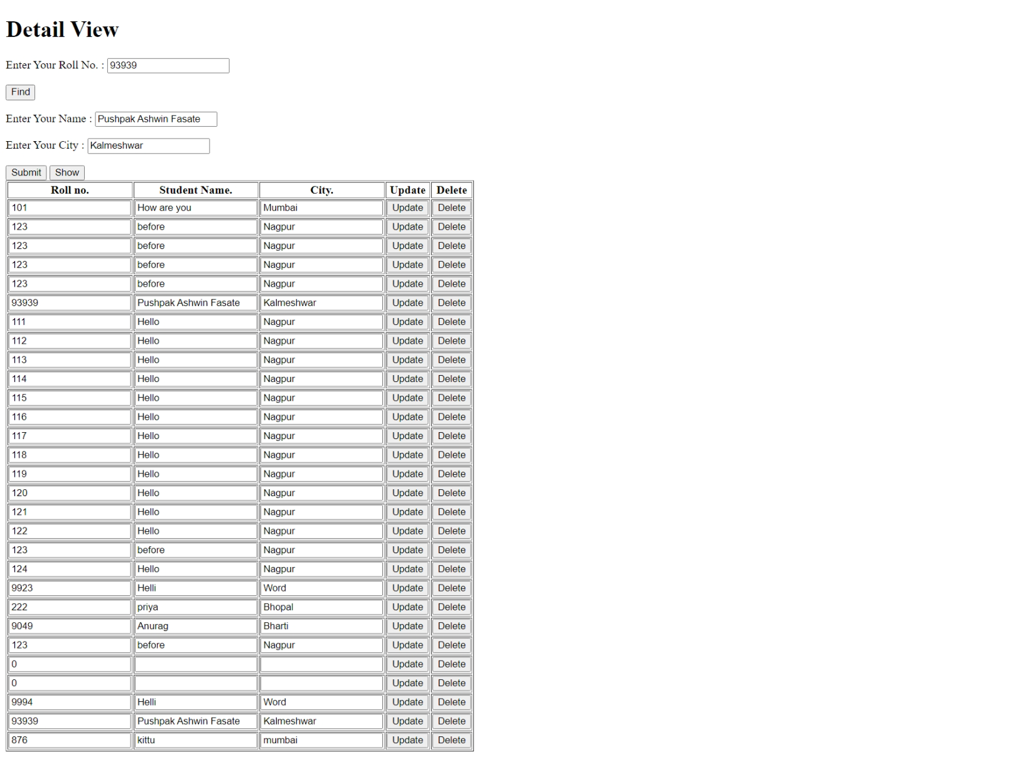

Update View

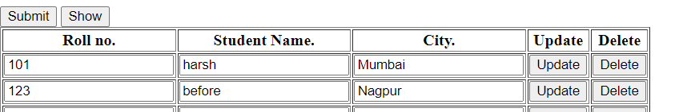

Delete

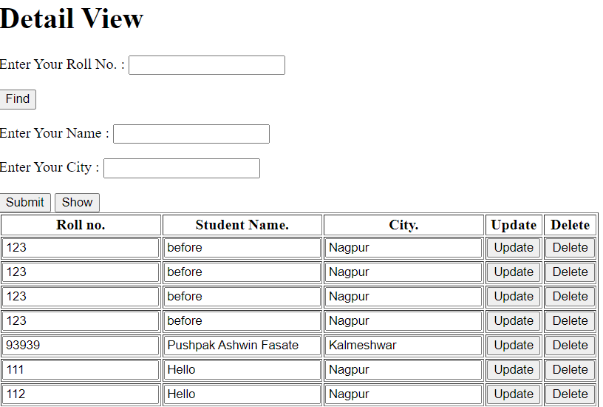

Find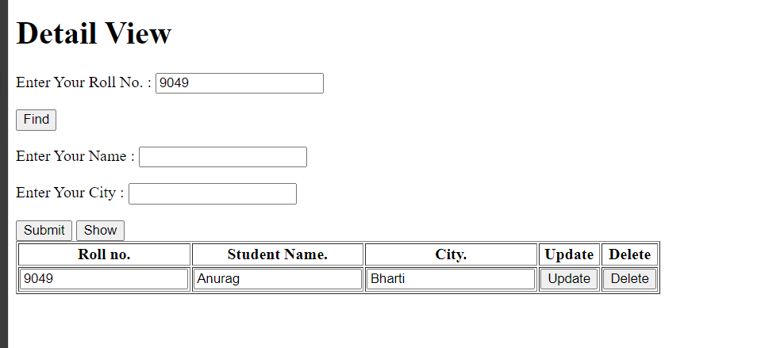

3 TIER ARCHITECTURE :

**WITHOUT STORE PROCEDURE**

**Reg.aspx.cs**

using System;

using System.Collections.Generic;

using System.Linq;

using System.Web;

using System.Web.UI;

using System.Web.UI.WebControls;

using BusinessLogic;

using BusinessObject;

namespace Task

{

public partial class Reg : System.Web.UI.Page

{

UserBL bl = new UserBL();

UserBO bo = new UserBO();

protected void Page_Load(object sender, EventArgs e)

{

}

protected void btnSubmit_Click(object sender, EventArgs e)

{

int returnvalue = 0;

bo.Roll = int.Parse(txtRoll.Text);

bo.Name = txtName.Text;

bo.City = txtCity.Text;

bo.Age = int.Parse(txtAge.Text);

returnvalue = bl.savedata(bo);

Response.Write("data inserted");

}

protected void btnUpdate_Click(object sender, EventArgs e)

{

int returnvalue = 0;

bo.Roll = int.Parse(txtRoll.Text);

bo.Name = txtName.Text;

bo.City = txtCity.Text;

bo.Age = int.Parse(txtAge.Text);

returnvalue = bl.checkupdatedata(bo);

Response.Write("data updated");

}

protected void btnDelete_Click(object sender, EventArgs e)

{

int returnvalue = 0;

bo.Roll = int.Parse(txtRoll.Text);

returnvalue = bl.checkdeletedata(bo);

Response.Write("data deleted");

}

protected void btnFind_Click(object sender, EventArgs e)

{

int returnvalue = 0;

bo.Roll = int.Parse(txtRoll.Text);

returnvalue = bl.checkfinddata(bo);

txtName.Text = bo.Name;

txtCity.Text = bo.City;

txtAge.Text = bo.Age.ToString();

}

}

}

**UserBO**

using System;

using System.Collections.Generic;

using System.Linq;

using System.Text;

using System.Threading.Tasks;

namespace BusinessObject

{

public class UserBO

{

private int _Roll;

private string _Name;

private string _City;

private int _Age;

private string _rname;

public int Roll

{

get

{

return _Roll;

}

set

{

_Roll = value;

}

}

public string Name

{

get

{

return _Name;

}

set

{

_Name = value;

}

}

public string City

{

get

{

return _City;

}

set

{

_City = value;

}

}

public int Age

{

get

{

return _Age;

}

set

{

_Age = value;

}

}

}

}

**UserDA**

using System;

using System.Collections.Generic;

using System.Linq;

using System.Text;

using System.Threading.Tasks;

using System.Data.SqlClient;

using BusinessObject;

using System.Configuration;

namespace DataAccess

{

public class UserDA

{

SqlConnection con = new SqlConnection(ConfigurationManager.AppSettings["Mydb"]);

// SqlConnection con = new SqlConnection(@"Data Source=MSI\SQLEXPRESS;Initial Catalog=TierDB;Integrated Security=True");

public SqlDataReader dr;

public int insertdata(UserBO objbo)

{

string i_command = "insert into studetail (Roll,Name,City,Age) values (@Roll1,@Name1,@City1,@Age1)";

SqlCommand com = new SqlCommand(i_command, con);

com.Parameters.AddWithValue("Roll1", objbo.Roll);

com.Parameters.AddWithValue("Name1", objbo.Name);

com.Parameters.AddWithValue("City1", objbo.City);

com.Parameters.AddWithValue("Age1", objbo.Age);

con.Open();

int Result = com.ExecuteNonQuery();

com.Dispose();

return Result;

}

// for update

public int updatedata(UserBO objbo2)

{

string u_command = "update studetail set Name = @Name1 ,City =@City1,Age = @Age1 where Roll= @Roll1";

SqlCommand com = new SqlCommand(u_command, con);

com.Parameters.AddWithValue("Roll1", objbo2.Roll);

com.Parameters.AddWithValue("Name1", objbo2.Name);

com.Parameters.AddWithValue("City1", objbo2.City);

com.Parameters.AddWithValue("Age1", objbo2.Age);

con.Open();

int result = com.ExecuteNonQuery();

com.Dispose();

return result;

}

public int deletedata(UserBO objbo3)

{

string d_command = "Delete from studetail where Roll=@Roll1";

SqlCommand com = new SqlCommand(d_command, con);

com.Parameters.AddWithValue("Roll1", objbo3.Roll);

con.Open();

int return2 = com.ExecuteNonQuery();

com.Dispose();

return return2;

}

public int finddata(UserBO objbo4 )

{

string f_command = "select * from studetail where Roll=@Roll1";

SqlCommand com = new SqlCommand(f_command, con);

com.Parameters.AddWithValue("Roll1", objbo4.Roll);

con.Open();

SqlDataReader dr = com.ExecuteReader();

// dr = com.ExecuteReader();

if(dr.Read())

{

objbo4.Name = dr["Name"].ToString();

objbo4.City = dr["City"].ToString();

objbo4.Age = int.Parse(dr["Age"].ToString());

}

//

dr.Close();

int return3 = com.ExecuteNonQuery();

com.Dispose();

return return3 ;

}

}

}

**UserBL**

using System;

using System.Collections.Generic;

using System.Linq;

using System.Text;

using System.Threading.Tasks;

using BusinessObject;

using DataAccess;

namespace BusinessLogic

{

public class UserBL

{

// for insert

public int savedata(UserBO objbo1)

{

UserDA objda = new UserDA();

return objda.insertdata(objbo1);

}

// for update

public int checkupdatedata(UserBO objbo1)

{

UserDA objda = new UserDA();

return objda.updatedata(objbo1);

}

public int checkdeletedata(UserBO objbo1)

{

UserDA objda1 = new UserDA();

return objda1.deletedata(objbo1);

}

public int checkfinddata(UserBO objbo6)

{

UserDA objda2 = new UserDA();

return objda2.finddata(objbo6);

}

}

}

**Output:**

**INSERT DATA**

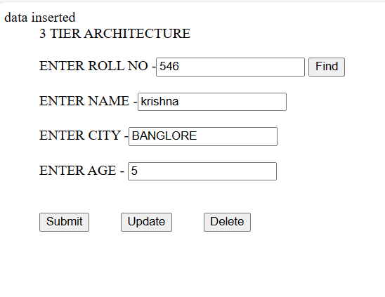

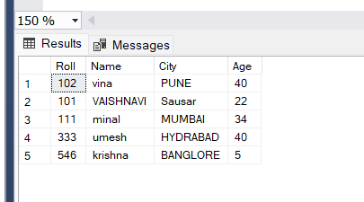

**UPDATE DATA**

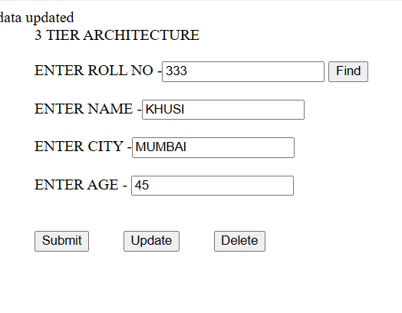

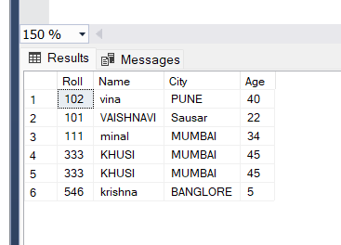

**DELETE DATA**

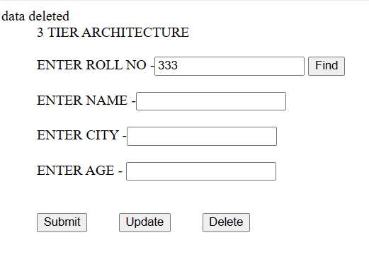

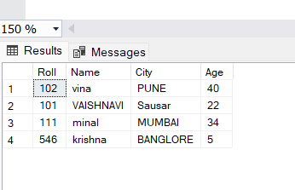

**FIND BUTTON**

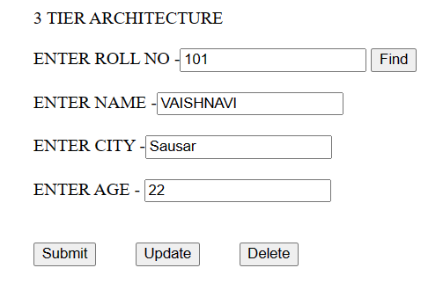

**WITH STORE PROCEDURE**

**STORE PROCEDURE**

**INSERT DATA**

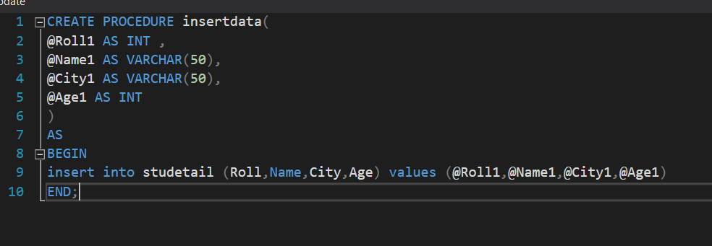

**UPDATE**

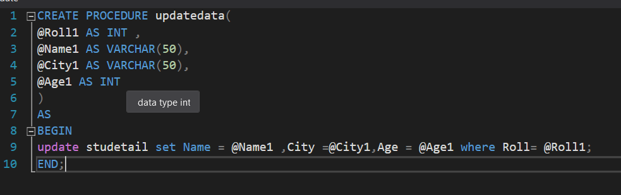

**DELETE DATA**

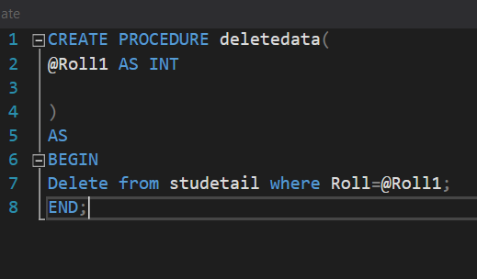

**FIND DATA**

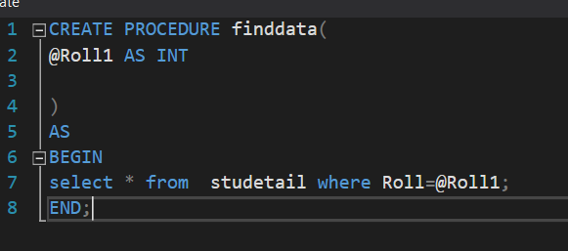

**Default.aspx.cs**

using System;

using System.Collections.Generic;

using System.Linq;

using System.Web;

using System.Web.UI;

using System.Web.UI.WebControls;

using BusinessLogic;

using BusinessObject;

namespace Samewebapplication1

{

public partial class Default : System.Web.UI.Page

{

UserBL bl = new UserBL();

UserBO bo = new UserBO();

protected void Page_Load(object sender, EventArgs e)

{

}

protected void btnSubmit_Click(object sender, EventArgs e)

{

int returnvalue = 0;

bo.Roll = int.Parse(txtRoll.Text);

bo.Name = txtName.Text;

bo.City = txtCity.Text;

bo.Age = int.Parse(txtAge.Text);

returnvalue = bl.savedata(bo);

Response.Write("data inserted");

}

protected void btnUpdate_Click(object sender, EventArgs e)

{

int returnvalue = 0;

bo.Roll = int.Parse(txtRoll.Text);

bo.Name = txtName.Text;

bo.City = txtCity.Text;

bo.Age = int.Parse(txtAge.Text);

returnvalue = bl.checkupdatedata(bo);

Response.Write("data updated");

}

protected void btnDelete_Click(object sender, EventArgs e)

{

int returnvalue = 0;

bo.Roll = int.Parse(txtRoll.Text);

// bo.Name = txtName.Text;

// bo.City = txtCity.Text;

// bo.Age = int.Parse(txtAge.Text);

returnvalue = bl.checkdeletedata(bo);

Response.Write("data deleted");

}

protected void btnFind_Click(object sender, EventArgs e)

{

int returnvalue = 0;

bo.Roll = int.Parse(txtRoll.Text);

returnvalue = bl.checkfinddata(bo);

//bo.rname = txtName.Text;

// bo.City = txtCity.Text;

// bo.Age = int.Parse(txtAge.Text);

txtName.Text = bo.Name;

txtCity.Text = bo.City;

txtAge.Text = bo.Age.ToString();

}

}

}

**UserBO**

using System;

using System.Collections.Generic;

using System.Linq;

using System.Text;

using System.Threading.Tasks;

namespace BusinessObject

{

public class UserBO

{

private int _Roll;

private string _Name;

private string _City;

private int _Age;

private string _rname;

public int Roll

{

get

{

return _Roll;

}

set

{

_Roll = value;

}

}

public string Name

{

get

{

return _Name;

}

set

{

_Name = value;

}

}

public string City

{

get

{

return _City;

}

set

{

_City = value;

}

}

public int Age

{

get

{

return _Age;

}

set

{

_Age = value;

}

}

public string rname

{

set

{

_rname = value;

}

get

{

return _rname;

}

}

}

}

**UserDA**

using System;

using System.Collections.Generic;

using System.Linq;

using System.Text;

using System.Threading.Tasks;

using System.Data.SqlClient;

using BusinessObject;

using System.Configuration;

using System.Data;

namespace DataAccess

{

public class UserDA

{

SqlConnection con = new SqlConnection(@"Data Source = MSI\SQLEXPRESS; Initial Catalog = TierDB; Integrated Security = True");

public SqlDataReader dr;

public int insertdata(UserBO objbo)

{

SqlCommand com = new SqlCommand("insertdata", con);

com.CommandType = CommandType.StoredProcedure;

com.Parameters.AddWithValue("Roll1", objbo.Roll);

com.Parameters.AddWithValue("Name1", objbo.Name);

com.Parameters.AddWithValue("City1", objbo.City);

com.Parameters.AddWithValue("Age1", objbo.Age);

con.Open();

int Result = com.ExecuteNonQuery();

com.Dispose();

return Result;

}

// for update

public int updatedata(UserBO objbo2)

{

SqlCommand com = new SqlCommand("updatetdata", con);

com.CommandType = CommandType.StoredProcedure;

com.Parameters.AddWithValue("Roll1", objbo2.Roll);

com.Parameters.AddWithValue("Name1", objbo2.Name);

com.Parameters.AddWithValue("City1", objbo2.City);

com.Parameters.AddWithValue("Age1", objbo2.Age);

con.Open();

int result = com.ExecuteNonQuery();

com.Dispose();

return result;

}

public int deletedata(UserBO objbo3)

{

SqlCommand com = new SqlCommand("deletedata", con);

com.CommandType = CommandType.StoredProcedure;

com.Parameters.AddWithValue("Roll1", objbo3.Roll);

con.Open();

int return2 = com.ExecuteNonQuery();

com.Dispose();

return return2;

}

public int finddata(UserBO objbo4)

{

SqlCommand com = new SqlCommand("finddata", con);

com.CommandType = CommandType.StoredProcedure;

com.Parameters.AddWithValue("Roll1", objbo4.Roll);

con.Open();

//int return3 = com.ExecuteNonQuery();

SqlDataReader dr = com.ExecuteReader();

if (dr.Read())

{

objbo4.Name = dr["Name"].ToString();

objbo4.City = dr["City"].ToString();

objbo4.Age = int.Parse(dr["Age"].ToString());

}

//

dr.Close();

int return3 = com.ExecuteNonQuery();

com.Dispose();

return return3;

}

}

}

**UserBL**

using System;

using System.Collections.Generic;

using System.Linq;

using System.Text;

using System.Threading.Tasks;

using BusinessObject;

using DataAccess;

namespace BusinessLogic

{

public class UserBL

{

// for insert

public int savedata(UserBO objbo1)

{

UserDA objda = new UserDA();

return objda.insertdata(objbo1);

}

// for update

public int checkupdatedata(UserBO objbo1)

{

UserDA objda = new UserDA();

return objda.updatedata(objbo1);

}

public int checkdeletedata(UserBO objbo1)

{

UserDA objda1 = new UserDA();

return objda1.deletedata(objbo1);

}

public int checkfinddata(UserBO objbo6)

{

UserDA objda2 = new UserDA();

return objda2.finddata(objbo6);

}

}

}