Assignment 1:

using System;

using System.Collections.Generic;

using System.Linq;

using System.Text;

using System.Threading.Tasks;

namespace Day_11_Assignment

{

class Program

{

static void Main(string[] args)

{

int sum = 0, greater = 0, smaller;

Console.Write("Enter number of elements : ");

int n = int.Parse(Console.ReadLine());

int[] arr = new int[n];

Console.Write("Enter " + n + " elements : ");

for(int i = 0; i < arr.Length; i++)

{

arr[i] = int.Parse(Console.ReadLine());

}

for(int i = 0; i< arr.Length; i++)

{

sum = sum + arr[i];

}

Console.Write("Sum : \t" + sum+"\n");

Console.Write("Even : ");

for (int i = 0; i < arr.Length; i++)

{

if(arr[i]%2 == 0)

{

Console.Write(arr[i] + "\t");

}

}

Console.Write("\nOdd : \t");

for (int i = 0; i < arr.Length; i++)

{

if (arr[i] % 2 != 0)

{

Console.Write(arr[i] + "\t");

}

}

for (int i = 0; i < arr.Length; i++)

{

if (greater < arr[i])

{

greater = arr[i];

}

}

Console.WriteLine("\nGreate Number : "+greater);

smaller = arr[0];

for (int i = 0; i < arr.Length; i++)

{

if (smaller > arr[i])

{

smaller = arr[i];

}

}

Console.WriteLine("Smaller Number : " + smaller);

Console.ReadKey();

}

}

}

Output:

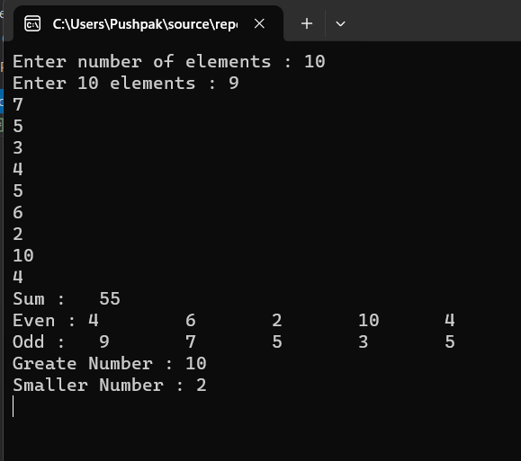

Assignment 2:

using System;

using System.Collections.Generic;

using System.Linq;

using System.Text;

using System.Threading.Tasks;

namespace Day_11_Assignment

{

class Program

{

static void Main(string[] args)

{

Console.Write("Enter number of elements : ");

int n = int.Parse(Console.ReadLine());

int[] arr = new int[n];

Console.Write("Enter " + n + " elements : ");

for(int i = 0; i < arr.Length; i++)

{

arr[i] = int.Parse(Console.ReadLine());

}

Console.WriteLine("Given Array : ");

for (int i = 0; i < arr.Length; i++)

{

Console.Write(arr[i] + "\t");

}

Console.ReadKey();

}

}

}

Output:

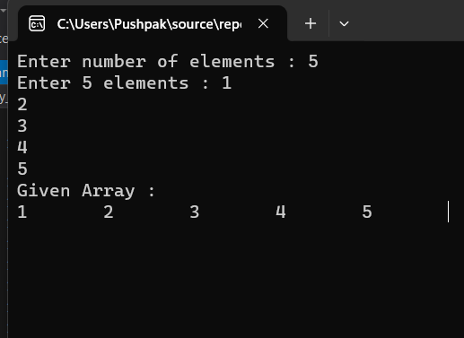

Assignment 3:

using System;

using System.Collections.Generic;

using System.Linq;

using System.Text;

using System.Threading.Tasks;

namespace Day_11_Assignment

{

class Program

{

static void Main(string[] args)

{

Console.Write("Enter number of elements : ");

int n = int.Parse(Console.ReadLine());

int[] arr = new int[n];

Console.Write("Enter " + n + " elements : ");

for(int i = 0; i < arr.Length; i++)

{

arr[i] = int.Parse(Console.ReadLine());

}

Console.WriteLine("Sum : " + arr.Sum());

Console.WriteLine("Min : " + arr.Min());

Console.WriteLine("Max : " + arr.Max());

Console.Write("Sorted Array : ");

Array.Sort(arr);

foreach(int i in arr)

{

Console.Write(i+"\t");

}

Console.ReadKey();

}

}

}

Output:

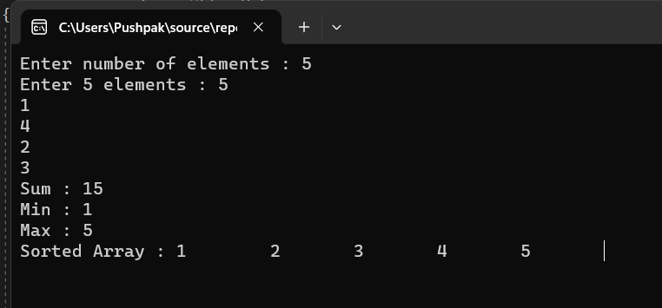

Assignment 4:

using System;

using System.Collections.Generic;

using System.Linq;

using System.Text;

using System.Threading.Tasks;

namespace Day_11_Assignment

{

class Program

{

static void Main(string[] args)

{

Console.Write("Enter the number of rows : ");

int r = int.Parse(Console.ReadLine());

Console.Write("Enter the number of Coloums : ");

int c = int.Parse(Console.ReadLine());

int[,] arr = new int[r, c];

Console.WriteLine("Enter " + r + " and " + c+" elements : ");

for(int i = 0; i < r; i++)

{

for(int j = 0; j < c; j++)

{

arr[i, j] = int.Parse(Console.ReadLine());

}

}

Console.WriteLine("Given Array : ");

for (int i = 0; i < r; i++)

{

for (int j = 0; j < c; j++)

{

Console.Write(arr[i, j] + "\t");

}

Console.WriteLine();

}

//Sum of rows

Console.WriteLine("\nPerforming operations : ");

for (int i = 0; i < r; i++)

{

int sumr = 0;

for (int j = 0; j < c; j++)

{

Console.Write(arr[i, j] + "\t");

sumr = sumr + arr[i, j];

}

Console.Write("Sum of rows " + i + " : " + sumr);

Console.WriteLine();

}

//Sum of coloums

Console.WriteLine();

for (int j = 0; j < c; j++)

{

int sumc = 0;

for (int i = 0; i < r; i++)

{

sumc = sumc + arr[i, j];

}

Console.WriteLine("Sum of cols " + j + " : " + sumc);

}

//Even

Console.Write("\nEven Number : \n");

for (int i = 0; i < r; i++)

{

for (int j = 0; j < c; j++)

{

if(arr[i, j]%2 == 0)

{

Console.Write(arr[i, j] + "\t");

}

}

}

//Odd

Console.Write("\nOdd Number : \n");

for (int i = 0; i < r; i++)

{

for (int j = 0; j < c; j++)

{

if (arr[i, j] % 2 != 0)

{

Console.Write(arr[i, j] + "\t");

}

}

}

Console.ReadKey();

}

}

}

Output:

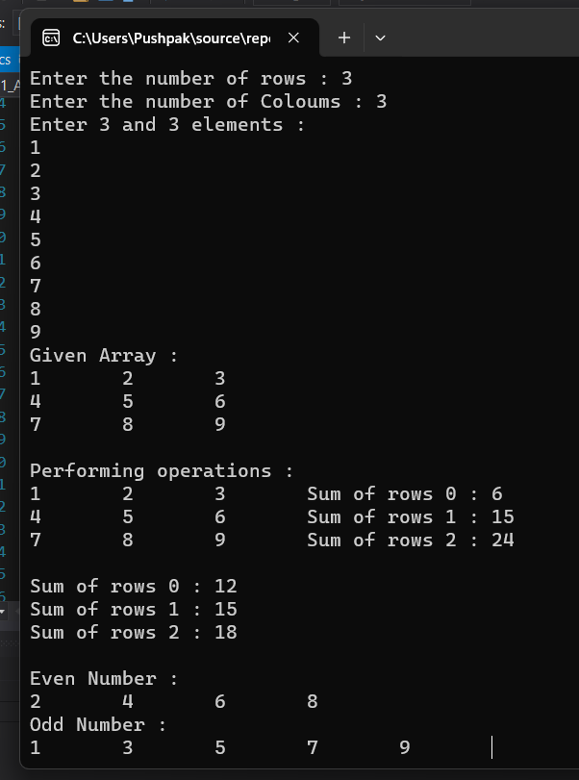

Assignment 5:

using System;

using System.Collections.Generic;

using System.Linq;

using System.Text;

using System.Threading.Tasks;

namespace Day_11_Assignment

{

class Program

{

struct student

{

public int roll;

public string name;

public string city;

public string branch;

public int per;

};

class College

{

public void input(int i_roll, string i_name, string i_city, string i_branch, int i_per)

{

Console.WriteLine("\n---------------------------------\nRoll No. : " + i_roll +

"\nName : "+i_name+

"\nCity : "+i_city+

"\nBranch : "+i_branch+

"\nPercentage : "+i_per

);

if(i_per >= 60)

{

Console.WriteLine("Grade A");

}

else if(i_per >= 50 && i_per <=60)

{

Console.WriteLine("Grade B");

}

else if(i_per >= 40 && i_per <=50 )

{

Console.WriteLine("Grade C");

}

else

{

Console.WriteLine("Fail");

}

}

}

static void Main(string[] args)

{

student s1;

Console.Write("Enter Roll No. : ");

s1.roll = int.Parse(Console.ReadLine());

Console.Write("Enter Name : ");

s1.name = Console.ReadLine();

Console.Write("Enter City : ");

s1.city = Console.ReadLine();

Console.Write("Enter Branch : ");

s1.branch = Console.ReadLine();

Console.Write("Enter Percentage : ");

s1.per = int.Parse(Console.ReadLine());

College c1 = new College();

c1.input(i_roll : s1.roll, i_name : s1.name, i_city : s1.city, i_branch : s1.branch, i_per : s1.per);

Console.ReadKey();

}

}

}

Output:

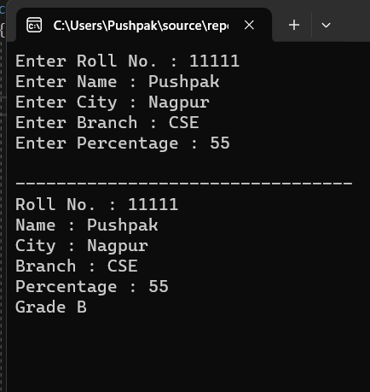

Assignment 6:

using System;

using System.Collections.Generic;

using System.Linq;

using System.Text;

using System.Threading.Tasks;

using System.Collections;

namespace Day_11_Assignment

{

class Program

{

static void Main(string[] args)

{

Console.Write("Enter number of elements : ");

int n = int.Parse(Console.ReadLine());

ArrayList arr = new ArrayList(n);

Console.WriteLine("Enter " + n + " elements : ");

for(int i = 0; i < n; i++)

{

arr.Add(Console.ReadLine());

}

Console.WriteLine("Enter the choice \n1.Count\n2.Sort\n3.Display\n4.Remove(using digit)\n5.Remove(using index)");

int ch = int.Parse(Console.ReadLine());

switch(ch)

{

case 1 :

Console.WriteLine("Count : "+arr.Count);

break;

case 2 :

Console.WriteLine("Sorted Array ; ");

arr.Sort();

foreach(var i in arr)

{

Console.Write(i + "\t");

}

break;

case 3 :

Console.WriteLine("Display Array : ");

foreach(var i in arr)

{

Console.Write(i + "\t");

}

break;

case 4 :

Console.WriteLine("Remove value by digit : ");

Console.Write("Enter the digit : ");

int temp = int.Parse(Console.ReadLine());

arr.Remove(temp);

foreach(var i in arr)

{

Console.Write(i + "\t");

}

break;

case 5:

Console.WriteLine("Remove value by digit : ");

Console.Write("Enter the digit : ");

int temp1 = int.Parse(Console.ReadLine());

arr.RemoveAt(temp1);

foreach (var i in arr)

{

Console.Write(i + "\t");

}

break;

default:

Console.WriteLine("Invalid Input");

break;

}

Console.ReadKey();

}

}

}