Assignment 1:

using System;

using System.Collections.Generic;

using System.Linq;

using System.Text;

using System.Threading.Tasks;

namespace Assignment_day_13

{

class Simple_array

{

public void display(params int[] value)

{

Console.WriteLine("Given Array : ");

foreach (int i in value)

{

Console.Write(i+"\t");

}

}

}

internal class Program

{

static void Main(string[] args)

{

Console.Write("Enter number of elements : ");

int n = int.Parse(Console.ReadLine());

int[] arr = new int[n];

Console.Write("Enter "+n+" elements : ");

for(int i =0; i < arr.Length; i++)

{

arr[i] = int.Parse(Console.ReadLine());

}

Simple_array s1 = new Simple_array();

s1.display(arr);

Console.ReadKey();

}

}

}

Output:

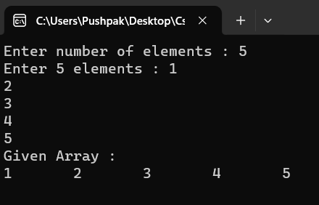

Assignment 2:

using System;

using System.Collections.Generic;

using System.Linq;

using System.Text;

using System.Threading.Tasks;

namespace Assignment_day_13

{

interface Student

{

void input(int s_roll, string s_name, string s_city, int s_age, int s_per);

}

interface result

{

void display();

}

class info : Student, result

{

int g_roll, g_age, g_per;

string g_name, g_city;

public void input(int s_roll, string s_name, string s_city, int s_age, int s_per)

{

g_roll = s_roll;

g_name = s_name;

g_city = s_city;

g_age = s_age;

g_per = s_per;

}

public void display()

{

Console.WriteLine(

"\nRoll No. : "+g_roll+

"\nName : "+g_name+

"\nCity : "+g_city+

"\nAge : "+g_age+

"\nPercent : "+g_per

);

if( g_per > 60)

{

Console.WriteLine("Grade A");

}

else if( g_per > 50 && g_per < 60)

{

Console.WriteLine("Grade B");

}

else if(g_per > 40 && g_per < 50)

{

Console.WriteLine("Grade C");

}

else

{

Console.WriteLine("Fail");

}

}

}

internal class Program

{

static void Main(string[] args)

{

Console.Write("Enter Roll No. : ");

int roll = int.Parse(Console.ReadLine());

Console.Write("Enter Name : ");

string name = Console.ReadLine();

Console.Write("Enter City : ");

string city = Console.ReadLine();

Console.Write("Enter Age : ");

int age = int.Parse(Console.ReadLine());

Console.Write("Enter Percent : ");

int per = int.Parse(Console.ReadLine());

info s1 = new info();

s1.input(roll, name, city, age, per);

s1.display();

Console.ReadKey();

}

}

}

Output:

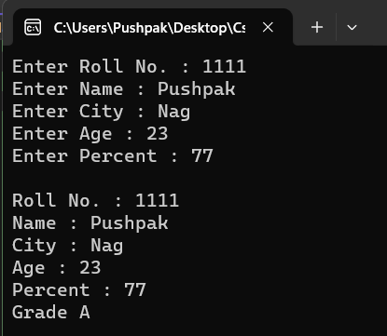

Assignment 3:

using System;

using System.Collections.Generic;

using System.Linq;

using System.Text;

using System.Threading.Tasks;

namespace Assignment_day_13

{

class Program

{

static void Main(string[] args)

{

Console.Write("Enter String : ");

string str = Console.ReadLine();

Console.Write("1.Count\n2.To Upper\n3.To Lower\n4.Concat\n5.Print char using Index" +

"\n6.Print index using char\nEnter Your Choice : ");

int ch = int.Parse(Console.ReadLine());

switch(ch)

{

case 1:

Console.WriteLine("\nLength of string : "+str.Length);

break;

case 2:

Console.WriteLine("\nIn Upper Case : "+str.ToUpper());

break;

case 3:

Console.WriteLine("\nIn Lower Case : " + str.ToLower());

break;

case 4:

Console.Write("\nEnter String to concat : ");

string str2 = Console.ReadLine();

Console.WriteLine("\nConcat two String :"+String.Concat(str+" "+str2));

break;

case 5:

Console.Write("\nEnter index number : ");

int n = int.Parse(Console.ReadLine());

Console.WriteLine("\nChar at index " + n + " : " + str[n]);

break;

case 6:

Console.Write("\nEnter char : ");

string chr = Console.ReadLine();

Console.WriteLine("\n"+ch + " is present at " + str.IndexOf(chr));

break;

}

Console.ReadKey();

}

}

}

Output:

