Assignment 1 –

File Name – default.aspx

<%@ Page Language="C#" AutoEventWireup="true" CodeBehind="default.aspx.cs" Inherits="Assignment_1._default" %>

<!DOCTYPE html>

<html xmlns="http://www.w3.org/1999/xhtml">

<head runat="server">

<title></title>

</head>

<body>

<form id="form1" runat="server">

<div>

<h1>Assigment 1</h1>

</div>

<p>

Enter Username :

<asp:TextBox ID="username" runat="server"></asp:TextBox>

</p>

<p>

Enter Date :

<asp:TextBox ID="date" runat="server"></asp:TextBox>

</p>

<p>

<asp:Button ID="submit" runat="server" OnClick="Button1_Click" Text="Submit" />

</p>

<p>

<asp:Label ID="output1" runat="server" Text="Label"></asp:Label>

</p>

<a href="contact.aspx">Click Here</a>

</form>

</body>

</html>

File Name – default.aspx.cs

using System;

using System.Collections.Generic;

using System.Linq;

using System.Web;

using System.Web.UI;

using System.Web.UI.WebControls;

namespace Assignment_1

{

public partial class _default : System.Web.UI.Page

{

protected void Page_Load(object sender, EventArgs e)

{

}

protected void Button1_Click(object sender, EventArgs e)

{

if(username.Text == "" || date.Text == "")

{

Response.Write("Enter All Fields");

}

else

{

string name = username.Text;

string c_date = date.Text;

if (c_date == DateTime.Now.ToString("dd/MMM/yyyy"))

{

output1.Text = "Valid User";

}

else

{

output1.Text = "Invalid User";

}

}

}

}

}

File Name – Contact.aspx

<%@ Page Language="C#" AutoEventWireup="true" CodeBehind="contact.aspx.cs" Inherits="Assignment_1.contact" %>

<!DOCTYPE html>

<html xmlns="http://www.w3.org/1999/xhtml">

<head runat="server">

<title></title>

</head>

<body>

<form id="form1" runat="server">

<div>

<h1>Contact Us Page</h1>

<asp:Label ID="v_iv" runat="server" Text="Label"></asp:Label>

</div>

</form>

</body>

</html>

File Name – contact.aspx.cs

using System;

using System.Collections.Generic;

using System.Linq;

using System.Web;

using System.Web.UI;

using System.Web.UI.WebControls;

namespace Assignment_1

{

public partial class contact : System.Web.UI.Page

{

protected void Page_Load(object sender, EventArgs e)

{

v_iv.Text = "Valid User";

Response.Write("<script>alert('valid User and redirect to the Contact us page')</script>");

}

}

}

Output-

Screen 1

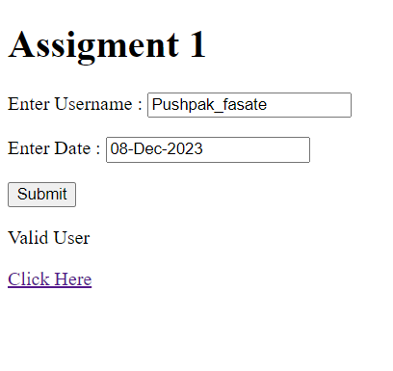

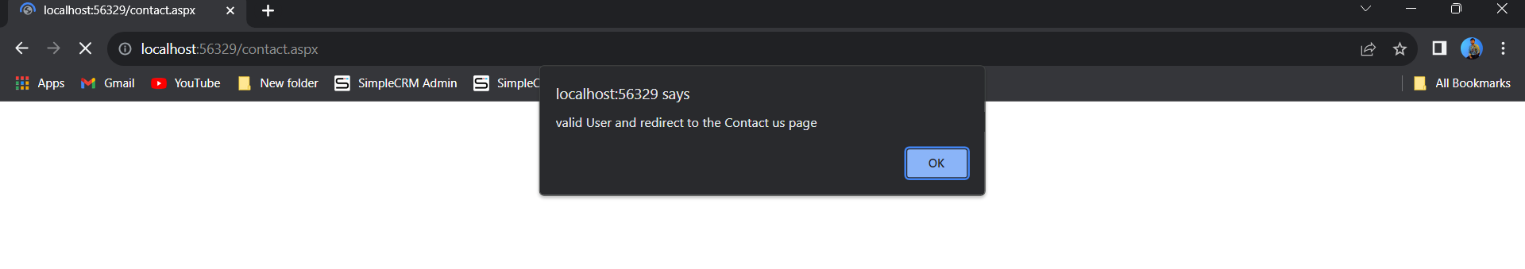

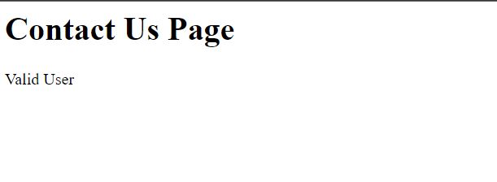

Assignment 2 –

File Name – default.aspx

<%@ Page Language="C#" AutoEventWireup="true" CodeBehind="default.aspx.cs" Inherits="m_view._default" %>

<!DOCTYPE html>

<html xmlns="http://www.w3.org/1999/xhtml">

<head runat="server">

<title></title>

</head>

<body>

<form id="form1" runat="server">

<div>

<h1>Assignment 1</h1>

<h3>Start Registration Form</h3>

<p>

<asp:Button ID="Button1" runat="server" Text="Start Form" OnClick="Button1_Click" />

</p>

</div>

</form>

</body>

</html>

File Name – default.aspx.cs

using System;

using System.Collections.Generic;

using System.Linq;

using System.Web;

using System.Web.UI;

using System.Web.UI.WebControls;

namespace m_view

{

public partial class _default : System.Web.UI.Page

{

protected void Page_Load(object sender, EventArgs e)

{

}

protected void Button1_Click(object sender, EventArgs e)

{

Response.Redirect("registration.aspx");

}

}

}

File Name – registration.aspx

<%@ Page Language="C#" AutoEventWireup="true" CodeBehind="registration.aspx.cs" Inherits="m_view.registration" %>

<!DOCTYPE html>

<html xmlns="http://www.w3.org/1999/xhtml">

<head runat="server">

<title></title>

</head>

<body>

<form id="form1" runat="server">

<div>

<h1>Registration Form</h1>

</div>

<asp:MultiView ID="MultiView1" runat="server" ActiveViewIndex="0">

<asp:View ID="View1" runat="server">

<center>Student Details</center>

<br /><br />

Name :

<asp:TextBox ID="textname" runat="server"></asp:TextBox>

<br /><br/>

City :

<asp:TextBox ID="textcity" runat="server"></asp:TextBox>

<br /><br/>

College :

<asp:TextBox ID="textcollege" runat="server"></asp:TextBox>

<br /><br/>

Email :

<asp:TextBox ID="textemail" runat="server"></asp:TextBox>

<br /><br/>

Mobile :

<asp:TextBox ID="textmobile" runat="server"></asp:TextBox>

<br /><br />

<asp:Button ID="Button1" runat="server" OnClick="Button1_Click1" Text="Next" /><br />

</asp:View>

<asp:View ID="View2" runat="server">

<center>Qualification Details</center>

Name :

<asp:Label ID="label_name" runat="server" Text="Label"></asp:Label>

<br /><br />

College Name :

<asp:Label ID="label_college" runat="server" Text="Label"></asp:Label>

<br /><br />

Branch :

<asp:TextBox ID="textbranch" runat="server"></asp:TextBox>

<br /><br />

Semester :

<asp:TextBox ID="textsem" runat="server"></asp:TextBox>

<br /><br />

Subject :

<asp:TextBox ID="textsub" runat="server"></asp:TextBox>

<br /><br />

<asp:Button ID="Button2" runat="server" Text="Next" OnClick="Button2_Click" />

</asp:View>

<asp:View ID="View3" runat="server">

<center>Mark Allotment</center>

Student Name :

<asp:Label ID="label_name_3" runat="server" Text="Label"></asp:Label>

<br /><br />

College Name :

<asp:Label ID="label_college_name_3" runat="server" Text="Label"></asp:Label>

<br /><br />

Branch Name :

<asp:Label ID="label_branch_3" runat="server" Text="Label"></asp:Label>

<br /><br />

Mark 1:

<asp:TextBox ID="mark1" runat="server"></asp:TextBox><br /><br />

Mark 2:

<asp:TextBox ID="mark2" runat="server"></asp:TextBox><br /><br />

Mark 3:

<asp:TextBox ID="mark3" runat="server"></asp:TextBox><br /><br />

Mark 4:

<asp:TextBox ID="mark4" runat="server"></asp:TextBox><br /><br />

Mark 5:

<asp:TextBox ID="mark5" runat="server"></asp:TextBox>

<br />

<br />

<asp:Button ID="Button3" runat="server" Text="Next" OnClick="Button3_Click" />

<br /><br />

</asp:View>

<asp:View ID="View4" runat="server">

<center>Mark Report</center>

Student Name :

<asp:Label ID="label4_name" runat="server" Text="Label"></asp:Label>

<br />

<br />

Email :<asp:Label ID="label4_email" runat="server" Text="Label"></asp:Label>

<br />

<br />

Mobile :<asp:Label ID="label4_mobile" runat="server" Text="Label"></asp:Label>

<br />

<br />

Branch :<asp:Label ID="label4_branch" runat="server" Text="Label"></asp:Label>

<br />

<br />

Subject :<asp:Label ID="label4_subject" runat="server" Text="Label"></asp:Label>

<br />

<br />

Total :<asp:Label ID="label4_total" runat="server" Text="Label"></asp:Label>

<br />

<br />

Grade :<asp:Label ID="label4_grade" runat="server" Text="Label"></asp:Label>

<br />

<br />

<asp:Button ID="Button4" runat="server" OnClick="Button4_Click" Text="Finish" />

</asp:View>

<asp:View ID="View5" runat="server">

Dear Student,

<asp:Label ID="label5_name" runat="server" Text="Label"></asp:Label>

<br />

<br />

City :<asp:Label ID="label5_city" runat="server" Text="Label"></asp:Label>

<br />

College :<asp:Label ID="label5_college" runat="server" Text="Label"></asp:Label>

<br />

Email :<asp:Label ID="label5_email" runat="server" Text="Label"></asp:Label>

<br />

Mobile :<asp:Label ID="label5_mobile" runat="server" Text="Label"></asp:Label>

<br />

Branch :<asp:Label ID="label5_branch" runat="server" Text="Label"></asp:Label>

<br />

Semester :<asp:Label ID="label5_sem" runat="server" Text="Label"></asp:Label>

<br />

Subject :<asp:Label ID="label5_sub" runat="server" Text="Label"></asp:Label>

<br />

Mark1 :<asp:Label ID="label5_m1" runat="server" Text="Label"></asp:Label>

<br />

Mark 2 :<asp:Label ID="label5_m2" runat="server" Text="Label"></asp:Label>

<br />

Mark 3 :<asp:Label ID="label5_m3" runat="server" Text="Label"></asp:Label>

<br />

Mark 4 :<asp:Label ID="label5_m4" runat="server" Text="Label"></asp:Label>

<br />

Mark 5 :<asp:Label ID="label5_m5" runat="server" Text="Label"></asp:Label>

<br />

Total :

<asp:Label ID="label5_total" runat="server" Text="Label"></asp:Label>

<br />

Grade :

<asp:Label ID="label5_grade" runat="server" Text="Label"></asp:Label>

<br />

<br />

Thank You To Register.

</asp:View>

</asp:MultiView>

</form>

</body>

</html>

File Name – registration.aspx.cs

using System;

using System.Collections.Generic;

using System.Linq;

using System.Web;

using System.Web.UI;

using System.Web.UI.WebControls;

namespace m_view

{

public partial class registration : System.Web.UI.Page

{

protected void Page_Load(object sender, EventArgs e)

{

}

protected void Button1_Click1(object sender, EventArgs e)

{

MultiView1.ActiveViewIndex = 1;

string name, city, college, email, mobile;

if (textname.Text == "" || textcity.Text == "" || textcollege.Text == "" || textemail.Text == "" || textmobile.Text == "")

{

Response.Write("Require all fields");

}

else

{

name = textname.Text;

city = textcity.Text;

college = textcollege.Text;

email = textemail.Text;

mobile = textmobile.Text;

label_name.Text = name;

label_college.Text = college;

label_name_3.Text = name;

label_college_name_3.Text = college;

label4_name.Text = name;

label4_email.Text = email;

label4_mobile.Text = mobile;

label5_name.Text = name;

label5_city.Text = city;

label5_college.Text = college;

label5_email.Text = email;

label5_mobile.Text = mobile;

}

}

protected void TextBox1_TextChanged(object sender, EventArgs e)

{

}

protected void Button2_Click(object sender, EventArgs e)

{

MultiView1.ActiveViewIndex = 2;

string branch, sem, sub;

if(textbranch.Text == "" || textsem.Text == "" || textsub.Text == "")

{

Response.Write("All Field are Require");

}

else

{

branch = textbranch.Text;

sem = textsem.Text;

sub = textsub.Text;

label_branch_3.Text = branch;

label4_branch.Text = branch;

label4_subject.Text = sub;

label5_branch.Text = branch;

label5_sem.Text = sem;

label5_sub.Text = sub;

}

}

protected void Button3_Click(object sender, EventArgs e)

{

MultiView1.ActiveViewIndex = 3;

if(mark1.Text == "" || mark2.Text == "" || mark3.Text == "" || mark4.Text == "" || mark5.Text == "")

{

Response.Write("All Marks Are Require");

}

else

{

int m1 = int.Parse(mark1.Text);

int m2 = int.Parse(mark2.Text);

int m3 = int.Parse(mark3.Text);

int m4 = int.Parse(mark4.Text);

int m5 = int.Parse(mark5.Text);

int total = m1 + m2 + m3 + m4 + m5;

label4_total.Text = total.ToString();

label5_total.Text = total.ToString();

if (total >= 250)

{

label4_grade.Text = "Grade A";

label5_grade.Text = "Grade A";

}

else if(total >=150 && total <=250)

{

label4_grade.Text = "Grade B";

label5_grade.Text = "Grade B";

}

else if(total >=100 && total <=150)

{

label4_grade.Text = "Grade C";

label5_grade.Text = "Grade C";

}

else

{

label4_grade.Text = "Fail";

label5_grade.Text = "Fail";

}

label5_m1.Text = m1.ToString();

label5_m2.Text = m2.ToString();

label5_m3.Text = m3.ToString();

label5_m4.Text = m4.ToString();

label5_m5.Text = m5.ToString();

}

}

protected void Button4_Click(object sender, EventArgs e)

{

MultiView1.ActiveViewIndex = 4;

}

}

}

Output –

Screen 1

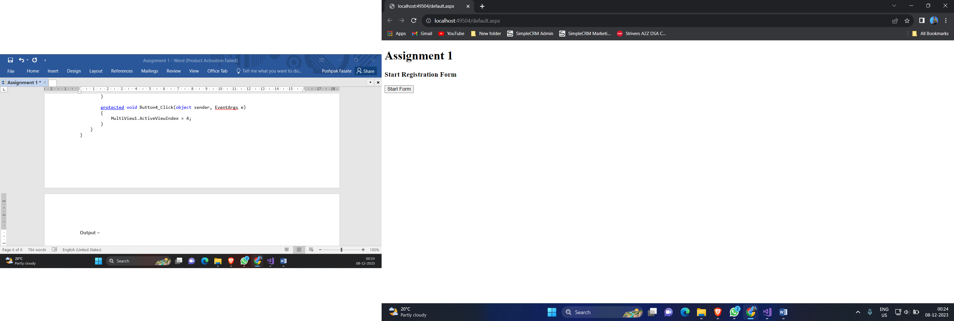

Screen 2

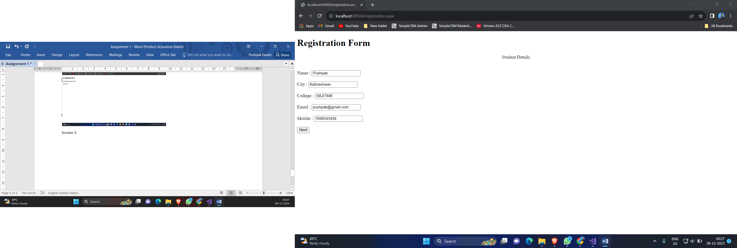

Screen 3

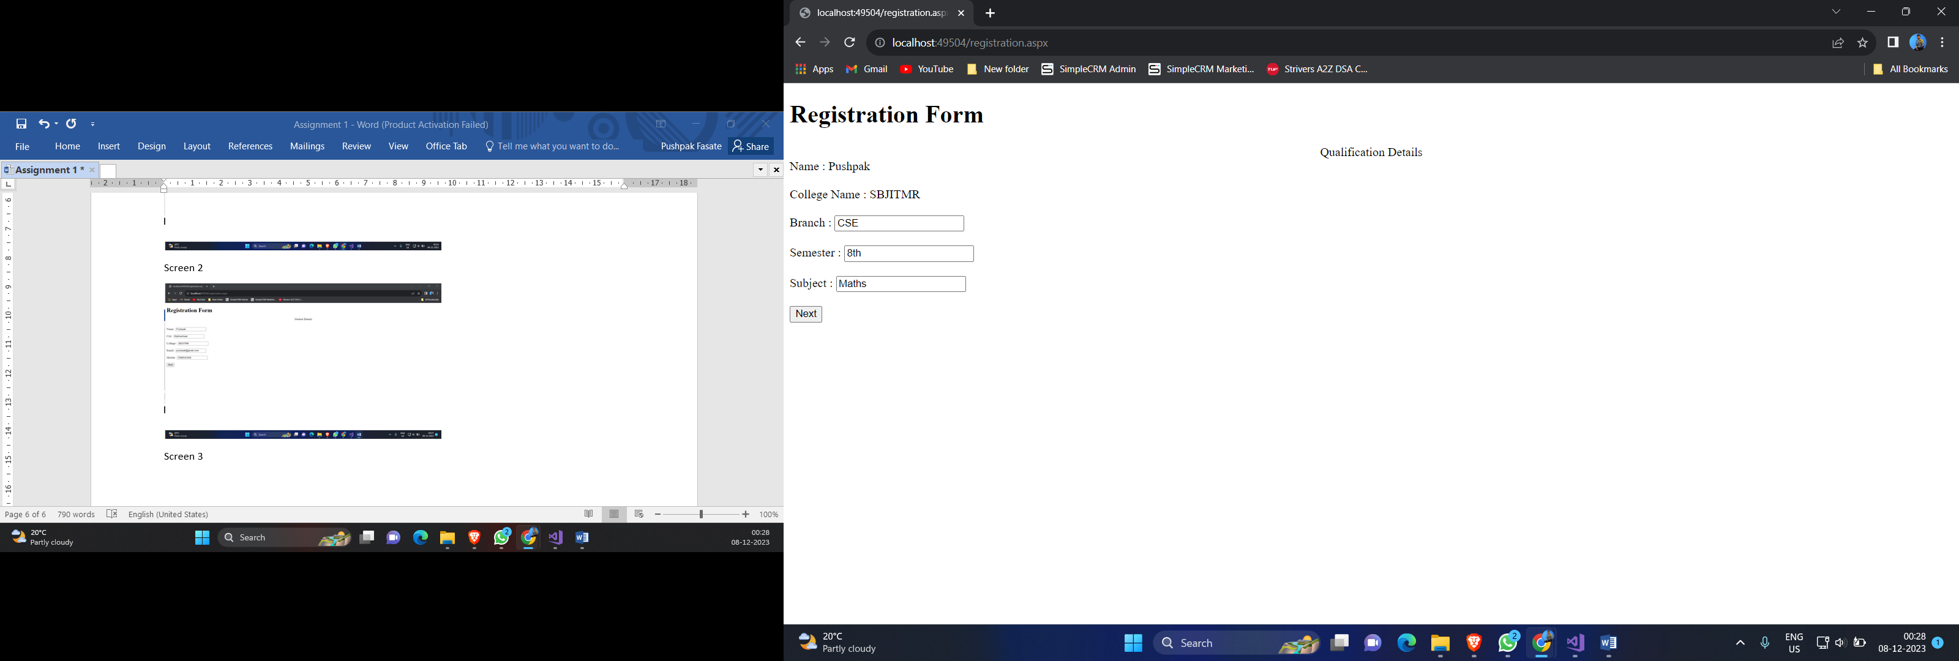

Screen 4

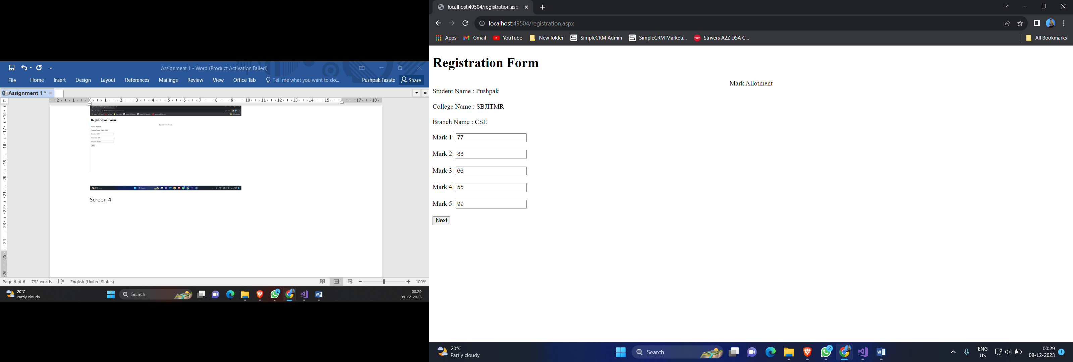

Screen 5

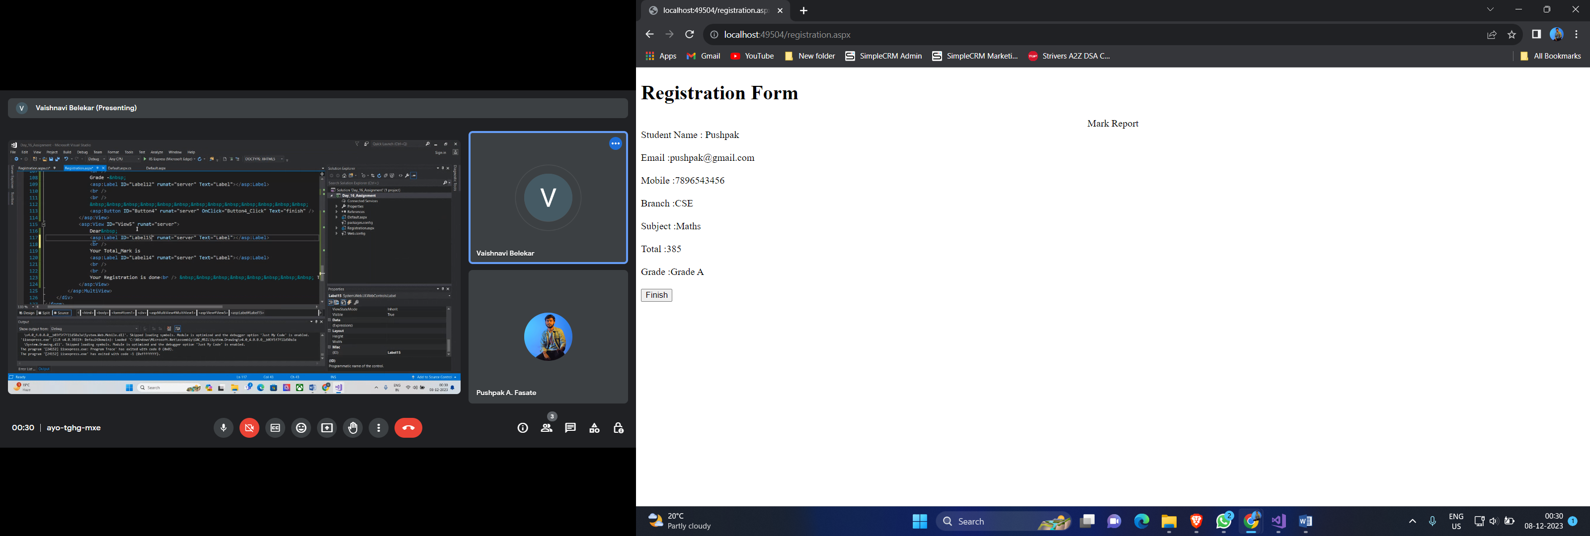

Screen 6

