Assignment 1:

File Name – Default.aspx

<%@ Page Language="C#" AutoEventWireup="true" CodeBehind="default.aspx.cs" Inherits="WebApplication1._default" %>

<!DOCTYPE html>

<html xmlns="http://www.w3.org/1999/xhtml">

<head runat="server">

<title></title>

</head>

<body>

<form id="form1" runat="server">

<div>

<h1>Implementing Query String.</h1>

</div>

<p>

Enter Name :

<asp:TextBox ID="t_name" runat="server"></asp:TextBox>

</p>

<p>

Enter Email :<asp:TextBox ID="t_email" runat="server"></asp:TextBox>

</p>

<p>

Enter City :

<asp:TextBox ID="t_city" runat="server"></asp:TextBox>

</p>

<asp:Button ID="Button1" runat="server" OnClick="Button1_Click" Text="Next" />

</form>

</body>

</html>

File Name – default.aspx.cs

using System;

using System.Collections.Generic;

using System.Linq;

using System.Web;

using System.Web.UI;

using System.Web.UI.WebControls;

namespace WebApplication1

{

public partial class _default : System.Web.UI.Page

{

protected void Page_Load(object sender, EventArgs e)

{

}

protected void Button1_Click(object sender, EventArgs e)

{

Response.Redirect("page2.aspx?name=" + t_name.Text + "&email=" +

t_email.Text + "&city=" + t_city.Text);

}

}

}

File Name – page2.aspx

<%@ Page Language="C#" AutoEventWireup="true" CodeBehind="page2.aspx.cs" Inherits="WebApplication1.page2" %>

<!DOCTYPE html>

<html xmlns="http://www.w3.org/1999/xhtml">

<head runat="server">

<title></title>

</head>

<body>

<form id="form1" runat="server">

<div>

<h1>Page 2:</h1>

</div>

<p>

Name :

<asp:Label ID="l_name" runat="server" Text="Label"></asp:Label>

</p>

<p>

Email :

<asp:Label ID="l_email" runat="server" Text="Label"></asp:Label>

</p>

<p>

City :

<asp:Label ID="l_city" runat="server" Text="Label"></asp:Label>

</p>

<p>

Branch :

<asp:TextBox ID="t_branch" runat="server"></asp:TextBox>

</p>

<p>

Subject : <asp:TextBox ID="t_sub" runat="server"></asp:TextBox>

</p>

<p>

<asp:Button ID="Button1" runat="server" Text="Next" OnClick="Button1_Click" />

</p>

</form>

</body>

</html>

File Name – page2.aspx.cs

using System;

using System.Collections.Generic;

using System.Linq;

using System.Web;

using System.Web.UI;

using System.Web.UI.WebControls;

namespace WebApplication1

{

public partial class page2 : System.Web.UI.Page

{

protected void Page_Load(object sender, EventArgs e)

{

l_name.Text = Request.QueryString["name"];

l_email.Text = Request.QueryString["email"];

l_city.Text = Request.QueryString["city"];

}

protected void Button1_Click(object sender, EventArgs e)

{

Response.Redirect("page3.aspx?branch=" + t_branch.Text +

"&sub=" + t_sub.Text +

"&name="+ Request.QueryString["name"] +

"&email=" + Request.QueryString["email"]+

"&city="+Request.QueryString["city"]

);

}

}

}

File Name – Page3.aspx

<%@ Page Language="C#" AutoEventWireup="true" CodeBehind="page3.aspx.cs" Inherits="WebApplication1.page3" %>

<!DOCTYPE html>

<html xmlns="http://www.w3.org/1999/xhtml">

<head runat="server">

<title></title>

</head>

<body>

<form id="form1" runat="server">

<div>

<h1>Page 3</h1>

</div>

<p>

Branch :

<asp:Label ID="l_branch" runat="server" Text="Label"></asp:Label>

</p>

<p>

Subject :

<asp:Label ID="l_sub" runat="server" Text="Label"></asp:Label>

</p>

<p>

College :

<asp:TextBox ID="t_col" runat="server"></asp:TextBox>

</p>

<p>

Principal :

<asp:TextBox ID="t_prin" runat="server"></asp:TextBox>

</p>

<asp:Button ID="Button1" runat="server" OnClick="Button1_Click" Text="Finish" />

</form>

</body>

</html>

File Name – page3.aspx.cs

using System;

using System.Collections.Generic;

using System.Linq;

using System.Web;

using System.Web.UI;

using System.Web.UI.WebControls;

namespace WebApplication1

{

public partial class page3 : System.Web.UI.Page

{

protected void Page_Load(object sender, EventArgs e)

{

l_branch.Text = Request.QueryString["branch"];

l_sub.Text = Request.QueryString["sub"];

}

protected void Button1_Click(object sender, EventArgs e)

{

Response.Redirect("finish.aspx?college="+t_col.Text+

"&prin="+t_prin.Text+

"&branch=" + Request.QueryString["branch"]+

"&sub=" + Request.QueryString["sub"]+

"&name="+ Request.QueryString["name"] +

"&email=" + Request.QueryString["email"]+

"&city="+Request.QueryString["city"]

);

}

}

}

File Name – final.aspx

<%@ Page Language="C#" AutoEventWireup="true" CodeBehind="finish.aspx.cs" Inherits="WebApplication1.finish" %>

<!DOCTYPE html>

<html xmlns="http://www.w3.org/1999/xhtml">

<head runat="server">

<title></title>

</head>

<body>

<form id="form1" runat="server">

<div>

<h1>Final Page</h1>

</div>

<p>

Name :

<asp:Label ID="l_name" runat="server" Text="Label"></asp:Label>

</p>

<p>

Email :

<asp:Label ID="l_email" runat="server" Text="Label"></asp:Label>

</p>

<p>

City :

<asp:Label ID="l_city" runat="server" Text="Label"></asp:Label>

</p>

<p>

Branch :

<asp:Label ID="l_branch" runat="server" Text="Label"></asp:Label>

</p>

<p>

Subject :

<asp:Label ID="l_sub" runat="server" Text="Label"></asp:Label>

</p>

<p>

College :

<asp:Label ID="l_col" runat="server" Text="Label"></asp:Label>

</p>

<p>

Principal :

<asp:Label ID="l_prin" runat="server" Text="Label"></asp:Label>

</p>

</form>

<p>

&nbsp;</p>

</body>

</html>

File Name – final.aspx.cs

using System;

using System.Collections.Generic;

using System.Linq;

using System.Web;

using System.Web.UI;

using System.Web.UI.WebControls;

namespace WebApplication1

{

public partial class finish : System.Web.UI.Page

{

protected void Page_Load(object sender, EventArgs e)

{

l_name.Text = Request.QueryString["name"];

l_email.Text = Request.QueryString["email"];

l_city.Text = Request.QueryString["city"];

l_branch.Text = Request.QueryString["branch"];

l_sub.Text = Request.QueryString["sub"];

l_col.Text = Request.QueryString["college"];

l_prin.Text = Request.QueryString["prin"];

}

}

}

Output –

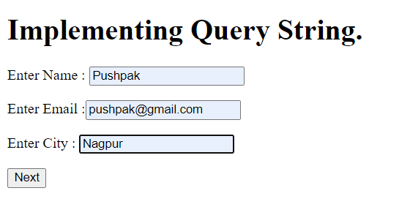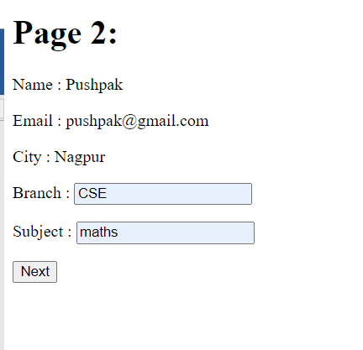

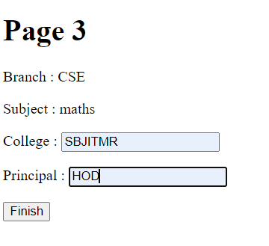

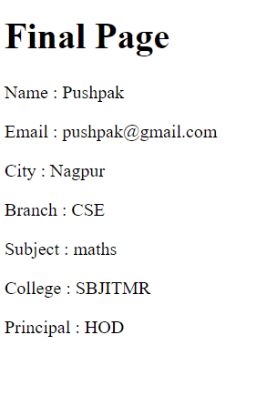

Assignment 2:

File Name – imagedata.aspx

<%@ Page Language="C#" AutoEventWireup="true" CodeBehind="imagedata.aspx.cs" Inherits="WebApplication2.imagedata" %>

<!DOCTYPE html>

<html xmlns="http://www.w3.org/1999/xhtml">

<head runat="server">

<title></title>

</head>

<body>

<form id="form1" runat="server">

<div>

<h1>Assignment 2

</h1>

<center>Upload Student Pic</center>

</div>

<asp:FileUpload ID="FileUpload1" runat="server" />

<br />

<br />

<asp:Button ID="Button1" runat="server" OnClick="Button1_Click" Text="Button" />

<br />

<br />

<asp:Label ID="Label2" runat="server" Text="Label"></asp:Label>

<br />

<br />

<asp:DropDownList ID="DropDownList1" runat="server" OnSelectedIndexChanged="DropDownList1_SelectedIndexChanged" AutoPostBack="True">

</asp:DropDownList>

<br />

<br />

<asp:Image ID="Image1" runat="server" Height="287px" Width="276px" />

<br />

</form>

</body>

</html>

File Name – imagedata.aspx.cs

using System;

using System.Collections.Generic;

using System.Linq;

using System.Web;

using System.Web.UI;

using System.Web.UI.WebControls;

namespace WebApplication2

{

public partial class imagedata : System.Web.UI.Page

{

protected void Page_Load(object sender, EventArgs e)

{

}

protected void Button1_Click(object sender, EventArgs e)

{

FileUpload1.SaveAs(Server.MapPath("~") + "//upload//" + FileUpload1.FileName);

DropDownList1.Items.Add(FileUpload1.FileName);

//Image1.ImageUrl = "~/upload/" + FileUpload1.FileName;

//Label2.Text = FileUpload1.FileName;

}

protected void DropDownList1_SelectedIndexChanged(object sender, EventArgs e)

{

Image1.ImageUrl = "~/upload/" + DropDownList1.SelectedValue;

}

}

}

Output –

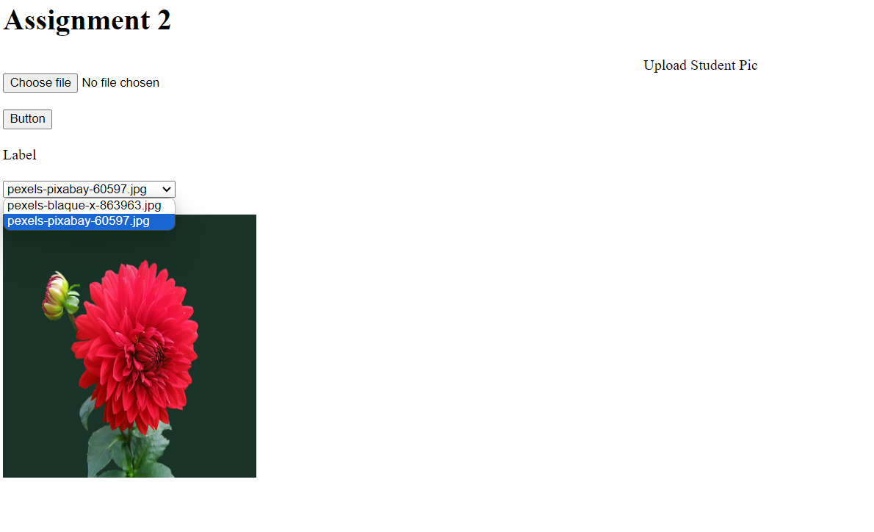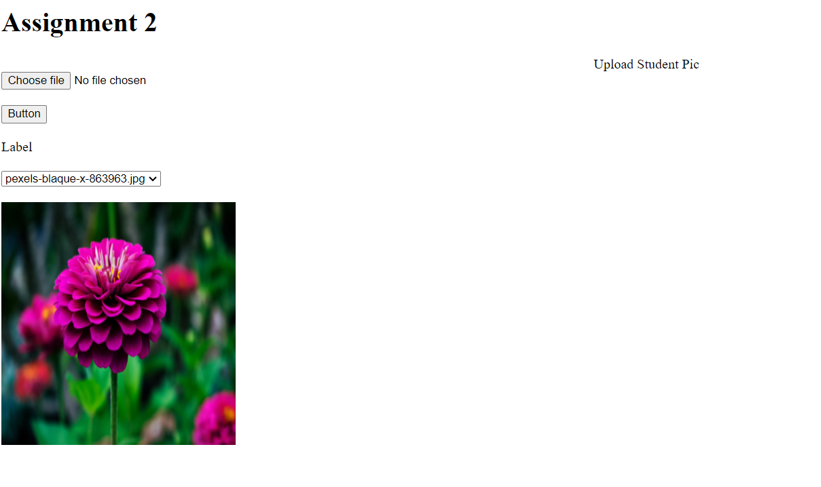

Assignment 3 –

File Name – Registration.aspx

<%@ Page Language="C#" AutoEventWireup="true" CodeBehind="registration.aspx.cs" Inherits="Assignment4.registration" %>

<!DOCTYPE html>

<html xmlns="http://www.w3.org/1999/xhtml">

<head runat="server">

<title></title>

</head>

<body>

<form id="form1" runat="server">

<div>

<center>Registration Form</center>

</div>

<p>

Name :

<asp:TextBox ID="name" runat="server"></asp:TextBox>

</p>

<p>

Email :

<asp:TextBox ID="email" runat="server"></asp:TextBox>

</p>

<p>

Mobile :

<asp:TextBox ID="mobile" runat="server"></asp:TextBox>

</p>

<p>

Password :

<asp:TextBox ID="password" runat="server"></asp:TextBox>

</p>

<p>

Date :

<asp:TextBox ID="date" runat="server"></asp:TextBox>

</p>

<p>

<asp:FileUpload ID="FileUpload1" runat="server" />

</p>

<p>

<asp:Button ID="Button1" runat="server" Text="Login" OnClick="Button1_Click" />

</p>

</form>

</body>

</html>

File Name – Registration.aspx.sc

using System;

using System.Collections.Generic;

using System.Linq;

using System.Web;

using System.Web.UI;

using System.Web.UI.WebControls;

namespace Assignment4

{

public partial class registration : System.Web.UI.Page

{

protected void Page_Load(object sender, EventArgs e)

{

date.Text = DateTime.Now.ToString("dd/MMM/yyyy");

}

protected void Button1_Click(object sender, EventArgs e)

{

if(name.Text == "" || email.Text == "" || mobile.Text == "" || password.Text == "")

{

Response.Write("All Field Are Require");

}

else

{

Session["name"] = name.Text;

Session["email"] = email.Text;

Session["mobile"] = mobile.Text;

Session["password"] = password.Text;

FileUpload1.SaveAs(Server.MapPath("~") + "//upload//" + FileUpload1.FileName);

Session["img"] = FileUpload1.FileName;

Response.Redirect("Login.aspx");

}

}

}

}

File Name – Login.aspx

<%@ Page Language="C#" AutoEventWireup="true" CodeBehind="Login.aspx.cs" Inherits="Assignment4.Login" %>

<!DOCTYPE html>

<html xmlns="http://www.w3.org/1999/xhtml">

<head runat="server">

<title></title>

</head>

<body>

<form id="form1" runat="server">

<div>

<center>Login Page</center>

</div>

<p>

Enter Email :<asp:TextBox ID="l_email" runat="server"></asp:TextBox>

</p>

<p>

Enter Password :

<asp:TextBox ID="l_password" runat="server"></asp:TextBox>

</p>

<asp:Button ID="Button1" runat="server" OnClick="Button1_Click" Text="Exam" />

</form>

</body>

</html>

File Name – Login.aspx.cs

using System;

using System.Collections.Generic;

using System.Linq;

using System.Web;

using System.Web.UI;

using System.Web.UI.WebControls;

namespace Assignment4

{

public partial class Login : System.Web.UI.Page

{

protected void Page_Load(object sender, EventArgs e)

{

}

protected void Button1_Click(object sender, EventArgs e)

{

if(l_email.Text == "" || l_password.Text == "")

{

Response.Write("Provide All Field");

}

else

{

if (l_email.Text == (string)Session["email"] && l_password.Text == (string)Session["password"])

{

Response.Redirect("exam.aspx");

}

else

{

Response.Write("Invalid User");

}

}

}

}

}

File Name – Exam.aspx

<%@ Page Language="C#" AutoEventWireup="true" CodeBehind="exam.aspx.cs" Inherits="Assignment4.exam" %>

<!DOCTYPE html>

<html xmlns="http://www.w3.org/1999/xhtml">

<head runat="server">

<title></title>

</head>

<body>

<form id="form1" runat="server">

<div>

<center>Education Details</center>

</div>

<p>

Name :

<asp:Label ID="l_name1" runat="server" Text="Label"></asp:Label>

</p>

<p>

Email :

<asp:Label ID="l_email1" runat="server" Text="Label"></asp:Label>

</p>

<p>

Mobile : <asp:Label ID="l_mobile1" runat="server" Text="Label"></asp:Label>

</p>

<p>

Select Branch :

<asp:DropDownList ID="DropDownList1" runat="server" AutoPostBack="True">

<asp:ListItem>Select</asp:ListItem>

<asp:ListItem>CSE</asp:ListItem>

<asp:ListItem>IT</asp:ListItem>

<asp:ListItem>ETC</asp:ListItem>

<asp:ListItem>ETRX</asp:ListItem>

</asp:DropDownList>

</p>

<p>

Select Semister :

<asp:DropDownList ID="DropDownList2" runat="server" AutoPostBack="True">

<asp:ListItem>Select</asp:ListItem>

<asp:ListItem>1</asp:ListItem>

<asp:ListItem>2</asp:ListItem>

<asp:ListItem>3</asp:ListItem>

<asp:ListItem>4</asp:ListItem>

<asp:ListItem>5</asp:ListItem>

<asp:ListItem>6</asp:ListItem>

<asp:ListItem>7</asp:ListItem>

<asp:ListItem>8</asp:ListItem>

</asp:DropDownList>

</p>

<p>

Select Shift :

<asp:DropDownList ID="DropDownList3" runat="server" AutoPostBack="True">

<asp:ListItem>Select</asp:ListItem>

<asp:ListItem>Morning Shift</asp:ListItem>

<asp:ListItem>Evening Shift</asp:ListItem>

</asp:DropDownList>

</p>

<p>

<asp:Button ID="Button1" runat="server" Text="Button" OnClick="Button1_Click" />

</p>

</form>

</body>

</html>

File Name Exam.aspx.cs

using System;

using System.Collections.Generic;

using System.Linq;

using System.Web;

using System.Web.UI;

using System.Web.UI.WebControls;

namespace Assignment4

{

public partial class exam : System.Web.UI.Page

{

protected void Page_Load(object sender, EventArgs e)

{

l_name1.Text = (string)Session["name"];

l_email1.Text = (string)Session["email"];

l_mobile1.Text = (string)Session["mobile"];

}

protected void Button1_Click(object sender, EventArgs e)

{

Session["branch"] = DropDownList1.SelectedValue;

Session["sem"] = DropDownList2.SelectedValue;

Session["shift"] = DropDownList3.SelectedValue;

//Session["name"] = name.Text;

Response.Redirect("Generateexam.aspx");

}

}

}

File Name Genrateexam.aspx

<%@ Page Language="C#" AutoEventWireup="true" CodeBehind="Generateexam.aspx.cs" Inherits="Assignment4.Generateexam" %>

<!DOCTYPE html>

<html xmlns="http://www.w3.org/1999/xhtml">

<head runat="server">

<title></title>

</head>

<body>

<form id="form1" runat="server">

<div>

Name :

<asp:Label ID="Label1" runat="server" Text="Label"></asp:Label>

<br />

Email :

<asp:Label ID="Label2" runat="server" Text="Label"></asp:Label>

<br />

Branch :

<asp:Label ID="Label3" runat="server" Text="Label"></asp:Label>

<br />

Semester :

<asp:Label ID="Label4" runat="server" Text="Label"></asp:Label>

<br />

<br />

Question 1 : What is the implicit return typr of Constructor?<br />

<asp:RadioButtonList ID="RadioButtonList1" runat="server">

<asp:ListItem>No return type</asp:ListItem>

<asp:ListItem>A class object in which it is define</asp:ListItem>

<asp:ListItem>void</asp:ListItem>

<asp:ListItem>None</asp:ListItem>

</asp:RadioButtonList>

</div>

<p>

Question 2 : Which is the object created with new keyword?</p>

<p>

<asp:RadioButtonList ID="RadioButtonList2" runat="server">

<asp:ListItem>At run time</asp:ListItem>

<asp:ListItem>At compile time</asp:ListItem>

<asp:ListItem>Depends on the code</asp:ListItem>

<asp:ListItem>None</asp:ListItem>

</asp:RadioButtonList>

</p>

<p>

Question 3 : Identify the incorrect constructor type.</p>

<asp:RadioButtonList ID="RadioButtonList3" runat="server">

<asp:ListItem>Friend Constructor</asp:ListItem>

<asp:ListItem>Default Constructor</asp:ListItem>

<asp:ListItem>Parameterized Constructor</asp:ListItem>

<asp:ListItem>Copy Constructor</asp:ListItem>

</asp:RadioButtonList>

<p>

Question 4 : Identify the scope resolution operator.</p>

<asp:RadioButtonList ID="RadioButtonList4" runat="server">

<asp:ListItem>:</asp:ListItem>

<asp:ListItem>::</asp:ListItem>

<asp:ListItem>?:</asp:ListItem>

<asp:ListItem>None</asp:ListItem>

</asp:RadioButtonList>

<p>

Question 5 : Choose the option below which is not a member of the class.</p>

<asp:RadioButtonList ID="RadioButtonList5" runat="server">

<asp:ListItem>Friend Function</asp:ListItem>

<asp:ListItem>Static Function</asp:ListItem>

<asp:ListItem>Virtual Function</asp:ListItem>

<asp:ListItem>Const Function</asp:ListItem>

</asp:RadioButtonList>

<p>

Question 6 : Total types of constructors in C++ are?</p>

<p>

<asp:RadioButtonList ID="RadioButtonList6" runat="server">

<asp:ListItem>1</asp:ListItem>

<asp:ListItem>2</asp:ListItem>

<asp:ListItem>3</asp:ListItem>

<asp:ListItem>4</asp:ListItem>

</asp:RadioButtonList>

</p>

<p>

Question 7 : Which of the following is not a type of inheritance?</p>

<p>

<asp:RadioButtonList ID="RadioButtonList7" runat="server">

<asp:ListItem>Multiple</asp:ListItem>

<asp:ListItem>Multilevel</asp:ListItem>

<asp:ListItem>Distributed</asp:ListItem>

<asp:ListItem>Hierarchical</asp:ListItem>

</asp:RadioButtonList>

</p>

<p>

Question 8 : What is an object in C++?</p>

<p>

<asp:RadioButtonList ID="RadioButtonList8" runat="server">

<asp:ListItem>It is a function of class</asp:ListItem>

<asp:ListItem>It is an instance of the class</asp:ListItem>

<asp:ListItem>it is a the data type of class</asp:ListItem>

<asp:ListItem>it is part of the syntax of class</asp:ListItem>

</asp:RadioButtonList>

</p>

<p>

Question 9 : Identify the operators which cannot be overloaded.</p>

<asp:RadioButtonList ID="RadioButtonList9" runat="server">

<asp:ListItem>?:</asp:ListItem>

<asp:ListItem>.(dot operator)</asp:ListItem>

<asp:ListItem>&gt;&gt;</asp:ListItem>

<asp:ListItem>Both A and B</asp:ListItem>

</asp:RadioButtonList>

<p>

Question 10 : By default, fields in a structure of a C program is?</p>

<asp:RadioButtonList ID="RadioButtonList10" runat="server">

<asp:ListItem>Public</asp:ListItem>

<asp:ListItem>Private</asp:ListItem>

<asp:ListItem>Protected</asp:ListItem>

<asp:ListItem>None</asp:ListItem>

</asp:RadioButtonList>

<br />

<br />

<asp:Button ID="Button1" runat="server" OnClick="Button1_Click" Text="Button" />

</form>

</body>

</html>

File Name – genrateexam.aspx.cs

using System;

using System.Collections.Generic;

using System.Linq;

using System.Web;

using System.Web.UI;

using System.Web.UI.WebControls;

namespace Assignment4

{

public partial class Generateexam : System.Web.UI.Page

{

protected void Page_Load(object sender, EventArgs e)

{

Label1.Text = (string)Session["name"];

Label2.Text = (string)Session["email"];

Label3.Text = (string)Session["branch"];

Label4.Text = (string)Session["sem"];

}

protected void Button1_Click(object sender, EventArgs e)

{

//Session["branch"] = DropDownList1.SelectedValue;

int sum = 0 ;

if(RadioButtonList1.SelectedIndex == 1)

{

sum++;

}

if(RadioButtonList2.SelectedIndex == 0)

{

sum++;

}

if(RadioButtonList3.SelectedIndex == 0)

{

sum++;

}

if(RadioButtonList4.SelectedIndex == 1)

{

sum++;

}

if(RadioButtonList5.SelectedIndex == 0)

{

sum++;

}

if(RadioButtonList6.SelectedIndex == 2)

{

sum++;

}

if(RadioButtonList7.SelectedIndex == 2)

{

sum++;

}

if(RadioButtonList8.SelectedIndex == 1)

{

sum++;

}

if(RadioButtonList9.SelectedIndex == 3)

{

sum++;

}

if(RadioButtonList10.SelectedIndex == 0)

{

sum++;

}

Session["totalmark"] = sum;

Response.Redirect("Score.aspx");

}

}

}

File Name – score.aspx

<%@ Page Language="C#" AutoEventWireup="true" CodeBehind="Score.aspx.cs" Inherits="Assignment4.Score" %>

<!DOCTYPE html>

<html xmlns="http://www.w3.org/1999/xhtml">

<head runat="server">

<title></title>

<style>

body {

background-color:lightpink

font-family: Arial, sans-serif;

display: flex;

justify-content: center;

align-items: center;

height: 100vh;

margin: 0;

background-color: #f4f4f4;

}

.container {

text-align: center;

background-color: #fff;

padding: 20px;

border-radius: 8px;

box-shadow: 0 0 10px rgba(0, 0, 0, 0.1);

width : 400px;

}

label {

display: block;

margin: 10px 0;

}

label {

padding: 8px;

margin: 5px 0;

width: 100%;

box-sizing: border-box;

}

button {

padding: 10px 20px;

background-color: #4caf50;

color: #fff;

border: none;

border-radius: 4px;

cursor: pointer;

margin-top: 10px;

}

.result {

margin-top: 20px;

border-top: 1px solid #ccc;

padding-top: 10px;

}

</style>

</head>

<body>

<form id="form1" runat="server">

<div>

</div>

<div class="container">

<asp:Image ID="Image1" runat="server" Height="130px" Width="104px" />

<br />

<asp:Label ID="Label13" runat="server" Text="Label"></asp:Label>

<br />

<asp:Label ID="Label14" runat="server" Text="Label"></asp:Label>

<h2>Marksheet </h2>

<form id="markForm">

<label for="name">

<br />

Name:</label><asp:Label ID="Label7" runat="server" Text="Label"></asp:Label>

<label for="email">Email:</label><asp:Label ID="Label8" runat="server" Text="Label"></asp:Label>

<label for="branch">Branch:</label><asp:Label ID="Label9" runat="server" Text="Label"></asp:Label>

<label for="sem">Semester:</label><asp:Label ID="Label10" runat="server" Text="Label"></asp:Label>

<label for="total">Total Marks:</label><asp:Label ID="Label11" runat="server" Text="Label"></asp:Label>

<label for="grade">Grade:</label><asp:Label ID="Label12" runat="server" Text="Label"></asp:Label>

</form>

<div class="result" id="resultSection"></div>

</div>

</form>

</body>

</html>

File Name – score.aspx.cs

using System;

using System.Collections.Generic;

using System.Linq;

using System.Web;

using System.Web.UI;

using System.Web.UI.WebControls;

namespace Assignment4

{

public partial class Score : System.Web.UI.Page

{

protected void Page_Load(object sender, EventArgs e)

{

Label7.Text = (string)Session["name"];

Label8.Text = (string)Session["email"];

Label9.Text = (string)Session["branch"];

Label10.Text = (string)Session["sem"];

Image1.ImageUrl = "~/upload/" + (string)Session["img"];

int value = (int)Session["totalmark"];

Label11.Text = value.ToString();

if ((int)Session["totalmark"] > 8)

{

Label12.Text = "Grade A";

}

else if((int)Session["totalmark"] > 6 && (int)Session["totalmark"] < 8)

{

Label12.Text = "Grade A";

}

else

{

Label12.Text = "Fail";

}

}

}

}

Output –

Screen 1 – 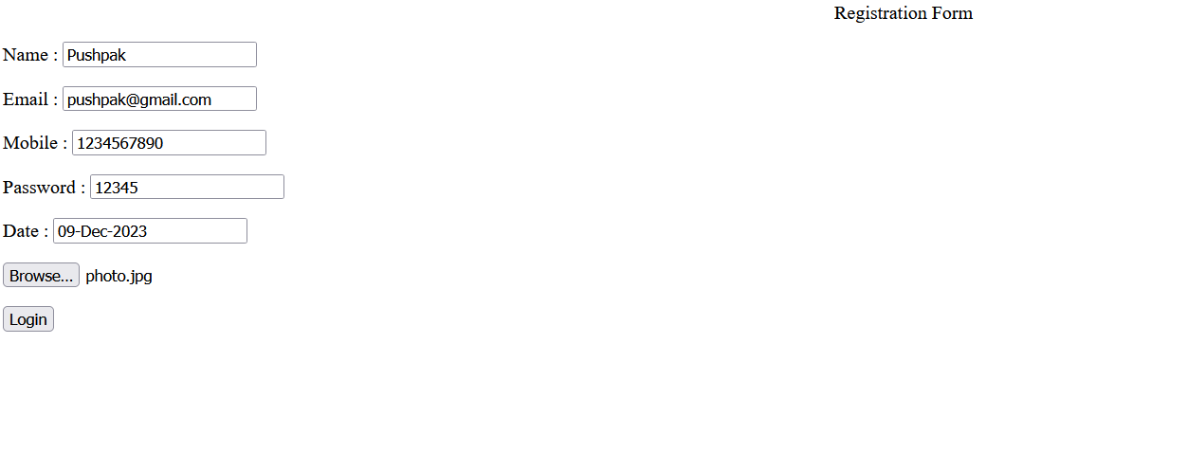

Screen 2 –

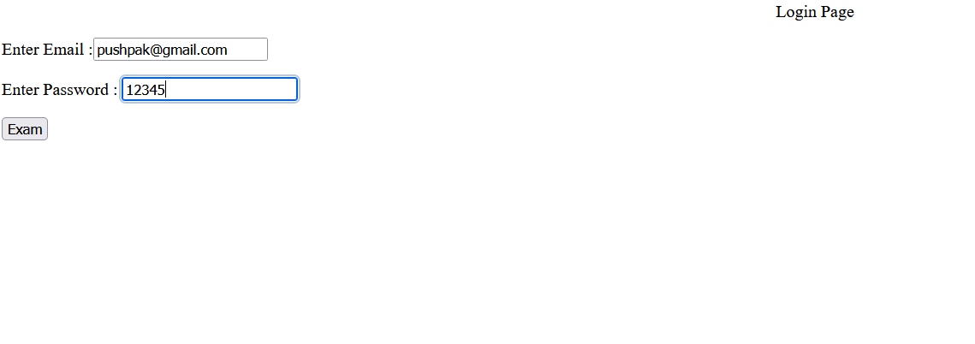

Screen 3 –

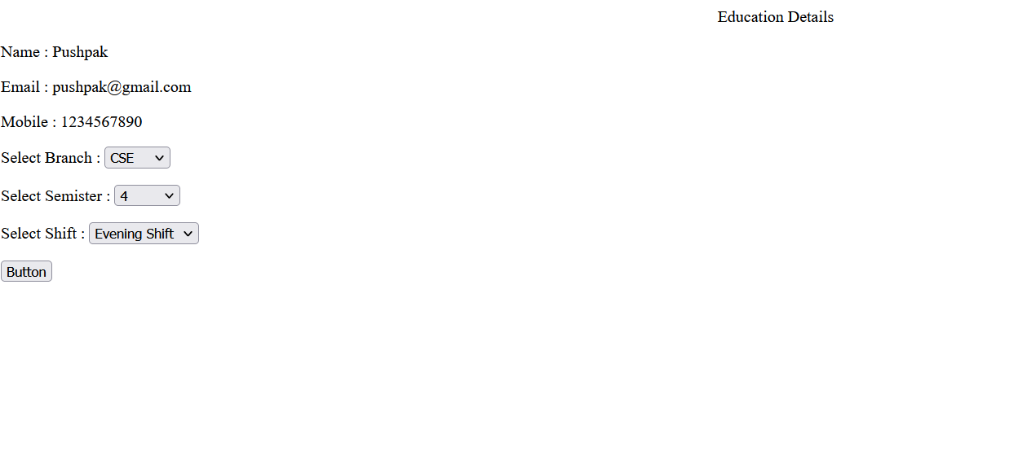

Screen 4 –

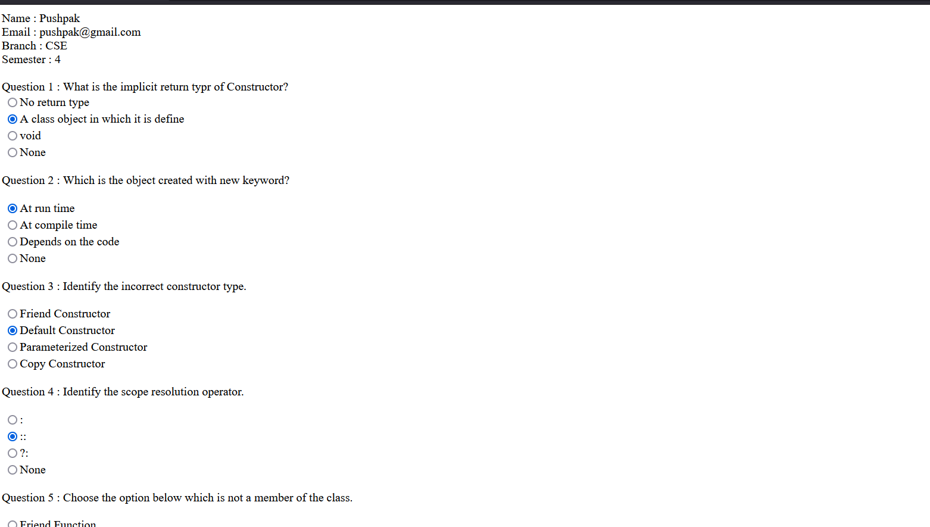

Screen 5 –

