File Name – Default.aspx

<%@ Page Language="C#" AutoEventWireup="true" CodeBehind="default.aspx.cs" Inherits="Assignment_1._default" %>

<!DOCTYPE html>

<html xmlns="http://www.w3.org/1999/xhtml">

<head runat="server">

<title></title>

</head>

<body>

<form id="form1" runat="server">

<div>

<h3>Registration Form</h3>

</div>

<label>Name : </label>

<asp:TextBox ID="txtname" runat="server"></asp:TextBox>

<br />

<br />

<label>Email : </label>

<asp:TextBox ID="txtemail" runat="server"></asp:TextBox>

<asp:RegularExpressionValidator ID="RegularExpressionValidator2" runat="server" ErrorMessage="Invalid Email" ControlToValidate="txtemail" ValidationExpression="^[a-zA-Z0-9+_.-]+@[a-zA-Z0-9.-]+$"></asp:RegularExpressionValidator>

<br />

<br />

<label>Pin Code : </label>

<asp:TextBox ID="txtpin" runat="server"></asp:TextBox>

&nbsp;<asp:RegularExpressionValidator ID="RegularExpressionValidator4" runat="server" ControlToValidate="txtpin" ErrorMessage="Invalid Pin Code " ValidationExpression="^[1-9]{1}[0-9]{5}"></asp:RegularExpressionValidator>

<br />

<br />

<label>Company Mail : </label>

<asp:TextBox ID="txtcemail" runat="server"></asp:TextBox>

<asp:RegularExpressionValidator ID="RegularExpressionValidator3" runat="server" ControlToValidate="txtcemail" ErrorMessage="Invalid Compnay Email" ValidationExpression="^[a-zA-Z0-9+_.-]+@[mastersoft.com]+$"></asp:RegularExpressionValidator>

<br />

<br />

<label>Mobile : </label>

<asp:TextBox ID="txtphone" runat="server"></asp:TextBox>

<asp:RegularExpressionValidator ID="RegularExpressionValidator1" runat="server" ControlToValidate="txtphone" ErrorMessage="Invalid Number " ValidationExpression="^\+91[0-9]{10}"></asp:RegularExpressionValidator>

<br />

<br />

Password :

<asp:TextBox ID="txtpassword" TextMode="Password" runat="server"></asp:TextBox>

<br />

<br />

<asp:Button ID="Button1" runat="server" OnClick="Button1_Click" Text="Submit" />

</form>

</body>

</html>

File Name – default.aspx.cs

using System;

using System.Collections.Generic;

using System.Linq;

using System.Web;

using System.Web.UI;

using System.Web.UI.WebControls;

namespace Assignment_1

{

public partial class _default : System.Web.UI.Page

{

protected void Page_Load(object sender, EventArgs e)

{

}

protected void Button1_Click(object sender, EventArgs e)

{

if (txtname.Text == "" || txtpassword.Text == "" || txtemail.Text == "" ||

txtpin.Text == "" || txtcemail.Text == "" || txtpassword.Text == "")

{

Response.Write("All Field are require");

}

else

{

Session["name"] = txtname.Text;

Session["email"] = txtemail.Text;

Session["pincode"] = txtpin.Text;

Session["c_email"] = txtcemail.Text;

Session["mobile"] = txtphone.Text;

Session["password"] = txtpassword.Text;

Response.Redirect("message.aspx");

}

}

}

}

File Name – message.aspx

<%@ Page Language="C#" AutoEventWireup="true" CodeBehind="message.aspx.cs" Inherits="Assignment_1.message" %>

<!DOCTYPE html>

<html xmlns="http://www.w3.org/1999/xhtml">

<head runat="server">

<title></title>

</head>

<body>

<form id="form1" runat="server">

<div>

Information -

<br />

<br />

Name :

<asp:Label ID="lblName" runat="server" Text="Label"></asp:Label>

<br />

<br />

Personal Email :

<asp:Label ID="lblEmail" runat="server" Text="Label"></asp:Label>

<br />

<br />

Pin Code :

<asp:Label ID="lblPin" runat="server" Text="Label"></asp:Label>

<br />

<br />

Company Email :

<asp:Label ID="lblCemail" runat="server" Text="Label"></asp:Label>

<br />

<br />

Mobile Number :

<asp:Label ID="lblMobile" runat="server" Text="Label"></asp:Label>

<br />

<br />

Password :

<asp:Label ID="lblPassword" runat="server" Text="Label"></asp:Label>

</div>

</form>

</body>

</html>

File Name – message.aspx.cs

using System;

using System.Collections.Generic;

using System.Linq;

using System.Web;

using System.Web.UI;

using System.Web.UI.WebControls;

namespace Assignment_1

{

public partial class message : System.Web.UI.Page

{

protected void Page_Load(object sender, EventArgs e)

{

lblName.Text = (string)Session["name"];

lblEmail.Text = (string)Session["email"];

lblPin.Text = (string)Session["pincode"];

lblCemail.Text = (string)Session["c_email"];

lblMobile.Text = (string)Session["mobile"];

lblPassword.Text = (string)Session["password"];

}

}

}

Output –

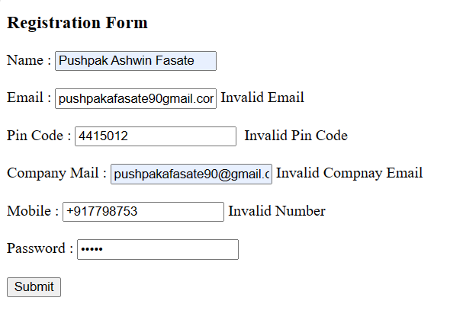

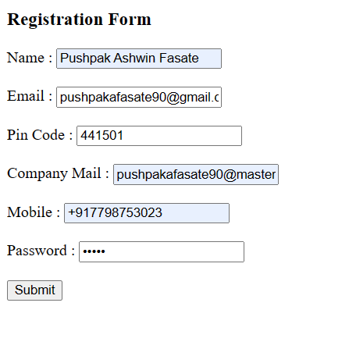

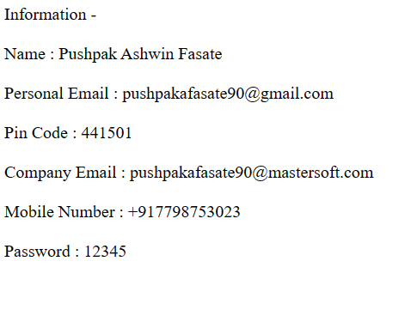

Assignment 2 –

File Name – default.aspx

<%@ Page Language="C#" AutoEventWireup="true" CodeBehind="default.aspx.cs" Inherits="Assignment_1._default" %>

<!DOCTYPE html>

<html xmlns="http://www.w3.org/1999/xhtml">

<head runat="server">

<title></title>

</head>

<body>

<form id="form1" runat="server">

<div>

<h3>Registration Form</h3>

</div>

<label>Name : </label>

<asp:TextBox ID="txtname" runat="server"></asp:TextBox>

<br />

<br />

<label>Email : </label>

<asp:TextBox ID="txtemail" runat="server"></asp:TextBox>

<asp:RegularExpressionValidator ID="RegularExpressionValidator2" runat="server" ErrorMessage="Invalid Email" ControlToValidate="txtemail" ValidationExpression="^[a-zA-Z0-9+_.-]+@[a-zA-Z0-9.-]+$">*</asp:RegularExpressionValidator>

<br />

<br />

<label>Pin Code : </label>

<asp:TextBox ID="txtpin" runat="server"></asp:TextBox>

&nbsp;<asp:RegularExpressionValidator ID="RegularExpressionValidator4" runat="server" ControlToValidate="txtpin" ErrorMessage="Invalid Pin Code " ValidationExpression="^[1-9]{1}[0-9]{5}">*</asp:RegularExpressionValidator>

<br />

<br />

<label>Company Mail : </label>

<asp:TextBox ID="txtcemail" runat="server"></asp:TextBox>

<asp:RegularExpressionValidator ID="RegularExpressionValidator3" runat="server" ControlToValidate="txtcemail" ErrorMessage="Invalid Compnay Email" ValidationExpression="^[a-zA-Z0-9+_.-]+@[mastersoft.com]+$">*</asp:RegularExpressionValidator>

<br />

<br />

<label>Mobile : </label>

<asp:TextBox ID="txtphone" runat="server"></asp:TextBox>

<asp:RegularExpressionValidator ID="RegularExpressionValidator1" runat="server" ControlToValidate="txtphone" ErrorMessage="Invalid Number " ValidationExpression="^\+91[0-9]{10}">*</asp:RegularExpressionValidator>

<br />

<br />

Password :

<asp:TextBox ID="txtpassword" TextMode="Password" runat="server"></asp:TextBox>

<br />

<br />

<asp:Button ID="Button1" runat="server" OnClick="Button1_Click" Text="Submit" />

<asp:ValidationSummary ID="ValidationSummary1" runat="server" />

</form>

</body>

</html>

File Name – default.aspx.cs

using System;

using System.Collections.Generic;

using System.Linq;

using System.Web;

using System.Web.UI;

using System.Web.UI.WebControls;

namespace Assignment_1

{

public partial class _default : System.Web.UI.Page

{

protected void Page_Load(object sender, EventArgs e)

{

}

protected void Button1_Click(object sender, EventArgs e)

{

if (txtname.Text == "" || txtpassword.Text == "" || txtemail.Text == "" ||

txtpin.Text == "" || txtcemail.Text == "" || txtpassword.Text == "")

{

Response.Write("All Field are require");

}

else

{

Session["name"] = txtname.Text;

Session["email"] = txtemail.Text;

Session["pincode"] = txtpin.Text;

Session["c_email"] = txtcemail.Text;

Session["mobile"] = txtphone.Text;

Session["password"] = txtpassword.Text;

Response.Redirect("message.aspx");

}

}

}

}

File Name – Message.aspx

<%@ Page Language="C#" AutoEventWireup="true" CodeBehind="message.aspx.cs" Inherits="Assignment_1.message" %>

<!DOCTYPE html>

<html xmlns="http://www.w3.org/1999/xhtml">

<head runat="server">

<title></title>

</head>

<body>

<form id="form1" runat="server">

<div>

Information -

<br />

<br />

Name :

<asp:Label ID="lblName" runat="server" Text="Label"></asp:Label>

<br />

<br />

Personal Email :

<asp:Label ID="lblEmail" runat="server" Text="Label"></asp:Label>

<br />

<br />

Pin Code :

<asp:Label ID="lblPin" runat="server" Text="Label"></asp:Label>

<br />

<br />

Company Email :

<asp:Label ID="lblCemail" runat="server" Text="Label"></asp:Label>

<br />

<br />

Mobile Number :

<asp:Label ID="lblMobile" runat="server" Text="Label"></asp:Label>

<br />

<br />

Password :

<asp:Label ID="lblPassword" runat="server" Text="Label"></asp:Label>

</div>

</form>

</body>

</html>

File Name – message.aspx.cs

using System;

using System.Collections.Generic;

using System.Linq;

using System.Web;

using System.Web.UI;

using System.Web.UI.WebControls;

namespace Assignment_1

{

public partial class message : System.Web.UI.Page

{

protected void Page_Load(object sender, EventArgs e)

{

lblName.Text = (string)Session["name"];

lblEmail.Text = (string)Session["email"];

lblPin.Text = (string)Session["pincode"];

lblCemail.Text = (string)Session["c_email"];

lblMobile.Text = (string)Session["mobile"];

lblPassword.Text = (string)Session["password"];

}

}

}

Output –

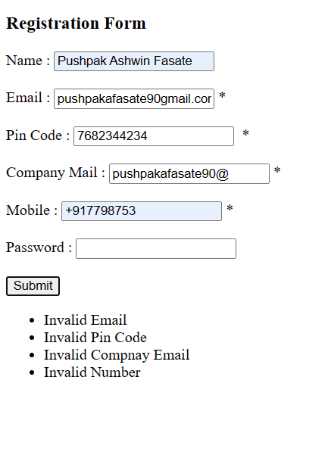

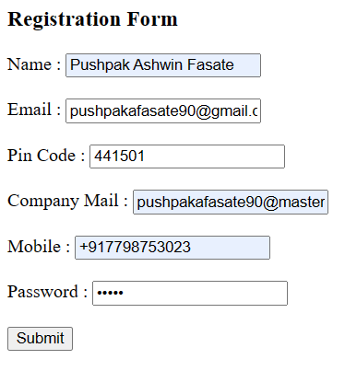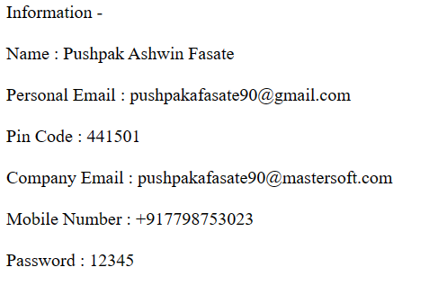

Assignment – 3

File Name –

Output –