Assignment 1 –

File Name – home.aspx

<%@ Page Language="C#" AutoEventWireup="true" CodeBehind="home.aspx.cs" Inherits="Assignment_1.home" %>

<!DOCTYPE html>

<html xmlns="http://www.w3.org/1999/xhtml">

<head runat="server">

<title></title>

</head>

<body>

<form id="form1" runat="server">

<div>

</div>

<p>

Enter Name :

<asp:TextBox ID="txtName" runat="server"></asp:TextBox>

<asp:RequiredFieldValidator ID="RequiredFieldValidator1" runat="server" ControlToValidate="txtName" ErrorMessage="Enter Name*">*</asp:RequiredFieldValidator>

</p>

<p>

Enter Email :

<asp:TextBox ID="txtEmail" runat="server"></asp:TextBox>

<asp:RequiredFieldValidator ID="RequiredFieldValidator2" runat="server" ControlToValidate="txtEmail" ErrorMessage="Enter Email * ">*</asp:RequiredFieldValidator>

</p>

<p>

Enter Password :

<asp:TextBox ID="txtPassword" runat="server" TextMode="Password"></asp:TextBox>

<asp:RequiredFieldValidator ID="RequiredFieldValidator3" runat="server" ControlToValidate="txtPassword" ErrorMessage="Enter Password*">*</asp:RequiredFieldValidator>

</p>

<p>

<asp:Button ID="btnLogin" runat="server" Text="Login" OnClick="btnLogin_Click" />

</p>

<asp:ValidationSummary ID="ValidationSummary1" runat="server" />

<p>

</p>

</form>

</body>

</html>

File Name – [home.aspx.cs](http://home.aspx.cs)

using System;

using System.Collections.Generic;

using System.Linq;

using System.Web;

using System.Web.UI;

using System.Web.UI.WebControls;

namespace Assignment_1

{

public partial class home : System.Web.UI.Page

{

protected void Page_Load(object sender, EventArgs e)

{

}

protected void btnLogin_Click(object sender, EventArgs e)

{

try

{

if (txtName.Text == "" || txtEmail.Text == "" || txtPassword.Text == "")

{

Response.Write("All Field Are Require");

}

else

{

Response.Cookies["name"].Value = txtName.Text;

Response.Cookies["email"].Value = txtEmail.Text;

Response.Cookies["password"].Value = txtPassword.Text;

txtName.Text = "";

txtEmail.Text = "";

txtPassword.Text = "";

Response.Redirect("login.aspx");

}

}

catch (Exception ob)

{

}

}

}

}

File Name – Login.aspx

<%@ Page Language="C#" AutoEventWireup="true" CodeBehind="login.aspx.cs" Inherits="Assignment_1.login" %>

<!DOCTYPE html>

<html xmlns="http://www.w3.org/1999/xhtml">

<head runat="server">

<title></title>

</head>

<body>

<form id="form1" runat="server">

<div>

Login Page

</div>

<p>

Enter Email :

<asp:TextBox ID="txtEmail" runat="server"></asp:TextBox>

</p>

<p>

Enter Password :

<asp:TextBox ID="txtPassword" runat="server"></asp:TextBox>

</p>

<p>

<asp:Button ID="btnLogin" runat="server" Text="Login" OnClick="btnLogin_Click" />

</p>

</form>

</body>

</html>

File Name – login.aspx.cs

using System;

using System.Collections.Generic;

using System.Linq;

using System.Web;

using System.Web.UI;

using System.Web.UI.WebControls;

namespace Assignment_1

{

public partial class login : System.Web.UI.Page

{

protected void Page_Load(object sender, EventArgs e)

{

}

protected void btnLogin_Click(object sender, EventArgs e)

{

Response.Cookies["email"].Expires = DateTime.Now.AddSeconds(1);

Response.Cookies["password"].Expires = DateTime.Now.AddSeconds(1);

if (Request.Cookies["email"].Value == "" && Request.Cookies["password"].Value == "")

{

Response.Redirect("home.aspx");

}

else if (Request.Cookies["email"].Value == txtEmail.Text && Request.Cookies["password"].Value == txtPassword.Text)

{

Response.Write("Valid User");

}

else

{

Response.Write("Invalid User");

}

}

}

}

Output –

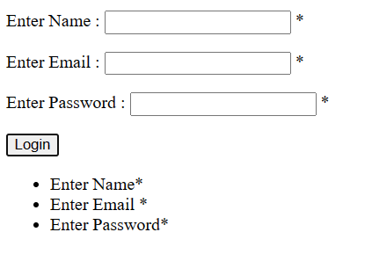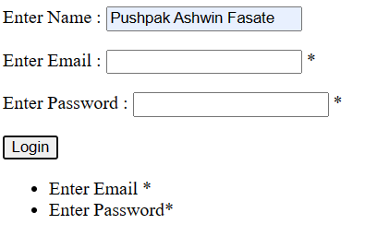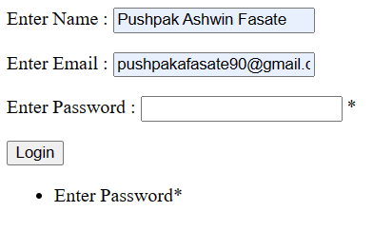

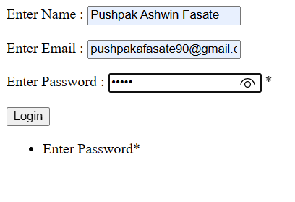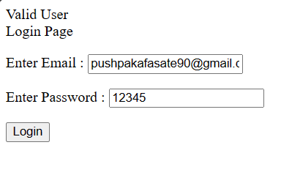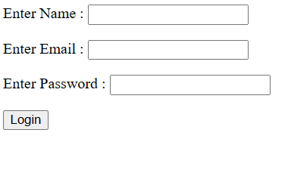

Assignment 2 –

File name – DOB.aspx

<%@ Page Language="C#" AutoEventWireup="true" CodeBehind="DOB.aspx.cs" Inherits="Assignment_2.DOB" %>

<!DOCTYPE html>

<html xmlns="http://www.w3.org/1999/xhtml">

<head runat="server">

<title></title>

</head>

<body>

<form id="form1" runat="server">

<div>

</div>

<p>

Select Date of Birth :

<asp:Calendar ID="Calendar1" runat="server"></asp:Calendar>

</p>

<p>

&nbsp;</p>

<p>

Age is :

<asp:TextBox ID="txtAge" runat="server"></asp:TextBox>

</p>

<p>

&nbsp;</p>

<p>

<asp:Button ID="btnCal" runat="server" OnClick="Button1_Click" Text="Calculate Age" />

</p>

</form>

</body>

</html>

File Name – DOB.aspx.cs

using System;

using System.Collections.Generic;

using System.Linq;

using System.Web;

using System.Web.UI;

using System.Web.UI.WebControls;

namespace Assignment_2

{

public partial class DOB : System.Web.UI.Page

{

protected void Page_Load(object sender, EventArgs e)

{

}

protected void Button1_Click(object sender, EventArgs e)

{

int select_date = int.Parse(Calendar1.SelectedDate.ToString("yyyy"));

int current_date = int.Parse(DateTime.Now.ToString("yyyy"));

int cal_age = current_date - select_date;

txtAge.Text = cal_age.ToString();

}

}

}

Output –

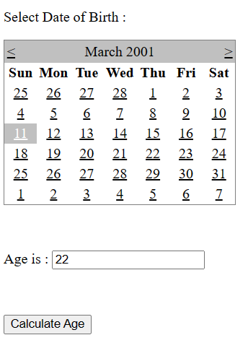

Assignment 3 –

File Name – default.aspx

<%@ Page Language="C#" AutoEventWireup="true" CodeBehind="default.aspx.cs" Inherits="Assignment_3._default" %>

<!DOCTYPE html>

<html xmlns="http://www.w3.org/1999/xhtml">

<head runat="server">

<title></title>

</head>

<body>

<form id="form1" runat="server">

<p>

<h1>Add Information</h1>

<br />

Enter Name :

<asp:TextBox ID="txtName" runat="server"></asp:TextBox>

<asp:RequiredFieldValidator ID="RequiredFieldValidator1" runat="server" ErrorMessage="Enter Name*" ControlToValidate="txtName">*</asp:RequiredFieldValidator>

<p>

Enter City :

<asp:TextBox ID="txtCity" runat="server"></asp:TextBox>

<asp:RequiredFieldValidator ID="RequiredFieldValidator2" runat="server" ErrorMessage="Enter City*" ControlToValidate="txtCity">*</asp:RequiredFieldValidator>

</p>

<p>

Enter College :

<asp:TextBox ID="txtCollege" runat="server"></asp:TextBox>

<asp:RequiredFieldValidator ID="RequiredFieldValidator3" runat="server" ErrorMessage="Enter College*" ControlToValidate="txtCollege">*</asp:RequiredFieldValidator>

</p>

<p>

Enter Branch :

<asp:TextBox ID="txtBranch" runat="server"></asp:TextBox>

<asp:RequiredFieldValidator ID="RequiredFieldValidator4" runat="server" ErrorMessage="Enter Branch*" ControlToValidate="txtCollege">*</asp:RequiredFieldValidator>

</p>

<p>

Enter Percentage :

<asp:TextBox ID="txtPer" runat="server"></asp:TextBox>

<asp:RequiredFieldValidator ID="RequiredFieldValidator5" runat="server" ErrorMessage="Enter Percent*" ControlToValidate="txtPer">*</asp:RequiredFieldValidator>

</p>

<div>

<asp:Button ID="btnSubmit" runat="server" Text="Submit" OnClick="btnSubmit_Click" />

</div>

<asp:ValidationSummary ID="ValidationSummary1" runat="server" />

<p>

<h1>Result :</h1>

<asp:Label ID="lblResult" runat="server" Text="Label"></asp:Label>

<br />

<asp:Label ID="lblgrade" runat="server" Text="Label"></asp:Label>

</p>

</form>

</body>

</html>

File Name – default.aspx.cs

using System;

using System.Collections.Generic;

using System.Linq;

using System.Web;

using System.Web.UI;

using System.Web.UI.WebControls;

namespace Assignment_3

{

public partial class _default : System.Web.UI.Page

{

protected void Page_Load(object sender, EventArgs e)

{

}

protected void btnSubmit_Click(object sender, EventArgs e)

{

info c1 = new info();

lblResult.Text = c1.input(txtName.Text, txtCity.Text, txtCollege.Text, txtBranch.Text,

int.Parse(txtPer.Text));

lblgrade.Text = c1.grade;

}

}

}

File Name – info.cs

using System;

using System.Collections.Generic;

using System.Linq;

using System.Web;

namespace Assignment_3

{

public class info

{

public string grade;

public string input(string name, string city, string college, string branch, int per)

{

if (per > 60)

{

grade = "Grade A";

}

else if (per > 50 && per < 60)

{

grade = "Grade B";

}

else

{

grade = "Fail";

}

return "Name : " + name + "<br/>City : " + city + "<br/>College : " + college + "<br/>Branch : "

+ branch + "<br/>Percentage : " + per;

}

}

}

Output –

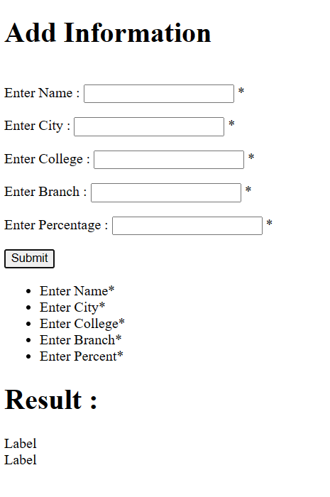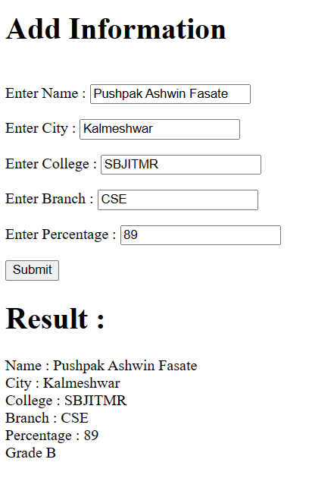

Assignment 4 –

File Name – Default.aspx

<%@ Page Language="C#" AutoEventWireup="true" CodeBehind="default.aspx.cs" Inherits="Assignment_4._default" %>

<!DOCTYPE html>

<html xmlns="http://www.w3.org/1999/xhtml">

<head runat="server">

<title></title>

</head>

<body>

<form id="form1" runat="server">

<div>

Enter Name :

<asp:TextBox ID="txtName" runat="server"></asp:TextBox>

<asp:RequiredFieldValidator ID="RequiredFieldValidator1" runat="server" ControlToValidate="txtName" ErrorMessage="Enter Name* ">*</asp:RequiredFieldValidator>

<br />

<br />

Enter College :

<asp:TextBox ID="txtCollege" runat="server"></asp:TextBox>

<asp:RequiredFieldValidator ID="RequiredFieldValidator2" runat="server" ControlToValidate="txtCollege" ErrorMessage="Enter College*">*</asp:RequiredFieldValidator>

<br />

<br />

Enter Subject :

<asp:TextBox ID="txtSubject" runat="server"></asp:TextBox>

<asp:RequiredFieldValidator ID="RequiredFieldValidator3" runat="server" ControlToValidate="txtSubject" ErrorMessage="Enter Subject*">*</asp:RequiredFieldValidator>

<br />

<br />

Enter Branch : <asp:TextBox ID="txtBranch" runat="server"></asp:TextBox>

<asp:RequiredFieldValidator ID="RequiredFieldValidator4" runat="server" ControlToValidate="txtBranch" ErrorMessage="Enter Branch*">*</asp:RequiredFieldValidator>

<br />

<br />

Enter Percentage :

<asp:TextBox ID="txtPer" runat="server"></asp:TextBox>

<asp:RequiredFieldValidator ID="RequiredFieldValidator5" runat="server" ControlToValidate="txtPer" ErrorMessage="Enter Percentage*">*</asp:RequiredFieldValidator>

<br />

<br />

<asp:Button ID="btnSubmit" runat="server" Text="Submit" OnClick="btnSubmit_Click" />

<br />

<asp:ValidationSummary ID="ValidationSummary1" runat="server" />

<br />

<br />

</div>

<asp:Label ID="lblResult" runat="server" Text="Label"></asp:Label>

<br />

<br />

<asp:Label ID="lblPer" runat="server" Text="Label"></asp:Label>

<br />

<asp:Label ID="lblGarde" runat="server" Text="Label"></asp:Label>

</form>

</body>

</html>

File Name – Default.aspx.cs

using System;

using System.Collections.Generic;

using System.Linq;

using System.Web;

using System.Web.UI;

using System.Web.UI.WebControls;

namespace Assignment_4

{

public partial class _default : System.Web.UI.Page

{

protected void Page_Load(object sender, EventArgs e)

{

}

protected void btnSubmit_Click(object sender, EventArgs e)

{

Student s1 = new Student();

lblResult.Text = s1.display(txtName.Text, txtCollege.Text, txtSubject.Text, txtBranch.Text);

lblPer.Text = s1.cal_grade(int.Parse(txtPer.Text));

lblGarde.Text = s1.grade;

}

}

}

File Name – Student.cs

using System;

using System.Collections.Generic;

using System.Linq;

using System.Web;

namespace Assignment_4

{

public class Student

{

public string grade;

public string display(string name, string college, string subject, string branch)

{

return "Name : " + name + "<br/>College : " + college + "<br/>Subject : " + subject +

"<br/>Branch : " + branch;

}

public string cal_grade(int per)

{

if(per > 60)

{

grade = "Grade A";

}

else if (per > 50 && per < 60 )

{

grade = "Grade B";

}

else

{

grade = "Fail";

}

return per.ToString();

}

}

}

Output –

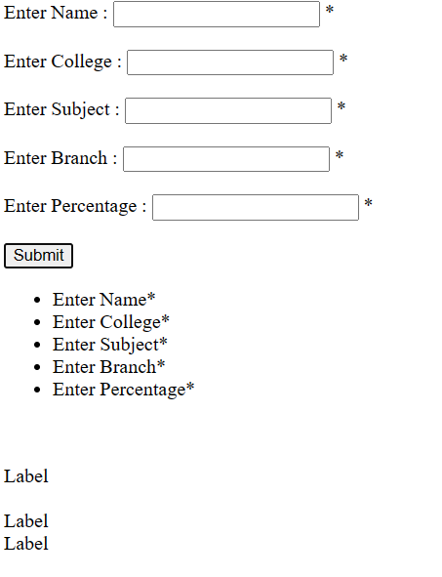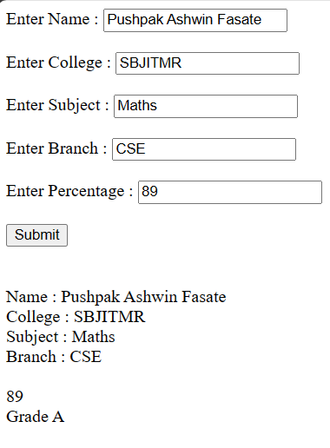

Assignment 5 –

File Name – Default.aspx

<%@ Page Language="C#" AutoEventWireup="true" CodeBehind="default.aspx.cs" Inherits="Assignment_5._default" %>

<!DOCTYPE html>

<html xmlns="http://www.w3.org/1999/xhtml">

<head runat="server">

<title></title>

</head>

<body>

<form id="form1" runat="server">

<div>

Enter Name :

<asp:TextBox ID="txtName" runat="server"></asp:TextBox>

<asp:RequiredFieldValidator ID="RequiredFieldValidator1" runat="server" ControlToValidate="txtName" ErrorMessage="Enter Name*"></asp:RequiredFieldValidator>

<br />

<br />

Enter City :

<asp:TextBox ID="txtCity" runat="server"></asp:TextBox>

<asp:RequiredFieldValidator ID="RequiredFieldValidator2" runat="server" ControlToValidate="txtCity" ErrorMessage="Enter City*"></asp:RequiredFieldValidator>

<br />

<br />

Enter College :

<asp:TextBox ID="txtCollege" runat="server"></asp:TextBox>

<asp:RequiredFieldValidator ID="RequiredFieldValidator3" runat="server" ControlToValidate="txtCollege" ErrorMessage="Enter College*"></asp:RequiredFieldValidator>

<br />

<br />

Enter Mark 1 :

<asp:TextBox ID="txtMark1" runat="server"></asp:TextBox>

<asp:RangeValidator ID="RangeValidator1" runat="server" ControlToValidate="txtMark1" ErrorMessage="Enter 1 to 100*" MaximumValue="100" MinimumValue="1" Type="Integer"></asp:RangeValidator>

<br />

<br />

Enter Mark 2 :

<asp:TextBox ID="txtMark2" runat="server"></asp:TextBox>

<asp:RangeValidator ID="RangeValidator2" runat="server" ControlToValidate="txtMark2" ErrorMessage="Enter 0 to 100" MaximumValue="100" MinimumValue="1" Type="Integer"></asp:RangeValidator>

<br />

<br />

Enter Mark 3 :

<asp:TextBox ID="txtMark3" runat="server"></asp:TextBox><asp:RangeValidator ID="RangeValidator3" runat="server" ErrorMessage="Enter 1 to 100*" MaximumValue="100" MinimumValue="1" Type="Integer" ControlToValidate="txtMark3"></asp:RangeValidator>

<br />

<br />

Enter Mark 4 :

<asp:TextBox ID="txtMark4" runat="server"></asp:TextBox>

<asp:RangeValidator ID="RangeValidator4" runat="server" ControlToValidate="txtMark4" ErrorMessage="Enter 1 to 100*" MaximumValue="100" MinimumValue="1" Type="Integer"></asp:RangeValidator>

<br />

<br />

Enter Mark 5 :

<asp:TextBox ID="txtMark5" runat="server"></asp:TextBox>

<asp:RangeValidator ID="RangeValidator5" runat="server" ControlToValidate="txtMark5" ErrorMessage="Enter 1 to 100*" MaximumValue="100" MinimumValue="1" Type="Integer"></asp:RangeValidator>

<br />

<br />

<asp:Button ID="Button1" runat="server" Text="Submit " OnClick="Button1_Click" />

<br />

<br />

<asp:Label ID="lblDsiplay" runat="server" Text="Label"></asp:Label>

<br />

<br />

<asp:Label ID="lblTotal" runat="server" Text="Label"></asp:Label>

<br />

<asp:Label ID="lblGrade" runat="server" Text="Label"></asp:Label>

</div>

</form>

</body>

</html>

File Name – Default.aspx.cs

using System;

using System.Collections.Generic;

using System.Linq;

using System.Web;

using System.Web.UI;

using System.Web.UI.WebControls;

namespace Assignment_5

{

public partial class _default : System.Web.UI.Page

{

protected void Page_Load(object sender, EventArgs e)

{

}

protected void Button1_Click(object sender, EventArgs e)

{

marksheet ms = new marksheet();

lblDsiplay.Text = ms.display(txtName.Text, txtCity.Text, txtCollege.Text);

int total_mark = ms.total(int.Parse(txtMark1.Text), int.Parse(txtMark2.Text),

int.Parse(txtMark3.Text),int.Parse(txtMark4.Text),

int.Parse(txtMark5.Text));

lblTotal.Text = total_mark.ToString();

lblGrade.Text = ms.g_grade;

}

}

}

File Name - marksheet.cs

using System;

using System.Collections.Generic;

using System.Linq;

using System.Web;

namespace Assignment_5

{

public class marksheet

{

public string g_grade;

public string display(string name, string city, string college)

{

return "Name : " + name + "<br/>City : " + city + "<br/>College : " + college;

}

public int total(int m1, int m2, int m3, int m4, int m5)

{

int total;

total = m1 + m2 + m3 + m4 + m5;

if (total > 250)

{

g_grade = "Grade A";

}

else if (total > 150 && total < 250)

{

g_grade = "Grade B";

}

else if(total > 100 && total < 150)

{

g_grade = "Grade C";

}

else

{

g_grade = "Fail";

}

return total;

}

}

}

Output –

