Que 1. Creating Table

CREATE TABLE Admission (Roll INT, Name VARCHAR(50), City VARCHAR(50), Email VARCHAR(50), Mobile VARCHAR(50), College VARCHAR(50), Branch VARCHAR(50), Semester INT, Address varchar(50), Total INT, Percentage INT CHECK (Percentage >= 60), Grade CHAR )

SELECT * FROM Admission;

Output –



Que 2. Inserting Data to Table –

INSERT INTO admission VALUES (101, 'Aysuh', 'Nagpur', 'aysuh@gmail.com', 1234567890, 'Carmel Academy', 'CSE', 8, 'Bus Stop', 87, 77, 'B')

SELECT * FROM Admission;

Output –



Que 3. Inserting Data using Inserting Line –

INSERT INTO Admission VALUES

(102, 'Atharva', 'Pune', 'athu@gmail.com', 2345678901, 'GNIT', 'CSE', 7, 'Katol naka', 255, 78, 'A'),

(103, 'Vrushal', 'Mumbai', 'vrushal@gmail.com', 3456789012, 'SBJITME', 'BCA', 5, 'Baba Traders', 260, 65, 'C'),

(104, 'Prany', 'Nagpur', 'pranay@gmail.com', 4567890123, 'NIT', 'ETC', 6, 'Ghue Shop', 300, 68,'C'),

(105, 'Sanket', 'Pune', 'sanket@gmail.com', 5678901234, 'GNIT', 'CSE', 8, 'Bajaj Nagar', 310, 85, 'B'),

(106, 'Tejas', 'Mumbai', 'tejas@gmail.com', 6789012345, 'SBJITMR', 'BCA', 7, 'Kamal Nath Ground', 332, 89, 'A'),

(107, 'Manoj', 'Nagpur', 'manoj@gmail.com', 7890123456, 'NIT', 'ETC', 8, 'Fetri', 289, 91, 'A'),

(108, 'Yash', 'Pune', 'yash@gmail.com', 8901234567, 'GNIT','CSE', 7, 'Yerla', 299, 89, 'B'),

(109, 'Durvesh', 'Mumbai', 'durvesh@gmail.com', 9012345678, 'SBJITMR', 'BCA', 5, 'Manish Nagar', 332, 71, 'A'),

(110, 'Tanvish', 'Nagpur', 'tancish@gmail.com', 0123456789, 'NIT', 'ETC', 7, 'kalmeshwar naka', 350, 89, 'B')

SELECT * FROM A dmission

Output

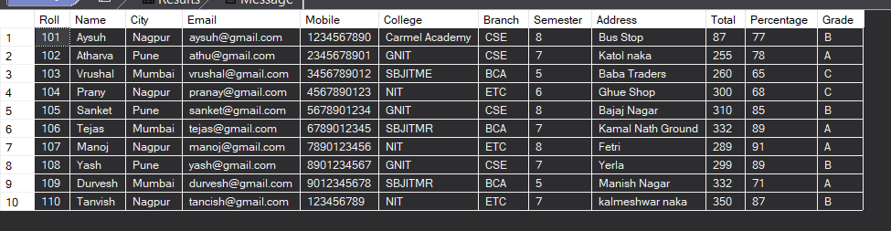

Que 4. Fetching Roll, Name and Branch form admission table

SELECT Roll, Name, branch FROM admission

Output –

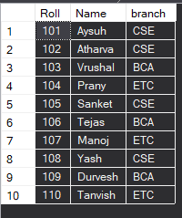

Que 5. Fetching record where city is Nagpur

SELECT * FROM Admission WHERE city = 'Nagpur'

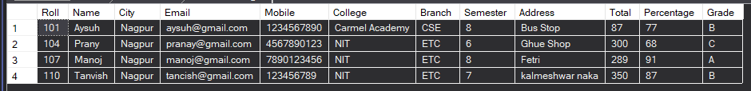

Que 6. Fetching record where city is Pune and total is greater than 300

SELECT * FROM Admission WHERE city = 'Mumbai' AND total >= 300



Que 7. Fetching record whose marks is between 300 to 350

SELECT * FROM Admission WHERE total BETWEEN 300 and 350

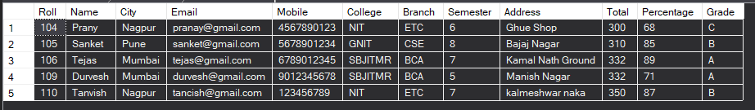

Que 8.Using Group by city

SELECT City FROM Admission GROUP BY City

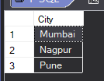

Que 9. Order name in ascending order

SELECT * FROM Admission ORDER BY Name

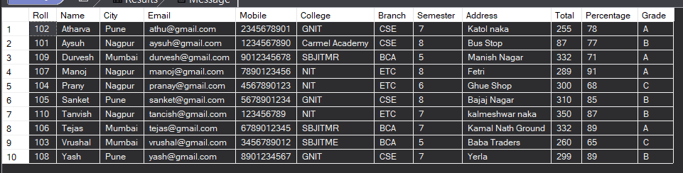

Que 10. Order by roll number in descending order

SELECT * FROM Admission ORDER BY Roll DESC

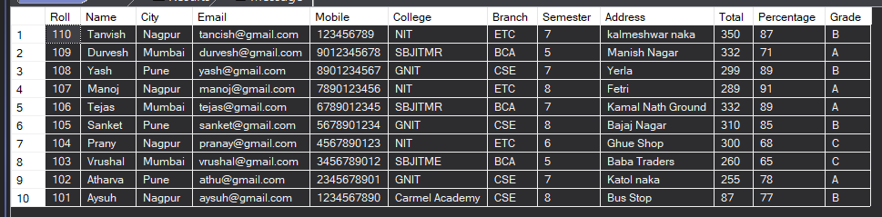

Que 10. Fetching record whose city is Nagpur and Pune.

SELECT * FROM Admission WHERE City IN('Nagpur', 'Pune');

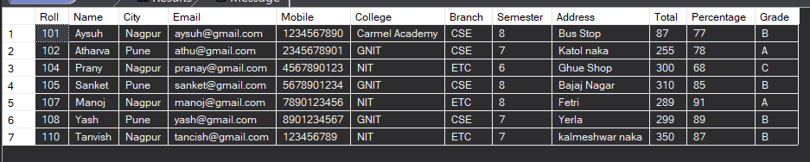

Que 11. Fetching record whose branch is not CSE and college is not GNIT but percentages is greater than 80

SELECT * FROM Admission WHERE Branch != 'CSE' AND College != 'GNIT' AND Percentage >= 80

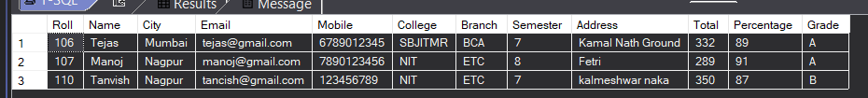

Que 12. Delete record whose roll number is 105

DELETE FROM Admission WHERE roll = 105

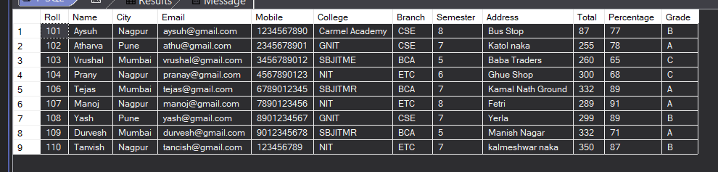

Que 13. Addition of total using SUM() function

SELECT SUM(total) AS total_marks FROM Admission

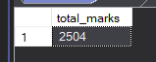

Que 14. Find average percentages using AVG() function

SELECT AVG(Percentage) AS avg_per FROM Admission



Que 15. Total number of record in admission table

SELECT count(Roll) AS No_Of_Record FROM Admission

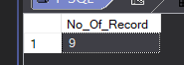

Que 16. Find minimum percentage using MIN() function

SELECT MIN(Percentage) AS Min_Percentage FROM Admission;



Que 17. Find Maximum percentages using MAX() function

SELECT MAX(Percentage) AS Max_Percentage FROM Admission;



Que 18. Find top 3 record whose percentage is greater than 85

SELECT TOP 3 * FROM Admission WHERE Percentage > 85

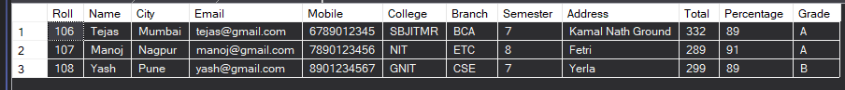

Que 19. Update name as suresh where roll no is 108

UPDATE Admission SET Name = 'Suresh' WHERE Roll = 108

SELECT * FROM Admission

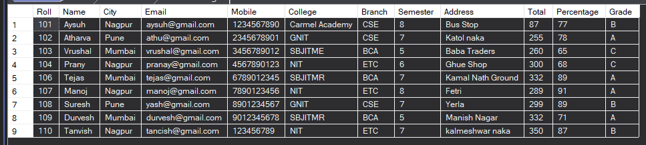

Que 20. Structure of admission table

sp_help admission

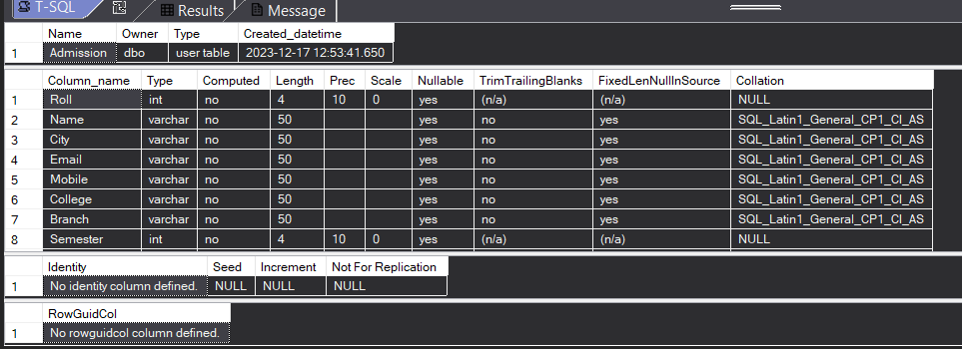

Que 21. Add new column to table name as subject

ALTER TABLE Admission ADD Suject VARCHAR(50);

SELECT * FROM Admission;

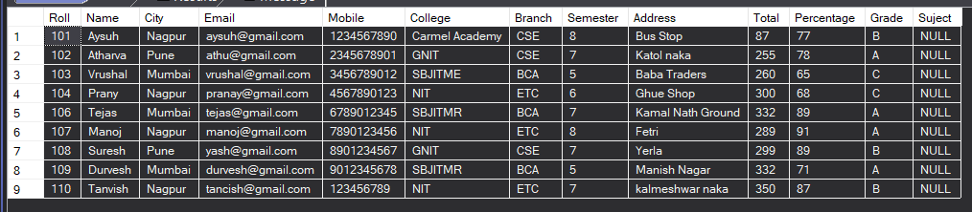

Que 22. Delete subject column form table

ALTER TABLE admission DROP COLUMN suject;

SELECT * FROM Admission;

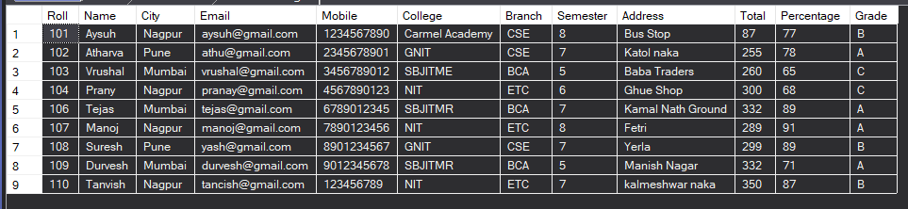

Que 23. Rename column Name

EXEC sp_rename 'admission.S_Grade', 'S_Grade', 'Column';

SELECT * FROM Admission;

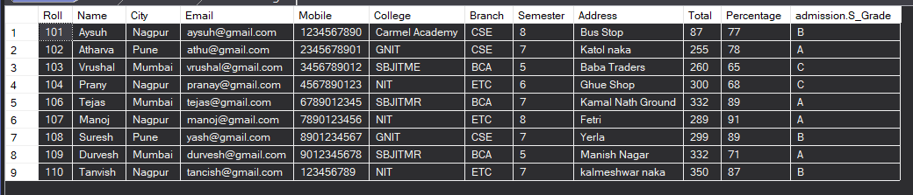

Que 24. Creating new table from existing table

SELECT * INTO Demo_Admission FROM Admission;

SELECT * FROM Demo_Admission;

