Assignment 1 :

using System;

using System.Collections.Generic;

using System.Linq;

using System.Text;

using System.Threading.Tasks;

namespace web

{

class Program

{

string gname, gcity, gstate, gcol, gmob, gbranch, gsub;

int gper, groll;

void display(int nroll, string nname, string ncity, string nstate, string ncol, string nmob, string nbranch, string nsub)

{

groll = nroll;

gcity = ncity;

gname = nname;

gstate = nstate;

gcol = ncol;

gmob = nmob;

gbranch = nbranch;

gsub = nsub;

display();

}

void display()

{

Console.WriteLine("\n------------------------\nRoll Number : " + groll +

"\nName : " + gname +

"\nCity : " + gcity +

"\nState : " + gstate +

"\nCollege : " + gcol +

"\nMobile : " + gmob +

"\nBranch : " + gbranch +

"\nSubject : " + gsub

);

}

void grade(int nper)

{

if (nper >= 60)

{

Console.WriteLine("Grade A");

}

else if (nper >= 50 && nper <= 60)

{

Console.WriteLine("Grade B");

}

else if (nper >= 40 && nper <= 50)

{

Console.WriteLine("Grade C");

}

else

{

Console.WriteLine("Fail");

}

}

static void Main(string[] args)

{

Program p1 = new Program();

Console.Write("Enter Roll No. : ");

int roll = int.Parse(Console.ReadLine());

Console.Write("Name : ");

string name = Console.ReadLine();

Console.Write("City : ");

string city = Console.ReadLine();

Console.Write("State : ");

string state = Console.ReadLine();

Console.Write("College : ");

string college = Console.ReadLine();

Console.Write("Mobile : ");

string mobile = Console.ReadLine();

Console.Write("Branch : ");

string branch = Console.ReadLine();

Console.Write("Subject : ");

string sub = Console.ReadLine();

Console.Write("Percentage : ");

int per = int.Parse(Console.ReadLine());

p1.display(roll, name, city, state, college, mobile, branch, sub);

p1.grade(per);

Console.ReadKey();

}

}

}

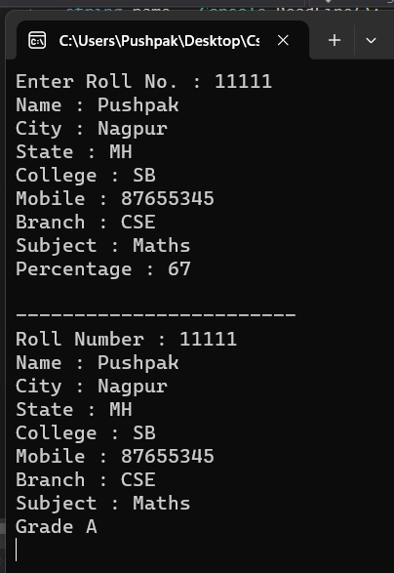

Assignment 2 :

using System;

using System.Collections.Generic;

using System.Linq;

using System.Text;

using System.Threading.Tasks;

namespace web

{

class Program

{

string gname, gcity, gstate, gcol, gmob, gbranch, gsub;

int gper, groll;

void input(int nroll, string nname, string ncity = "Nagpur", string nstate, string ncol, string nmob, string nbranch, string nsub)

{

groll = nroll;

gcity = ncity;

gname = nname;

gstate = nstate;

gcol = ncol;

gmob = nmob;

gbranch = nbranch;

gsub = nsub;

display();

}

void display()

{

Console.WriteLine("\n------------------------\nRoll Number : " + groll +

"\nName : " + gname +

"\nCity : " + gcity +

"\nState : " + gstate +

"\nCollege : " + gcol +

"\nMobile : " + gmob +

"\nBranch : " + gbranch +

"\nSubject : " + gsub

);

}

void grade(int nper)

{

if (nper >= 60)

{

Console.WriteLine("Grade A");

}

else if (nper >= 50 && nper <= 60)

{

Console.WriteLine("Grade B");

}

else if (nper >= 40 && nper <= 50)

{

Console.WriteLine("Grade C");

}

else

{

Console.WriteLine("Fail");

}

}

static void Main(string[] args)

{

Program p1 = new Program();

Console.Write("Enter Roll No. : ");

int roll = int.Parse(Console.ReadLine());

Console.Write("Name : ");

string name = Console.ReadLine();

Console.Write("City : ");

string city = Console.ReadLine();

Console.Write("State : ");

string state = Console.ReadLine();

Console.Write("College : ");

string college = Console.ReadLine();

Console.Write("Mobile : ");

string mobile = Console.ReadLine();

Console.Write("Branch : ");

string branch = Console.ReadLine();

Console.Write("Subject : ");

string sub = Console.ReadLine();

Console.Write("Percentage : ");

int per = int.Parse(Console.ReadLine());

p1.input(roll, name, city, state, college, mobile, branch, sub);

p1.grade(per);

Console.ReadKey();

}

}

}

Assignment 3.1:

using System;

using System.Collections.Generic;

using System.Linq;

using System.Text;

using System.Threading.Tasks;

namespace web

{

class Program

{

void basic_info(string nname, string ncity, string nemail, string nmobile, string nstate, string ncountry)

{

Console.WriteLine("------------------------------------\nName : " + nname +

"\nCity : " + ncity +

"\nEmail : " + nemail +

"\nMobile : " + nmobile +

"\nState : " + nstate +

"\nCountry : " + ncountry);

}

void qualification(string col, string sem1, string nbranch, string naddress)

{

Console.WriteLine("------------------------------------\nCollege : " + col +

"\nSem : " + sem1 +

"\nBranch : " + nbranch +

"\nAddress : " + naddress

);

}

void exprence(string ncomp, string ndest, int sal, string njoining)

{

Console.Write("------------------------------------\nCompnay : " + ncomp +

"\nDest : " + ndest +

"\nSalary : " + sal +

"\nJoining : " + njoining

);

}

static void Main(string[] args)

{

Program p1 = new Program();

Console.Write("Name : ");

string name = Console.ReadLine();

Console.Write("City : ");

string city = Console.ReadLine();

Console.Write("Email : ");

string email = Console.ReadLine();

Console.Write("Mobile : ");

string mobile = Console.ReadLine();

Console.Write("State : ");

string state = Console.ReadLine();

Console.Write("Country : ");

string country = Console.ReadLine();

Console.Write("College : ");

string college = Console.ReadLine();

Console.Write("Semi : ");

string sem = Console.ReadLine();

Console.Write("Branch : ");

string branch = Console.ReadLine();

Console.Write("Address : ");

string address = Console.ReadLine();

Console.Write("Compnay : ");

string comp = Console.ReadLine();

Console.Write("Dest : ");

string dest = Console.ReadLine();

Console.Write("Salary : ");

int salary = int.Parse(Console.ReadLine());

Console.Write("Joining : ");

string joining = Console.ReadLine();

p1.basic_info(name, city, email, mobile, state, country);

p1.qualification(college, sem, branch, address);

p1.exprence(comp, dest, salary, joining);

Console.ReadKey();

}

}

}

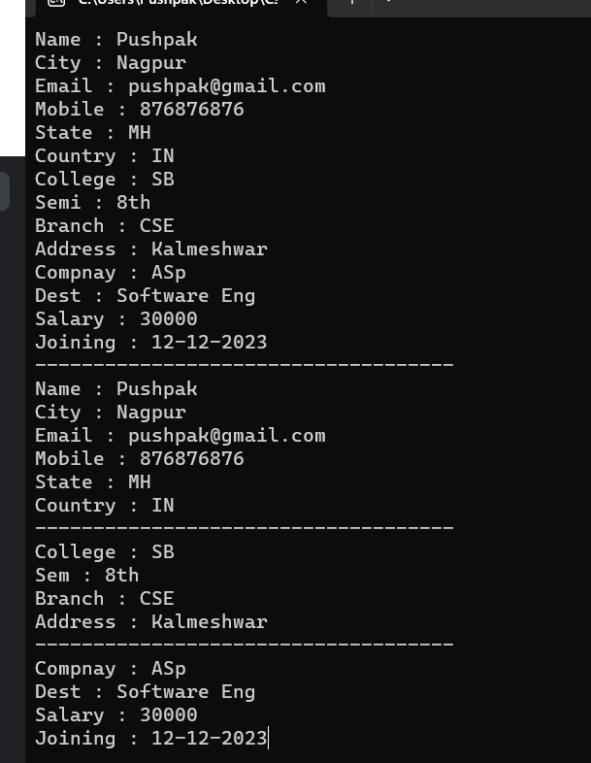

Assignment 3.2:

using System;

using System.Collections.Generic;

using System.Linq;

using System.Text;

using System.Threading.Tasks;

namespace web

{

class Program

{

int per;

void basic_info(string nname, string ncity, string ncol, string nbranch, int npercent)

{

Console.WriteLine("------------------------------------\nName : " + nname +

"\nCity : " + ncity +

"\nCollege : " + ncol +

"\nBranch : " + nbranch +

"\nPercent : " + npercent

);

per = npercent;

grade(per);

}

void grade(int per)

{

if (per >= 60)

{

Console.WriteLine("Grade A");

}

else if (per >= 50 && per <= 60)

{

Console.WriteLine("Grade B");

}

else if (per >= 40 && per <= 50)

{

Console.WriteLine("Grade C");

}

else

{

Console.WriteLine("Fail");

}

}

static void Main(string[] args)

{

Program p1 = new Program();

Console.Write("Name : ");

string name = Console.ReadLine();

Console.Write("City : ");

string city = Console.ReadLine();

Console.Write("College : ");

string col = Console.ReadLine();

Console.Write("Branch : ");

string branch = Console.ReadLine();

Console.Write("Percent : ");

int percent = int.Parse(Console.ReadLine());

p1.basic_info(name, city, col, branch, percent);

Console.ReadKey();

}

}

}

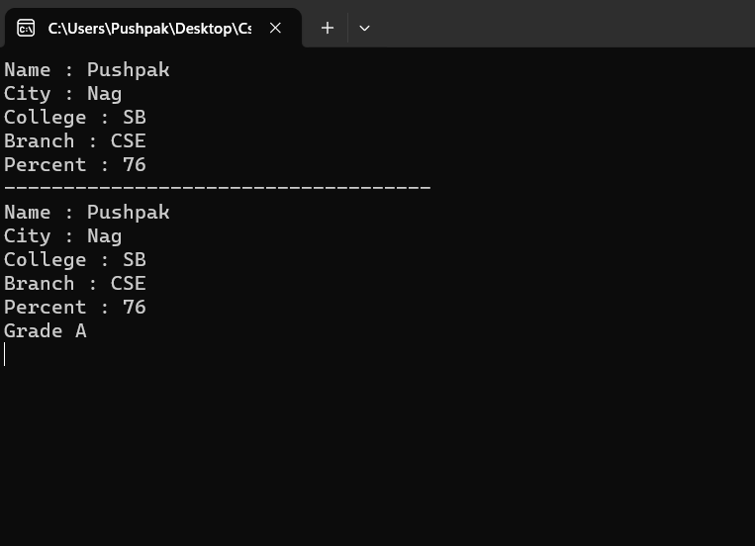

Assignment 3.3:

using System;

using System.Collections.Generic;

using System.Linq;

using System.Text;

using System.Threading.Tasks;

namespace web

{

class Program

{

int gtotal, gm1, gm2, gm3, gm4, gm5;

string gname, gcity, gcol;

void input(string nname, string ncity, string ncol, int m1, int m2, int m3, int m4, int m5)

{

gname = nname;

gcity = ncity;

gcol = ncol;

gm1 = m1;

gm2 = m2;

gm3 = m3;

gm4 = m4;

gm5 = m5;

int total = m1 + m2 + m3 + m4 + m5;

gtotal = total;

display();

grade();

}

void display()

{

Console.WriteLine("\n----------------------------------\nName:" + gname +

"\nCity : " + gcity +

"\nCollege : " + gcol +

"\nMark 1 : " + gm1 +

"\nMark 2 : " + gm2 +

"\nMark 3 : " + gm3 +

"\nMark 4 : " + gm4 +

"\nMark 5 : " + gm5

);

}

void grade()

{

if (gtotal >= 250)

{

Console.WriteLine("First Division");

}

else if (gtotal > 150 && gtotal < 250)

{

Console.WriteLine("Second Division");

}

else

{

Console.WriteLine("Fail");

}

}

static void Main(string[] args)

{

Program p1 = new Program();

Console.Write("Name : ");

string name = Console.ReadLine();

Console.Write("City : ");

string city = Console.ReadLine();

Console.Write("College : ");

string col = Console.ReadLine();

Console.Write("Mark 1 : ");

int mark1 = int.Parse(Console.ReadLine());

Console.Write("Mark 2 : ");

int mark2 = int.Parse(Console.ReadLine());

Console.Write("Mark 3 : ");

int mark3 = int.Parse(Console.ReadLine());

Console.Write("Mark 4 : ");

int mark4 = int.Parse(Console.ReadLine());

Console.Write("Mark 5 : ");

int mark5 = int.Parse(Console.ReadLine());

p1.input(name, city, col, mark1, mark2, mark3, mark4, mark5);

Console.ReadKey();

}

}

}

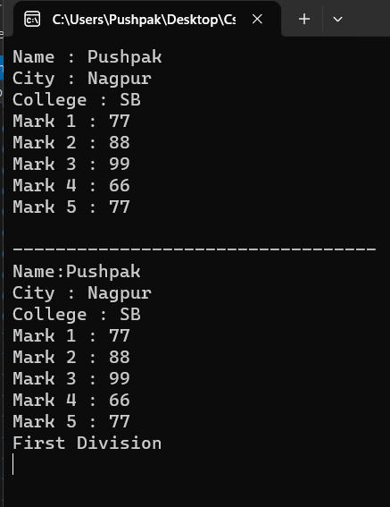

Assignment 3.4:

using System;

using System.Collections.Generic;

using System.Linq;

using System.Text;

using System.Threading.Tasks;

namespace web

{

class Program

{

string gname, gcol, gbranch, gsubject;

int gper;

void input(string nname, string ncol, string nsubject, string nbranch, int npercent)

{

gname = nname;

gcol = ncol;

gsubject = nsubject;

gbranch = nbranch;

gper = npercent;

grade();

display();

}

void grade()

{

Console.WriteLine("\n---------------------------------------");

if (gper >= 60)

{

Console.WriteLine("Grade A");

}

else if (gper >= 50 && gper <= 60)

{

Console.WriteLine("Grade B");

}

else

{

Console.WriteLine("Fail");

}

}

void display()

{

Console.Write(

"\nName : " + gname +

"\nCollege : " + gcol +

"\nSubject : " + gsubject +

"\nBranch : " + gbranch +

"\nPercentage : " + gper

);

}

static void Main(string[] args)

{

Console.Write("Name : ");

string name = Console.ReadLine();

Console.Write("College : ");

string college = Console.ReadLine();

Console.Write("Subject : ");

string subject = Console.ReadLine();

Console.Write("Branch : ");

string branch = Console.ReadLine();

Console.Write("Percentage : ");

int percent = int.Parse(Console.ReadLine());

Program p1 = new Program();

p1.input(name, college, subject, branch, percent);

Console.ReadKey();

}

}

}

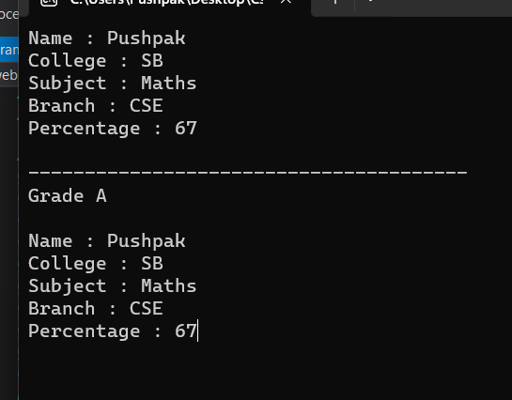

Assignment 4:

using System;

using System.Collections.Generic;

using System.Linq;

using System.Text;

using System.Threading.Tasks;

namespace web

{

class Program

{

public Tuple<string, string, string, int> input(string nname, string ncity, string ncountry, int nphone)

{

return new Tuple<string, string, string, int>(nname, ncity, ncountry, nphone);

}

static void Main(string[] args)

{

Console.Write("Name : ");

string name = Console.ReadLine();

Console.Write("City : ");

string city = Console.ReadLine();

Console.Write("Country : ");

string country = Console.ReadLine();

Console.Write("Phone : ");

int phone = int.Parse(Console.ReadLine());

Program p1 = new Program();

var mess = p1.input(name, city, country, phone);

Console.WriteLine();

Console.WriteLine(mess);

Console.WriteLine("Name : " + mess.Item1);

Console.WriteLine("City : " + mess.Item2);

Console.WriteLine("Country : " + mess.Item3);

Console.WriteLine("Phone : " + mess.Item4);

Console.ReadKey();

}

}

}

