1. Open eclipse then file_new_java project

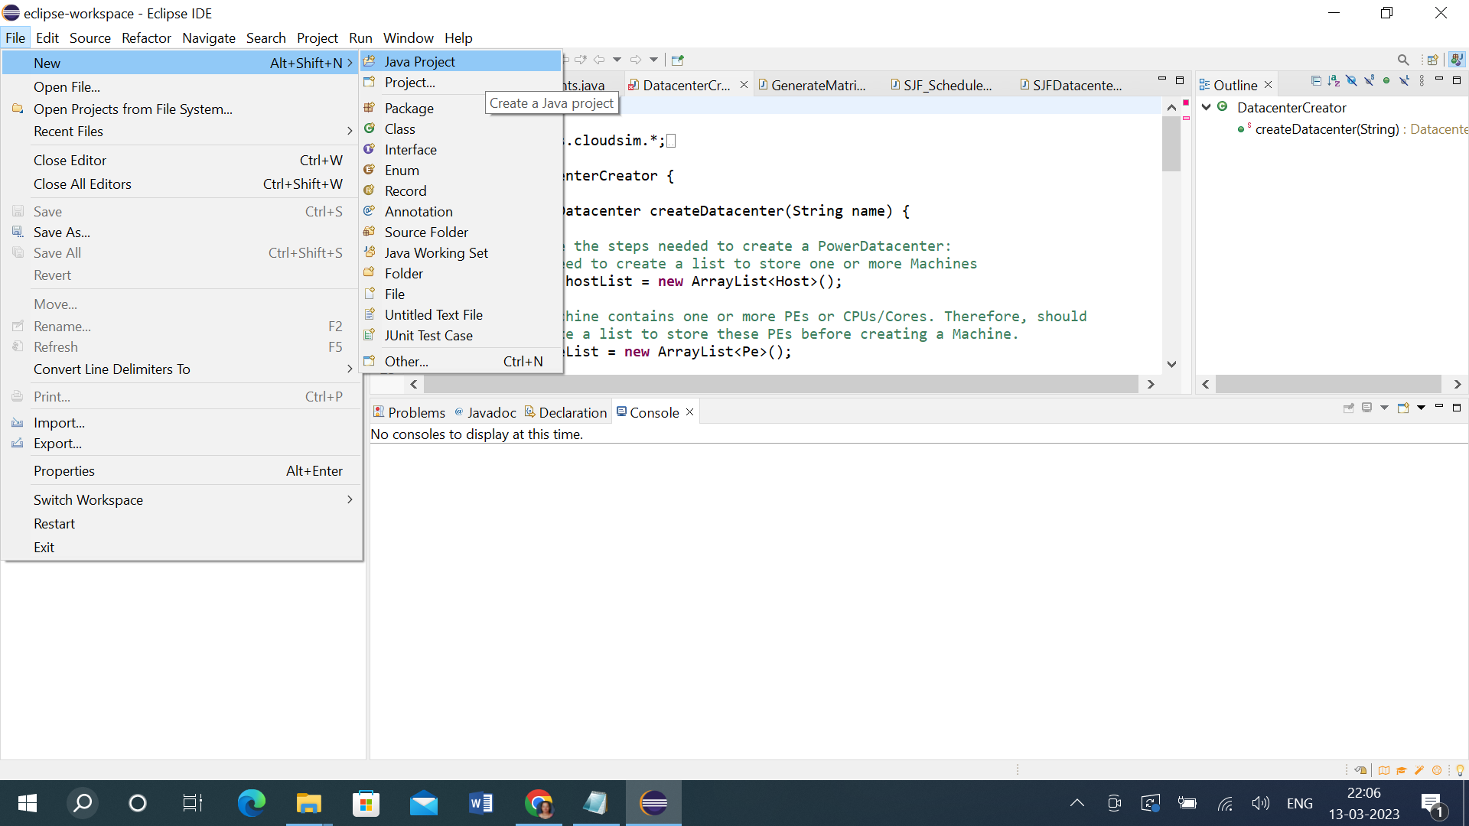

2. Give project name Ex. sjfschedular

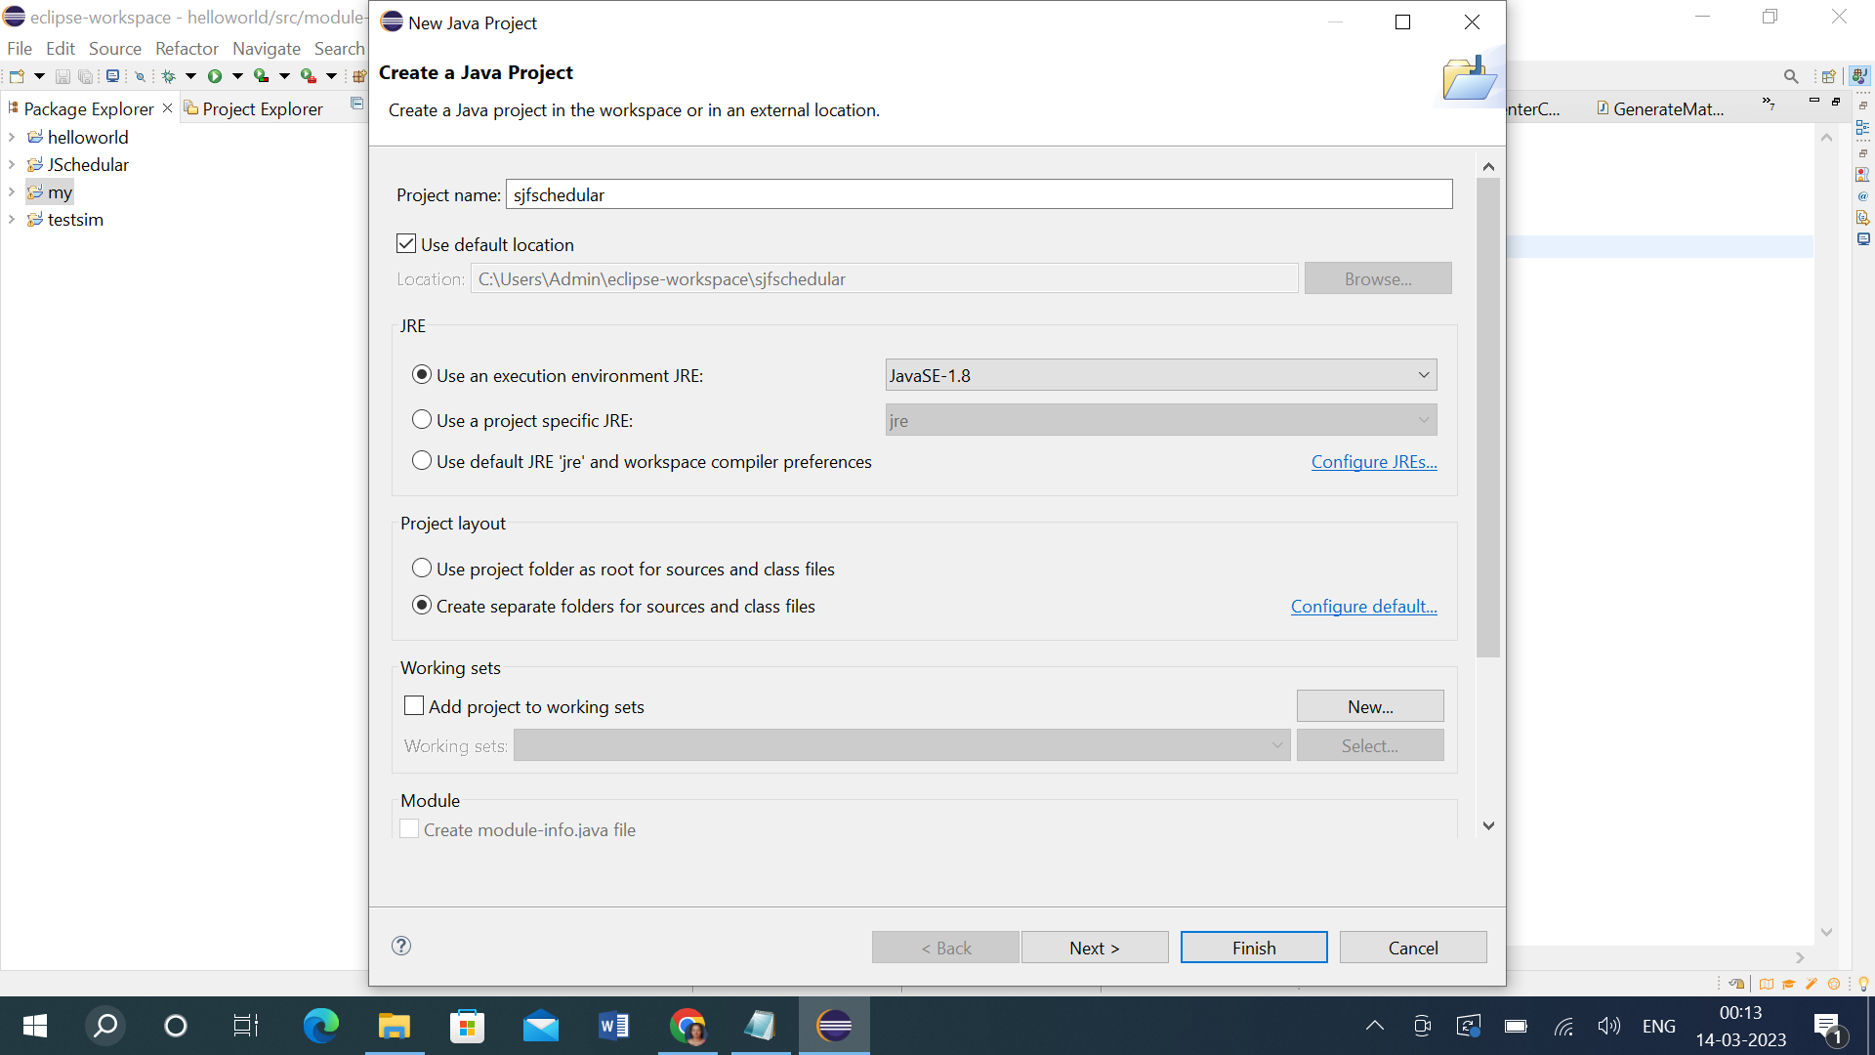

3. In Sjfschedular –src file create package

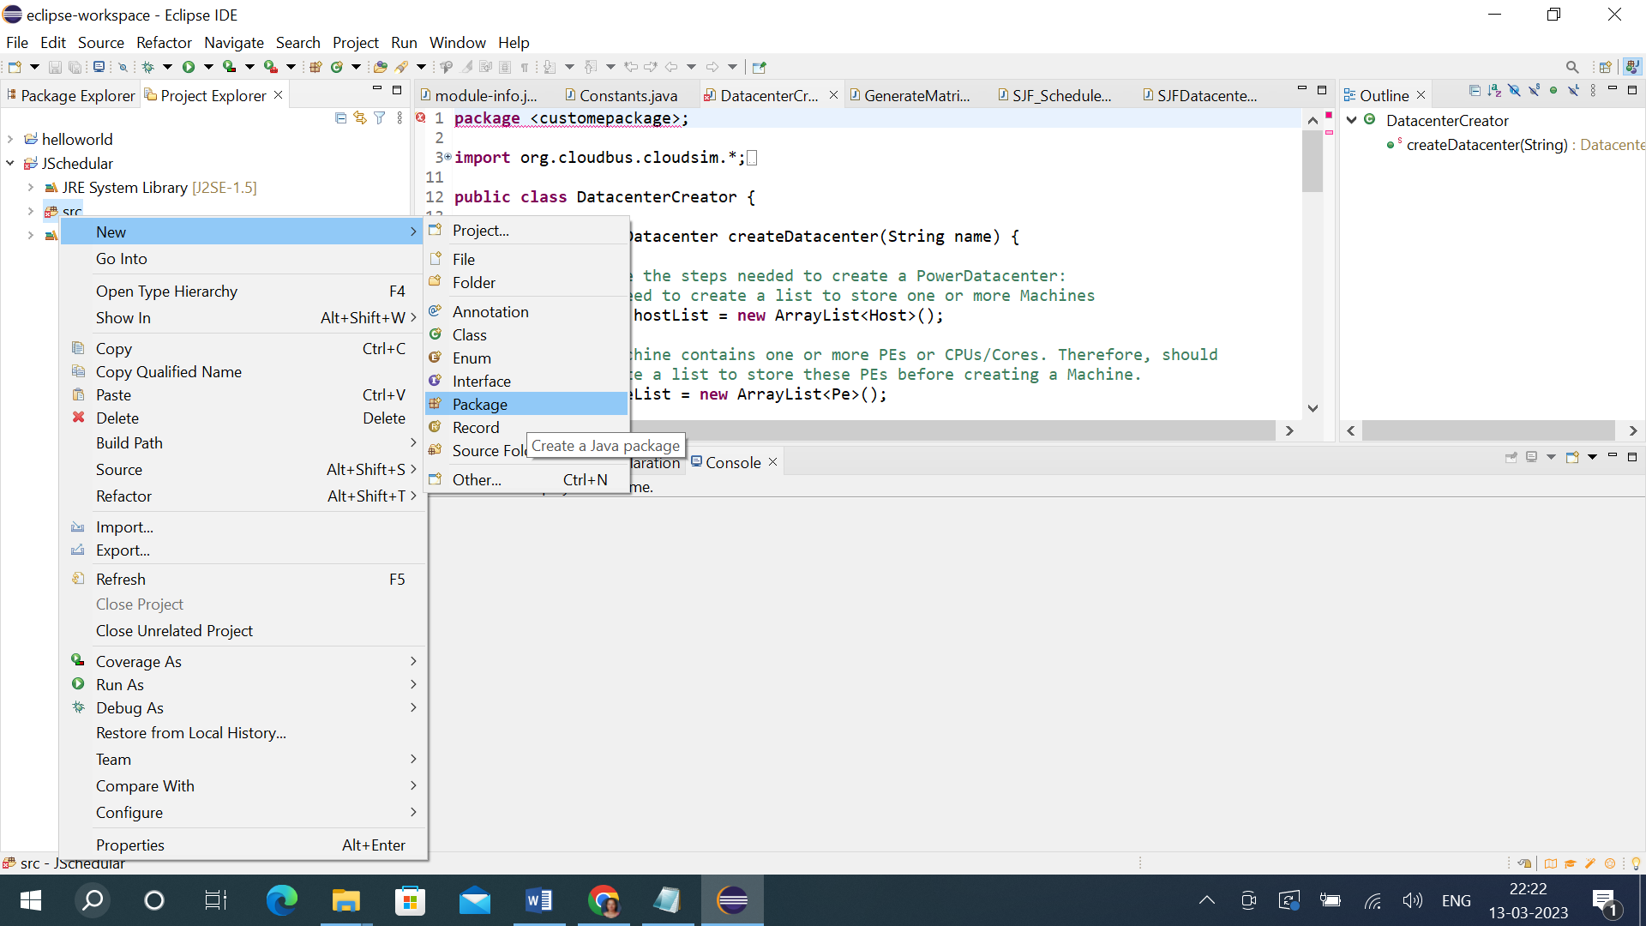

4. Give name to pacakage Ex. costom_package and click on finish.

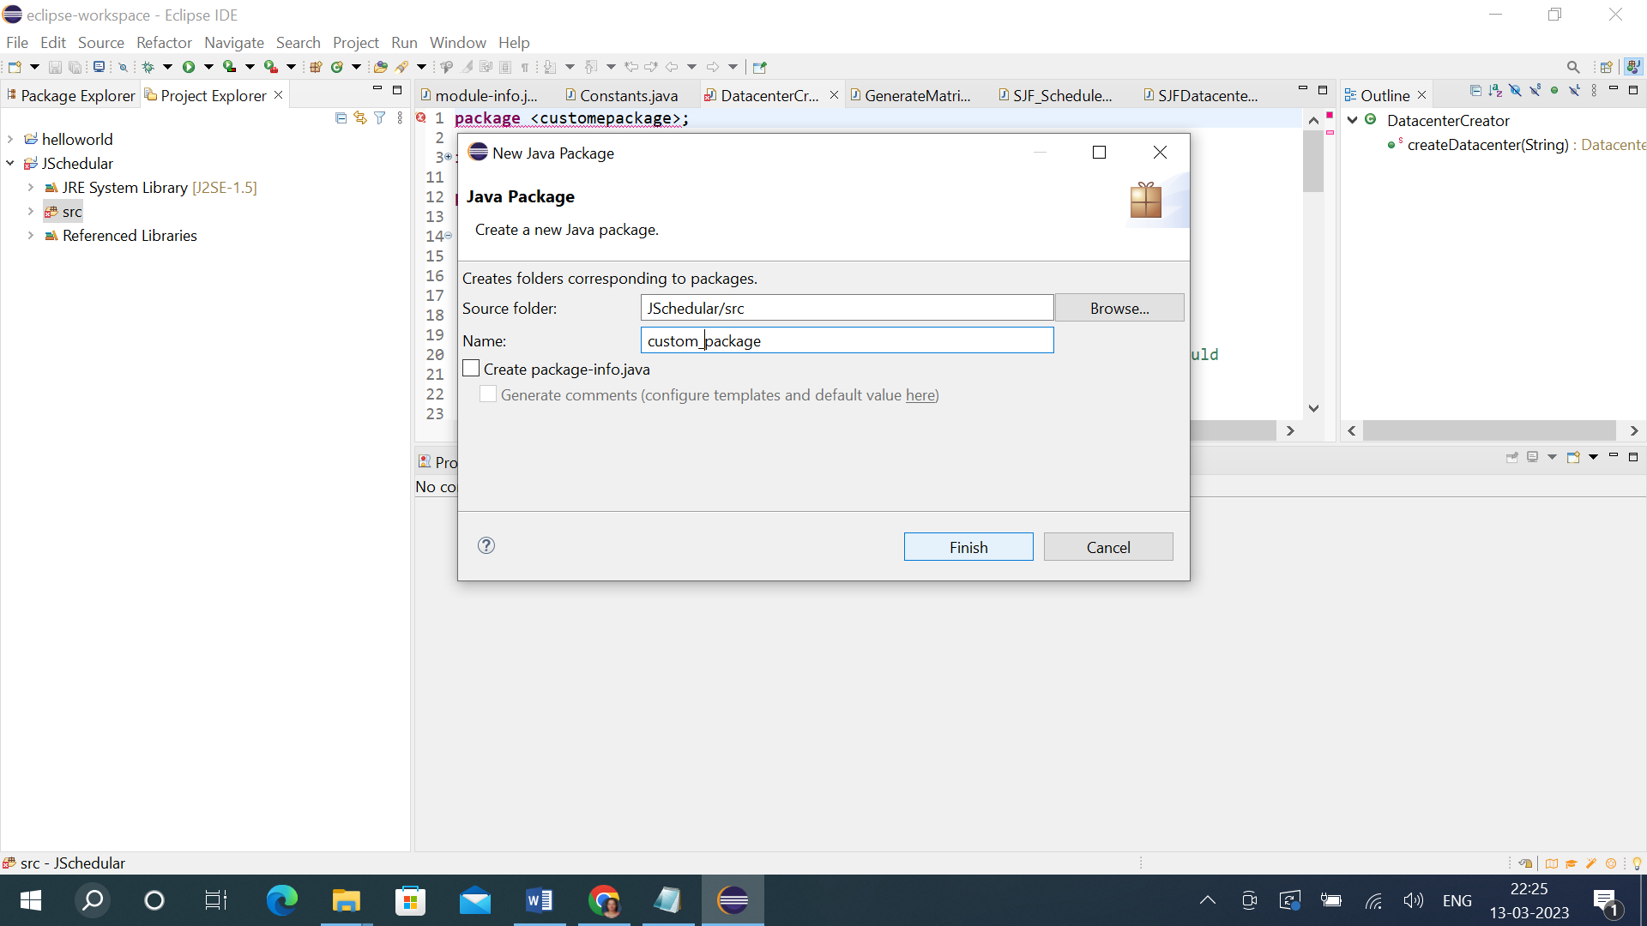

5. In side the costom_package file dumped all files present in source file. For that open it in system explorer.

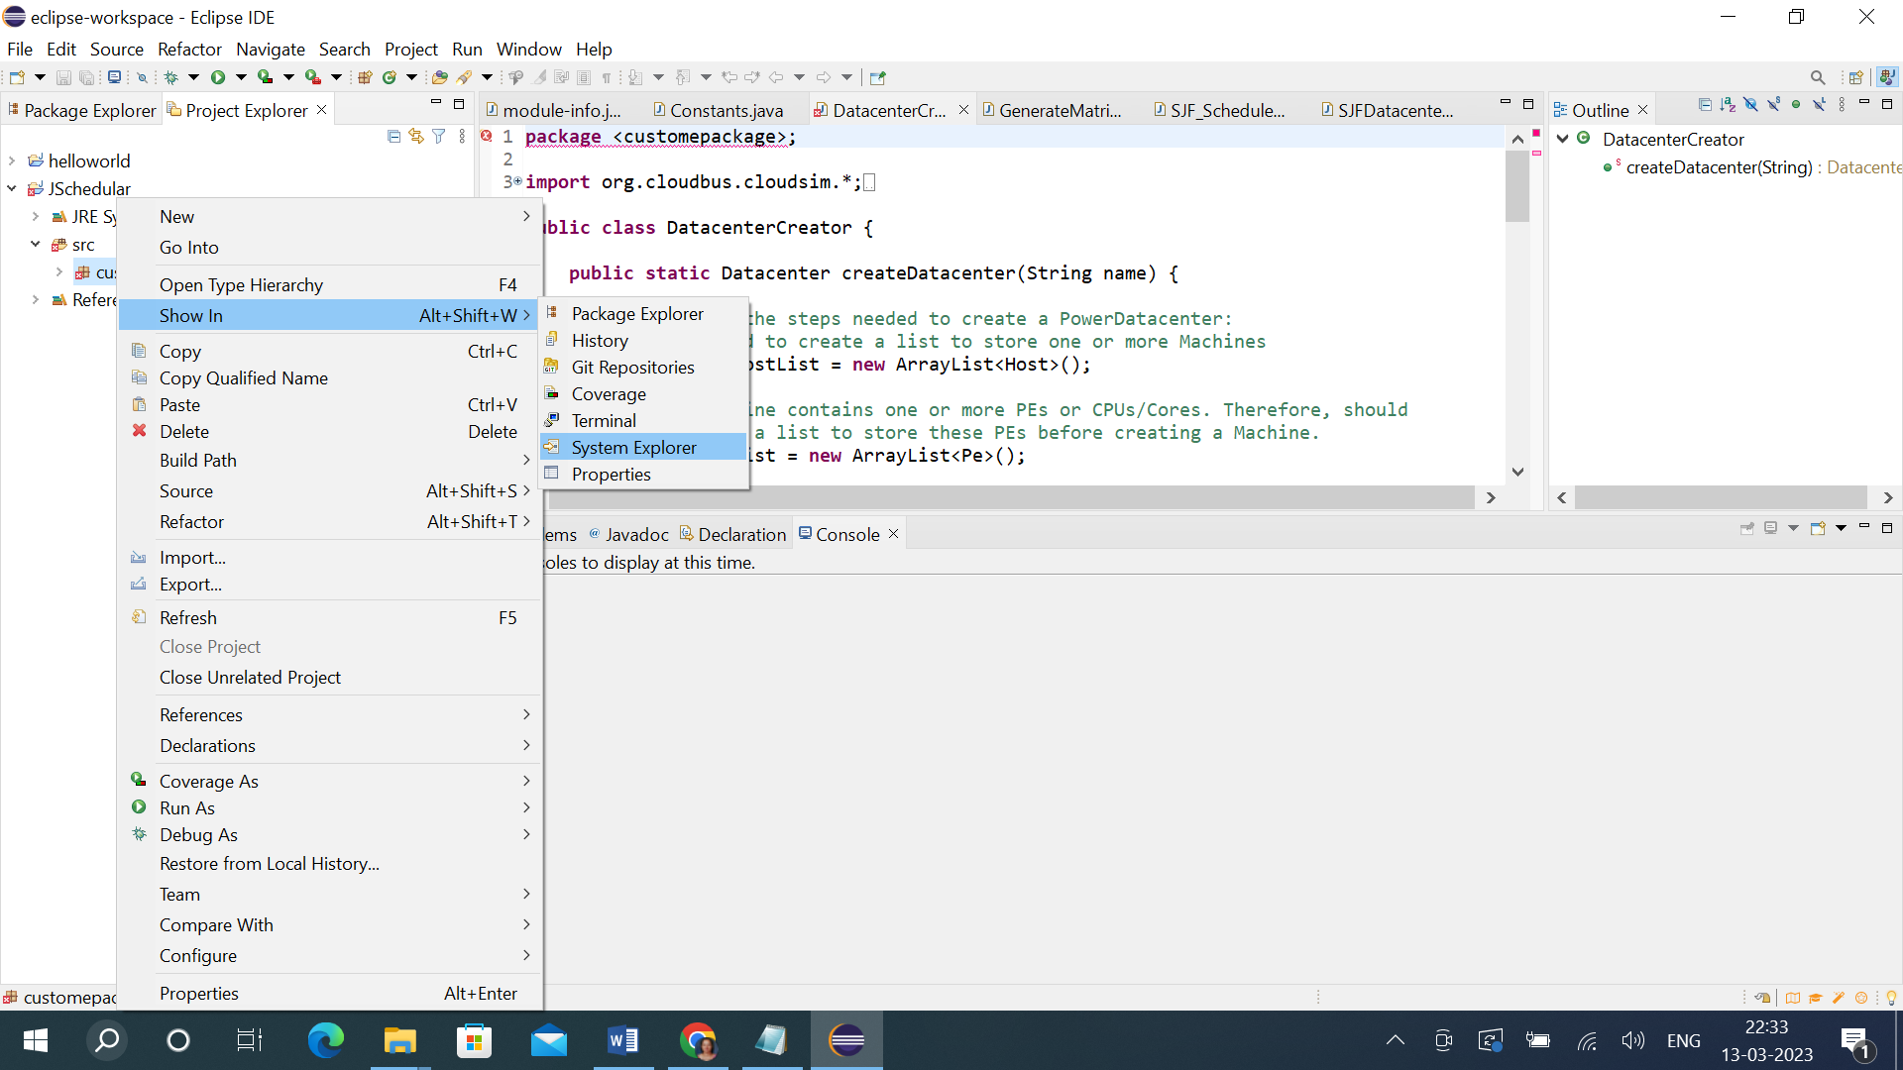

6. In costom_package copy all files present in source file and paste into the package.

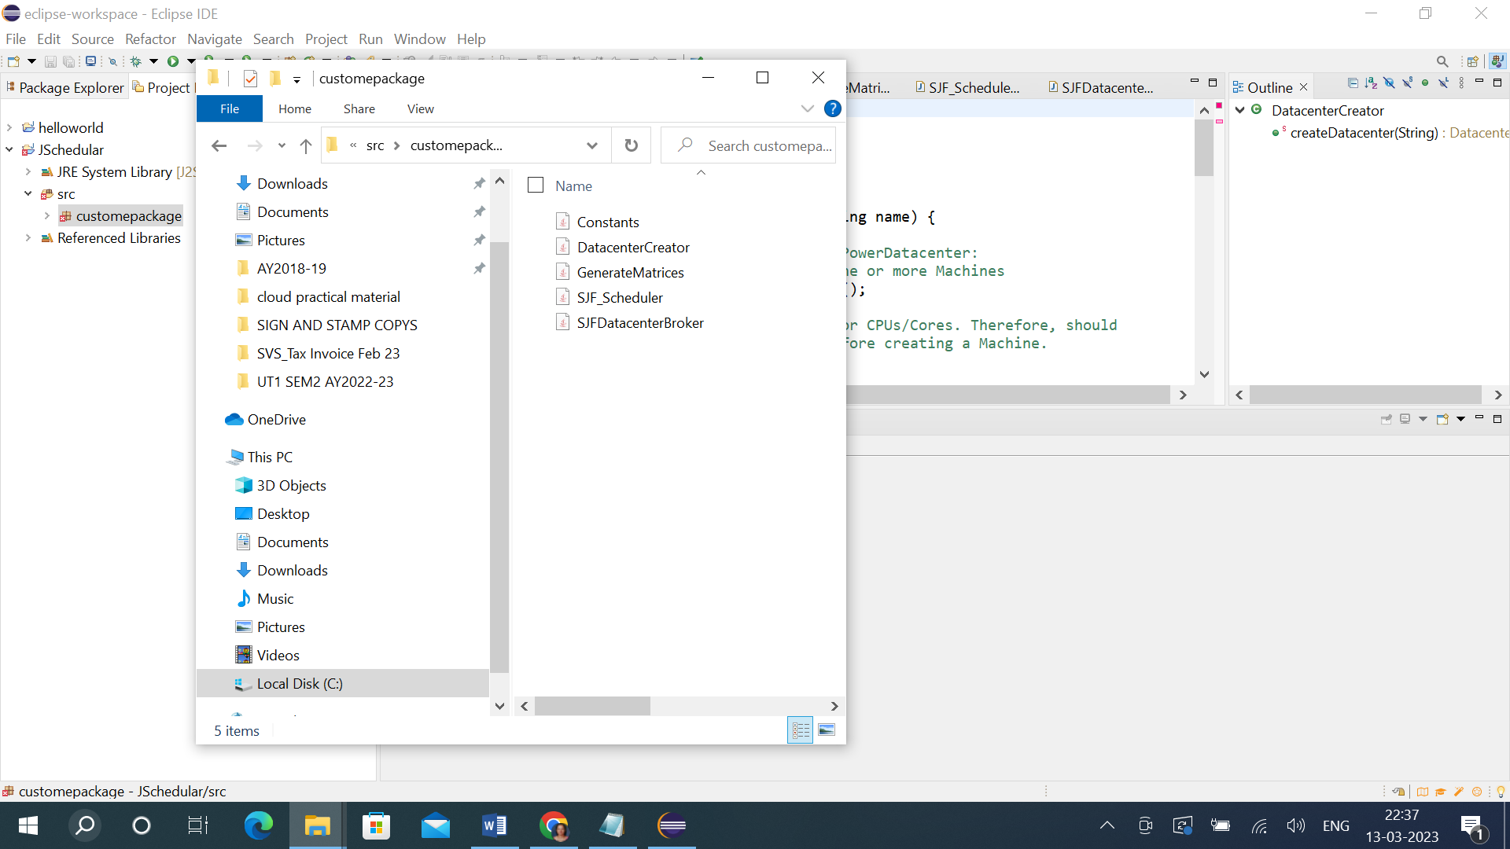

7. After this close the project and again open it. Then you can see all the files available in costom_package.

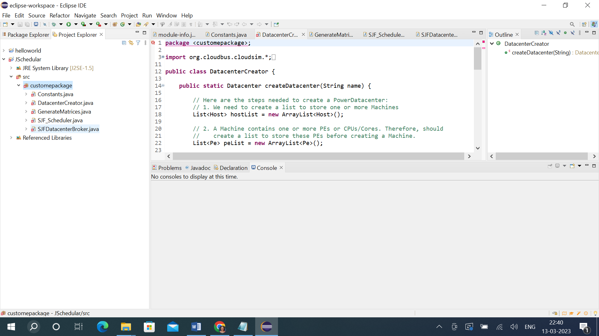

8. Here you can see cross mark on files, because package name in those files code is different. It must be same. For that open each file and change package name as per name given in the project. Ex. costom-package.

9. Then add jar files/ cloudsim files for that right click on sjfschedular->Build Path->configure build path-> add external jars. Then give the path where jar files are saved.

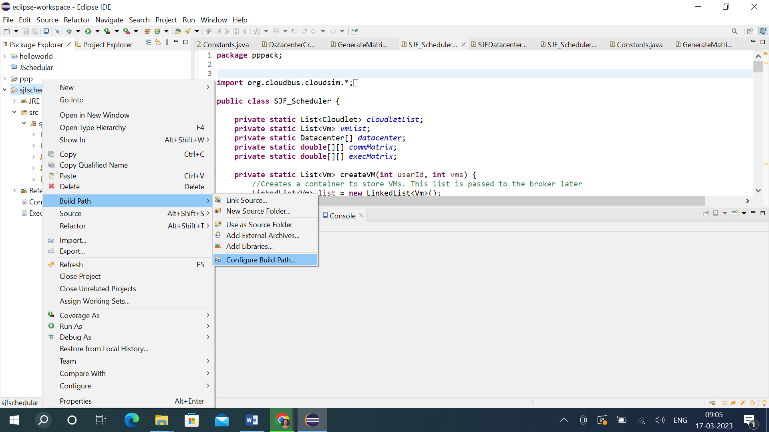

10. Select both Jar files ->open it->Apply->Apply and close.

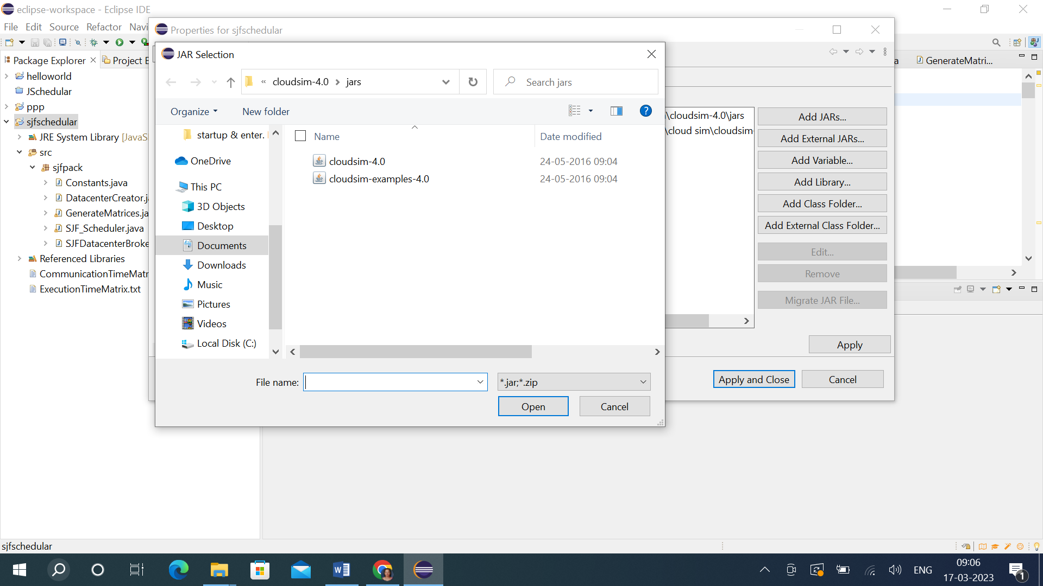

11. Run Schedular file, Ex. SJF_Scheduler.java file. For that right click ->Run As->Java Application.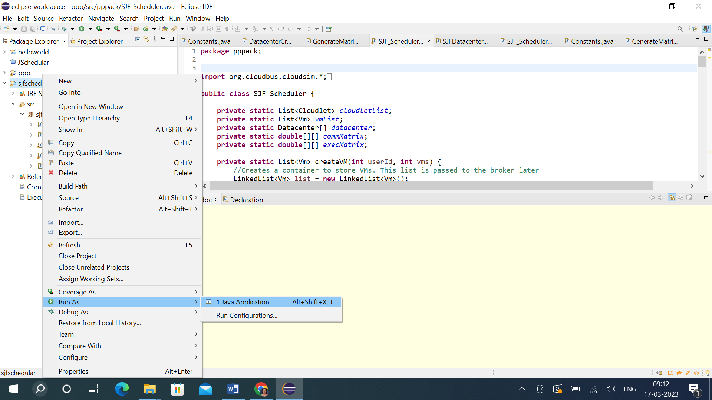

12. Then give our Package name. Ex. SJF_Scheduler-sjfpack then -> ok

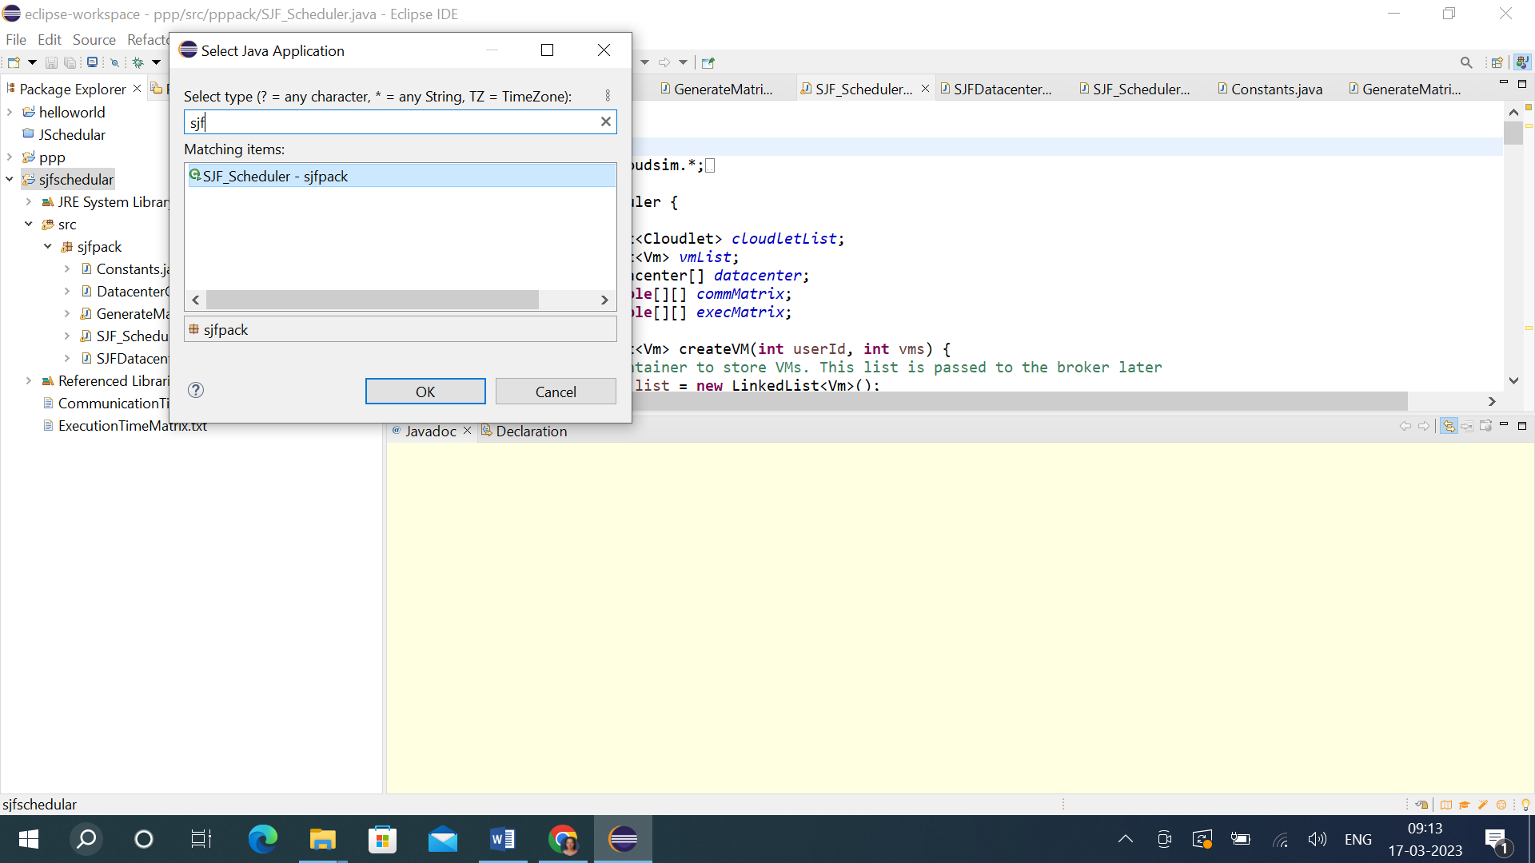

13. You will get output at output window.

