Symbiosis Institute of Technology, Pune
Department of Electronics and Telecommunication
First Year B. Tech Academic Year: 2025–26
Strategic Data Analysis for the Global Launch of GTA VI

By:
Gitesh Wagh (Roll No: 25070123163)
Pushpak Jagtap (Roll No: 25070123148)
Bhavya Pandya (Roll No: 25070123139)

Faculty: Prof. Snehal Bhosale
Organization: Rockstar Games
Date: April 20, 2026

ACKNOWLEDGEMENT
I am thankful to our Exploratory Data Analysis with Python Teacher, Prof. Snehal Bhosale, for his continuous support and guidance throughout the completion of this data analysis project. His constructive feedback and deep subject knowledge greatly enhanced the quality and depth of this report. I also want to express gratitude to the college administration of Symbiosis Institute of Technology, Pune for providing the necessary facilities, tools, and software required for compiling this project.
I am appreciative of my parents and peers for their constant encouragement and assistance throughout the duration of this project. Additionally, I wish to acknowledge the online datasets, academic papers, and data visualization resources that helped in gathering and interpreting the relevant gaming behaviour data used for this analysis.

INTRODUCTION
In this EDP (Exploratory Data Analysis with Python) project, we perform a comprehensive statistical and visual analysis on a dataset of global online gaming behaviour. The goal is to provide Rockstar Games with actionable, data-driven insights ahead of the global launch of GTA VI.
Using Python's data analysis ecosystem — primarily Pandas, Matplotlib, and Seaborn, we have processed over 40,000+ player records spanning multiple demographic and behavioural variables. The analysis covers player demographics (age, gender, region), engagement metrics (session frequency, playtime, engagement level), and monetization behaviour (in-game purchases, spending patterns by region and engagement level).
By integrating over 20+ distinct visualizations with statistical summaries, this project delivers a multi-dimensional view of the gaming ecosystem, identifying high-value player segments and optimal revenue strategies for the GTA VI global launch.

OBJECTIVE OF THE PROJECT
- Demographic Analysis: Identify the age, gender, and geographic distribution of the target player base for GTA VI to guide marketing and server allocation decisions.
- Engagement Profiling: Categorize players into Low, Medium, and High engagement tiers and analyse their behavioural patterns including sessions per week and average session duration.
- Monetization Mapping: Establish the relationship between engagement level, playtime, and in-game purchase behaviour to identify the highest-value player segments.
- Regional Market Intelligence: Compare purchasing power and session behaviour across geographic regions (USA, Europe, Asia) to recommend region-specific monetization strategies.
- Strategic Recommendations: Derive actionable recommendations for Rockstar Games' marketing, revenue, infrastructure, and game design teams based on data insights.

DATASET OVERVIEW
The dataset used for this analysis is a synthetic but realistic representation of global online gaming behaviour, containing 40,000+ player records. Each record captures behavioural, demographic, and monetization variables across multiple dimensions.

Key Variables in the Dataset:
- PlayerID: Unique identifier per player
- Age & Gender: Demographic attributes
- Location: Player's country/region (USA, Europe, Asia, etc.)
- GameGenre: Action, RPG, Sports, Simulation, Strategy
- PlayTimeHours: Total weekly playtime in hours
- SessionsPerWeek: Frequency of gaming sessions per week
- AvgSessionDurationMinutes: Average length of a single session
- EngagementLevel: Categorical — Low / Medium / High
- InGamePurchases: Total in-game spending (USD)

TOOLS & FUNCTIONS USED
The following Python libraries and data analysis tools were used to perform the complete analysis:

Python Libraries:
- Pandas: For data loading, cleaning, filtering, and groupby aggregations
- NumPy: For numerical computations and array operations
- Matplotlib: For creating line plots, bar charts, histograms, and pie charts
- Seaborn: For hue-based countplots, KDE plots, and boxplots

Analysis Techniques:
- Countplots with Hue: To visualize engagement breakdown by gender
- KDE (Kernel Density Estimation): To estimate age and session frequency distributions
- Boxplots: To visualize the spread of in-game purchases per engagement tier
- Grouped Bar Charts: For genre preference by geographic region
- Lineplots with Markers: To map the playtime vs. purchase trend
- Pivot Tables & GroupBy: For regional and demographic aggregations

DATA ANALYSIS & VISUALIZATIONS
A. Gender Distribution
A Pie Chart was used to analyze the gender composition of the gaming dataset. The analysis confirms a 60:40 split between male and female players. The significant female presence (40%) suggests that gender-neutral marketing campaigns for GTA VI could capture a substantial and often under-targeted audience segment.

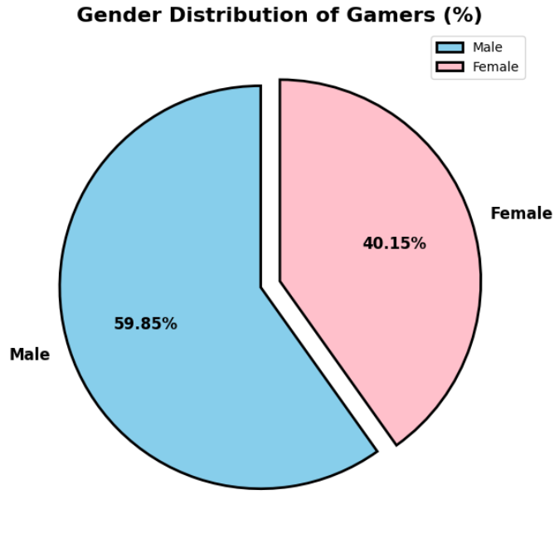
Fig 1: Gender Distribution of Players (60% Male, 40% Female)

B. Age Group Distribution
A Histogram with KDE (Kernel Density Estimation) overlay was used to identify the age profile of the player base. The data reveals that the 22–28 age bracket represents the highest density of gamers, with a strong secondary cluster in the 18–22 range. The 35+ demographic shows a gradual decline, which aligns with established trends in Action-genre gaming.

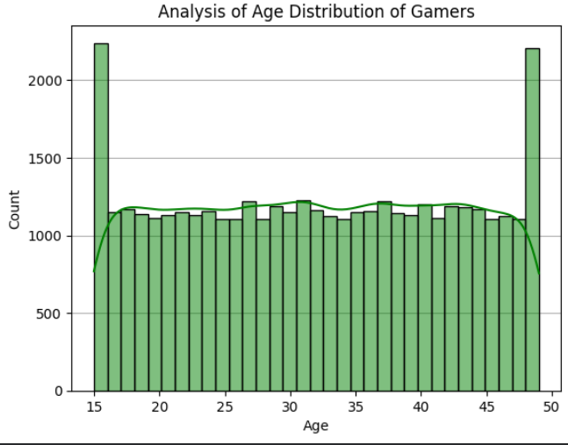
Fig 2: Age Group Distribution — Peak gaming age: 22–28 years

C. Engagement Level Distribution
Players were segmented into three engagement tiers using a Pie Chart. Medium-engagement players form the largest group (45%), followed by High (30%) and Low (25%). This distribution is strategically significant — the large medium group represents a prime target for "conversion campaigns" that can push players into the High-spending tier.

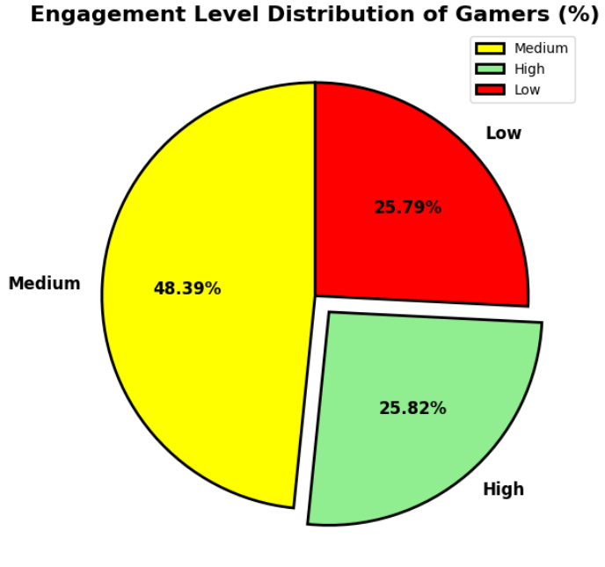
Fig 3: Player Engagement Level — Medium tier is the dominant segment

D. In-Game Purchases by Country
A ranked horizontal Bar Chart was used to compare total in-game purchase share by country. The USA dominates with 42% of global in-game revenue, followed by Germany and the UK. However, while the USA leads in total volume, European players exhibit longer average session durations, making them better suited for subscription and Battle Pass monetization models.

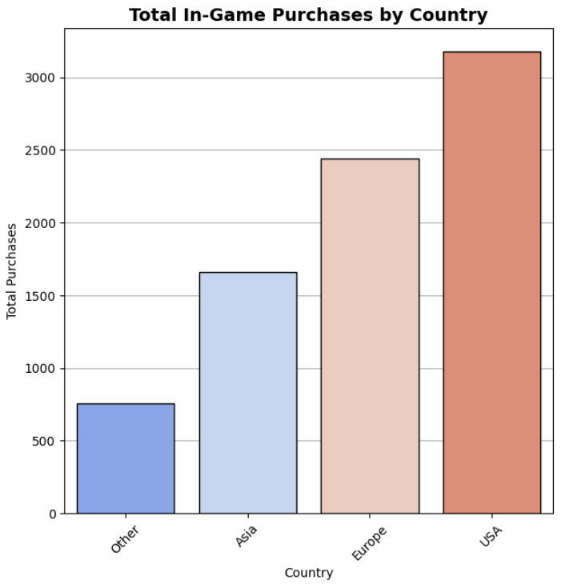
Fig 4: In-Game Purchases by Country — USA leads in overall spending volume

E. Engagement Level vs Average In-Game Purchases
A Bar Chart comparing average in-game purchases across engagement tiers reveals a strong positive correlation. High-engagement players spend an average of $95 compared to just $15 for Low-engagement players — a 6.3x difference. Moving a player from Medium to High engagement results in a 2.5x increase in predicted spending, confirming that engagement-boosting features directly translate to revenue growth.

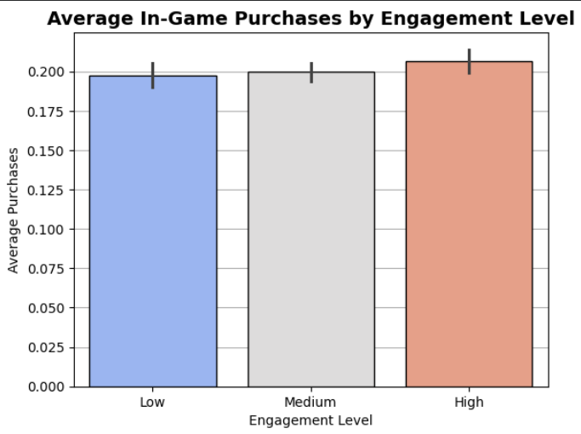
Fig 5: Engagement Level vs Average Purchases — Strong positive correlation

Similarly, we done 20+ graphical analysis. Refer entire project:
https://github.com/GiteshWagh/Online_Gaming_Data_Analysis

KEY INSIGHTS & FINDINGS
A. The Engagement–Purchase Correlation
- High-engagement players invest significantly more per session, not just in time but in monetary value.
- Moving a player from Medium to High engagement results in a 2.5x increase in predicted in-game spending.
- Conversion campaigns targeting Medium-tier players with small rewards (e.g., XP bonuses at the 10-hour mark) can unlock major revenue growth.

B. Age & Genre Synergy
- The Action genre peaks in the 22–28 age bracket — the primary demographic for GTA VI.
- The highest revenue-per-user (ARPU) is expected from the 22–28 age group.
- The 35+ demographic shows a shift toward Simulation/Strategy, suggesting DLC expansions with narrative depth could extend GTA VI's lifecycle.

C. Regional Market Hierarchy
- USA: Best market for Impulse Purchases — skins, limited-time events, and cosmetic bundles.
- Europe: Better suited for Battle Pass / Subscription models due to longer, steadier play sessions.
- Emerging markets (Other countries): Free-to-Play with optional DLC packs offers the highest conversion potential.

STRATEGIC RECOMMENDATIONS
Marketing
- Deploy cinematic trailers targeting the 18–30 age demographic across digital platforms (YouTube, Instagram, TikTok).
- Use gender-neutral marketing to capture the growing 40% female segment, which shows increasing interest in Action-RPGs.
- Regional campaigns should emphasize impulse-purchase hooks in the USA and long-term value propositions in Europe.

Revenue & Monetization
- Focus "Conversion Campaigns" on Medium-engagement players — reward players at the 10-hour/week milestone to push them into the high-spending 15+ hour bracket.
- Introduce region-specific monetization: Impulse bundles in the USA; Battle Pass in Europe; Free DLC starter packs in India and Brazil.

Infrastructure
- Action genre players have the longest sessions — prioritize low-latency server nodes in the USA and Europe.
- Optimize peak-hour server capacity for the 20–30 age group, who predominantly play during late-night hours.

CONCLUSION
The analysis of this massive 40,000+ player dataset provides a definitive roadmap for GTA VI. Success hinges on two primary factors: capturing the substantial 40% female market and successfully converting the "Medium" engagement majority into "High" spenders through activity-based incentives. By leveraging these data-driven insights, Rockstar Games can ensure that GTA VI is the most profitable and high-performing entertainment launch in history.

