PredictaX Demand Prediction — Architecture Overview

1. What the Platform Does
The platform is a single web dashboard that helps UAE automobile businesses forecast demand, understand customers, plan inventory, and track how world events affect the car market. It combines a transaction database, three predictive models, and a live news-analysis pipeline into one interface, organized into seven modules a user navigates between.

2. Technology Choices
Layer | Technology | Why it fits
Application & UI | Streamlit (Python) | Lets a data/ML team ship a full interactive dashboard without a separate frontend codebase
Charts | Plotly | Interactive charts and the dealer map, rendered directly from Python
Data storage | SQLite, accessed through SQLAlchemy | Lightweight, file-based, zero setup — appropriate for a POC/demo scale
Demand forecasting | Prophet (time-series forecasting library) | Handles seasonality and external factors well with modest data volume
Customer segmentation | K-Means clustering | Simple, explainable grouping of customers into behavioral segments
Lead scoring | XGBoost + SHAP | Strong tabular-data performance, with SHAP providing a "why" behind each prediction
News & sentiment | GDELT news feed + an AI language model, with a rule-based fallback | Combines real-world events with a consistent no-cost fallback when the AI service isn't configured

3. System Architecture
The platform is organized in layers: a UI layer the user interacts with, an application layer that manages navigation and filters, the seven intelligence modules themselves, the analytics engines that do the actual prediction work, and the data layer underneath everything.


Diagram 1
A single set of filters (date range, Emirate, city, brand, vehicle type, fuel type) sits above all seven modules and narrows down what each one shows. Choosing a module on the left simply swaps which module renders in the main panel the filters and underlying data connection stay the same underneath.
One important operating characteristic: nothing is cached. Each time a user changes a filter or a setting, the relevant module re-queries the database and on the Forecasting page retrains its prediction model from scratch. This keeps every view fully up to date at the cost of some responsiveness; it's a reasonable tradeoff at the current data volume and worth revisiting if usage grows.

4. Data Model
All business data lives in a relational database with nine tables. Customers, vehicles, and dealers are the core reference entities sales and inventory records connect them together and a separate set of tables tracks daily market conditions and news-derived sentiment
Two independent copies of this database exist side by side: one holding real UAE market data and one holding synthetic test data. The application currently always runs against the real-data copy, though the underlying design supports switching between the two.
A practical detail worth documenting on hosting environments where the application's own folder can't be written to, the platform automatically detects this and works from a temporary writable copy of the database instead, so the app doesn't crash any changes made in that situation simply don't persist past that session, and the committed database is never at risk of corruption.

5. End-to-End Data Flow

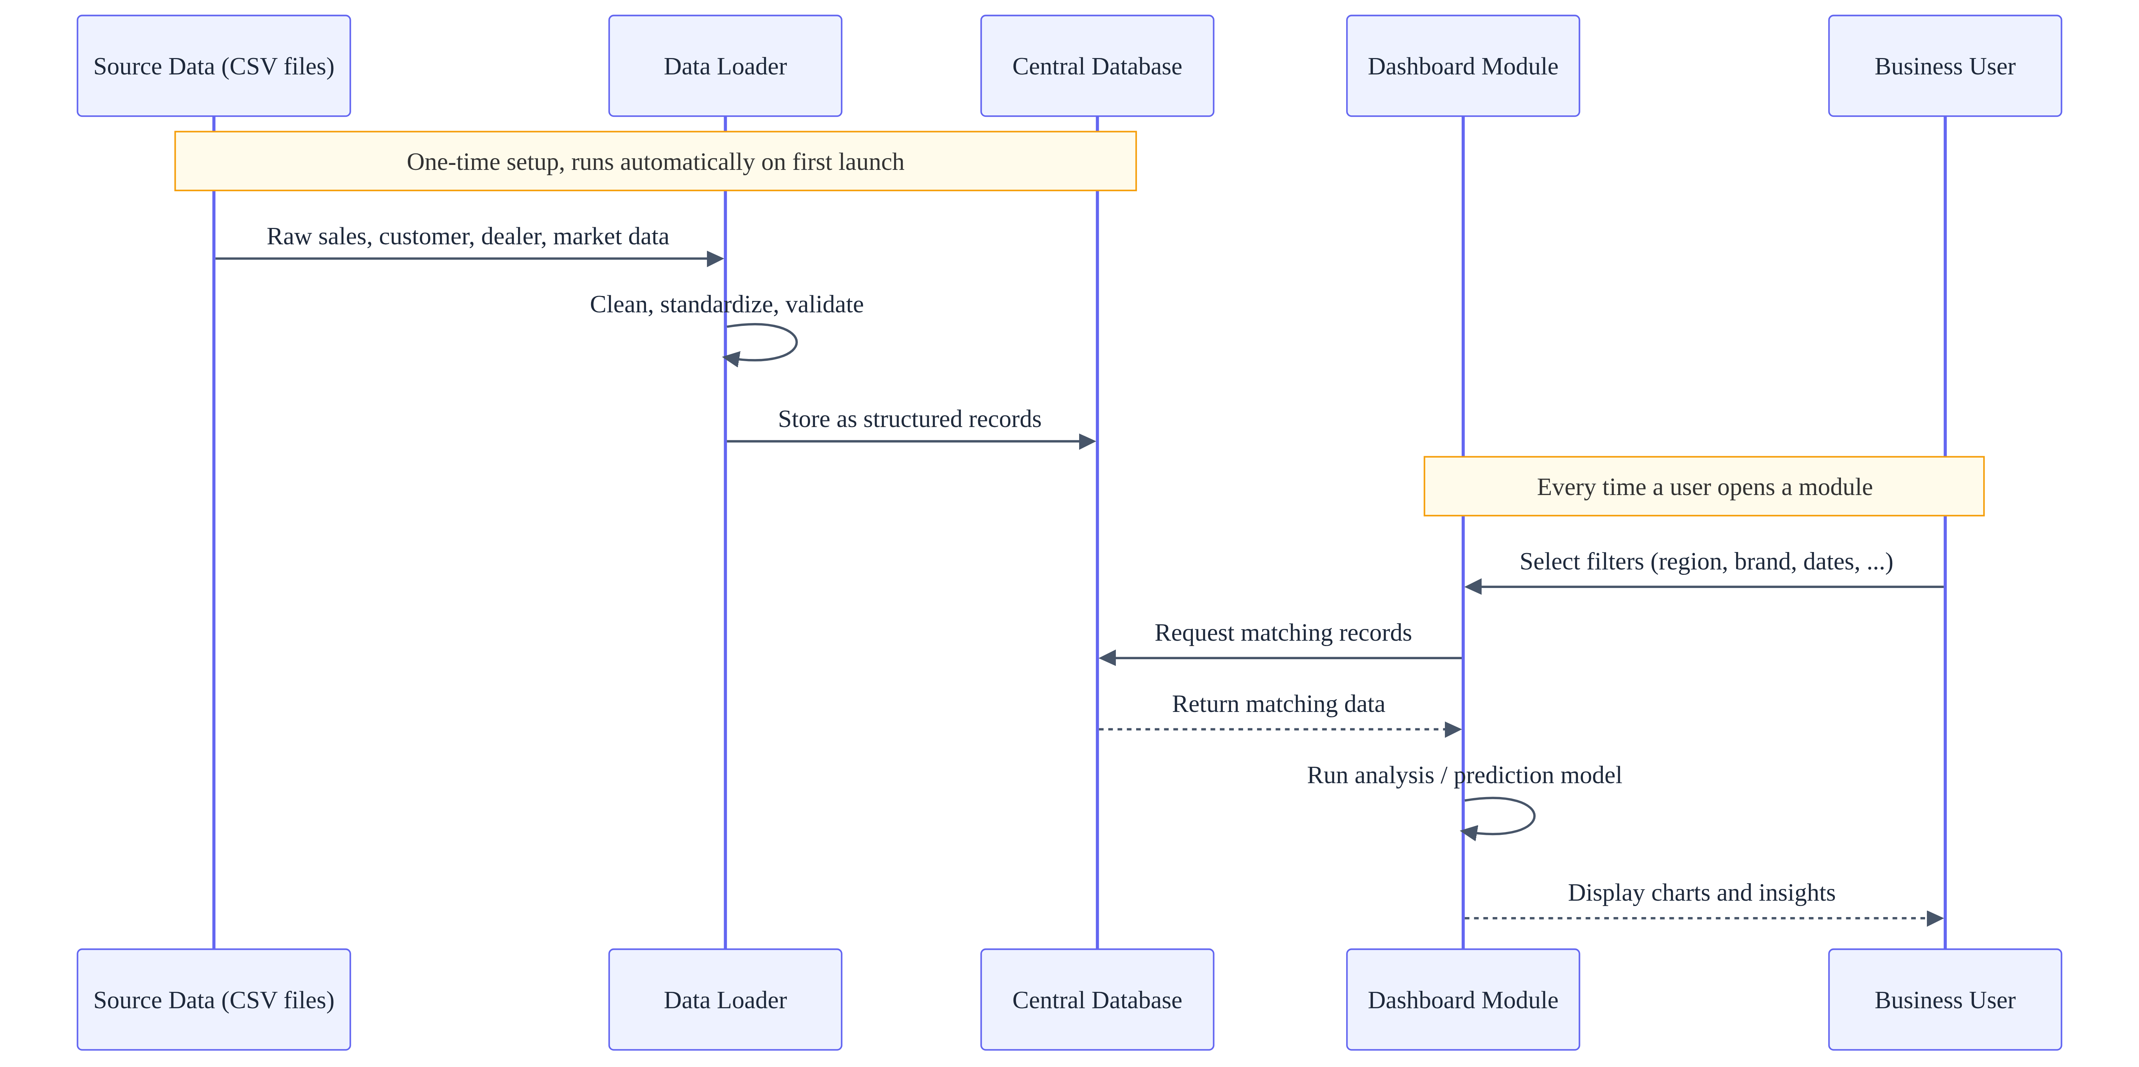
Diagram 2
The news and sentiment pipeline runs on a separate track from this it doesn't happen automatically on page load. It only runs when a user explicitly refreshes it, or a lightweight version of it runs quietly in the background the first time someone opens the Sentiment module in a session, described in Section 8.

6. Demand Forecasting
The forecasting module predicts future sales volume or revenue using a time-series model trained on historical transactions plus market condition data (fuel prices, inflation, tourism activity, and similar factors). It automatically learns weekly and yearly seasonal patterns from the sales history, so it captures effects like holiday spikes or slow months on its own.
Setting | Value
Forecast horizon | 30 to 365 days, user-selectable
Confidence range | 70%–99%, user-selectable
Seasonal patterns learned | Weekly and yearly
Market factors considered | Up to 18, including fuel prices, GDP growth, inflation, exchange rate, tourism, and EV infrastructure each only used if it actually varies in the data
Model validation | Last 30 days of history held back and compared against the model's own prediction, to report accuracy honestly

What-if scenario testing
The most interactive part of this module lets a user drag sliders for market conditions for example, raising the assumed petrol price and immediately see how the forecast shifts. Two things happen together when a slider moves:
- The model itself is re-evaluated with the new assumption applied to the future period only (history is never altered).
- A secondary, hand-tuned sensitivity reference (built from domain assumptions about how strongly each factor typically affects car demand) further scales the future prediction, so the visual effect of moving a slider is clear and proportionate.

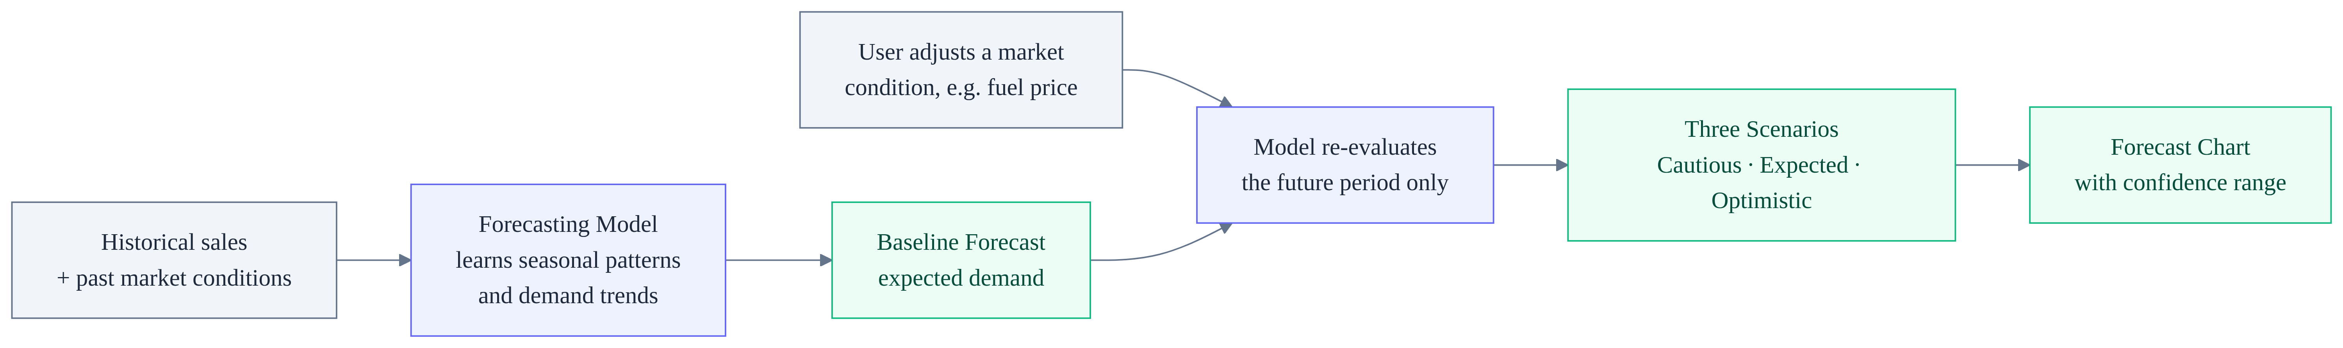
Diagram 3
The three scenario lines shown on the chart (Cautious, Expected, Optimistic) come from the model's own statistical confidence range at the confidence level the user selected they widen or narrow directly with that slider.
The same forecasting model, optionally combined with sentiment data from Section 8, powers the "Forecast Comparison" view running two versions side by side (with and without news sentiment as an input) so the team can see whether factoring in current events actually improves prediction accuracy.

7. Customer & Lead Intelligence
Two separate models work together in the Customer module.

Customer segmentation
Every customer is grouped into one of five behavioral segments such as Premium Buyer, Budget Buyer, or High Repeat Customer based on income, credit score, past purchase count, loyalty, and churn risk. The grouping is done automatically by a clustering algorithm, and the resulting segment labels are then written back onto each customer's record so the rest of the platform can use them.

Lead conversion scoring
The interactive lead-scoring tool takes a hypothetical customer's details (income, credit score, offer terms, financing type, and so on) and returns a likelihood that they will actually convert into a sale. Alongside the score, it shows which specific factors pushed the likelihood up or down this explanation is produced by inspecting the trained model's actual decision process (not a separate guess), so it reflects what the model really weighed.

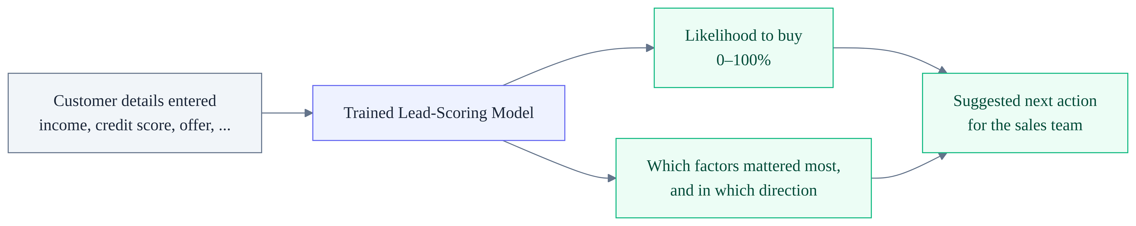
Diagram 4
Both models are trained ahead of time on historical data rather than learning live from each interaction using them in the dashboard is fast because it's just applying an already-trained model, not retraining one.

8. Sentiment & Geopolitical Risk Pipeline
This module connects real-world news to expected car demand. It pulls recent articles relevant to the UAE auto market, fuel prices, and the broader economy from a global news index, then scores each one for sentiment (positive/negative), potential impact, and economic risk level.
The system automatically uses the AI scoring service when it's configured, and falls back to a consistent rule-based scorer when it isn't (or if the AI service has a temporary issue) either way, the dashboard always has something meaningful to show, and the two paths produce results in exactly the same format so nothing downstream needs to know which one ran.
The daily risk score itself reflects both how negative the day's news was and how much of it was negative a single very negative headline moves the needle less than a day where most articles lean negative. To avoid unnecessary AI usage, a lightweight version of this scoring runs automatically and quietly using only the fallback method whenever someone opens the Sentiment module; the full AI-powered analysis only runs when a user explicitly clicks "Refresh Data."

9. Module Reference
Module | What it's built on
Executive Overview | Aggregated sales/revenue queries
Demand Forecasting | Forecasting model (Section 6)
Comparative Analytics | Year-over-year queries, plus a dedicated competitive analysis of Chinese auto brands entering the UAE market
Regional Intelligence | Dealer performance queries, mapped geographically
Customer Intelligence | Segmentation + lead-scoring models (Section 7)
Inventory Intelligence | Stock-level and reorder queries, compared against forecasted demand
Sentiment Analysis | News and sentiment pipeline (Section 8)

Three additional modules a broader scenario simulator, a CSV data-upload tool, and a model-performance viewer are already built but not currently switched on in the navigation menu. They're straightforward to enable if the roadmap calls for them.

