PredictaX Demand Prediction — Technical Documentation
Product name: PredictaX
Purpose: Streamlit dashboard for UAE automobile demand forecasting, customer/lead intelligence, inventory planning, and geopolitical/news sentiment analysis.
It covers architecture, data flow, database schema, the ML/forecasting internals, the sentiment pipeline, configuration, and deployment. Diagrams render natively on GitHub and in VS Code.

1. Tech Stack
Layer | Technology
UI / app framework | Streamlit >=1.35.0, streamlit-option-menu for the sidebar nav
Charts | Plotly >=5.22.0 (all charts, incl. the Mapbox dealer map)
Data layer | SQLAlchemy >=2.0.0 ORM over SQLite (two separate .db files)
Forecasting | Facebook/Meta Prophet >=1.1.5
Customer segmentation | scikit-learn KMeans >=1.4.0
Lead scoring | XGBoost >=2.0.0 (XGBClassifier) + SHAP >=0.45.0 for explainability
News ingestion | GDELT Doc 2.0 API (public, no key)
Sentiment scoring | xAI Grok (grok-3-mini, via OpenAI-compatible SDK) with a deterministic keyword-based mock fallback
Config | python-dotenv (.env), no st.secrets used anywhere
Packaging / deploy | Docker (Dockerfile, docker-compose.yml)

No JavaScript/frontend framework exists — Streamlit generates the entire UI server-side from Python.

2. Repository Layout
app.py Entry point / router / global filters
train_models.py CLI: seeds test DB + trains all ML artifacts
dashboard/ One render_*(filters) function per page
overview.py Executive Overview [active]
forecasting.py Demand Forecasting [active]
comparison.py Comparative Analytics [active]
regional.py Regional Intelligence [active]
customers.py Customer Intelligence [active]
inventory.py Inventory Intelligence [active]
sentiment_analysis.py Sentiment / Geo Risk [active]
ai_insights.py Scenario Simulator [written, NOT routed]
upload_data.py CSV upload + retrain UI [written, NOT routed]
metrics.py Model metrics viewer [written, NOT routed]
database/
connection.py Dual SQLAlchemy engines, mode switch, writable-path fallback
models.py ORM models — 9 tables
queries.py Every read query used by the dashboards
forecasting/
prophet_forecasting.py Prophet train/predict pipeline, market-driver overrides
ml_models/
customer_segmentation.py KMeans clustering (writes segments back to DB)
xgboost_model.py Lead-conversion classifier + SHAP explainability
sentiment/
fetchers/gdelt_fetcher.py GDELT news client (rate-limited)
analyzers/grok_analyzer.py LIVE (Grok) / MOCK sentiment scorer
signal_processor.py Aggregation, formulas, orchestration
preprocessing/
seed_database.py CSV → SQLite loader (test mode)
seed_real_database.py CSV → SQLite loader (real mode)
clean_data.py Shared per-table cleaning/typing functions
fix_*.py, patch_*.py, ... One-off data-repair scripts (hand-tuning real dataset)
utils/helpers.py CSS injection, KPI card renderer, palette
models/ Persisted pickles, mode-scoped: {clustering,xgboost}/{test,real}/
automobile_datasets/ Synthetic "test" mode source CSVs
realdata-datasets/ Real UAE market source CSVs
assets/ Logo, custom.css
.streamlit/config.toml Dark theme config (no secrets.toml committed)
Dockerfile, docker-compose.yml
Two SQLite files live at repo root and are used interchangeably depending on data mode: automobile_demand.db (test) and real_demand.db (real).

3. High-Level Architecture

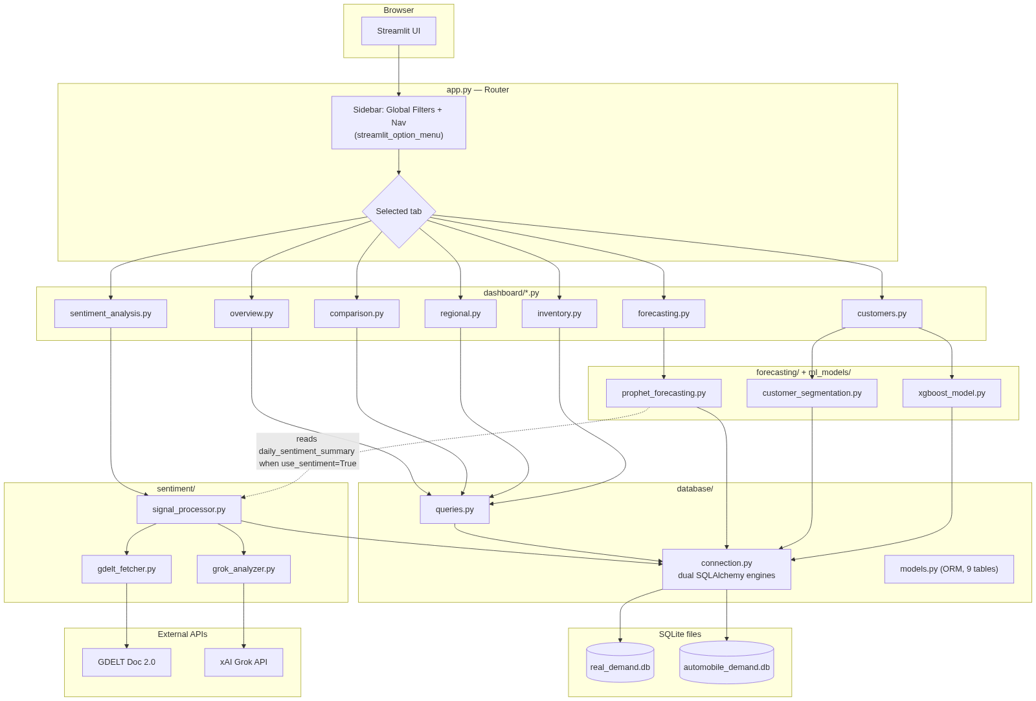
Diagram 1
Key architectural fact: there is no caching layer anywhere in the app (@st.cache_data / @st.cache_resource are not used). Every widget interaction triggers a full Streamlit script rerun, which re-runs all DB queries and — on the Forecasting page — retrains Prophet from scratch twice (once for validation metrics, once on the full dataset). This is fine for a demo/POC at current data volume but is the first thing to address before scaling usage.

4. Application Bootstrap & Routing (`app.py`)
- st.set_page_config(page_title="Automobile Demand Intelligence Platform", layout="wide", initial_sidebar_state="expanded").
- inject_custom_css() (utils/helpers.py) loads assets/styles/custom.css.
- Data mode bootstrap: st.session_state.data_mode defaults to "real". The Test/Real switch UI exists in code but is fully commented out — the app is effectively hard-locked to Real mode unless someone edits app.py or calls set_data_mode("test") directly.
- On first load in Real mode, if the sales table is empty, preprocessing/seed_real_database.py::main() runs inside a spinner, then st.rerun().
- Sidebar nav is streamlit_option_menu.option_menu with 7 live entries; 3 more (Insights & Simulator, Data Ingestion Engine, Model Performance Metrics) exist but their imports/menu entries are commented out.
- Global filters (date range, Emirate, Area, Brand, Vehicle Category, Fuel Type) are collected once into a filters: dict and passed positionally into every render_*(filters) call. Area options dynamically re-query based on the selected Emirate.
- Routing is a plain if/elif chain on the selected menu string → dashboard.<module>.render_*(filters).

Session state keys in use
data_mode, market_overrides, sentiment_pipeline_running, sentiment_pipeline_status, sentiment_briefing, sentiment_briefing_stats, fc_cmp_base, fc_cmp_sent, fc_cmp_target, fc_cmp_horizon.

5. Database Layer

5.1 Dual-engine design
database/connection.py maintains two independent SQLAlchemy engines/sessions in the same process:
Mode | File | Env override
real (default, only reachable mode via UI) | real_demand.db | REAL_DATABASE_URL
test | automobile_demand.db | DATABASE_URL

set_data_mode(mode) / get_data_mode() flip a module-level global; get_db_session() returns a session from whichever engine is active. This single switch also controls which model-pickle subfolder (models/{clustering,xgboost}/{test,real}/) each ML module loads from, and several dashboard branches (Overview, Customers, Regional) that show different KPI columns per mode.

5.2 Writable-path fallback
Relevant to the earlier commits fixing DB writability on read-only hosts (e.g. Streamlit Community Cloud):
# database/connection.py — _resolve_writable_sqlite_path (paraphrased)
try:
open(target_path, "r+b") # actually probe the real DB file
except OSError:
shutil.copy(target_path, tempfile.gettempdir())
target_path = tempdir_copy_path # writes land in temp, not the repo
The earlier bug was probing a *sibling* file's writability, which can succeed even when the committed DB file itself is locked/read-only. The fix opens the actual target file. If unwritable, it copies the committed DB into the OS temp directory and points the engine there — writes survive for the life of that process only; a redeploy always resets to the checked-in baseline. Both DBs go through this resolver independently.

5.3 Schema (ER diagram)

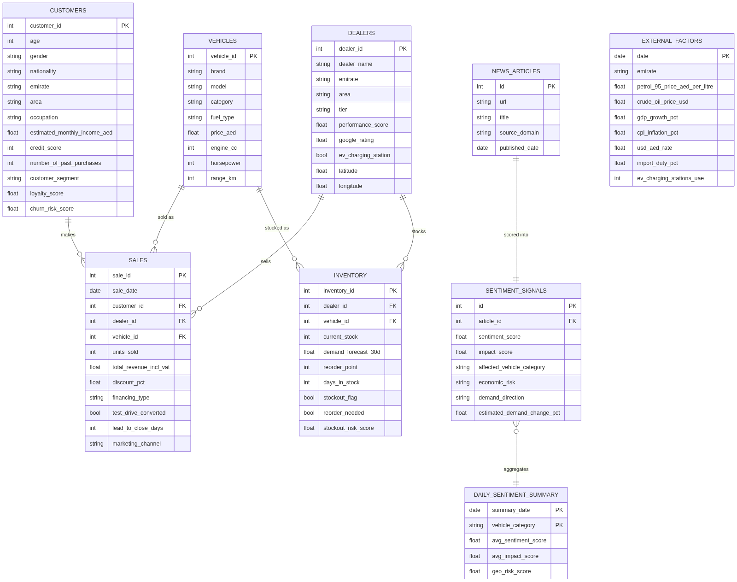
Diagram 2
Note: Sale denormalizes brand/vehicle_category/fuel_type/emirate/area directly onto each row (in addition to the FK relationships) purely for query-speed convenience in the dashboards.

5.4 Query layer (`database/queries.py`)
- Every function takes a SQLAlchemy Session and returns a dict (KPI functions) or a pd.DataFrame (via pd.read_sql).
- _apply_sale_filters is a shared helper applying region/city/category/fuel/brand/financing/date filters — used by nearly every Sale-based query.
- National scaling: the dataset is a documented 1-in-17 sample of the real UAE market. NATIONAL_SCALE_FACTOR = 17 is applied to sales/revenue KPIs so displayed numbers represent estimated national totals, not raw row counts.
- The "Chinese Brand Pressure" queries (get_chinese_brand_yearly_share, get_price_competitiveness, get_ev_segment_by_brand_year, get_market_share_shift) intentionally ignore the sidebar brand filter so the competitive-analysis section always shows the full market. The 2027 share projection uses np.polyfit (simple linear regression) on year-over-year share.

6. Data Flow (Seed → Query → Render)

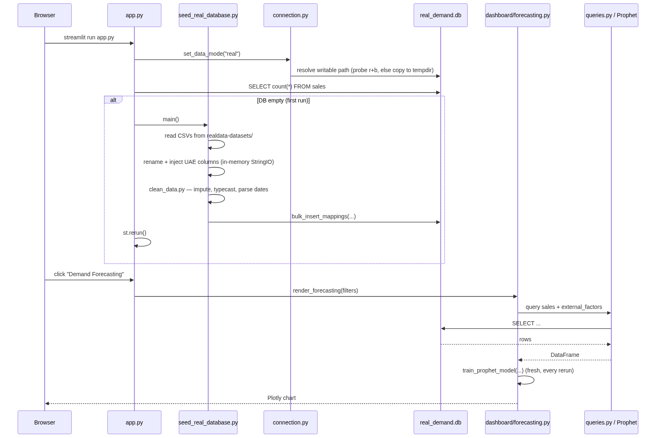
Diagram 3
The sentiment pipeline is a separate, user-triggered flow (see §8) — it doesn't run on page load, only on the "Refresh Data" button or lazily via ensure_recent_articles_analyzed() (mock-only, on tab open).

7. Forecasting Engine (`forecasting/prophet_forecasting.py`)
Single entry point: train_prophet_model(category, region, fuel_type, target, horizon_days=90, interval_width=0.95, use_sentiment=False, market_overrides=None) — called fresh on every UI interaction, no caching.
Pipeline:
- Pull daily Sale.units_sold or Sale.total_revenue_incl_vat, filtered by category/region/fuel_type, reindexed to fill missing dates with 0.
- Pull ExternalFactor columns (monthly), resample to daily via .resample('D').ffill(), merge onto sales by date.
- If use_sentiment=True, merge avg_sentiment_score and geopolitical_risk_score from signal_processor.get_daily_summaries() (wrapped in try/except — a missing sentiment table fails silently, forecast just proceeds without those regressors).
- Model config: Prophet(yearly_seasonality=True, weekly_seasonality=True, daily_seasonality=False, interval_width=interval_width). Growth type and changepoint settings are left at Prophet defaults — not tuned anywhere.
- Regressors: iterates a fixed candidate list of ~18 external-factor/sentiment columns; each is added via model.add_regressor(reg) only if present and has more than one distinct value (constant columns auto-excluded).
- Validation split: last 30 rows held out; reports RMSE, MAE, and a custom accuracy = max(0, min(1, 1 - mae/mean_y)) * 100.
- Retrains on the full dataset for the actual forecast — i.e. every call trains Prophet twice.
- future = full_model.make_future_dataframe(periods=horizon_days); historical regressor values are back-filled, then user market-driver overrides are applied only to future-dated rows.
- forecast = full_model.predict(future); negative yhat/bounds are clipped to 0.

7.1 What-if slider → forecast chart, full path

Diagram 4
Important nuance: the visible chart movement when a slider is dragged is not purely Prophet's regressor fit. Two mechanisms stack:
- The override value genuinely changes what Prophet sees as input (future[col] = value), so Prophet's own fitted regressor coefficient has a real (usually small) effect.
- A separate, hand-authored DRIVER_SENSITIVITY dict in dashboard/forecasting.py (e.g. "−8% demand per +1 AED/L petrol", "+3.5% per +1pt GDP growth") computes a net_impact_pct from the override deltas and multiplies all three future-period lines by 1 + net_impact_pct/100, clamped to [0.3, 3.0]. This static elasticity table is what dominates the visible chart delta and the "Market Driver Impact" summary banner — worth knowing if the forecast ever needs to be defended as "purely ML-driven."
Bear/Base/Bull = yhat_lower / yhat / yhat_upper — Prophet's native uncertainty interval at the chosen confidence-slider width, after the sensitivity scaling above is applied.
Seasonality charts are read directly off Prophet's own forecast['weekly'] / forecast['yearly'] component columns, grouped by day-name/month-name.

8. ML Models

8.1 Customer Segmentation (`ml_models/customer_segmentation.py`)
- Algorithm: scikit-learn KMeans, n_clusters=5, random_state=42, n_init=10.
- Features (6, median-imputed then StandardScaler-normalized): age, estimated_monthly_income_aed, credit_score, number_of_past_purchases, loyalty_score, churn_risk_score.
- Cluster → label mapping is rule-based on centroid ranking, not learned: highest-income cluster → "Premium Buyer"; lowest-income of the rest → "Budget Buyer"; highest past-purchases of the rest → "High Repeat"; highest loyalty of the rest → "EV Enthusiast"; leftover → "Fleet Buyer"/"Regular Buyer".
- Side effect to know about: training this model writes customer_segment back into the live customers table via bulk_update_mappings — it's not a pure read-only artifact-producing step.
- Persists scaler.pkl, kmeans.pkl, cluster_mapping.pkl to models/clustering/{test|real}/.
- Inference: predict_customer_segment(customer_data: dict) loads the pickles; falls back to "Regular Buyer" on any exception.

8.2 Lead Conversion Scoring (`ml_models/xgboost_model.py`)
- Predicts Sale.test_drive_converted (binary) via XGBClassifier(n_estimators=100, max_depth=5, learning_rate=0.08, random_state=42, eval_metric="logloss").
- Features: 7 categorical (LabelEncoded: financing type, marketing channel, vehicle category, fuel type, emirate, gender, occupation) + 6 numeric (StandardScaler-scaled: base price, discount %, age, income, credit score, loyalty score).
- 80/20 stratified train/test split. Requires ≥100 rows to train.
- Persists scaler.pkl, encoders.pkl, xgboost_model.pkl, feature_names.pkl to models/xgboost/{test|real}/ — trained offline (via train_models.py), loaded from pickle at inference time.

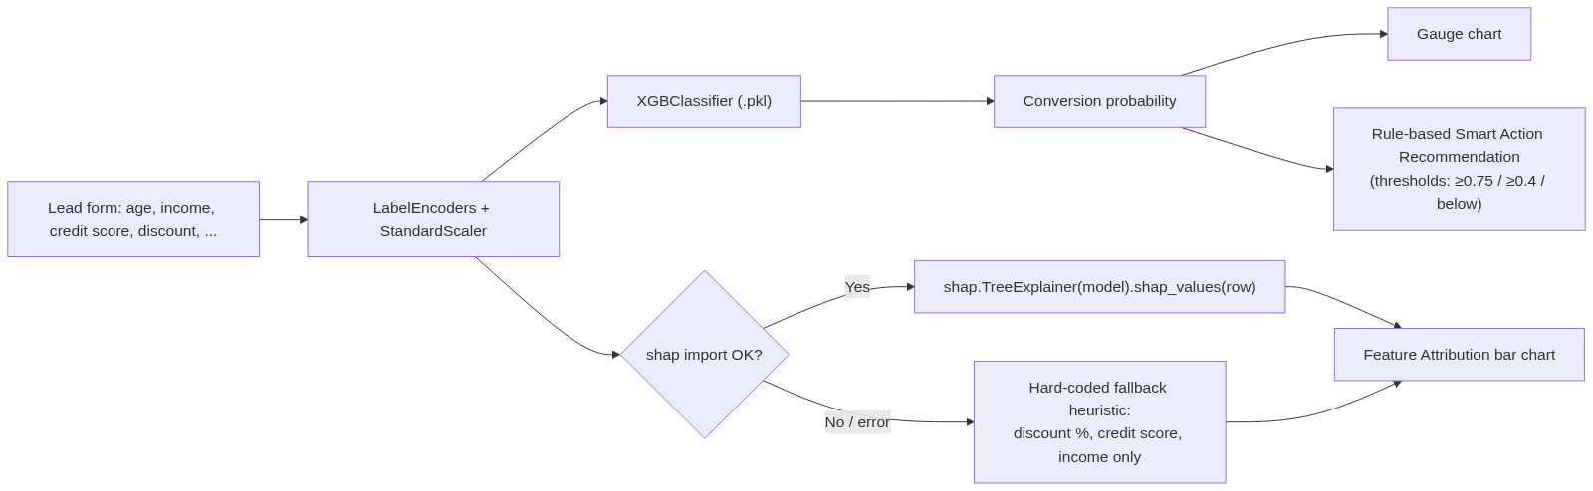
Diagram 5
The SHAP path is real per-instance SHAP (TreeExplainer) when the shap package is importable and succeeds. If it throws for any reason, the UI silently switches to a hard-coded heuristic using only 3 fields — this is a fallback that looks identical in the UI but is not actually model-derived. Worth knowing before quoting the "explainability" feature as fully SHAP-backed in all cases.

8.3 `train_models.py` — what it actually trains
Run manually or at Docker build time (Dockerfile runs it during image build). It does 4 things, all against the test-mode engine only:
- preprocessing.seed_database.main() — seeds automobile_demand.db from automobile_datasets/.
- train_customer_segmentation(n_clusters=5).
- train_xgboost_pipeline().
- A verification-only Prophet run for category="SUV".
Gap to be aware of: there is no equivalent orchestrator for real-mode ML artifacts. The models/{clustering,xgboost}/real/ pickles and real_demand.db must have been produced/committed separately outside this script. If you need to retrain on updated real data, you'll need to either extend train_models.py to accept a --mode real flag or run the training functions manually against the real engine.

9. Sentiment & Geopolitical Risk Pipeline

9.1 News ingestion (`sentiment/fetchers/gdelt_fetcher.py`)
- Endpoint: https://api.gdeltproject.org/api/v2/doc/doc (GDELT Doc 2.0, free, no key). Uses both mode=ArtList (article search) and mode=TimelineTone (daily tone series).
- 6 themed queries (UAE_AUTO_QUERIES): uae_auto_demand, ev_market_uae, fuel_oil_prices, uae_macro_economy, geopolitical_risk, luxury_suv_uae.
- Rate limiting: client-enforced minimum 6-second gap between requests (GDELT's real limit is ~1 req/5s), serialized process-wide via a threading.Lock so concurrent Streamlit sessions can't both slip past the check. On HTTP 429: exponential backoff from 10s, up to 3 retries.
- combine_queries=True (default): issues one combined OR'd query instead of 6 separate calls, then re-tags each result to its best-matching theme by keyword overlap — a 6x reduction in request volume.
- one_per_day=True (default): keeps only the most recent article per (theme, day).
- Persistence dedupes by URL (unique constraint + in-memory check) — idempotent inserts.

9.2 Sentiment scoring — LIVE vs MOCK (`sentiment/analyzers/grok_analyzer.py`)
The toggle is a single environment check:
_XAI_API_KEY = os.getenv("XAI_API_KEY", "").strip()
def is_live_mode() -> bool:
return bool(_XAI_API_KEY)

- LIVE mode: openai.OpenAI(api_key=XAI_API_KEY, base_url="https://api.x.ai/v1") — the openai SDK is only used as a generic OpenAI-compatible client pointed at xAI, not OpenAI itself. Model defaults to grok-3-mini (overridable via GROK_MODEL env var). System prompt instructs a fixed JSON schema per article: sentiment_score (−1..1), impact_score (0..1), affected_vehicle_category, economic_risk, demand_direction, estimated_demand_change_pct, confidence, summary. If the returned count mismatches the batch, or parsing/the API call fails, that batch silently falls back to mock scoring.
- MOCK mode: fully deterministic — hashlib.md5(title) seeds a random.Random, so the same headline always scores identically. Uses hand-curated word lists for sentiment, impact, category, and risk.
- Cost-control detail worth knowing: ensure_recent_articles_analyzed() runs automatically every time the Geopolitical Risk / Economic Signals / AI Insights sub-tabs are opened, but it always uses mock scoring regardless of `XAI_API_KEY` — this is deliberate, to avoid firing billed Grok calls just from a tab click. Only the explicit "Refresh Data" button (run_full_pipeline()) uses real Grok analysis when the key is set.

9.3 Formulas (`sentiment/signal_processor.py`)
Per day (and per vehicle category, plus an "All" aggregate row):
- positive_signals = count where sentiment_score > 0.15; negative_signals = count where < -0.15; rest = neutral.
- avg_sentiment_score, avg_impact_score, avg_demand_change_pct = plain (NaN-safe) means.
- Geopolitical risk index: geo_risk = avg_impact_score × (negative_signals / total_signals) — impact scaled by the *proportion* of negative-sentiment articles that day, not raw sentiment magnitude.
- dominant_demand_direction = plurality vote across the day's signals.
The dashboard's "live" KPI variants (compute_live_overall_stats, etc.) recompute these same formulas directly from just-analyzed articles in memory, so the Geopolitical Risk tab updates instantly without waiting for the full daily_sentiment_summary table rebuild.
Fallback values: when there's no analyzed data yet, dashboard/sentiment_analysis.py::_geo_risk_fallback() generates plausible numbers seeded by date.today().toordinal() — stable within a day, varies day to day — instead of showing hard zeros. This is the mechanism behind the recent "Randomize Geopolitical Risk fallback values" commits.

9.4 Forecast Comparison (sentiment-enhanced forecasting)
_render_forecast_comparison() trains two independent Prophet models: train_prophet_model(..., use_sentiment=False) and train_prophet_model(..., use_sentiment=True), then overlays both yhat lines + confidence bands and diffs RMSE/MAE/accuracy. There is no separate blending/ensemble logic — "enhancement" simply means Prophet gets two extra regressor columns (avg_sentiment_score, geopolitical_risk_score) and fits its own coefficients for them.

10. Dashboard Modules — Data & Logic Reference
Module | Queries / models used | Core logic
overview.py | get_executive_kpis, get_monthly_revenue_trend, get_sales_by_category, get_sales_by_fuel_type, get_sales_by_region | KPI cards 3–4 swap content by data mode (Real: UAE base rate + top brand share; Test: avg discount + lead-close velocity)
forecasting.py | forecasting.prophet_forecasting | See §7
comparison.py | get_yoy_comparison, plus Chinese-brand queries (get_chinese_brand_yearly_share, get_price_competitiveness, get_ev_segment_by_brand_year, get_market_share_shift) | YoY overlap, category/region growth, Chinese-brand competitive section (brand filter deliberately ignored, 2027 projection via np.polyfit)
regional.py | get_dealer_performance_leaderboard | Plotly Mapbox bubble map (lat/lon, size=units, color=revenue) with scatter fallback if coordinates missing; leaderboard table, mode-dependent columns
customers.py | get_customer_segments_data, ml_models.customer_segmentation, ml_models.xgboost_model | Tab 1: segmentation charts. Tab 2: live lead form → predict_deal_probability() → gauge + SHAP/heuristic bars + rule-based recommendation
inventory.py | get_inventory_status | KPI cards, urgent-restock table sorted by stockout_risk_score, stock-vs-forecast bar, slow-moving inventory, warehouse-zone pie
sentiment_analysis.py | sentiment.signal_processor, sentiment.analyzers.grok_analyzer | See §9. 4 active sub-tabs; a 5th ("Recent News") is written but commented out of the tab list
ai_insights.py (dead) | — | Scenario simulator (petrol shift, EV incentive checkbox, supply-chain constraint selector, marketing spend multiplier) — fully written, not wired into app.py
upload_data.py (dead) | — | CSV drag-and-drop, schema auto-detection, validation checklist — fully written, not wired into app.py
metrics.py (dead) | — | XGBoost hyperparameters + feature importances viewer, reads pickles directly — fully written, not wired into app.py

11. Configuration & Environment Variables
.env (gitignored, loaded via python-dotenv in database/connection.py and preprocessing/seed_real_database.py):
Variable | Purpose
DATABASE_URL | Optional override for the test-mode SQLAlchemy URL
REAL_DATABASE_URL | Optional override for the real-mode SQLAlchemy URL
DEBUG | Debug flag
XAI_API_KEY | Presence toggles Grok LIVE mode; absence = MOCK sentiment scoring everywhere
GROK_MODEL | Optional, defaults to grok-3-mini
SERPER_API_KEY | Present in .env but not referenced anywhere in the current codebase — likely leftover/unused

.streamlit/config.toml sets a fixed dark theme (primaryColor #6366f1, backgroundColor #0b0f19, etc.). No secrets.toml is committed, and no code reads st.secrets — all configuration flows through .env/os.getenv.
Real/Test mode toggle: st.session_state.data_mode, consumed via get_data_mode()/set_data_mode(). Controls: which SQLite engine every query hits, which model-pickle subfolder each ML module loads, and several dashboard rendering branches. The switch UI itself is commented out in app.py — full plumbing exists, but it's currently unreachable from the running app.

12. Dependencies (`requirements.txt`)
streamlit>=1.35.0 pandas>=2.2.0 numpy>=1.26.0
plotly>=5.22.0 prophet>=1.1.5 xgboost>=2.0.0
scikit-learn>=1.4.0 sqlalchemy>=2.0.0 python-dotenv
streamlit-option-menu shap>=0.45.0 openai>=1.0.0
requests>=2.31.0
No pyproject.toml in the repo — requirements.txt is the single source of truth for dependencies.

13. Deployment
- Local dev: streamlit run app.py.
- Docker: Dockerfile (Python 3.11-slim) installs requirements.txt, then runs `python train_models.py` at image build time — this bakes a seeded test DB and trained test-mode ML pickles into the image. Exposes port 8501; CMD ["streamlit", "run", "app.py", "--server.port=8501", "--server.address=0.0.0.0"].
- `docker-compose.yml`: single web service built from the Dockerfile, 8501:8501, mounts .:/app plus named volumes for /app/.venv and /app/models, sets DATABASE_URL=sqlite:////app/automobile_demand.db, DEBUG=False, restart: always.
- No CI config (.github/workflows absent), no Procfile.

14. Known Gaps / Things to Fix Before Scaling
These aren't bugs blocking the demo, but a new engineer should know about them before treating this as production-ready:
- No caching anywhere. Prophet retrains twice per interaction on the Forecasting page and every DB query re-runs on every rerun. Adding @st.cache_data (for queries) and @st.cache_resource (for trained models, keyed by filter combination) would be the highest-leverage performance fix.
- Real-mode ML artifacts have no training script. train_models.py only seeds/trains test mode. Retraining on updated real data currently requires manual intervention.
- Three dashboard modules are dead code (ai_insights.py, upload_data.py, metrics.py) — fully written but not routed in app.py. Confirm with product whether these should be re-enabled, finished, or deleted.
- SHAP has a silent heuristic fallback. If the shap import/computation fails, xgboost_model.py falls back to a 3-feature hard-coded heuristic that renders identically to real SHAP output in the UI — there's no visible indicator distinguishing the two. Worth surfacing a debug flag or log line if this matters for demo integrity.
- The "Market Driver Impact" chart movement is dominated by a static elasticity table (DRIVER_SENSITIVITY), not purely by Prophet's fitted regressor coefficients. Fine for a compelling demo; be precise about this if asked "is this a real ML prediction" in a technical review.
- `SERPER_API_KEY` is unused — likely safe to remove from .env.example/docs unless there's a planned integration.
- Real/Test mode switch is UI-disabled but the full plumbing exists end-to-end — trivial to re-enable if a test-mode demo is ever needed again.
- `real_estate_demand.db` at repo root is an unrelated/legacy file not referenced by any code — safe to delete after confirming with the team.

15. Quick Orientation for New Contributors
- Want to change a KPI or chart? Start in the relevant dashboard/*.py file — it will point you to the exact queries.py function or ML module it calls.
- Want to change what the forecast reacts to? forecasting/prophet_forecasting.py (data/regressors) + dashboard/forecasting.py (DRIVER_SENSITIVITY, FACTOR_CONFIG for slider bounds).
- Want to add a new DB column? Update database/models.py, then the relevant preprocessing/clean_data.py + seed_*.py functions, then any queries.py function that should expose it.
- Want to retrain ML models after a data change? Run python train_models.py for test mode; for real mode, call train_customer_segmentation() / train_xgboost_pipeline() manually against the real engine (set_data_mode("real") first).
- Want to test the sentiment pipeline without burning Grok API calls? Just don't set XAI_API_KEY — MOCK mode is deterministic and fully functional end-to-end.

