Threat Model and Secure Configuration
Project Report • Security Analysis of a Sample Web Application

1. Introduction
This project identifies security risks in a sample web application that supports user registration, login, and profile viewing. It documents assets, data flows, trust boundaries, STRIDE threats, risk priorities, and recommended defensive controls. The scores below are illustrative and should be updated after reviewing the actual application.

2. Objectives
- Identify assets, users, data flows, and trust boundaries.
- Identify likely threats using STRIDE.
- Rank risks by likelihood and impact.
- Recommend proportionate defensive controls.
- Provide a hardening checklist and verification plan.

3. Scope and assumptions
The sample application supports user registration, login, and profile viewing. It uses a browser, a web application server, a database, and an external email service. This architecture is illustrative and must be adapted to the actual system.

4. Assets to protect
Asset | Description
User accounts | Authentication and account access
Passwords | Authentication secrets; store only secure password hashes
Personal data | User profile and other private information
Session tokens | Maintain authenticated sessions
Application server | Processes requests and enforces security rules
Database | Stores user records and application data
Application code and secrets | Business logic, configuration, API keys
Audit logs and backups | Support investigation and recovery

5. Threat-model diagram
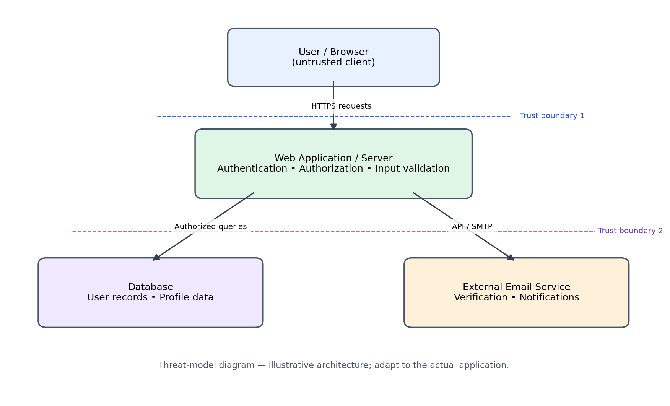
Trust boundary 1 separates the browser from the server. Trust boundary 2 represents controlled interactions between the server and data/external-service components.

6. STRIDE methodology
Category | Meaning / example
Spoofing | Pretending to be another user; e.g., use of stolen credentials.
Tampering | Unauthorized modification of requests or stored data.
Repudiation | Denying an action when audit evidence is insufficient.
Information Disclosure | Unauthorized exposure of private data or secrets.
Denial of Service | Making the service unavailable through excessive requests.
Elevation of Privilege | Gaining permissions beyond the user's role.

7. Risk register
Risk score = Likelihood × Impact. Scale: 1 (low) to 5 (high). Suggested bands: 1–4 Low, 5–9 Medium, 10–15 High, 16–25 Critical.
ID / Threat | Asset | L | I / Score | Priority
T1 Account compromise / spoofing | User accounts | 4 | 5 / 20 | Critical
T2 SQL injection / tampering | Database | 3 | 5 / 15 | High
T3 Broken access control | Personal data | 4 | 5 / 20 | Critical
T4 Session theft or fixation | Session tokens | 3 | 4 / 12 | High
T5 Sensitive data exposure | Personal data and secrets | 3 | 5 / 15 | High
T6 Denial of service | Application server | 3 | 4 / 12 | High
T7 Insufficient logging / repudiation | Audit logs | 3 | 3 / 9 | Medium
T8 Privilege escalation | Admin functions | 3 | 5 / 15 | High
These scores are illustrative estimates for the sample system, not evidence from a live security test.

8. Prioritized hardening plan
- Authentication and access: Enforce secure password hashing; add login rate limits; use MFA for privileged accounts where possible; verify authorization on every protected action; apply least privilege.
- Application security: Use parameterized SQL queries; validate inputs server-side; encode output appropriately; use HTTPS; protect state-changing requests against CSRF where applicable.
- Session security: Set HttpOnly, Secure, and appropriate SameSite cookie attributes; rotate session IDs after authentication; set idle/absolute expiry; invalidate sessions at logout.
- Data and configuration: Keep secrets out of source code; use environment or secret-management configuration; disable production debug mode; return generic errors; restrict database network access.
- Monitoring and recovery: Record relevant authentication and administrative events; restrict log access; configure backups; test restoration; keep dependencies patched; monitor unusual request volumes.

9. Verification test plan
Test | Expected secure behavior
Invalid login | Request is rejected without revealing whether an account exists; attempts are rate-limited.
Other user's profile | Server denies access to records the signed-in user is not authorized to view.
Unexpected input | Input is safely handled; no database command or script execution occurs.
Repeated requests | Rate limiting or other protective controls engage without exposing sensitive details.
Normal user opens admin page | Server returns an access-denied response.
Application error | Response does not expose stack traces, secrets, or internal configuration.
Security event review | Relevant events are recorded; passwords, tokens, and unnecessary personal data are not logged.

10. Completion steps
- Identify application components, assets, users, and external dependencies.
- Draw the data-flow diagram and mark trust boundaries.
- Identify threats using STRIDE: Spoofing, Tampering, Repudiation, Information Disclosure, Denial of Service, Elevation of Privilege.
- Score each threat using Likelihood × Impact on a 1–5 scale.
- Address critical and high risks first; assign an owner and target date in a real project.
- Implement and verify defensive controls in an authorized test environment.
- Record evidence, remaining risks, and follow-up actions.

11. Expected results
- Documented assets, components, data flows, and trust boundaries.
- A STRIDE-based threat list and risk register.
- A prioritized security hardening plan.
- A checklist and test plan for verifying controls.

12. Conclusion
Threat modeling helps teams find and prioritize security risks before they become incidents. By documenting assets, applying STRIDE, scoring risks, and verifying suitable defensive controls, a development team can improve the security of its web application. The model must be reviewed whenever the application architecture or threat landscape changes.

Appendix: Submission note
This package is ready for review as a sample threat-modeling deliverable. The controls have not been independently implemented or tested. Upload the report and supporting files to one cloud folder or repository, then submit that folder's view-only/public link.

