Name :A.Pushpanjali
Roll No : 2303A54050
Batch : 47-B

AI Assisted Coding Assignment - 02

Lab 2: Exploring Additional AI Coding Tools beyond Copilot – Gemini (Colab) and Cursor AI
Task 1: Statistical Summary for Survey Data
- Scenario: You are a data analyst intern working with survey responses stored as numerical lists.
  - Prompt used :
"Write a Python function that takes a list of numbers and returns the mean, minimum, and maximum values."
  - Generated code :
import statistics
def analyze_numbers(numbers):
"""
Calculates the mean, minimum, and maximum of a list of numbers. Args:
numbers (list): A list of numerical values. Returns:
tuple: A tuple containing (mean, minimum, maximum). Returns (None, None, None) if the list is empty.
"""
if not numbers:
return None, None, None
mean_value = statistics.mean(numbers) min_value = min(numbers)
max_value = max(numbers)
return mean_value, min_value, max_value
Example Usage
data = [10, 20, 30, 40, 50]
mean, minimum, maximum = analyze_numbers(data) print(f"List: {data}")
print(f"Mean: {mean}") print(f"Minimum: {minimum}") print(f"Maximum: {maximum}")

data_empty = []
mean_empty, min_empty, max_empty = analyze_numbers(data_empty) print(f"\nList: {data_empty}")
print(f"Mean: {mean_empty}") print(f"Minimum: {min_empty}") print(f"Maximum: {max_empty}")
  - Sample Output :
List: [10, 20, 30, 40, 50] Mean: 30 Minimum: 10 Maximum: 50 List: [] Mean: None Minimum: None Maximum: None
  - Short Explanation of Logic :

The mean represents the average of a set of numbers. It is obtained by adding all the values in the list and dividing the sum by the total number of elements.
The minimum value is the smallest number present in the list, and the maximum value is the largest number present in the list. These values are calculated using Python’s built-in min() and max() functions.
The function accepts a list of numerical values as input, computes the mean, minimum, and maximum values, and displays them as a statistical summary of the given data.
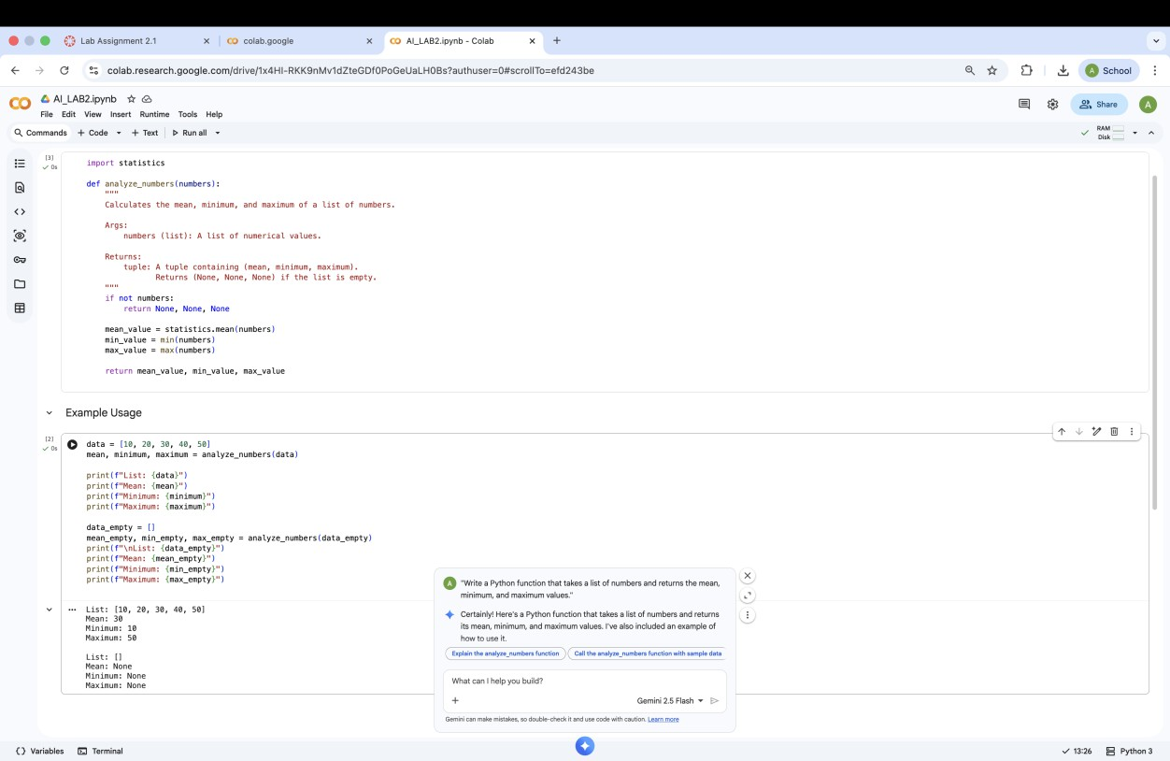

Task 2: Armstrong Number – AI Comparison
- Scenario : You are evaluating AI tools for numeric validation logic.
  - Prompt used (Gemini):

"Write a Python program to check whether a given number is an Armstrong number."
  - Prompt used (Copilot):
"Write a Python program to check whether a given number is an Armstrong number."
  - Generated code (Gemini):
def is_armstrong_number(number):
"""
Checks if a given number is an Armstrong number.
An Armstrong number (also known as a narcissistic number, pluperfect digital invariant, or plus perfect number)
is a number that is the sum of its own digits each raised to the power of the number of digits.
rgs:
number (int): The integer to check. Returns:
bool: True if the number is an Armstrong number, False otherwise. """
if not isinstance(number, int) or number < 0: return False
num_str = str(number) n = len(num_str) sum_of_powers = 0
for digit_char in num_str: digit = int(digit_char) sum_of_powers += digit ** n
return sum_of_powers == number
  - Generated code (Copilot):
#!/usr/bin/env python3 """Armstrong number checker (task2).

Usage:
python3 task2.py 153
python3 task2.py # prompts for input """
import argparse import sys

def is_armstrong(n: int) -> bool:
if n < 0:
return False
digits = [int(d) for d in str(n)] p = len(digits)
return sum(d ** p for d in digits) == n

def main() -> None:
parser = argparse.ArgumentParser(description='Check Armstrong numbers') parser.add_argument('number', nargs='?', type=int, help='integer to check') args = parser.parse_args()

if args.number is None:
try:
s = input('Enter a non-negative integer: ').strip() num = int(s)
except (EOFError, ValueError): print('Invalid input', file=sys.stderr) sys.exit(1)
else:
num = args.number

if is_armstrong(num):
print(f"{num} is an Armstrong number.") else:
print(f"{num} is not an Armstrong number.")

if name == ' main ': main()
  - Sample Input (Gemini):
# Test with some numbers
print(f"Is 153 an Armstrong number? {is_armstrong_number(153)}") # Expected: True (1^3 + 5^3 + 3^3 = 1 + 125 + 27 = 153)
print(f"Is 9474 an Armstrong number? {is_armstrong_number(9474)}") # Expected: True (9^4 + 4^4 + 7^4 + 4^4 = 6561 + 256 + 2401 + 256 = 9474)
print(f"Is 9 an Armstrong number? {is_armstrong_number(9)}") # Expected: True (9^1
= 9)
print(f"Is 10 an Armstrong number? {is_armstrong_number(10)}") # Expected: False (1^2 + 0^2 = 1 != 10)
print(f"Is 123 an Armstrong number? {is_armstrong_number(123)}") # Expected: False
  - Sample Input (Copilot):
Enter a non-negative integer: 343
  - Sample Output (Gemini):
Is 153 an Armstrong number? True Is 9474 an Armstrong number? True Is 9 an Armstrong number? True
Is 10 an Armstrong number? False Is 123 an Armstrong number? False
  - Sample Output (Copilot):
343 is not an Armstrong number.
  - Side-by-Side Comparison Table :

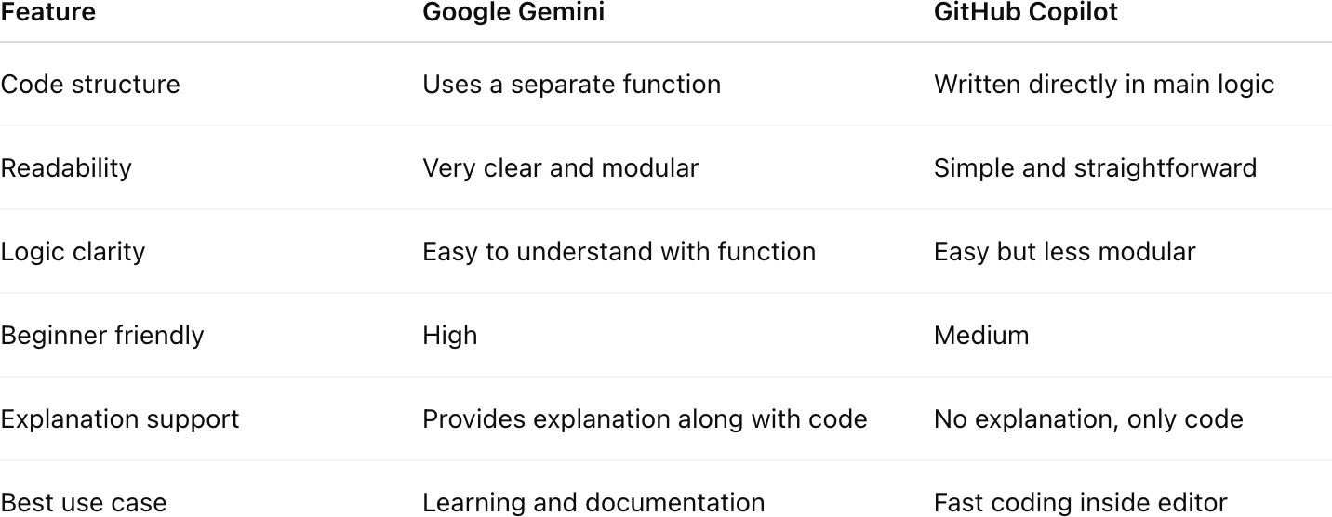
  - Side-by-Side Comparison Table :
Analysis : Google Gemini generated a well-structured and modular solution using a function, making it suitable for learning and reuse. GitHub Copilot produced a concise and direct implementation, which is efficient for quick development within an IDE. Both tools correctly implemented the Armstrong number logic, but Gemini provided better clarity and explanation, while Copilot focused on speed and simplicity.
Conclusion : Both AI tools effectively generated correct Armstrong number checking programs. Google Gemini is more helpful for understanding and learning due to its explanations, while GitHub Copilot is ideal for rapid code generation during development.
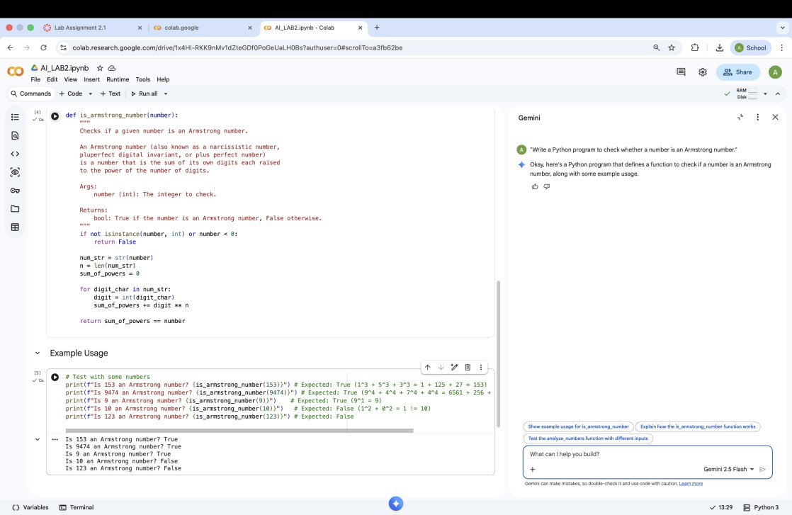

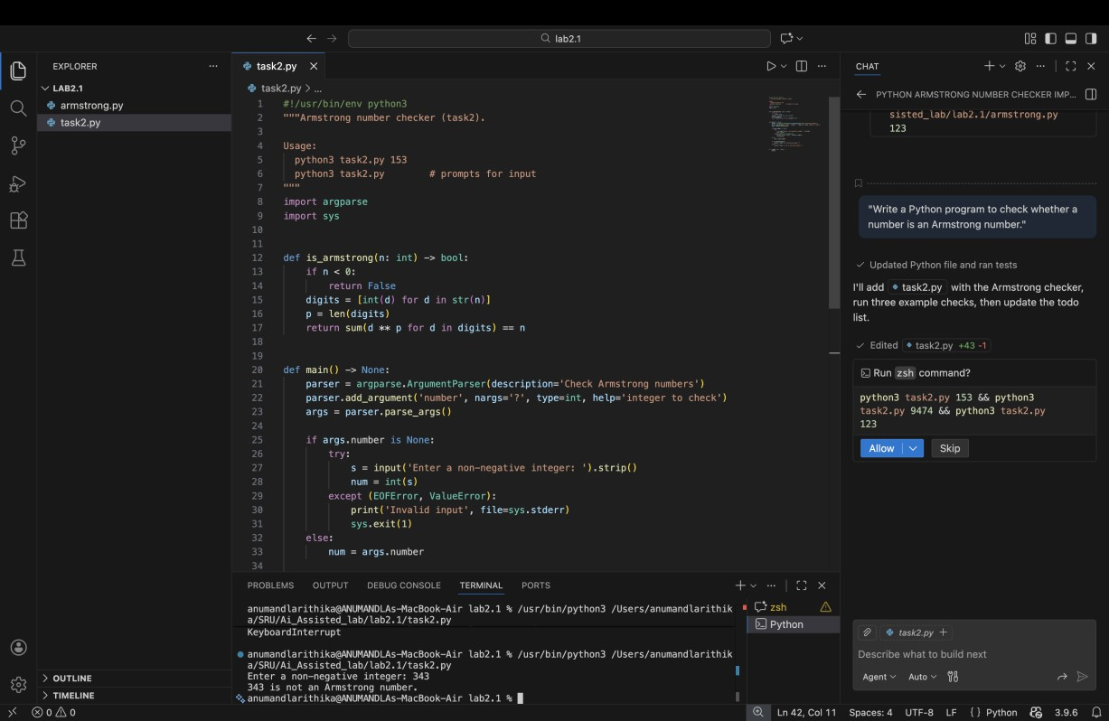
Task 3: Leap Year Validation Using Cursor AI
- Scenario : You are validating a calendar module for a backend system.
  - Prompt 1:
"Write a Python program to check whether a given year is a leap year."
  - Generated code :
year = int(input("Enter a year: ")) # A year is a leap year if:
# - It is divisible by 4 AND
# - not divisible by 100, UNLESS # - it is also divisible by 400
if (year % 4 == 0 and year % 100 != 0) or (year % 400 == 0): print(f"{year} is a leap year.")
else:
print(f"{year} is not a leap year.")
  - Prompt 2 :
"Write an optimized Python program with proper conditions and comments to check whether a year is a leap year."
  - Generated code :
year = int(input("Enter a year: "))

# A year is a leap year if:
# 1. It is divisible by 400 → leap year
# 2. Else if it is divisible by 100 → not a leap year # 3. Else if it is divisible by 4 → leap year
# 4. Otherwise → not a leap year

if year % 400 == 0: print(f"{year} is a leap year.") elif year % 100 == 0:
print(f"{year} is not a leap year.")
elif year % 4 == 0: print(f"{year} is a leap year.") else:
print(f"{year} is not a leap year.")

  - Sample Input :
Enter a year: 2026
  - Sample Output :
2026 is not a leap year.
  - Short Explanation of Logic :
The first version of the code generated by Cursor AI provided basic leap year validation logic. The second prompt resulted in improved code with better readability and clear comments explaining the conditions. The optimized version is easier to understand and more suitable for real-world applications.
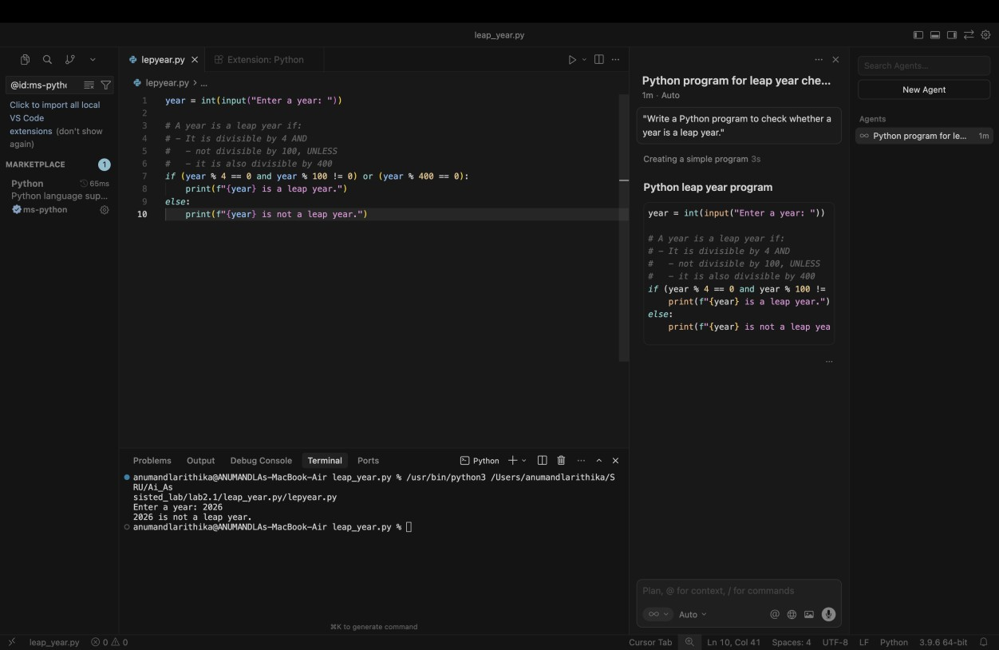

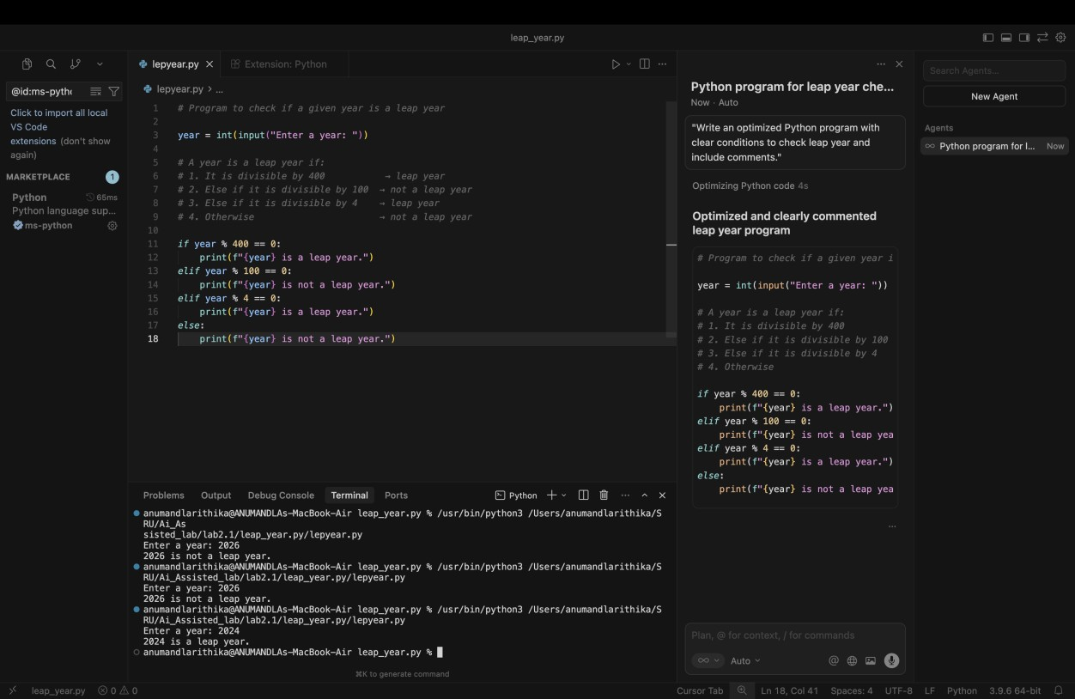
Task 4: Student Logic + AI Refactoring (Odd/Even Sum)
- Scenario : Company policy requires developers to write logic before using AI.
  - Prompt used :
"Refactor this Python code to improve readability and efficiency."
  - Student Code:

T = (1, 2, 3, 4, 5, 6, 7)

even_sum = 0

odd_sum = 0 for i in t:
if i % 2 == 0:

even_sum = even_sum + i else:
odd_sum = odd_sum + i

print("Sum of even numbers:", even_sum) print("Sum of odd numbers:", odd_sum)
  - AI Code:

t = (1, 2, 3, 4, 5, 6, 7)

# Using generator expressions with sum for clarity and efficiency
even_sum = sum(i for i in t if i % 2 == 0) odd_sum = sum(i for i in t if i % 2 != 0)

print("Sum of even numbers:", even_sum) print("Sum of odd numbers:", odd_sum)

  - Sample Output :
Sum of even numbers: 12 Sum of odd numbers: 16

