**GoogleMapPlaces**

This is just the sample app that shows GoogleMap SDK integration.I can customize the markers on map as well as design it in better way.

This map shows different tabs indicating different events.Clicking on each tab will display events specific to that tab.

Clicking On marker will display Event Name and Clicking on that window will navigate to other controller displaying details of that event.

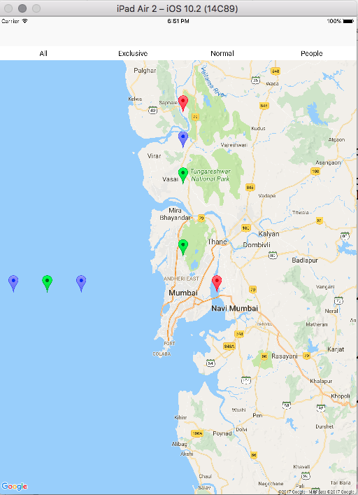

1]Display All Events

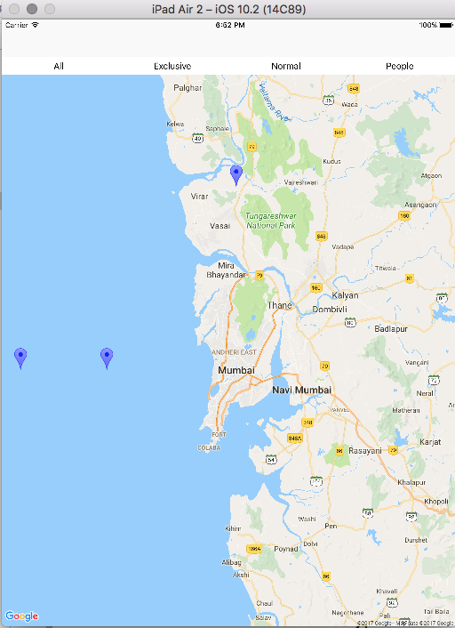

2]Exclusive Events Only

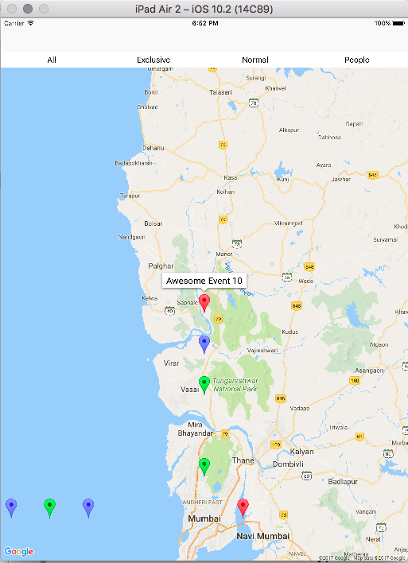

3]Clicking on Marker