**STAT PORTABLE PROCEDURE**

Website: [https://oasis.umedex.com](https://oasis.umedex.com/)

username: **imam**

password: **imam#**

Note:

* Umedex and stat portable websites are same. Just login credentials are different and should open in internet explorer only.
* Before opening any stat portable case, first check for prior.
* Prior will not get opened on a same system.
* Prior should open on a separate system only.
* Note: Prior should open on a separate system. Before opening any stat portable case, we have to check for prior first. If prior is there, we should open current case on one system and prior on another system.

--------------------------------------------------------------------------------------------------

1. First open internet explorer.

2. Open the stat portable website in internet explorer.

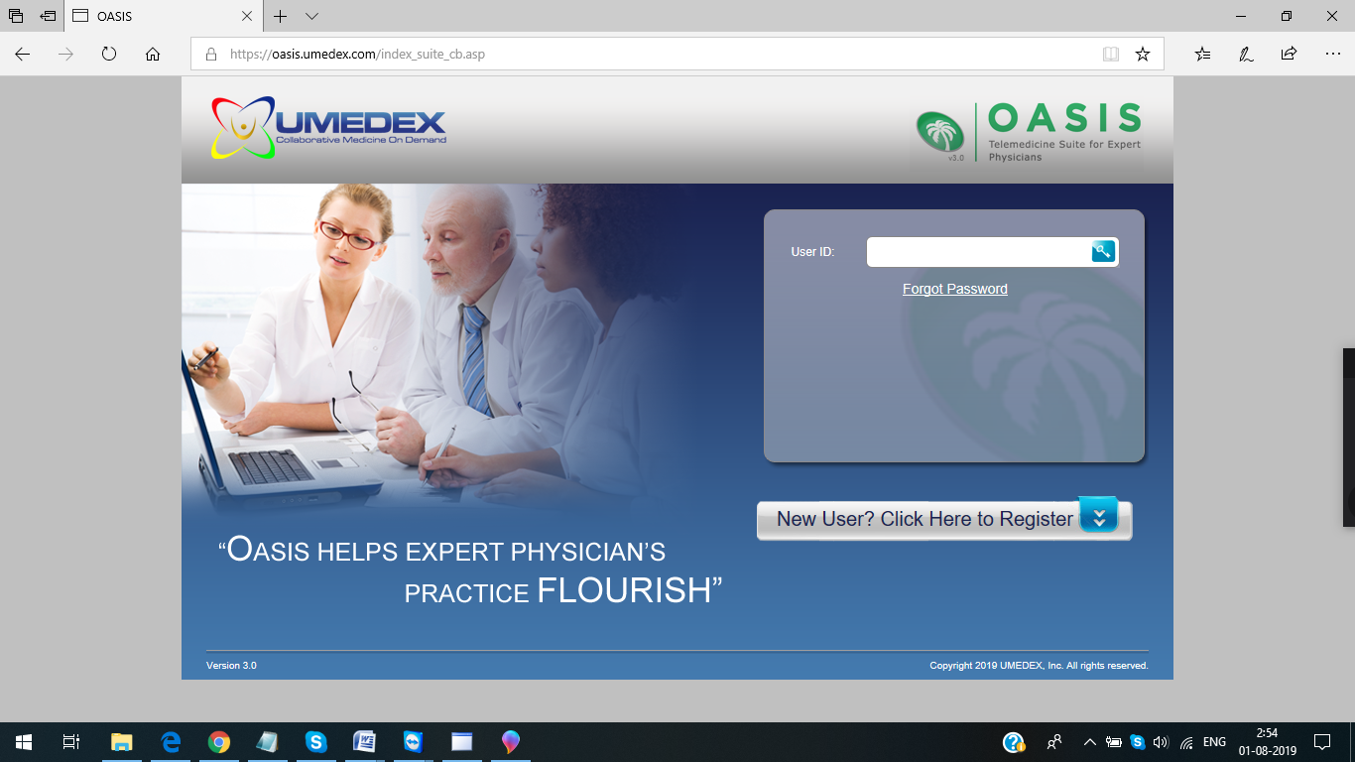

Username:  **imam –**NEXT - Click on the Key symbol.

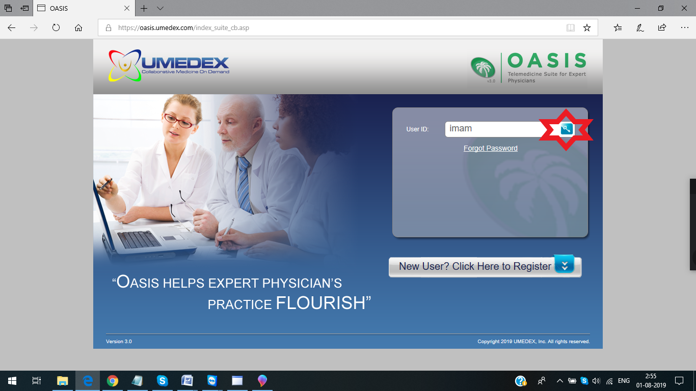

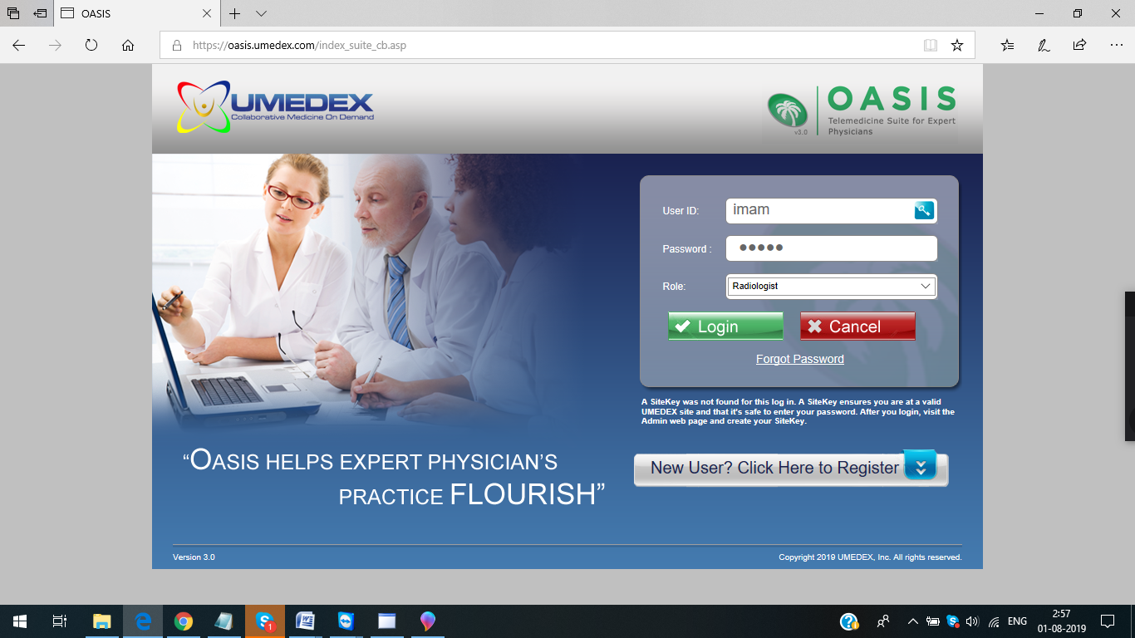

Password:  **imam#**  

NEXT - Click on **LOGIN**.

Close the POP-up – **User profile Webpage Dialogue**

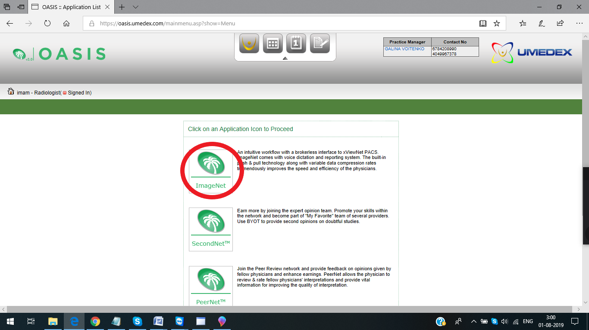

Next – Click on “**Image Net” (**An intuitive workflow with a brokerless interface to xViewNet PACS.)

--------------------------------------------------------------------------------------------------

This is stat portable x-ray---US (ultrasound) worklist

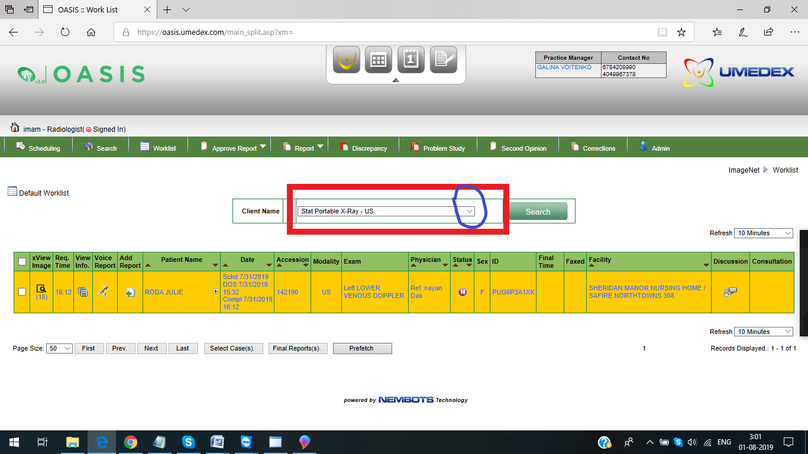

Click on down arrow button to get X-ray worklist

Select the stat portable X-ray----X-ray

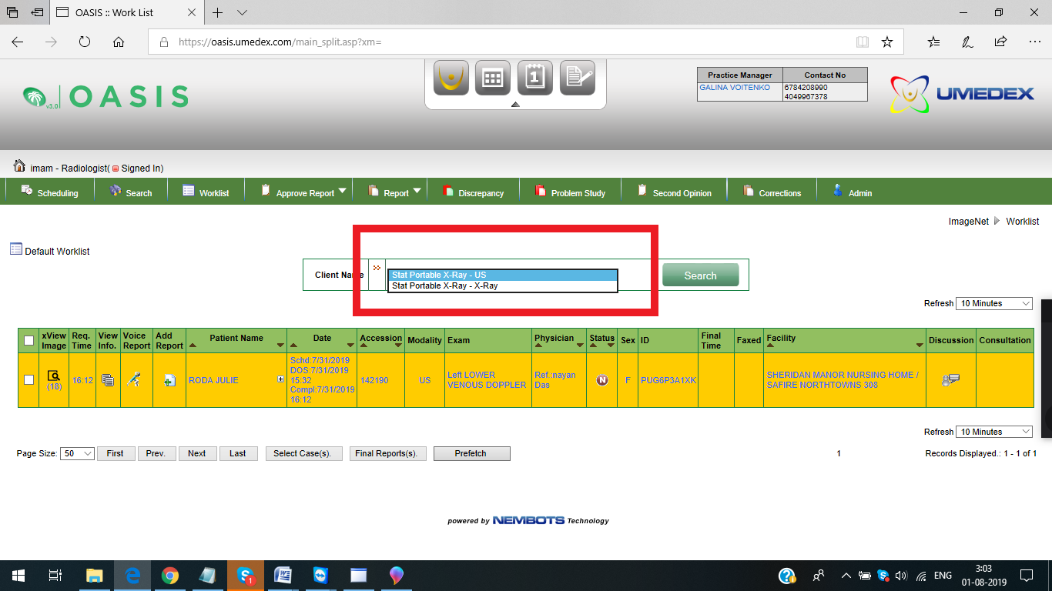

---------------------------------------------------------------------------------------------------------

Stat portable X-ray worklist

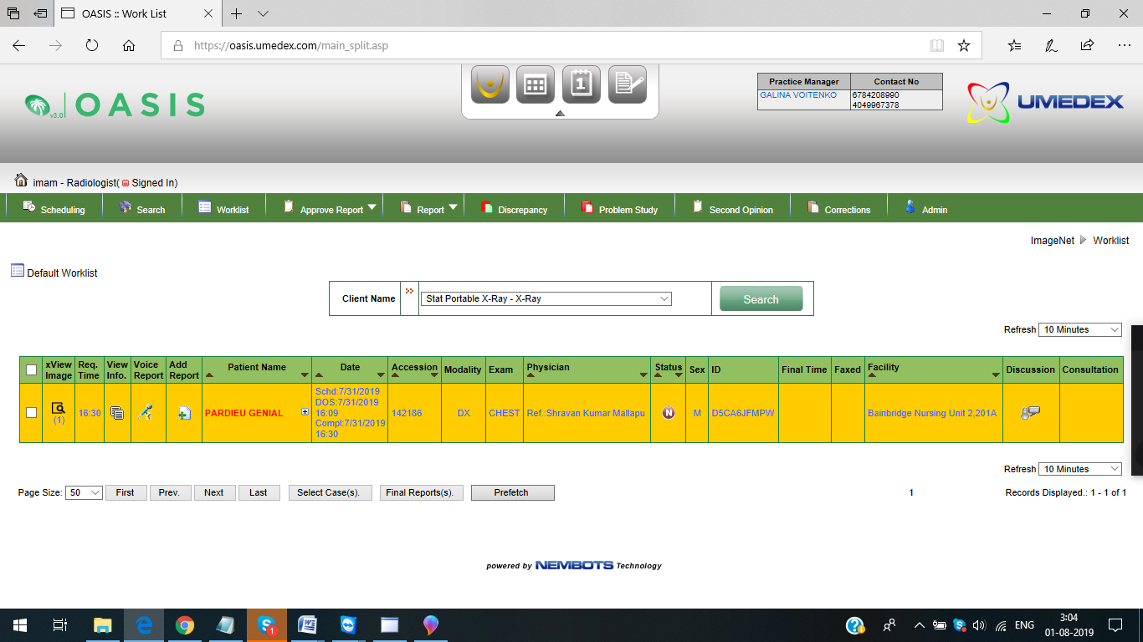

To open a case, click on the magnifier (view image colum) icon.

To open the Report/document–Click on **Add Report/Plus Symbol +.**

Once the case is opened, follow the 7 steps.

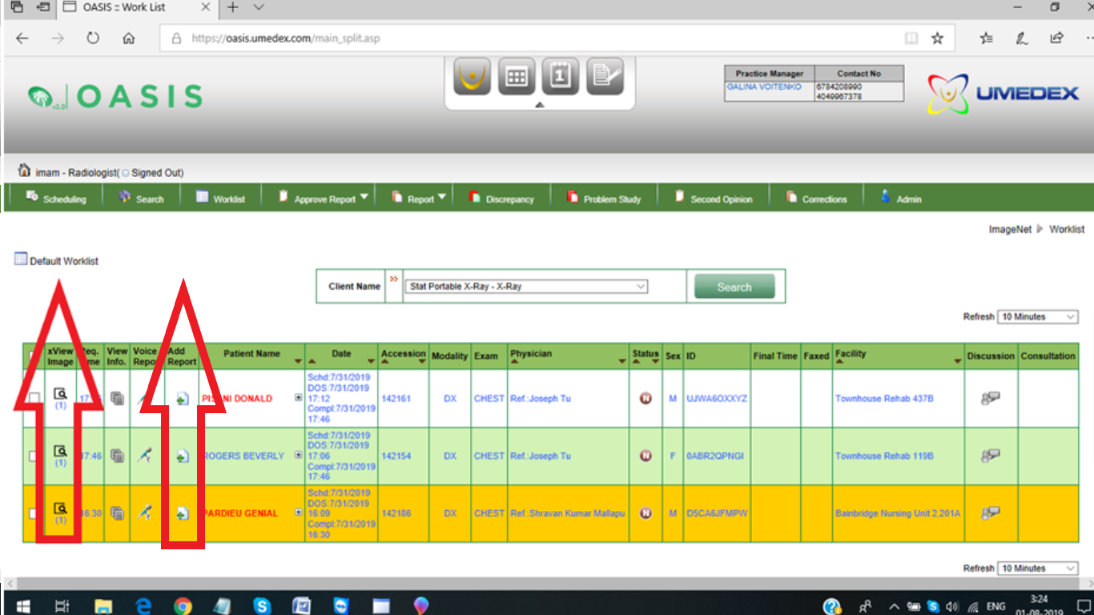

After opening the report – Follow the 7 steps.

Please check for History, number of views, DOB.

(Comparison should open on a separate system only. Before opening a case, check for prior and do accordingly).

For History see “**Study Information –Indication**.

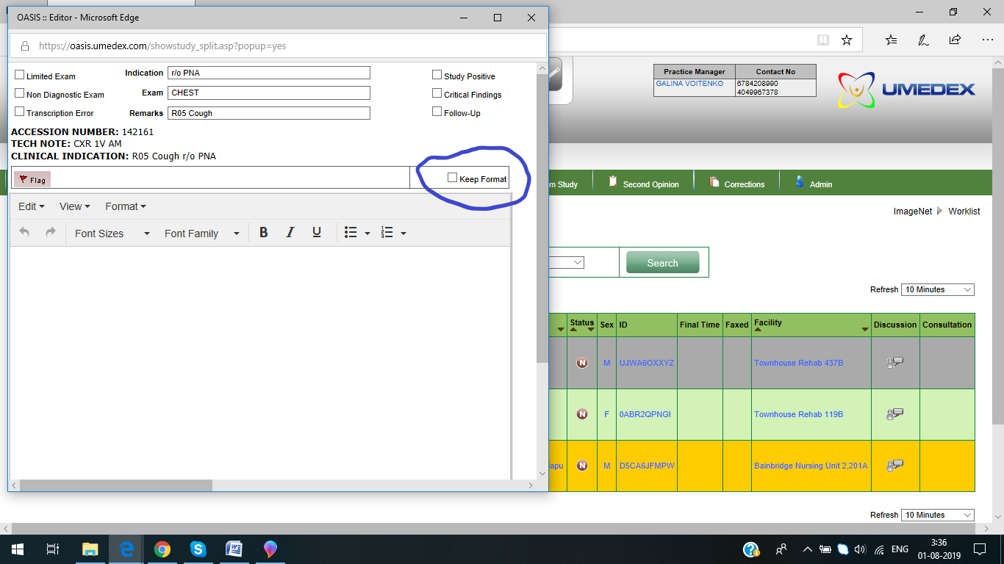

Click on that “Keep format” option on right side, which keeps the report in format. If we do not click on that option, report will not be in a format.

Then paste the macro in report.

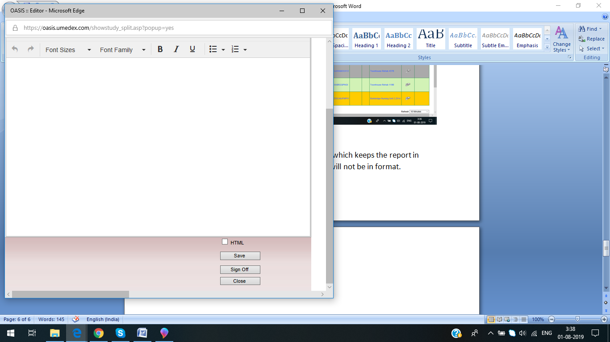

Once the report is completed - Click on **sign off**option.

Next – Message from WebRadiology “**Have you answered the requested the radiological evaluation**?

Click on **OK**option.

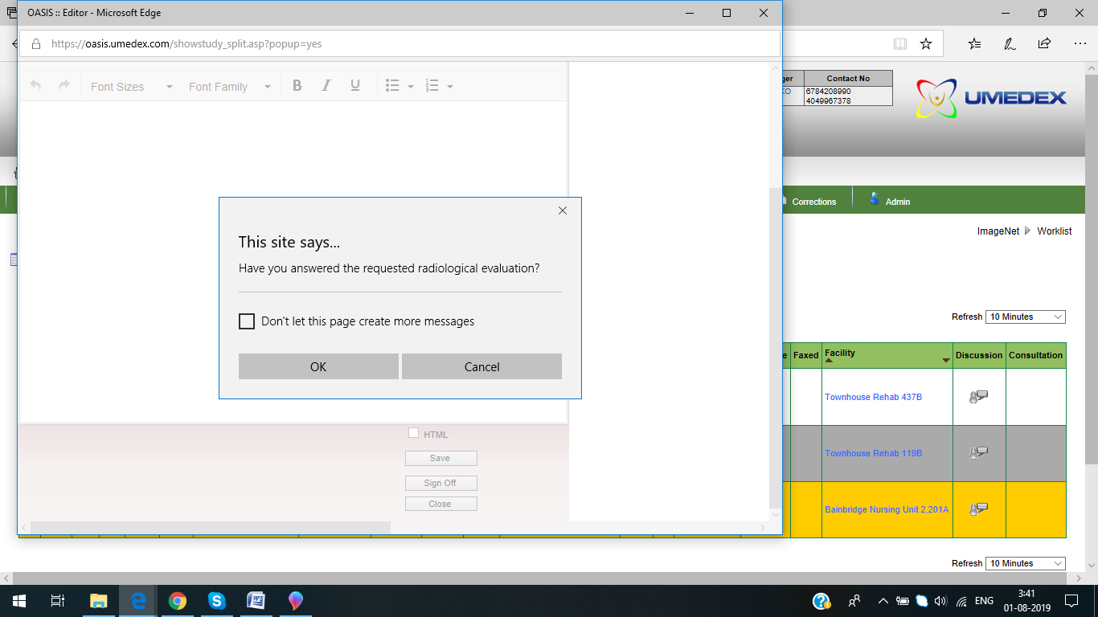

Click on “OK”

************************************************************

To check for PRIOR: click on the small “+button”

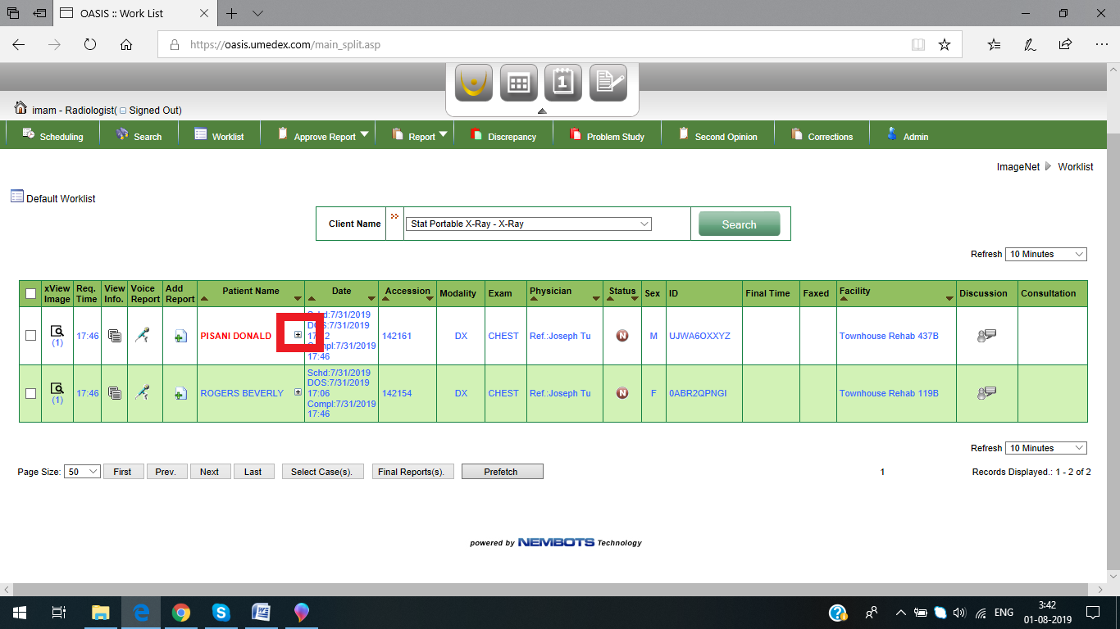

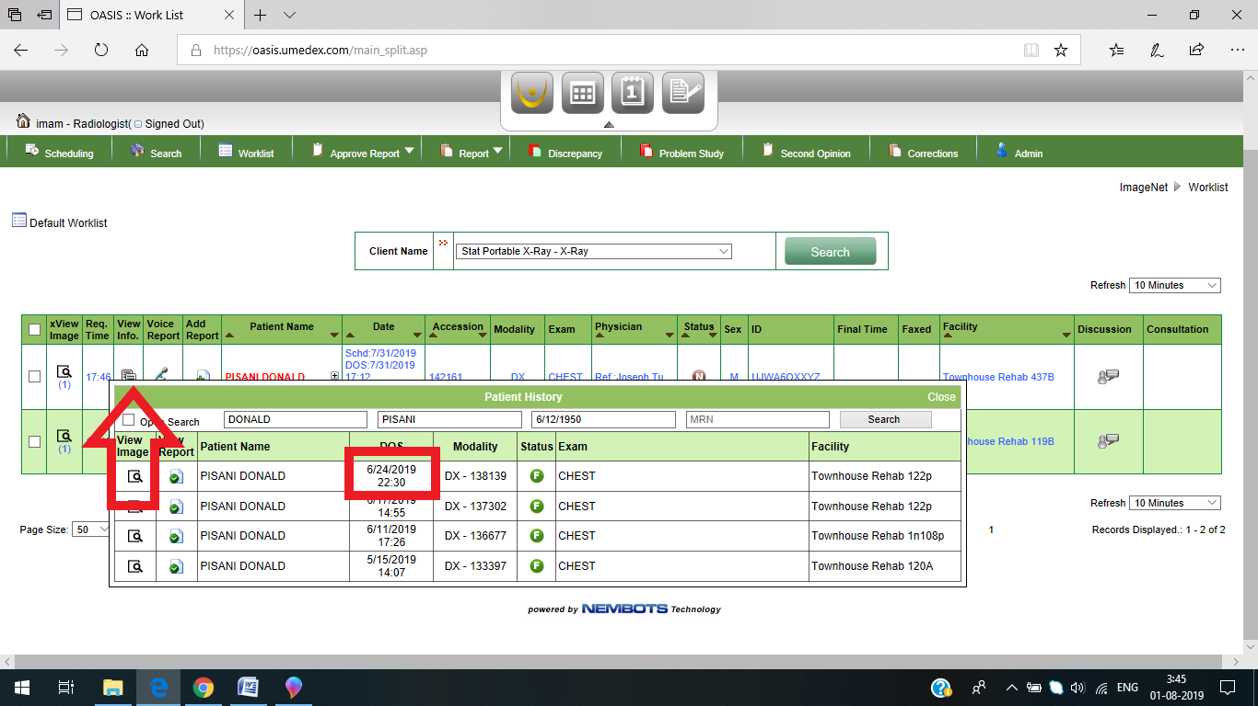

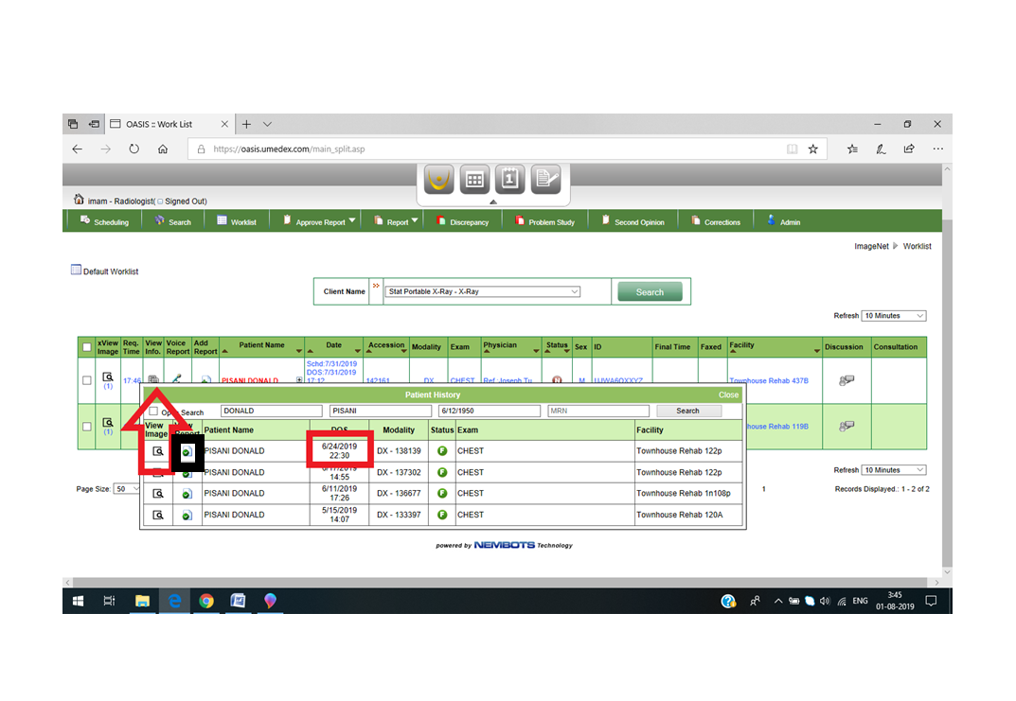

Click on the recent prior date:

View image (magnifier icon) to open prior images

View report (document icon) to open prior report.

Note: Prior should open on a separate system. Before opening any stat portable case, we have to check for prior first. If prior is there, we should open current case on one system and prior on another system.

**************************************************************

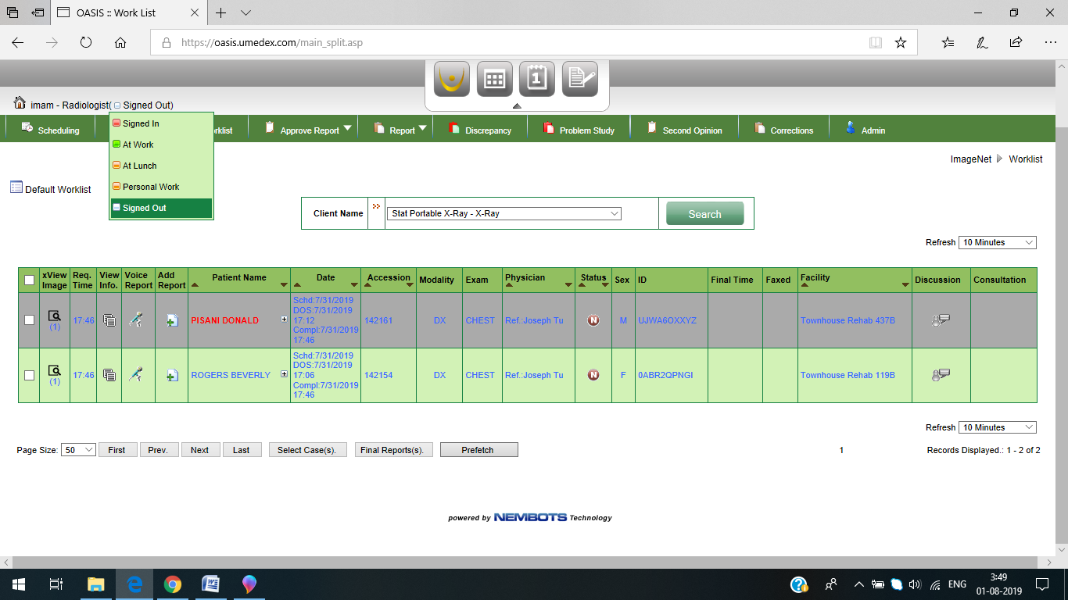

Once done with stat portable cases, Signed out from stat portable website.

**Stat portable procedure screenshots**

1.



2. 

3. 

4. 

5. 

6. 

7. 

8. 

9.



10. 

****************************************************************

11. To check for prior:



12. 

****************************************************************