DETAILED DESIGN DOCUMENT
AEM Edge Delivery Services + Adobe App Builder
Multi-Market Quick Service Restaurant (QSR)
US • UK • JP
Repository: github.com/pushparajanramar/aem-eds-appbuilder
Document Version: 1.0 | Date: February 2026

Table of Contents

1. Executive Summary
This document provides a comprehensive detailed design for the aem-eds-appbuilder project, a multi-market AEM Edge Delivery Services (EDS) implementation backed by Adobe App Builder serverless actions. The system follows the BYOM (Bring Your Own Markup) pattern to deliver dynamic, server-rendered content through EDS overlay routes.
The solution serves a Quick Service Restaurant (QSR) brand across three markets: United States (US), United Kingdom (UK), and Japan (JP). Each market has its own EDS site configuration with shared Adobe App Builder actions, Svelte Web Components, and Fastly CDN device detection logic.

1.1 Key Design Goals
- Multi-market content delivery with market-specific configuration (locale, currency, timezone, EDS host).
- Serverless API layer via Adobe App Builder for menu, store, rewards, user, and BFF proxy capabilities.
- Device-aware rendering using Fastly VCL for mobile, tablet, desktop, kiosk, and digital menu boards.
- Automated CI/CD pipeline with per-market EDS publishing and centralized App Builder deployment.
- Real-time cache invalidation via AEM Author webhooks triggering EDS Admin API purges.
- Shared component library built with Svelte, compiled with Vite, and distributed to each market site.

1.2 Document Scope
This document covers the system architecture, component design, data flows, integration patterns, deployment strategy, security model, and non-functional requirements. It is intended for solution architects, developers, and technical leads involved in the project.

2. System Architecture
The system follows a layered architecture with clear separation of concerns across content authoring, serverless compute, CDN edge processing, content delivery, and client-side hydration.

2.1 High-Level Architecture Diagram
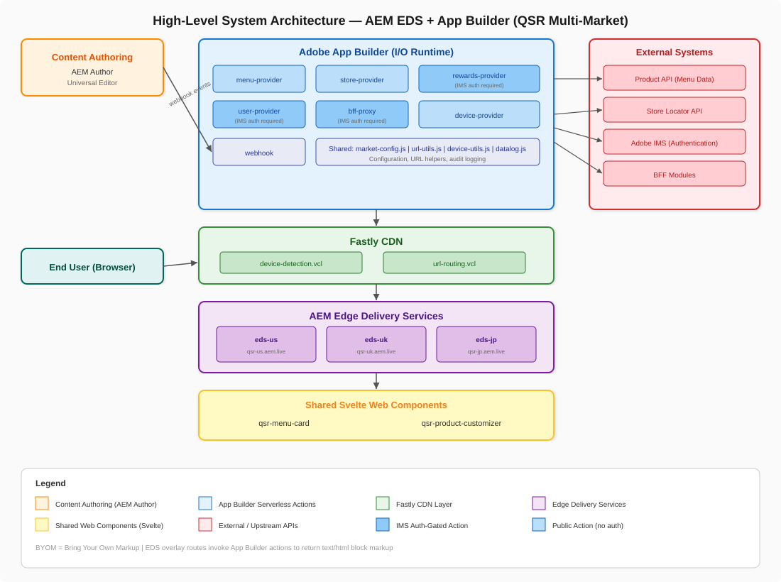
Figure 1: High-Level System Architecture — AEM EDS + App Builder (QSR Multi-Market)

2.2 Architecture Layers
The system consists of six distinct architectural layers, each with well-defined responsibilities:

2.2.1 Content Authoring Layer
AEM Author (Cloud Service) serves as the content management system. Content authors create and manage pages using the Universal Editor. When content is published, unpublished, or deleted, AEM triggers webhook events to the App Builder webhook action, initiating cache invalidation on EDS.

2.2.2 Serverless Compute Layer (Adobe App Builder)
Adobe App Builder runs on Adobe I/O Runtime, providing seven serverless actions grouped under the qsr package. These actions follow the BYOM pattern, fetching data from upstream APIs and transforming it into EDS-compatible HTML block markup. Three actions (rewards-provider, user-provider, bff-proxy) require Adobe IMS authentication, while three (menu-provider, store-provider, device-provider) are publicly accessible. The webhook action handles AEM Author publish events.

2.2.3 CDN Edge Layer (Fastly)
Fastly CDN sits in front of AEM EDS and provides two critical capabilities through VCL (Varnish Configuration Language) snippets. The device-detection.vcl parses User-Agent headers and sets an X-Device-Type header supporting six device types: mobile, tablet, desktop, kiosk, digital-menu-board, and headless. The url-routing.vcl handles device-based URL routing via subdomain redirect or subdirectory rewrite patterns.

2.2.4 Content Delivery Layer (AEM EDS)
AEM Edge Delivery Services hosts three market-specific sites: eds-us (main--qsr-us--org.aem.live), eds-uk (main--qsr-uk--org.aem.live), and eds-jp (main--qsr-jp--org.aem.live). Each site has overlay routes defined in site-config.json that map URL paths to App Builder action endpoints.

2.2.5 Client-Side Component Layer
Shared Svelte Web Components (qsr-menu-card and qsr-product-customizer) are built with Vite and distributed to each market site. These components hydrate the server-rendered HTML blocks, adding interactivity for menu browsing and product customization.

2.2.6 External Integration Layer
External systems include the Product API (menu data), Store Locator API, Adobe IMS (authentication), and BFF Modules (Backend-for-Frontend). App Builder actions serve as the integration middleware, abstracting these systems from the front-end delivery layer.

3. Component Design

3.1 App Builder Actions
All seven serverless actions are declared in app-builder/app.config.yaml under the qsr package. They share common utility modules located in app-builder/actions/shared/.
Action | Endpoint | Auth | Response Type | Description
menu-provider | GET /api/v1/web/qsr/menu-provider | None | text/html | Fetches menu items from Product API; returns EDS menu-grid/menu-item block markup. Params: market, category.
store-provider | GET /api/v1/web/qsr/store-provider | None | text/html | Fetches store locations; returns EDS stores-list/store-locator block markup. Params: market, city.
rewards-provider | GET /api/v1/web/qsr/rewards-provider | IMS Required | text/html | Fetches rewards catalog (auth-gated); returns EDS rewards-list/promotion-banner markup.
user-provider | GET /api/v1/web/qsr/user-provider | IMS Required | text/html | Returns user-profile block markup for the /account overlay.
bff-proxy | GET|POST /api/v1/web/qsr/bff-proxy | IMS Required | application/json | Secure BFF module proxy; allowlisted module names only. Params: module, subpath, method, body.
device-provider | GET /api/v1/web/qsr/device-provider | None | text/html or JSON | Reads X-Device-Type header from Fastly; returns meta snippet or layout hints.
webhook | POST /api/v1/web/qsr/webhook | IMS Required | application/json | Handles AEM publish/unpublish/delete events; triggers EDS Admin API cache purge per market.
Table 1: App Builder Actions Reference

3.2 Shared Utility Modules
All actions import shared modules from app-builder/actions/shared/ for consistent behavior:
Module | Purpose
market-config.js | Defines EDS host, locale, currency, and timezone per market (us, uk, jp). Central lookup table for all market-specific configuration.
url-utils.js | Provides safe URL construction helpers and Dynamic Media URL builders for serving optimized images from Adobe Dynamic Media.
device-utils.js | Device type detection logic and layout configuration. Maps device types (mobile, tablet, desktop, kiosk, digital-menu-board, headless) to layout parameters.
datalog.js | Structured request audit logging. Records action invocations with timestamps, request parameters, market context, and response metadata for operational monitoring.
Table 2: Shared Utility Modules

3.3 Market Configuration
Each market is configured with specific EDS host, locale, currency, and timezone settings:
Market | EDS Host | Locale | Currency | Timezone
us | main--qsr-us--org.aem.live | en-US | USD | America/Los_Angeles
uk | main--qsr-uk--org.aem.live | en-GB | GBP | Europe/London
jp | main--qsr-jp--org.aem.live | ja-JP | JPY | Asia/Tokyo
Table 3: Market Configuration Matrix

3.4 Svelte Web Components
The packages/eds-components/ directory contains shared Svelte Web Components built with Vite. Two primary components are provided:
- qsr-menu-card: Renders interactive menu item cards with images, pricing, nutritional information, and add-to-cart functionality. Hydrates server-rendered menu-item EDS blocks.
- qsr-product-customizer: Provides product customization UI (size, toppings, modifications) within the product-detail EDS block. Integrates with auth.js for authenticated user preferences.
Both components share utility modules: api.js for API communication and auth.js for client-side Adobe IMS token management. Built bundles are output to dist/ and copied to each market site’s blocks/ directories during the CI/CD pipeline.

3.5 EDS Site Structure
Each market site under apps/ follows an identical structure. The site-config.json maps overlay routes (such as /menu, /stores, /rewards, /account, /rewards-feed) to the corresponding App Builder action URLs. The blocks/ directory contains EDS block implementations including menu-item, product-detail, and promotion-banner. Component definitions, filters, and models are specified in JSON files for the Universal Editor. Global styles reside in the styles/ directory, and the core EDS runtime is provided by scripts/aem.js.

4. Data Flow Diagrams

4.1 Menu Page Request Flow (BYOM Overlay)
The following sequence diagram illustrates a typical menu page request, demonstrating how EDS overlay routes invoke App Builder actions to fetch upstream data and return server-rendered HTML markup:
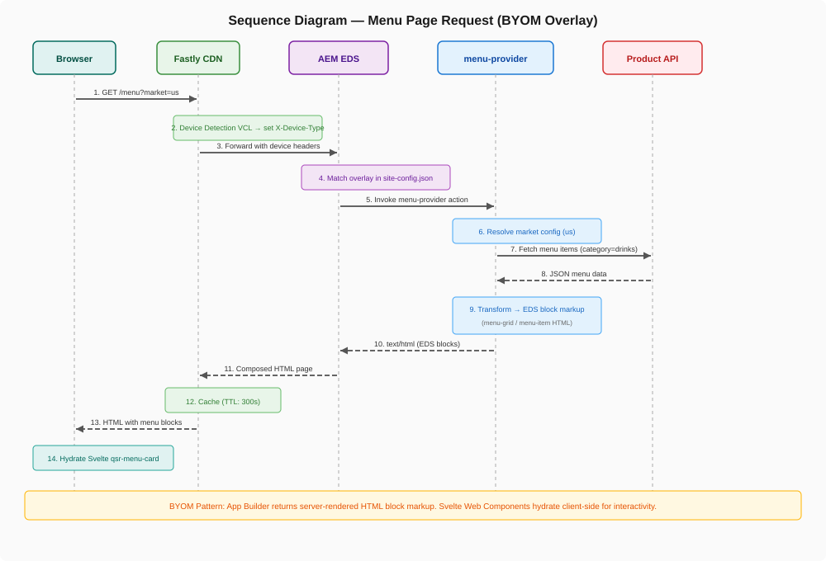
Figure 2: Sequence Diagram — Menu Page Request (BYOM Overlay Pattern)
The flow begins when a user requests /menu. Fastly CDN processes the request through device detection VCL, setting the X-Device-Type header. EDS matches the /menu path to the overlay route in site-config.json and invokes the menu-provider App Builder action. The action resolves market configuration, fetches menu items from the upstream Product API, transforms the JSON data into EDS block markup (menu-grid and menu-item HTML), and returns it to EDS. The composed page is cached at the CDN layer with a 300-second TTL. On the client side, Svelte’s qsr-menu-card components hydrate the server-rendered blocks for interactivity.

4.2 Webhook and Cache Invalidation Flow
Content updates published through AEM Author trigger the following cache invalidation workflow:
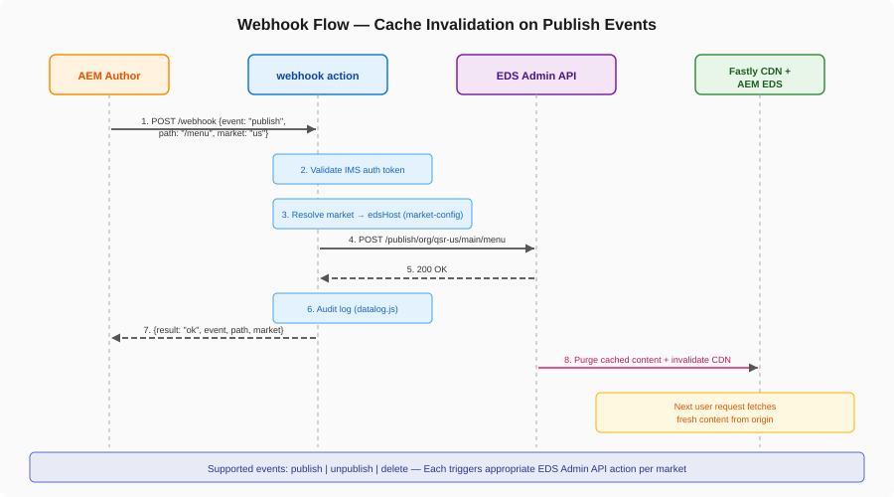
Figure 3: Sequence Diagram — Webhook Cache Invalidation on Publish Events
When an author publishes, unpublishes, or deletes content in AEM, the webhook action receives the event with the content path and market identifier. After validating the IMS authentication token, the action resolves the target EDS host via market-config.js and issues a cache purge request to the EDS Admin API (admin.hlx.page). The Admin API then invalidates both the EDS origin cache and the Fastly CDN cache, ensuring the next user request fetches fresh content.

4.3 Cache TTL Strategy
Each overlay route is configured with a specific cache TTL in site-config.json, balancing freshness with performance:
Overlay Route | Provider | Cache TTL | Rationale
/menu | menu-provider | 300s (5 min) | Menu changes are infrequent; webhook triggers purge for immediate updates.
/stores | store-provider | 600s (10 min) | Store data is relatively static; longer TTL reduces origin load.
/rewards | rewards-provider | 120s (2 min) | Rewards catalog updates more frequently; shorter TTL for freshness.
/account | user-provider | 60s (1 min) | User-specific content; minimal caching to respect personalization.
/rewards-feed | bff-proxy | 60s (1 min) | Dynamic feed data; short TTL to ensure relevance.
Table 4: Cache TTL Strategy by Overlay Route

5. Repository Structure
The monorepo is organized into five top-level directories, each with a distinct responsibility:
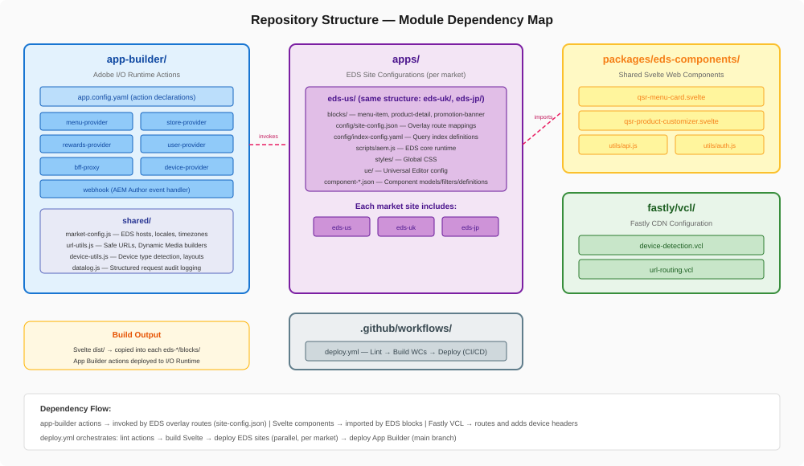
Figure 4: Repository Structure — Module Dependency Map
The app-builder/ directory contains the Adobe App Builder application with seven serverless actions and four shared utility modules. The apps/ directory holds per-market EDS site configurations, each with blocks, config, scripts, styles, and Universal Editor settings. The packages/eds-components/ directory houses the shared Svelte Web Component library. The fastly/vcl/ directory provides Fastly CDN VCL snippets for device detection and URL routing. Finally, the .github/workflows/ directory contains the CI/CD pipeline definition.

5.1 Module Dependencies
App Builder actions are invoked by EDS via the overlay routes defined in each market’s site-config.json. Svelte Web Components are imported by EDS blocks at runtime. The build process compiles Svelte components and distributes them into each market’s blocks/ directory. Fastly VCL runs independently at the CDN edge, adding device detection headers that are consumed by both EDS and the device-provider action.

6. CI/CD Pipeline
The project uses GitHub Actions for continuous integration and deployment. The deploy.yml workflow runs on every push to main and on pull requests.
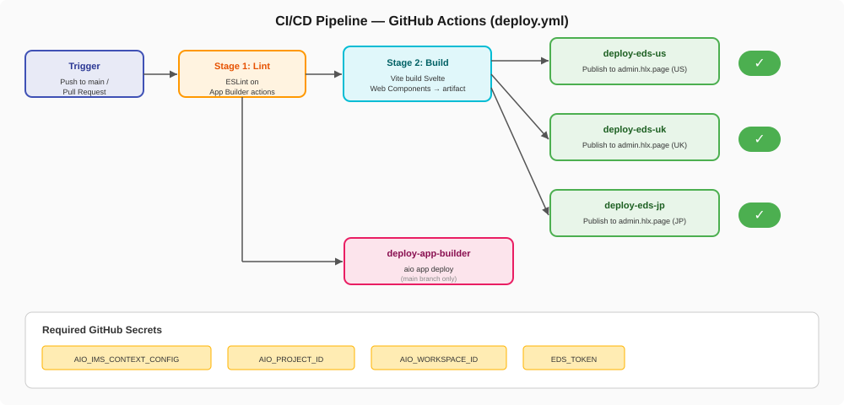
Figure 5: CI/CD Pipeline — GitHub Actions Workflow

6.1 Pipeline Stages
The pipeline consists of four stages executed in a dependency chain:
Stage 1 — Lint: ESLint runs against all App Builder action source files to enforce code quality standards.
Stage 2 — Build Components: Vite builds the Svelte Web Components library, producing optimized bundles in packages/eds-components/dist/. The build artifact is uploaded for subsequent deployment stages.
Stage 3 — Deploy EDS Sites: Three parallel jobs publish each market site (US, UK, JP) to the EDS Admin API (admin.hlx.page) using the EDS_TOKEN. The compiled Svelte bundles are included in the deployment.
Stage 4 — Deploy App Builder: Runs only on main branch merges. Executes aio app deploy to push all serverless actions to Adobe I/O Runtime.

6.2 Required Secrets
Secret | Description
AIO_IMS_CONTEXT_CONFIG | Base64-encoded Adobe IMS context JSON for authenticating aio app deploy.
AIO_PROJECT_ID | Adobe Developer Console project identifier.
AIO_WORKSPACE_ID | Adobe Developer Console workspace identifier.
EDS_TOKEN | Bearer token for AEM EDS Admin API (admin.hlx.page) used for content publishing.
Table 5: Required GitHub Secrets

7. Security Design

7.1 Authentication Model
The system employs a dual authentication model. Public actions (menu-provider, store-provider, device-provider) require no authentication and serve publicly cacheable content. Protected actions (rewards-provider, user-provider, bff-proxy, webhook) require Adobe IMS bearer tokens with the scope openid, AdobeID, read_organizations. The IMS client ID is configured per market in site-config.json.

7.2 BFF Proxy Security
The bff-proxy action implements an allowlist pattern for BFF module names. Only explicitly permitted module names can be invoked through the proxy, preventing unauthorized access to backend services. Combined with IMS authentication, this provides defense-in-depth for the BFF integration layer.

7.3 Webhook Security
The webhook action requires Adobe IMS authentication (require-adobe-auth: true). This ensures that only authenticated AEM Author instances can trigger cache invalidation events. The action validates the IMS token before processing any event.

7.4 Secret Management
All sensitive credentials are stored as GitHub repository secrets and injected into the CI/CD pipeline at runtime. The .env file for local development is excluded via .gitignore. Adobe IMS context configuration is Base64-encoded to prevent accidental exposure.

8. Device Detection and Adaptive Rendering

8.1 Fastly VCL Device Detection
The device-detection.vcl script parses incoming User-Agent headers at the CDN edge and classifies requests into one of six device types: mobile, tablet, desktop, kiosk, digital-menu-board, and headless. The classification is set in the X-Device-Type response header, which is consumed downstream by both EDS and the device-provider action.

8.2 URL Routing
The url-routing.vcl handles device-based URL routing through two strategies: subdomain redirect (e.g., redirecting mobile users to m.example.com) and subdirectory rewrite (e.g., rewriting to /mobile/path internally). The routing strategy can be configured per market.

8.3 Device Provider Action
The device-provider action serves as a content negotiation endpoint. When the Accept header is text/html, it returns a meta snippet suitable for head injection. When the Accept header is application/json, it returns structured layout hints including deviceType, layout configuration, market, and locale. This enables both server-side and client-side device adaptation.

8.4 Supported Device Types
Device Type | Use Case
mobile | Smartphone browsers; touch-optimized layouts with compact navigation.
tablet | Tablet devices; hybrid layout between mobile and desktop.
desktop | Standard desktop browsers; full-width layouts with expanded navigation.
kiosk | In-store ordering kiosks; large touch targets, simplified checkout flow.
digital-menu-board | In-store digital displays; read-only menu rendering, auto-rotation, high contrast.
headless | API consumers and programmatic clients; JSON-only responses.
Table 6: Supported Device Types

9. Overlay Routing Configuration
EDS overlay routes are the mechanism by which AEM Edge Delivery Services delegates content rendering to external providers. Each market’s site-config.json defines the mapping from URL paths to App Builder action endpoints.

9.1 Site Configuration Schema
The site-config.json follows a structured schema with version, siteId, overlays map, auth configuration, market identifier, and EDS host. Each overlay entry specifies the provider name, the full App Builder action URL, and the cache TTL in seconds. The auth section provides the IMS client ID and OAuth scopes for protected routes.

9.2 Overlay Request Processing
When EDS receives a request matching an overlay path, it forwards the request to the configured App Builder action URL. The action processes the request (fetching external data, applying market configuration, transforming to HTML) and returns EDS block markup. EDS then composes the full page, combining the overlay response with static page structure, headers, footers, and navigation elements.

10. Non-Functional Requirements

10.1 Performance
- CDN-first caching strategy with configurable TTLs (60s to 600s) per overlay route.
- Serverless cold-start mitigation through lightweight action design and shared module caching.
- Edge-side device detection to avoid round-trip latency for device classification.
- Svelte Web Components compiled to minimal JavaScript bundles for fast client-side hydration.

10.2 Scalability
- Adobe I/O Runtime provides auto-scaling serverless execution for all App Builder actions.
- Multi-market deployment is additive: new markets require only a new apps/eds-{market}/ directory and market-config.js entry.
- Fastly CDN provides global edge caching with capacity to absorb traffic spikes.

10.3 Maintainability
- Monorepo structure keeps all related code in a single repository with unified CI/CD.
- Shared utility modules (market-config, url-utils, device-utils, datalog) centralize cross-cutting concerns.
- Structured audit logging via datalog.js provides operational visibility across all actions.

10.4 Observability
All App Builder actions accept a LOG_LEVEL parameter for configurable verbosity. The datalog.js module provides structured audit logging covering request parameters, market context, response metadata, and error details. These logs feed into Adobe I/O Runtime’s monitoring infrastructure for operational dashboards and alerting.

11. Project Lifecycle
The project follows a five-phase engagement model with dedicated runbooks and reference documents for each phase:
Phase | Name | Key Activities | Reference Documents
1 | Kickoff | Blueprint review, kickoff deck creation | Blueprint Runbook, Kickoff Deck Template
2 | Discovery | UX solution design, content architecture, analytics, optimization discovery | Discovery Runbook, UX Solution Design, AEM Sites Checklist, Analytics Template
3 | Implementation | AEM configuration, AA/AT/Launch automation, template styling, content creation | Implementation Runbook, AEM Configuration Guide, Front-End Styling Runbook
4 | Go-Live | Pre-production sign-off, cutover, launch | Go-Live Checklist, Go-Live Runbook
5 | Optimisation | Audience configuration, test planning, execution, and optimization | Optimisation Runbook (Chapters 3-5)
Table 7: Project Lifecycle Phases

12. Technology Stack Summary
Layer | Technology | Version / Details
CMS | AEM Author (Cloud Service) | Universal Editor for authoring
Delivery | AEM Edge Delivery Services | aem.live hosted delivery
Serverless Compute | Adobe App Builder (I/O Runtime) | Node.js 18.x actions
CDN | Fastly | VCL for device detection / routing
Authentication | Adobe IMS | OAuth 2.0 (openid, AdobeID)
Frontend Components | Svelte | Web Components (custom elements)
Build Tool | Vite | Component bundling
CI/CD | GitHub Actions | deploy.yml workflow
Languages | JavaScript, CSS, Svelte, HTML, VCL | 38% JS, 28% CSS, 26% Svelte
Runtime | Node.js | 18.x
Package Manager | npm | 9+
CLI Tooling | Adobe I/O CLI (@adobe/aio-cli) | Latest
Table 8: Technology Stack

— End of Document —

