Hardware Concurrency, Memory Models & Lock-Free Design
Research notes | EPAM CoE

Purpose and scope
(1) the CPU–cache–RAM hierarchy, (2) concurrency versus parallelism and cache lines, and (3) the relationship between memory ordering, cache coherence, atomics and lock-free design. It is a research foundation, not a claim that benchmarks have already been run. Performance conclusions should be verified on the machine used for the practical phase.

1. CPU → cache → RAM hierarchy
A processor core needs data and instructions to execute. Main memory (RAM) provides large capacity, but accessing it is usually slower than accessing data already held in a nearby CPU cache. CPUs therefore use a hierarchy of small, fast caches (commonly L1, L2 and a larger last-level cache such as L3). Exact sharing and sizes vary by processor model; L1 and L2 are often private to a core, while the last-level cache may be shared by several cores.
Caches transfer data in fixed-size blocks called cache lines, not one source-language variable at a time. A common cache-line size on modern desktop/server CPUs is 64 bytes, but code should not assume this is universal without checking the target platform.

Simplified data path
CPU core ⇄ L1 cache ⇄ L2 cache ⇄ last-level cache ⇄ RAM
This is a conceptual hierarchy rather than a promise that every access travels through every level. A cache hit can be served at that level; a miss may require fetching the line from a lower level. Caching improves average access time, but it introduces a coordination problem when multiple cores cache the same memory location.

Why this matters for concurrent code
If one core writes a memory location while another core has a cached copy, the hardware must coordinate the copies so that cores do not keep using stale cache-line states. Coherence traffic can cost time even when the threads do not contend on a programming-language lock.

2. Concurrency, parallelism and cache lines
Concurrency means multiple tasks are in progress during overlapping periods; parallelism means tasks are literally executing at the same time, for example on different CPU cores. A concurrent program may run on one core through interleaving, while a parallel program uses multiple execution resources simultaneously.

Cache coherence in one paragraph
A cache-coherence protocol coordinates cached copies of the same memory location across cores. MESI is a widely taught protocol whose state names are Modified, Exclusive, Shared and Invalid. These states describe a cache line's relationship to other cached copies and memory. MESI is a useful model, but real processors may use protocol variants and implementation details that are not visible to application code.

False sharing
False sharing occurs when threads update different variables that happen to occupy the same cache line. The variables are logically independent, yet a write by one core can require coherence actions affecting the line used by another core. Repeated ownership transfers can reduce throughput. This is different from true sharing, where threads genuinely access the same variable.
Illustration: one cache line may contain [counter_A | counter_B | other data]. Thread A updates counter_A and Thread B updates counter_B. If both counters are on the same line, the line can bounce between cores. Padding or alignment can separate frequently updated fields, but padding increases memory use and should be tested rather than applied blindly.

How to test the claim
- Build two versions: adjacent counters and counters separated/aligned so they are likely to occupy separate cache lines.
- Run the same number of worker threads and updates for both versions; use multiple repetitions.
- Record CPU model, operating system, compiler/runtime version, thread count, iteration count and elapsed time.
- Report updates per second (throughput) and, if relevant, time per operation. Include the median and spread across runs.
- Avoid claiming a universal speedup: results depend on CPU, compiler, scheduling, workload and measurement noise.

3. Memory ordering, coherence, atomics and lock-free design

The distinction: coherence is not the whole memory model
Cache coherence helps cores agree on the state/value of a particular cache line. A programming-language memory model defines which cross-thread ordering guarantees a program has. Coherence alone does not make an arbitrary multi-variable communication pattern safe; synchronization is still needed.

Data race and visibility
In C++, a data race occurs when conflicting accesses to the same memory location happen concurrently, at least one is a write, and the accesses are not properly ordered or atomic. A data race on ordinary objects is undefined behavior. A test that happens to pass does not prove the program is race-free; the failure may depend on timing, compiler optimization or CPU.

Acquire and release
A release operation is commonly used when a thread publishes data. An acquire operation on the same atomic object can synchronize with that release when it observes the published value. This creates a happens-before relationship: writes performed before the release become visible to the acquiring thread after the acquire. The relationship depends on the acquire reading from the relevant release (or its release sequence); merely using the words acquire and release somewhere in a program is not sufficient.
Sequentially consistent atomics provide a stronger guarantee: sequentially consistent operations participate in one total order consistent with the language rules. This can make reasoning easier, though the performance cost depends on the architecture and generated code.

Small publication pattern (C++11 or later)
#include <atomic>
#include <iostream>
int payload = 0;
std::atomic<bool> ready{false};
// Producer thread:
void produce() {
payload = 42;
ready.store(true, std::memory_order_release);
}
// Consumer thread:
void consume() {
if (ready.load(std::memory_order_acquire)) {
std::cout << payload << '\\n'; // guaranteed to observe 42
}
}
Important: the example is a pattern, not a complete executable benchmark. The consumer must actually observe the true value published by the release store; in a real program, thread creation/joining and output should be handled correctly. Do not replace the atomic ready flag with a normal bool: that would introduce a data race.

Atomic operations and compare-and-swap (CAS)
An atomic operation is indivisible with respect to concurrent access to that atomic object. Compare-and-swap (CAS) checks whether a value still equals an expected value and, if it does, replaces it with a new value atomically. A CAS loop typically retries if another thread changed the value first. Atomics provide tools for coordination, but they do not automatically make a whole data structure correct.

What lock-free means
Lock-free algorithms do not rely on a traditional mutex to protect their central progress path and use atomics to coordinate updates. In the formal progress sense, system-wide progress continues: some operation completes even if an individual thread can repeatedly lose a race and retry. Lock-free does not mean wait-free, contention-free or automatically faster. Correctness also requires attention to issues such as memory reclamation and, in some algorithms, the ABA problem.

Ring buffers and the LMAX Disruptor
A ring buffer is a fixed-capacity array treated as circular storage. Producer and consumer positions advance around the array, reusing slots after they are safe to reuse. A concurrent ring buffer needs a clear ownership protocol and correct memory ordering so a consumer does not read a slot before the producer has published it, and a producer does not overwrite data before it has been consumed.
The LMAX Disruptor is a high-throughput inter-thread messaging design built around a ring buffer, sequence numbers and coordination between producers/consumers. Its performance comes from a combination of design choices—not from the ring buffer alone—including careful sequencing, reduced allocation and attention to contention/cache behavior. It should be described as an example of a design that can be efficient for suitable workloads, not as a guarantee that every lock-free structure is faster than a mutex.

Concept map
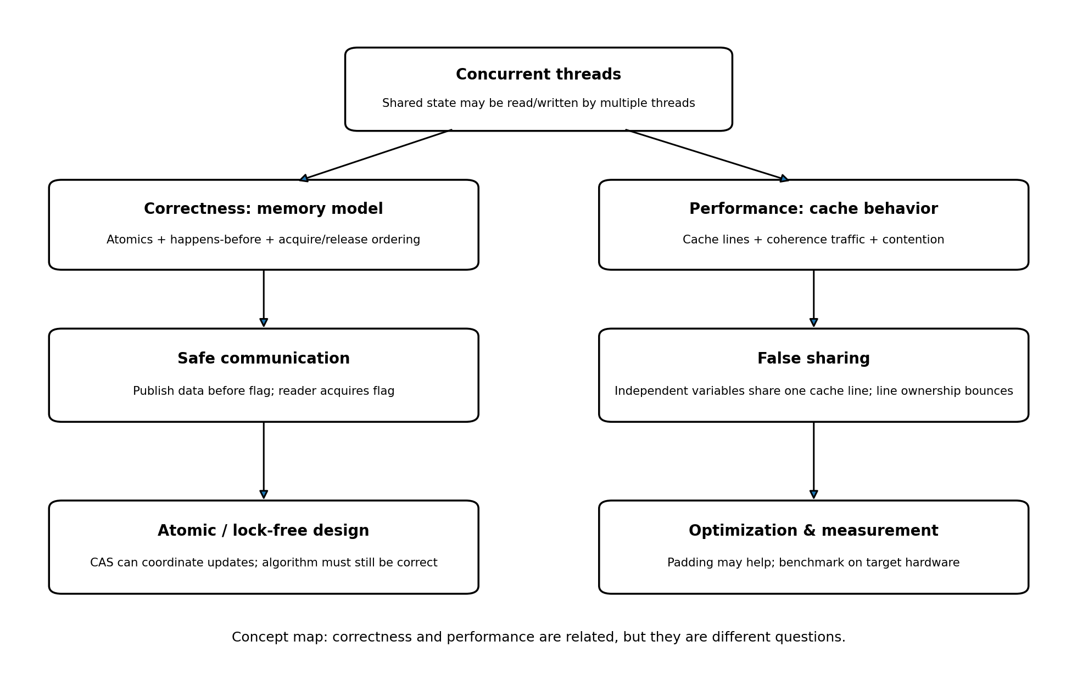

Key takeaways
- CPU caches reduce average memory-access cost; cache lines are the unit of coherence activity.
- Concurrency and parallelism are related but not identical.
- False sharing is a performance problem caused by independent data sharing a cache line.
- Memory ordering is a correctness contract; cache coherence by itself does not prevent data races.
- Release/acquire can safely publish data when the acquire observes the corresponding release.
- CAS is a building block, not a complete correctness proof for a lock-free data structure.
- Benchmark claims need measured results, machine details and repeated runs; theory alone cannot establish a speedup.

