SUMAN IT
Flat.no: 208A, 2ND floor, adhitya enclave, nilgiri block, ameerpet, hyd. 8019242423, 7386977110.
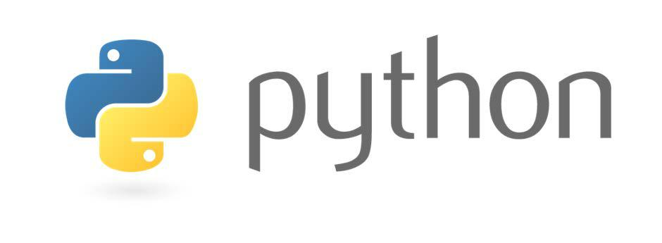

What is Python?

Python is an open source, interpreted, object-oriented, high-level programming language. Python's simple, easy to learn syntax emphasizes readability and makes it very attractive for Rapid Application Development, as well as for use as a scripting or glue language to connect existing components together. Python supports modules and packages, which encourages program modularity and code reuse. The Python interpreter and the extensive standard library are available in source or binary form without charge for all major platforms, and can be freely distributed.

Why learn Python?

Python is a general- purpose language, which means it can be used to build just about anything, which will be made easy with the right tools/libraries.

Professionally, Python is great for backend web development, data analysis, artificial intelligence, and scientific computing. Many companies are now using Python as there go-to language due to its less development time.

Who should attend?

Any fresher who is aspiring career into Python Development or experienced wishing to improve their skill set.

What you will learn in this course?

- Installing Python.

- Core concepts of Python programming Language.

- Comparison with other languages like Java.

Which job roles you are eligible for?

Python Developer.

What Next?

- Learn Python Modules Like Pandas, Numpy etc.

- Learn Django, a Python Framework for Backend Web Development.

COURSE CONTENT:

Getting Started:

- Introduction to Programming
- Introduction to Python
- Why Python? Why Now?
- Python 2.x vs. Python 3.x

Installations:

- Installation of Python
- Introduction to IDLE
- Introduction to Jupyter Notebook.

Python Programming Basics:

- Data Types
- String Concatenation and Replication
- Storing Values with Variables
- Getting Input from Users
- Indent Spacing in Python
- Comments
- Common Function
  - Print()
  - Input()
  - Len()
  - Str(),Int(),Float(),type()
  - Sequential vs Non-Sequential

- Boolean Values
- Operators
- Arithmetic Operators
- Comparison Operators
- Assignment Operators
- Logical Operators
- Bitwise Operators
- Python Membership Operators
- Python Identity Operators

- Flow Control
- If statement
- Else statement
- Elif statement
- While Loop
- Break and Continue Statement
- For Loop
- Range Function
- While True

- Functions

    - Def Statement and Parameter
    - Lambda Functions
    - Return Value ,Return Statement, None Value
    - Multiple Arguments, Keyword Arguments and Default Arguments
    - Local and Global Variables
    - Map, Filter, Reduce functions on List

- Lists
    - Introduction to List Data type
    - List Indexing and Negative Indexing
    - Getting Sub lists and Slicing
    - List Concatenation and Replication
    - Working with Lists
    - List Methods

- Tuples
    - Mutable vs Immutable Data types
    - Tuple Methods
    - Deep Copy and Shallow Copy
    - Conversion of Tuples ,Lists ,Strings and Vice Versa

- Strings
    - String Escape Characters and Raw Strings
    - String Formatting
    - Indexing and Slicing of Strings
    - String Methods
    - Join(),Split(),Strip() and Just() methods

- Dictionary
    - Introduction Dictionary
    - Key Value Pair Concept
    - Dictionary Methods
    - *args and **kwargs concept
    - Setdefault Method

- Operating System
  - Introduction to OS module
  - Introduction to Packages(PIP)
  - Import OS
  - Import Shutil
  - Dirs(List,Tuple,Set,Str,Dict)
  - Rename , Remove
  - Getcwd(),Chdir()
  - Copy , Copytree ,Move ,Unlink
  - Absolute vs Relative Path
  - ispath() ,abspath(),isdir()

- File Handling
  - Introduction to Files, Files Path
  - File Reading and Writing
  - File open and close
  - File append method
  - seek () and Tell Cursor

- Object Oriented Programming (OOPs)
  - Introduction to Object Oriented Paradigm
  - Introduction to Classes and Objects
  - __init__ method and self-concept
  - Constructors
  - Static Methods
  - Class Methods
  - Multiple Inheritance
  - Polymorphism and Encapsulation
  - Super Keyword
  - Operator Overriding and operator Overloading
  - Iterators and Generators

Contact: 7386977110
- Exception handling
  - Errors and Exceptions
  - Types of Exceptions
  - Try and Except Block
  - Else Block
  - Finally Block

- Debugging
- Memory Management

- Regular Expressions
- Introduction to Pattern Matching
- Introduction to re module
- Search, Match, Find all functions
- Grouping and Matching
- Greedy and Non Greedy Matching
- Character Classes
- Significance of ^,$ and dot

- Database Operations In Python
  - Introduction to Database
  - Introduction to MS SQL
  - Introduction to SQLite3 Module
  - Fetchone()
  - Fetchmany()
  - Creating Database
  - CRUD Operations on Table
  - Create Table
  - Select Data
  - Insert Data
  - Drop Table

