CHAPTER 1

1. INTRODUCTION

  - Introduction To Website

We are using advance, Free and Open Source techniques of Web Development with PHP & MySQL for developing a Dynamic Website. The Website will be used for “Building Community of people who can share their ideas and interests”.

  - Problem Statement
Online Repairing Availability providing dedicated customer service, you don’t have to spend much time on searching or waiting for a skilled technician to land at your doorstep with the required tools. Also, we give you the choice to pick the time and date for your much needed services. The best part is our services are budget friendly and affordable.

  - Aim:
The Aim of this Project is to Analyzing the content Online Repairing Availability needs and the growing demand for appliances in our day to day lives, Online Repairing Availability has been quick to offer fast solutions for all home service needs and requirements. In the first changing world, information technology and information management are going to play an information role .We are living in the computer age during past some year. The Computer has gaining popularity Computer revolution found its way into almost every aspect of human life and living . A Computer is admirably suited to handle any information and hence is an information processor that is, it can handle any information and hence is an information processor that is, it can receive data, perform some basic operation on that data and producers results according to a predetermined program.

1.4 Definitions, Abbreviations And Acronyms

- CSS : Cascading Style Sheets.
- HTML : HyperText Markup Language.
- X-HTML : Extensible Markup Language.

BASIC TERMINOLOGIES:

- HTML ( Hypertext Markup Language)
HTML is a computer language devised to allow website creation. These websites can then be viewed by anyone else connected to the Internet. It is relatively easy to learn, with the basics being accessible to most people in one sitting; and quite powerful in what it allows you to create. It is constantly undergoing revision and evolution to meet the demands and requirements of the growing Internet audience under the direction of the » W3C, the organization charged with designing and maintaining the language.

The definition of HTML is HyperText Markup Language. HyperText is the method by which you move around on the web — by clicking on special text called hyperlinks which bring you to the next page. The fact that it is hyper just means it is not linear — i.e. you can go to any place on the Internet whenever you want by clicking on links — there is no set order to do things in. Markup is what HTML tags do to the text inside them. They mark it as a certain type of text (italicised text, for example).

- MySQL (Open Source Database Management System)
MySQL is currently the most popular open source database server in existence. On top of that, it is very commonly used in conjunction with PHP scripts to create powerful and dynamic server-side applications.
MySQL has been criticized in the past for not supporting all the features of other popular and more expensive Data Base Management Systems.

CHAPTER 2

- LITERATURE SURVEY

2.1 Study of current system

Online Repairing Availability pharmacy is a web-based page. This application provides information for daily consumption of Items. This application provides user login to the customer. And admin can get the all expired Items information and he /she can able to see all orders information of clients.
User interfaces are user friendly and attractive. It takes very less time for the delivery to get use with the portal.

2.2 Proposed System

ONLINE REPAIRING AVAILABILITY web page is accessible by users divided in 2 categories :
•Admin
•Customer
When a user first open the page then index page appear on the screen and after 3-5 second page open only when Mechanics Login already . In this activity , customer can see the product name send by ADMIN.
Main page of this web page is homepage opens automatically , this page provides an interface to allow the user to select from various option available . The option are listed below:-
•Admin login
•Mechanics Login

2.3 Feasibility Study

FEASIBILTY ANALYSIS
Feasibility analysis is a cross life cycle activity, which has to be continuously performed throughout the system development. By using the creeping commitment approach, feasibility is measured at different times in the system development. This evaluation ensures that the project is beneficial and practical to an organization.
Feasibility Test:
There are three categories of feasibility tests:
- Operational Feasibility
- Technical Feasibility
- Time Feasibility
- Economic Feasibility.
2.3.1 OPERATIONAL FEASIBILTY:
Admin Login- On selecting the admin login option the user is referred to login page that allows the admin to provide unique password which is given by the developer .On successful login the admin is referred to page where search customer order and review option are displaying they can perform action as listed on this interface :-
- Send order
- Search customer
- Update password
- Logout

Send order-This interface provide to send order means send product name with brand, it also have type of product .

It consists of the following:
1. Statement of the problem: A carefully worded statement of the problem that led to analysis.
2. Summary of finding and recommendations: A list of the major findings and recommendations of the study. It is ideal for the user who requires quick access to the results of the analysis of the system under study. Conclusion is stated, followed by a list of the recommendation and a justification for them.
3. Details of findings: An outline of the methods and procedures under-taken by the existing system followed by coverage of the objectives and procedures of the candidate system. Included are also discussions of output reports, file structures, and costs and benefits of the candidate system.
4. Recommendations and Conclusions: Specific recommendations regarding the candidate system, including personnel assignments, costs, project schedules, and target dates.
It is how well the solution will work in the organization and how the end-users and managers feel about the system. This people oriented test measures the urgency of problem or the acceptability of a solution. I.e. is the problem worth solving?
‘PIECES’ is used as the basis for analyzing the urgency of problem or the effectiveness of a solution.

PIECES stand for:

P – Performance
- Throughput
- Response Time
I – Information
- Input
- Output
- Stored data
E – Economics
- Cost of processing high.
- Too many employee involve in one operation
C – Control
- Too little control or security
- Effort required for job is excessive.
E – Efficiency
- Reports generated are erroneous.
S – Services provided to the customers. Feedback and response from the customers.

2.3.2 TECHNICAL FEASIBILTY
It centers on the existing computer system and to what extent it can support the proposed system. The system is technically feasible as existing system (hardware and software) etc is Sufficient for the proposed system. There will be no overburden of the system.
Example, if the current computer is operating at 0 percent capacity- an arbitrary ceiling- then running another application could overload the system or require addition hardware. This involves financial consideration to accommodate technical enhancements; if the budget is the serious constraint then the project is judged not feasible, a study of functions, performance and constraints.

This is concerned with specifying equipment and software that will successfully satisfy the user requirement. The technical needs of the system may vary considerably, but might include:
- The facility to produce outputs in a given time.
- Response time under certain conditions.
- Ability to process a certain volume of transaction at a particular speed.
- Facility to communicate data to distant location.
After examining technical feasibility, we give more importance to the configuration of the system than the actual make of hardware. The configuration gives the complete picture about the system's requirements:

2.3.3 TIME FEASIBILITY
Measure of how reasonable the project timetable is. Schedule can be mandatory or desirable. It’s better to deliver a properly functioning information system later than to deliver an error-prone.

2.3.4 ECONOMICAL FEASIBILTY
It includes the cost – benefit analysis. That is to determine whether the procedure to be applied is benefits and savings are expected from the candidate system. Economic analysis is most frequently used method for evaluating the effectiveness of a candidate system. More commonly known as cost/benefit analysis, the procedure is to determine the benefits and savings that are expected from candidate system and compare them with cost. An evaluation of development costs weighed against the available income or benefits derived from the developed system or project.
With the help of this application it will lead to decrease in cost of opening and maintaining offices which will be more than the cost of developing and maintaining the Application. Lesser manpower is needed to maintain an application than a branch office, which will again lead to decrease in cost.
This application is economically feasible because there is no special hardware required for this project and for any up gradation in future to this project, only functionality has to be changed to fulfill the new requirements of customer.

After gathering all the details of the existing system a lot of problems come to light. The user stated problems are as follows:
- Difficulty in finding any information about the food items at any instance.
- Lack of appropriate report to submit the management on demand due to large manual processing done on various relevant registers.
- Difficulty in calculation of total bill.
- Long processing taken at the peak hours. As a result poor performance of the system causes dissatisfaction.
- Difficulty in updating of the items purchased.
- Financial loss due to late manual report generation.
Consequently, costs and benefits are described with greater accuracy at this stage.

FEASABILITY STUDY DONE WITH FRIENDS-E-WORLD:-

- TIME FEASABILITY

This project is time feasible since it requires less time for registration and creating profile.

- TECHNICAL FEASABILITY

The technology used in this project is mainly PHP and X-HTML as provides various features that can be used to implement the project. Thus all the networking and event handling features of PHP makes this project technically feasible.

- ECONOMIC FEASABILITY

The only thing that this project needs is that, at least one computer. Since this project does not require any special hardware therefore it is economically feasible.

CHAPTER 3

- REQUIREMENT ANALYSIS

3.1 Identify The Problem

Considering the great impact of System Analysis on the overall project development a systematic and detailed analysis was conducted for the development of Production Management and Analysis System. Study was conducted to determine the initial scope of the system. Preliminary investigation comprising of request clarification, feasibility study etc. were carried out.

The current Search Method is manual and it was a failure, as it could not meet the entire requirement of the prospect clients. During analysis we studied manual system to find out their functionalities and deficiencies.

The fact-finding activities on a system study produces detail that describes current operation and point to areas where improvement is needed or possible. To evaluate the existing system analyst consider the current system capacity including the people, equipment, storage space, time and procedures involved

3.2 Requirement Overview

3.2.1 Purpose:

Online Repairing Availability manages customer as well as allow them to get the purchase online Items. Hence this project offers an effective solution where user can view various Items available and select the brand and product.

3.2.2 Scope:

When a user first open the page then index page appear on the screen and after 3-5 second page open only when Mechanics Login already . In this activity , customer can see the product name send by ADMIN.
3.2.3 Overall Description:
3.2.3.1 Product perspective:
3.2.3.2 Product functions: the functions of the product are
- Creating profile and begin socializing.
3.2.3.3 User characteristics: customer must be aware of working of computers and must have basic information about HTML, PHP and X-HTML technology on which the software is built.
3.2.4 Specific Requirement
1) Input: input given is as Login id and password by the help of which user can begin socializing.
2) Output: As output we get web pages which will show the profile of the user.
3) Functional requirement: The user must be a member and know his Login ID and password.
3.2.5 External Interface Requirement
3.2.5.1 User interface: the user interface should be intuitive. The user must have general idea of using the computer , so that he can create his profile and can view others .
3.2.5.2 Performance constraints: operations should be performed in minimum time and the user must receive instant responses just on the time of click.
3.2.5.3 Design Constraints
Software constraints: . Server Requirements

- Apache Web Server
- MySQL 5.x
- PHP 5.x (mod_php/CGI)
- Support for MySql

Client Side Requirements

- Internet Browser

Hardware Constraints: The software will run on processor having 1 GB ram and the processor should have continuous power supply and a proper GUI interface.

3.3 INFRASTRUCTURE

3.3.1 Hardware Requirement

Software Requirements : PHP ENVIRONMENT
RAM : Minimum 128 Mb
Operating Platform : Win XP(for better visualization)
Hard Disk : Minimum 20 GB
Processor : Pentium Series

CHAPTER 4

4. TECHNOLOGICAL SURVEY

4.1. Overview of PHP Development Environment
Taken directly from PHP's home, PHP.net, "PHP is an HTML-embedded scripting language. Much of its syntax is borrowed from C, Java and Perl with a couple of unique PHP-specific features thrown in. The goal of the language is to allow web developers to write dynamically generated pages quickly."

This is generally a good definition of PHP. However, it does contain a lot of terms you may not be used to. Another way to think of PHP is a powerful, behind the scenes scripting language that your visitors won't see!
When someone visits your PHP webpage, your web server processes the PHP code. It then sees which parts it needs to show to visitors(content and pictures) and hides the other stuff(file operations, math calculations, etc.) then translates your PHP into HTML. After the translation into HTML, it sends the webpage to your visitor's web browser.

It is also helpful to think of PHP in terms of what it can do for you. PHP will allow you to:
- Reduce the time to create large websites.
- Create customized user experience for visitors based on information that you have gathered from them.
- Open up thousands of possibilities for online tools. Check out PHP - Hot Scripts for examples of the great things that are possible with PHP.
- Allow creation of shopping carts for e-commerce websites.

PHP's syntax and semantics are similar to most other programming languages (C, Java, Perl) with the addition that all PHP code is contained with a tag, of sorts.

4.2 MySQL (Open Source Database Management System)

MySQL is currently the most popular open source database server in existence. On top of that, it is very commonly used in conjunction with PHP scripts to create powerful and dynamic server-side applications.

MySQL has been criticized in the past for not supporting all the features of other popular and more expensive Database Management Systems. However, MySQL continues to improve with each release (currently version 5), and it has become widely popular with individuals and businesses of many different sizes.

what is a database?

A database is a structure that comes in two flavors: a flat database and a relational database. A relational database is much more oriented to the human mind and is often preferred over the gabble-de-gook flat database that are just stored on hard drives like a text file. MySQL is a relational database.

In a relational structured database there are tables that store data. The columns define which kinds of information will be stored in the table. An individual column must be created for each type of data you wish to store (i.e. Age, Weight, Height).

On the other hand, a row contains the actual values for these specified columns. Each row will have 1 value for each and every column. For example a table with columns (Name, Age, Weight-lbs) could have a row with the values (Bob, 65, 165). If all this relational database talk is too confusing, don't despair. We will talk about and show a few examples in the coming lessons.

why use a database?
Databases are most useful when it comes to storing information that fits into logical categories. For example, say that you wanted to store information of all the employees in a company. With a database you can group different parts of your business into separate tables to help store your information logically. Example tables might be: Employees, Supervisors, and Customers. Each table would then contain columns specific to these three areas. To help store information related to each employee, the Employees table might have the following columns: Hire, Date, Position, Age, and Salary.

4.3 CSS ( Cascading Style Sheets)

It is time to take your web designing skills to the next level with Cascading Style Sheets (CSS). They are a way to control the look and feel of your HTML documents in an organized and efficient manner. With CSS you will be able to:
Add new looks to your old HTML
Completely restyle a web site with only a few changes to your CSS code
Use the "style" you create on any webpage you wish!

A style sheet can, and should be, completely separate from your HTML documents. When you have mastered CSS and HTML, you will be able to separate your web site's design and formatting (CSS) from the content (HTML).

4.4 HTML ( Hypertext Markup Language)

HTML is a computer language devised to allow website creation. These websites can then be viewed by anyone else connected to the Internet. It is relatively easy to learn, with the basics being accessible to most people in one sitting; and quite powerful in what it allows you to create. It is constantly undergoing revision and evolution to meet the demands and requirements of the growing Internet audience under the direction of the » W3C, the organization charged with designing and maintaining the language.

The definition of HTML is HyperText Markup Language.

HyperText is the method by which you move around on the web — by clicking on special text called hyperlinks which bring you to the next page. The fact that it is hyper just means it is not linear — i.e. you can go to any place on the Internet whenever you want by clicking on links — there is no set order to do things in.
Markup is what HTML tags do to the text inside them. They mark it as a certain type of text (italicised text, for example). HTML is a Language, as it has code-words and syntax like any other language.

Module Specification:-

- Objective Of Module 1

Basically module 1 SERVER SIDE code that request to a client for connection and waits until the connection is not established. When connection gets established it can constantly monitor the clients desktop and can handle it using mouse.

- Objective Of Module 2

Module 2 is CLIENT SIDE code which accepts the servers request for connection and establishes a connection between them so that server can view its desktop and handle its devices.

- Objective Of Module 3

Module 3 is basically for EVENT HANDLING. It enables user sitting on server side to control the events of remote desktop with its device.

CHAPTER 5

5. TESTING
SYSTEM TESTING
System testing phase makes sure that programs perform the intended tasks. Once the system is designed it should be tested for validity. During system testing, the system is used experimentally to ensure that the software does not fail i.e. it will run according to its specification and in the way users expect it to work.
System testing represents the ultimate review of specification, design and coding. This review may be based on the feedbacks obtained from the users.
System testing is concerned with finding such errors which do result from interactions/interfacing among sub-systems. System testing would be concerned with checking that the system meets the organization’s objective.
System testing can be of the following five types:
- Unit Testing
- White-Box Testing or Glass-Box Testing or Structural Testing.
- Black-Box Testing or Functional Testing
- Alpha Testing or Acceptance Testing
- Beta Testing
5.1 Unit Testing
Unit testing focuses verification effort on the smallest unit of software design- The software component or module. Using component level design description as a guide, important control paths are tested to uncover errors within the boundary of the module. Tests of data flow across a module interface were carried out for each module of the software, i.e. unit testing ensures that functions or procedures are operating correctly. Each component is tested individually.
White-Box Testing
White-Box Testing is concerned with the implementation of the program. In this type of testing, different programming structures and data structures used in the program are tested for proper operations. This test concentrates on the examinations of the coding. The system software engineers and programmers coin test-cases that have the likelihood of finding out possible errors.
Black-Box Testing
Black-box testing is concerned with the proper execution of the program specifications. In this testing, each function or sub-program used in the main program is first identified. Here after test-cases are devised to test each function or sub-program separately. Test-cases are decided solely on the basis of the requirements or specifications of the program and not on the basis of the coding (such as data structure used) of the modules.
Black-box testing is complementary to white box techniques. It uncovers a different class of errors which are not discovered by white box methods. This type of testing attempts to find the following errors:
- Interface errors
- Incorrect or missing functions
- Errors in external database access
- Performance errors
- Initialization and termination errors
5.4 Alpha Testing
A test performed at the developer’s site before the system is finally installed in the real working environment (user’s site) is known as Alpha testing. It involves testing the system with live data supplied by the organization rather than by the test data used by system designer. Alpha Testing is also known as Acceptance test since it is performed before the system is accepted as being fit for the intended users.
5.5 Beta Testing
In Beta Testing, the system is delivered to a number of potential users who agree to use that system and provide feedback to the designers. Testing should be repeated if any modification is done based on the feedback given by the users. Hence, it is sometimes called as regression testing.

CHAPTER 6

6. OBJECT ORIENTED ANALYSIS MODELLING

Analysis modeling uses a combination of text and diagrammatic forms to depict requirements for data, function, and behavior in a way that is relatively easy to understand, and more important, straightforward to review for correctness, completeness and consistency.
Object oriented analysis and modeling includes
- Scenario based modeling
- Use case diagram
- Activity diagram
- Flow oriented modeling
- Data flow diagram
- Class based modeling
- Class diagram
- Behavioral modeling
- State transition diagram
- Sequence diagram
- Collaboration diagram

6.1 SCENARIO BASED MODELING

Scenario modeling is a hypothetical -but testable- program or data structure designed for a specific purpose. The data set is the variables that get plugged into your program, formula or structure. Quite often, a data set is chosen because you know in advance how it should appear or what it should do once inserted into the scenario. And usually, the model is a representation of some real-world task or description -you want to see how closely the model anticipates the real-world scenario you are testing. The data set stands in for real-world variables.
In this model, scenarios are organized hierarchically and they capture the system functionality at various abstraction levels including scenario groups, scenarios, and sub-scenarios. Combining scenarios or sub-scenarios can form complex scenarios. Data are also separately identified, organized, and attached to scenarios. This scenario model can be used to cross check with the UML model. It can also direct systematic scenario-based testing including test case generation, test coverage analysis with respect to requirements, and functional regression testing.

6.1.1 USE CASE DIAGRAM

A use case is a description of how users will perform tasks on the project. A use case describes a sequence of interactions between a user and a project without specifying the user interface.
A use case includes two main parts:
- the steps a user will take to accomplish a particular task on the project.
- the way the project should respond to a user's actions
A use case begins with a user's goal and ends when that goal is fulfilled.
Each use case captures:
- The actor (who is using the project?)
- The interaction (what does the user want to do?)
- The goal (what is the user's goal?)
A use case diagram is a graphical representation of the relationship between actor and use case.
An actor in a use case represents a user or another system that will interact with the system you are modeling .

Customer

A use case is a set of scenarios that describing an interaction between a user and a system.

FIGURE NO.1 Use Case Diagram

Login
Register
Customer

See
Invoice
View Dashboard
Purchases
Items
User Options
Client

USE CASE DIAGRAM FOR ONLINE REPAIRING AVAILABILITY

6.1.2 ACTIVITY DIAGRAM

An activity diagram is used to display the sequence of activities. Activity diagrams show the workflow from a start point to the finish point detailing the many decision paths that exist in the progression of events contained in the activity. They may be used to detail situations where parallel processing may occur in the execution of some activities. Activity diagrams are useful for business modelling where they are used for detailing the processes involved in business activities.

FIGURE NO.2 ACTIVITY DIAGRAM

START
REGISTERED?
LOGIN
REGISTER
VALIDATE?
View PROFILE
See Invoice

Purchase Items

Print Invoice
in Detail

Items
Bill Generate
NAVIGATE
LOGOUT
Manage Your Account

ACTIVITY DIAGRAM FOR BILLING SYSTEM

6.2 FLOW ORIENTED MODELING( STRUCTURED ANALYSIS)

Structured Analysis (SA) in software engineering and its allied technique, Structured Design (SD), are methods for analyzing and converting business requirements into specifications and ultimately, computer programs, hardware configurations and related manual procedures.
Structured analysis and design techniques are fundamental tools of systems analysis
The analysis consists of interpreting the system concept (or real world) into data and control terminology, that is into data flow diagrams. The flow of data and control from bubble to data store to bubble can be very hard to track and the number of bubbles can get to be extremely large. One approach is to first define events from the outside world that require the system to react, then assign a bubble to that event, bubbles that need to interact are then connected until the system is defined.
Data Dictionaries are needed to describe the data and command flows and a process specification is needed to capture the transaction/transformation information
SA and SD were accompanied by notational methods including structure charts, data flow diagrams and data model diagrams, of which there were many variations.

6.2.1 DATA FLOW DIAGRAM

A Data Flow Diagram (DFD) is a graphical representation of the "flow" of data through an information system. It differs from the system flowchart as it shows the flow of data through processes instead of hardware. The DFD is designed to show how a system is divided into smaller portions and to highlight the flow of data between those part

FIGURE NO.3 DATAFLOW DIAGRAM

Enter Login
ID
&
Pas

User Account Options
Register Client
Invalid
Valid
Database
Check
Result
View Dashboard
LEVEL 2
Database

User Account Options

Enter Users Registration Info
Admin
Decision
Authentication Failed

cation Failed
Invalid
Valid

Valid by Admin
Add Client to Database
Register
Client
Purchase Items
Admin Decision
Login Failed
Invalid
Validate Details
Database
Valid
LEVEL 3

6.3 CLASS BASED MODELLING:

In class based modeling the whole system is described using the classes involved in them. For this purpose class diagrams are used. Class diagrams are the main stay of object-oriented analysis and design. Class diagrams show the classes of the system, their interrelationships (including inheritance, aggregation, and association), and the operations and attributes of the classes. Class diagrams are used for a wide variety of purposes, including both conceptual/domain modeling and detailed design modeling.

FIGURE NO.4 CLASS DIAGRAM

Login
User Name : String
password : String
+ GET() :
+ POST():

6.4 BEHAVIOURAL MODELING

A behavioral model reproduces the required behavior of the original analyzed system, such as there is a one-to-one correspondence between the behavior of the original system and the simulated system. That namely implies that the model uniquely predicts future system states from past systems states.

6.4.1 STATE DIAGRAM (STD)
An STD is a way of describing the time-dependent behavior of a system. The basic consistency rule is: "A system's behavior in any state must be the same no matter by which path the state is arrived at".
States:
- A state is an observable mode of behavior of the system.
- At any time a particular STD can only be in one state.
- But a system's behavior could be described by more than one state transition diagram
Transition conditions:
- internal events or events external to the system
Transition actions:
- actions in response to the events
- triggering one-shot actions
- synchronizing between different STD's
- producing control outputs
Drawing STD's:
- Identify observable states of the system
- Select the states with normal behavior
- Specify the conditions that mark a transition
- Specify the actions to produce the observable behavior in the destination state for each transition
- If the system is complex, partition the diagram in several STD's

FIGURE NO.5 STATE DIAGRAM

do/registration
Login
do/login check
Register Client
Valid Register
User Options Page
Valid Login
Invalid Login
Select user options
Do/Select options
Add Brands
Do/add Price
View, Profile
Purchase
Community Users
Do/Connect
Action Complete
Validate Transactions Details
Add Item
View Stock
Valid Connect
View Dashboard
Valid

STATE TRANSITION DIAGRAM FOR ONLINE REPAIRING AVAILABILITY

6.4.2 SEQUENCE DIAGRAM
Sequence diagrams model the flow of logic within your system in a visual manner, enabling you both to document and validate your logic, and are commonly used for both analysis and design purposes. Sequence diagrams are the most popular UML artifact for dynamic modeling, which focuses on identifying the behavior within your system.

FIGURE NO.6
Sequence diagram for ONLINE REPAIRING AVAILABILITY

Main Menu

Registration
Screen
Registration
Manager
ADMIN
Creator

USER
Register. Form
Register. Form
Register(USER)
Register
Register. Form

Home
Page
Registration
Screen
Administrator
User
Creator
Create User
User Name and Password

Home
Page
Login
Controller
Validation
Login
Screen
Login
User Name & Password
Login
(UserName,pwd)
Validate
(Username,pwd)
USER

Login
Controller
Validation
Result
User
Screen
Valid
User
Invalid
User
Validator
Home
Page
Login
Screen

USER
LOGIN

LOGIN CONTROLLER
POST ON WALL
DATABASE REFERRENCE
FRONTEND DISPLAY
Valid user
Argument Passing
Query
Log out
Again

CHAPTER 7

7. PROCESS MODEL PLANNING AND SCHEDULING
OBJECT: LOGIN
REGISTER MANAGER
ADMINISTRATOR
TRAVERSED
FLASH DETAILS
NAVIGATOR
FLASH
DATABASE
SEARCH

7.1 Process Model

Software process models often represent a networked sequence of activities, objects, transformations, and events that embody strategies for accomplishing software evolution. Such models can be used to develop more precise and formalized descriptions of software life cycle activities. Their power emerges from their utilization of a sufficiently rich notation, syntax, or semantics, often suitable for computational processing.
Out of all process models we have used WATERFALL MODEL in our project.
The waterfall model is a popular version of the systems development life cycle model for software engineering. Often considered the classic approach to the systems development life cycle, the waterfall model describes a development method that is linear and sequential. Waterfall development has distinct goals for each phase of development. Imagine a waterfall on the cliff of a steep mountain. Once the water has flowed over the edge of the cliff and has begun its journey down the side of the mountain, it cannot turn back. It is the same with waterfall development. Once a phase of development is completed, the development proceeds to the next phase and there is no turning back.
The advantage of waterfall development is that it allows for departmentalization and managerial control. A schedule can be set with deadlines for each stage of development and a product can proceed through the development process like a car in a carwash, and theoretically, be delivered on time. Development moves from concept, through design, implementation, testing, installation, troubleshooting, and ends up at operation and maintenance. Each phase of development proceeds in strict order, without any overlapping or iterative steps.
The disadvantage of waterfall development is that it does not allow for much reflection or revision. Once an application is in the testing stage, it is very difficult to go back and change something that was not well-thought out in the concept stage. Alternatives to the waterfall model include joint application development (JAD), rapid application development (RAD), synch and stabilize, build and fix, and the spiral model.

FIGURE NO.7 WATERFALL MODEL
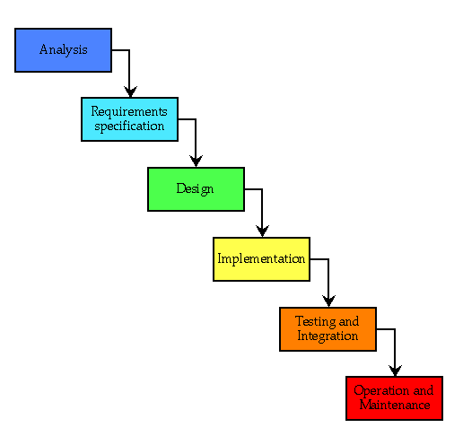

7.2 Project Scheduling

Scheduling of the project means deciding the start and end date of the project. Project schedules a project from the information you enter about the overall project, the individual work items (called tasks (task: An activity that has a beginning and an end. Project plans are made up of tasks.)) Required to complete the project, and, if necessary, the resources (the people, equipment, and materials) needed to complete those tasks.
Project can be scheduled using PERT CHART.

7.2.1 Pert Chart
There are two tools and techniques that support project managers. Two such tools are PERT and Gantt Charts. PERT, which stands for Project Evaluation and Review Technique, is a model for project management designed to analyze and represent the tasks involved in completing a given project. PERT is a method to analyze the involved tasks in completing a given project, especially the time needed to complete each task, and identifying the minimum time needed to complete the total project. A PERT chart is a graphical network model that depicts a project’s tasks and the relationships between those tasks. A PERT chart is a tool that facilitates decision making. PERT was developed to make clear the interdependence between project tasks before those tasks are scheduled. Two consecutive events in a PERT chart are linked by activities, which are conventionally represented as arrows. The arrows indicate that one task is dependent on the start or completion of another task. The events are presented in a logical sequence and no activity can commence until its immediately preceding event is completed. The planner decides which milestones should be PERT events and also decides their “proper” sequence. A PERT chart may have multiple pages with many sub-tasks.
Arrow is used to represent Task
Circles represent the beginning or completion of task.

The PERT chart process includes following steps: -
- Identifies the specific activities and milestone.
- Determine the proper sequence of the activities.
- Construct a network diagram.
- Estimate the time required for each activity.
- Determine the critical path.
- Update the PERT chart as the process progresses.

FIGURE NO.8 PERT CHART

1
Problem Definition

2
Feasibility study
3
4

3
System analyze
2

4
Class Diagram
12

5
Flow chart
58

7
Data Dictionary
3
6
Coding and Complete Documentation
50

8
Testing
12

9
Implementation
8

Actual Process Of Pert Chart

S. No | Phase | Time Estimate in days | Actual Time/Day
1. | Problem Definition | 3 | 3
2. | Feasibility Study | 4 | 3
3.  3.1.  3.2.  3.3. | System Analysis and Design  Class Diagram  Data Dictionary  Complete Documentation | 2  5  3  25 | 3  6  3  10
4. | Coding | 25 | 30
5. | Testing | 12 | 10
6. | Implementation | 8 | 4
(Table)

Total Number of Hours = 94 days * 5 hrs.
= 490 Hours

7.3 DEPLOYMENT & USER MANUAL

7.3.1 User Manual

Remote monitoring system project is made using PHP technology. So for its working the user will require PHP environment on his computer. To implement this program the users want to run their respective codes on their sides. First the user whose desktop is to be viewed must run its code then, the user who wants to view the remote computer must run his project by giving the IP address and port numbers. If the given inputs are verified then a window will open on the viewing computer which will show all the activities of the remote computer and will allow its desktop to handle with mouse.

7.3.2 Deployment Diagram

Deployment diagram depicts a static view of the run-time configuration of processing nodes and the components that run on those nodes. In other words, deployment diagrams show the hardware for your system, the software that is installed on that hardware, and the middleware used to connect the disparate machines to one another. Deployment diagrams can also be created to explore the architecture of embedded systems, showing how the hardware and software components work together. In short, you may want to consider creating a deployment diagram for all but the most trivial of systems.

FUTURE WORK

The main aim of developing this website is to supply the Items by just a single click and to reduce the time consumption. Online pharmacy is a web based application. The user can post requirement for Items. User can purchase Items online. Items is provided at your doorstep by the nearest associate store.

The prescription is mandatory ordering Items . As per the prescription, the user can search Items and useful information . This application provides information for daily consumption of Items . This application provides user login to the customer . And admin can get the all expired Items information and he can able to see all orders information of clients.

- Usage of JavaScript for Form Validations.
- AJAX (For implementing chat box)
- JQuery (For User Registrations)

FIGURE NO.9

REGISTRATION FORM

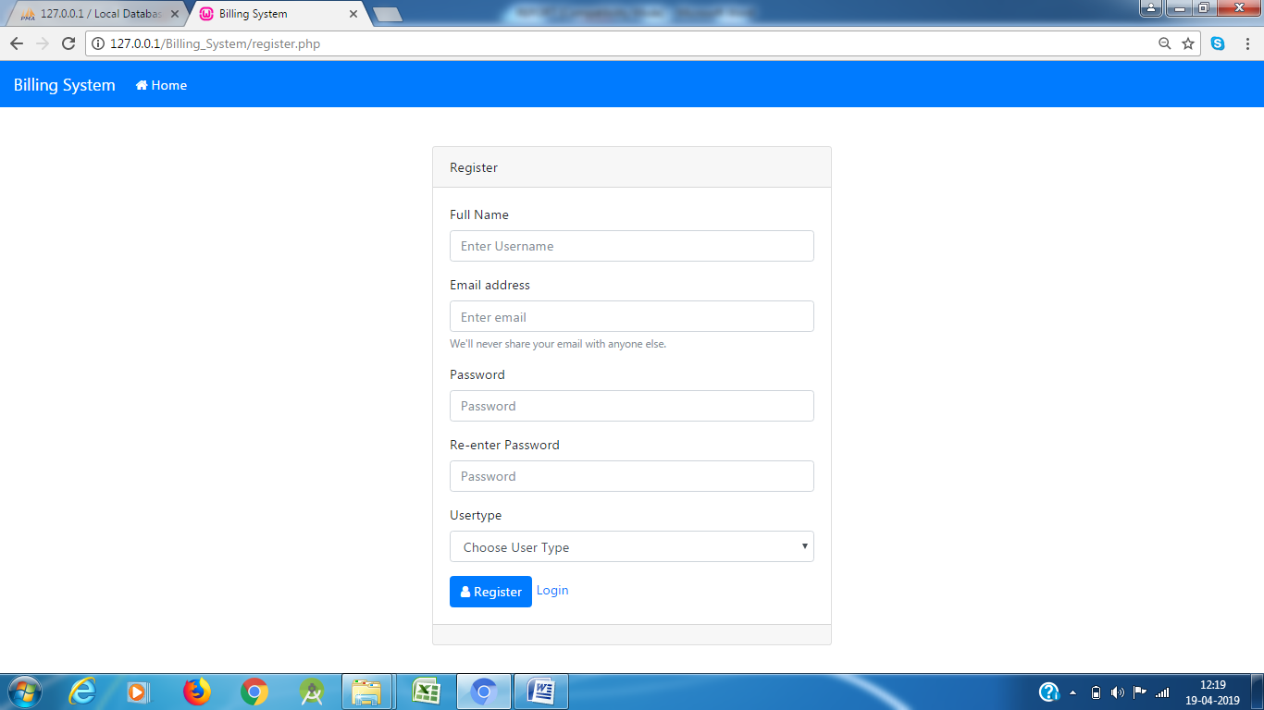

FIGURE NO.10
ADMIN LOGIN PAGE

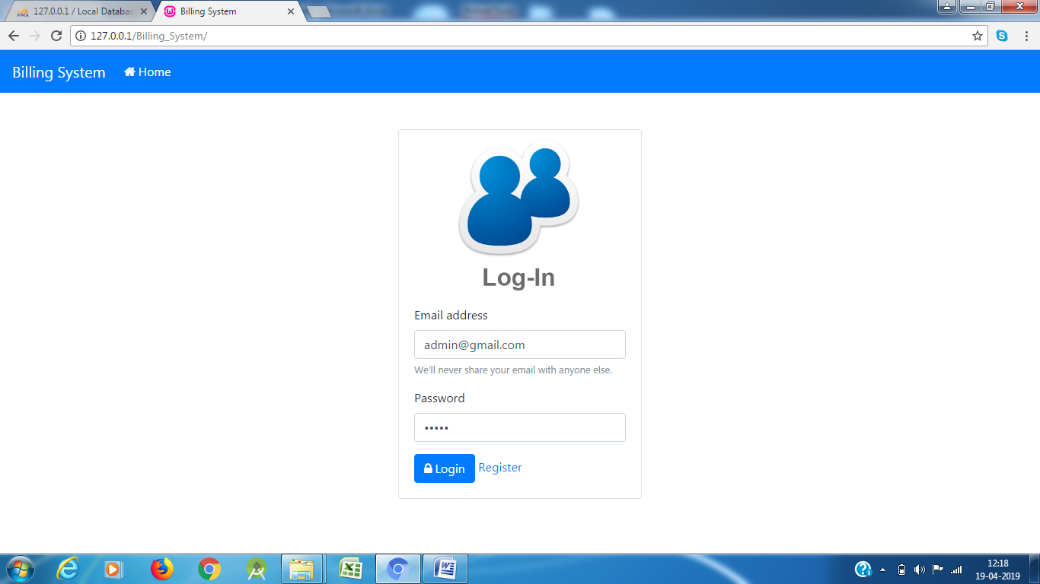

FIGURE NO.11
Admin Dashboard

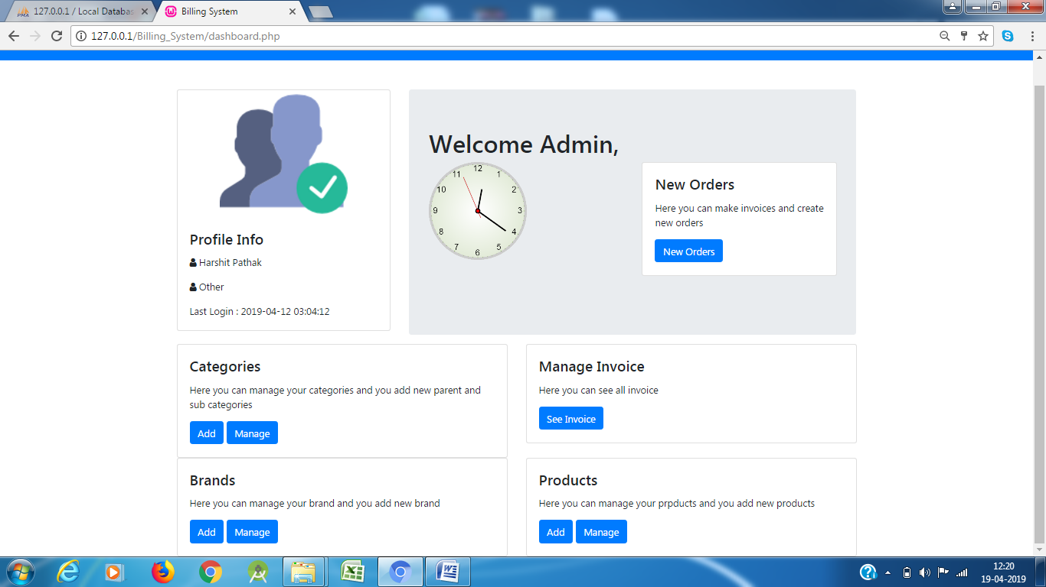

FIGURE NO.12
Product Categories

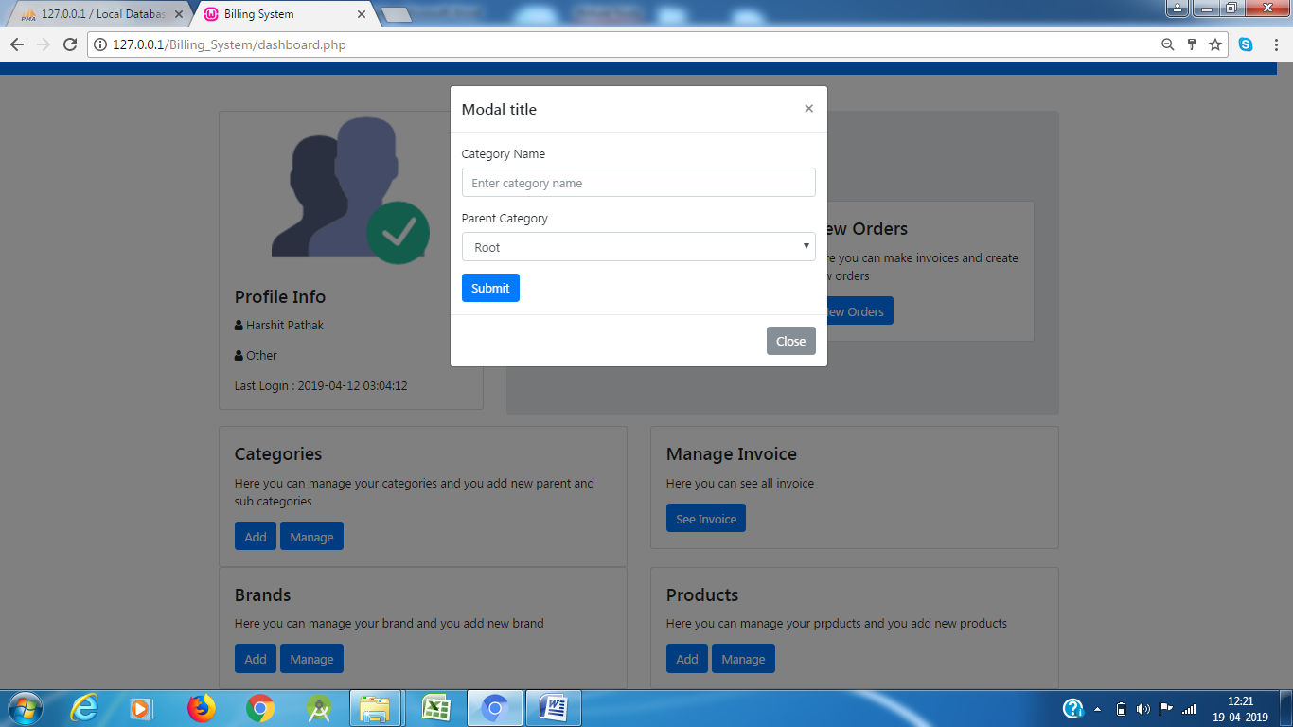

FIGURE NO.13
Brand Entry

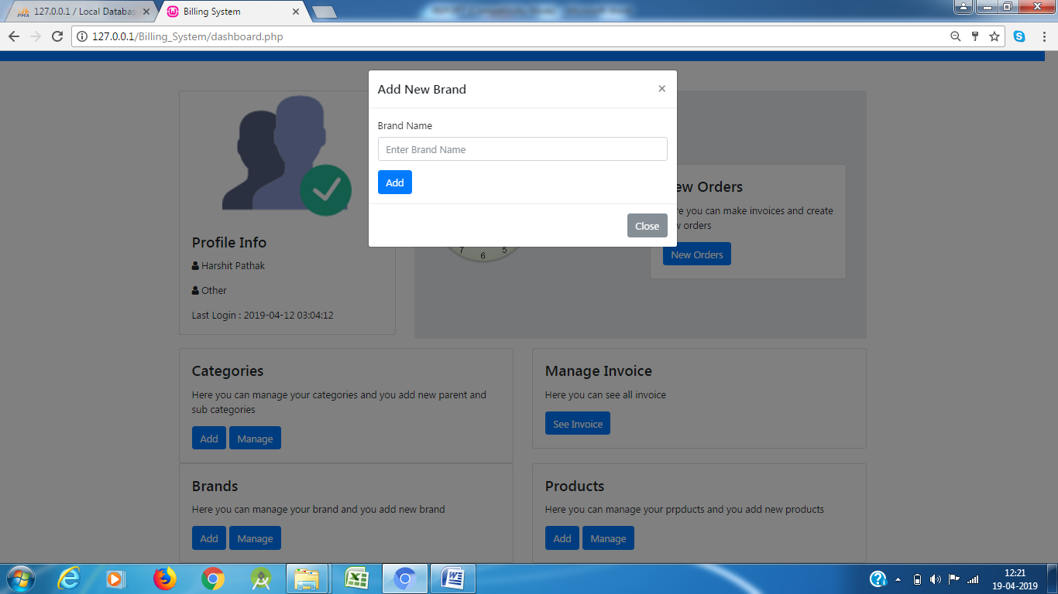

FIGURE NO.14

Add New Products

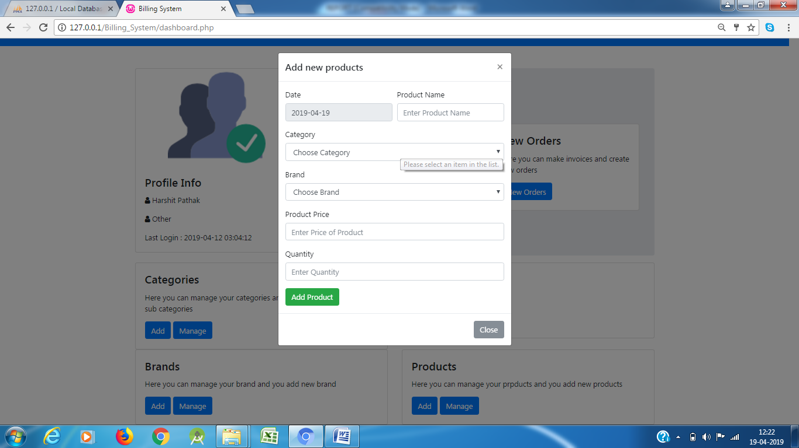

FIGURE NO.15
Manage Invoice

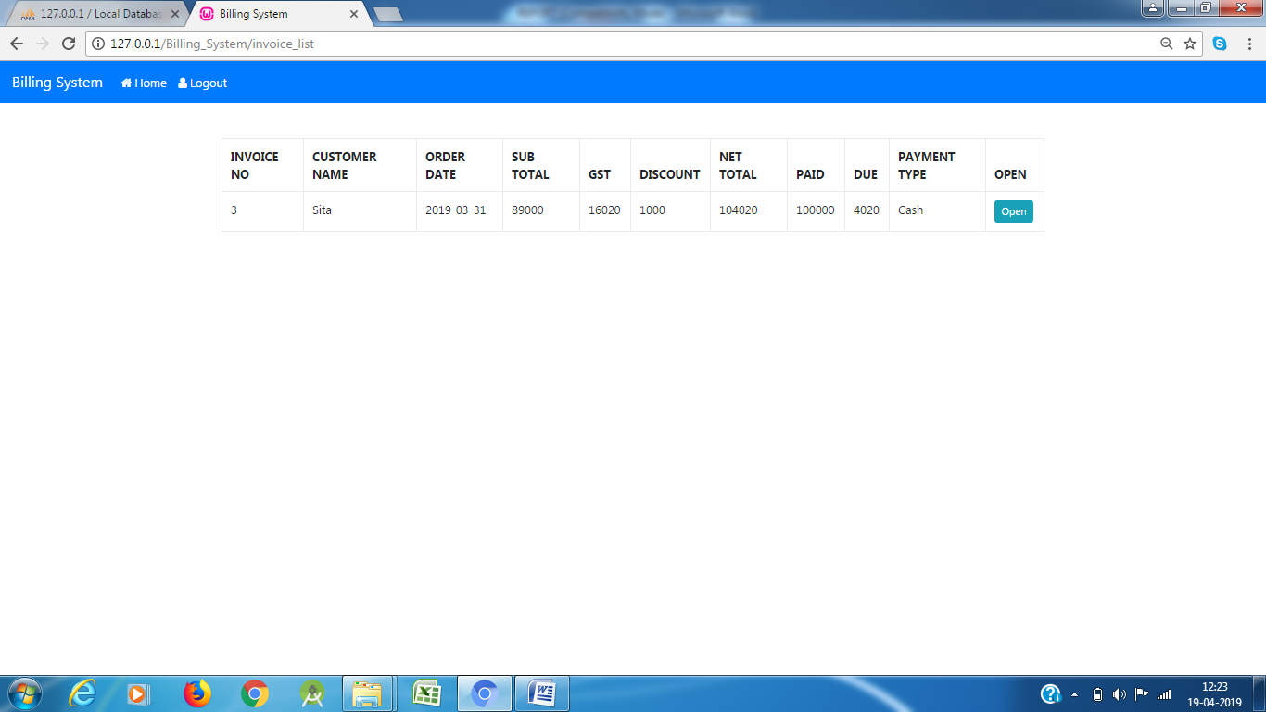

FIGURE NO.16
Customer Bill

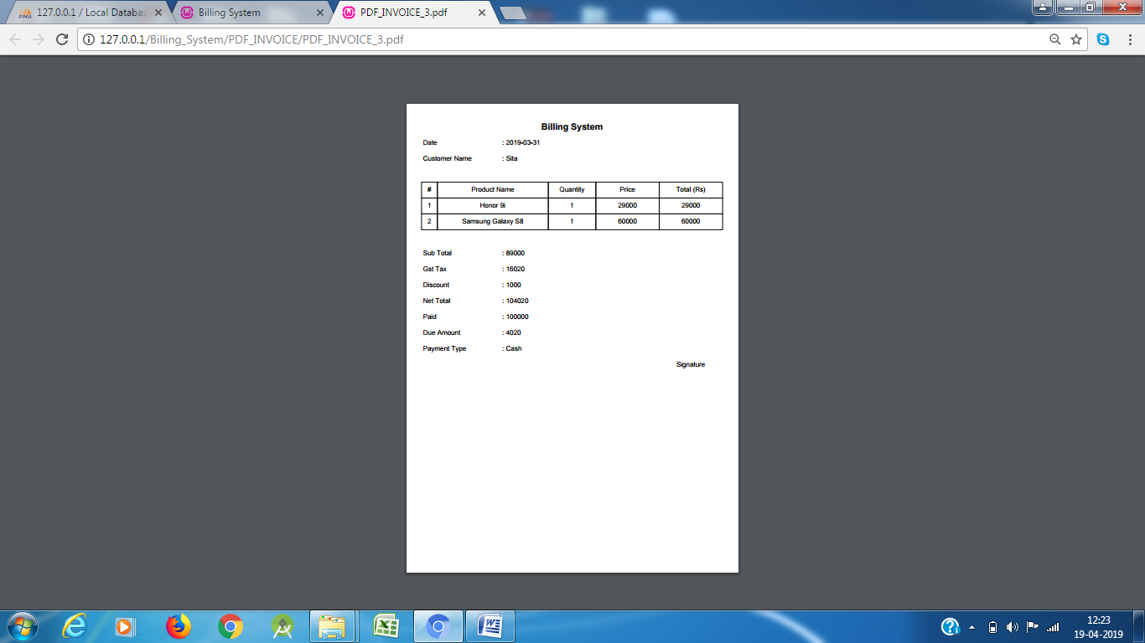

FIGURE NO.17
USER Dashboard

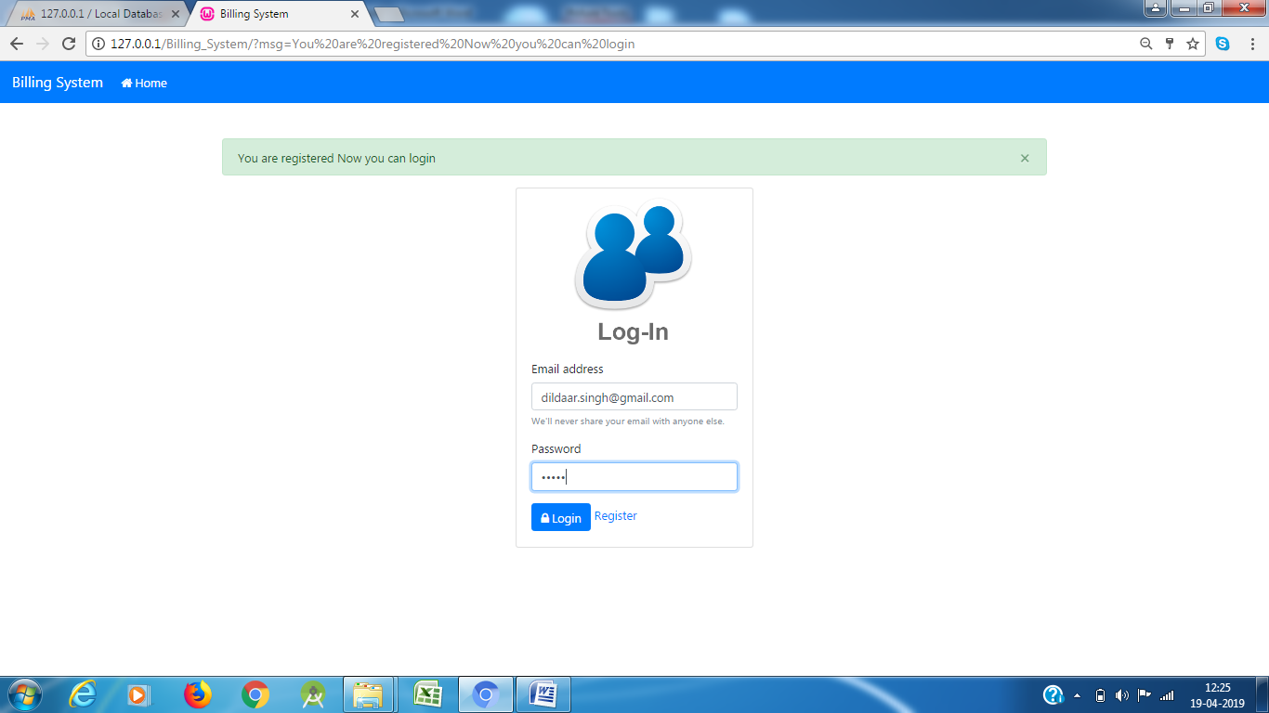

FIGURE NO.18
USER Dashboard

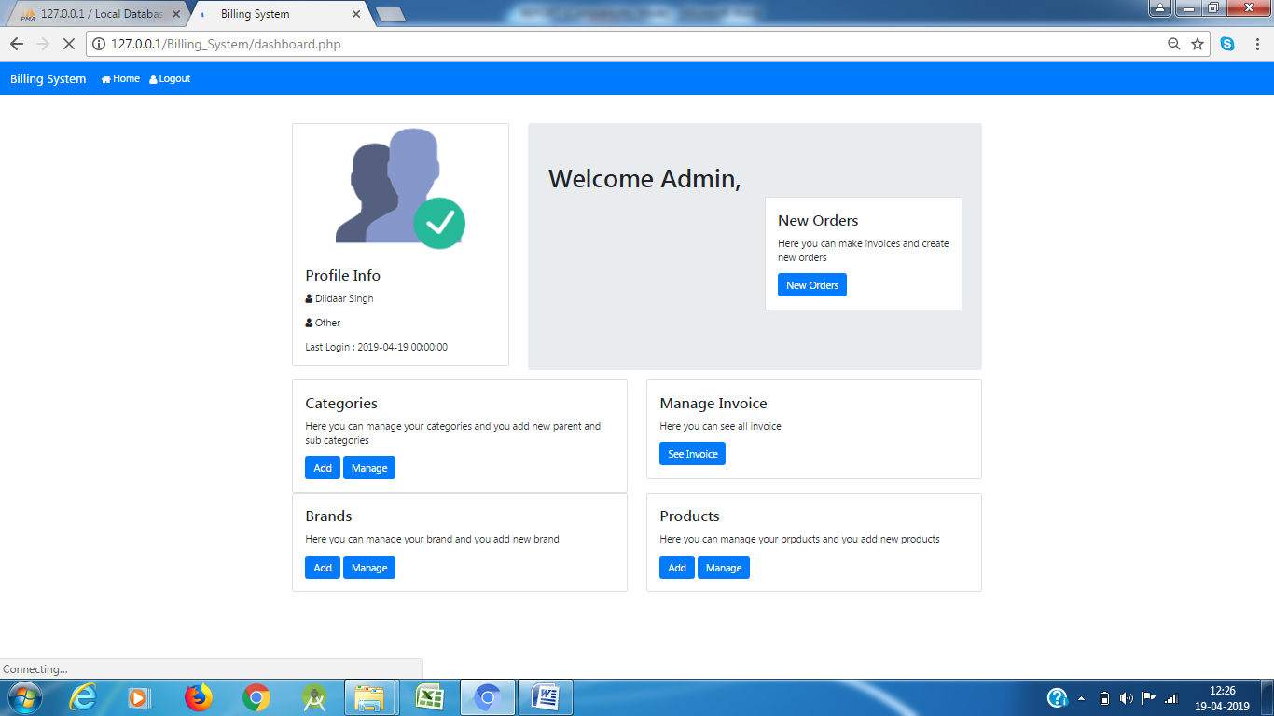

FIGURE NO.18
Customer Purchasing Items

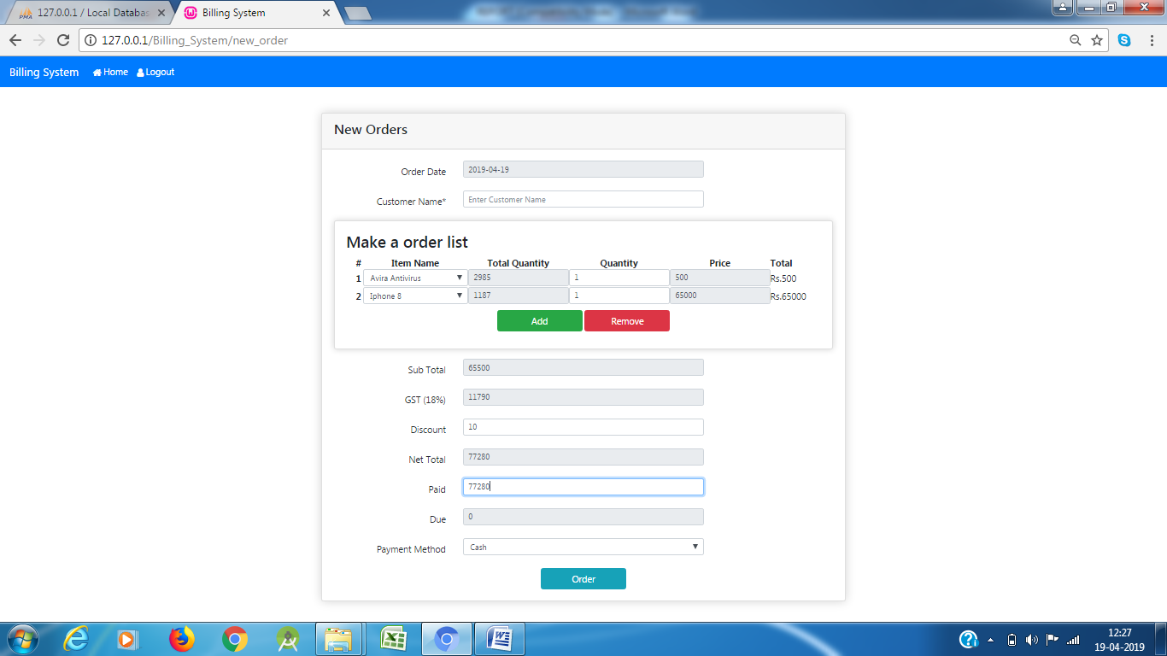

CONCLUSION

Online Repairing Availability providing dedicated customer service, you don’t have to spend much time on searching or waiting for a skilled technician to land at your doorstep with the required tools. Online Repairing Availability gives a better way to search any technician and easily call them at our home for our needs. Online Repairing Availability will help you to save your lots of time. you can easily search the electrician without going anywhere.

REFERENCES

Website References:

- www.php.net
- W3schools.com

Book references:

- PHP Explored
- PHP -The complete reference

