Architecture Design

# Bank Marketing Analytics

**`**

|  |  |
| --- | --- |
| **Written By** | Chetan Patil |
| **Document Version** | 0.3 |
| **Last Revised Date** | 02/01/2023 |

**DOCUMENT CONTROL**

**Work Flow Record:**

|  |  |  |  |
| --- | --- | --- | --- |
| **Sr.No** | **DATE** | **AUTHOR** | **COMMENTS** |
| 1 | 22- Nov-  2022 | Abhishek, Chetan, Pushpendra, Rupam | Introduction and architecture and flow decided. Discussion of cleaning the data  Such as Grouping of age, Education, Job, follow ups and Duration of Calling |
| 2 | 26 - Nov-  2022 | Chetan Patil | Cleaning of data in Python |
| 3 | 27 - Nov  2022 | Abhishek, Pushpendra | Connecting Final Csv to snowflake and connecting it to Power BI |
| 4 | 29- Nov  -2022 | Abhishek, Chetan, Pushpendra, Rupam | Discussion of Charts and Tabs Required in the Report. |
| 5 | 30- Nov -  2022 | Rupam | Representation of charts & discussions on Drawbacks |
| 6 | 02- Dec-  2022 | Rupam | 2nd Cut for the Reports and Discussion. |
| 7 | 04- Dec -  2022 | Rupam | Final Power BI Report |
| 8 | 07- Dec-  2022 | Abhishek, Chetan, Pushpendra, Rupam | Discussion on Creation of required documents Such as HL LLD, Architecture, Wireframe, Videos. |
| 9 | 08- Dec-  2022 | Abhishek, Chetan, Pushpendra, Rupam | Allotment of Task Abhishek - HLD, LLD Chetan - Architecture, DPR Pushpendra - Video Rupam - Wireframe |
| 10 | 14- Dec -  2022 | Rupam | Final Submission of Wire Frame |
| 11 | 15- Dec-  2022 | Abhishek | Final Submission of HLD & LLD |
| 12 | 16- Dec -  2022 | Chetan | Final Submission of Architecture, DPR |
| 13 |  | Abhishek, Chetan, Pushpendra, Rupam | Creation of YouTube Video |

**Contents**

1. Introduction 04
   1. What is Architecture Design Document? 04
   2. Scope 04
2. Architecture 04
   1. introduction 05
   2. Power BI Architecture 05
   3. Gateway/Load Balancer 06
   4. Sourcing data  06
   5. Report and publish 06
   6. Creating dashboards 06
3. Deployment 08
   1. Deployment Options in Power BI 09
   2. Power BI Deployment Pipeline 10

# Introduction

## What is Architecture design document?

Any software needs the architectural design to represents the design of software. IEEE defines architectural design as “the process of defining a collection of hardware and software components and their interfaces to establish the framework for the development of a computer system.” The software that is built for computer-based systems can exhibit one of these many architectures.

Each style will describe a system category that consists of :

* A set of components (eg: a database, computational modules) that will perform a function required by the system.
* The set of connectors will help in coordination, communication, and cooperation between the components.
* Conditions that how components can be integrated to form the system.
* Semantic models that help the designer to understand the overall properties of the system.

## Scope

Architecture Design Document (ADD) is an architecture design process that follows a step-by-step refinement process. The process can be used for designing data structures, required software architecture, source code and ultimately, performance algorithms. Overall, the design principles may be defined during requirement analysis and then refined during architectural design work.

# Architecture

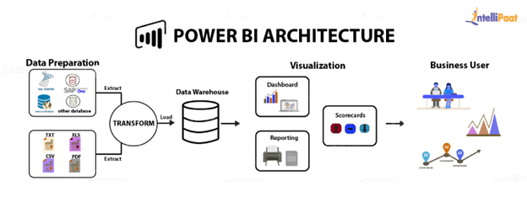

**Power Bi Server Architecture**

Power BI architecture is a service built on top of Azure. There are multiple data sources that Power BI can connect to. Power BI Desktop allows you to create reports and data visualizations on the dataset. Power BI gateway is connected to on-premise data sources to get continuous data for reporting and analytics

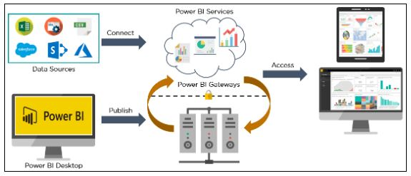



### ARCHITECTURE DESIGN

**6**

The following diagram shows Power Bi Server’s architecture:



* **Gateway :** acts as a bridge to provide quick and secure data transfer between on-premises data (data that isn't in the cloud) and several Microsoft cloud services
* **Sourcing data:**Power BI extracts data from various servers, Excel sheets, CSV files, and databases. The extracted information can be directly imported to Power BI, or a live service link is established to receive it. If you directly import the data in Power BI, it will only be compressed up to 1 GB. Post that, you can only run live queries on your chunky datasets.
* Transforming the data: Before visualizing the data, cleaning and pre-processing it should be done. This means removing useless or missing values from rows or columns. Following that, certain rules will be applied to transform and load the datasets into the [warehouse](https://intellipaat.com/blog/tutorial/data-warehouse-tutorial/).
* **Report and publish:**After cleaning and transforming the data, reports will be created based on requirements. A report is a visualization of the data with different filters and constraints presented in the form of graphs, pie charts, and other figures.
* **Creating dashboards:**[Power BI Dashboards](https://intellipaat.com/blog/power-bi-dashboard/) are created by pinning individual elements or pages of live reports. Dashboards should be created after you have published your reports to the BI service. When the reports get saved, the visual maintains the filter settings chosen so that the user can apply filters and slice

1. **Deployment Description**

## Deployment options in Power BI

 Deployment pipelines enable creators to develop and test Power BI content in the Power BI service, before the content is consumed by users. The content types include reports, paginated reports, dashboards, datasets and dataflows.

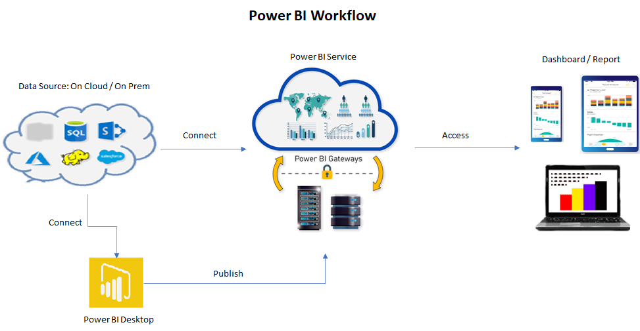

* **File Share:**Reports are created using Power BI Desktop and shared/ published to a file share or a document collaboration area/repository.
* **SharePoint:**Reports are published/embedded to the SharePoint portal.
* **Third-party integration:**Reports are published/embedded to a third-party server/web portal.
* Power BI Service: **Report consumption, sharing, security, collaboration, data refresh happens in the Power BI service.**

**Power BI Deployment Pipeline**

* In May 2020, Microsoft announced a feature known as Deployment pipeline as a part of Power BI Service, that enables BI creators to manage the lifecycle of organizational content. A new and improved way for BI teams to manage content life cycle within the [Power BI Premium](https://docs.microsoft.com/en-us/power-bi/admin/service-premium-what-is). First, and foremost, you must have a premium subscription and the workspace must resite within the premium capacity to utilize the deployment pipeline.
* In the Power BI service, you can use the deployment pipeline tool to test your content before you release it to your users. The deployment pipeline tool can help you deploy reports, dashboards, datasets, and paginated reports.
* **Why should BI creators use deployment pipelines?**
* Deployment Pipeline is an efficient and reusable process and maintains the development, test, and production environments. It’s easy to use and takes a few minutes to set up. Contents are uploaded from one workspace to another with a single click. BI creators can incrementally transition new or updated content between environments.
* Deployment Pipeline eliminates manual errors as it has very limited user intervention as only the Metadata is uploaded to the next stage which considerably reduces content upload time. It provides a single user interface/navigation page to keep a check of the content across the different environments, and also reconfigure the dataset with the appropriate data connections and permissions. Deployment pipelines now can also manage [sensitivity labels](https://docs.microsoft.com/en-us/power-bi/admin/service-security-sensitivity-label-overview), enabling users to enhance their data security capabilities which Power BI offers.
* During the deployment, we either:
* Always copy and always override; e.g.: visuals, tiles, schema.
* Never copy and never override; e.g.: data, URL, or permissions.
* With the help of the deployment pipeline, multiple team members can update the same report, dataset, etc. It has removed the limitation of re-publishing the updates of the reports using Power BI Desktop. This can now build a consistent experience within the team to manage content together and streamline updates within the workspace.
* Stages of Pipeline
* The tool is designed as a pipeline with three stages as follows
* **Development:**This is the first stage in the deployment process. This stage is used to design, build, and upload new content in collaboration with developers.
* **Test:**This stage is where we test the needed changes implemented in the content. Modified content is uploaded from the Development to the Test stage and shared with testers and reviewers. Users tend to load and run tests with larger volumes of data, test apps to see how it will look for end-users.
* **Production:**After testing the content, it is now uploaded to the Production stage and the final version of the content is shared with business users across the organization