Wireframe Documentation

BANK MARKETING ANALYTICS
Created by
Rupam Gupta

As per the problem statement, we have divided analysis into nine sections: -

1. Analysis of campaigns by Age Groups & Education
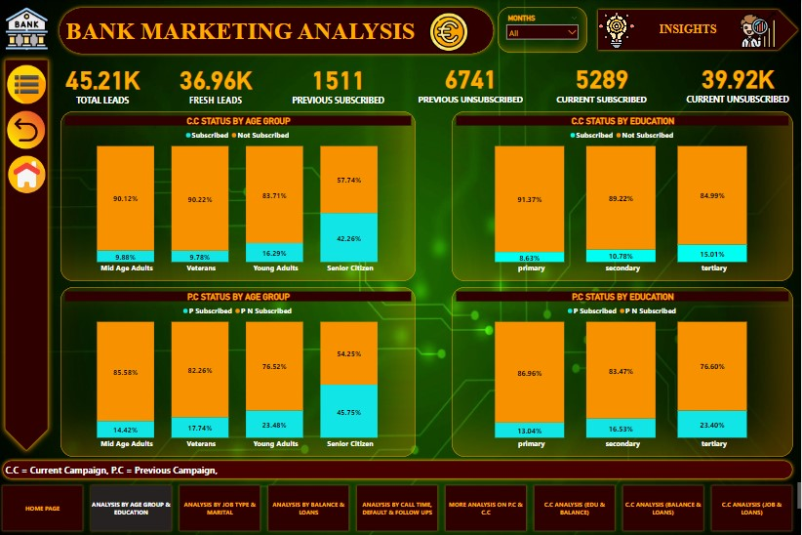

In this section we designed our first dashboard and tried to interpret the following:-
- Relation between Age Group and Subscription status in both the Campaigns (C.C & P.C)
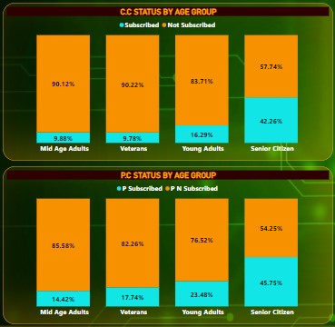
- Relation between Customers Education and Subscription status in both the Campaigns (C.C & P.C)
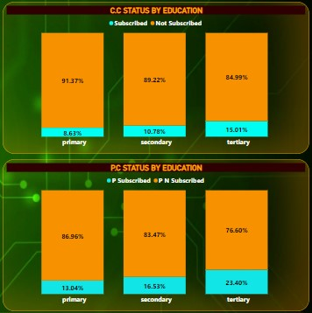

the lowest conversion rates

2. Analysis of campaigns by Jobs Type & Marital
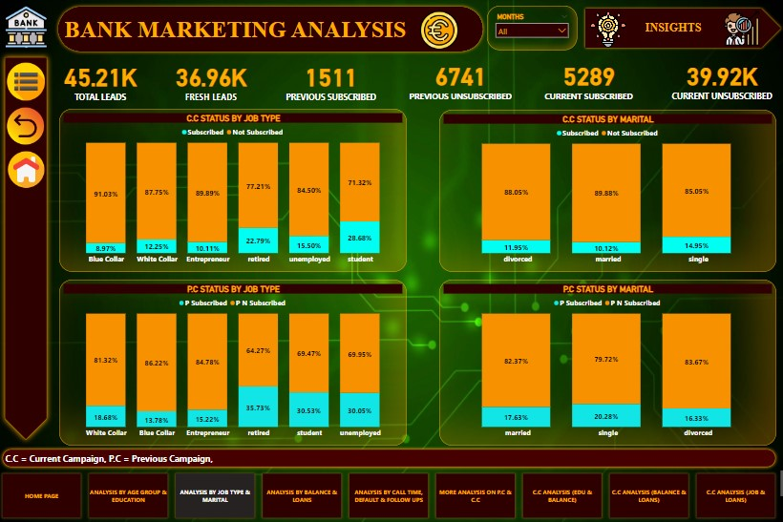

In this section we designed our second dashboard and tried to interpret the following:-
- Relation between Job Type and Subscription status in both the Campaigns (C.C & P.C)
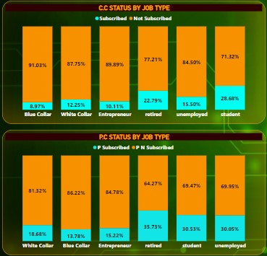
- Relation between Marital status and Subscription status in both the Campaigns (C.C & P.C)
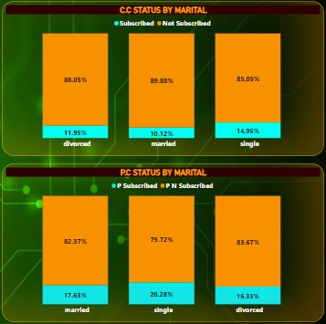

3. Analysis of campaigns by Account Balance & Loans Takers
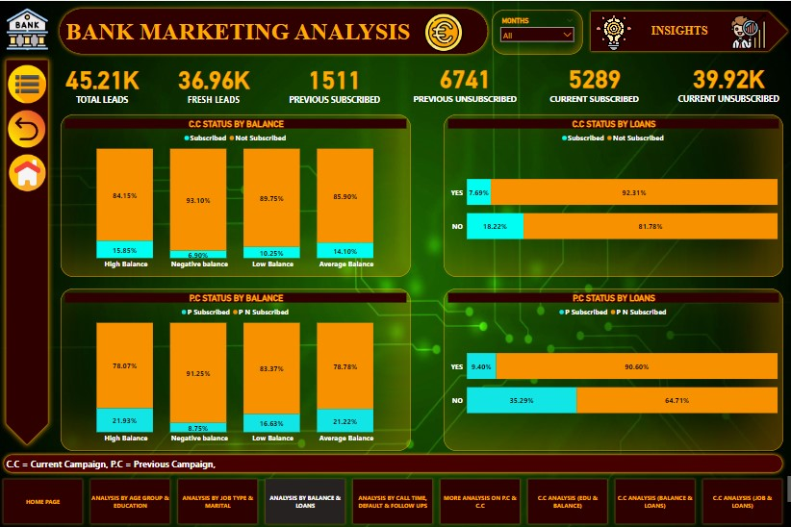

In this section we designed our third dashboard and tried to interpret the following:-
- Relation between Balance and Subscription status in both the Campaigns (C.C & P.C)
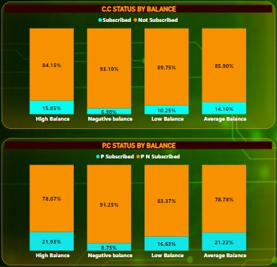
- Relation between Loan Takers and Subscription status in both the Campaigns (C.C & P.C)
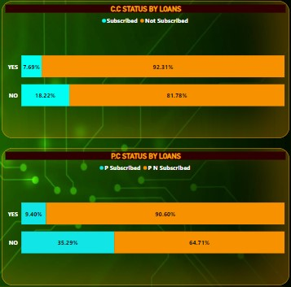

4. Analysis of campaigns by Call Time, Follow Up & Default
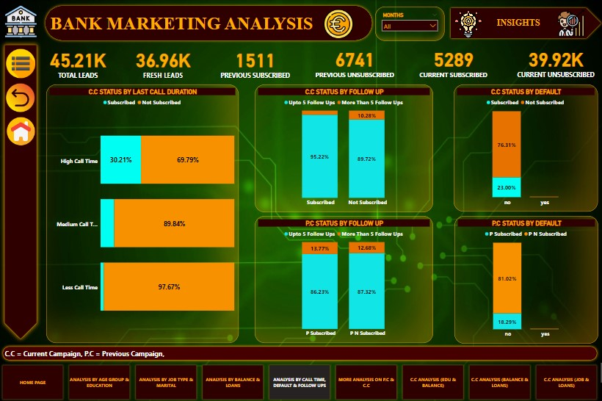

In this section we designed our fourth dashboard and tried to interpret the following:-
- Relation between Last Call Duration and Subscription status in the Current Campaigns.
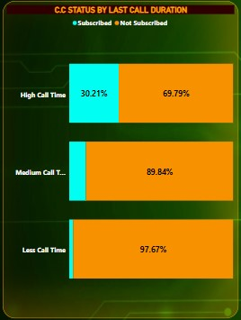
- Relation between Follow Up status and Subscription status in both the Campaigns (C.C & P.C)
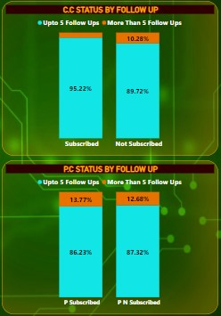
- Relation between Default status and Subscription status in both the Campaigns (C.C & P.C)
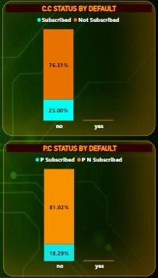

5. Some More Analysis on both the Campaigns
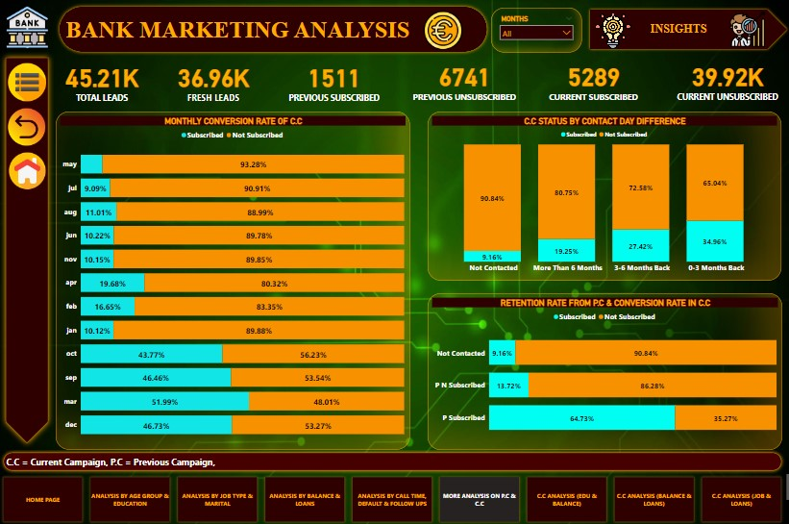

In this section we designed our fifth dashboard and tried to interpret the following:-
- Relation between Months and Subscription status in the Current Campaigns.
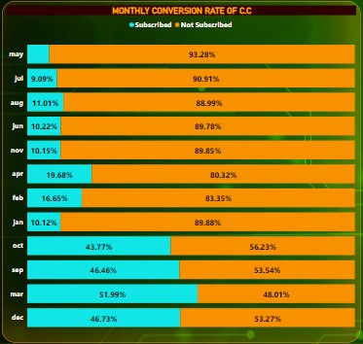
- Relation between Contact Day Difference and Subscription status in the Current Campaigns.
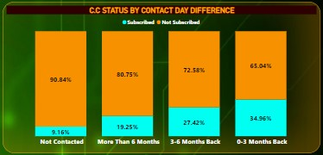

- Relation between Retention Rate from P.C and Conversion Rate in C.C.
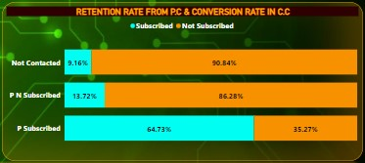

6. Some More Analysis on both the Campaigns using Custom Charts.
In this section we designed our sixth, seventh & eighth dashboard and tried to interpret the following:-

- Relation between Account Balance and Loans from C.C with Subscription Status
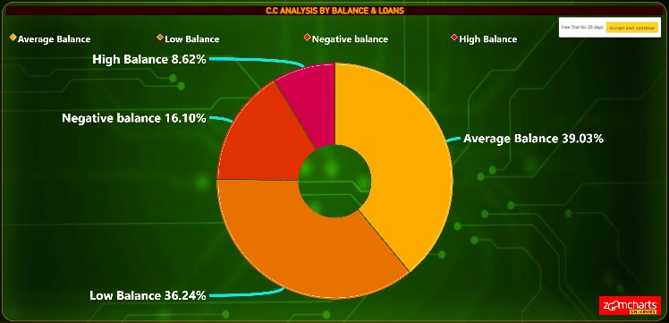

- Relation between Job Type and Loans from C.C with Subscription Status
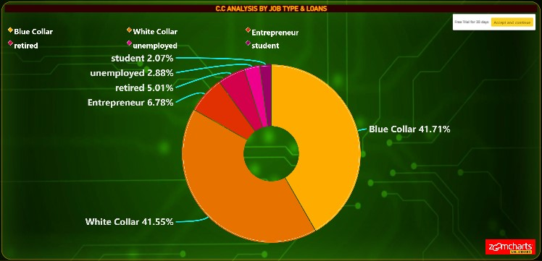

- Relation between Job Type and Loans from C.C with Subscription Status
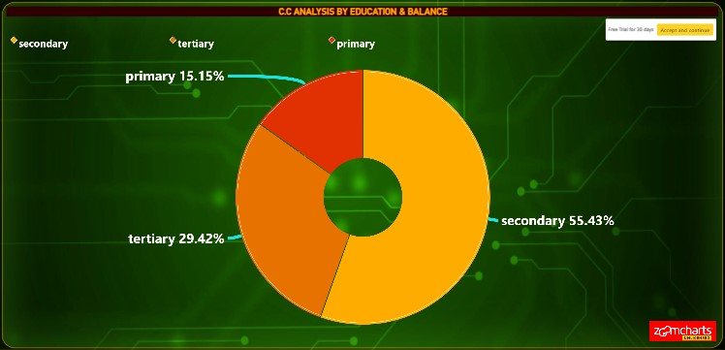

THANK YOU

