**EC2 Instance Movement from one Region (N. Virginia) to another Region (Mumbai)**

Step 1: Login to AWS account, select Region (**N. Virginia**) and create EC2 Instance.

* Logged in the AWS account

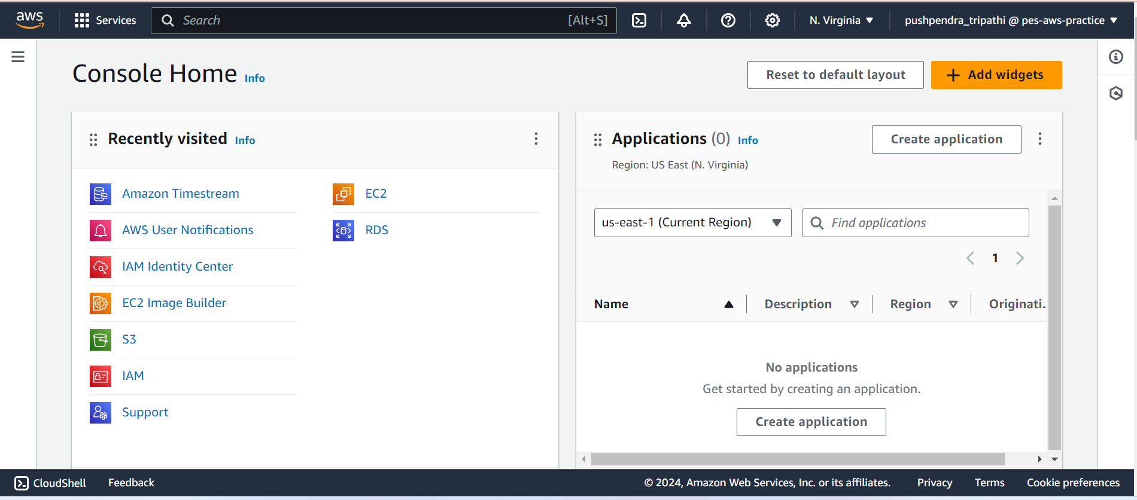

* Create EC2 Instance with name HMServer

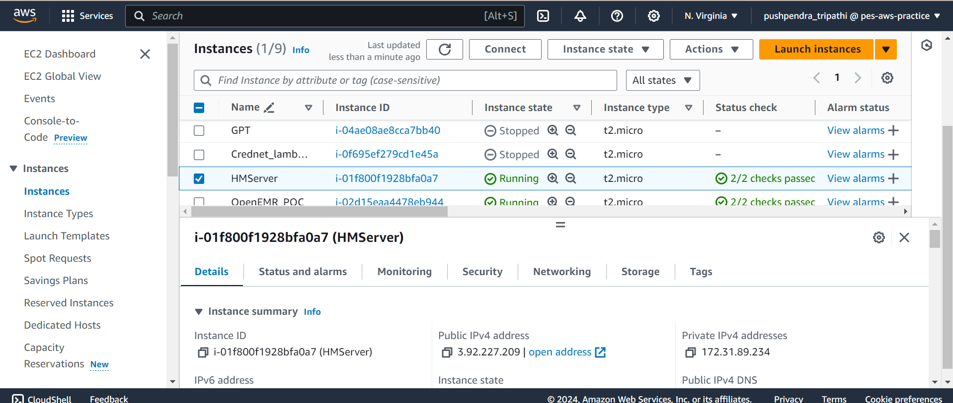

* Go to Storage Section and open Volumeid

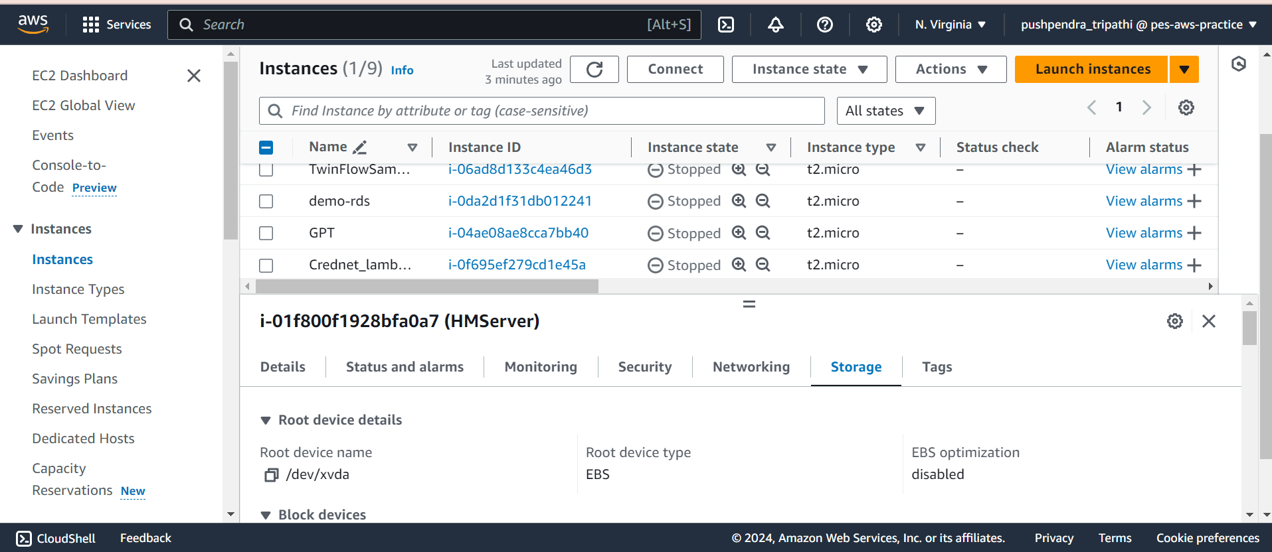

* Volume ID Page

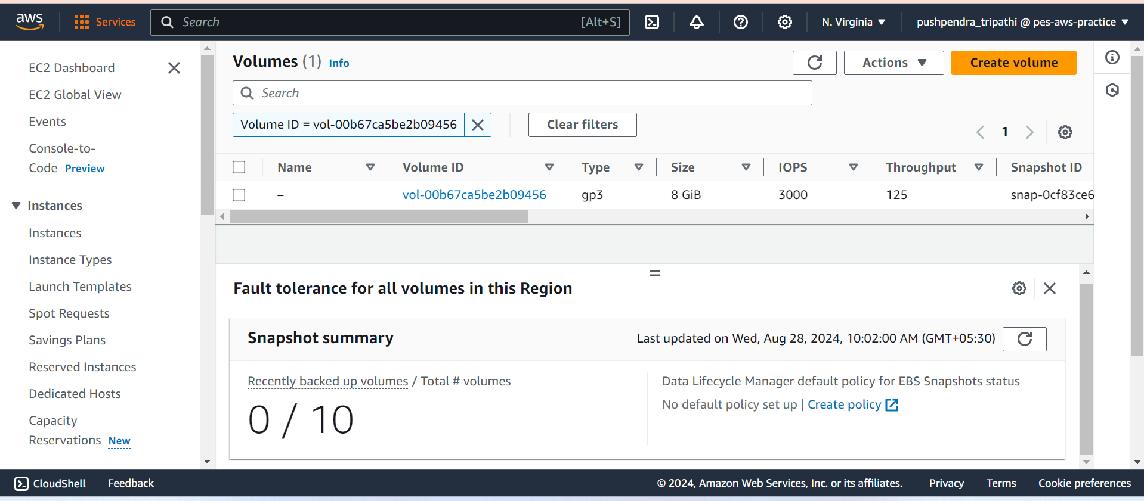

**YOUR TITLE HERE**