# Discounts on Apparel

## Release Note

1. **Programming Language:** **Java** language is used for the solution.
2. **Input:**
   1. An input file, ***Input.csv***, is placed in “***res***” directory of the project.
   2. Location: ***"./res/Input.csv"***
   3. Input file is read in “main” method from the location and processed further.
3. **Test Evidences**

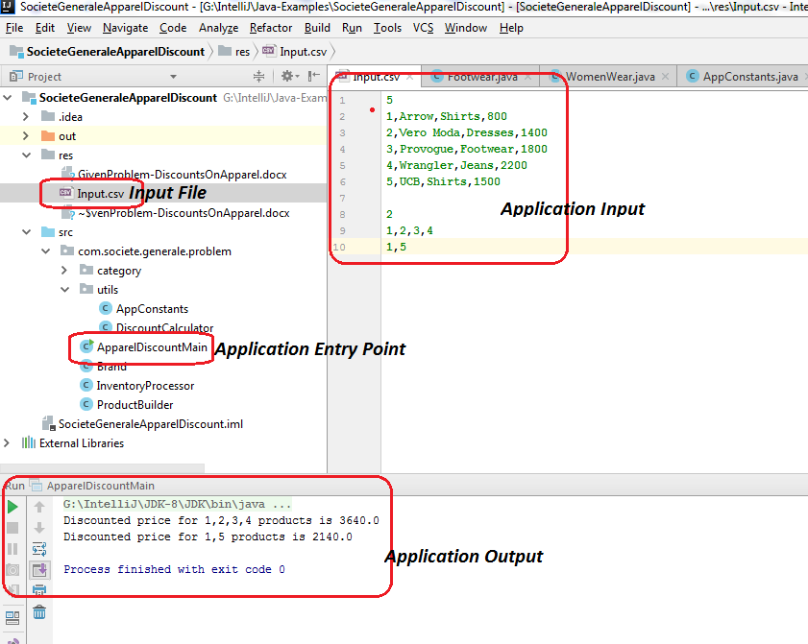

1. **GitHub Repository**

<https://github.com/pushpkgp/SocieteGeneraleDiscountsOnApparel>

1. **High Level Design**

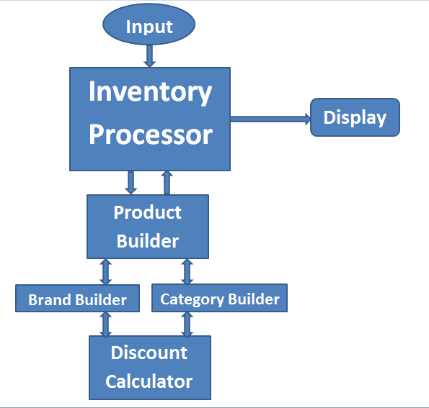

1. **Design Assumptions and Explanation**
   1. The structure followed is little different from the one given in the problem shared.
   2. Ihave followed the general category-subcategory structure followed across by major e-commerce players such as Flipkart, Amazon etc.
   3. There are two main categories namely MenWear and WomenWear.
   4. MenWear has two main subcategories namely Casuals and Formals.
      1. Casuals subcategory has Jean and T-Shirt in it.
      2. Formals subcategory has Trouser and Shirt in it.
   5. WomenWear has two main subcategories namely FootWear and Dress.
2. **Categories**
   1. **Men Wear**
      1. Casuals
         1. Jean
         2. T-Shirt
      2. Formals
         1. Trouser
         2. Shirt
   2. **Women Wear**
      1. Foot Wear
      2. Dress

**Note:** The structure followed here is highly modular and hence scalable in such a way that any number of subcategories can be added to with much change.

1. **Instructions to Run Application**

### JAR

Run the jar present in ***“./res”*** directory by using “***java –jar <jar name>*** ” command and follow the instructions provided for command line input option.

### Code

Import the code as an IntelliJ project and simply run the project from “***ApparelDiscountMain.java***” using either “command line input” option or “file input” option.

* If “command line input” option is used, follow the instructions provided for command line input option.
* If “file input” option is used, use the input file present in ***“./res”*** directory [***"./res/Input.csv"***]. Or use a file that has the same pattern as that of the input file pattern.

### Command Line

Use below instructions for your reference while using command line input option.

1. Enter Number of Products. Expected input is one number. E.g. 2
2. Enter Products. Expected input is this format: “1,Arrow,Shirts,800”. Avoid any white spaces in between. E.g. use ” VeroModa” instead of “Vero Moda”.(2,VeroModa,Dresses,1400)
3. Enter Number of Products for which discounted price to be calculated. Expected input is one number. E.g. 2
4. Enter Products serial number for which discounted price is to be calculated. E.g. 2 is serial number in product "2,VeroModa,Dresses,1400".