

**Project Report**

**On**

**letsblog**

***Submitted in Partial fulfillment for the award of degree of Bachelor of***

***Engineering in Computer Science and Engineering***

Submitted to

Rajiv Gandhi Pradyogiki Vishwavidyalaya, Bhopal (M.P.)

Submitted By:

Sudeep Batkya (0126CS191110)

Ujjawal Kumar Tiwari (0126CS191116)

Pushpraj Singh Pawar(0126CS191085)

Sumukh Patidar(0126CS191111)

Under the Guidance of **Prof.** **Umesh Joshi**

# Department of Computer Science & Engineering

## ORIENTAL COLLEGE OF TECHNOLOGY, BHOPAL

**Approved by AICTE New Delhi & Govt. of M.P.**

**Affiliated to Rajiv Gandhi Pradyogiki Vishwavidyalaya, Bhopal (M.P.)**

### Session: 2021-22



## ORIENTAL COLLEGE OF TECHNOLOGY, BHOPAL

**Approved by AICTE New Delhi & Govt. of M.P. & Affiliated to Rajiv Gandhi Pradyogiki Vishwavidyalaya, Bhopal(M.P).**

**DEPARTMENT OF COMPUTER SCIENCE & ENGINEERING**

# CERTIFICATE

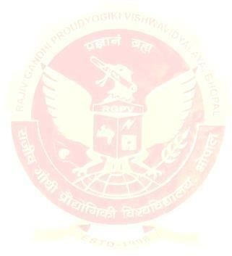This is to certify that the work embodied in this Project ,Dissertation Report entitled as **“Python Based letsblog”** being Submitted by **Sudeep Batkya(0126CS191110), Ujjawal Kumar Tiwari (0126CS191116), Pushpraj Singh pawar(0126CS191085), Sumukh Patidar(0126CS191111)** in partial fulfillment of the requirement for the award of **“Bachelor of Technology ” in Computer Science & Engineering** discipline to Rajiv Gandhi Pradyogiki Vishwavidyalaya, Bhopal (M.P.) during the academic year 2021-22 is a record of bona fide piece of work, carried out under my supervision and guidance in the Department of Computer Science & Engineering in Oriental College of Technology, Bhopal.

## Approved By :-

**Prof. Umesh Joshi** -Guide

**Prof. Amit Dubey** -Head of Department

**Dr. Amita Mahor**–Director

2



### ORIENTAL COLLEGE OF TECHNOLOGY,BHOPAL

**Approved by AICTE New Delhi & Govt. of M.P. & Affiliated to Rajiv Gandhi Pradyogiki**

**Vishwavidyalaya, Bhopal(M.P.)**

**DEPARTMENT OF COMPUTER SCIENCE & ENGINEERING**

## CERTIFICATE OF APPROVAL

This Project **“Python Based letsblog”** being submitted by **Sudeep Batkya**

### (0126CS191110), Ujjawal Kumar Tiwari (0126CS191116), Pushpraj Singh

**Pawar(0126CS191085) , Sumukh Patidar(0126CS191111)** has been examined by me & hereby approve for the partial fulfillment of the requirement for the award of **“ Bachelor of Technology in Computer Science & Engineering ”** for which it has been submitted. It is understood that by this approval the undersigned do not necessarily endorse or approve any statement made, opinion expresses or conclusion draw there in, but the Project only for the purpose for which it has been submitted.



|  |  |
| --- | --- |
| INTERNAL EXAMINER | EXTERNAL EXAMINER |
| Date: | Date: |

3

## CANDIDATE DECLARATION

We hereby declare that the Project dissertation work presented in the report entitled as “Python Based letsblog” submitted in the partial fulfillment of the requirements for the award of the degree of Bachelor of Engineering in Computer Science & Engineering of Oriental College of Technology is an authentic record of our own work.

We have not submitted the part and partial of this report for the award of

any other degree or diploma.

Sudeep Batkya(0126CS191110)

Ujjawal Kumar Tiwari (0126CS191116)

Pushpraj Singh Pawar(0126CS191085)

Sumukh Patidar(0126CS191111)

Date:

This is to certify that the above statement made by the candidates is correct to the best of my knowledge.

**Prof. Umesh Joshi**

**Guide**

# ACKNOWLEDGMENT

We are heartly thankful to the Managementof **Oriental College of Technology** for providing us all the facilities and infrastructure to take our work to the final stage.

It is the constant supervision, moral support and proper guidance of our respected Director **Dr. Amita Mahor**, who motivated through out the work.

We express deep sense of gratitude and respect to our learned guide **Prof. Umesh Joshi,** Professor in the Department of Computer Science & Engineering, during all phases of our work. Without this enthusiasm and encouragement this dissertation would not have been completed. His valuable knowledge and innovative ideas helped us to take the work to the final stage. He has timely suggested actions and procedures for which we are really grateful and thankful to him.

We express our gratefulness to **Prof. Amit Dubey** Head of Computer Science & Engineering Department for providing all the facilities available in the department for his continuous support, advice, and encouragement during this work and also help to extend our knowledge and proper guidelines.

Constant help, moral and financial support of our loving parents motivated us to complete the work. We express our heartily thanks to our all family members for their co-operation.

We really admire the fond support of our class-mates for their co-operation and constant help. It gives immense pleasure to acknowledge the encouragement and support extended by them. Last but not the least we are extremely thankful to all who have directly or indirectly helped us for the completion of the work.

Sudeep Batkya (0126CS191116)

Ujjawal Kumar Tiwari (0126CS191116)

Pushpraj Singh Pawar (0126CS191085)

Sumukh Patidar (0126CS191111)

# ABSTRACT

Letsblog is a web based application in which someone can become a blogger and he/she could publish blogs on plethora of topics such as sports , lifestyle , culture, socio-economic topic and , could possibly interact with reader with the help of comment sections .

* Providing quality content on our system.
* Understand how to plan and conduct user research related to web usability.
* Increasing useful content on web

## TABLE OFCONTENTS

### INTRODUCTION

* PURPOSE OF THE PROJECT

* CURRENT AND PROPOSED SYSTEM

* CURRENT SYSTEM

* PROPOSAL

* SCOPE OF THE PROJECT

* GLOSSARY

* ADVANTAGES

* REQUIREMENTS

* SOFTWARE REQUIREMENTS

* HARDWARE REQUIREMENTS

* FUNCTIONAL REQUIREMENTS

* NON-FUNCTIONAL REQUIREMENTS

* SYSTEM ANALYSIS

* INTRODUCTION

* EXISTING SYSTEM

* PROPOSED SYSTEM

* SOFTWARE REQUIREMENTS

* HARDWARE REQUIREMENTS

* SYSTEM DESIGN

**INTRODUCTION**

Overview of Project

Letsblog is a python -based framework Django web product , it is using database sqlite3 .Letsblog is a web based application in which someone can become a blogger and he/she could publish blogs on plethora of topics such as sports , lifestyle , culture, socio-economic topic and , could possibly interact with reader with the help of comment sections

Objective

Our team will need to build and maintain the software as part of the implementation of Our Quest project This web-blog application should serve the blogger that use our website as to

* To grow writing skills
* Gain engagement with readers
* Taking feedback and improving their skills.
* For readers to read valuable blogs free.

# **PROBLEM STATEMENT**

## Problem

• Scarcity of free and open to all blog application for new authors to publish content based on their mobile phones.

## Solution

• Letsblog is a web based application in which someone can become a blogger and he/she could publish blogs on plethora of topics such as sports , lifestyle , culture, socio-economic topic and , could possibly interact with reader with the help of comment sections.

## Detailed Project Profile

### This Project is design for two types of user:-

* Blog authors.
* Blog readers .

#### User:-

* Blog authors can publish blogs on plethora of topics such as sports , lifestyle , culture, socio-economic topic
* **Readers:-**
* The readers can read blog and can give feedback to the author.

#### Feature of our project:-

* Fast program due to manufacture in python language .
* Secured files of records due to its existence in binary form in database.
* Record management facility.
* Could be updated easily and added by new blogs as expected by bloggers.
* Simple interface and easy to run.
* Easily update on blogs .

## Software Requirement Specification

### PURPOSE

Purpose is to provide a website for bloggers to publish their blogs .

### SCOPE

After deployment the project can cater to wide variety of audience and bloggers , so that they can create content on the website.

### FEASIBILITY STUDY

This is a free project and doesn’t provide any promotion. The purpose of the project is to help bloggers to provide a platform to publish their blogs. The project is developed with minimum complexity. The cost of project varies on the quality of blogs uploaded in it.

### SOFTWARE REQUIREMENT

**REQUIREMENTS**

**Software Requirements**:

* Browser.
* Python 3 ,Django, sqlite, bootstrap
* Operating system: Any Windows version only (64 bit).

**Hardware Requirements:**

* Ram: 250mb or more

**Functional Requirements:**

* The system provides interface to publish blogs.
* The system provides bloggers with engagement facilities with readers.

### PREREQUISITES

* Python language
* Frontend with html CSS JavaScript
* COMMAND PROMPT BASIC KNOWLEDGE.
* Git basics

# **DEFINATION**

Letsblog is a web based application in which someone can become a blogger and he/she could publish blogs on plethora of topics such as sports , lifestyle , culture, socio-economic topic and , could possibly interact with reader with the help of comment sections.

**Non-Functional Requirements:**

* Responsiveness to mobile devices.
* Fast browsing (due to embedded bootstrap ) .

## SYSTEM ANALYSIS

**INTRODUCTION**

System analysis is the process of gathering and interpreting facts, diagnosing problems and using the information to recommend improvements on the system. System analysis is a problem solving activity that requires intensive communication between the system users and system developers. System analysis or study is an important phase of any system development process. The system is studied to the minutest detail and analyzed. The system analyst plays the role of an interrogator and dwells deep into the working of the present system. The system is viewed as a whole and the inputs to the system are identified. The outputs from the organization are traced through the various processing that the inputs phase through in the organization A detailed study of these processes must be made by various techniques like Interviews Questionnaires etc. The data collected by these sources must be scrutinized to arrive to a conclusion. The conclusion is an understanding of how the system functions. This system is called the existing system. Now the existing system is subjected to close study and the problem area are identified The designer now functions as a problem solver and tries to sort out the difficulties that the enterprise faces. The solutions are given as a proposal The proposal is then weighed with the existing system analytically and the best one is selected the proposal is presented to the user for an endorsement by the user The proposal is reviewed on user request and t suitable changes are made. This loop ends as soon as the user is satisfied with the proposal

### EXISTING SYSTEM

The existing method of blogging is creating your own website from scratch and publishing content in it , but with help of this we will provide bloggers to publish their blogs by registering with the system.

### PROPOSED SYSTEM

The proposed web based application registers users and allocate them their place as to where they can publish their blogs, without needing to create website.

### TESTING • SYSTEM TESTING

Testing is a set activity that can be planned and conducted systematically. Testing begins at the module level and work towards the integration of

entire computers based system. Nothing is complete without testing, as it is vital success of the system.

• **Testing Objectives:**

There are several rules that can serve as testing objectives, they are

1. Testing is a process of executing a program with the intent of finding an error
2. A good case undiscovered error is one that has high probability of finding an absolute error.
3. A successful test is one that uncovers an undiscovered error if testing is conducted successfully according to the objectives as stated above, it would uncover errors in the software. Also testing demonstrates that software functions appear to the working according to the user requirement specification, that performance requirements appear to have been met.

There are three ways to test a program:

1. For Correctness
2. For Implementation efficiency
3. For Computational Complexity

Tests for correctness are supposed to verify that a program does exactly what it was designed to do. This is much more difficult than it may at first appear especially for large programs. Tests for implementation efficiency attempt to find ways to make a a correct program faster or use less storage. It is a code-refining process, which reexamines the implementation phase of algorithm development Tests for computational complexity amount to an experimental analysis of the complexity of an algorithm or an experimental comparison of two or more algorithms, which solve the same problem.

### Testing Correctness

The following ideas should be a part of any testing plan:

1. Preventive Measures
2. Spot checks
3. Testing all parts of the program
4. Test Data
5. Looking for trouble
6. Time testing
7. Testing

The data is entered in all forms separately and whenever an error occurred, it is corrected immediately. A quality team deputed by the management verified all the necessary documents and tested the Software while entering the data at all levels. The entire testing process can be divided into 3 phases

1. Unit Testing
2. Integrated Testing

3.Final/System testing

### UNIT TESTING

As this system was partially GUI based WINDOWS application, the following were tested in this phase

1. Tab Order
2. Reverse Tab Order
3. Field length

In our system, Unit testing has been successfully handled. The test data was given to each and every module in all respects and got the desired output. Each module has been tested found working properly.

#### INTEGRATION TESTING

Test data should be prepared carefully since the data only determines the efficiency and accuracy of the system. Artificial data are prepared solely for testing. Every program validates the input data.

#### VALIDATION TESTING

In this, all the Code Modules were tested individually one after the other.

The following were tested in all the modules.

1. Loop testing
2. Boundary Value analysis
3. Equivalence Partitioning Testing

In our case all the modules were combined and given the test data. The combined module works successfully without any side effect on other programs. Everything was found fine working.

#### OUTPUT TESTING

This is the final step in testing. In this the entire system was tested as a whole with all forms, code, modules and class modules. This form of testing is popularly known as Black Box testing or system testing.

Black Box testing methods focus on the functional requirement of the software. That is, Black Box testing enables the software engineer to derive sets of input conditions that will fully exercise all functional requirements for a program. Black Box testing attempts to find errors in the following categories; incorrect or missing functions, interface errors, errors in data structures or external database access, performance errors and initialization errors and termination errors.

#### FUTURE ENHANCEMENT

**Descriptions**

With deployment in Heroku the proposed web based application can help bloggers and reads.

#### CONCLUSION

Easy to access and could be easily amended to form a better website with features of old project. Due to its manufacture in python language it us fast.

Project snapshot:

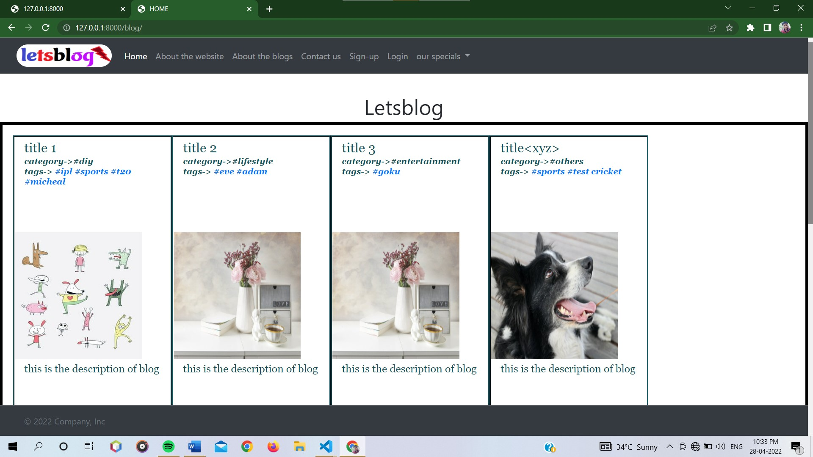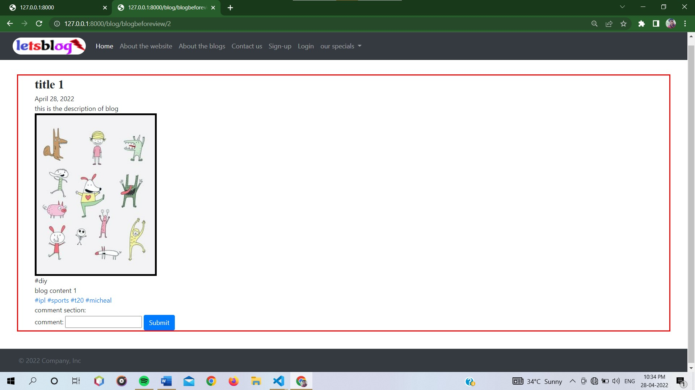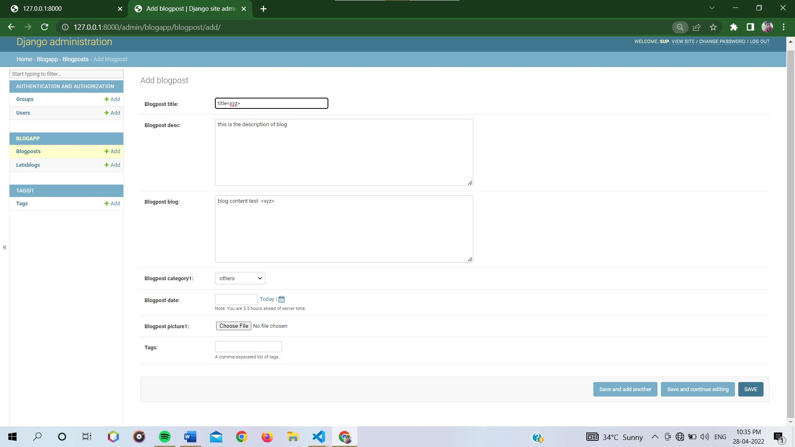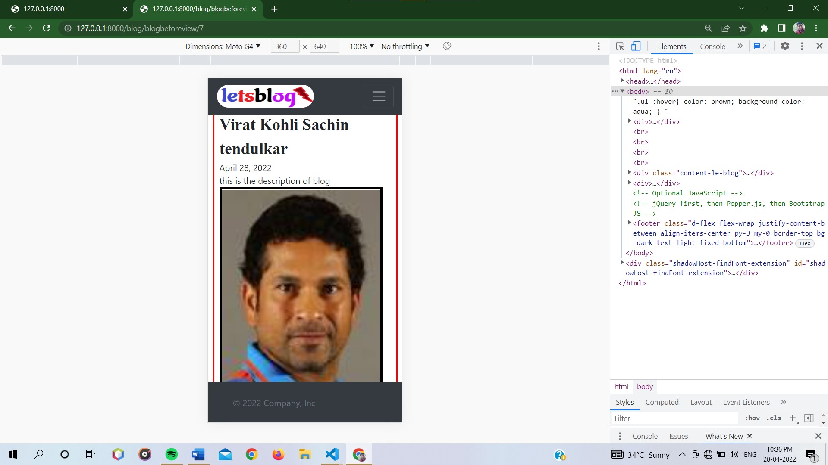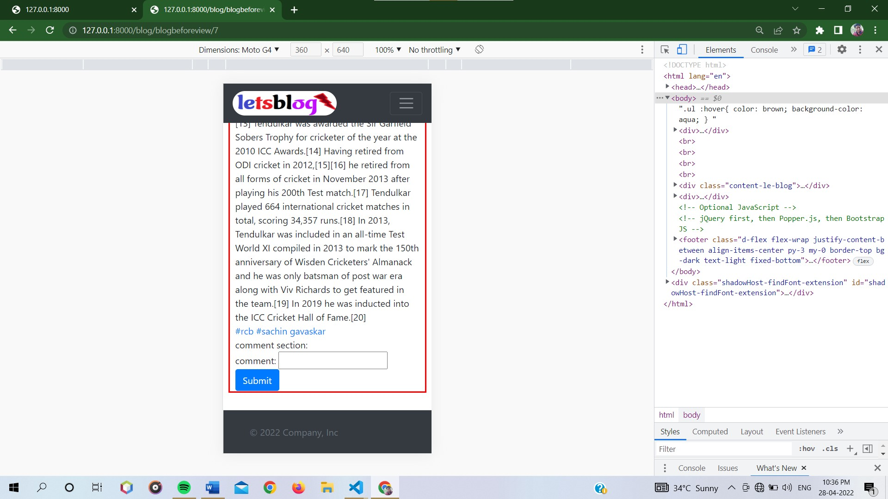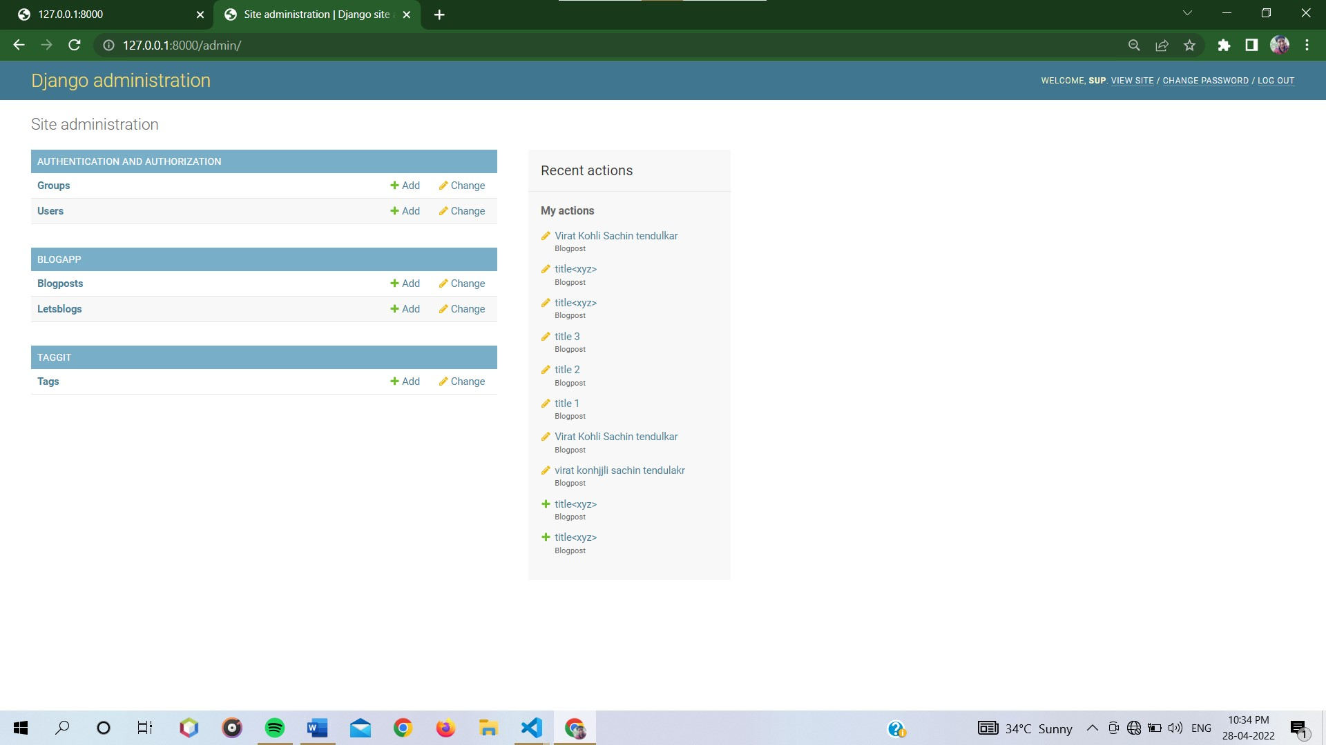

Code is uploaded on GitHub::

Along with requirements of installing the project on your local environment

Link :::>> [to github repo](https://github.com/pushprajSinghPawar/django-blog-letsblog.git).

Coding snapshots::

