HOMEWORK – 1
Networking-I

Problem1
Given Link Transmission rate R = 2Mbps = 2*106 bps
Propagation speed s =2.5*108 m/sec
Length between hosts = 2000km = 2*106 m
a. Propagation delay d prop = d/s = (2*106)/(2.5*108) = 2/250 = 0.008 sec
b. Bandwidth-delay product = R x dprop = 2*106*0.008 = 16000 bits
c. Bandwidth-delay product = R x dprop = 102*106*0.008 = 800000 bits

Problem2
01001100 01101001
01101110 01101011
10111010 11010100
00100000 01001100
110111011 0010000
01100001 01111001
1 00111100 10011001
Since there are 17bits, the MSB needs to be wraparound
00111100 10011001
1
00111100 10011010
01100101 01110010
10100010 00001100
The checksum is obtained by taking 1’s compliment of above. The result is 01011101 11110011
Problem3
RTT is time for a small packet to travel from client to server and back
Non persistent
Client initiates TCP connection for every object including the html file, meaning it requires 2 RTTs for one object. Client needs to access the HTML file which references 4 objects on same server.
Hence 1 TCP connection and 1 HTTP connection for HTML page => 2 RTT
1TCP and 1 HTTP for each if the 4 objects => 2*4 => 8 RTT
Total RTTs needed are 10.
Persistent
TCP connection is established only once and then one RTT for each object when there is no pipelining.
Hence 1 TCP connection and 1 HTTP connection for HTML page => 2 RTT
1 HTTP for each if the 4 objects => 1*4 => 4 RTT
Total RTTs needed are 6.

Problem 4

4.a
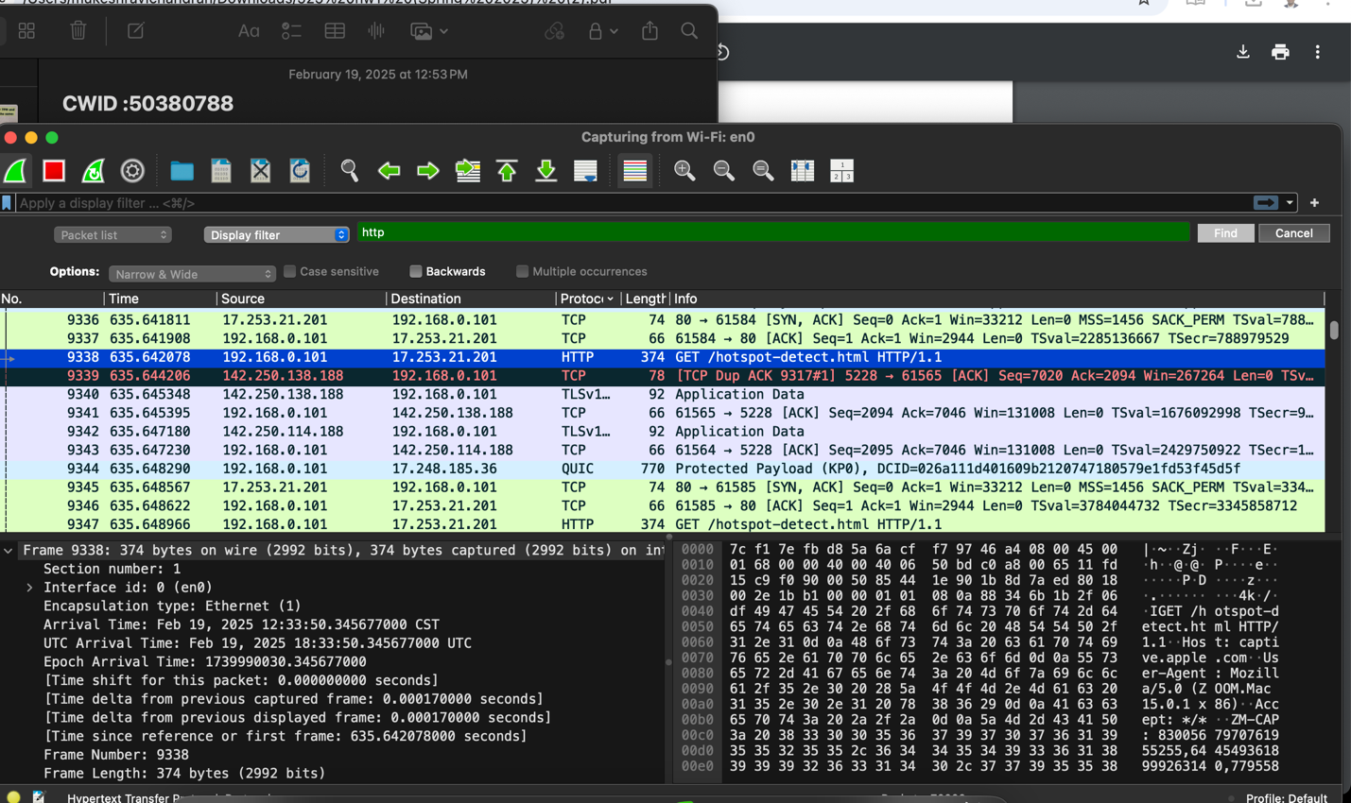

4.b
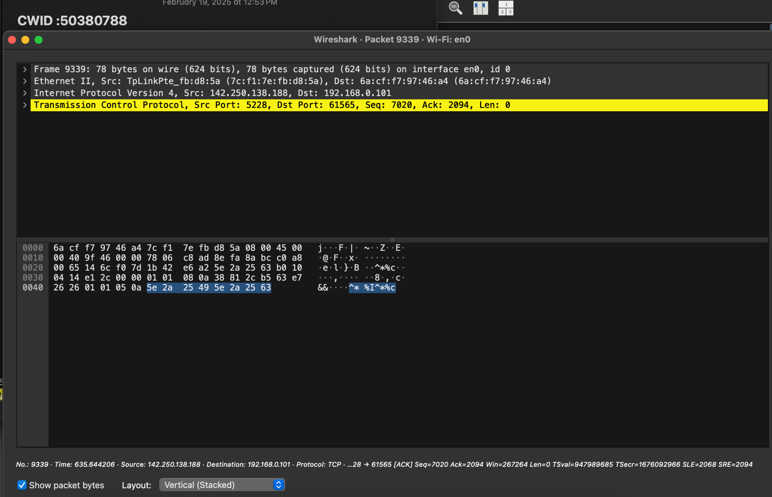
Frame 9339: 78 bytes on wire (624 bits), 78 bytes captured (624 bits) on interface en0, id 0
Ethernet II, Src: TpLinkPte_fb:d8:5a (7c:f1:7e:fb:d8:5a), Dst: 6a:cf:f7:97:46:a4 (6a:cf:f7:97:46:a4)
Internet Protocol Version 4, Src: 142.250.138.188, Dst: 192.168.0.101
Transmission Control Protocol, Src Port: 5228, Dst Port: 61565, Seq: 7020, Ack: 2094, Len: 0
Source Port: 5228
Destination Port: 61565
[Stream index: 77]
[Conversation completeness: Complete, WITH_DATA (63)]
[TCP Segment Len: 0]
Sequence Number: 7020 (relative sequence number)
Sequence Number (raw): 457369250
[Next Sequence Number: 7020 (relative sequence number)]
Acknowledgment Number: 2094 (relative ack number)
Acknowledgment number (raw): 1579820387
1011 .... = Header Length: 44 bytes (11)
Flags: 0x010 (ACK)

