
Emergency Room Efficiencies: From Bottleneck to Breakthrough
Presented by: East Texas A&M
November 6th, 2025
Sponsored by: Alteryx | Curated by: Capitalize Consulting

The Challenge
Overview
At Meridian City Hospital’s ER, more than 400 patients stream through the doors each day but only 4 in 10 are seen by a provider within 15 minutes, the average patient waits over 45 minutes before seeing a provider and spends nearly 2.5 hours in the ER from arrival to discharge. With the recent increase in wait times and poor feedback surveys from patients and customers, Meridian’s Hospital Management brought in a team of analysts and consultants to gain visibility & find solutions for their ER.
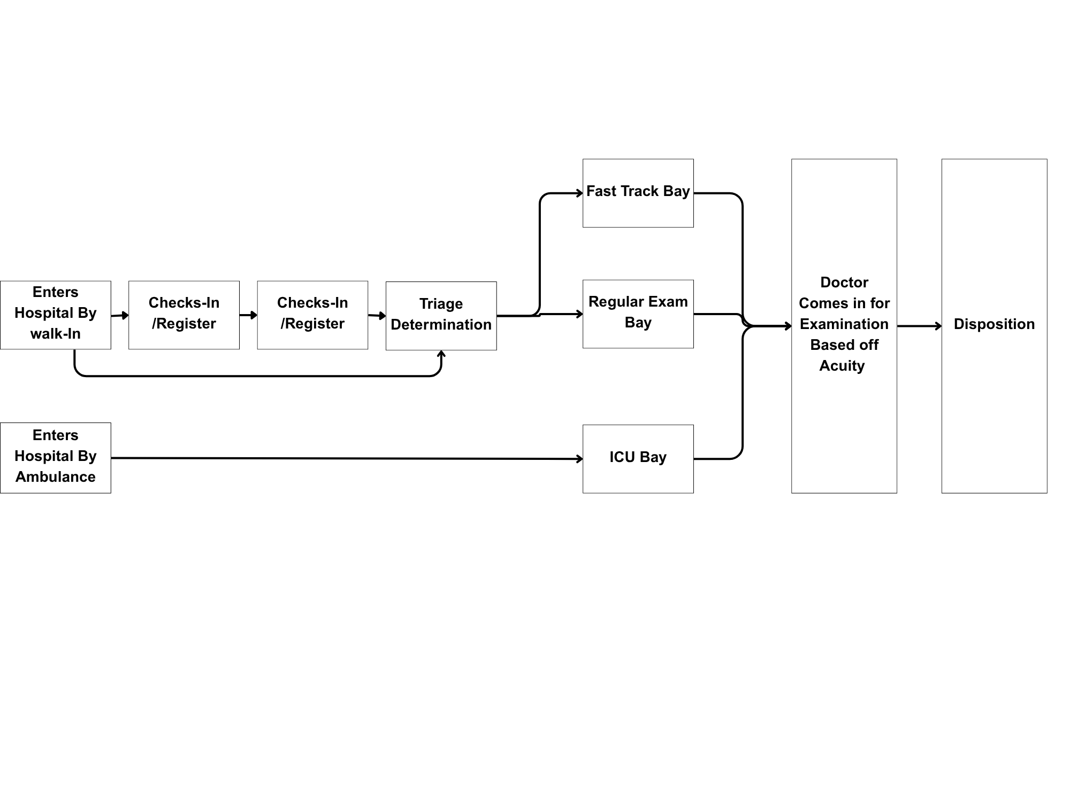
Problem Statement
Meridian City’s Hospital Management's would like your team’s help to uncover what is causing their wait times to increase more over time and what solutions are available to mitigate bottlenecks and other ER inefficiencies. For the purpose of this research Meridian City only wants to focus on analyzing it’s East ER location.
Your team’s challenge is to analyze patient flow and operational data to identify the primary causes of delays and propose actionable solutions or insights to improve overall ER throughput, staffing efficiency, and operational performance.

Background on Meridian City Hospital

Meridian Hospital Workflow Overview
Arrival
Patients enter the Emergency Department either by ambulance or walk-in. Upon arrival, they are registered in the hospital system, where basic information such as name, demographics, insurance (if applicable), and reason for visit is collected.
Triage
Next a patient will be assessed by a nurse to classify the severity of the case. Triage is the first step in their care journey: the process of quickly assessing each patient’s condition to determine the urgency of care needed.
- Level 1-Immediate: Life-threatening; requires immediate intervention
- Level 2-Emergency: Potentially life-threatening without prompt care
- Level 3-Urgent: Requires attention but not immediately life-threatening
- Level 4-Semi-urgent: Stable; care needed soon but not critical
This prioritization ensures that patients with the most serious conditions receive care first, even if they arrive later than others.
After triage, patients follow one of two main paths:
- Exam Room Admission: The patient is taken to an exam room for further evaluation and treatment. If no rooms are available, they are placed in a queue, this varies in length depending on the number of critical cases and available space.
- Fast-Track Service: Patients with minor injuries or conditions are directed to a fast-track area intended to provide quicker care for low-acuity cases. The Fast-Track area is generally staffed during day and evening hours, with most rooms closing by 11 PM when night shift volume drops.
During the analysis period, operations adjusted Fast-Track hours and room use based on typical evening patterns. These scheduling decisions were made to try and improve efficiency, though actual patient flow sometimes varied from the projections.
Doctor Seen
Once a patient is placed in an exam room, they are seen by a nurse and a physician (or even a physician assistant/nurse practitioner). The care team reviews the patient’s history, conducts a physical examination, and may order diagnostic tests such as lab work or imaging, as well as treatments or procedures to address their condition. The duration of this stage varies depending on case severity, test turnaround times, room availability, and staff workload.
Disposition
Once treatment is complete, the care team decides on the patient’s next step: discharge or admission. Patients who are stable and can recover at home are discharged with instructions and follow-up information. Those who require further care, observation, or surgery are admitted to an inpatient unit. This stage will depend on hospital bed availability and the efficiency of communication between departments.

Stakeholder Interviews
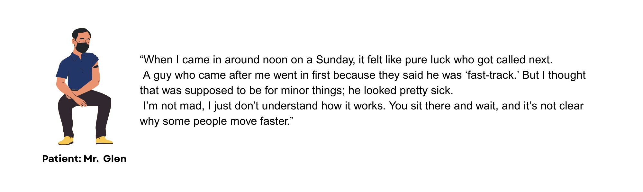

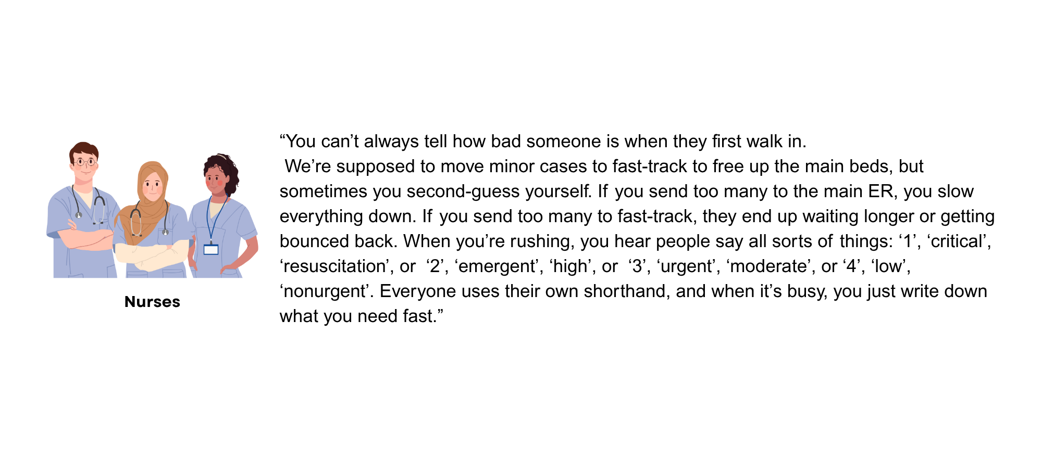
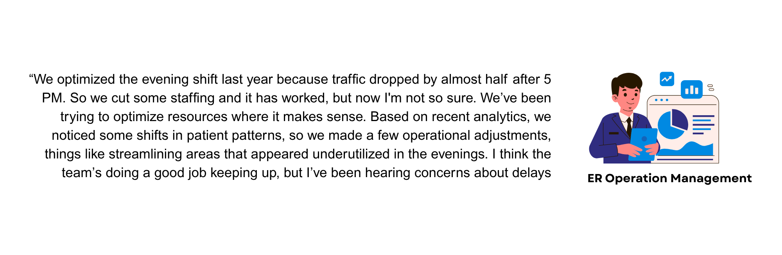

About the Data
Overview
This dataset represents a simulated Emergency Room (ER) management system for Meridian City ER. Each table models a core aspect of hospital management such as patient demographics, ER visit timelines, staffing schedules, facility capacity, and patient outcomes; together they form a complete view of the ER’s daily operations.
For detailed descriptions of every column, including data types, definitions, and contextual notes, please refer to the accompanying Data Dictionary (Data_Dictionary.xlsx). This document provides an attribute-level breakdown for each dataset.
Hospital_Patients.csv
This dataset contains demographic information for all patients who visited Meridian City ER during the 90-day period. Each record represents a unique patient and includes their medical record identifier, age, gender, and insurance type.
Hospital_Visits.csv
This is the core transactional table capturing each patient’s full journey through the ER. Each record represents a single visit and includes timestamps from arrival, registration, and triage through to when the patient is seen by a doctor and ultimately exits the department. Each visit is also assigned a triage level indicating acuity. These attributes enable analyses of throughput, bottlenecks, and service delays across shifts and patient types.
Hospital_Staffing.csv
This table represents the daily operational schedule of Meridian City ER. It includes the number of nurses, doctors, and specialists assigned per date and shift, along with total bed capacity and fast-track bed availability. Shifts at Meridian City ER are divided by time of day:
- Day Shift: 7:00 AM – 3:00 PM
- Evening Shift: 3:00 PM – 11:00 PM
- Night Shift: 11:00 PM – 7:00 AM
Hospital_Facility.csv
This dataset provides static facility information, representing the ER’s physical capacity and infrastructure. It lists the hospital’s identifier, total number of beds, ICU capacity, fast-track beds, and general ER beds. Analysts can join this table to staffing and visit data for additional context on available resources.
Hospital_Outcomes.csv
This table links directly to Hospital_Visits.csv through the shared Visit ID field and records how each ER encounter concluded. It captures the patient’s disposition, whether discharged, admitted, or transferred, as well as their satisfaction score, which reflects both time-in-system and case severity. The dataset supports evaluations of patient experience, operational efficiency, and quality-of-care metrics.
Getting Started & Important Info
Requirements
To Begin, you will need to open the start file within Alteryx Designer Desktop. The datasets have also been given to you, so you will need to load those into Alteryx. You will need to submit a recording of your findings.
The minimum required materials are as follows:
- 1 Alteryx Workflow
- A power point presentation (5-8 slides) with a voiceover recording of findings (video length 7-10 minutes)
- A 200-300 word executive summary
Tips
If you need some directions on where to start, look through the instructions one more time! Start cleaning and prepping any/all the datasets. Think about the problem and its underlying factors. Remember, even just showing interesting/new insights about the data is a HUGE gamechanger for Meridian City Hospital!
Remember this is a Datathon! You can get as creative, fancy, technical, business oriented, etc. as you would like; show us what you got. If you need ideas, other files can include: more workflows, demos, recommendations & solutions, documents, written proposals, dashboards, excel charts, it’s really open ended!!)
Office Hours will be hosted on 11/07/2025 10am-1pm through appointment only, scheduled with this booking link.
Submission
Submissions are due: November 9th by 12:00am. Please use this submission portal when your team is ready to submit, and make sure to include all required material as well as other material. You will need to submit using a OneDrive Folder, please read the directions in the submission portal carefully to submit correctly. We will only be judging based off the material submitted through the OneDrive Folder linked in your submission.

