An Internship Report
Of
Python Full Stack Development
Submitted
To
School of Computer Science and Engineering
IILM University, Greater Noida, U.P.
In partial fulfilment of the requirement of degree of
B.Tech CSE

By
Roll Number of Student: CS23411436
Name of Student: ANJALI VERMA
Class/Section: 4CSE1
Batch: 2023-2027

CANDIDATE'S DECLARATION
I, ANJALI VERMA, do hereby declare that the internship report titled “Python Full Stack Development” has been completed by me to fulfil the requirement for the award of the degree of Bachelor of Technology in Computer Science and Engineering. All the references have been quoted and I have not taken as such any material from any other source. I affirm that this report is my own and has not been submitted to any other institute for any degree/diploma requirement, and further I shall be solely responsible for any kind of copyright violation in this regard.
Signature:-
Student Name: ANJALI VERMA
Roll No.: CS23411436

ACKNOWLEDGEMENT
I am using this opportunity to express my gratitude to everyone who supported me throughout the Internship Program. I am thankful for their aspiring guidance, invaluably constructive criticism and friendly advice during this work. I am sincerely grateful to them for sharing their truthful and illuminating views on a number of issues related to this work.
I would like to thank the AICTE – EduSkills Virtual Internship Program team and EduSkills Academy for providing me the opportunity and the structured platform to learn and gain hands-on exposure in the domain of Python Full Stack Development. I am also thankful to my institute, IILM University, Greater Noida, and the faculty of the School of Computer Science and Engineering for their continuous support and encouragement.
I express my gratitude to my parents for their blessings.
Signature:
Student Name: ANJALI VERMA
Roll No.: CS23411436

TABLE OF CONTENTS
1. Candidate's Declaration i
2. Acknowledgement ii
3. Internship Completion Certificate -
4. Project Description 1
4.1 Introduction 1
4.2 Organization Profile 1
4.3 Problem Statement 2
4.4 Project Objectives 2
4.5 Scope of the Project 3
4.6 Technologies and Tools Used 3
4.7 System Architecture 4
4.8 Methodology 5
4.9 Expected Outcomes 6
4.10 Certificates of Completion and Communication Proof 7
5. Bibliography/References 8

3. INTERNSHIP COMPLETION CERTIFICATE
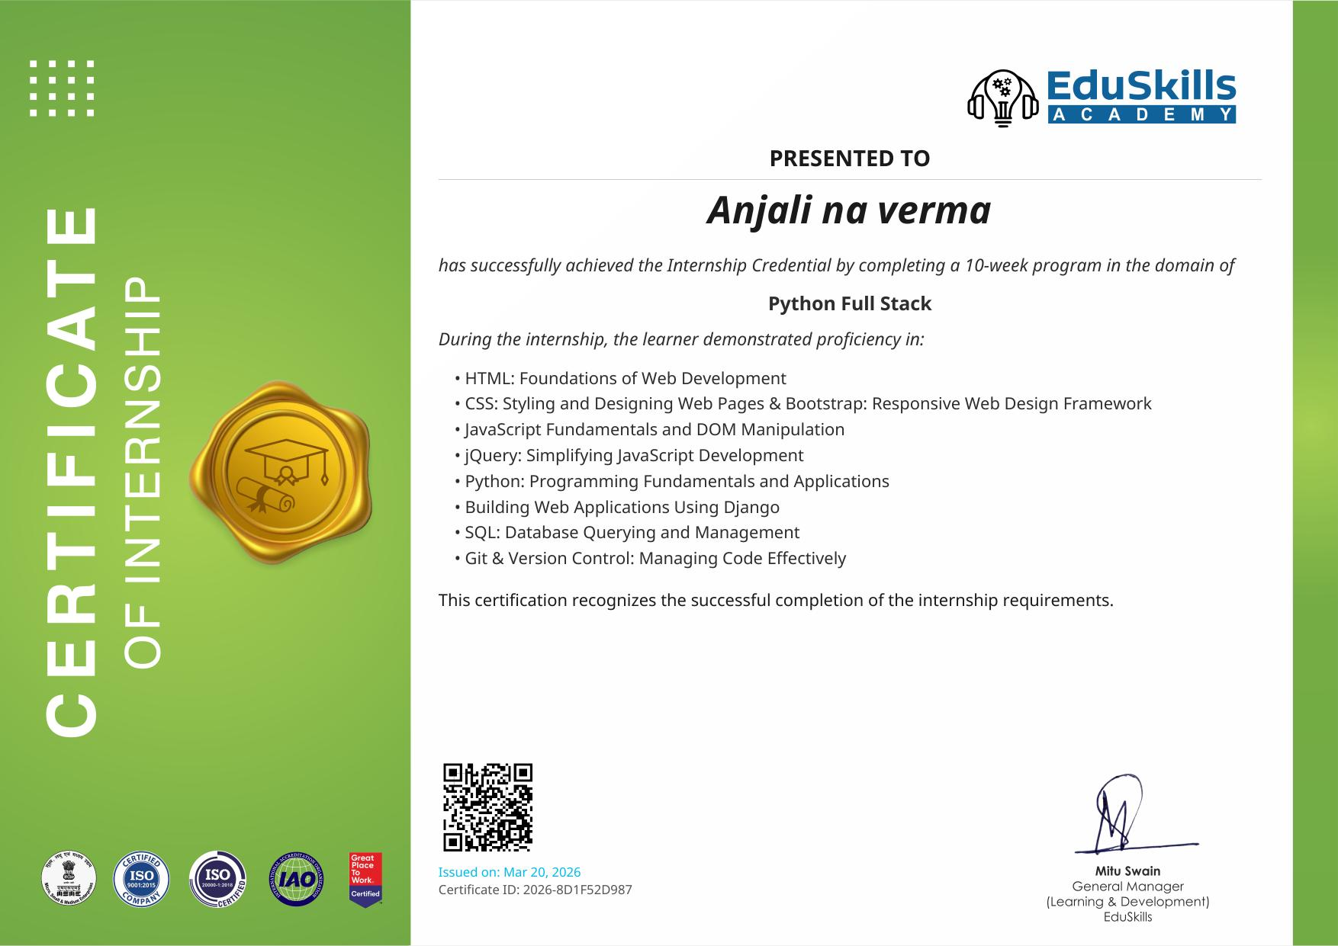

Internship Offer Letter
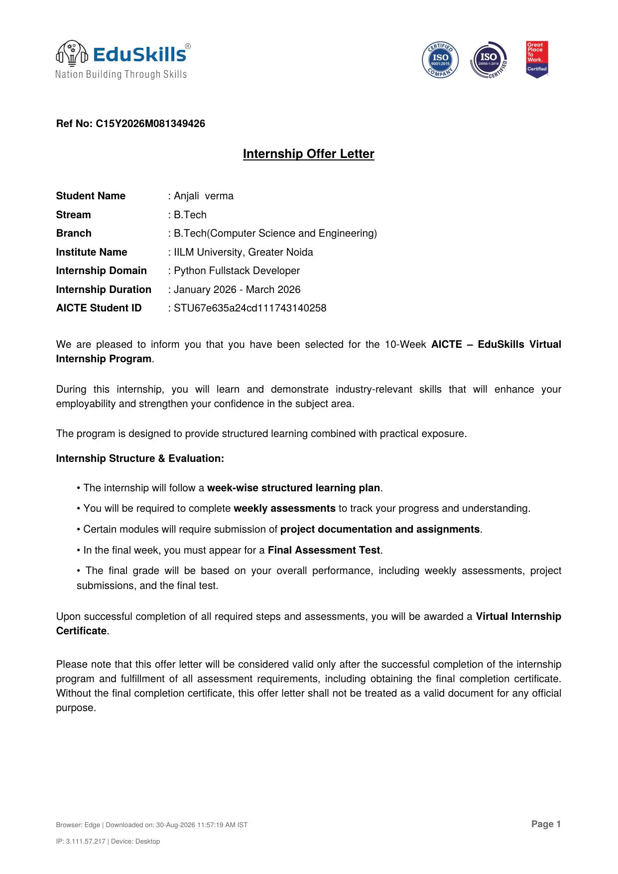

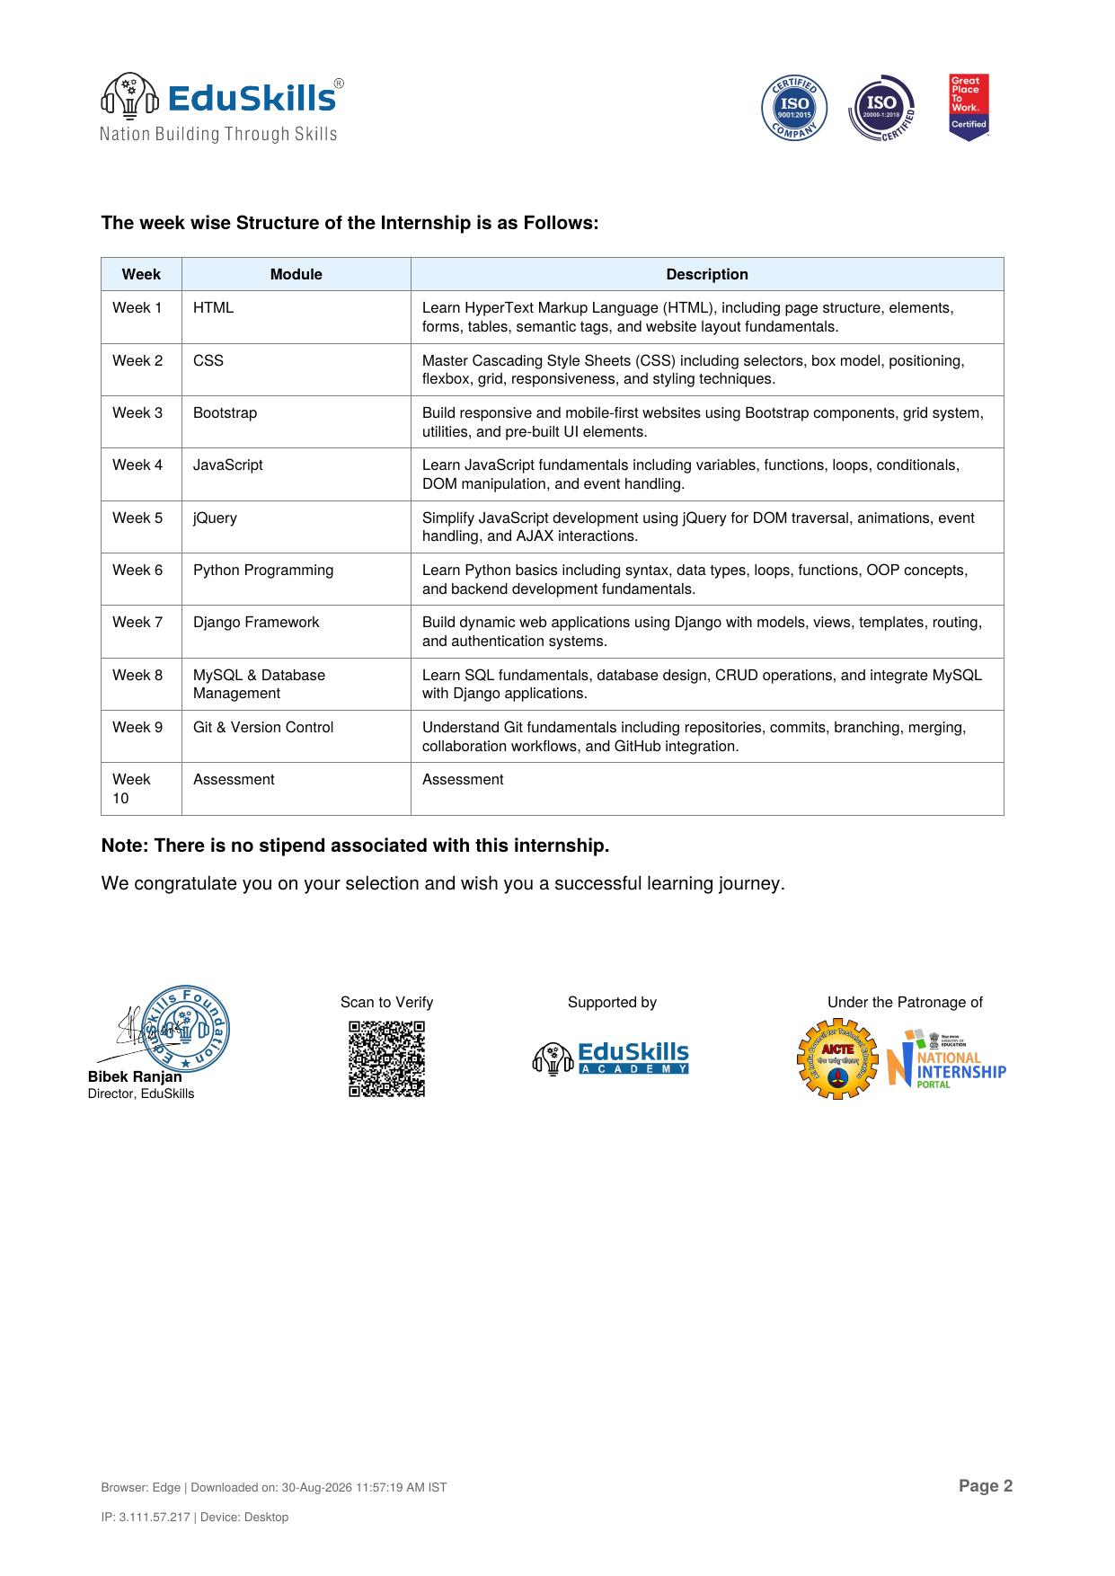

4. PROJECT DESCRIPTION

4.1 Introduction
This report presents a detailed account of the 10-week Virtual Internship undertaken under the AICTE – EduSkills Virtual Internship Program, in the domain of “Python Full Stack Development”. The internship was carried out from January 2026 to March 2026 as part of the requirement of the Bachelor of Technology (Computer Science and Engineering) programme at IILM University, Greater Noida. The primary aim of this internship was to build a strong, practical foundation across the entire web development stack — starting from structuring and styling web pages, progressing through client-side scripting and dynamic interactivity, and culminating in server-side programming, web application development, and database management.
The internship followed a structured, week-wise curriculum that combined conceptual learning with hands-on assignments, weekly assessments, and project documentation. On successful completion of all the requirements, including the final assessment, a Virtual Internship Certificate was awarded by EduSkills Academy.

4.2 Organization Profile
EduSkills Academy is an ISO 9001:2015 and ISO 20000-1:2018 certified organization working under the theme “Nation Building Through Skills”. EduSkills partners with the All India Council for Technical Education (AICTE) to run the AICTE – EduSkills Virtual Internship Program under the patronage of the AICTE National Internship Portal. The organization collaborates with leading technology companies and academic institutions to design industry-aligned virtual internship curricula that help engineering students strengthen their employability and gain practical exposure to in-demand technology domains such as Full Stack Web Development, Artificial Intelligence, Cloud Computing, and Cybersecurity, among others.

4.3 Problem Statement
Engineering students are commonly introduced to individual pieces of web technology — a page here, a script there — but rarely get a chance to see how these pieces fit together into one working application. Front-end design, client-side interactivity, server-side logic, and data storage are often taught in isolation, leaving a gap between academic knowledge and the ability to build a complete, functioning web application end-to-end. The problem addressed by this internship was to bridge that gap by learning and practically applying every layer of the web development stack — from markup and styling to scripting, back-end programming with Python and Django, and database management with MySQL — within a single, connected learning path.

4.4 Project Objectives
- To understand the structure of web pages and build them using HTML, including forms, tables, and semantic tags.
- To style and lay out responsive web pages using CSS, covering the box model, positioning, flexbox, and grid.
- To build mobile-first, responsive interfaces rapidly using the Bootstrap framework.
- To learn JavaScript fundamentals — variables, functions, loops, conditionals, DOM manipulation, and event handling.
- To simplify DOM traversal, animations, and event handling using jQuery, and to fetch data asynchronously using AJAX.
- To learn Python programming fundamentals, including data types, loops, functions, and object-oriented programming concepts.
- To build dynamic, data-driven web applications using the Django framework, covering models, views, templates, routing, and authentication.
- To learn SQL fundamentals and database design, and to integrate a MySQL database with a Django application.
- To apply version control practices using Git and GitHub for managing code effectively.

4.5 Scope of the Project
The scope of this internship spans the complete web development pipeline — from designing and styling static web pages, to adding client-side interactivity and asynchronous data handling, to building and serving a dynamic web application backed by a relational database. It covers both the front-end (HTML, CSS, Bootstrap, JavaScript, jQuery, AJAX) and the back-end (Python, Django, MySQL) layers of a full-stack application, along with version control using Git and GitHub. The internship was limited to a structured, virtual, lab-based learning environment provided by EduSkills Academy and did not involve deployment on any live organizational production system.

4.6 Technologies and Tools Used
- Markup & Styling: HTML, CSS
- Front-End Framework: Bootstrap
- Client-Side Scripting: JavaScript, jQuery, AJAX
- Programming Language: Python
- Web Framework: Django
- Database: MySQL / SQL
- Version Control: Git, GitHub

4.7 System Architecture
The general architecture followed while building a full-stack web application during the internship can be summarized in the following layers:
- Presentation Layer: Web pages structured with HTML and styled with CSS and Bootstrap for a responsive, mobile-first layout.
- Interaction Layer: JavaScript and jQuery handle DOM manipulation, form validation, and event-driven behavior on the client side.
- Data Exchange Layer: AJAX enables asynchronous communication between the client and the server, allowing data to be fetched or submitted without a full page reload.
- Application Layer: The Django framework handles URL routing, views, business logic, and template rendering to generate dynamic pages.
- Data Layer: A MySQL database stores and manages application data, accessed through Django's models using SQL-based queries.
- Version Control Layer: Git and GitHub are used throughout to track changes, manage code versions, and maintain a structured project history.

4.8 Methodology
The internship followed a structured, week-wise methodology combining conceptual learning, hands-on practice, and weekly assessments, as summarized in the table below.

Week | Module | Description
Week 1 | HTML | Learn HyperText Markup Language (HTML), including page structure, elements, forms, tables, semantic tags, and website layout fundamentals.
Week 2 | CSS | Master Cascading Style Sheets (CSS) including selectors, box model, positioning, flexbox, grid, responsiveness, and styling techniques.
Week 3 | Bootstrap | Build responsive and mobile-first websites using Bootstrap components, grid system, utilities, and pre-built UI elements.
Week 4 | JavaScript | Learn JavaScript fundamentals including variables, functions, loops, conditionals, DOM manipulation, and event handling.
Week 5 | jQuery | Simplify JavaScript development using jQuery for DOM traversal, animations, event handling, and AJAX interactions.
Week 6 | Python Programming | Learn Python basics including syntax, data types, loops, functions, OOP concepts, and back-end development fundamentals.
Week 7 | Django Framework | Build dynamic web applications using Django with models, views, templates, routing, and authentication systems.
Week 8 | MySQL & Database Management | Learn SQL fundamentals, database design, CRUD operations, and integrate MySQL with Django applications.
Week 9 | Git & Version Control | Understand Git fundamentals including repositories, commits, branching, merging, collaboration workflows, and GitHub integration.
Week 10 | Assessment | Final Assessment Test to evaluate overall understanding and application of the complete Python full-stack curriculum.

Each week concluded with a weekly assessment to evaluate conceptual understanding, and selected modules required submission of project documentation and assignments. In the final week, a Final Assessment Test was conducted, and the overall grade was based on performance across weekly assessments, project submissions, and the final test.

4.9 Expected Outcomes
- Ability to independently design and structure responsive web pages using HTML, CSS, and Bootstrap.
- Practical skill in adding client-side interactivity and dynamic behavior using JavaScript and jQuery.
- Understanding of asynchronous data handling using AJAX, without requiring full page reloads.
- Working knowledge of Python programming, including core syntax and object-oriented concepts.
- Capability to build and serve a dynamic, data-driven web application using the Django framework.
- Skill in designing and querying relational databases using SQL, and integrating MySQL with a Django application.
- Familiarity with version control practices using Git and GitHub for effective code management.
- A working, end-to-end understanding of how front-end and back-end components combine into a complete full-stack web application.

4.10 Certificates of Completion and Communication Proof
The Internship Offer Letter and the Internship Completion Certificate issued by EduSkills Academy, confirming successful completion of the 10-week AICTE – EduSkills Virtual Internship Program in Python Full Stack Development, are attached in Chapter 3 of this report.

5. BIBLIOGRAPHY/REFERENCES
1. EduSkills Academy, “AICTE – EduSkills Virtual Internship Program – Python Fullstack Developer,” Internship Offer Letter, Ref No. C15Y2026M081349426, 2026.
2. EduSkills Academy, “Certificate of Internship – Python Full Stack,” Certificate ID: 2026-8D1F52D987, Issued on March 20, 2026.
3. HTML Living Standard, https://html.spec.whatwg.org/
4. MDN Web Docs – CSS, https://developer.mozilla.org/en-US/docs/Web/CSS
5. Bootstrap Documentation, https://getbootstrap.com/docs/
6. MDN Web Docs – JavaScript, https://developer.mozilla.org/en-US/docs/Web/JavaScript
7. jQuery Documentation, https://api.jquery.com/
8. Python Documentation, https://docs.python.org/3/
9. Django Documentation, https://docs.djangoproject.com/
10. MySQL Documentation, https://dev.mysql.com/doc/
11. Git Documentation, https://git-scm.com/doc

