Virtual Healthcare Platform Implementation Report



Submitted by: Pushti Radadiya (22BCP111)

Submitted to: Dr. Amitava Chaudhary

Submitted on: 07/11/2024

Subject: Web Technology (23CP306P)

**Computer Science and Engineering**

**School of Technology**

**Pandit Deendayal Energy University**

**Table of Contents**

Executive Summary 5

Key Features and Implementation 5

1. Seamless User Experience 5

2. Advanced Health Monitoring 7

3. AI-Powered Health Assistant 8

4. Hospital Connection Platform 9

ER Diagram 10

Technical Aspects 10

Platform Architecture 10

User Benefits 12

1. Healthcare Access 12

2. Personal Health Management 12

3. Time and Cost Efficiency 12

Future Works and Improvements 12

1. Planned Enhancements 12

2. Scaling Opportunities 13

3. Security Enhancements 13

Conclusion 13

# Table of Figures

Figure 1: Signup 6

Figure 2: Login 7

Figure 3: Dashboard 7

Figure 4: Services 8

Figure 5: AI chatbot 8

Figure 6: About us 9

Figure 7: Medical records 9

Figure 8: Add medical record 10

Figure 9: Chat with AI 10

Figure 10:Find nearby hospitals 11

Figure 11: ER diagram 12

Figure 12: Patient history database table 13

Figure 13: Users database table 13

Figure 14: Chat logs database table 14

## Executive Summary

We have successfully implemented a comprehensive virtual healthcare platform that bridges the gap between patients and healthcare services through innovative technology. The platform transforms traditional healthcare access by providing users with AI-powered health management tools, personalized hospital recommendations, and secure health tracking capabilities. This implementation addresses the growing need for accessible, efficient, and user-centric healthcare solutions in the digital age.

## Key Features and Implementation

### 1. Seamless User Experience

* **Intuitive Account Management**
  + Simplified registration process with email and username integration

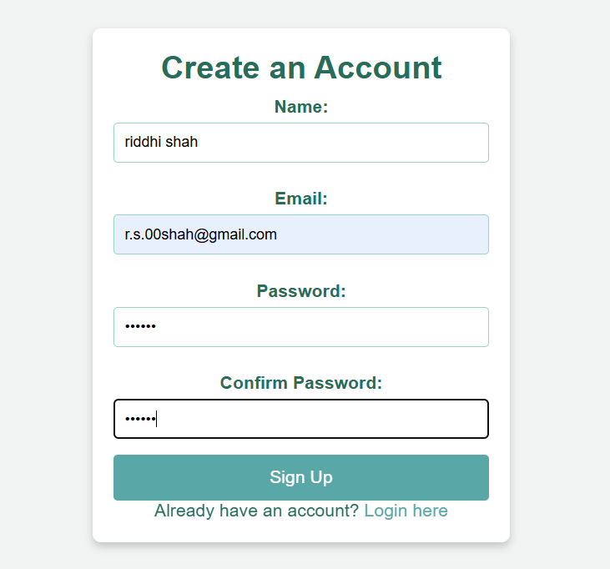

Figure 1: Signup

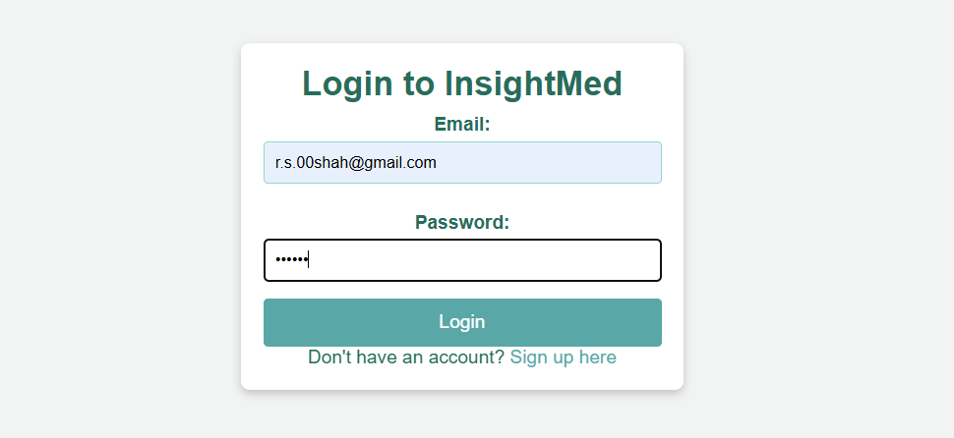

Figure 2: Login

* + Personalized dashboards displaying health metrics and appointment history

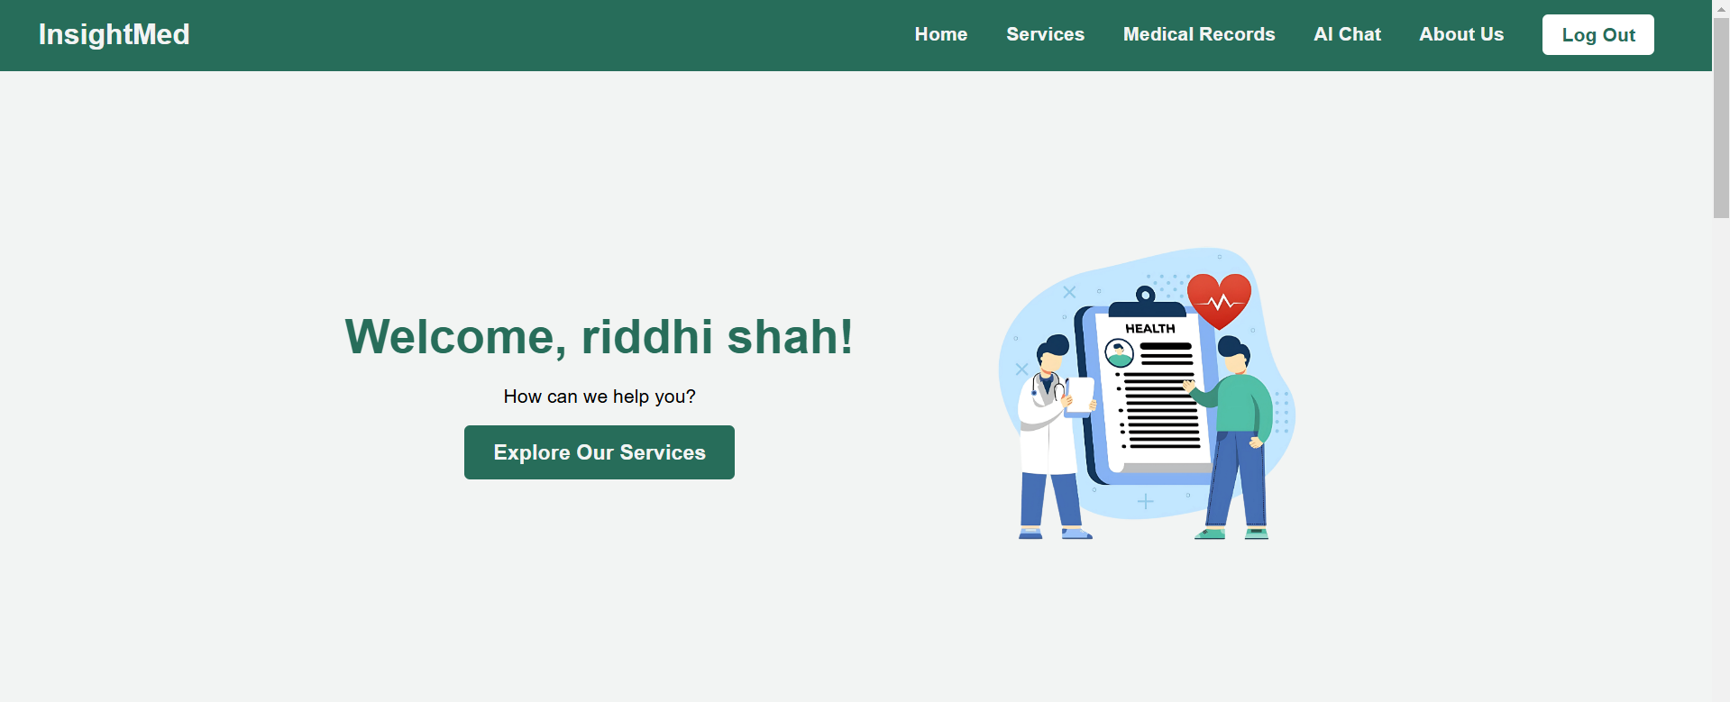

Figure 3: Dashboard

* + Easy-to-navigate interface optimized for all devices

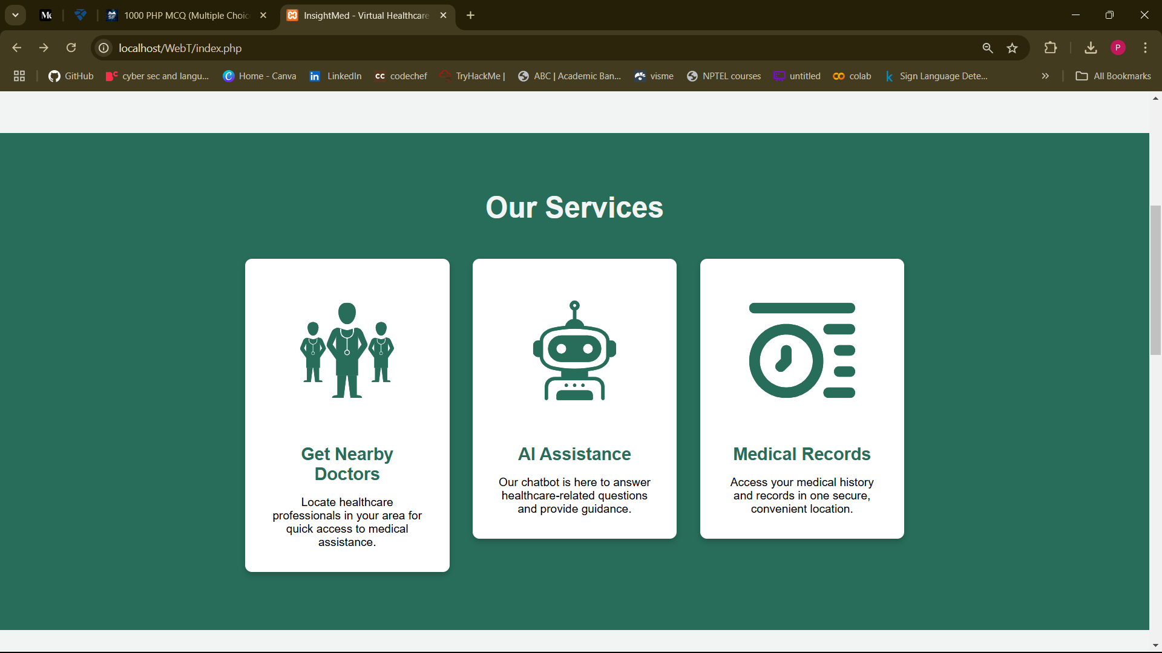

Figure 4: Services

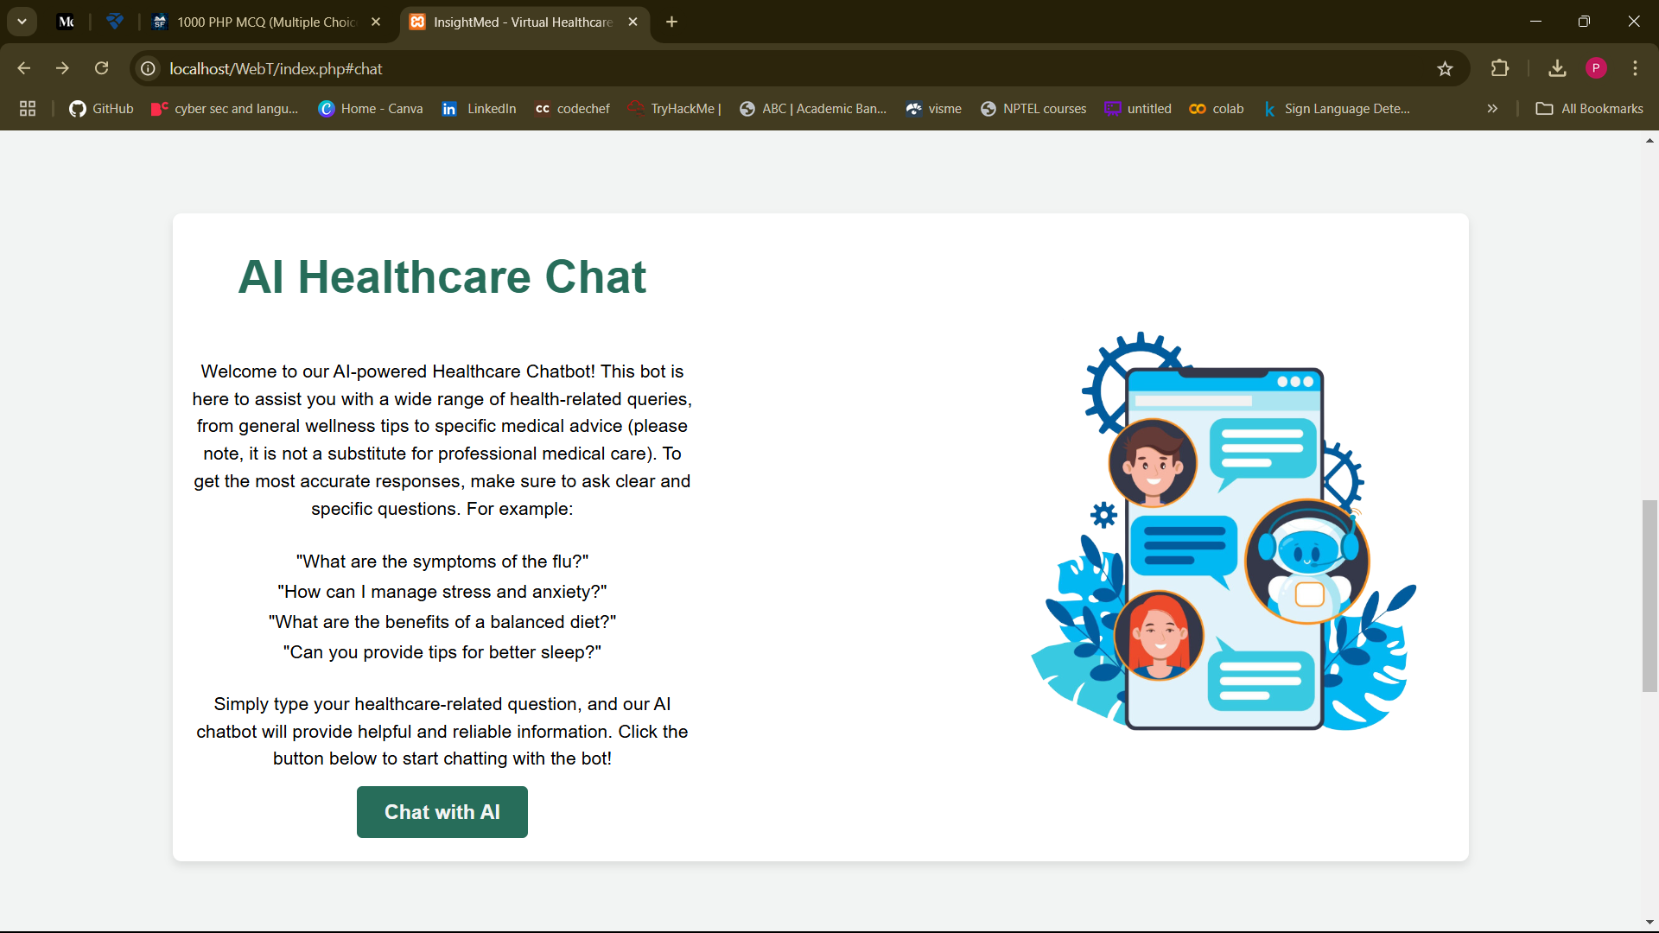

Figure 5: AI chatbot

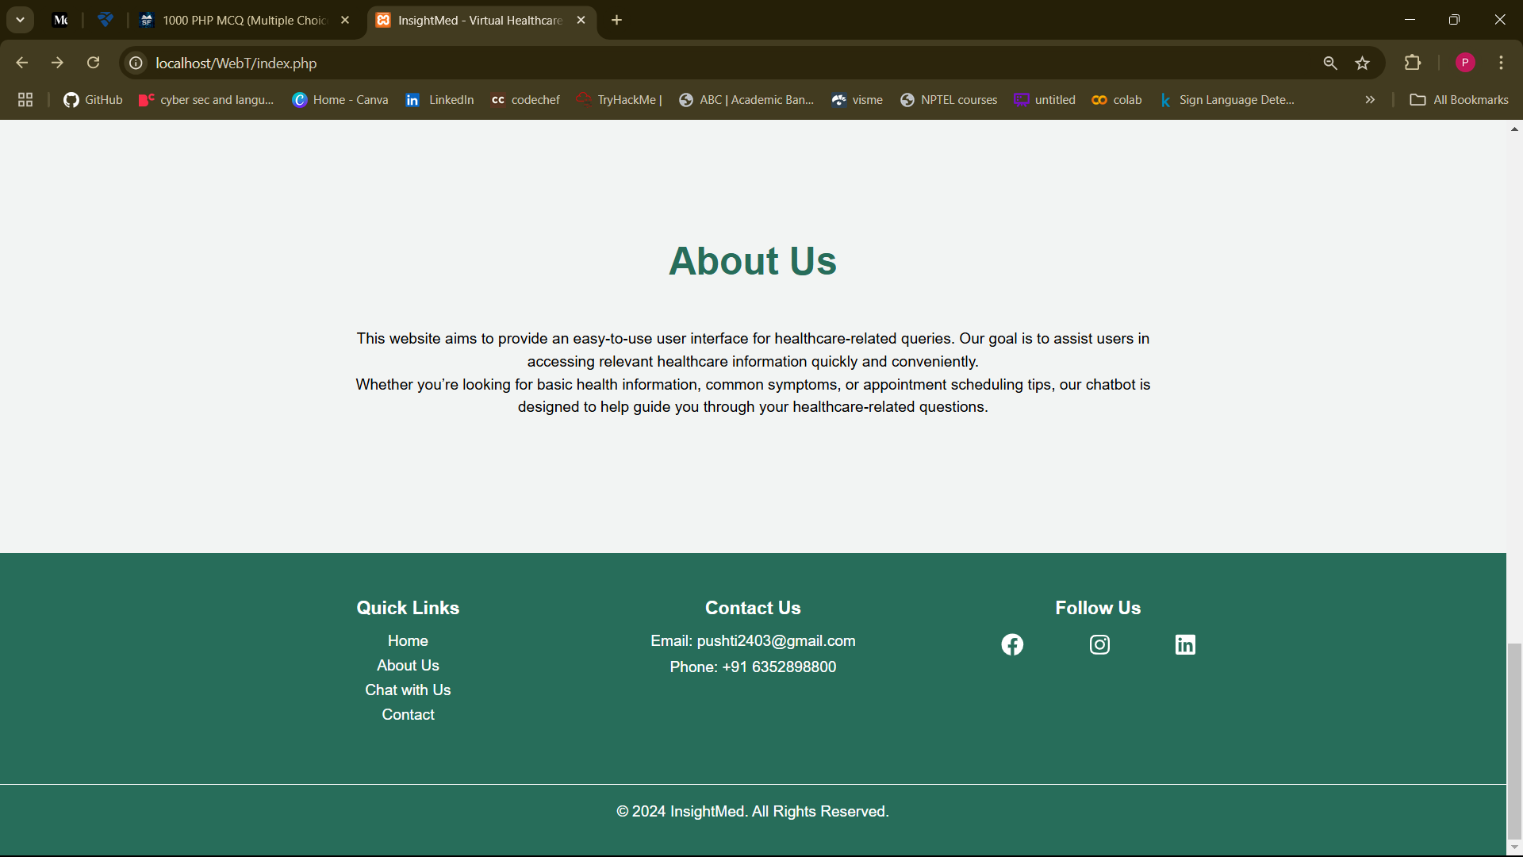

Figure 6: About us

### 2. Advanced Health Monitoring

* **Personal Health Tracking**
  + Personalised dashboard allowing user to track his medical history

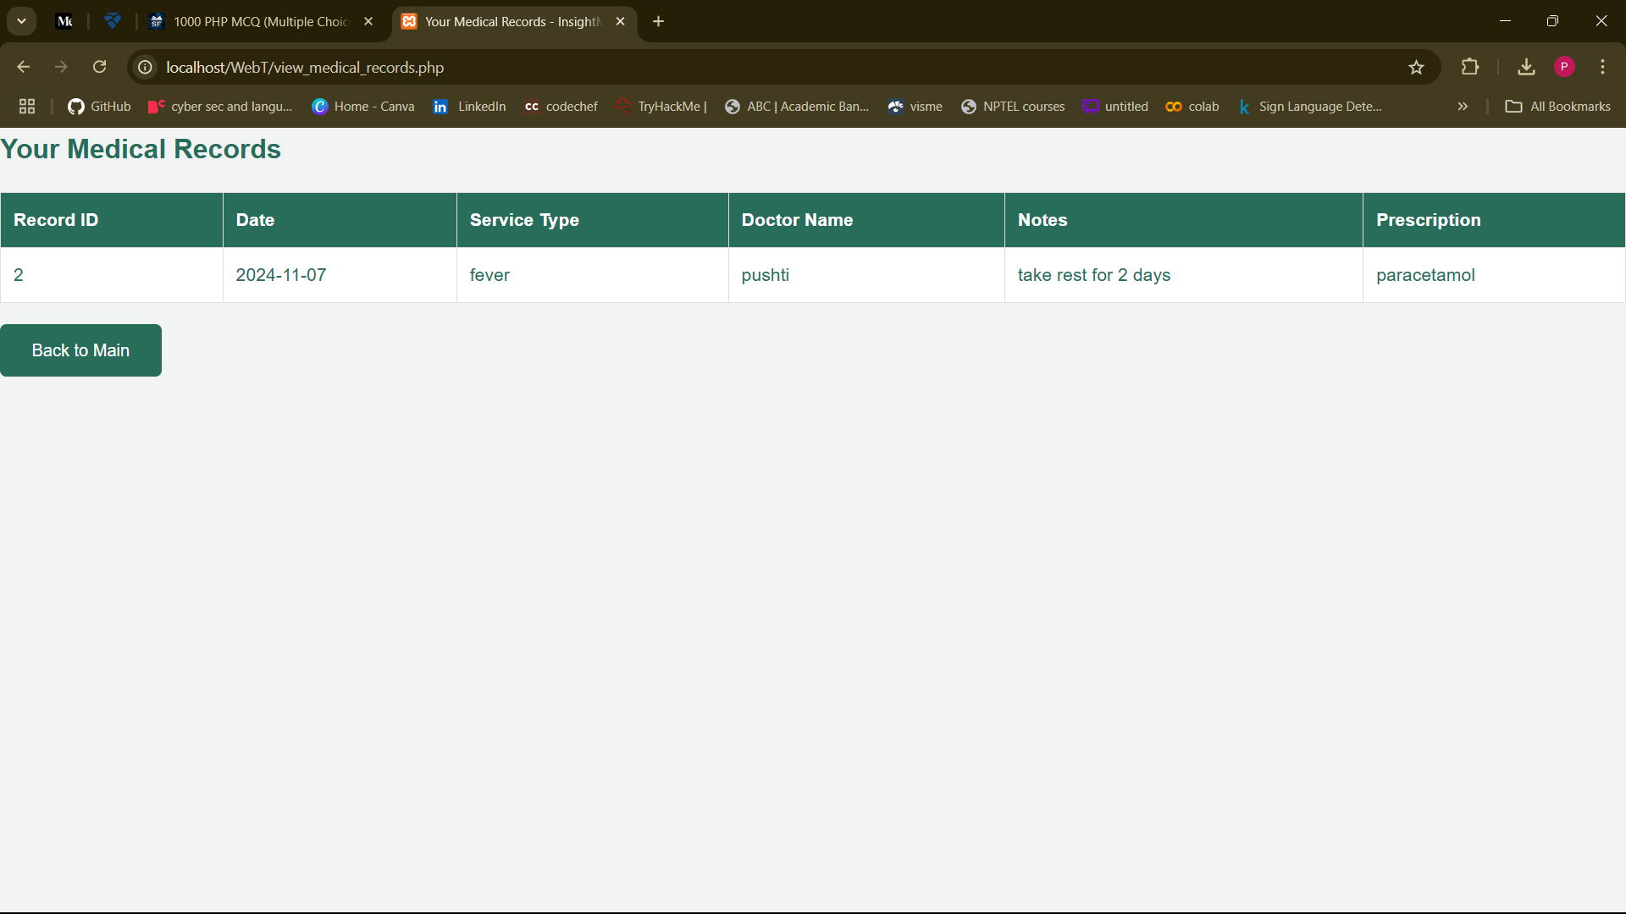

Figure 7: Medical records

* + User can access consulted doctor, prescription and disease diagnosed

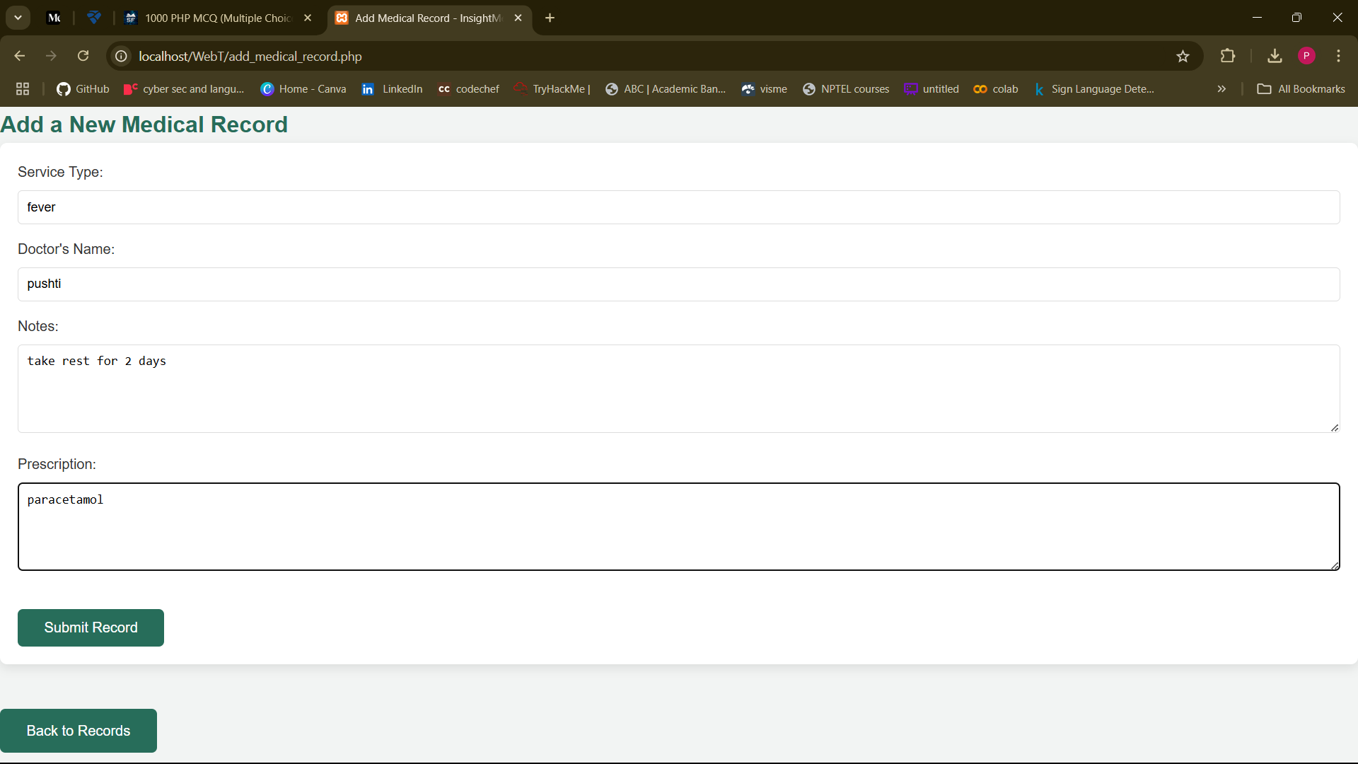

Figure 8: Add medical record

### 3. AI-Powered Health Assistant

* **Smart Symptom Analysis**
  + Natural language processing for symptom interpretation
  + Personalized preliminary health assessments

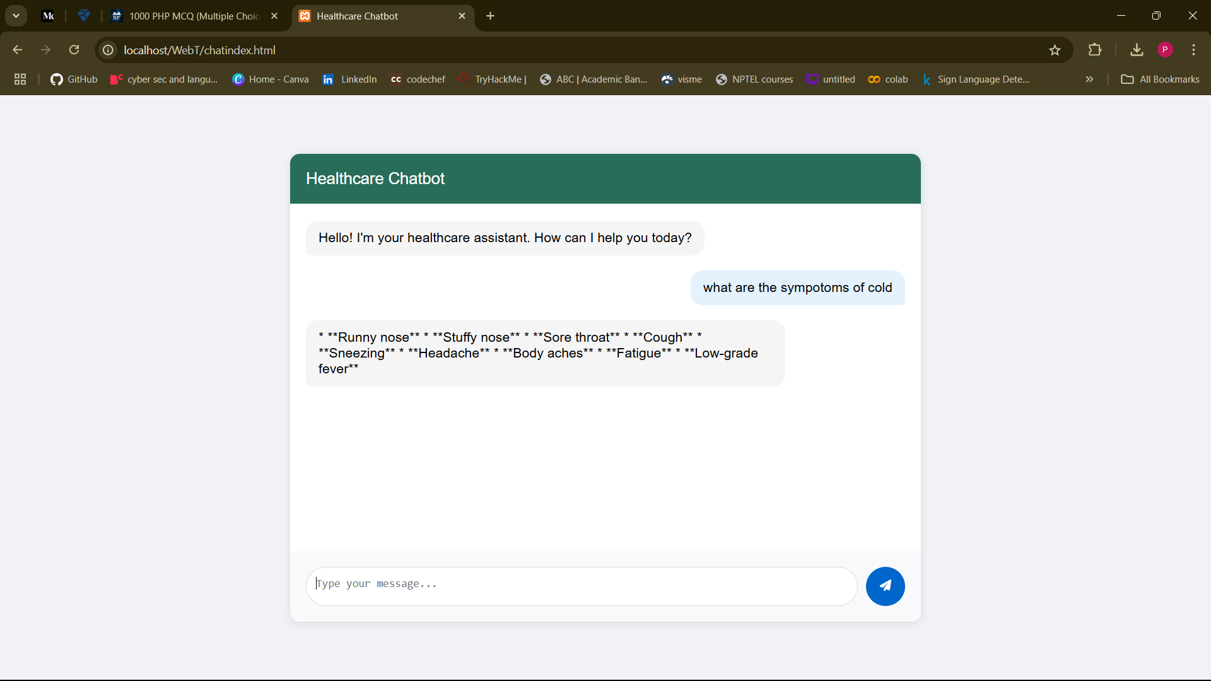

Figure 9: Chat with AI

### 4. Hospital Connection Platform

* **Smart Hospital Recommendations**
  + Location-based hospital suggestions
  + Users can see nearby location by entering their current location

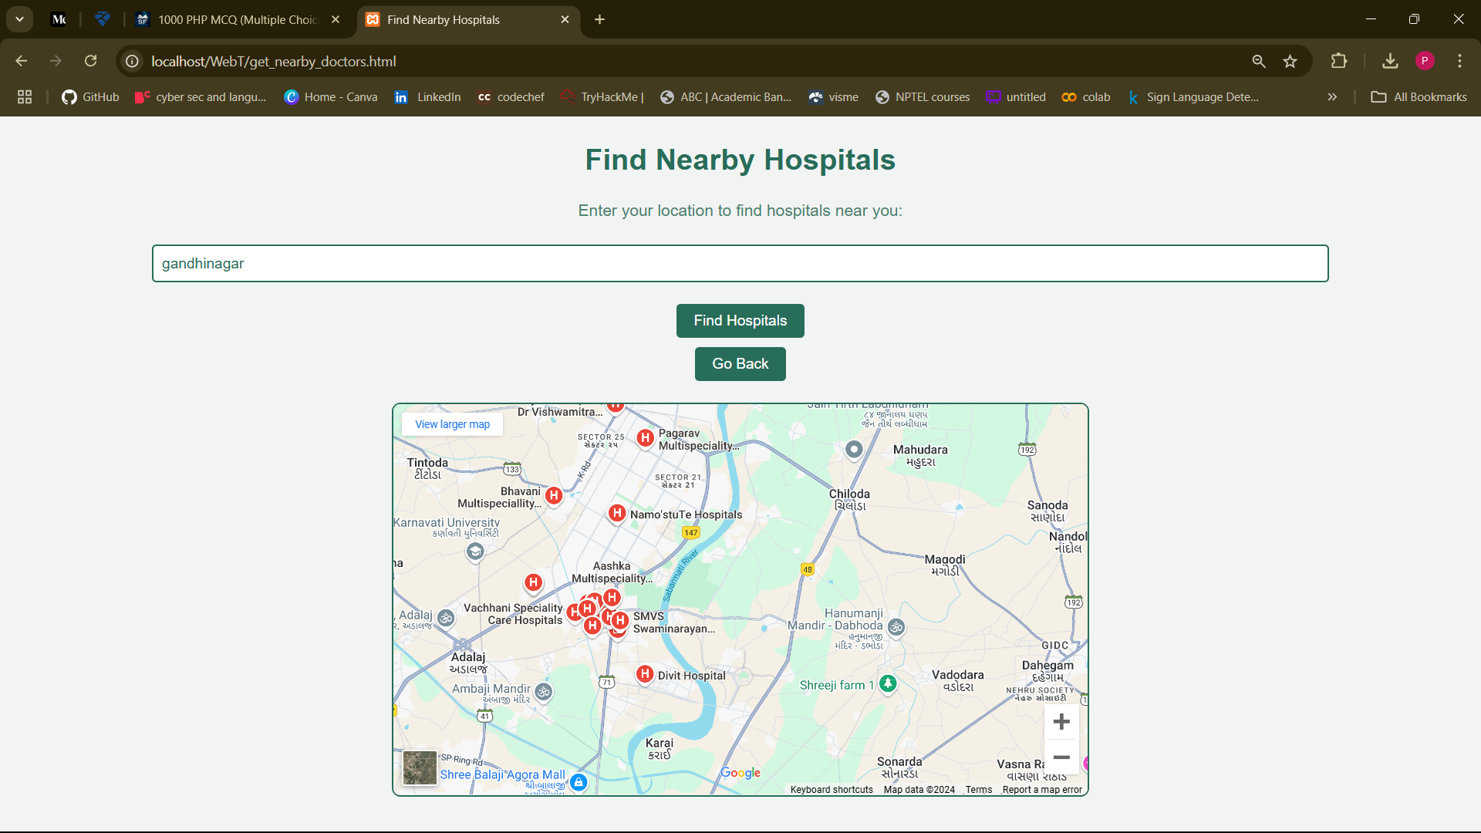

Figure 10:Find nearby hospitals

## ER Diagram

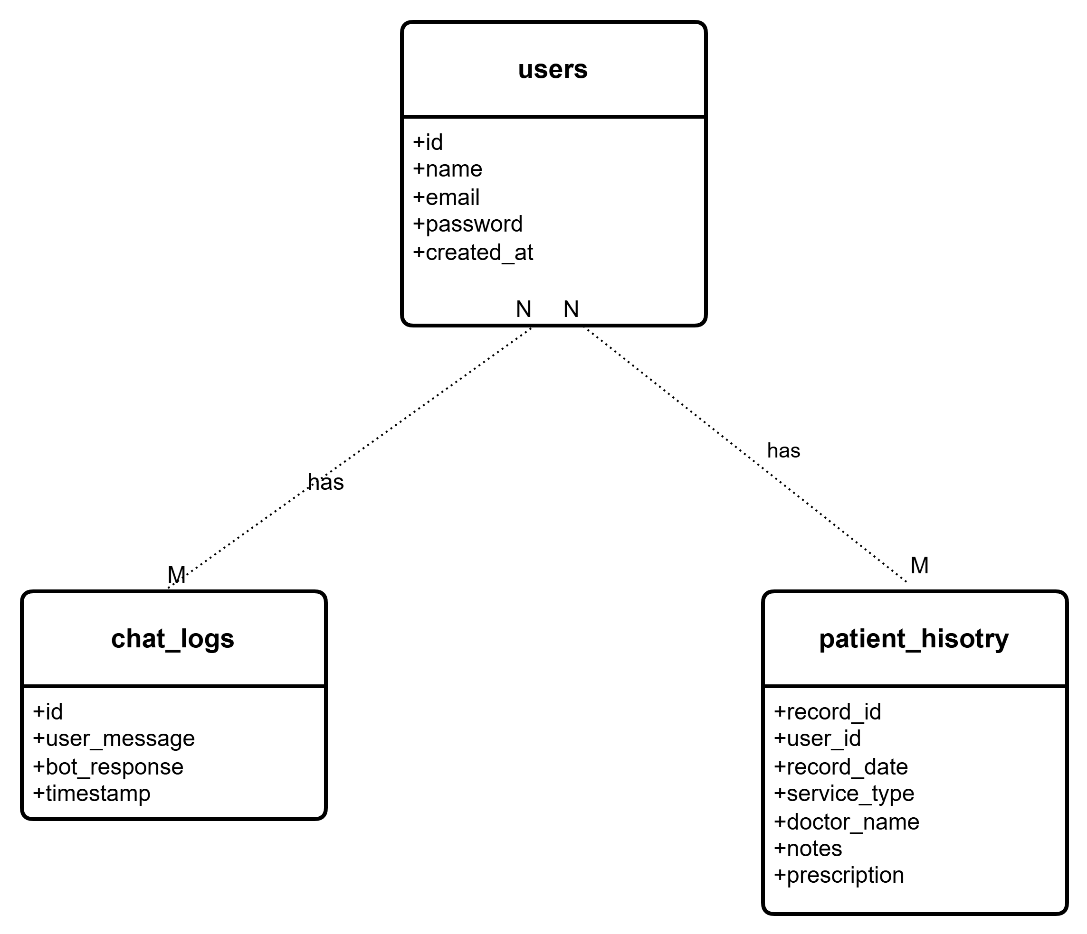

Figure 11: ER diagram

## Technical Aspects

### Platform Architecture

* **Frontend Development**
  + React.js for dynamic user interface
  + Responsive design framework for cross-device compatibility
* **Backend Infrastructure**
  + php server environment
  + mysql for secure database management

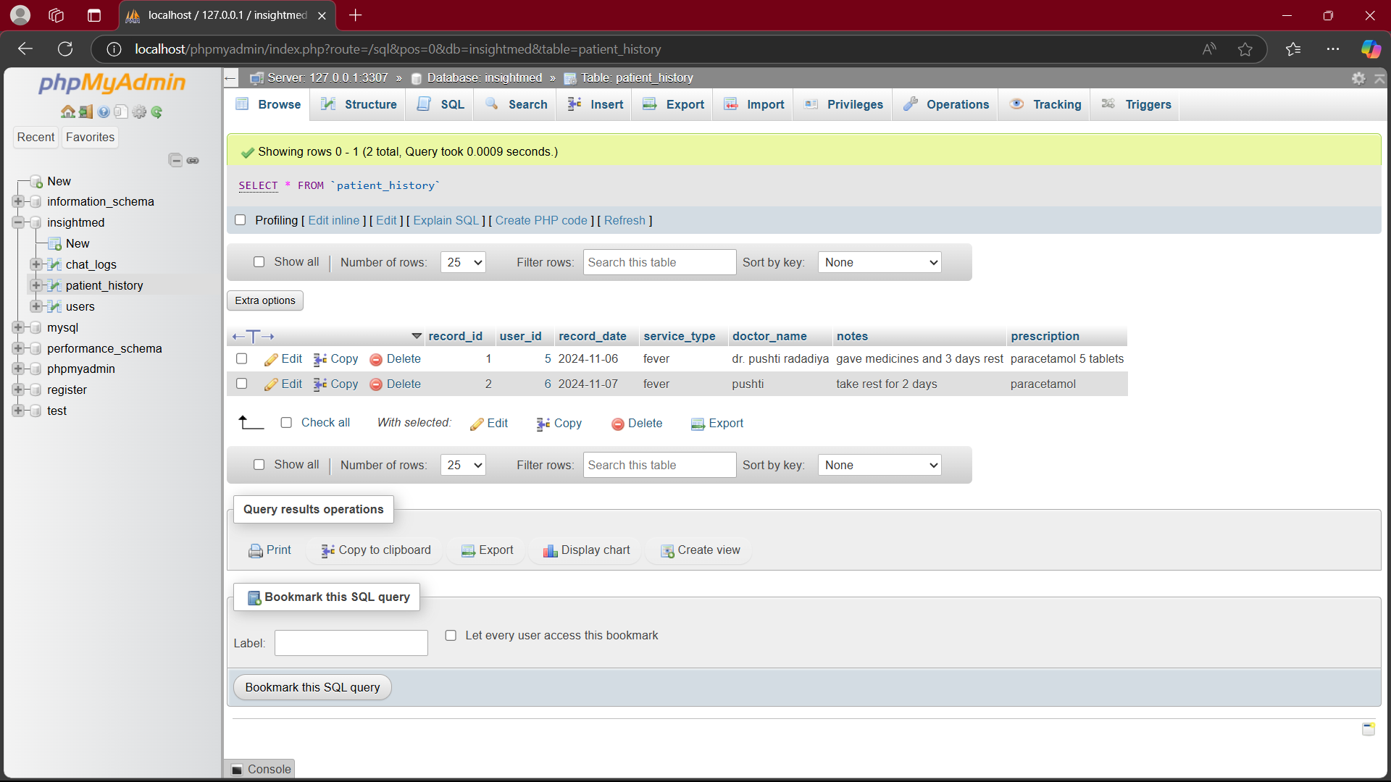

Figure 12: Patient history database table

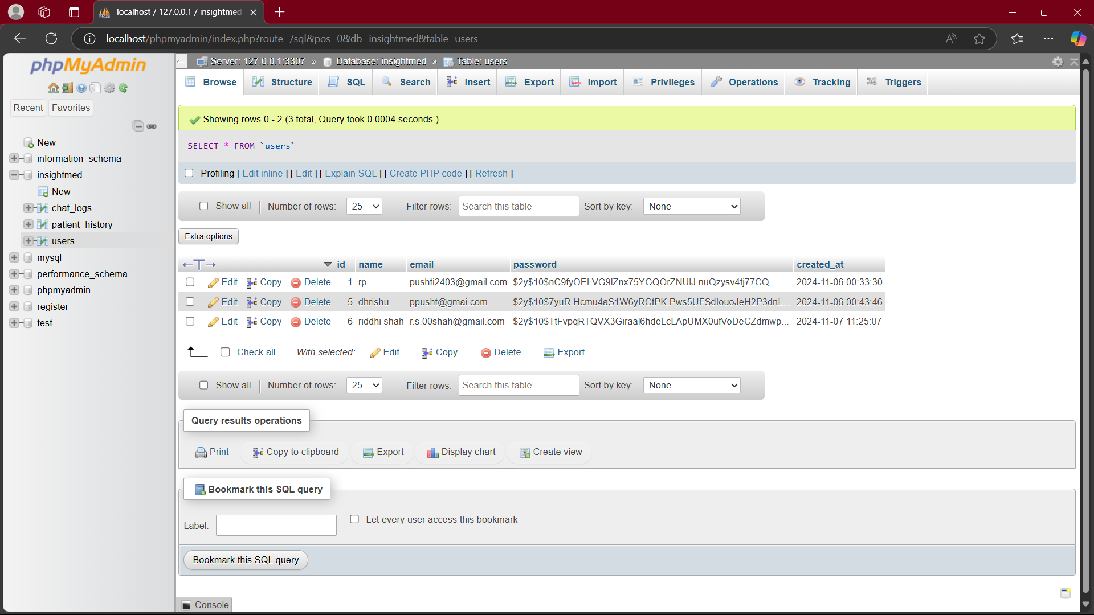

Figure 13: Users database table

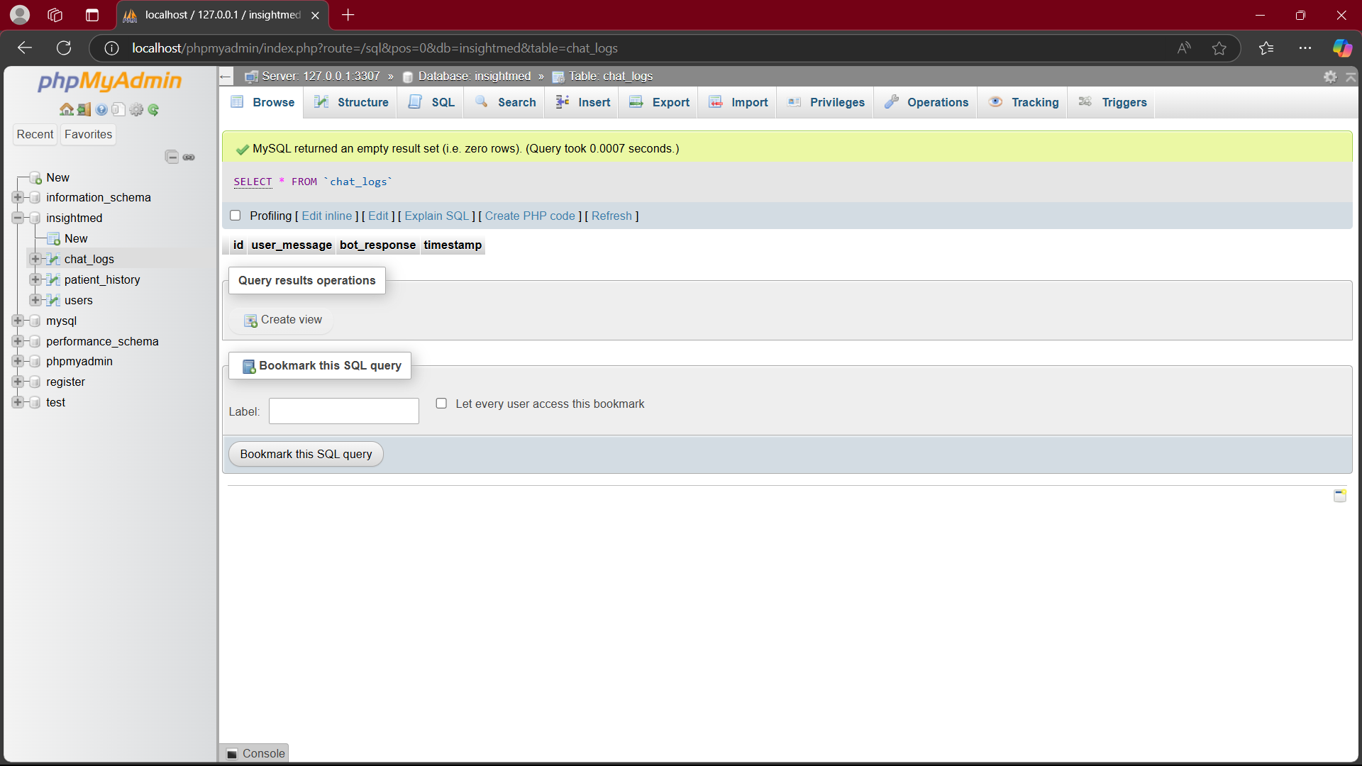

Figure 14: Chat logs database table

## User Benefits

### 1. Healthcare Access

* 24/7 availability of health information and support
* Reduced waiting times for medical consultations
* Easy access to specialized healthcare services

### 2. Personal Health Management

* Comprehensive health tracking and monitoring
* Early detection of health issues through AI analysis
* Improved health awareness and preventive care

### 3. Time and Cost Efficiency

* Eliminated unnecessary hospital visits
* Reduced healthcare management costs

## Future Works and Improvements

### 1. Planned Enhancements

* Integration with wearable health devices
* Advanced telemedicine capabilities
* Enhanced AI diagnostic capabilities
* Saving the chat logs to ensure better response from the bot

### 2. Scaling Opportunities

* Mobile application development
* International healthcare provider network expansion
* Integration with electronic health record systems

## 3. Security Enhancements

* Security measures according to HIPPA
* User medical history security enhancement
* User login 2-factor authentication

## Conclusion

The implementation of this virtual healthcare platform marks a significant advancement in digital healthcare delivery. By combining user-friendly design with powerful technology, we have created a solution that not only meets current healthcare needs but also establishes a foundation for future healthcare innovations. The project has achieved its core objectives of:

* Creating a secure and efficient healthcare management system
* Implementing innovative AI-driven health assistance
* Establishing a reliable hospital recommendation system
* Developing a scalable and user-friendly platform

This implementation serves as a stepping stone toward revolutionizing healthcare delivery, making quality healthcare more accessible, efficient, and user-centric than ever before.