Lab-1:
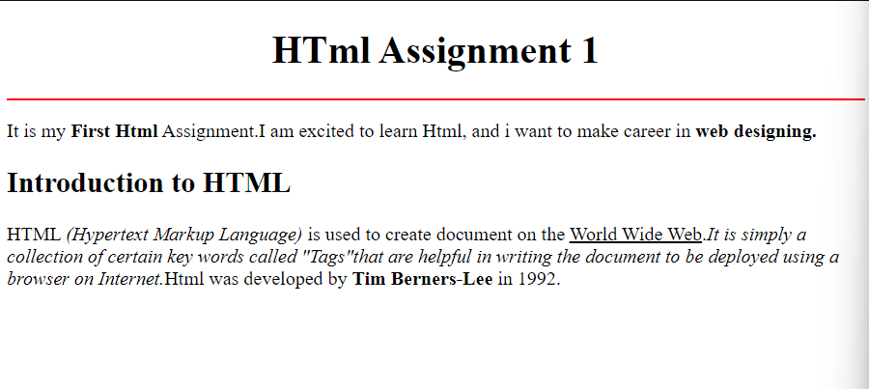
Code:
<!DOCTYPE html>
<html lang="en">
<head>
<meta charset="UTF-8">
<meta http-equiv="X-UA-Compatible" content="IE=edge">
<meta name="viewport" content="width=device-width, initial-scale=1.0">
<title>Document</title>
</head>
<body>
<div class="container">
<h1 align="center">HTml Assignment 1</h1>
<hr color="red" height ="3px">
<p>It is my <strong>First Html</strong> Assignment.I am excited to learn Html, and i want to make career in <strong>web designing.</strong></p>
<h2>Introduction to HTML</h2>
<abbr>HTML </abbr><em>(Hypertext Markup Language)</em> is used to create document on the <u>World Wide Web</u>.<i>It is simply a collection of certain key words called "Tags"that are helpful in writing the document to be deployed using a browser on Internet.</i><abbr>Html</abbr> was developed by <b>Tim Berners-Lee</b> in 1992.
</div>

</body>
</html>

Lab-2:

Code:
<!DOCTYPE html>
<html lang="en">

<head>
<meta charset="UTF-8">
<meta http-equiv="X-UA-Compatible" content="IE=edge">
<meta name="viewport" content="width=device-width, initial-scale=1.0">
<title>Document</title>
</head>

<body>
<h2 align="center"><U>MODEL QUESTION PAPER FOR SUMMATIVE TEST-II <br />MATHEMATICS <br />CLASS-VIII</U></h2>
Maximum Marks:20 <br /><br />
<b>General instuctions </b>
<br />
<ol>
<li>All questions are compulsory</li>
<li>The question paper consist of 7 question divided into 2 section A and B</li>
<li>Section A contains 4 question of 2 marks each</li>
<li>Section B contains 3 questions of 4 marks each.</li>
</ol>

<div class="conatiner" id="section_B">
<h2 align="center"><U>SECTION A</U></h2>
<span>Q1.What will be the product of (a<sup>2</sup>)x(2a<sup>22</sup>)x(4a<sup>26</sup>)</span>
<ol type="a">
<li>8a<sup>46</sup></li>
<li>8a<sup>48</sup></li>
<li>6a<sup>50</sup></li>
<li>8a<sup>50</sup></li>
</ol>

<span>Q2.water is oxidised to oxygen by</span>
<ol type="a">
<li>H<sub>2</sub>O<sub>2</sub></li>
<li>KMnO<sub>4</sub></li>
<li>ClO<sub>2</sub></li>
<li>Fluorine</li>
</ol>

</div>

<p name="footer" align="center"><del>Cutting is Not Allowed</del>Select Only one Options</p>

</body>

</html>

Lab-3:

Code:
<!DOCTYPE html>
<html lang="en">

<head>
<meta charset="UTF-8">
<meta http-equiv="X-UA-Compatible" content="IE=edge">
<meta name="viewport" content="width=device-width, initial-scale=1.0">
<title>Lab-3</title>
</head>

<body background="bg_image.jpeg">
<p>
<h2 align="center">
<font color="red">CURRICULUM VITAE</font>
</h2>
</p>
<font color="white">
<strong>Infomax Academy</strong><br /><br />
<small> Address:sanogau Imadol<br />
bagmati zone,Nepal <br /> <br />
Mobile:+977=9851144394 <br /><br />
Email:info@infomaxacademy.com </small><br /> <br />

<strong>Career Objective</strong><br />
<small>To perceive a career firm with dedicated efforts and to associate myself with an organization that give
me chance to update my knowledge</small><br /><br />
<strong><u>Educational Qualifications</u></strong><br /><br />
<small>Graduation B.com (computer science)under Osmania University from sandeepani Degree
ccollege.kamareddy-2009 <br />
Intermediate <abbr>C.E.C</abbr>under Board of Intermediate Education,from sandeepani Jr.College,Kamareddy
2006
<abbr>S.S.C</abbr>from Board of Secondary School,Domakonda 2004.
</small>
<br /><br />
<strong><u>Computer skills:</u><br /></strong>
<small>
<abbr>P.G.D.C.A</abbr>(Post Graduate Diploma in Computer Science)<br />
<abbr>A.D.C.A</abbr> (Advance Diploma in Computer science)<br />
<abbr>D.T.P</abbr>(Desktop Publisher)<br>
Operation system(XP,2000,98,and others)
</small>

</font>

</body>

</html>

Lab-4:

<!DOCTYPE html>
<html lang="en">

<head>
<meta charset="UTF-8">
<meta http-equiv="X-UA-Compatible" content="IE=edge">
<meta name="viewport" content="width=device-width, initial-scale=1.0">
<title>Lab-4</title>
</head>

<body background="bg_image2.jpg">
<h1 align="center">
<font color="red">INFOMAX COMPUTER</font>
<br />
<font color="white">ACADEMY</font>
</h1><br />
<hr />
<marquee>
<font color="white"><i>Welcome to INFOMAX Official Website</i></font>
</marquee>
<hr />
<div class="container" align="center">
<marquee direction="up" width="400px" height="400px">
<font color="yellow" >
<p >Registration dates along with payment verification for July 2022 Exam cycle of NIELIT â€˜Oâ€™ Level course is open till 10th April 2022 for both Direct & Institute candidates. For A/B/C Level for direct candidate registration date along with payment verification is till 31st March 2022 & for institute candidates till 10th April 2022. Institute/Candidates are advised not to wait for last to fill the registration form </p>
</font>
</marquee>
</div>

</body>

</html>

Lab:5
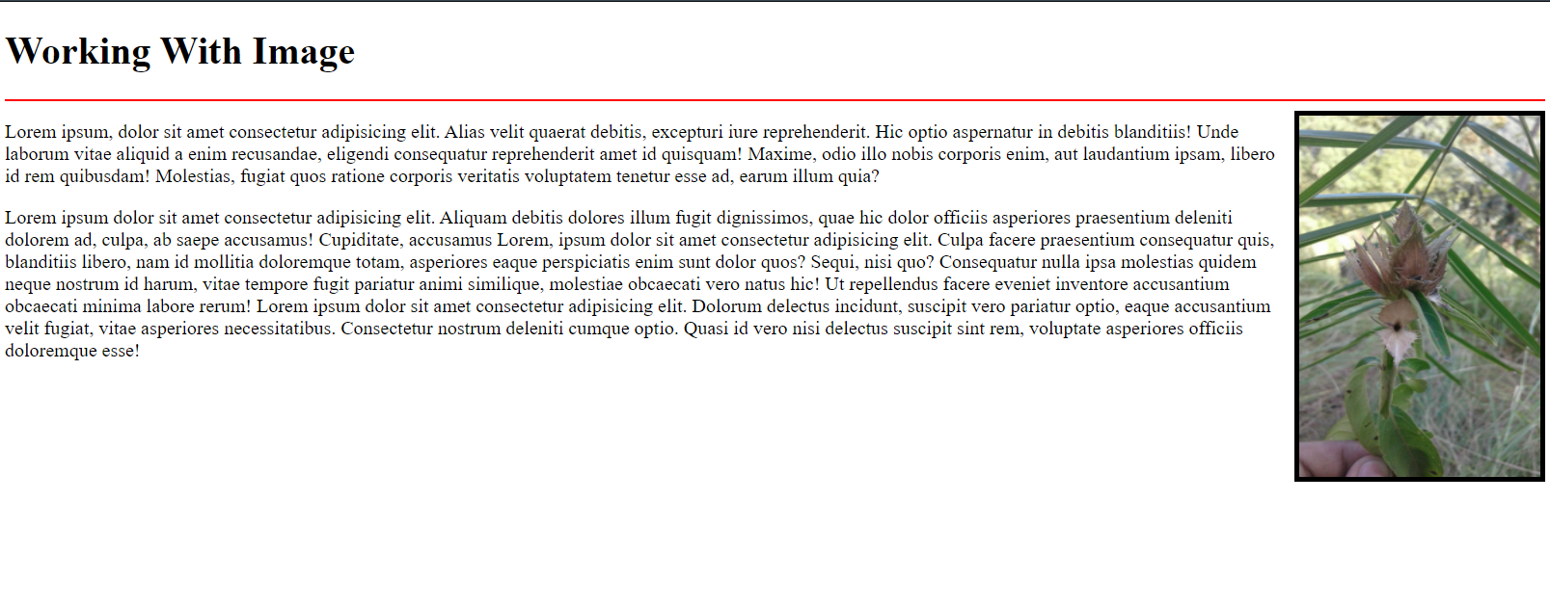
<!DOCTYPE html>
<html lang="en">
<head>
<meta charset="UTF-8">
<meta http-equiv="X-UA-Compatible" content="IE=edge">
<meta name="viewport" content="width=device-width, initial-scale=1.0">
<title>Lab-5</title>
</head>
<body>
<h1 >Working With Image</h1>
<hr color="red" />
<img align="right" src="bg_image3.jpg" alt="Error loading Image" width="200px" height="300px" border="4px" padding="10px,10px,10px,10px">
<p>Lorem ipsum, dolor sit amet consectetur adipisicing elit. Alias velit quaerat debitis, excepturi iure reprehenderit. Hic optio aspernatur in debitis blanditiis! Unde laborum vitae aliquid a enim recusandae, eligendi consequatur reprehenderit amet id quisquam! Maxime, odio illo nobis corporis enim, aut laudantium ipsam, libero id rem quibusdam! Molestias, fugiat quos ratione corporis veritatis voluptatem tenetur esse ad, earum illum quia?</p>
<p>Lorem ipsum dolor sit amet consectetur adipisicing elit. Aliquam debitis dolores illum fugit dignissimos, quae hic dolor officiis asperiores praesentium deleniti dolorem ad, culpa, ab saepe accusamus! Cupiditate, accusamus Lorem, ipsum dolor sit amet consectetur adipisicing elit. Culpa facere praesentium consequatur quis, blanditiis libero, nam id mollitia doloremque totam, asperiores eaque perspiciatis enim sunt dolor quos? Sequi, nisi quo? Consequatur nulla ipsa molestias quidem neque nostrum id harum, vitae tempore fugit pariatur animi similique, molestiae obcaecati vero natus hic! Ut repellendus facere eveniet inventore accusantium obcaecati minima labore rerum! Lorem ipsum dolor sit amet consectetur adipisicing elit. Dolorum delectus incidunt, suscipit vero pariatur optio, eaque accusantium velit fugiat, vitae asperiores necessitatibus. Consectetur nostrum deleniti cumque optio. Quasi id vero nisi delectus suscipit sint rem, voluptate asperiores officiis doloremque esse!</sed></p>
</body>
</html>

Lab-6
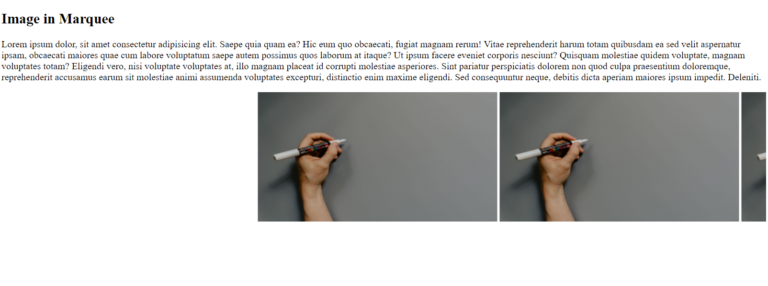
Code:
<!DOCTYPE html>
<html lang="en">
<head>
<meta charset="UTF-8">
<meta http-equiv="X-UA-Compatible" content="IE=edge">
<meta name="viewport" content="width=device-width, initial-scale=1.0">
<title>lab-6</title>
</head>
<body>
<h2>Image in Marquee</h2>
<p>Lorem ipsum dolor, sit amet consectetur adipisicing elit. Saepe quia quam ea? Hic eum quo obcaecati, fugiat magnam rerum! Vitae reprehenderit harum totam quibusdam ea sed velit aspernatur ipsam, obcaecati maiores quae cum labore voluptatum saepe autem possimus quos laborum at itaque? Ut ipsum facere eveniet corporis nesciunt? Quisquam molestiae quidem voluptate, magnam voluptates totam? Eligendi vero, nisi voluptate voluptates at, illo magnam placeat id corrupti molestiae asperiores. Sint pariatur perspiciatis dolorem non quod culpa praesentium doloremque, reprehenderit accusamus earum sit molestiae animi assumenda voluptates excepturi, distinctio enim maxime eligendi. Sed consequuntur neque, debitis dicta aperiam maiores ipsum impedit. Deleniti.</p>
<marquee>
<img src="bg_image2.jpg" width="400px" alt="image not founf at 1"/>
<img src="bg_image2.jpg" width="400px"alt="image not founf at 2"/>
<img src="bg_image2.jpg" width="400px"alt="image not founf at 3"/>
<img src="bg_image2.jpg" width="400px"alt="image not founf at 4"/>
<img src="bg_image2.jpg" width="400px"alt="image not founf at 5"/>
</marquee>

</body>
</html>

Lab-7:
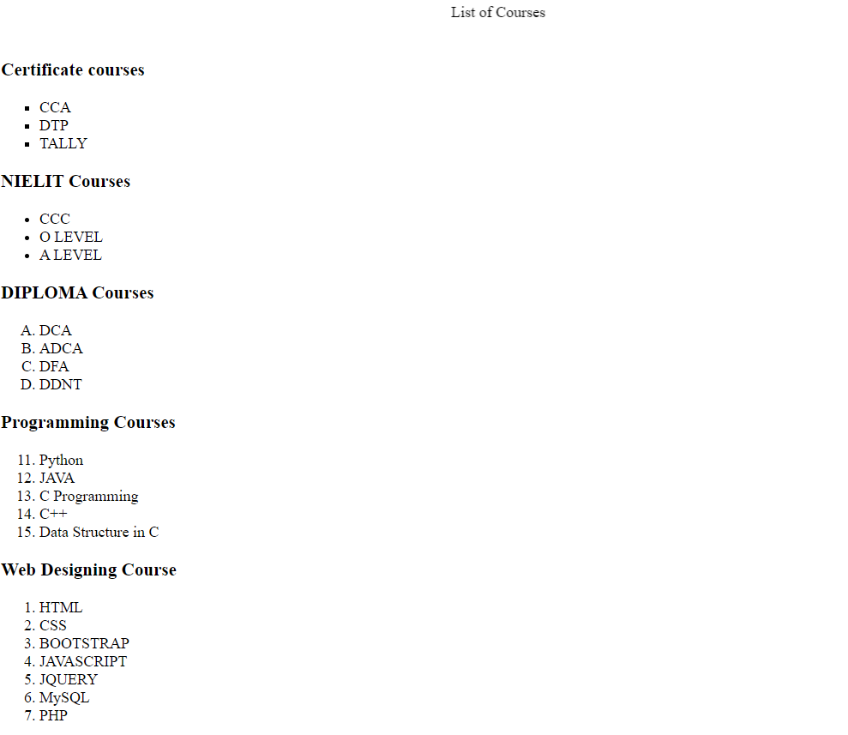
Code:
<!DOCTYPE html>
<html lang="en">
<head>
<meta charset="UTF-8">
<meta http-equiv="X-UA-Compatible" content="IE=edge">
<meta name="viewport" content="width=device-width, initial-scale=1.0">
<title>lab-7</title>
</head>
<body>

<marquee>List of Courses</p></marquee>
<h3>Certificate courses</h3>
<ul type="square">
<li>CCA</li>
<li>DTP</li>
<li>TALLY</li> </ul>
<h3>NIELIT Courses</h3>
<ul type="I">
<li>CCC</li>
<li>O LEVEL</li>
<li>A LEVEL</li>
</ul>
<h3>DIPLOMA Courses</h3>
<ol type="A">
<li>DCA</li>
<li>ADCA</li>
<li>DFA</li>
<li>DDNT</li>
</ol>
<h3>Programming Courses</h3>
<ol type="1" start="11">
<li>Python</li>
<li>JAVA</li>
<li>C Programming</li>
<li>C++</li>
<li>Data Structure in C</li>
</ol>
<h3>Web Designing Course</h3>
<ol type="1">
<li>HTML</li>
<li>CSS</li>
<li>BOOTSTRAP</li>
<li>JAVASCRIPT</li>
<li>JQUERY</li>
<li>MySQL</li>
<li>PHP</li>

</ol>
</body>
</html>

Lab-8:

Code:
<!DOCTYPE html>
<html lang="en">

<head>
<meta charset="UTF-8">
<meta http-equiv="X-UA-Compatible" content="IE=edge">
<meta name="viewport" content="width=device-width, initial-scale=1.0">
<title>Lab-8</title>
</head>

<body>

<h3>Nested List</h3>
<ol type="I">
<li>Background Skills</li>
<ol type="A">
<li>Unix Commands</li>
<li>Vim Test Editors</li>

</ol>
<li>HTML</li>
<ol type="A">
<li>Minimal Page</li>
<li>Headings</li>
<li>Elements</li>
<li>Lists</li>
<ol type="i">
<li>Unordered</li>
<li>Ordered</li>
<li>Definition</li>
<li>Nested</li>
</ol>
<li>Links</li>
<ol type="i">
<li>Absolute</li>
<li>Relative</li>
</ol>
<li>Images</li>
</ol>
<li>CSS</li>
<ol type="A">
<li>Anatomy</li>
<li>Basic Selectors</li>
<ol type="i">
<li>ELements</li>
<li>CLass</li>
<li>ID</li>
<li>Group</li>
</ol>
<li>DOM</li>
<li>Advance Selectors</li>
<li>Box Model</li>
</ol>
<li>Programming</li>
<ol type="A">
<li>Python</li>
<li>JavaScrpt</li>
</ol>
<li>Database</li>
<ol type="A">
<li>FlatFIile</li>
<li>Relational</li>

</body>

</html>

Lab-9:
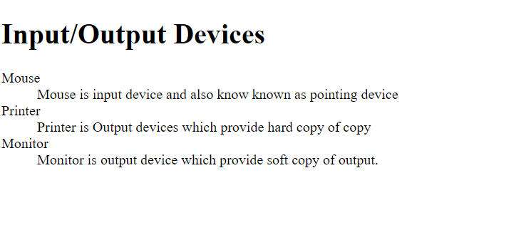
Code:
<!DOCTYPE html>
<html lang="en">

<head>
<meta charset="UTF-8">
<meta http-equiv="X-UA-Compatible" content="IE=edge">
<meta name="viewport" content="width=device-width, initial-scale=1.0">
<title>lab-9</title>
</head>

<body>
<h1>Input/Output Devices</h1>
<dl>
<dt>Mouse</dt>
<dd>Mouse is input device and also know known as pointing device</dd>
<dt>Printer</dt>
<dd>Printer is Output devices which provide hard copy of copy</dd>
<dt>Monitor</dt>
<dd>Monitor is output device which provide soft copy of output.</dd>
</dl>
</body>

</html>

Lab:10
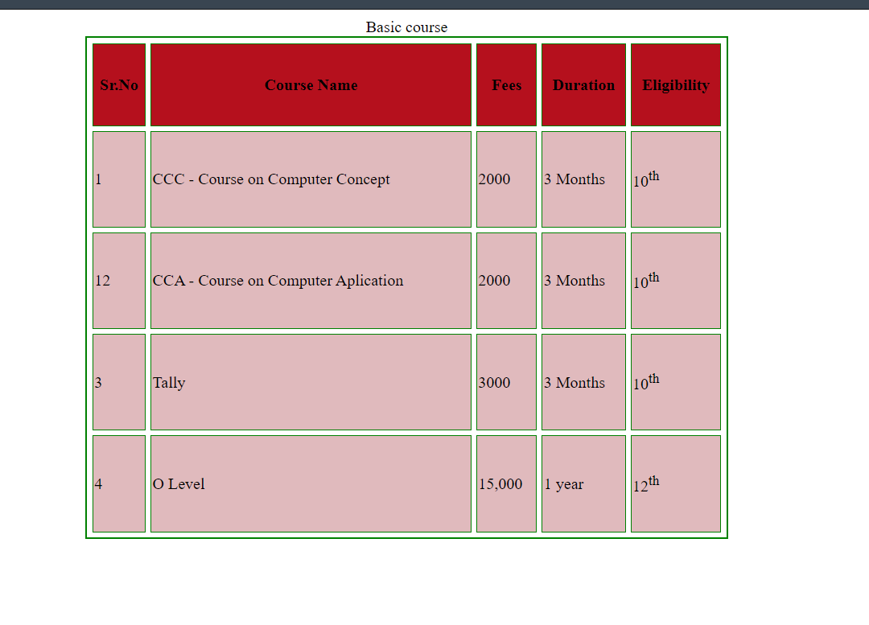
Code:
<!DOCTYPE html>
<html lang="en">
<head>
<meta charset="UTF-8">
<meta http-equiv="X-UA-Compatible" content="IE=edge">
<meta name="viewport" content="width=device-width, initial-scale=1.0">
<title>Lab-10</title>
</head>
<body>
<table cellspacing="5" border="2px" width="50%" height="500px" align="center" bordercolor="green" >
<caption><storng>Basic course</strong></caption>
<tr bgcolor="#b5101d" >
<th>Sr.No</th>
<th>Course Name</th>
<th>Fees</th>
<th>Duration</th>
<th>Eligibility</th>
</tr>

<tr bgcolor="#e0babd" >
<td>1</td>
<td>CCC - Course on Computer Concept </td>
<td>2000</td>
<td>3 Months</td>
<td>10<sup>th</sup></td>
</tr>

<tr bgcolor="#e0babd">
<td>12</td>
<td>CCA - Course on Computer Aplication </td>
<td>2000</td>
<td>3 Months</td>
<td>10<sup>th</sup></td>
</tr>

<tr bgcolor="#e0babd">
<td>3</td>
<td>Tally </td>
<td>3000</td>
<td>3 Months</td>
<td>10<sup>th</sup></td>
</tr>

<tr bgcolor="#e0babd">
<td>4</td>
<td>O Level </td>
<td>15,000</td>
<td>1 year</td>
<td>12<sup>th</sup></td>
</tr>
</table>
</body>
</html>

Lab-11

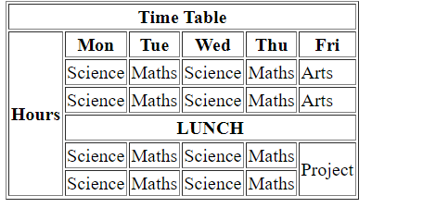
Code:
<!DOCTYPE html>
<html lang="en">

<head>
<meta charset="UTF-8">
<meta http-equiv="X-UA-Compatible" content="IE=edge">
<meta name="viewport" content="width=device-width, initial-scale=1.0">
<title>lab-11</title>
</head>

<body>
<table border="1" cellspaging="1">
<tr>
<th colspan="6">Time Table</th>
</tr>
<tr>
<th rowspan="6">Hours</th>
<th>Mon</th>
<th>Tue</th>
<th>Wed</th>
<th>Thu</th>
<th>Fri</th>
</tr>

<tr>
<td>Science</td>
<td>Maths</td>
<td>Science</td>
<td>Maths</td>
<td>Arts</td>
</tr>
<tr>
<td>Science</td>
<td>Maths</td>
<td>Science</td>
<td>Maths</td>
<td>Arts</td>
</tr>

<tr>
<th colspan="5">LUNCH</th>
</tr>
<tr>
<td>Science</td>
<td>Maths</td>
<td>Science</td>
<td>Maths</td>
<td rowspan="2">Project</td>
</tr>
<tr>
<td>Science</td>
<td>Maths</td>
<td>Science</td>
<td>Maths</td>

</tr>
</table>
</body>

</html>

Lab-12
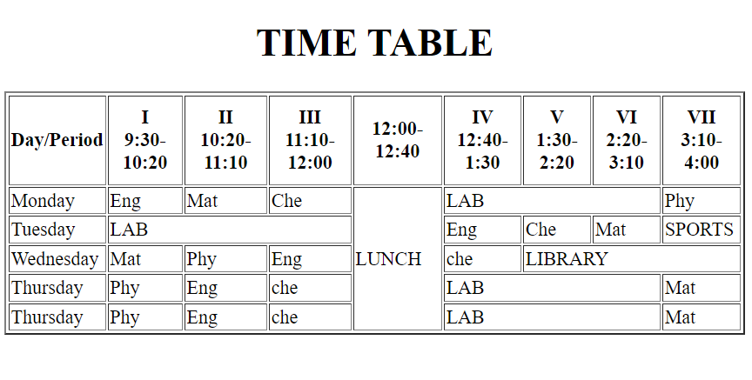
Code:
<!DOCTYPE html>
<html lang="en">
<head>
<meta charset="UTF-8">
<meta http-equiv="X-UA-Compatible" content="IE=edge">
<meta name="viewport" content="width=device-width, initial-scale=1.0">
<title>Lab12</title>
</head>
<body>
<h1 align="center">TIME TABLE</h1>
<table align="center" border="2px" width="100%">
<tr height="75px" width="75px">
<th>Day/Period</th>
<th>I <br />9:30-10:20</th>
<th>II <br />10:20-11:10</th>
<th>III <br />11:10-12:00</th>
<th>12:00-12:40</th>
<th>IV <br />12:40-1:30</th>
<th>V <br />1:30-2:20</th>
<th>VI <br />2:20-3:10</th>
<th>VII <br />3:10-4:00</th>
</tr>

<tr>
<td>Monday</td>
<td>Eng</td>
<td>Mat</td>
<td>Che</td>
<td rowspan="100%">LUNCH</td>
<td colspan="3">LAB</td>
<td>Phy</td>
</tr>

<tr>
<td>Tuesday</td>
<td colspan="3">LAB</td>
<td>Eng</td>
<td>Che</td>
<td>Mat</td>
<td>SPORTS</td>
</tr>

<tr>
<td>Wednesday</td>
<td>Mat</td>
<td>Phy</td>
<td>Eng</td>
<td>che</td>
<td colspan="3">LIBRARY</td>
</tr>

<tr>
<td>Thursday</td>
<td>Phy</td>
<td>Eng</td>
<td>che</td>
<td colspan="3">LAB</td>
<td>Mat</td>
</tr>
<tr>
<td>Thursday</td>
<td>Phy</td>
<td>Eng</td>
<td>che</td>
<td colspan="3">LAB</td>
<td>Mat</td>
</tr>
</table>
</body>
</html>

Lab:13
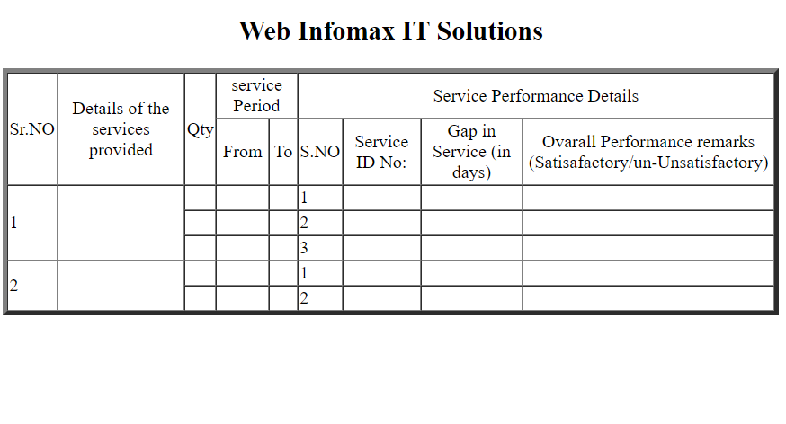
<!DOCTYPE html>
<html lang="en">

<head>
<meta charset="UTF-8">
<meta http-equiv="X-UA-Compatible" content="IE=edge">
<meta name="viewport" content="width=device-width, initial-scale=1.0">
<title>Lab-13</title>
</head>

<body>
<h2 align="center">Web Infomax IT Solutions</h2>

<table border="4px" cellspacing="0">
<tr>
<td rowspan="2"align="center">Sr.NO</td>
<td rowspan="2"align="center">Details of the services provided</td>
<td rowspan="2"align="center">Qty</td>
<td colspan="2" align="center">service Period</td>
<td colspan="4" align="center">Service Performance Details</td>
</tr>
<tr>
<td align="center">From</td>
<td align="center">To</td>
<td align="center">S.NO</td>
<td align="center"> Service ID No:</td>
<td align="center">Gap in Service (in days)</td>
<td align="center">Ovarall Performance remarks (Satisafactory/un-Unsatisfactory)</td>
</tr>
<div class="container" name="First">
<tr>
<td rowspan="3">1</td>
<td rowspan="3"></td>
<td></td>
<td></td>
<td></td>
<td>1</td>
<td></td>
<td></td>
<td></td>
</tr>

<tr>
<td></td>
<td></td>
<td></td>
<td>2</td>
<td></td>
<td></td>
<td></td>
</tr>
<tr>
<td></td>
<td></td>
<td></td>
<td>3</td>
<td></td>
<td></td>
<td></td>
</tr>
</div>
<div class="container" name="second">
<tr>
<td rowspan="3">2</td>
<td rowspan="3"></td>
<td></td>
<td></td>
<td></td>
<td>1</td>
<td></td>
<td></td>
<td></td>
</tr>

<tr>
<td></td>
<td></td>
<td></td>
<td>2</td>
<td></td>
<td></td>
<td></td>
</tr>

</div>
</table>
</body>

</html>

Lab-14
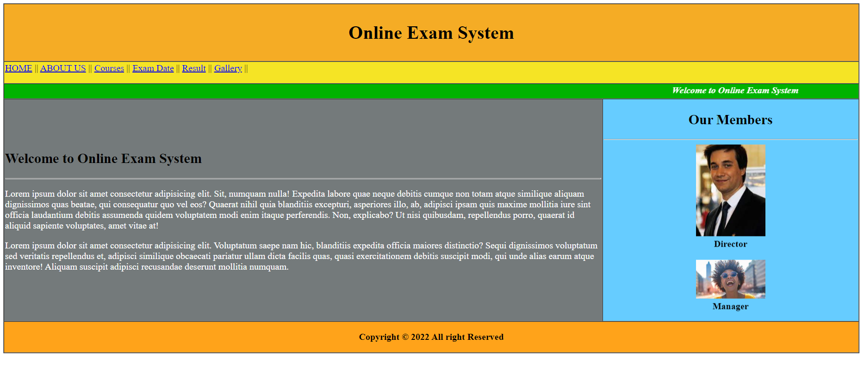
Code:
<!DOCTYPE html>
<html lang="en">

<head>
<meta charset="UTF-8">
<meta http-equiv="X-UA-Compatible" content="IE=edge">
<meta name="viewport" content="width=device-width, initial-scale=1.0">
<title>lab-14</title>
</head>

<body>

<table border="1px" cellspacing="0" width="100%" height="500px">

<tr bgcolor="#f5ac25" height="100px">
<th colspan="100%">
<h1>Online Exam System</h1>
</th>
</tr>

<tr bgcolor="#f5e425" height="10px" cellspacing="0">
<td colspan="100%">
<a href="#">HOME</a> ||
<a href="#">ABOUT US</a> ||
<a href="#">Courses</a> ||
<a href="#">Exam Date</a> ||
<a href="#">Result</a> ||
<a href="#">Gallery</a> ||
</p>
</td>
</tr>
<tr bgcolor="#00b300" width="100%">
<th colspan="10%">
<marquee><b><i>
<font color="white">Welcome to Online Exam System</font>
</i></b></marquee>

</th>
</tr>

<tr bgcolor="#747a7b">
<td width="70%">
<h2>Welcome to Online Exam System</h2>
<hr />
<p>
<font color="white">Lorem ipsum dolor sit amet consectetur adipisicing elit. Sit, numquam nulla!
Expedita
labore quae neque debitis cumque non totam atque similique aliquam dignissimos quas beatae, qui
consequatur quo vel eos? Quaerat nihil quia blanditiis excepturi, asperiores illo, ab, adipisci
ipsam quis maxime mollitia iure sint officia laudantium debitis assumenda quidem voluptatem modi
enim itaque perferendis. Non, explicabo? Ut nisi quibusdam, repellendus porro, quaerat id
aliquid
sapiente voluptates, amet vitae at!<br />
<p>Lorem ipsum dolor sit amet consectetur adipisicing elit. Voluptatum saepe nam hic, blanditiis
expedita officia maiores distinctio? Sequi dignissimos voluptatum sed veritatis repellendus
et,
adipisci similique obcaecati pariatur ullam dicta facilis quas, quasi exercitationem debitis
suscipit modi, qui unde alias earum atque inventore! Aliquam suscipit adipisci recusandae
deserunt
mollitia numquam.
</font>
</p>
</td>

<td bgcolor="#66ccff">
<h2 align="center">Our Members</h2>
<hr />
<marquee direction="up" height="300px">
<center>
<img src="person1.jpg" width="120px" /><br /> <b>Director</b><br /><br />
<img src="person2.jpg" width="120px" /><br /> <b>Manager</b><br /><br />
<img src="person3.jpg" width="120px" /><br /> <b>Sales Manager</b><br /><br />
</center>
</marquee>

</td>

</tr>

<tr bgcolor="#ffa31a">

<th colspan="100%">
<p align="center">Copyright © 2022 All right Reserved</p>
</th>

</tr>
</table>
</body>

</html>

Lab:15
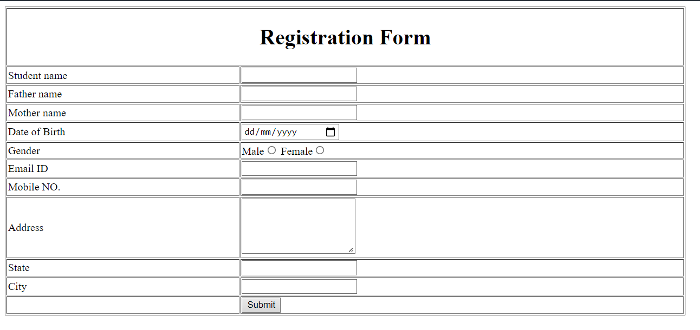
Code:
<!DOCTYPE html>
<html lang="en">

<head>
<meta charset="UTF-8">
<meta http-equiv="X-UA-Compatible" content="IE=edge">
<meta name="viewport" content="width=device-width, initial-scale=1.0">
<title>Document</title>
</head>

<body>
<form action="#" method="post">
<table border="1px" width="1005">
<th align="center" colspan="100%" height="50px"><h1>Registration Form</h1></th>
<tr>
<td>Student name</td>
<td><input type="text"></td>
</tr>
<tr>
<td>Father name</td>
<td><input type="text"></td>
</tr>
<tr>
<td>Mother name</td>
<td><input type="text"></td>
</tr>
<tr>
<td>Date of Birth</td>
<td><input type="date"></td>
</tr>
<tr>
<td>Gender</td>
<td>
Male<input type="radio" name="gender">
Female<input type="radio" name="gender">
</td>
</tr>
<tr>
<td>Email ID</td>
<td><input type="email"></td>
</tr>
<tr>
<td>Mobile NO.</td>
<td><input type="tel"></td>
</tr>
<tr>
<td>Address</td>
<td><textarea rows="5"></textarea></td>
</tr>
<tr>
<td>State</td>
<td><input type="text"></td>
</tr>
<tr>
<td>City</td>
<td><input type="text"></td>
</tr>
<tr>
<td></td>
<td><input type="Submit"></td>
</tr>
</table>
</form>
</body>

</html>

Lab-16
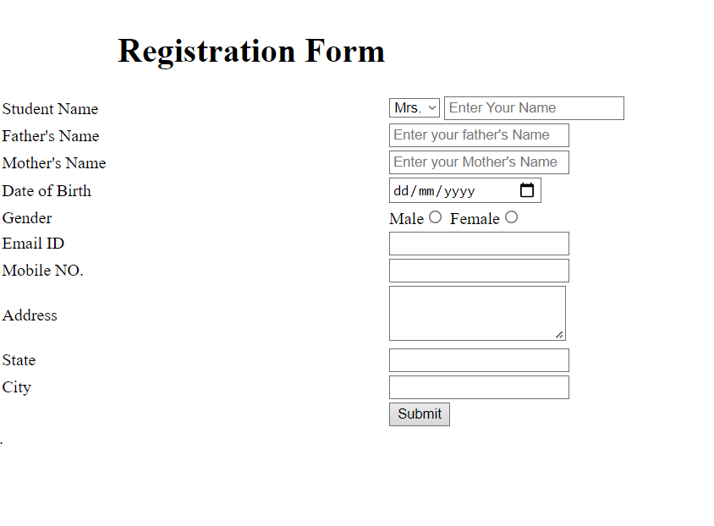
Code:
<!DOCTYPE html>
<html lang="en">

<head>
<meta charset="UTF-8">
<meta http-equiv="X-UA-Compatible" content="IE=edge">
<meta name="viewport" content="width=device-width, initial-scale=1.0">
<title>Lab-16</title>
</head>

<body>
<form action="#" method="post">
<table width="100%">
<tr align="right">
<th>
<h1>Registration Form</h1>
</th>
</tr>
<tr>
<td> Student Name </td>
<td><select name="gender">
<option value="mr">Mr.</option>
<option value="mrs" selected>Mrs.</option>
</select>
<input type="text" placeholder="Enter Your Name">
</td>

</tr>
<tr>
<td> Father's Name </td>
<td><input type="text" placeholder="Enter your father's Name"></td>
</tr>

<tr>
<td> Mother's Name</td>
<td><input type="text" placeholder="Enter your Mother's Name"></td>
</tr>

<tr>
<td> Date of Birth </td>
<td><input type="date"> </td>
</tr>
<tr>
<td>Gender</td>
<td>
Male<input type="radio" name="gender">
Female<input type="radio" name="gender">
</td>
<tr>
<td>Email ID</td>
<td><input type="email"></td>
</tr>
<tr>
<td>Mobile NO.</td>
<td><input type="tel"></td>
</tr>
<tr>
<td>Address</td>
<td><textarea rows="3"></textarea></td>
</tr>
<tr>
<td>State</td>
<td><input type="text"></td>
</tr>
<tr>
<td>City</td>
<td><input type="text"></td>
</tr>
<tr>
<td></td>
<td><input type="Submit"></td>
</tr>
</table>

.
</form>
</body>

</html>

Lab:17
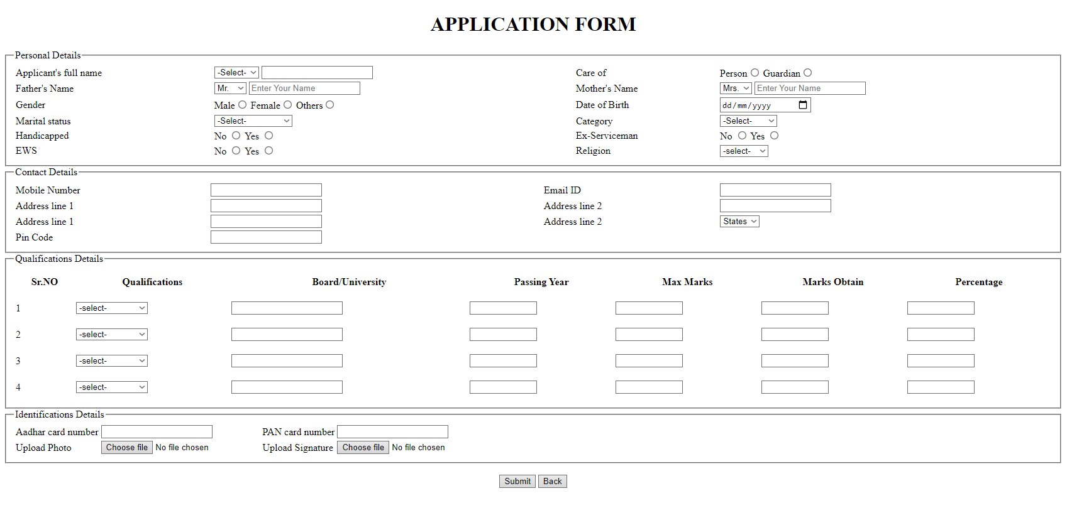
Code:
<!DOCTYPE html>
<html lang="en">

<head>
<meta charset="UTF-8">
<meta http-equiv="X-UA-Compatible" content="IE=edge">
<meta name="viewport" content="width=device-width, initial-scale=1.0">
<title>Document</title>
</head>

<body>
<form action="#" method="post">
<h1 align="center">APPLICATION FORM</h1>
<fieldset>
<legend>Personal Details</legend>
<table width="100%">
<tr>
<td>Applicant's full name</td>
<td>
<select name="fname" id="">
<option value="none" disabled selected>-Select-</option>
<option value="Mr">Mr.</option>
<option value="Mrs">Mrs</option>
<option value="miss">Miss</option>
</select>
<input type="name">
</td>
<td>Care of</td>
<td>Person<input type="radio" name="careof">
Guardian<input type="radio" name="careof"></td>
</tr>
<tr>
<td>Father's Name</td>
<td><select name="fgender">
<option value="mr"selected>Mr.</option>
<option value="mrs" >Mrs.</option>
</select>

<input type="text" placeholder="Enter Your Name">
</td>
<td>Mother's Name</td>
<td><select name="fgender">
<option value="mr">Mr.</option>
<option value="mrs" selected>Mrs.</option>
</select>

<input type="text" placeholder="Enter Your Name">
</td>
</tr>
<tr>
<td>Gender</td>
<td>Male<input type="radio" name="gender">
Female<input type="radio" name="gender">
Others<input type="radio" name="gender">
</td>
<td>Date of Birth</td>
<td><input type="date"></td>
</tr>
<tr>
<td>Marital status</td>
<td>
<select name="fname" id="">
<option value="name1" disabled selected>-Select-</option>
<option value="name2">married</option>
<option value="name2">Unmarried</option>
<option value="name2">divorced/option>
</select>
</td>
<td>Category</td>
<td>
<select name="Category" id="">
<option value="name1" disabled selected>-Select-</option>
<option value="mr">category1.</option>
<option value="mrs">category1..</option>
</select>
</td>
</tr>
<tr>
<td> Handicapped</td>
<td>
No <input type="radio" name="handicapped">
Yes <input type="radio" name="handicapped">
</td>
<td> Ex-Serviceman</td>
<td>
No <input type="radio" name="service">
Yes <input type="radio" name="service">
</td>
</tr>
<tr>
<td> EWS</td>
<td>
No <input type="radio" name="EWS">
Yes <input type="radio" name="EWS">
</td>
<td> Religion</td>
<td>
<select name="religion">

<option value="none" selected disabled>-select-</option>
<option value="hindu">Hindu</option>
<option value="Muslim">Muslim</option>
<option value="Buddhist">Buddhist</option>
</select>
</td>
</tr>
</table>
</fieldset>
<fieldset>
<legend>Contact Details</legend>
<table width="100%">
<tr>
<td>Mobile Number</td>
<td><input type="tel"></td>
<td>Email ID</td>
<td><input type="email"></td>
</tr>
<tr>
<td>Address line 1</td>
<td><input type="text"></td>
<td>Address line 2</td>
<td><input type="text"></td>
</tr>
<tr>
<td>Address line 1</td>
<td><input type="text"></td>
<td>Address line 2</td>
<td><select name="state">
<option value="none" selected disabled>States</option>
<option value="state1">state1</option>
<option value="state2">state2</option>
<option value="state3">state3</option>
<option value="state4">state4</option>
<option value="state5">state5</option>
</select></td>
</tr>
<tr>
<td>Pin Code</td>
<td><input type="number"></td>
</tr>
</table>
</fieldset>
<fieldset>
<legend>Qualifications Details</legend>
<table width="100%">
<tr height=40px>
<th align="center">Sr.NO</th>
<th align="center">Qualifications</th>
<th align="center">Board/University</th>
<th align="center">Passing Year</th>
<th align="center">Max Marks</th>
<th align="center">Marks Obtain</th>
<th align="center">Percentage</th>
</tr>
<tr height=40px>
<td>1</td>
<td>
<select name="qualifications">
<option value="none" disabled selected>-select-</option>
<option value="Slc">SLC/SEE</option>
<option value="undergraduate">Undergraduate</option>
<option value="intermediate">intermediate</option>
<option value="post-graduate">post-graduate</option>
</select>
</td>
<td><input type="text"></td>
<td><input type="text" size="10"></td>
<td><input type="text" size="10"></td>
<td><input type="text" size="10"></td>
<td><input type="text" size="10"></td>
</tr>
<tr height=40px>
<td>2</td>
<td>
<select name="qualifications">
<option value="none" disabled selected>-select-</option>
<option value="Slc">SLC/SEE</option>
<option value="undergraduate">Undergraduate</option>
<option value="intermediate">intermediate</option>
<option value="post-graduate">post-graduate</option>
</select>
</td>
<td><input type="text"></td>
<td><input type="text" size="10"></td>
<td><input type="text" size="10"></td>
<td><input type="text" size="10"></td>
<td><input type="text" size="10"></td>
</tr>
<tr height=40px>
<td>3</td>
<td>
<select name="qualifications">
<option value="none" disabled selected>-select-</option>
<option value="Slc">SLC/SEE</option>
<option value="undergraduate">Undergraduate</option>
<option value="intermediate">intermediate</option>
<option value="post-graduate">post-graduate</option>
</select>
</td>
<td><input type="text"></td>
<td><input type="text" size="10"></td>
<td><input type="text" size="10"></td>
<td><input type="text" size="10"></td>
<td><input type="text" size="10"></td>
</tr>
<tr height=40px>
<td>4</td>
<td>
<select name="qualifications">
<option value="none" disabled selected>-select-</option>
<option value="Slc">SLC/SEE</option>
<option value="undergraduate">Undergraduate</option>
<option value="intermediate">intermediate</option>
<option value="post-graduate">post-graduate</option>
</select>
</td>
<td><input type="text"></td>
<td><input type="text" size="10"></td>
<td><input type="text" size="10"></td>
<td><input type="text" size="10"></td>
<td><input type="text" size="10"></td>
</tr>
</table>
</fieldset>
<fieldset>
<legend>Identifications Details</legend>
<table>
<tr>
<td>Aadhar card number</td>
<td><input type="number"></td>
<td>PAN card number</td>
<td><input type="number"></td>
</tr>
<tr>
<td> Upload Photo</td>
<td><input type="file"></td>
<td> Upload Signature</td>
<td><input type="file"></td>
</tr>
</table>
</fieldset>
<br />
<center><input type="submit">
<input type="button" value="Back">
</center>
</form>
</body>

</html>

