**Software Requirements Specification**

**for**

Study Management System

**Version 1.0 approved**

**Prepared by**

**Jasmin Jahan Puspo**

**North East University Bangladesh**

**Date:19.01.2020**

**Table of Contents**

**Table of Contents ii**

**Revision History ii**

**1.** **Introduction test 1**

1.1 Purpose 1

1.2 Document Conventions 1

1.3 Intended Audience and Reading Suggestions 1

1.4 Product Scope 2

1.5 References 2

**2.** **Overall Description 3**

2.1 Product Perspective 2

2.2 Product Functions 2

2.3 User Classes and Characteristics 3

2.4 Operating Environment 3

2.5 Design and Implementation Constraints 3

2.6 User Documentation 3

2.7 Assumptions and Dependencies 4

**3.** **External Interface Requirements 4**

3.1 User Interfaces 4

3.2 Hardware Interfaces 8

3.3 Software Interfaces 8

3.4 Communications Interfaces 8

**4.** **System Features 9**

4.1 System Feature 1 9

**5.** **Other Nonfunctional Requirements 9**

5.1 Performance Requirements 9

5.2 Safety Requirements 9

5.3 Security Requirements 9

5.4 Software Quality Attributes 9

5.5 Business Rules 10

**6.** **Other Requirements 11**

**Appendix A: Glossary 11**

**Appendix B: Analysis Models 11**

**Appendix C: To Be Determined List 12**

**Revision History**

|  |  |  |  |
| --- | --- | --- | --- |
| **Name** | **Date** | **Reason For Changes** | **Version** |
|  |  |  |  |
|  |  |  |  |

# **Introduction**

## **Purpose**

A software requirements specification (**SRS**) is a detailed description of a software system to be developed with its functional and non-functional requirements.

1)The main purpose is to computerize the system and help students in their regular study.

2)This system provides a friendly environment to maintain the details of documents and student information.

3) The purpose of this project is to maintain an easy circulation system using a computer.

## **Document Conventions**

Entire document should be justified.

Convention for main title:

1) Font Face: Times New Roman.

2) Font Style: Bold.

3) Font Size: 14.

Convention for sub title:

1) Font Face:Arial.

2) Font Style: Bold.

3) Font Size: 14.

Convention for body:

1) Font Face: Arial.

2) Font Style: Normal.

3) Font Size: 12.

## **Intended Audience and Reading Suggestions**

1)Admin

2)Developers

3)All User

## **Product Scope**

The document is about study management system.This management system will help students in their regular study and also this system will keep their information .Nowadays students are wasting lots of time on social media . And this system is also a digital platform where students can study and this system will also help their regular studies.The project is specifically designed for the use of students and teacher and authority. The project will work as a complete user

interface for students and ordinary users. The project can be easily implemented under various situations.We can add new features as and when we require, making reusability

possible as there is flexibility in all the modules.This management system will be updated and more features will be added so that students can get more benefits.

## **References**

PHP: - http://www.phptherightway.com

HTML5: - http://www.w3schools.com

CSS3: - http://www.w3schools.com

# **Overall Description**

## **Product Perspective**

The implementation of Library Management starts with entering and updating master records like documentation and student information. Any further transaction like book ,documents will automatically update this system. The proposed Management System will take care of the current information and details of information. For any further information they can contact admin also they can comment and share those documents to other user.Admin can change , delete or update any information.

## **Product Functions**

1)The main purpose of this project is to reduce manual work.

2)This software is capable of managing documents,profile and other information and user requirements.

## **User Classes and Characteristics**

We have two levels of users-

* User module: In the user module,users can find documents and information .
* Administrative modules: The admin will update,edit or delete the information .Take decisions for other necessary things.

## **Operating Environment**

The product will be operating in a windows environment. The Study Management System is a website and shall operate in all famous browsers, for a model we are talking Microsoft Internet Explorer, Google Chrome and Mozilla Firefox. Also it will be compatible with the IE 6.0. Most of the features will be compatible with the Mozilla Firefox and Opera 7.0 or higher version. The only requirement to use this online product would be the internet connection.

The hardware configuration includes Hard Disk: 4GB, Monitor: 15 inch Color monitor, Keyboard: 122 keys. The basic input devices required are keyboard, mouse and output devices are monitor etc.

## **Design and Implementation Constraints**

Each member has a unique username whenever they enter the software.Whenever they want to download a book or comments or like any post they need to use the username.

## **User Documentation**

The product will include a user manual. The user manual will include product overview, complete configuration of the used software (such as SQL server), technical details, backup procedure and contact information which will include email address. There will be no online help for the product at this moment. The product will be compatible with the Internet Explorer 6.0 or higher. The databases will be created in MySQL.

## **Assumptions and Dependencies**

The assumptions are:-

* The coding should be error free.
* The system should be user friendly so that it is easy to use for the users.
* The system should be user friendly so that it is easy to use for the users.
* The information of all users,documents, information and other things must be stored in a database that is accessible by the website.
* The system should have more capacity and provide fast access to the database.
* The system should provide a search facility ..
* Users may access from any computer that has internet browsing capabilities and an internet connection.
* Users and authorities must have their correct username and passwords to enter into their online accounts and do actions.

The dependencies are :-

* The specific hardware and software due to which the product will be run.
* On the basis of listing requirements and specification the project will be developed and run.
* The end users should have proper understanding of the product.
* The system should have the general report store.
* The information of all users must be stored in a database that is accessible by the management system.
* Any update regarding the student information is to be recorded to the database and the data entered should be correct.

# **External Interface Requirements**

## **User Interfaces**

The software provides a good graphical interface for the user and admin can operate on the system.

* Users can comment from the user panel.
* Users can search for documents.
* User will get notified for any update..
* Admin can view ,edit,delete everything on the product.
* All necessary panels:
* Home Panel:



* Document Panel:

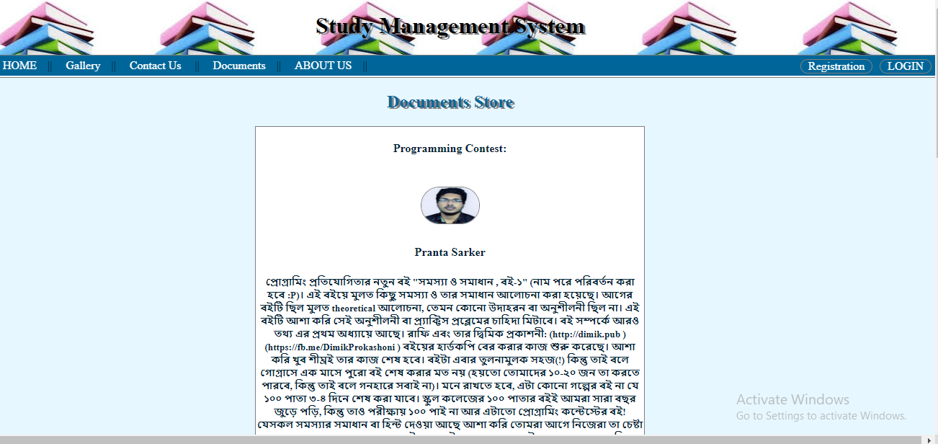

* Gallery Panel:



* Contact Us Panel:

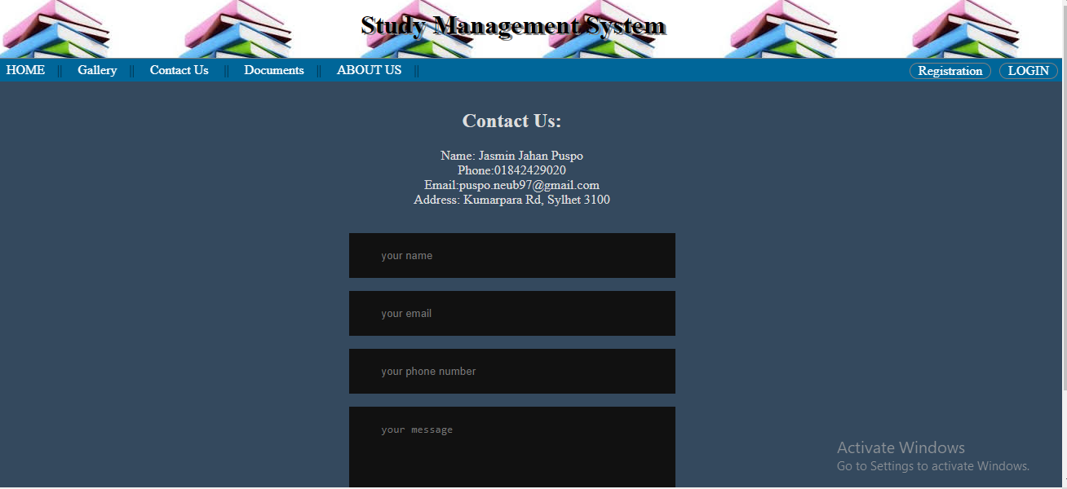

* About US:

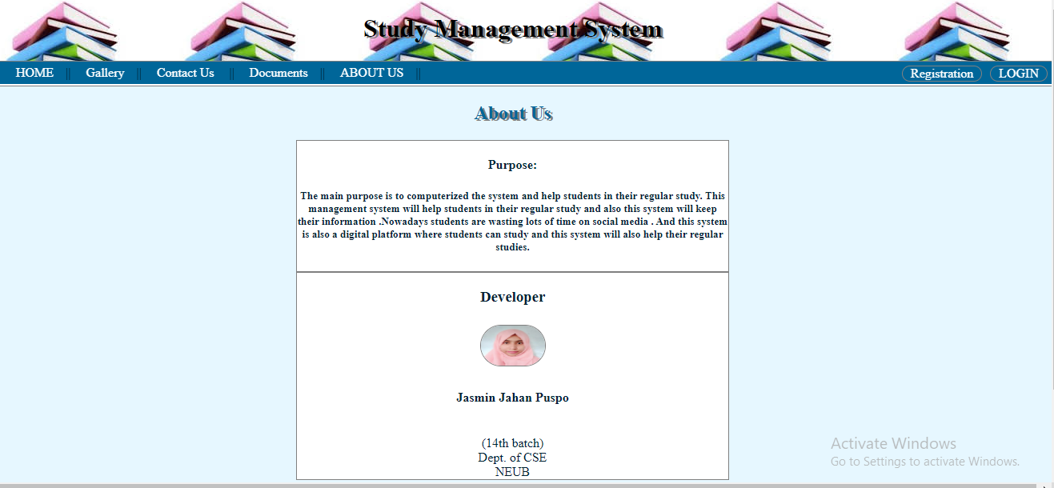

* Registration Panel:

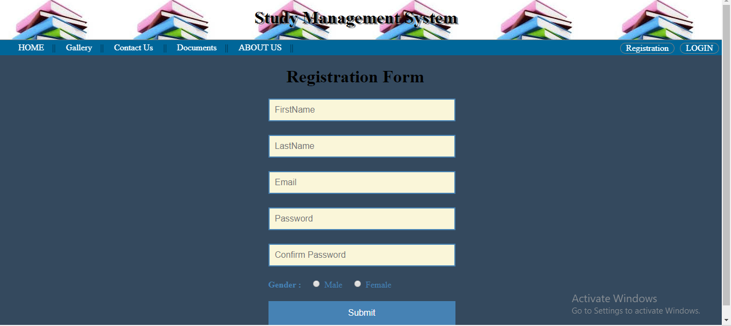

* Login Panel:

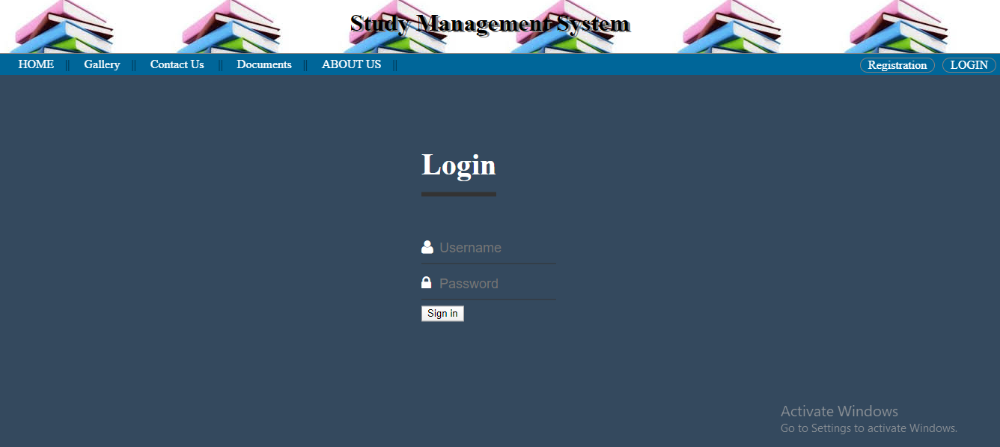

## **Hardware Interfaces**

* Operating system : windows
* Hard disk :40 GB
* RAM: 512 MB.
* Processor : Pentium(R)Dual-core CPU

## **Software Interfaces**

* XAMPP
* NOTEPAD++
* MySQL

## **Communications Interfaces**

The Customer must connect to the Internet to access the Website:

* Dialup Modem of 52 kbps
* Broadband Internet
* Dialup or Broadband Connection with an Internet Provider.

# **System Features**

## **System Feature 1**

The users of the system should be provided the surely that their account is secure this is possibly by providing:

* User authentication and validation of members using their unique username.
* Proper maintenance by admin.
* Here member defined by the admin.
* The Search process is easy.
* Proper accountability which includes not allowing a member to see other member’s accounts. Only the administrator will see and manage all members' accounts.
* The Information is accurate.

# **Other Nonfunctional Requirements**

## **Performance Requirements**

The capability of the computer depends on the performance of the software. The software can take any number of inputs provided the database size is large enough. This would depend on the available memory space.

The proposed system that we are going to develop will be the chief performance system within students and all users. Therefore it is expected that the database would perform functionally at the requirements that are specified by the admin.

* The performance of the system should be faster.
* Admin should handle expected and non expected errors in ways that prevent loss in information and long downtime period. Thus it should have in built error testing to identify invalid username or password.
* The system should be able to handle large amounts of data. Thus it should accommodate a high number of information and users without any fault.

## **Safety Requirements**

The database may get crushed at any certain time due to virus or operating system failure. Therefore it is required to take the database backup so that the database is not lost. Proper UPS/ Inverter facilities should be there in case of power supply failure.

## **Security Requirements**

* System will use a secured database.
* Normal users can just read information but they cannot edit or modify anything.
* System will have different types of users and every user has access constraints.
* Proper user authentication should be provided.
* No one should be able to hack user passwords.
* There should be separate accounts for admin and users. Only admin has the right to access the database and update it.

## **Software Quality Attributes**

* There may be multiple admin’s creating the project, all of them will have the right to create changes to the system. But the members or other users cannot do changes.
* The project should be open source.
* The quality of the database is maintained in such a way so that it can be very user friendly to all the users of the database.
* The user is able to easily download and install the system.

## **Business Rules**

A business rule is anything that captures and implements business policies and practices. A rule can enforce business policy, make a decision, or infer new data from existing data. This includes the rules and regulations that the system users should abide by. This includes the cost of the project and the discount offers provided. The users should avoid illegal rules and protocols. Neither admin nor members should cross the rules and regulations.

# **Other Requirements**

There are different categories of users namely Admin, Student and normal user. Depending upon the category of user the access rights are decided. It means if the user is an admin then he can be able to modify the data, delete, append etc. All other users except the admin only have the rights to retrieve the information about the database.

**Appendix A: Glossary**

The following are the list of conventions and acronyms used in this document and the project as well:

* Administrator: A login id representing a user administration privileges to the software.
* User: Normally users can comment or view and like details of documents availability.
* Client: Intended users for the software.
* SQL: Structured Query Language,used to retrieve information from a database.
* Layer: Represents a section of the project.
* User interface layer: The section of the assignment referring to what the user interacts with directly.
* Application logic layer: The section of the assignment referring to the web server. This is where all computations are completed.
* Data storage level: The section of assignment referring to where all data is recorded.
* Use case: A broad level diagram of the project showing a basic overview.
* Class diagram:It is a type of diagram that describes the structures of a system by showing the system’s cases,their attributes ,and the relationships between the classes.
* Interface: Something used to communicate across different mediums.
* Unique key: Used to differentiate entries in a database.