Warsaw, 08.01.2017

Paula Kochanska  
Faculty of Physics  
Warsaw University of Technology  
*kochanska.paula@gmail.com*

**“Computer-generated holograms compression algorithm” documentation**

1. **Introduction**

This project is a part of Bachelor’s thesis: “*Design of the algorithm of a lossless compression of computer-generated holograms*”. This document describes basic usage of 4 python files created for the purposes of this project.:

1. Bytes algorithm -files: *encode_bytes.py*, *decode_bytes.py*

Designed for bitmaps with size that is a multiple of 8.

1. 4-bits algorithm – files: *encode_4bits.py, decode_4bits.py*
2. **Technical requirements**

Below you can find suggested requirements for using the scripts. Even though it is probably possible to use different versions of libraries, programs were not tested for other configurations.

* Python 3.5, e.g. distribution Anaconda (<https://www.continuum.io/downloads>)
* Libraries: numpy, os, math, io, sys, time
* OpenCV 3.1 for Python 3.5 (example instructions for Windows: <https://www.scivision.co/install-opencv-python-windows/> )

1. **Files usage**

Execution of the file:

*python <name_of_the_file>*

Example:

*python decode_bytes.py*

After execution of the file a proper message is printed into console and the user is asked for the location of binary/bmp files (highlighted in listing below). Sample listing of the program *encode_bytes.py*:

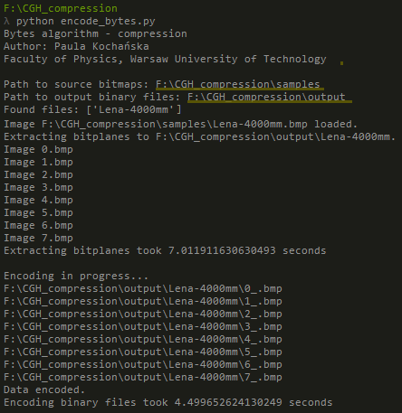

Listing of decoding scripts are similar. Listing of *decode_bytes.py* file is shown below. Again highlighted directories are provided by the user.

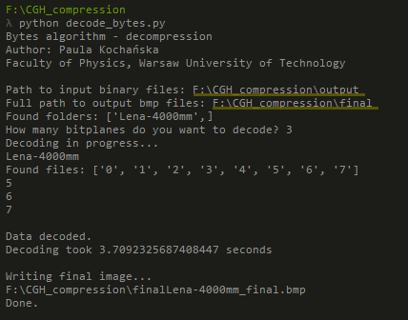

It is possible to encode/decode multiple images in one script execution. In *samples* folder attached to documentation you can find some sample holograms. Executing one of the encoding scripts with providing source directory as absolute path to *samples* will result in encoding all of the images at once. It is crucial to remember to always provide full path to the directory with the file location, not the single file name nor full path with file name.

For any other information please contact me: [kochanska.paula@gmail.com](mailto:kochanska.paula@gmail.com). I will be happy to answer all of the questions.