Location-Based Inventory Optimization: Integrating Customer Behavior Analytics in Vending Machine Operations

Putanyn Manee

[putanyn_manee@cmu.ac.th](mailto:putanyn_manee@cmu.ac.th)

Chiang Mai University

Chiang Mai, Thailand

***Abstract*– Vending machines are more than just places to buy snacks and drinks. They can tell us a lot about what people like to buy. Our research, "Location-Based Inventory Optimization: Integrating Customer Behavior Analytics in Vending Machine Operations," looks at how to use sales data from vending machines to better manage what's inside them. We believe that where a vending machine is placed has a big effect on what people buy from it. We'll look at where machines are, who lives or works nearby, and when people are buying things to see patterns in what they buy. With this information, we plan to create models that can predict what products will be popular at different locations and times. By doing this, vending machine owners can make sure they have the right items in stock to meet customer demand. We will use statistics and machine learning to analyze sales data and come up with ways to keep the right amount of products in machines. This will help keep customers happy by making sure their favorite items are always available. Our study will help vending machine owners use modern customer management strategies to run their machines better and improve shopping for customers.**

***Keyword–Inventory Optimization, Customer Behavior Analytics, Vending Machine Operations***

I. INTRODUCTION

In the rapidly transforming landscape of retail, the emergence of automated vending machines marks a significant evolution towards enhancing convenience and operational efficiency, directly catering to the fast-paced and on-the-go lifestyle of today's consumers. The widespread presence and easy accessibility of vending machines have firmly established them as a vital component of the contemporary retail ecosystem, offering an extensive variety of products ranging from quick refreshments like beverages and snacks to essential items including electronics and personal care products. Beyond their traditional role as simple points of sale, these automated retail units are now at the cusp of a major paradigm shift, poised to leverage advanced data analytics to revolutionize the way inventory management is approached, especially when viewed through the prism of location-based optimization and in-depth customer behavior analytics.

The essence of this research proposal, titled "Location-Based Inventory Optimization: Integrating Customer Behavior Analytics in Vending Machine Operations," revolves around a deep exploration of the intricate relationship that exists between the geographical positioning of vending machines and the purchasing patterns exhibited by customers. This study is founded on the critical understanding that consumer behavior is far from homogenous; it is instead shaped by a complex array of factors. These factors span geographical variances, demographic distinctions, temporal influences including time of day, and even seasonal changes, each contributing uniquely to consumer purchasing decisions. The strategic harnessing of these multifaceted insights promises to offer a robust framework for optimizing the inventory within vending machines, ensuring optimal product availability that aligns with consumer demand, thus effectively reducing instances of stockouts and surplus inventory while maximizing sales and elevating customer satisfaction levels.

This ambitious research endeavor is committed to unraveling the complex dynamics of customer interactions with vending machines. It aims to do so by leveraging a detailed analysis of transactional data to uncover distinct patterns and preferences that are characteristic of different locations. By integrating these valuable insights into refined inventory management practices, the study aspires to formulate a comprehensive model that not only boosts operational efficiency but also significantly enhances the consumer experience. The ultimate goal is to forge a data-informed, customer-focused vending machine ecosystem that seamlessly aligns product offerings with the dynamic demands of consumers, fostering an environment that is both responsive and attuned to the needs of the modern shopper.

In accomplishing these objectives, this research is poised to make significant contributions to the broader domain of Customer Relationship Management (CRM) within the sphere of automated retail. It aims to do so by offering actionable strategies and insights for vending machine operators and businesses, enabling them to cultivate deeper customer loyalty, adeptly adapt to the evolving needs of consumers, and skillfully navigate the complex landscape of inventory management in an increasingly competitive retail setting.

By delving into these areas, the research not only seeks to enhance the operational aspects of vending machine use but also aims to underscore the potential of these automated units to serve as key nodes within the larger retail ecosystem, capable of delivering valuable insights into consumer behavior. This, in turn, can inform more nuanced and effective business strategies, ultimately leading to a more engaging, satisfying, and personalized shopping experience for consumers.

II. LITERATURE REVIEW

The evolving landscape of automated retail, particularly vending machine operations, necessitates an intricate understanding of inventory management, consumer behavior, and demand forecasting. This literature review synthesizes insights from pivotal studies that explore these dimensions, setting a solid foundation for the proposed research on "Location-Based Inventory Optimization: Integrating Customer Behavior Analytics in Vending Machine Operations."

1. *Innovations in Demand Forecasting*

Moroff et al. (2021) provide a comprehensive analysis of the intersection between machine learning and statistical methods for demand forecasting. Their study evaluates a spectrum of forecasting models, highlighting the nuanced capabilities of advanced machine learning techniques like LSTM networks, which excel in capturing long-term dependencies in time series data[1]. This is particularly relevant for vending machine operations where historical sales data can unveil patterns crucial for predicting future demand. The research underscores the importance of model selection, tailored to the specificities of the data and operational context, which resonates with the core objective of our proposal to develop predictive models for vending machine inventory management.

Furthermore, Moroff et al. emphasize the adaptability of forecasting models to dynamic market conditions, a critical consideration given the varying consumer preferences and seasonal trends affecting vending machine sales. Their exploration of ARIMA and SARIMA models for handling seasonal fluctuations provides a methodological blueprint for addressing similar challenges in vending machine inventory optimization.

1. *Algorithmic Optimization Strategies*

Perez et al. (2021) delve into algorithmic approaches for inventory management, focusing on the challenges posed by uncertain consumer demand in a multi-echelon supply chain. Their exploration of deterministic and stochastic programming, alongside reinforcement learning, offers a nuanced perspective on managing inventory levels adaptively. This approach aligns with the proposed research's aim to utilize transactional data from vending machines for dynamic inventory optimization[2]. The study's findings highlight the potential of reinforcement learning to devise reorder policies that adjust to changing demand patterns, an insight that could revolutionize inventory management in vending machines by enabling a more responsive replenishment strategy.

The comparative analysis conducted by Perez et al. provides valuable insights into the trade-offs between different optimization strategies, informing the selection of appropriate models for vending machine operations based on factors such as service level requirements and inventory holding costs.

1. *Behavioral Segmentation and Consumer Insights*

Susilo's (2016) empirical investigation into the impacts of behavioral segmentation on consumer loyalty offers a compelling angle on the importance of understanding consumer behavior in depth. By segmenting consumers based on behavioral characteristics, Susilo demonstrates how tailored marketing and pricing strategies can significantly enhance consumer value perception and loyalty[3]. This segmentation approach is directly applicable to vending machine operations, where understanding the specific preferences and purchasing behaviors of consumers at different locations can lead to more targeted and effective inventory management strategies.

The application of structural equation modeling by Susilo to analyze the complex interrelations between marketing strategies, consumer value, and loyalty provides a robust analytical framework that can be adapted for studying consumer interactions with vending machines. The insights gained from such an analysis could inform the development of inventory optimization models that not only cater to consumer preferences but also foster loyalty by ensuring the availability of preferred products.

1. *Synthesis and Implications for Vending Machine Operations*

The collective insights from the reviewed studies underscore the multifaceted nature of inventory optimization in the context of automated retail. The integration of machine learning for demand forecasting, algorithmic approaches for inventory management, and behavioral segmentation for understanding consumer preferences presents a comprehensive strategy for enhancing vending machine operations. By synthesizing these methodologies, the proposed research aims to develop a predictive model that accurately forecasts demand, optimizes inventory levels, and tailors product offerings to meet the nuanced needs of consumers across different vending machine locations.

In doing so, the research not only contributes to the academic discourse on inventory management and consumer behavior analytics but also offers practical strategies for vending machine operators to navigate the complexities of modern retail environments. The ultimate goal is to establish a data-driven, customer-centric approach to inventory management that maximizes operational efficiency, consumer satisfaction, and profitability.

III. METHODOLOGY

The methodology of this research is meticulously structured to analyze vending machine sales data, aiming to elucidate the complex interplay between consumer purchasing behavior and the influence of geographical locations. This analytical journey is subdivided into dedicated sections, each focusing on a critical aspect of the research process.

1. *Data Analysis: Behavioral and Location Insights*

The initial phase of the methodology is dedicated to a thorough examination of sales data from vending machines. This involves an in-depth analysis of various factors, such as the time of day, product preferences, and sales volumes. The goal is to derive meaningful insights into consumer behavior and how it is shaped by the specific characteristics of each vending machine's location.

1. Predictive Modeling for Demand Forecasting

The development of predictive models is a cornerstone of this research, beginning with a comprehensive time series analysis. Utilizing models such as ARIMA, SARIMA, and Holt-Winters' seasonal method, this section aims to capture the nuanced patterns in sales data, accounting for both regular and seasonal variations. The inclusion of advanced machine learning techniques, particularly LSTM networks, enhances the model's capability to accurately forecast future demand by learning from extensive historical data. Feature engineering plays a pivotal role in refining these models, integrating engineered features derived from the transactional data to bolster the models' predictive power.

Optimizing the predictive models involves a meticulous process of model evaluation and refinement. Time series cross-validation techniques are employed to assess the forecasting performance of various models, ensuring the selection of the most effective model in terms of accuracy and complexity. Hyperparameter tuning, through methods such as grid search or random search, further enhances the models' ability to predict demand fluctuations accurately. The exploration of ensemble methods is also undertaken to combine forecasts from multiple models, aiming to improve the overall reliability and accuracy of demand predictions.

1. *Inventory Optimization Strategies*

This section delves into the application of fundamental inventory management principles to optimize inventory levels for each product. The Economic Order Quantity (EOQ) model is utilized to determine the most cost-effective order quantity, considering factors such as demand forecasts, holding costs, and ordering costs. The calculation of safety stock levels is also undertaken to safeguard against the unpredictability of demand and supply chain uncertainties. Category management principles are employed to tailor inventory strategies to specific product categories, ensuring that inventory levels are aligned with the sales dynamics and profitability of each category.

Through this structured methodology, the research aims to integrate advanced predictive modeling techniques with strategic inventory management practices. The objective is to enhance the operational efficiency of vending machine deployments, ensuring that product offerings are optimally aligned with consumer demands and preferences, thereby elevating customer satisfaction and maximizing sales performance.

IV. RESULT

1. *Data Analysis: Behavioral and Location Insights*

The expansive evaluation of 9,350 vending machine transactions across four diverse locations provides profound insights into consumer behaviors and the impact of location-specific characteristics on product preferences.

1. Location and Product Diversity

Analysis highlights "GuttenPlans" as the sales frontrunner, claiming approximately 38.5% of the transactions with "Coca Cola - Zero Sugar" being the most favored product. This preference underscores the popularity of zero-sugar carbonated beverages.

1. Product Categories

Food items lead sales volumes, comprising 56.6% of transactions, emphasizing the convenience eating trend at vending locations.

1. Transaction Types

Cash transactions prevail at 65.3%, suggesting an inclination towards cash payments for their immediacy and convenience.

1. Sales Dynamics

The broad spectrum of product prices with an average of $1.93 and an average transaction value of $2.19, aligns with the single-item purchase pattern, indicative of on-the-go consumption.

1. Temporal Patterns

Temporal analysis reveals significant sales fluctuations, with 7/14/2022 marking the peak, suggesting the influence of time-specific factors on purchasing behavior.

1. Data Integrity

Complete data across all attributes ensures the robustness of our analysis, forming a solid basis for further consumer behavior exploration.

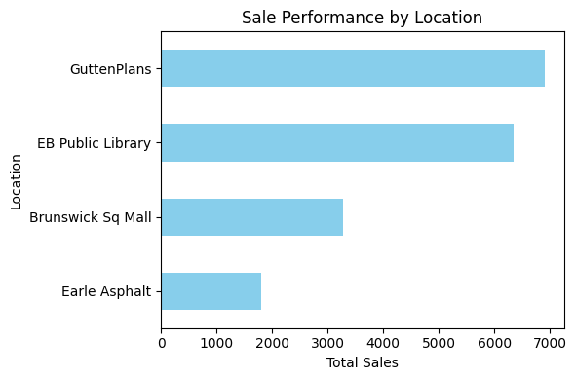Fig. 1. Sale Performance by Location

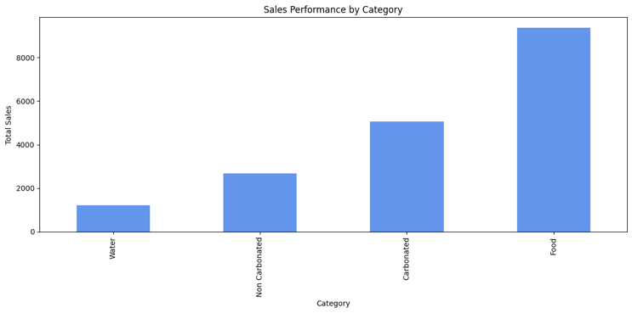

Fig. 2. Sales Performance by Category

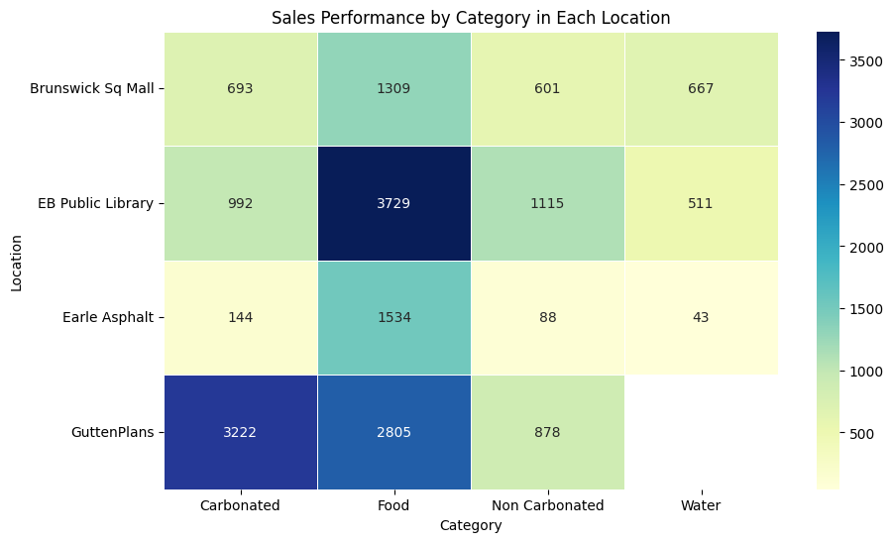

Fig. 3. Sales Performance by Category in Each Location

Graphical Insights (Figures 1, 2, & 3):Graphs and heatmaps visually illustrate the dominance of "GuttenPlans" in sales (Fig. 1) and the overarching preference for food products (Fig. 2), with nuanced differences across locations—evident through the popularity of carbonated drinks at "Earle Asphalt." A heatmap (Fig. 3) provides detailed insights into category-specific sales performance across locations, revealing distinct consumer preferences.

Operational Insights: Insights gathered from the operational data of the vending locations reveal that "GuttenPlans" with extended operation hours has high sales, suggesting a demand for meal replacement options. "EB Public Library" shows a versatile product range necessity due to diverse, high foot traffic. "Brunswick Sq Mall" has moderate sales owing to alternative options, and "Earle Asphalt" shows a preference for carbonated beverages, indicating a demand for quick refreshment options.

Fig. 4. Quantity Sold by Category in Each Location

Fig. 5. Overall Quantity Sold in Each Location

Categorical Sales Trends (Figures 4 & 5):Line graphs (Fig. 4) detail monthly sales by product category, showing the stable demand for food with fluctuating beverage sales. Another set of line graphs (Fig. 5) displays the total monthly quantity sold across all categories, illustrating overall sales trends and identifying peak periods for each location.

Synthesis of Analysis: The data suggest that vending machine product selection should be tailored to the operational characteristics and consumer profiles of each location. Operational hours, location type, and consumer demographics are key factors influencing sales performance.

Implications for Stakeholders: These insights are invaluable for stakeholders in vending machine services. Strategic product placement, inventory management, and promotional efforts must be adapted to meet the specific demands of each location to maximize sales potential.

1. *Predictive Modeling for Demand Forecasting*

Using LSTM networks, a type of recurrent neural network adept at modeling time-series data, we have forecasted future demand across various vending machine locations and product categories. The LSTM's proficiency in learning from extensive historical data allowed us to capture complex patterns and predict forthcoming trends.

1. Forecasting Overview

Utilizing Long Short-Term Memory (LSTM) networks, renowned for their proficiency in modeling time-series data, this study embarked on forecasting future demand trends across diverse vending machine locations and product categories. Through the meticulous analysis of substantial historical sales data, LSTMs demonstrated unparalleled capability in discerning complex consumption patterns, thereby facilitating accurate predictions of forthcoming trends.

1. Visualization of Forecasting Outcomes

The LSTM model's predictive insights were encapsulated in a series of line graphs (referenced as Fig. 6 in this document), illustrating a month-wise projection of sales volumes. These projections, depicted through dashed red lines across each subplot, indicated a consistent month-over-month decline in sales volumes for varied product categories and locations. The visual representation served as a clear manifestation of the anticipated market-wide downturn in demand for vending machine products.

Fig. 6. LSTM Forecasting Results

1. Detailed Analysis of LSTM Predictive Insights

The analysis of the LSTM model's outputs unveiled several key trends:

* A pronounced, uniform decline in sales was observed at the Brunswick Sq Mall, cutting across all product categories, with carbonated beverages projected to suffer the most significant sales reduction.
* Earle Asphalt location exhibited a similar downward trajectory in sales, particularly evident in both carbonated and non-carbonated beverage categories. This trend may be indicative of seasonal demand fluctuations or alterations in consumer purchasing behavior.
* The forecast for GuttenPlans suggested a less severe decline in demand, especially noticeable within the food and non-carbonated beverage segments, hinting at a possibly more stable consumer demand base.
* The EB Public Library faced a broad reduction in product demand, with a gradual decrease in food sales, potentially attributable to a consistent patronage rate.

These insights corroborate the significance of understanding detailed consumer behavior patterns and their impact on sales, as demonstrated in related research [3].

1. Implications for Vending Service Providers

The forecasts provided by the LSTM model offer crucial insights for vending service operators, urging a proactive adaptation of inventory management and marketing strategies. Anticipating a decline in demand, operators might consider adjusting stock levels or deploying targeted promotions to mitigate the projected sales downturn.

1. Operational Strategy Adaptations

Armed with predictive insights, vending machine operators are better equipped to make informed operational decisions. Tailoring product assortments and promotional efforts in response to anticipated sales declines can serve as effective measures to uphold sales figures despite adverse market conditions.

The application of LSTM networks for demand forecasting represents a strategic asset for vending machine operators, enabling a forward-looking approach crucial for optimizing inventory management and seizing potential sales opportunities amid forecasted market contractions. This study not only highlights the predictive prowess of LSTM networks but also underscores the importance of adaptive operational strategies in the face of changing market dynamics.

1. *Inventory Optimization Strategies*

The study explores the integration of traditional inventory management models with advanced forecasting techniques to optimize product inventory levels efficiently. Utilizing the Economic Order Quantity (EOQ) model, it calculates ideal order quantities that balance forecasted demand with the costs associated with holding and ordering inventory. Safety stock levels are determined to safeguard against unpredictability in demand and supply chain disruptions. Adopting category management principles, the strategy is customized according to sales trends within each product category, aiming to improve turnover and profitability. This approach is further refined by considering factors like lead times, supplier reliability, and market trends, which are crucial for enhancing forecasting models and adjusting inventory strategies accordingly. Advanced analytics and machine learning techniques are integrated into the forecasting methods, providing a significant improvement in predicting future demand and potential supply chain issues. The study also reviews best practices in inventory management across different industries, offering insights into addressing various challenges with tailored strategies. This comprehensive analysis aims to ensure optimal inventory levels and enhance supply chain efficiency and responsiveness to market changes, ultimately aiming for operational excellence and a competitive advantage in the marketplace.

1. Safety Stock and Reorder Point Calculations

Using standard deviations of forecasted demands and lead times, along with a service level set to 95%, safety stock levels were determined for each category at all locations. The safety stock ensures adequate buffer inventory to maintain service levels despite demand and supply fluctuations. Reorder points, the levels at which new orders should be triggered, were also calculated, incorporating both the lead time demand and safety stock.

1. Economic Order Quantity (EOQ) Assessment

The EOQ calculations, performed under assumed ordering and holding costs due to data limitations, indicate the most cost-effective order sizes to minimize total inventory costs. These order sizes are optimized to meet forecasted demands without incurring unnecessary expenditure on holding or ordering.

To address the challenge posed by the unavailability of specific data points crucial for a detailed EOQ analysis, assumptions were made regarding ordering costs, holding costs, and lead times. The necessity to estimate these parameters arises from difficulties in acquiring comprehensive cost structures and operational timelines in vending machine operations. Despite these constraints, our assumptions were based on industry norms and best practices to ensure the EOQ model's applicability and the reliability of our calculations. This approach, while contingent upon certain assumptions, demonstrates the model's potential to optimize inventory levels effectively and underscores the importance of collecting and analyzing more detailed operational data for future studies.

1. Inventory Optimization Outcomes

The analysis produced actionable data for inventory management at each location. For instance, "Brunswick Sq Mall" exhibits a lower EOQ for carbonated drinks, which aligns with the forecasted sales decline. Conversely, the higher EOQ for water suggests a relatively stable demand. At "Earle Asphalt," the EOQ for non-carbonated beverages indicates a higher stock turnover rate, justifying larger order quantities. "GuttenPlans" showed a varied EOQ across categories, reflecting the diverse consumption patterns of its clientele. Interestingly, the EOQ for water was zero, suggesting an inventory review. "EB Public Library" also displayed varied EOQs, signaling the need for differentiated inventory strategies across categories.

1. Strategic Inventory Management Implications

The application of these optimization strategies, underpinned by precise demand forecasts, provides a clear direction for managing inventory levels at each vending location effectively. It emphasizes the need for a robust inventory management system that can dynamically adapt to changing consumer behaviors and market conditions.

Inventory Optimization Metrics: Demonstrates the calculated safety stock, reorder point, and EOQ for each product category within the respective locations. The table provides a clear guide for inventory planning based on forecasted demand.

The integration of EOQ and safety stock calculations with LSTM-based demand forecasts represents a methodological advancement in inventory management for vending services. Although the study assumed certain costs due to data constraints, the optimization strategy outlined is a testament to the potential efficiencies that can be achieved with comprehensive data. This approach can significantly enhance operational efficacy, ensuring optimal product availability, high customer satisfaction, and maximized sales performance in the vending machine industry.

V. CONCLUSION

In the comprehensive study titled "Location-Based Inventory Optimization: Integrating Customer Behavior Analytics in Vending Machine Operations," we explored the intricate dynamics of vending machine transactions across various locations, analyzing a dataset of 9,350 transactions to derive insights into consumer behavior, product preferences, and the impact of location on vending machine sales. The study was divided into multiple sections, each focusing on different aspects of vending machine operations, including data analysis of behavioral and location insights, predictive modeling for demand forecasting, and inventory optimization strategies.

1. Data Analysis Insights

The analysis provided valuable insights into the diversity of product preferences across different locations, with "GuttenPlans" emerging as the most popular location and "Coca Cola - Zero Sugar" as the favored product, highlighting the consumer trend towards zero-sugar options. It also indicated a strong preference for food items and cash transactions, suggesting trends towards convenience eating and the immediacy of cash payments. Sales dynamics and temporal patterns were scrutinized to understand purchasing behavior better, revealing that product selection and operational strategies should be tailored to each location's specific characteristics and consumer demographics.

1. Predictive Modeling for Demand Forecasting

LSTM networks were employed to forecast future demand across various vending machine locations and product categories. The predictive models indicated a general decrease in sales volumes, providing actionable insights to adapt inventory and marketing strategies proactively. The detailed predictive results highlighted trends across different locations, suggesting the need for strategic adjustments in product assortments and promotional efforts.

1. Inventory Optimization Strategies

Our study further delved into classical inventory management models, integrating them with advanced forecasting methods to streamline inventory levels. By applying the Economic Order Quantity (EOQ) model and calculating safety stock levels, we provided a framework for optimizing inventory strategies tailored to the sales dynamics of each product category. This approach aimed to balance demand forecasts with associated holding and ordering costs, enhancing operational efficiency and profitability.

1. Synthesis and Implications for Vending Services

The integration of customer behavior analytics with location-based inventory optimization strategies presents a novel approach to vending machine operations. Our study underscores the importance of understanding consumer preferences, seasonal trends, and operational characteristics to tailor product offerings and inventory levels accordingly. By leveraging predictive modeling and inventory optimization techniques, vending machine operators can anticipate market trends, prepare for demand fluctuations, and optimize product availability. This forward-looking approach is crucial for maintaining high customer satisfaction, maximizing sales performance, and ensuring the operational efficacy of vending services.

In conclusion, the study demonstrates the significant impact of integrating customer behavior analytics with inventory optimization strategies in vending machine operations. The insights gleaned from our analysis offer valuable guidance for stakeholders in the vending machine industry, enabling them to make informed decisions that align with consumer preferences and market demands. As we move forward, the methodologies and findings presented in this study will serve as a foundation for further research and innovation in optimizing vending machine operations, ultimately contributing to the advancement of the vending industry as a whole.

REFERENCE

[1] N. U. Moroff, E. Kurt, and J. Kamphues, “Machine Learning and Statistics: A Study for assessing innovative Demand Forecasting Models,” Procedia Computer Science, vol. 180, pp. 40–49, 2021, doi: https://doi.org/10.1016/j.procs.2021.01.127.

[2] H. D. Perez, C. D. Hubbs, C. Li, and I. E. Grossmann, “Algorithmic Approaches to Inventory Management Optimization,” Processes, vol. 9, no. 1, p. 102, Jan. 2021, doi: https://doi.org/10.3390/pr9010102.

[3] W. H. Susilo, “An impact of behavioral segmentation to increase consumer loyalty: Empirical study in higher education of postgraduate institutions at Jakarta,” Procedia - Social and Behavioral Sciences, vol. 229, pp. 183–195, Aug. 2016, doi: 10.1016/j.sbspro.2016.07.128