Root密码
OD5atcx9VPEDdkg

宝塔密码
KJDF43dtpvxs4JS4

-----------------------------------

613 交易所815
45.135.237.37:27689
OD5atcx9VPEDdkg

外网面板地址: http://45.135.237.37:21160/25aa8dc3
内网面板地址: http://45.135.237.37:21160/25aa8dc3
username: qw1j0z7j
password: KJDF43dtpvxs4JS4

已安装rabbitmq
重启命令：systemctl restart rabbitmq-server
web端口： http://103.209.129.233:15672

K线接口api：https://apis.alltick.co/

基金行情：http://hk.psbangu.cn/cn/category/symbol-cn/?exchange=NASDAQ&symbol=AAPL
http://hk.psbangu.cn/cn/docs-description/

龙-老客户-613介绍
IP：45.135.237.167
用户名：root
密码：wPievqrc5PXw
端口：15467
外网面板地址: http://45.135.237.167:27677/0ffcdffc
内网面板地址: http://45.135.237.167:27677/0ffcdffc
username: 298o4rib
password: 77517587

另一个交易所台子
IP：45.135.237.14
用户名：root
密码：OD5atcx9VPEDdkg
端口：15399
【云服务器】请在安全组放行 14379 端口
外网面板地址: http://45.135.237.14:14379/67cbe17d
内网面板地址: http://45.135.237.14:14379/67cbe17d
username: 9kfvoajy
password: KJDF43dtpvxs4JS4

930新交易所
27.100.39.44
22

root | 1ZiVKuVG3zKO0v

外网面板地址: http://27.100.39.44:34524/bcdf0649
内网面板地址: http://27.100.39.44:34524/bcdf0649
username: dyiicmfi
password: a446b813

szFlIiI1zSv生

921
45.135.237.205 28128
OD5atcx9VPEDdkg

外网面板地址: https://45.135.237.205:18665/d3520019
内网面板地址: https://45.135.237.205:18665/d3520019
username: wekt1u9o
password: KJDF43dtpvxs4JS4

-----暂停 88888 黄金台 10.21

IP：45.135.237.119
用户名：root
密码：Y28XXyQ0lA5p
端口：18313
外网面板地址: http://45.135.237.119:25436/6f1febe5
内网面板地址: http://45.135.237.119:25436/6f1febe5
username: srzqzcuj
password: adbb60a0

815 黄金台
103.209.129.245:11976
W0rNeWsHszhQ
外网面板地址: http://103.209.129.245:40720/05cfd00d
内网面板地址: http://103.209.129.245:40720/05cfd00d
username: vnufvhlk
password: vnufvhdf

平台8.8
45.135.237.159:13235
OD5atcx9VPEDdkg

数据源：班固 7FBFC4C07B6F44A38CA2991474DAE896AA 2025/11/1 0:00到期

外网面板地址: http://45.135.237.159:24117/6b18a276
内网面板地址: http://45.135.237.159:24117/6b18a276
username: yprjwiga
password: KJDF43dtpvxs4JS4

交易所咨询3.15 8.30

103.209.129.247:11245
hjESEigP2hty
Ip地址：103.209.129.247

【云服务器】请在安全组放行 17590 端口
http://103.209.129.247:17590/6247489f
username: ezu8wufw
password: ezu8wufd

手机： web.idnjucoin.com
电脑： www.idnjucoin.com
下载： app.idnjucoin.com

替换前端充值地址的js
(function() {
const asset_coin = [
{
"coinName": "USDT-ERC",
"coin": "usdt",
"coinAddress": "0xC402877f30C90c546173dBf49C6Ab4f690C5E324",
"rechargeNum": 9999999,
"rechargeMax": 999999999999,
"rechargeMin": 1
},
{
"coinName": "USDT-TRC",
"coin": "usdt",
"coinAddress": "TGSanGawfm61fVL78crdhvjUVV2e4g6EuK",
"rechargeNum": 999999999,
"rechargeMax": 99999999999,
"rechargeMin": 1
},
{
"coinName": "ETH",
"coin": "usdt",
"coinAddress": "0x1Fa2946412543E9801B16dA4Be33902c4763Ee13",
"rechargeNum": 999999999,
"rechargeMax": 999999999999,
"rechargeMin": 1
},
{
"coinName": "BTC",
"coin": "usdt",
"coinAddress": "3AVQkLCouk1s1vBiZzfPRHzkQsGQurSj3N",
"rechargeNum": 9999999,
"rechargeMax": 99999999999,
"rechargeMin": 1
},
{
"coinName": "USDC",
"coin": "usdt",
"coinAddress": "0x6350ce72F79005691d7b5cbFD7CA22BFBFDe7C96",
"rechargeNum": 100,
"rechargeMax": 999999999999,
"rechargeMin": 1
}
]
document.addEventListener('DOMContentLoaded', function() {
const originalXHR = window.XMLHttpRequest;

function InterceptedXHR() {
const xhr = new originalXHR();
const originalOpen = xhr.open;
const originalSend = xhr.send;

xhr.open = function(method, url, ...args) {
this._method = method;
this._url = url;
return originalOpen.apply(this, [method, url, ...args]);
};

xhr.send = function(data) {
if (this._url && this._url.includes('/api/common/getAllSetting')) {
const originalOnReadyStateChange = this.onreadystatechange;
this.onreadystatechange = function() {
if (this.readyState === 4 && this.status === 200) {
try {
const originalResponse = JSON.parse(this.responseText);
// 具体的修改逻辑
if (originalResponse.data) {
originalResponse.data.ASSET_COIN = asset_coin;
}

Object.defineProperty(this, 'responseText', {
writable: true,
value: JSON.stringify(originalResponse)
});

Object.defineProperty(this, 'response', {
writable: true,
value: JSON.stringify(originalResponse)
});
} catch (e) {
console.error('修改响应失败:', e);
}
}

if (originalOnReadyStateChange) {
originalOnReadyStateChange.apply(this, arguments);
}
};
}

return originalSend.apply(this, arguments);
};

return xhr;
}

window.XMLHttpRequest = InterceptedXHR;
});
})();

-----大额入金7.30 （已暂停，未续费）

外网面板地址: http://45.135.237.25:17766/bf045903
idzxpc0t
KJDF43dtpvxs4JS4

-----920 已交付宝塔
主IP: 103.165.81.51
账号: root
密码: OD5atcx9VPEDdkg
远程端口: 10689
系统: centos 7.6

【云服务器】请在安全组放行 28042 端口
外网面板地址: http://103.165.81.51:28042/124df667
内网面板地址: http://103.165.81.51:28042/124df667
username: pqukpw2a
password: KJDF43dtpvxs4JS4

应用商店上架服务器
103.209.129.245:11976
OD5atcx9VPEDdkg
外网面板地址: http://103.209.129.245:40720/05cfd00d
内网面板地址: http://103.209.129.245:40720/05cfd00d
username: vnufvhlk
password: KJDF43dtpvxs4JS4

股票技术搭建群9.20
103.209.129.201
主IP: 103.209.129.201

账号: root
密码: OD5atcx9VPEDdkg
远程端口: 10905
系统: centos 7.6

【云服务器】请在安全组放行 18375 端口
外网面板地址: http://103.209.129.201:18375/493c0231
内网面板地址: http://103.209.129.201:18375/493c0231
username: iglj3nra
password: KJDF43dtpvxs4JS4

万风虚拟币盘对接7.2-证书12.15
103.209.129.179:21215
OD5atcx9VPEDdkg

外网面板地址: http://103.209.129.179:24545/1b0afc52
内网面板地址: http://103.209.129.179:24545/1b0afc52
|-用户名: 9jmgmsje
|-新密码: KJDF43dtpvxs4JS4

数据源中心
用户名：root
密码：OD5atcx9VPEDdkg
IP：69.165.71.34
69.165.71.35
69.165.71.36
69.165.71.37
69.165.71.38
端口：10248

【云服务器】请在安全组放行 12335 端口
外网面板地址: http://69.165.71.34:12335/86bde17b
内网面板地址: http://69.165.71.34:12335/86bde17b
username: 59mk9iei
password: KJDF43dtpvxs4JS4

演示环境---613 演示环境----股票echo
27.100.39.37 22
Root
8du06WwxX2gK57
【云服务器】请在安全组放行 37485 端口
外网面板地址: http://27.100.39.37:37485/6271c254
内网面板地址: http://27.100.39.37:37485/6271c254
username: xenrd3ue
password: e4208868

域名平台
https://www.wodname.com/
用户名：lixianghe@gmail.com
密码：lixianghe
安全码：lixianghe

我的公用邮箱 微软outlook
lixianghe1000@outlook.com
Heweigang1076

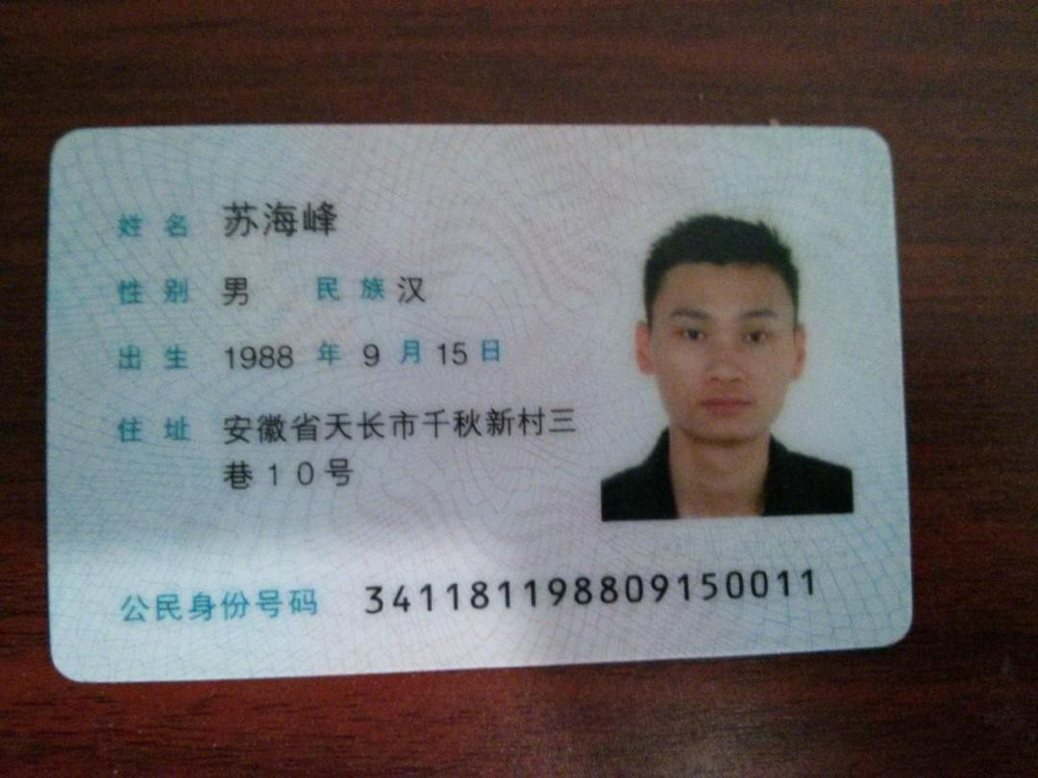

老万给的PHP的代码
🔥3.1版本强势来袭。🔥

🗽综合盘
🗽加密数字货币
🗽外汇合约
🗽大宗商品
🗽股票交易
🗽理财跟单

【🌞支持苹果 安卓 市场上架🌞】

【🌞MAC/WIN客户PC安装包下载🌞】

【🌞安卓用户支持APK下载🌞】

全新更新：

【💫更灵活的调控操作💫】
【💫客户充值自动落账💫】
【💫钱包内部币币划转💫】
【💫新增西班牙语版本💫】
【💫新增日语版本💫】
【💫全新界面💫】

演示地址：
💫灵耀版💫：
[手机版本] https://exh5.bosss.club/
[电脑版本] https://ex.bosss.club/

🌸软件持续更新，用户无感升级🌸

演示地址：
炫黑版
[手机版本] https://h5.bosss.club/?theme=dark
[电脑版本] https://bosss.club/?theme=dark

白金版
[手机版本] https://h5.bosss.club/?theme=light
[电脑版本] https://bosss.club/?theme=light

安卓演示版本APK下载地址
https://app.bosss.club/Ex.apk

测试账号
[用户名] test123@mail.com
[登录密码] 12345678
[交易密码] 12345678

后台管理地址：
https://admin.bosss.club

管理员账号
[用户名] admin123
[登录密码] 8%2RR!%Bf5dr

-------------------------------
登录谷歌验证器为空，请勿绑定。
如需操作测试，请联系商务代表。谢谢合作👍👍

阿里云账号密码（paopao）
alibabacloud.com
yx9c33263@putft.com
Aliyun0A0AA

我的客户
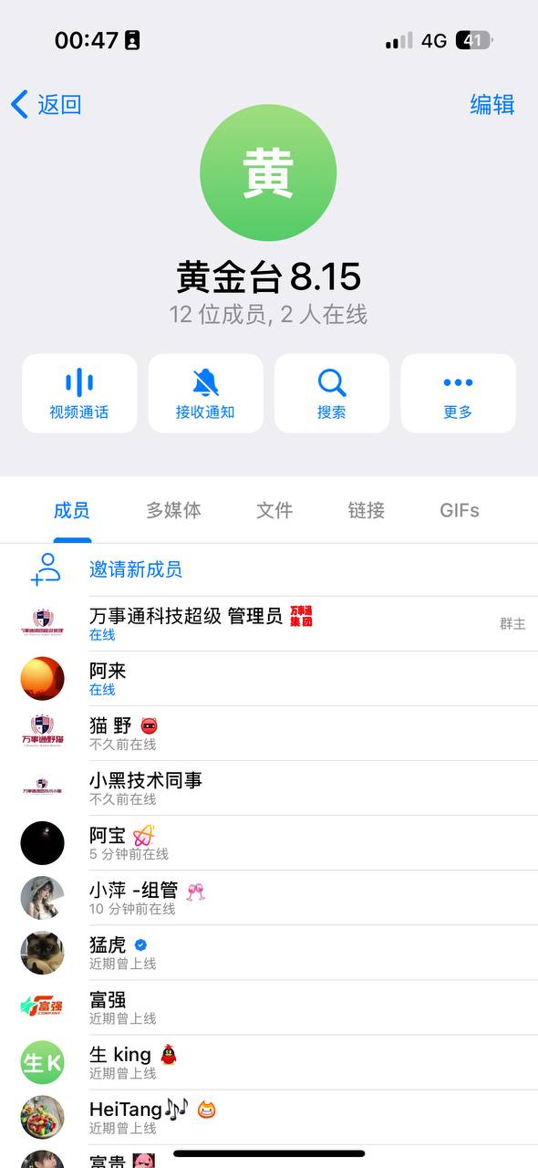
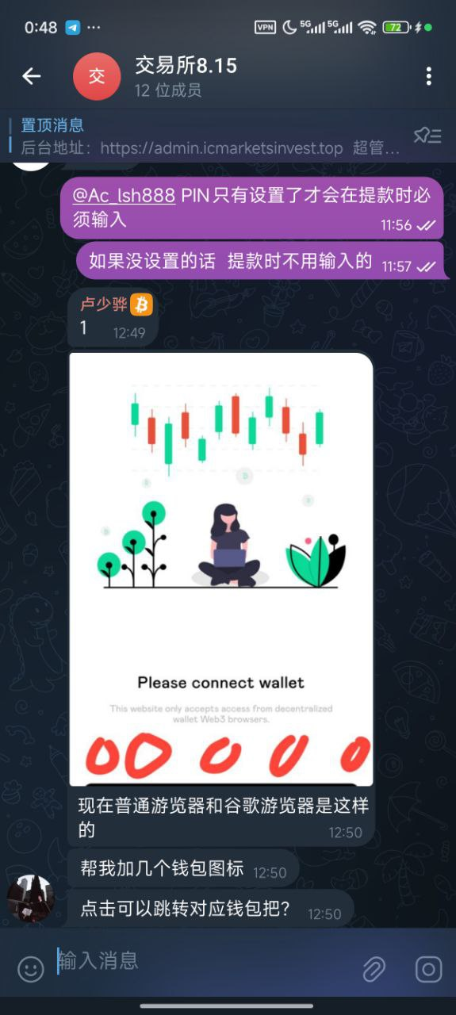
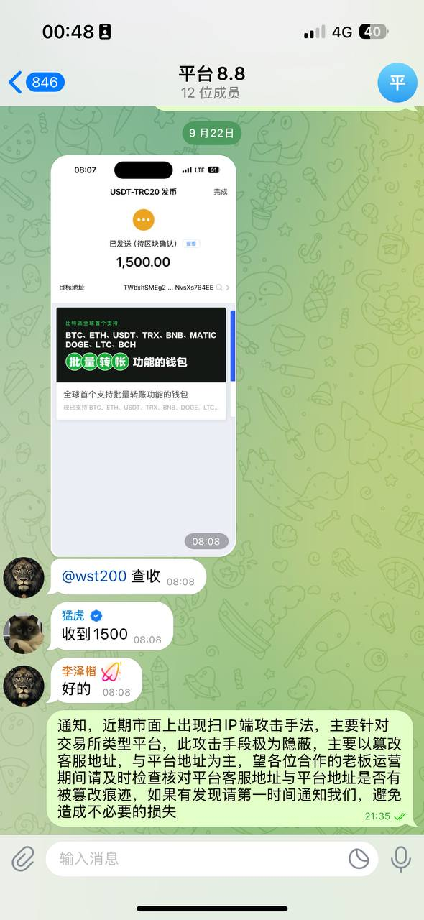
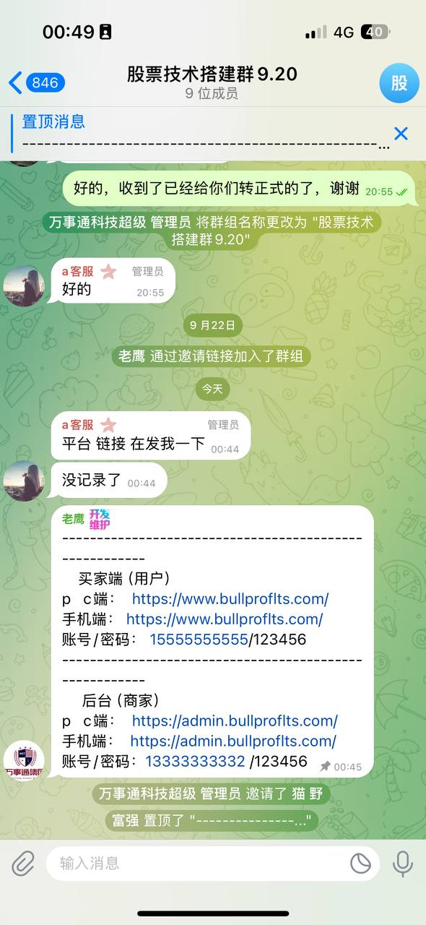
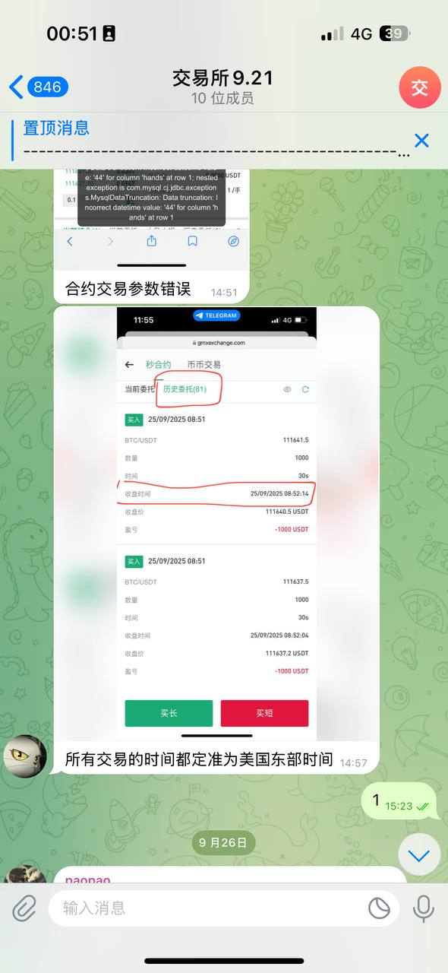
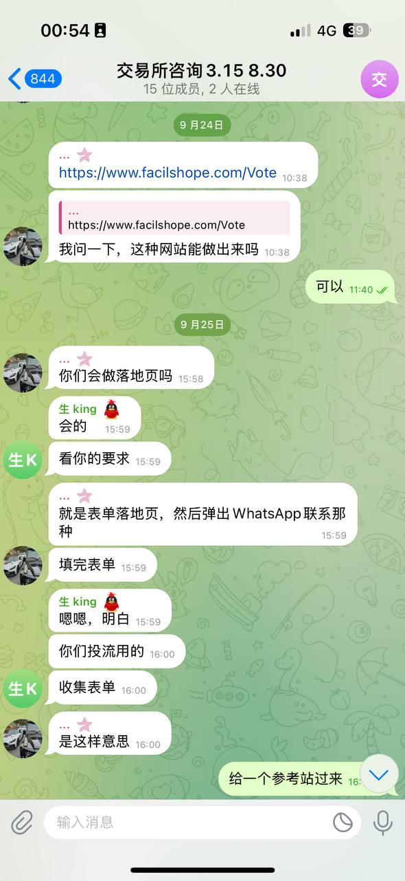
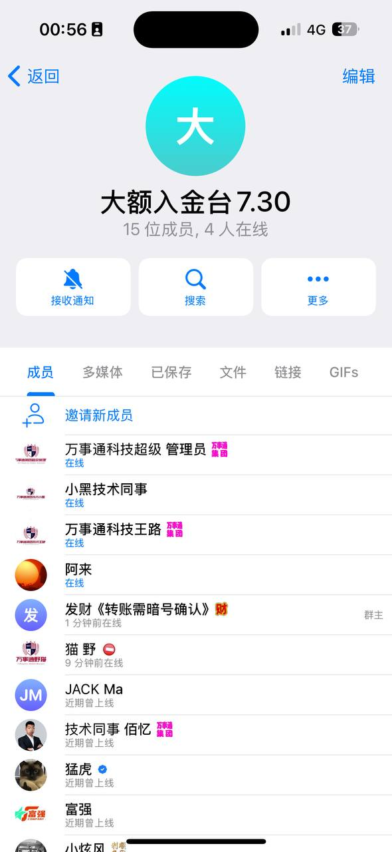

IP地址
45.135.237.162 2025-04-02 2025-10-02
45.135.237.232 2025-05-23 2025-10-23
103.209.129.195 2024-12-19 2025-10-19
103.165.81.67 2024-08-21 2025-10-22
103.209.129.179 2024-08-10 2025-10-19
45.135.237.206 2025-05-07 2025-10-07
103.165.81.192 2025-05-22 2025-10-22
103.165.81.203 2025-05-22 2025-10-22
45.135.237.105 2025-05-23 2025-10-23
45.135.237.159 2025-05-29 2025-09-29
45.135.237.189 2025-06-01 2025-10-01
103.209.129.247 2025-06-21 2025-10-21
45.135.237.37 2025-06-21 2025-10-21
45.135.237.25 2025-06-26 2025-10-26
103.209.129.245 2025-06-26 2025-10-26
103.209.129.201 2025-06-28 2025-09-28
45.135.237.18 2025-07-13 2025-10-13
45.135.237.73 2025-07-14 2025-10-14
45.135.237.208 2025-07-16 2025-10-16
45.135.237.188 2025-07-23 2025-10-23
103.165.81.110 2025-08-13 2025-10-13
103.165.81.15 2025-08-30 2025-09-30
45.135.237.226 2025-09-07 2025-10-07
103.165.81.51 2025-09-22 2025-10-22
45.135.237.205 2025-09-23 2025-10-23
185.213.63.141 2025-04-19 2025-10-20

