- src\util\public.js 第147行
修改为： timezone = Intl.DateTimeFormat().resolvedOptions().timeZone

- charting-library插件在处理高价格的k线图时会存在问题，已增加判断逻辑进行修复，src\views\trade\components\candlestick.vue 第151行 增加代码：
if(this.coinInfo.amount > 10000){
tempPricescale = 10000;
}

- src\views\trade\index.vue 1752行 注释一下代码：
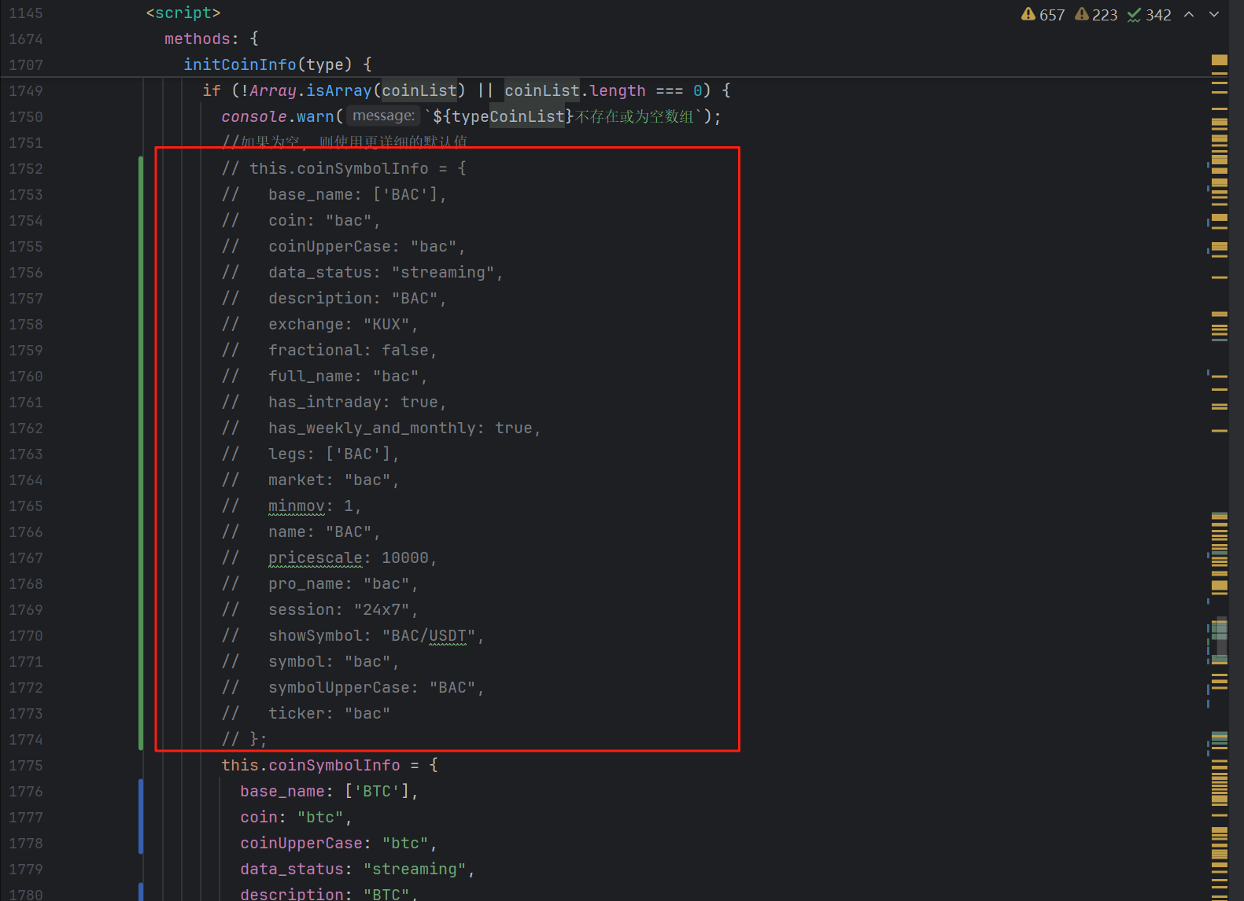
增加以下代码：
this.coinSymbolInfo = {
base_name: ['BTC'],
coin: "btc",
coinUpperCase: "btc",
data_status: "streaming",
description: "BTC",
exchange: "KUX",
fractional: false,
full_name: "btc",
has_intraday: true,
has_weekly_and_monthly: true,
legs: ['BTC'],
market: "binance",
minmov: 1,
name: "BTC",
pricescale: 10000,
pro_name: "btc",
session: "24x7",
showSymbol: "BTC/USDT",
symbol: "btc",
symbolUpperCase: "BTC",
ticker: "btc"
};

- src\views\trade\index.vue
60行：由 coinSymbolInfo.coinUpperCase 修改为coinSymbolInfo.showCoin
795行 由 coinSymbolInfo.coinUpperCase 修改为coinSymbolInfo.showCoin

- src\views\user\register.vue
213行-234行 注释掉邀请码相关的代码
95行 修改为： <el-form-item prop="email" v-if="loginType == 'email'">
104行 修改为：<el-form-item prop="phone" v-if="loginType == 'phone' || loginType == 'email'">
- src\store\modules\common.js
67行代码修改为：getPlatFormConfigApi().then((res) => {

