
SECP1513 – 02 TECNOLOGY AND INFORMATION SYSTEM
Project Management dan System Development
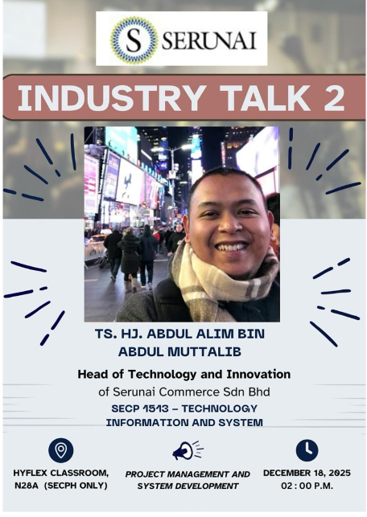
Group members:
 |  | 
MUHAMMAD AIDIL FARHAN BIN ZAMRI | LIM LI JING | PUTERI ANIS ANNISA BINTI MAT LAZIM
A25CS0260 | A25CS0248 | A25CS0339

Lecturer: Dr. Aryati binti Bakri
1.0 Introduction
Project Management and System Development are crucial components in the field of computer science, particularly in ensuring that complex systems are delivered efficiently, systematically, and high quality. On 18 December 2025, an industry talk related to project management and system development was conducted to expose students to real-world practices and professional insights.

2.0 Speaker’s Experience
TS. HJ ABDUL ALIM BIN ABDUL MUTTALIB graduated from UTM in 2014/2015, over 10 years ago. Currently head of technology and innovation at a company building halal solutions. Emphasized importance of project management and system development skills for career sustainability. He stated that coding alone is insufficient, project implementation skills are critical in the industry. He advised students to value system development and project management beyond textbook chapters.

3.0 Project Management and System Development
Project management is the process of initiating, planning, monitoring, and closing the work carried out by a team. It ensures you stay on track, on time, within budgets, and help you coordinate with designers, testers and other developers effectively (Umer Waqar,2021). Waterfall and Agile are methodologies of project management used in software development. Waterfall project management uses a sequential and linear process that can be effectively applied in projects where all requirements are fixed. Agile project management allows flexibility and can handle changing requirements by getting feedback from the user. System Development can be described as an entire process of software system development using an overall framework of Software Development Life Cycle (SDLC). SDLC involves phases like requirement analysis, design, implementation, testing, deployment, and maintenance. For instance, in our daily live likes cooking and traveling describe how concepts of SDLC can be applied to day-to-day activities and stressed that it is more necessary to learn concepts rather than terminology. Data Engineering project management helps in efficient design and maintenance of data pipes and warehouses. Agile project management helps in flexibility to adapt to varied and ever-changing sources and business needs. System development can be applied in scalable ETL development and real-time processing systems (Kimball & Ross, 2013).

REFLECTION
How you will successful in the computer science related in next four year?

MUHAMMAD AIDIL FARHAN BIN ZAMRI:
I will make sure I fully understand the foundations and basics of computer science before plunging myself deeper into the study of more complicated and intricate computer science-related subjects. I also will not be completely reliant on artificial intelligence, not as a convenient tool to finish my projects or complete my assignments, but as a tool to help me learn faster, improve my understanding, search and collect information quicker. Using the agile method, I can swiftly strengthen my strength and repair my weakness simultaneously. Not forgotten, I could consequently improve my soft skills by being active in my community and joining more programs where communications are a huge aspect. This way, I can learn to communicate with people better, voicing out my opinion and points in a much better and clear way. All these approaches will surely help me improve as a person and be more successful in my course in the upcoming four years.
LIM LI JING:
I will apply the Agile method in my learning and project development process instead of relying on artificial intelligence to complete tasks for me. By using an agile method, I can better manage my academic projects and personal skill growth. Through this method, I can identify my weaknesses early and improve my coding, system design, and debugging skills by using my brain, not artificial intelligence. I also can focus on learning more technical skills like programming language and app development. At the same time, I will develop soft skills, especially communication skills to communicate with others confidently by joining some workshop and club. This approach will help me to handle more challenges effectively in the future.
PUTERI ANIS ANNISA BINTI MAT LAZIM:
From the talk, I believe the most crucial component for ensuring my success in the computer science field is strategic planning and preparation. This involves implementing a structured , continous planning process for my daily ,semester and even yearly goals,specifying what knowledge I must acquire , what skills I need to implement and what projects I aim to build.This systemic approach is essential for achieving career readiness. I will focus on expand my professional network and develop essential soft skills by joining relevant universities club and programs during my degree.Concurrently, it will sharpen my critical thinking and technical expertise by participating in industry competitions to master technical skills required for my future specialization. The talk also highlighted that future employability relies on a balance. Therefore,I will prioritise mastering core fundamentals and viewing AI tools as a powerful aid rather that a replacement for fundamental understanding. I also believe the Agile Methodology is highly transferable to personal and academic goal achievement. I will adopt this approach by listing all major goals and tasks, prioritizing them, and executing them within a specific timeframe. The final step will be a continuous review process to analyze outcomes, identify areas for improvement, and adapt my plan accordingly.Since the computer science field evolves rapidly, continuous learning is not an option but a necessity. By structuring my four years using a proactive, adaptive strategy, I am confident that I will be well-equipped to face future industry challenges and secure a competitive position upon graduation.

REFERENCE
Kimball, R. and Ross, M. (2013) The Data Warehouse Toolkit: The Complete Guide to Dimensional Modeling. 3rd Edition, John Wiley & Sons, Inc., Indianapolis.
https://www.scirp.org/reference/referencespapers?referenceid=1644581
Umer Waqar (April 2021) What Is Project Management? A Quick Introduction to the Essentials?
https://blog.udemy.com/what-is-project management/?utm_campaign=Search_Keyword_Alpha_Prof_la.ES_cc.ROW-Spanish&utm_source=google&utm_medium=paid-search&portfolio=ROW-Spanish&utm_audience=mx&utm_tactic=nb&utm_term=curso%20de%20project%20management&utm_content=g&funnel=&test=&gad_source=1&gad_campaignid=21487757262&gbraid=0AAAAADROdO2KInPBWMGnX7CgwXnsWz_Ax&gclid=CjwKCAiA9aPKBhBhEiwAyz82J88QDiOmxzXAyNvIVWBiP8KIXkqmodBNMApcnDyv9HGivbhgKMdDIhoC8zwQAvD_BwE

