**How to build and run services :**

**Run Apache Kafka**

1. Open to path you installed Kafka, I installed it in D:\MASTER\kafka_2.11-1.1.1\bin\windows
2. Open command prompt in that path and type words below to start zookeeper

D:\MASTER\kafka_2.11-1.1.1\bin\windows>zookeeper-server-start.bat ../../config/zookeeper.properties

1. In the same path, open new command prompt and type words below to start kafka

D:\MASTER\kafka_2.11-1.1.1\bin\windows>kafka-server-start.bat ../../config/server.properties

**Working with Project**

1. Create a git folder to clone. In my case, I create it in D:\DREAM\puteri-repo
2. Run git bash with right click inside the folder, and choose **Git Bash Here **
3. Make a clone to git

$ git clone <https://github.com/puterisarahn/puteri-repo>

You will see the java maven project : flight-airport

1. Once you done this, open your Java IDE to build the flight-airport, in this case I use Eclipse
2. Import project in eclipse, with instruction below.

* Right click under Project Exploere, choose menus under

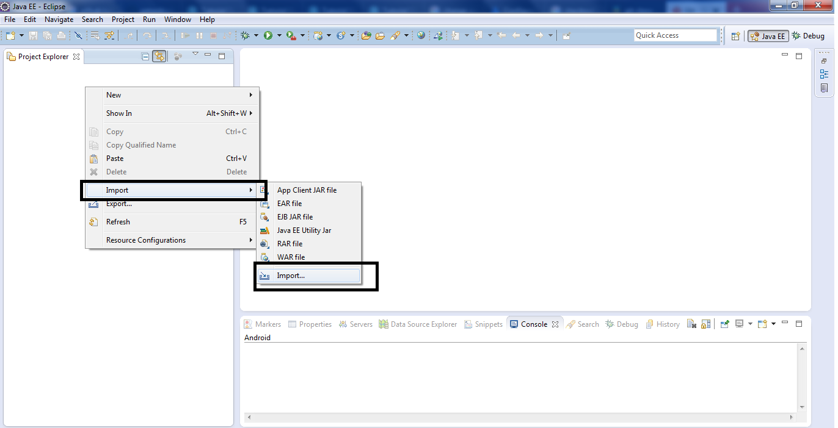

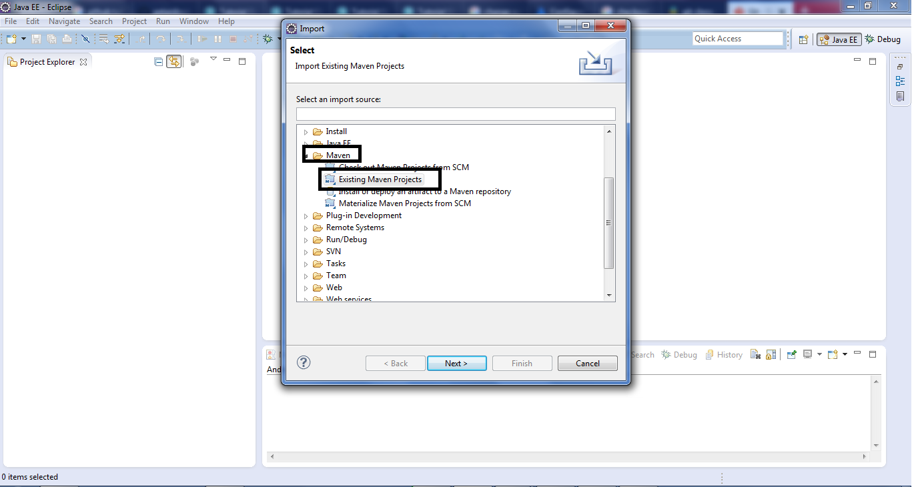

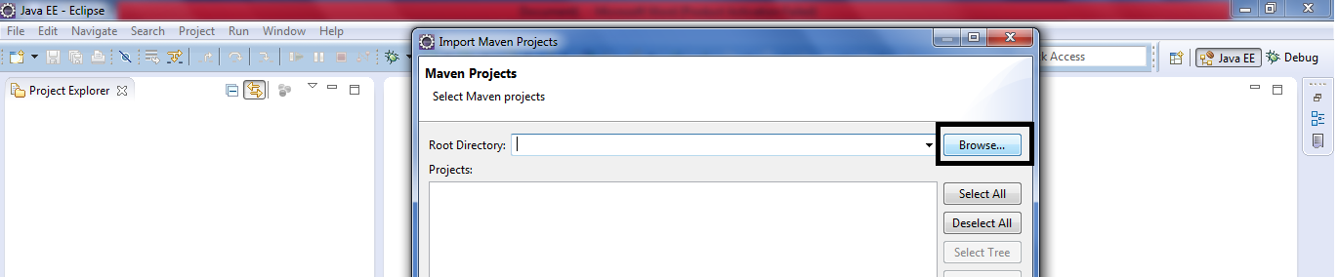

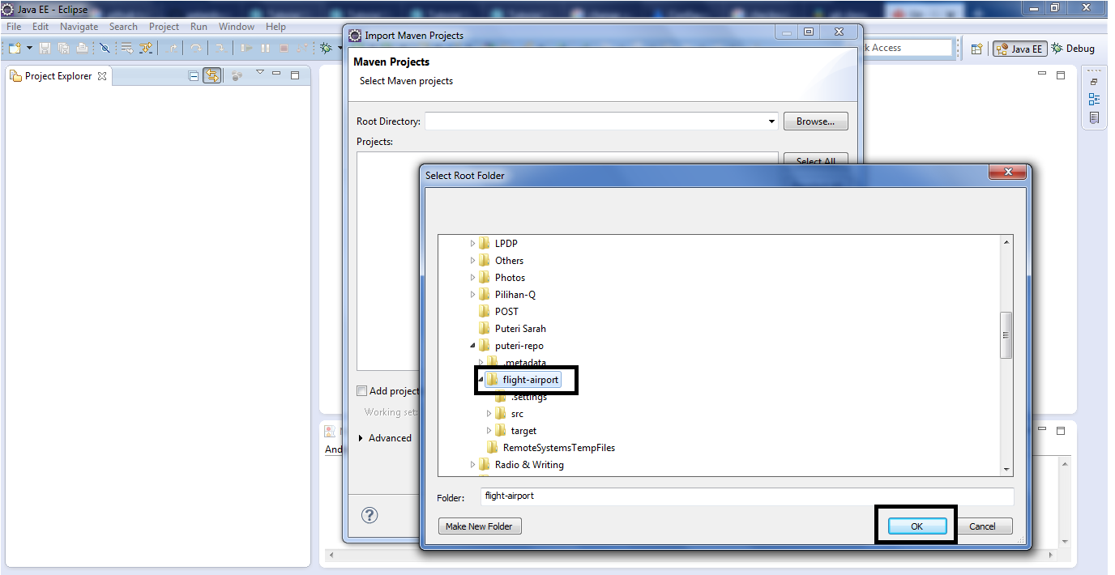

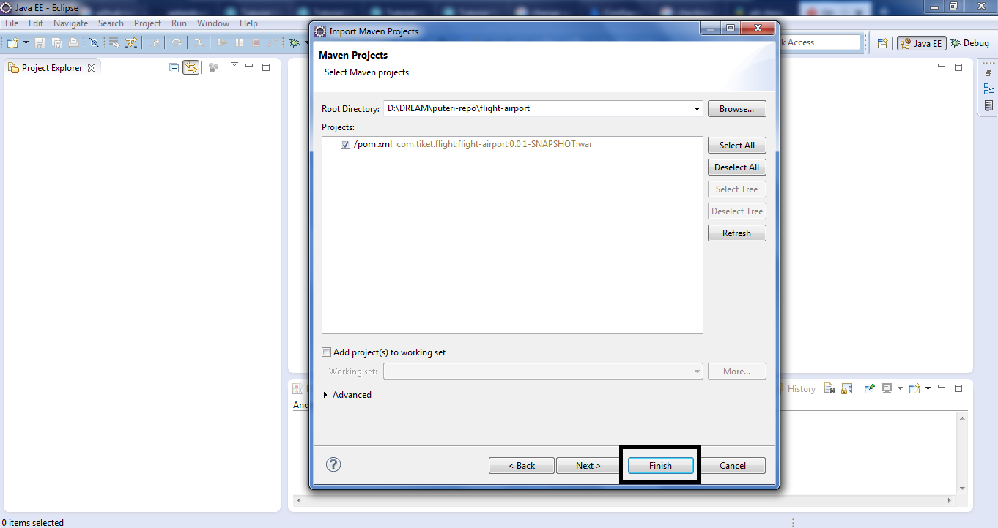

1. Once project is imported, build the project using mvn clean install with instruction below:

* Right click on flight-airport project, choose menus under

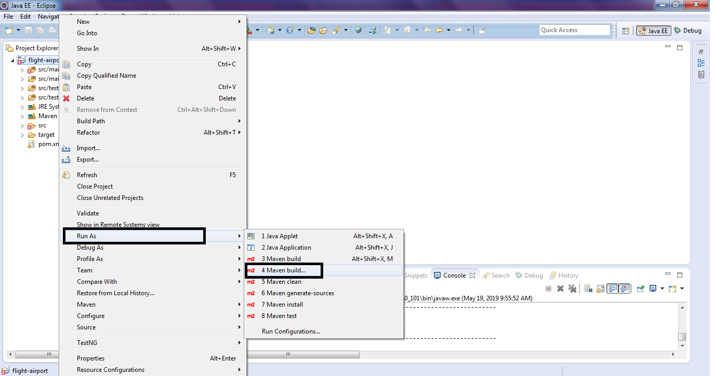

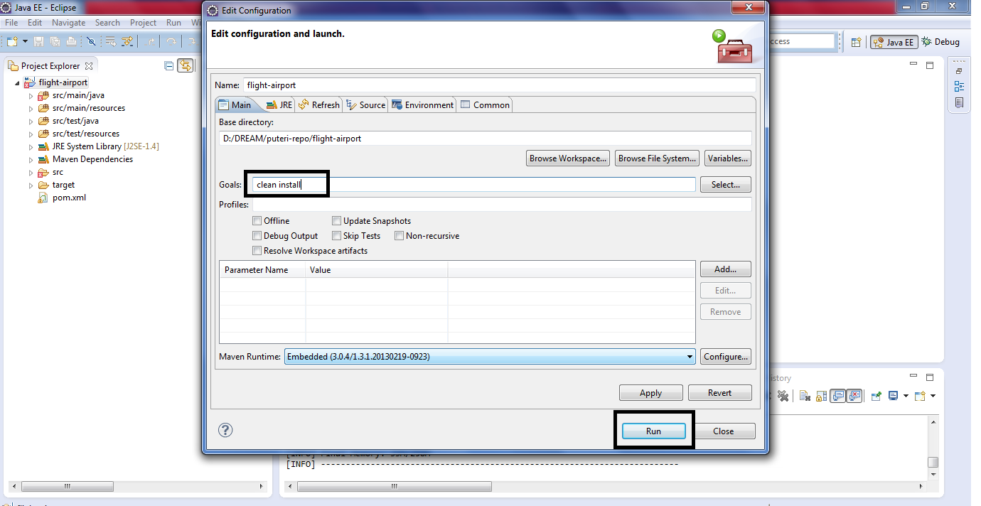

1. You can now running application using mvn spring-boot:run with instruction below

* Right click on flight-airport project, choose menus under



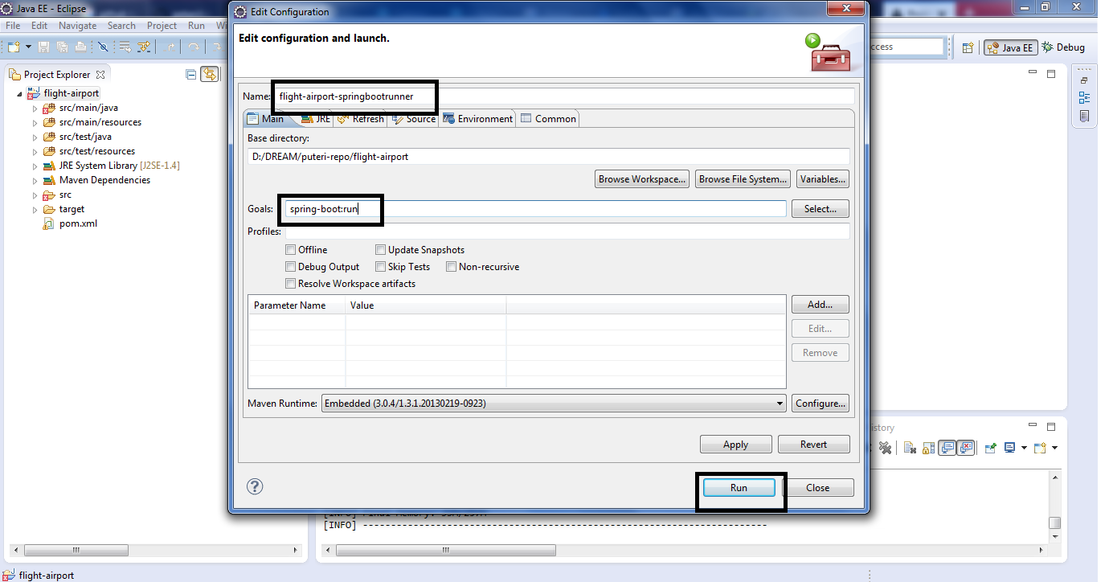

**Testing**

**Publisher**

Test from Advance Rest Controller :

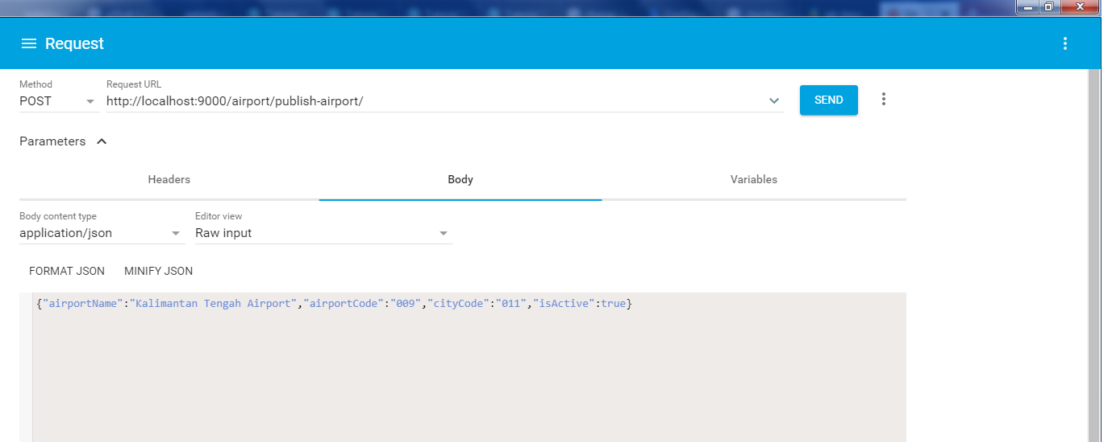

**Consumer**

Shown in console

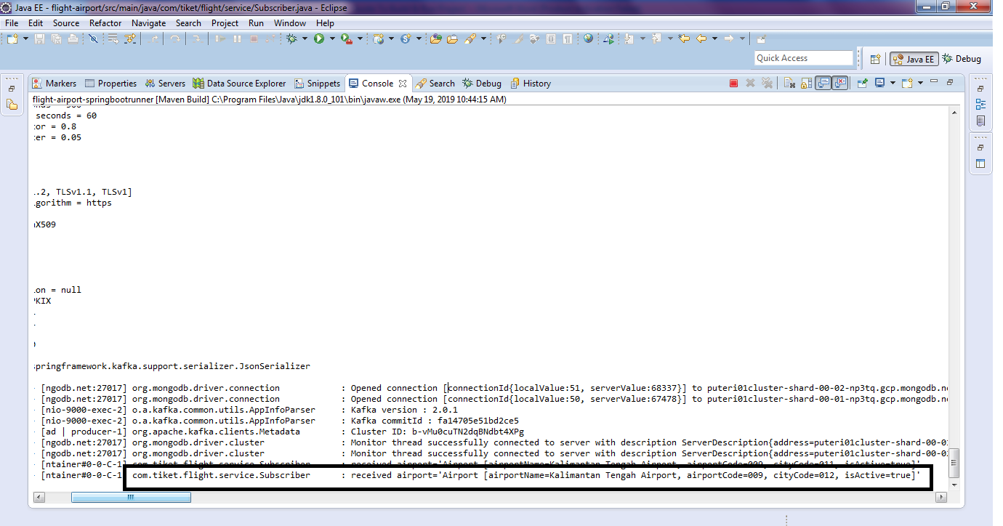

Check data added to AiportSubscriber:

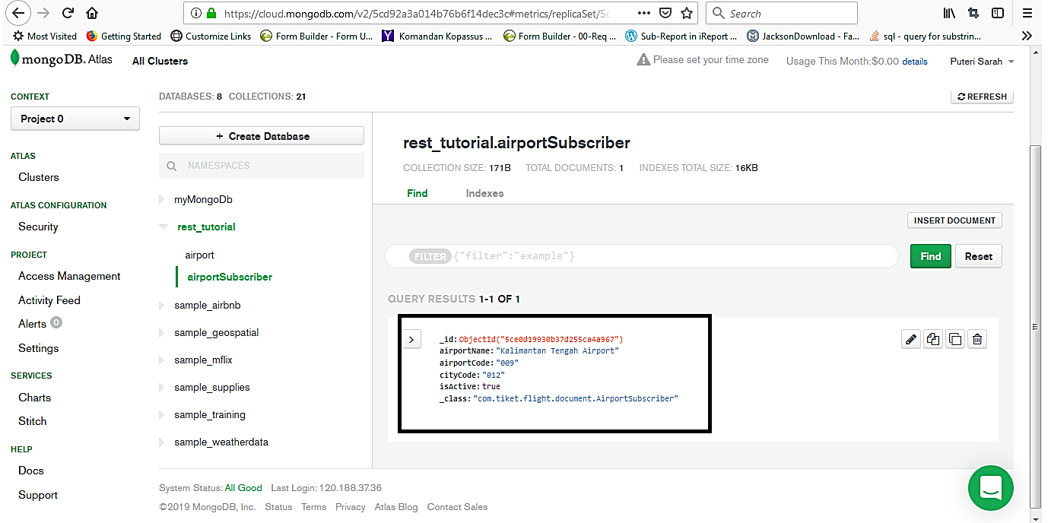

Check if update from Rest

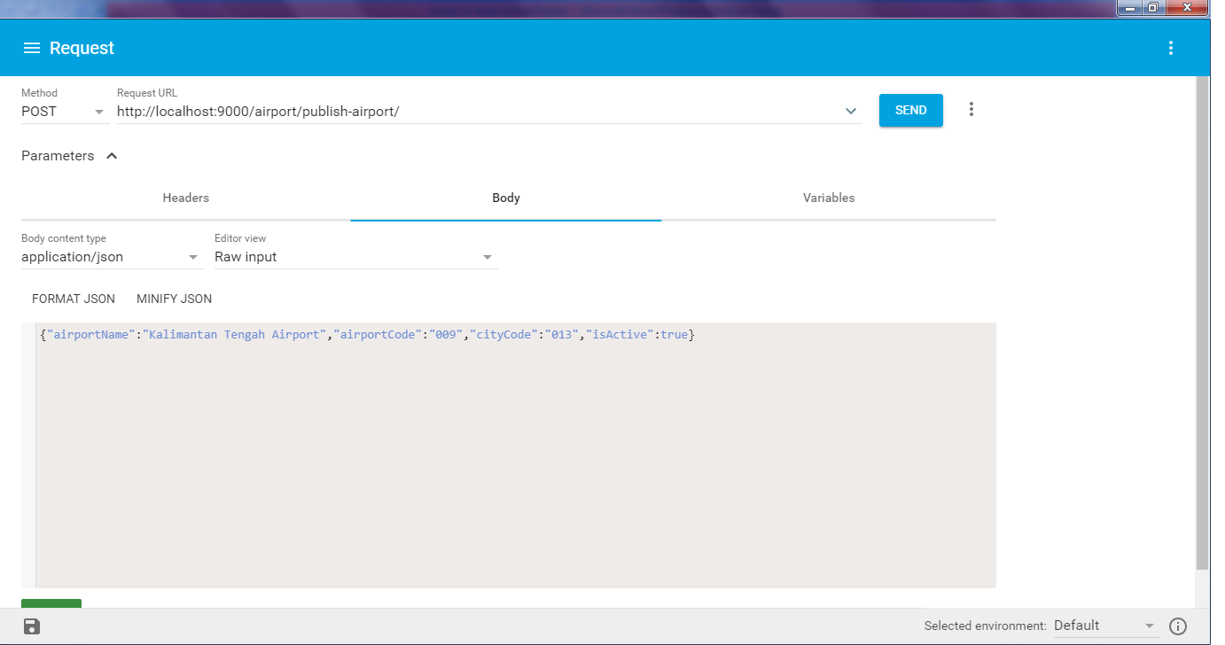

Check in DB AirportSubscriber, there is changing in CityCode.

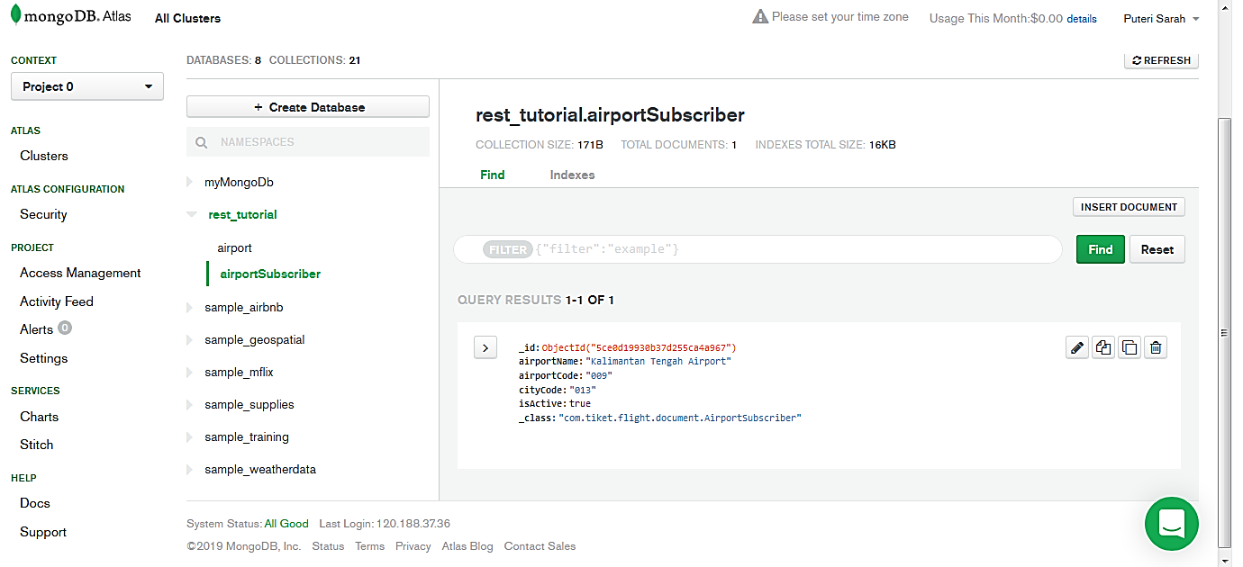

To Find out all data in AirportSubscriber, we can access it with rest in http://localhost:9000/airport-subscriber/

