**Nama: ILA ILHAM**

**Kelas: 10 RPL**

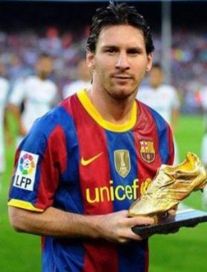

**Lionel Messi i**s a football player who came from Argentina. Currently, Messi played as the striker for the Spanish football club, FC Barcelona.

Messi was born on June 24th, 1987 in Rosario, Santa Fe province, Argentina. His mother, Celia María Cuccittini, is a part-time cleaner. His father was a worker in the steel factory is Jorge Horacio Messi. Messi has two elder brothers named Rodrigo and Matías, and a sister named María Sol.

Messi started his football career at the age of 5 years. At that time, he played for the club Grandoli where his father was the coach of the football club. In 1995, Messi joined Newell’s Old Boys in his hometown, Rosario.

At the age of 11, Messi was diagnosed with a growth hormone deficiency. The football club River Plate was interested in his talent, but they didn’t want to pay Messi’s therapy.

Carles Rexach, the sports director of FC Barcelona, had discovered Messi’s talents offered to pay for his treatment if he wanted to move to Spain. Messi and his father decided to move to Barcelona, Spain.

On 16 November, 2003, Messi finally appeared officially for the first time in a friendly match against FC Porto at the age of 16 years 145 days.

Meanwhile, in La Liga debut for Messi was on 16 October 2004 when Barcelona against RCD Espanyol. The opportunity given by Frank Rijkaard, made him into the third youngest player for Barcelona.

Messi said to Frank Rijkaard, “I will never forget the fact that he’d started my career, which gave me the confidence I had at the age of 16 and 17 years”.

By the ability of his fantastic left leg, now Messi had won many titles with Barcelona. The most unforgettable title was the best player in the world for four consecutive years, namely in 2009, 2010, 2011, and 2012.